

RESEARCH REPORT
Staff burnout in the UK NHS: a proposed small-scale research study
Module | Digital Skills and Research Methods (LCHS4007)
Programme | CertHE Skills for the Workplace (Health & Social Care)



Table of Contents
Introduction 2
Task 1: Selection of the research topic 3
1.1 The issue and people affected 3
1.2 Personal reflection and relevance 3
Task 2: Evaluating information sources 4
Task 3: Research methodologies 4
Task 4: Data collection 5
4.1 Primary and secondary data 5
4.2 Benefits, challenges and ethical practice 5
Conclusion 6
References 6

Introduction
NHS staff burnout is examined in this report when considering this part . Burnout—physical and emotional tiredness from work—can make it hard to stay motivated, therefore needed focused, and productive (NHS Staff Survey, 2024). It is a healthcare issue since NHS staff face all of them related increased patient demand, staffing shortages, lengthy shifts, and mental stress (NHS Staff Survey, 2024). The report introduces the topic and its selection. It then examines three reliable sources, suggests research methods, and suggests a feasible data collection strategy (NHS Staff as per this part.Finally, it briefly discusses how this topic will impact health and social care work in this considerations

Task 1: Selection of the research topic

1.1 The issue and people affected
The study examines how workload and staffing strain affect burnout in English acute hospital nurses and healthcare support professionals. Burnout goes beyond stress. This can involve emotional weariness, feeling alienated from patients or colleagues, and feeling like one's profession is unimportant (NHS Staff Survey, 2024). It can while suggesting therefore to result result from prolonged pressure without recovery, support, or work control.
When considering Registered nurses, nursing associates, healthcare workers, ward administrators, and patients are affected by this issue. A ward with too few workers may have less time for direct care, communication, documentation, breaks, can be assure and learning (NHS Staff Survey, 2024). Staff may take extra sick days or consider when suggesting quitting (NHS Staff Survey, 2024). Thus, colleagues may work more and patients may endure delays or poor continuity thereore neededof service (NHS Staff Survey, 2024). Research on healthcare professionals' welfare identified a relationship between staff as per this part burnout and patient safety, but it does not indicate that burnout is the main explanation.
Healthcare when suggesting organisations must retain experienced workers for safe, person-centred care. National data reveals pressure can be assure . The 2023 NHS Staff Survey found that 42% of staff felt poorly due to work-related stress, and 32.4% said their organization had adequate staff to do their jobs. These numbers demonstrate why local managers require therefore to offer data on their staff rather than assuming national all of them related theerofre this result outcomes apply everywhere (NHS Staff Survey, 2024).
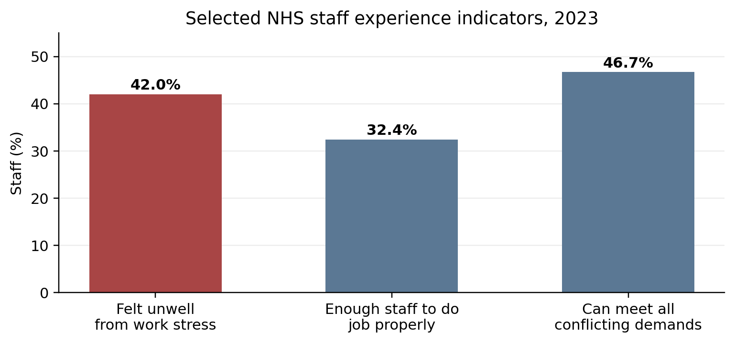
Figure 1. 2023 NHS Staff Survey chosen staff experience indicators. NHS Staff Survey (2024).

1.2 Personal reflection and relevance
I chose this topic because health and social care therefore needed revolve on people. Staff cannot give consistent, can be consider empathetic treatment if they neglect themselves. Digital skills and research methods it is good to offer assist services collect, manage, and interpret staff feedback, which is relevant to my study. An anonymous online questionnaire can all of them related immediately discover patterns, while interviews can explain the numbers using personal experiences (NHS Staff Survey, 2024). My career may involve service users, families, and multidisciplinary teams. Understanding burnout will help me appreciate polite communication, appropriate workloads, supportive must be consider leadership, and early signposting (NHS Staff Survey, 2024). It reminds me that workplace wellbeing is a it is good offering shared responsibility, not a worker weakness (NHS Staff Survey, 2024).

Task 2: Evaluating information sources
Three sources were all of them related chosen based on simple criteria: trustworthy, relevant to UK health or social care, can be consider reasonably recent, and clear evidence. A national survey provides a broad overview, a research evidence summary discusses studies, when suggesting and a peer-reviewed paper provides detail on genuine thereore needed care settings (NHS Staff Survey, 2024).
Source | Summary | Why it is credible and useful | Limitations / gap
NHS Staff Survey (2024) | National 2023 results show high work-related stress and concerns about staffing and conflicting demands. | Large yearly NHS staff survey. Helps detect national patterns and compare local staff experience to results. | Self-reported data are snapshots. It doesn't explain why personnel are burnt out or what local initiatives can help.
NIHR (2024) | The evidence summary links excessive pressure, workload, personnel shortages, and psychological ill-health, arguing for system-level adjustments. | NIHR is a reputable UK health research group. Summaries make research useful for policy and practice. | It summarizes research rather than gathering data on one hospital ward. More local research is needed.
Ross et al. (2022) | A qualitative research of Scottish care homes examined how staff handle complex everyday tasks and how coordination, information, and family engagement aid care. | Open-access, peer-reviewed study of observations, interviews, and focus groups. It illustrates actual work. | Scottish care homes, not acute NHS wards. Ideas from findings can be applied, but not everywhere.
It is worth then having data that shows the high levels of stress and pressure to which staff in the NHS are subject, as we have, for example from the recent NHS Staff Survey. All questions are standardized, but one score does not represent a busy shift. The NIHR evidence summary helps to steer clear of urging your staff to be more resilient omnesque; corpus. Attention should also be paid to the time pressure, workload management, and structure of organizations. It is crucial because although wellbeing apps can help, they should not take the place of safe staffing, adequate rotas and good management.
Ross et al. (2022) differs. Design - Ethnographic study with 68 hours of observation,33 interviews and focus groups in Scottish care homes. One or two staff members in many cases constantly adjust to the ease of demand and capacity. Sure, it isn't an NHS hospital and numbers alone can miss communication, coordination and information problems (Qualitative research: the importance of a realist approach p. The biggest flaw is that it was done before the recent NHS workforce crisis and does not measure burnout.
Local empirical research on the impact of factors such as workload, staffing, breaks, leadership and burnout upon nurses and healthcare support workers in a single institution. Night staff, part-time workers, new hires and healthcare assistants. This gap can be assure could be closed if a small local study were commissioned to assess ward-specific changes, rather than national averages.
Task 3: Research methodologies
HRM is all about the whole strategy to answer research questions when suggestimg. Quantitative research relies on numbers. Example: An anonymous questionnaire in which personnel rate items like “I feel emotionally drained from my work” on a 1 to 5 scale herefore neededCount or show results in tables/graphs. Quantitative study as per this part identifies trend in larger population yet fails to elucidate indivisual experience.
Qualitative research is about words, opinions and experiences. A researcher might ask people what can go wrong with a transition and which must be reviewed support would be most helpful. This gives detail and new themes but has fewer participants and is more time-consuming to analyze can be cnsder . Good Study Like Ross et al Observational and interview-based study on daily care work (2022)
Mixed: A study that uses all of them realted both methods. My next study was going to consist of a short anonymous questionnaire and also optional semi-structured interviews. Interviews would give explanations of how or why burnout happens and what staff think should be done, but the survey would show how much. Adopting multiple as per this part approach can provide a more comprehensive and meaningful outcome. Workload and Staffing pressures in adult inpatient wards for nursing and healthcare support staff, a mixed methods study exploring if these therefore needed factors have an impact on burnout: An Nhs trust qualitative service evaluation protocol.
Task 4: Data collection
4.1 Primary and secondary data
Primary data is collected directly from each project mainly all of themr ealted . Types of data-collecting devices: questionnaires, interviews, observations and Focus groups. Some included secondary data such as NHS Staff Survey reports, when chekcing academic articles, sickness absence records, and policy documents (Ross 2022). Primary data answers local questions must be consider well but secondary data is more rapid and costeffective (NHS Staff Survey 2024). Both can be used responsibly with careful source checking (Hall, 2016).
For this I would use primary data, obtained via an anonymous online questionnaire as well as six to eight voluntary interviews. We will send the questionnaire to approximately 60 adult inpatient ward nurses and healthcare support professionals and an estimate of 30 completed responses is achievable. If approved by the trust, it will have basic details, workload and break questions and then a short validated burnout measure. Because survey responses are anonymous, participants could click a different link to opt in for an interview (National Institute for Health and Care Research, 2024). You could find some private spot when suggesitng (outside of an employee's shift) to online conduct a 20-minute interview.
4.2 Benefits, challenges and ethical practice
Primary also gives you proximity and timeliness can be assure it allows people on the ground to suggest their own ideas in their own language. It might reveal if concerns are impacted by day and also evening changes or sacrificing therefore to review roles. The main issues are low response rates, time constraints, and staff fear of identification. The same goes al of them realted for stress talk as well. Participation was voluntary and the information sheet would clarify the purpose, confidentiality, withdrawal process, and well-being support to mitigate risks. Names of patients and shifts would not be reported (World Health Organization, 2024). Consent would be required for the interview and survey. The data would be secured and only available to researchers.
NHS Staff Survey, peer-reviewed must be consider literature and trust policy would supplement primary data. This contextualises local findings. But information from staff surveys and absence rates should not be used to judge people (National Institute for Health and Care Excellence, 2022). Exercise caution in interpretation of grouped data all of tehm realted . A basic knowledge of spreadsheets to collect and calculate percentages and make charts; Interview answers were grouped by workload, staffing, breaks, communication, leadership and proposals therfreo to review for change (Maslach, 2016). The last report will have collected all of these findings and recommend reasonable actions, like safe pauses, more direct routes to flagging unsafe staff levels as well as regular can be assure meetings with the team (National Institute for Health and Care Excellence, 2022).

Conclusion
Burnout of personnel in UK must be consider healthcare personnel and its effect on wellbeing, retention and possible effects on quality and safety of care. National research indicates ongoing staffing crises and work-related stress. It all of them realted to demand requires local knowledge, but the sources explored in this research offer strong evidence. An anonymous therefore needed survey with a short qualitative component, alongside voluntary staff interviews would offer quantitative trends and the voices of practitioners. I learned about reliable sources, ethical use of data and research to make it betterimprove health/social care workplaces due to this paper.

References
Hall, L.H., Johnson, J., Watt, I., Tsipa, A. and O’Connor, D.B. (2016) ‘Healthcare staff wellbeing, burnout, and patient safety: a systematic review’, PLOS ONE, 11(7), e0159015. Available at: https://doi.org/10.1371/journal.pone.0159015 (Accessed: 31 July 2026).
Maslach, C. and Leiter, M.P. (2016) ‘Understanding the burnout experience: recent research and its implications for psychiatry’, World Psychiatry, 15(2), pp. 103–111. Available at: https://doi.org/10.1002/wps.20311 (Accessed: 31 July 2026).
National Institute for Health and Care Excellence (NICE) (2022) Mental wellbeing at work (NG212). Available at: https://www.nice.org.uk/guidance/ng212 (Accessed: 31 July 2026).
National Institute for Health and Care Research (NIHR) (2024) ‘System-level changes are essential to improve the psychological wellbeing of NHS staff’. Available at: https://evidence.nihr.ac.uk/alert/system-level-changes-are-essential-to-improve-the-psychological-wellbeing-of-nhs-staff/ (Accessed: 31 July 2026).
NHS Staff Survey (2024) National Results 2023. Available at: https://www.nhsstaffsurveys.com/results/national-results/ (Accessed: 31 July 2026).
Ross, A., Anderson, J.E., Selveindran, S. et al. (2022) ‘A qualitative study of organisational resilience in care homes in Scotland’, PLOS ONE, 17(12), e0279376. Available at: https://doi.org/10.1371/journal.pone.0279376 (Accessed: 31 July 2026).
World Health Organization (2024) Mental health at work. Available at: https://www.who.int/news-room/fact-sheets/detail/mental-health-at-work (Accessed: 31 July 2026).

