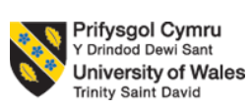

International Business

Student Name:ANUJA VINODKUMAR

Student Code:2218255

Lecture Name:LAN DANG

Module Code:LCMB7014

Submission Date:28/07/2023

Number Of Words:6107

Table of Contents

Introduction 3

Internationalisation strategy 3

Factors considered during the formulation of the Internationalisation strategy 3

Key decisions underpinning international organisational strategy 7

Contextual factors affecting internationalisation strategy 11

Conclusions 20

References 22

Introduction

Toyota motor corporation, founded in 1937, has become a global leader in the automotive industry. Its headquarters are located in Toyota City, Japan. Toyota motor corporation is well known for its dedication to efficiency, quality, and innovation. It is known for creating dependable vehicles that meet a variety of consumer needs. This report focuses on important facets of Toyota's internationalization strategy, significant choices influencing its overall organisational strategy, and contextual factors affecting its global expansion using a PESTLE analysis. Exploring these aspects reveals important information about Toyota's strategic approach and the factors that contribute to its widespread success. The paper provides substantial advantages, such as a thorough comprehension of Toyota's strategy for international expansion and its performance in a variety of areas. Insights into the elements Toyota takes into account when entering new markets are available to stakeholders, aiding strategic decision-making. The paper highlights how crucial localization, adaptability, and strategic relationships are to Toyota's global business operations.

Internationalization strategy

Factors considered during the formulation of the Internationalization strategy.

The internationalization strategy formulated by Toyota for entry into the market of China is highly focused on the mitigating factors for political issues, as the two countries are already facing political clashes that possess the power to destroy the opportunities available for Toyota in the automobile sector of China market. Toyota has a polycentric internalization strategy that focuses on hiring and staffing strategy whereby foreign subsidiaries of a country hire personnel from the host country instead of from the location of the parent firm (Toyota, 2022). It has been mentioned in the study of Cooke (2020) that the business performance of Toyota was significantly affected by the political and social instability arising due to world war II, followed by the riots of 2005, labour unrest happened in 2010 and social unrest amongst netizens regarding territorial disputes in 2012. Furthermore, Toyota also focuses on other factors while formulating an international strategy for the Chinese market, which are scanning the business environment of China, government business policies implemented in China for international companies, the competitive environment in the Chinese market and technological environments (Toyota’s global strategy, 2022). It is also mentioned in Toyota (2022) that the global vision of Toyota is related to focusing on the formulation of specific plans and strategies considering the specificness of individual regions concerning its product integrity and loss redemption strategy. It is also mentioned in the source that Toyota has formulated a specific team for the Chinese market that focuses on the changing behaviour of the business environment of China that possesses the power to affect the business operation of Toyota in the automobile market of China (Sanders, 2023).

Scanning business environment of China: It is mentioned in Toyota (2022) that the business environment of the automobile sector of China market has a driving force which is required for the future growth in the business operation of Toyota that makes scanning of the business environment of the Chinese market more crucial in order to levity opportunity and threat at an early stage to get first mover advantage. The polycentric internationalization strategy of Toyota focuses on the effective scanning of the business environment of the Chinese market in order to implement local business practices in the offices and business areas of Toyota in the demographics of China so that it can communicate and perform business activities effectively in China. Toyota uses the local labour force for its store being operated in the market of China in order to make effective communication between store employees and local customers (Li et al. 2020).

Geo-political tensions: Toyota also needs to focus on monitoring the government policies being implemented in the business environment of the Chinese market for international MNCs operated with a special focus on the automobile sector. Government policies are highly affected by geopolitical tensions arising between Japan and China or other countries that create threats to the effective business operation of Toyota in the market of China. It is mentioned in Toyota's global strategy (2022) that Toyota is facing trouble in the China market due to the fallout of the Japanese occupational growth of China in World War II. It is also mentioned in the source that the riots of 2005 have increased the political tension between Japan and China, which makes its business relationship weak, creating threats to the market expansion of Toyota in China market as government policies are not in favour of Japanese companies. Furthermore, the territorial disputes of 2010 over the uninhabited islands in the South China Sea created geopolitical tensions among both countries, making their business relation worse. Continuously deteriorating business relations between China and Japan make it a critical factor that is considered by Toyota to formulate a polycentric international strategy that focuses on the improvement of business relations between China and Japan.

The competitive environment in the Chinese market: Toyota also focuses on a close analysis of its competitive environment before formulating its polycentric internationalization business strategy. It has been mentioned in the study of Wang (2022) that Toyota invest its time and expertise to ensure the effective conduction of analysis of the competitive environment of the Chinese environment to know the updated business strategies that are being practiced in the automobile industry of China.

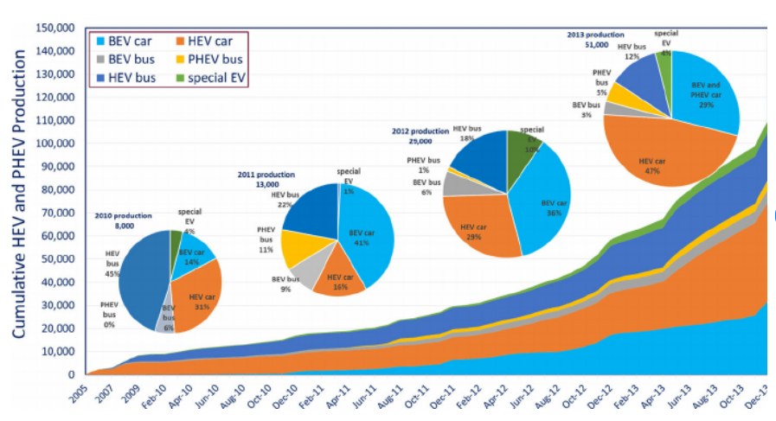

Figure 1: HEV and PHEV production in China shows growing shares of HEV cars and BEV cars.

Source: Hey and PHEV production in China (2019)

Figure 1 represents an overall increase in the production of automobiles in the Chinese market that further indicates the rising demand for automobiles creating a highly competitive automobile market that includes automobile giants including BYD motors, SAIC motors, Geely and NIO. Figure 1 also shows that the automobile industry of the Chinese market has high demand, production and competition for the BEC cars followed by HEV cars.

Technological environments: Another crucial factor that Toyota considered while formulating its international business strategy is related to the technological environment of the automobile sector of the Chinese market. It is mentioned in the study by Kim, Paek, and Lee (2022) that Toyota invests millions of dollars each year to promote R&D in the automobile industry of the global market, including the Chinese automobile market. As a result, the company can now boast of some technological achievements. The authors further mentioned in their study that Toyota believes that Innovative hydrogen vehicles are necessary to maintain the business in the cutthroat industry of the Chinese automobile sector. With its focus on research and development, Toyota was the first to release hydrogen-powered vehicles on the market (Kim, Paek and Lee, 2022). The future of the automotive industry lies in hydrogen and electric vehicles. Toyota advanced from its rivals by introducing hydrogen-powered vehicles. According to technical developments, Toyota adheres to the principle of constant advancement. It has consistently adopted the most recent advancements in automotive technology, helping the brand to maintain its leadership position in the world market. Furthermore, owing to the selection of a polycentric internationalization business strategy, Toyota has to focus on the technological upgradation in the Chinese automobile sector very closely in order to implement the updates of technological applications in the business environment of Toyota as soon as possible in order to win competitive advantage (Kim, Paek and Lee, 2022).

Key decisions underpinning international organisational strategy.

Toyota has developed a global approach over the last several decades which has assisted it in overcoming its difficult times and establishing itself as the most widely recognised corporation in the world. A firm's ability to depart from the paradigm of local utilisation, which is the product or service it is producing through marketplaces outside of the country where it operates, is one of the finest ways to establish a multinational companionship, according to the published and rapid academic investigations (Chivaka, 2018). The implementation of FDAs in both real and intangible properties, local employment, advancement of leadership, and innovation in both domestic and foreign markets are all part of this approach (global. Toyota, 2023). Of all the customers in a nation, generally the staff members; while the number of employees declines, revenues also decrease. Multinational juggernauts from Japan have witnessed it. Internal spending slowed as the nation's adult workforce shrank, and Japanese businesses began to drop off the Global 500 list. There was a 94% relationship between the fall in the working-age population and the departure of Japanese companies from the Global 500. According to figures from Toyota's business performance for 2019, just 25% of the company's revenues were dependent on domestic consumption, with the remaining 75% going to markets besides Japan. Take an investigate international car sales data from 2018, Toyota is in the position of leader with an overall percentage of 9.46%, and although its biggest markets are North America (32%) and Japan (25%), it still requires an emphasis on countries beyond Japan and North America owing to a decrease in people living within a single and growing populist thinking across various locations that prioritise the purchasing of locally produced businesses over foreign-made cars, but this is currently being tackled as part of the international investment subsection (global. Toyota, 2023). A majority of companies have to be disbanded because the business setting within which they conduct business is difficult. One of the most competitive industries in the world is that of making cars; therefore, in order to survive in lightning-fast, highly chaotic operating circumstances, automotive producers require the implementation of competitive advantage-promoting tactics. The Toyota Group embraced a range of product innovations and a comprehensive corporate view to create an ongoing edge over competitors (Rintala, 2023). With the establishment of manufacturing centres abroad and the use of the acquisition and merger techniques, the corporation carried out its worldwide growth plan. In order to get ahead of its rivals, the corporation places a steady commitment to refining its industrial process, including increasing its ability to manufacture. As a majority of businesses, confronting the fierce rivalry throughout the vehicle-producing industry has proved difficult. In order for effective competition, the Toyota Group adopted a plan of attack that integrated reliability across all of its manufacturing processes. Partnerships with partners and varied social obligation approaches define the car manufacturing company (Bhattacharya, 2023). The Toyota Group created and implemented a number of techniques, such as outstanding development and dedication to the environment, with the goal of establishing itself as a significant participant in the car manufacturing market. The organisation's comprehensive management system gave it the ability to react swiftly and effectively to the requirements of its customers. In the words of (), the main skills can potentially be easily applied throughout the company's operational segments inside a unit tied jointly through a single management structure. Toyota, in this instance, is able to promptly mobilize its assets while enhancing the efficiency of its worldwide manufacturing operations and raising the calibre of its goods. The organisation's standpoint allows it to conserve significant finances because only a single employee (Chivaka, 2018) manages the consolidated leadership structure. As shown throughout the Toyota Group, good planning and resource allocation encourage productivity and operating effectiveness. The Toyota group has expanded via acquisitions and mergers in the past. For instance, it bought Skoda in the 1990s, a time when the manufacturer already existed (Benkarim and Imbeau, 2022). This showed how the business's plan for acquisition might be used for implementing analytical advancements and technology. Due to its creativity and technology supremacy, which are a result of its methods such as the firm has been managed to develop high-quality products. Furthermore, everyone gained the ability to develop plans and began utilising one another's contributions, leading to a development of a number of fresh and high-quality brands for the consumer. The business has the people capital, technological capabilities, and approach to carry out its plan and achieve its vision of dominating the vehicle manufacturing sector (Kliestik, Nagy and Valaskova, 2023). (Kliestik, Nagy and Valaskova 2023) Toyota's global organisational strategy is centred on effective supply chain and manufacturing processes. To meet local demand and reduce logistical challenges, the business strategically creates production plants in key regions. Toyota is able to produce high-quality vehicles in various markets quickly and affordably because of decisions about production capacity, location choice, and supply chain optimisation. Toyota understands the value of customizing its goods to meet the distinct preferences and needs of regional markets. The business uses a localization approach that entails adapting their cars to take into account cultural, governmental, and infrastructure factors. Toyota promotes customer happiness and keeps a competitive edge in the global automobile sector by tailoring its products to individual markets. A key component of Toyota's organisational strategy is developing a strong brand position in foreign markets. To communicate dependability, quality, and innovation in a variety of cultural situations, the corporation designs its brand image with care. Toyota uses regional marketing approaches that connect with its target audience and clearly convey the brand's value. Toyota is able to increase customer loyalty and improve its reputation globally thanks to these strategic choices. Forming alliances and partnerships is another crucial choice supporting Toyota's global organisational strategy. Toyota works together with regional businesses, suppliers, and distributors to access their knowledge of the market and their distribution networks. These alliances make it easier to enter new markets, aid with complex regulatory issues, and improve brand recognition.(Magnusson and Berggren, 2011) states that Toyota's international organisational strategy heavily relies on its dedication to technological innovation and advancement. To include innovative technologies and environmentally friendly solutions in its cars, the corporation makes research and development investments. Toyota is able to stay competitive, fulfil changing consumer wants, and handle global environmental issues thanks to important technological innovation decisions. Toyota's global success can be attributed to a number of important decisions that have defined its international organisational approach. Toyota has made a significant global impact through careful market selection, manufacturing optimisation, product adaptability, brand positioning, collaborations, and technology innovation. By making these choices, Toyota has been able to navigate various markets successfully, satisfy regional tastes, and preserve its competitive advantage. Toyota's strategic decision-making will continue to be essential in determining how its global expansion and organisational growth will be shaped as the automotive industry develops.

Contextual factors affecting internationalization strategy.

PESTLE analysis is highly effective in the analysis of contextual factors that affected the internationalization business strategy of Toyota for the automobile sector of the Chinese market. Pestle's analysis focuses on the factors, including a political, legal, ecological, social, technological, legal and ethical environments, which possess the power to significantly affect the internationalization strategy of Toyota that has been formulated to ensure the effective conduction of business operations in the automobile sector of the Chinese market.

Political environment: Political environment of the internationalization business strategy formulated by Toyota for its business expansion in the automobile market of China is significantly vulnerable that can be analysed with the history of the geo-politic relationships between Japan and China. It has been mentioned in the study of Chivaka, Reason (2018) that the political and social turmoil caused by World War II, which was followed by riots in 2005, strikes in 2010, and social unrest among netizens over territorial issues in 2012, had a considerable negative impact on Toyota's corporate performance. The authors further stated in their study that the operations could be affected by political unrest in China, where Toyota has manufacturing plants, or by significant sales. This includes the possibility of civil unrest, governmental shifts, and other disturbances that might have an impact on Toyota's manufacturing, sales, or supply chain procedures (Smith, Wesseler, and Zilberman, 2021). The polycentric internationalization business strategy formulated by Toyota has also benefited from the economic policy developed by the Chinese government that focuses on the cost-cutting factors in the manufacturing of entire industries of China, including the Automobile industry (Teo et al. 2019). It is mentioned in the study of Kaneko (2019) that the US-China trade war is the most effective economic factor that has affected the internationalization business strategy of Toyota as the Chinese government stopped providing assistance to the companies and organisations that have tied up with the United States of America. The authors further stated in their study that Toyota has benefited from the current economic policies of the Chinese government that focuses on the elimination of trade and ownership restrictions imposed on the automobile sector. On April 17, 2018, the Chinese government announced that it would revise its regulations to limit international automakers' ownership of vehicle manufacturing to 50% and that it would abolish a two-decade requirement that they cooperate with Chinese manufacturers' state-owned businesses (Kaneko, 2019). The authors further stated that, In particular, the Chinese government claims that it will abolish these limitations on producers of electric vehicles sometime in 2018, commercial vehicle manufacturers in 2020, and traditional passenger vehicle manufacturers in 2022.

Economic environment: The economic environment for the internationalization strategy of Toyota includes fluctuations in the inflation rate, price index, employment rate, fluctuation in fuel prices, interest rates and exchange rate. Kim has opined it, Paek and Lee (2022) that Toyota sales in China region are highly affected by the vulnerabilities in the economic conditions of the automobile sector of China. The authors further stated in their study that the polycentric internationalization business strategy of Toyota for the Chinese market had been highly affected by the economic turmoil due to the covid 19 pandemic, which has increased the general price level making it tough for Toyota to rely on the Chinese market for the fulfilment of the requirement of raw material for the manufacturing of automobiles. Furthermore, the closure of international routes further affected the business strategy of Toyota as business communication was affected to a significant extent initially. It has been mentioned in the study of Kim, Paek and Lee (2022) that Toyota is established in Japan, but it has to keep its eye on the fluctuation of foreign exchange rates of countries in which it operates, including China. Changes in the exchange rate can certainly affect the overall cost of production of automobiles by Toyota in the Chinese market, leading to an increase in the price of its product that further leads to a decrease in demand in accordance with the law of demand.

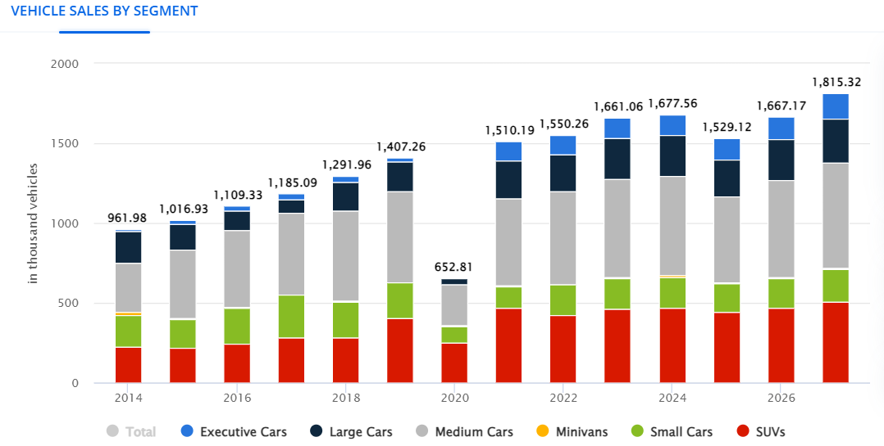

Figure 2: Sales of Toyota in China Market

Source: Toyota (passenger cars) - china: Statista market forecast (2022)

It can be analysed from Figure 1 that the overall sales made by Toyota in China market are increasing after 2020 with a financial figure of US $1,510.9 million in 2021 that has increased to US $1,550.9 in 2022, followed by a sales forecast of US $1661.06million for the year 2023. It can be seen in Figure 1 that the sales forecast has been made, which indicates that Toyota will earn more and more revenue over the years, which indicates positive changes in the economic environment of internationalization business strategy for Toyota for its market expansion in the automobile market of China.

Social environment: There is an increasing preference for eco-friendly items as society grows more ecologically conscious. With the Prius, one of the first commercially successful hybrid cars, Toyota has been a pioneer in this field. Toyota continues to invest in hybrid, electric, and hydrogen fuel cell technology (Soviar et al. 2019). The authors further mentioned in their study that internationalization business strategy also focuses on the positive trends of the social environment by manufacturing automobiles like Prius that helps in the sustainable development, a concept which is trending in society. Toyota's business strategy also focuses on the reduction of co2 emissions from its business operation in order to maintain the effective quality of the environment.

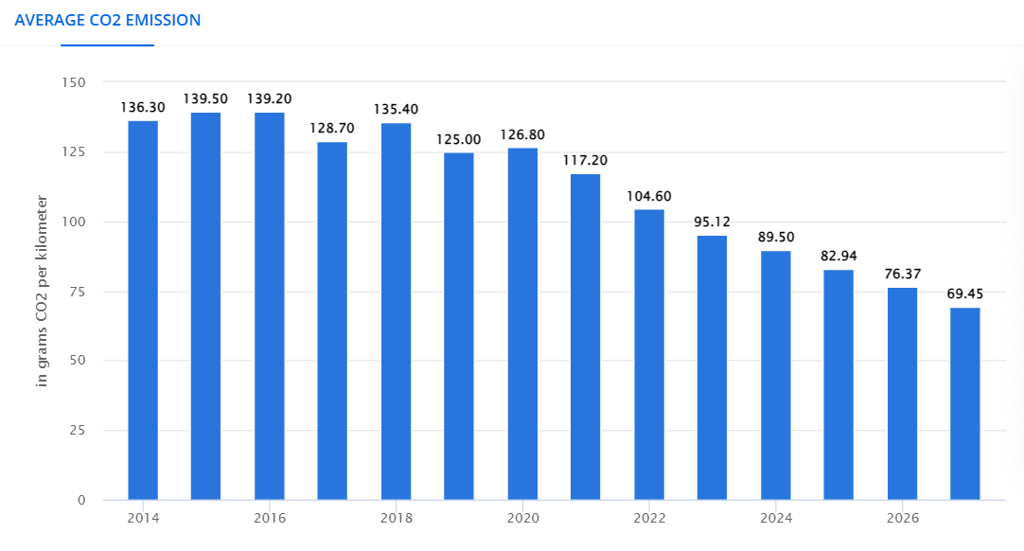

Figure 3: CO2 emission by business operation of Toyota

Source: Toyota (passenger cars) - china: Statista market forecast (2022)

It is evident from Figure 3 that the internationalization business strategy of Toyota has been successful in reducing its co2e emission in order to grab the opportunity from its social environment by establishing its reputation in the automobile sector for the Chinese market that, further helps it to increase the number of sales followed by an increase in the scale of operation in the market of China. Toyota witnessed a Co2 emission of 136.30 grams from the business operation in 2014, had increased to the level of 139.50 grams in 2015, but then again reduced to 139.20 grams in 2016, followed by a CO2 emission of 128.70 in 2017, which was the lowest CO12 emission in Toyota that time. Furthermore, the CO2 emission of Toyota has been witnessed to the level of 104.60 for the year 2022, has been forecasted to reduce to the level of 95.12 grams in 2023, followed by 89.50 in 2024, has been forecasted to reduce to the level of 69.45 grams for the year of 2027.

Technological environment: Technological environment of internationalization business strategy of Toyota is coerced by the implementation of innovation and technology in the automobile sector of the Chinese market in order to increase the number of sales, followed by an increase in the sales of operation by expanding its market, which is the primary objective of the internationalization strategy of Toyota. It has been mentioned in the study of Toyota et al. (2021) that after turning to local partner BYD for crucial technologies to produce an affordable yet roomy runaround ultimately, Toyota Motor Corp introduced an all-electric small sedan in China in December 2021. The authors further stated in their study that the vehicle has acted as an electric "holy grail" for Toyota, which has spent years trying to develop a compact EV that is both comfortable and cost-competitive in China.

Legal environment: Different laws, rules, and policies that control how foreign businesses operate in China have an impact on the legal environment that Toyota is subject to abroad. These legal frameworks include provisions for the protection of the environment, labour, investment, and intellectual property rights (Shen et al., 2022). To operate efficiently and effectively in the Chinese market. The foreign investment law (FIL) is a crucial element of China's legal system. The FIL offered a uniform legal framework for foreign investment in China and went into force in January 2020. It aims to encourage investment liberalization, provide a fair playing field, and safeguard the rights and interests of international investors. Toyota and other foreign businesses are given the same access to markets, rights to government contracts, and access to technology as domestic businesses under the FIL (Cheng et al. 2022). For Toyota in China, labour laws and regulations are also crucial factors. The People's Republic of China's Labour Law lays out the fundamental privileges and duties that apply to both employers and workers. It addresses topics including employment agreements, working conditions, pay, social security, and the settlement of labour disputes (Su, Miao, and Wang, 2022). Patents, trademarks, copyrights, and trade secrets are all protected by laws and regulations in the nation. Toyota is a major global automaker that significantly relies on its intellectual property resources. It must make sure that its innovations are safeguarded and that any infringements are successfully dealt with by the Chinese legal system. To guarantee that its workers are treated fairly and equally, to maintain a safe workplace, and to prevent labour conflicts, Toyota must abide by certain regulations. Another crucial aspect of the legal system is intellectual property protection, according to Shen, Turner, and Antonopoulos ( 2022). China has worked hard to improve its system for protecting intellectual property rights (IPR). Another important component of China's legal system is taxation. The nation has a complicated tax structure that consists of municipal taxes, value-added tax, and corporate income tax. To guarantee effective tax planning, correct reporting, and avoidance of any tax-related concerns, Toyota must comprehend and abide by certain tax requirements.

Ethical environment: Toyota places a high priority on honesty and conformity. The business upholds high ethical standards and makes sure that all of its workers do as well. All workers at Toyota are guided by the company's Code of Conduct, which outlines standards for moral conduct, adherence to rules and regulations, and ethical decision-making (Zhang et al. 2021). These policies also apply to the company's operations in China and place a strong emphasis on adhering to all applicable local laws and ordinances, particularly those that deal with labour, the environment, and safety. Second, Toyota is dedicated to advancing environmental responsibility and sustainability. The corporation aggressively works to reduce its environmental effect since it understands how important environmental concerns are. To cut down on carbon emissions, Toyota China has created hybrid and electric automobiles and employed eco-friendly production techniques. Additionally, it actively supports environmental conservation programs by working with regional communities, NGOs and governmental entities. Thirdly, Toyota places a high priority on the health and safety of its customers and staff. By adhering to occupational health and safety regulations in China, the firm makes sure that its employees have a safe place to work (Zhang, Mas’ and Sulaiman, 2022). Toyota also focuses much emphasis on quality control with the goal of providing its customers with dependable and secure automobiles. Toyota reacts quickly to fix problems and keeps customers informed when there are product recalls or safety issues. The fourth point is that Toyota actively participates in CSR projects in China. The business wants to help the neighborhood grow while tackling societal issues. Toyota works with regional partners to undertake initiatives that are concerned with social welfare, environmental protection, and education. These programs help educational institutions, raise public awareness of traffic safety, and offer emergency catastrophe aid.

Factors | Explanation
Political environment | Given the history of the geopolitical ties between Japan and China, it is possible to analyse how politically sensitive the Toyota corporate strategy for internationalization is for its development into the Chinese vehicle market.  This covers potential civil unrest, political changes, and other disturbances that could affect Toyota's production, sales, or supply chain practices.  The Chinese government's economic plan, which emphasises cost-cutting measures in the manufacture of all sectors of the Chinese economy, including the automobile industry, has benefited Toyota's polycentric internationalization business model.  The economic environment for the internationalization business strategy of Toyota for market expansion in the Chinese market is highly vulnerable.
Ecological environment | Toyota's internationalization plan must take into account the changing inflation rate, price index, employment rate, fuel prices, interest rates, and currency rate, as well as other economic factors.  The economic uncertainty brought on by the COVID-19 pandemic, which has raised general prices, has had a significant impact on Toyota's polycentric internationalization business strategy for the Chinese market, making it difficult for Toyota to rely on the Chinese market to meet its raw material needs for the production of automobiles.  Toyota will continue to generate increasing amounts of income over time, indicating good developments in the economic environment for its internationalization business plan for market expansion in China's auto market.
Social environment | As society becomes more environmentally conscious, there is an increasing preference for eco-friendly products. Toyota has been a leader in this industry with the Prius, one of the first commercially successful hybrid vehicles.  By producing cars like the Prius that aid in sustainable development, a concept that is popular in society, that internationalization business plan also focuses on the good tendencies of the social environment.  Toyota's business strategy also emphasises lowering CO2 emissions from its operations in order to preserve the environment's useful quality.  By building its reputation in the automotive industry for the Chinese market, Toyota has been successful in reducing its CO2 emissions in order to seize the opportunity from its social environment. This has helped it to increase sales, which has led to an expansion of its operations in the Chinese market.
Technological environment | The primary goal of Toyota's internationalization strategy is to increase sales, which will be followed by an increase in operating sales by expanding its market. The technological environment of this strategy is forced by the implementation of innovation and technology in the Chinese market's automobile sector.  Toyota Motor Corp. has announced an all-electric small sedan in China in December 2021 after turning to local partner BYD for critical technology to develop an economical yet roomy runaround ultimately.  For Toyota, who has spent years trying to create a compact EV that is both comfortable and cost-competitive in China, the car has served as the "holy grail" of electric vehicles.
Legal environment | Toyota operates in China under the country's legislative framework, which entails rules for foreign investment, the protection of intellectual property, labour laws, taxes, and environmental protection. Fair operations, the protection of intellectual property, respect for labour standards, tax compliance, and environmental responsibility are all ensured by observing these rules.
Ethical environment | Integrity, compliance, and openness are highly valued in Toyota's ethical workplace in China. The business upholds rigorous ethical standards and demands that its staff do the same. Toyota's efforts to reduce environmental effects and create eco-friendly automobiles are also centred on sustainability and environmental responsibility in China. Through a dedication to a safe working environment and quality assurance, employee and customer safety is prioritised. Initiatives for corporate social responsibility, such as assistance for environmental protection, disaster relief, and education, are aggressively pursued. Communication with stakeholders that is open and transparent is promoted, and moral business practices and competitive competition are upheld. Overall, Toyota's ethical culture in China is a reflection of its commitment to ethical and environmentally friendly business practices, with the purpose of fostering trust and making a big difference in the neighborhood.

Table 1: PESTLE analysis of the Internationalization strategy of Toyota

Source: Self-made

Conclusions

The political climate and long-standing geopolitical tensions between Japan and China pose a serious threat to Toyota's worldwide business plan for growth in the Chinese car market. Toyota's activities in China have been hampered by the social upheaval, trade tensions between the US and China, and political turbulence. To entice international manufacturers, the Chinese government has altered regulations and enacted economic policies. Toyota has nonetheless profited from these actions as well. Toyota operates in China within a complicated legal framework that includes rules governing foreign investment, intellectual property protection, labour legislation, taxation, data protection, and environmental standards. Toyota's success and compliance in the Chinese market depend on adhering to these legislative standards. Toyota's dedication to honesty, compliance, safety, corporate social responsibility, sustainability and open communication and fair competition has created the company's ethical environment in China. These values serve as the company's operating guidelines and demonstrate its commitment to ethical business conduct in China's automobile industry.

References

Benkarim, A. and Imbeau, D., 2022. Investigating the implementation of Toyota’s human resources management practices in the aerospace industry. Merits, 2(3), pp.126-145. Available at: https://doi.org/10.3390/merits2030010 (Accessed: 09 June 2023).

Bhattacharya, S., 2023. Multinational working capital management a study on Toyota Motor Corporation. International Journal of Finance & Economics, 28(1), pp.236-256. Available at: https://doi.org/10.1002/ijfe.2418 (Accessed on 9 June 2023)

Cheng, H., Lyu, K., Li, J. and Shiu, H., 2022. Bridging the Digital Divide for Rural Older Adults by Family Intergenerational Learning: A Classroom Case in a Rural Primary School in China. International Journal of environmental research and public health, 19(1), p.371 Available at:.https://doi.org/10.3390/ijerph19010371(Accessed on 9 June 2023)

Chivaka, Reason. (2018). GLOBAL CORPORATE STRATEGY-TOYOTA CASE STUDY. Available at: https://www.researchgate.net/publication/327239007_GLOBAL_CORPORATE_STRATEGY-TOYOTA_CASE_STUDY/citation/download (Accessed on 9 June 2023)

Cooke, P., 2020. Gigafactory logistics in space and time: Tesla’s fourth gigafactory and its rivals. Sustainability, 12(5), p.2044.Available at: https://doi.org/10.3390/su12052044 (Accessed: 09 June 2023).

global. Toyota. (2023). Toyota Motor Corporation Official Global Website. Available at: https://global.toyota/en/ (Accessed on 9 June 2023)

Hev and PHEV production in China (2019) Available at: https://www.researchgate.net/figure/HEV-and-PHEV-production-in-China-shows-growing-shares-for-HEV-cars-and-BEV-cars-from-2011_fig3_276481714 (Accessed: 09 June 2023).

Kaneko, M., 2019. A lifecycle analysis of the corporate average fuel economy standards in Japan. Energies, 12(4), p.677. Available at: https://doi.org/10.3390/en12040677 (Accessed: 09 June 2023).

Kim, J., Paek, B. and Lee, H., 2022. Exploring innovation ecosystem of incumbents in the face of technological discontinuities: Automobile firms. Sustainability, 14(3), p.1606. Available at: https://doi.org/10.3390/su14031606 (Accessed: 09 June 2023).

Kim, J., Paek, B. and Lee, H., 2022. Exploring innovation ecosystem of incumbents in the face of technological discontinuities: Automobile firms. Sustainability, 14(3), p.1606. Available at: https://doi.org/10.3390/su14031606 (Accessed: 09 June 2023).

Kim, J., Paek, B. and Lee, H., 2022. Exploring the innovation ecosystem of incumbents in the face of technological discontinuities: Automobile firms. Sustainability, 14(3), p.1606. https://doi.org/10.3390/su15054167 (Accessed: 09 June 2023). Toyota (passenger cars) - china: Statista market forecast (2022) Statista. Available at: https://www.statista.com/outlook/mmo/passenger-cars/toyota/china#unit-sales (Accessed: 09 June 2023).

Kliestik, T., Nagy, M. and Valaskova, K., 2023. Global value chains and industry 4.0 in the context of lean workplaces for enhancing company performance and its comprehension via the digital readiness and expertise of the workforce in the V4 nations. Mathematics, 11(3), p.601. Available at: https://doi.org/10.3390/math11030601 (Accessed: 09 June 2023).

Kliestik, T., Nagy, M. and Valaskova, K., 2023. Global value chains and industry 4.0 in the context of lean workplaces for enhancing company performance and its comprehension via the digital readiness and expertise of workforce in the V4 nations. Mathematics, 11(3), p.601.Available at:https://doi.org/10.3390/math11030601 (Accessed on 9 June 2023)

Li, L., Msaad, H., Sun, H., Tan, M.X., Lu, Y. and Lau, A.K., 2020. Green innovation and business sustainability: New evidence from energy-intensive industry in China. International Journal of Environmental Research and Public Health, 17(21), p.7826. Available at: https://doi.org/10.3390/ijerph17217826 (Accessed: 09 June 2023).

Magnusson, T. and Berggren, C., 2011. Entering an era of ferment–radical vs incrementalist strategies in automotive power train development. Technology Analysis & Strategic Management, 23(3), pp.313-330.Available at:https://doi.org/10.1080/09537325.2011.550398 (Accessed on 9 June 2023)

Rintala, O., 2023. How to not lose oneself: the case for relational identity in collaborative supply relationships. International Journal of Physical Distribution & Logistics Management, 53(2), pp.231-247. Available at: https://doi.org/10.1108/IJPDLM-12-2021-0512 (Accessed on 9 June 2023)

Sanders, S., 2023. Environmental Status Goods and Market-Based Conservation: An Arm of Ostrom's Polycentric Approach? Sustainability, 15(5), p.4167. Available at: https://doi.org/10.3390/su15054167 (Accessed: 09 June 2023).

Shen, A., Turner, S. and Antonopoulos, G., 2022. Driven to Death: A Chinese case study on the counterfeiting of automotive components. Asian Journal of Criminology, 17(3), pp.311-329. Available at: https://doi.org/10.1007/s11417-022-09365-8(Accessed on 9 June 2023)

Shen, T., Chen, H.H., Zhao, D.H. and Qiao, S., 2022. Examining the impact of environmental regulations and resource endowment on technology innovation efficiency: From the microdata of Chinese renewable energy enterprises. Energy Reports, 8, pp.3919-3929. Available at:https://doi.org/10.1016/j.egyr.2022.03.037

Smith, V., Wesseler, J.H. and Zilberman, D., 2021. New plant breeding technologies: An assessment of the political economy of the regulatory environment and implications for sustainability. Sustainability, 13(7), p.3687.Available at: https://doi.org/10.3390/su13073687 (Accessed: 09 June 2023).

Soviar, J., Holubčík, M., Vodák, J., Rechtorík, M. and Pollák, F., 2019. The Presentation of Automotive Brands in the On-Line Environment—The Perspective of KIA, Peugeot, Toyota and VW in the Slovak Republic. Sustainability, 11(7), p.2132. Available at: https://doi.org/10.3390/su11072132 (Accessed: 09 June 2023).

Su, Y., Miao, Z. and Wang, C., 2022. The experience and enlightenment of Asian smart city development—a comparative study of China and Japan. Sustainability, 14(6), p.3543. Available at: https://doi.org/10.3390/su14063543(Accessed on 9 June 2023)

Teo, H.C., Lechner, A.M., Walton, G.W., Chan, F.K.S., Cheshmehzangi, A., Tan-Mullins, M., Chan, H.K., Sternberg, T. and Campos-Arceiz, A., 2019. Environmental impacts of infrastructure development under the belt and road initiative. Environments, 6(6), p.72. Available at: https://doi.org/10.3390/environments6060072 (Accessed: 09 June 2023).

Toyota (2022). Available at: https://www.toyota-global.com/pages/contents/company/message_from_president/president110309.pdf (Accessed: 09 June 2023).

Toyota (passenger cars) - china: Statista market forecast (2022a) Statista. Available at: https://www.statista.com/outlook/mmo/passenger-cars/toyota/china#technical-specifications (Accessed: 09 June 2023).

Toyota, K., Miyakawa, H., Hiruta, C., Sato, T., Katayama, H., Ohira, T. and Iguchi, T., 2021. Sex determination and differentiation in decapod and cladoceran crustaceans: an overview of endocrine regulation. Genes, 12(2), p.305. Available at: https://doi.org/10.3390/genes12020305 (Accessed: 09 June 2023).

Toyota’s global strategy - トヨタ自動車株式会社 公式 ...(2022) Available at: https://global.toyota/pages/global_toyota/ir/presentation/20041603_en.pdf (Accessed: 09 June 2023).

Wang, S., 2022. Exploring the Sustainability of China’s New Energy Vehicle Development: Fresh Evidence from Population Symbiosis. Sustainability, 14(17), p.10796.Available at: https://doi.org/10.3390/su141710796 (Accessed: 09 June 2023).

Zhang, S., An, K., Li, J., Weng, Y., Zhang, S., Wang, S., Cai, W., Wang, C. and Gong, P., 2021. Incorporating health co-benefits into technology pathways to achieve China's 2060 carbon neutrality goal: a modelling study. The Lancet Planetary Health, 5(11), pp.e808-e817. Available at:https://doi.org/10.1016/(Accessed on 9 June 2023)

Zhang, W., Mas’ od, A. and Sulaiman, Z., 2022. Moderating Effect of Collectivism on Chinese Consumers’ Intention to Adopt Electric Vehicles—An Adoption of VBN Framework. Sustainability, 14(19), p.12398 Available at:.https://doi.org/10.3390/su141912398(Accessed on 9 June 2023)

