Ashley John Rees (2009258)
L4 – Introduction to Web and Database Concepts (Web)
ACCA4023
HTML & CSS Web Development
25/04/2021

Table of Contents
Introduction 3
Requirements 4
Implementation 5
Screenshots 5
Index page (page 1) 5
Page 2 6
Page 3 7
Page 4 8
Page 5 9
Validation 10
Evaluation 11
References 13
Appendices 14

Introduction

Using HyperText Markup Language (HTML) I have created a five-page website, using web standards. I have based my website on part of a hobby that I am passionate about. In this report I will be discussing the process it takes to create a website using HTML. I will be including screenshots of my finished webpages as well as the code behind the creation.
I will be using webs design principles, which concentrate on the content, the way the website looks as well as how it is has been laid out. I will also be using the two fundamental web standards which are HTML and CSS. I will also make sure that my created websites work on multiple web browsers and work on mobile devices, such as Tablets and Mobile phones.
I have based this website on a hobby of mine, this will give me knowledge on who I intend to target with the information included.

Requirements

I have based my website on Mountain biking, which is a hobby of mine. Mountain Biking is a very broad hobby, so I have narrowed it down to create a website on the suspension component aspect.
This website’s purpose will be providing people wanting to purchase one of these products an in-depth review. The review will include product information, technical information, the products intended use, a first look, an opinion and test where I have used the product in real world, which I go into detail the advantages and disadvantages of the product. Based on the information within the website consumers would be able to make an informed choice on which product would be better suited to their riding style and budget.
I have created 5 web pages, an index page which has an introduction to the website, there is two pages that looks at two sets of suspension forks, one from Fox and another from Rock Shox and the other two pages look at rear suspension form Fox and Rock Shox.

Implementation

Screenshots

Index page (page 1)
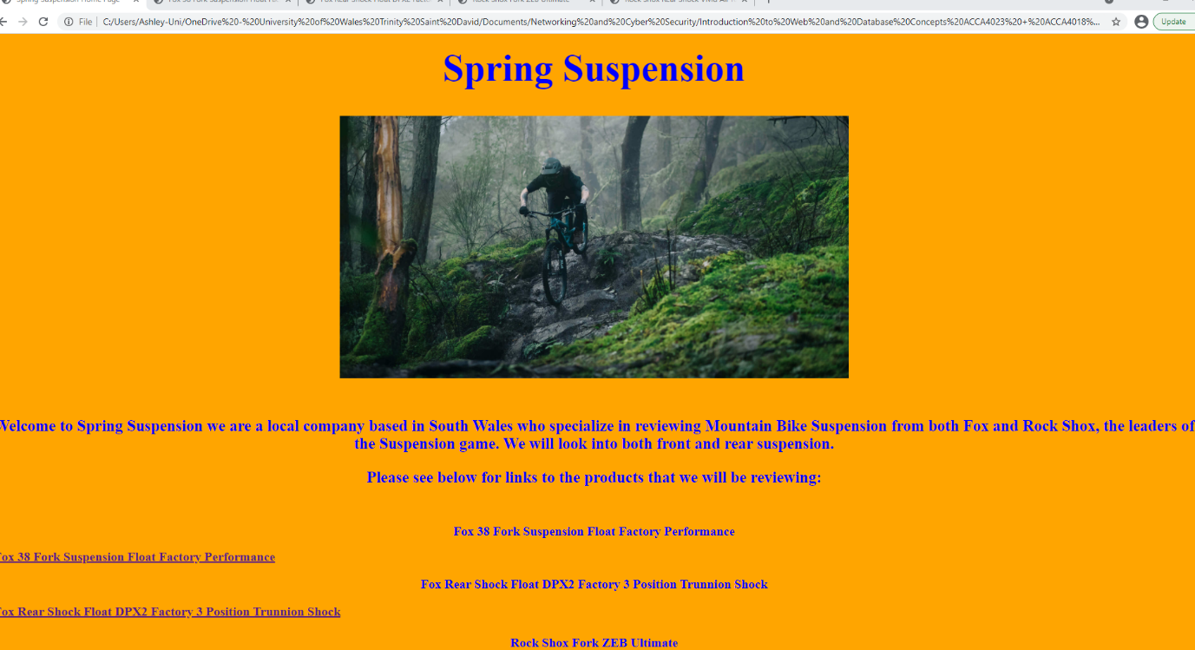
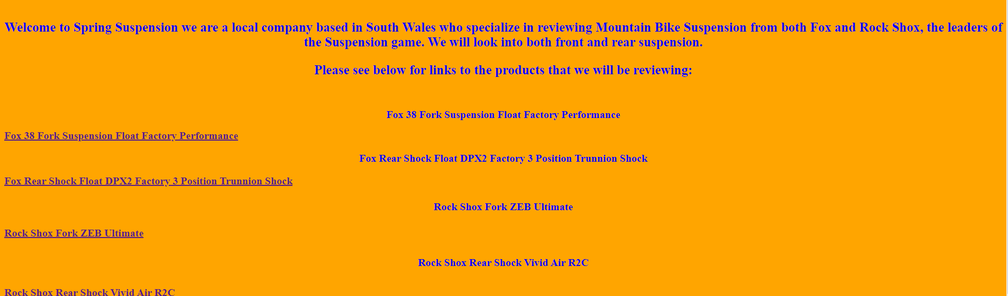

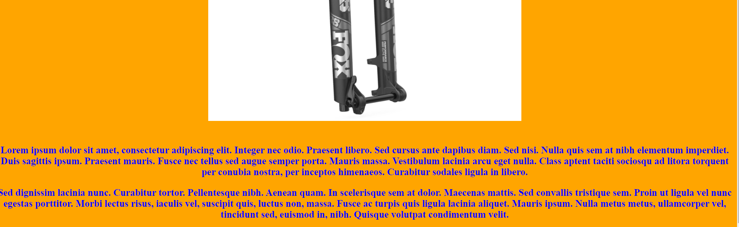
Page 2
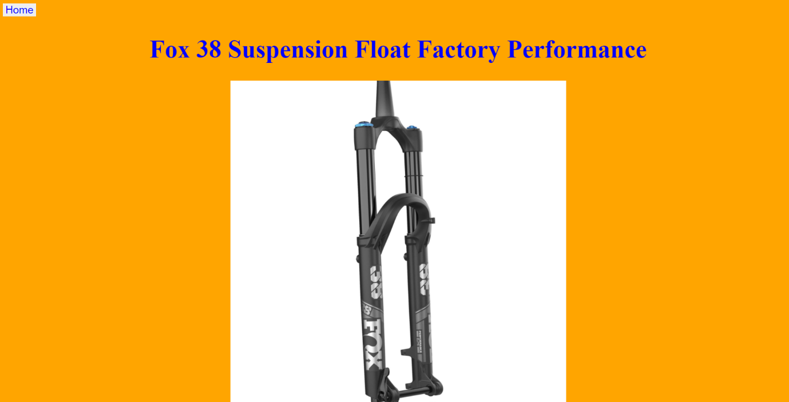

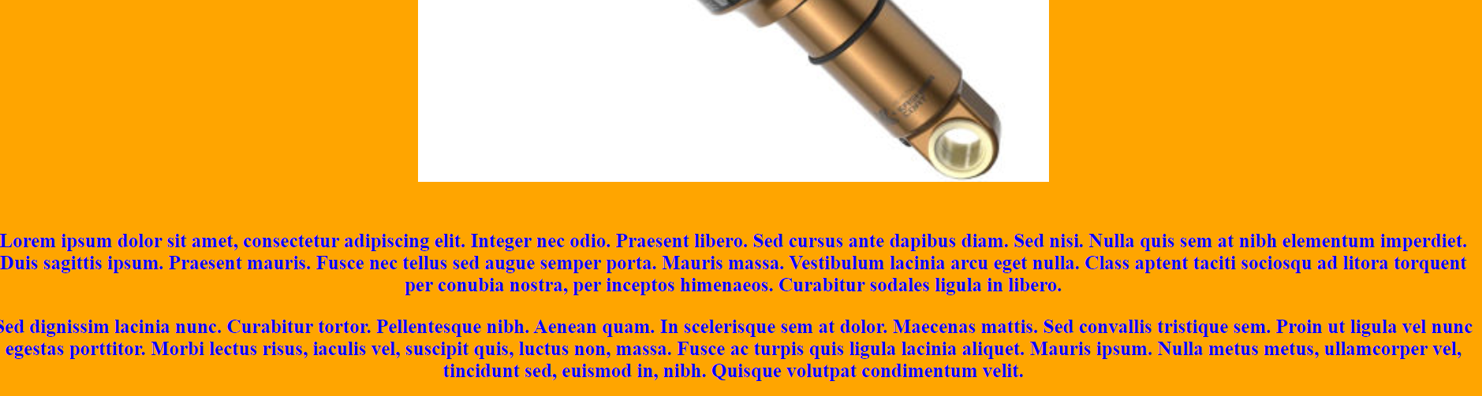
Page 3
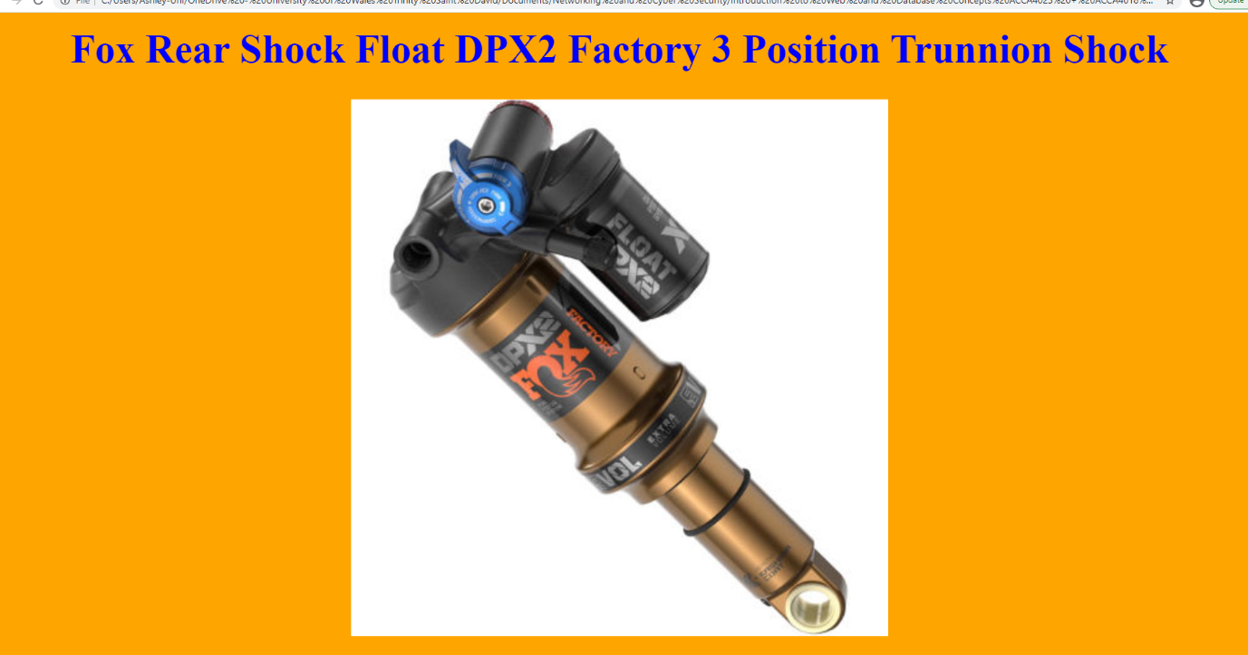

Page 4

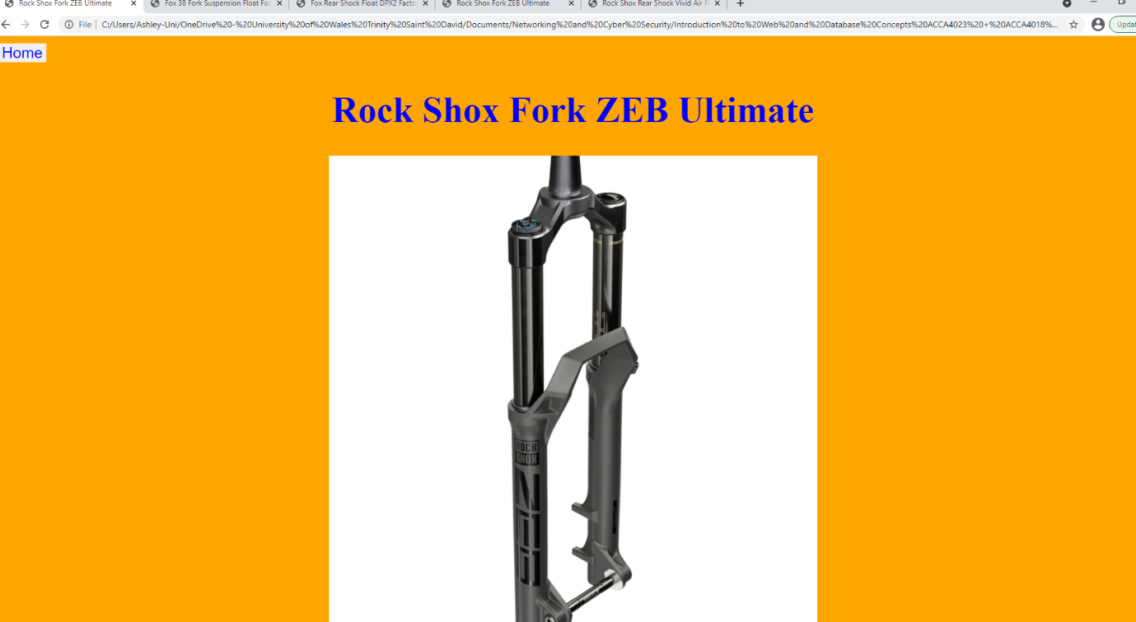

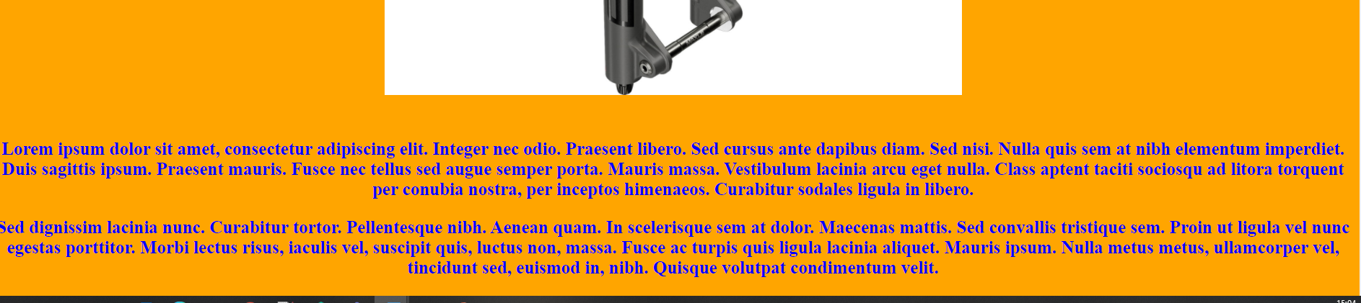

Page 5

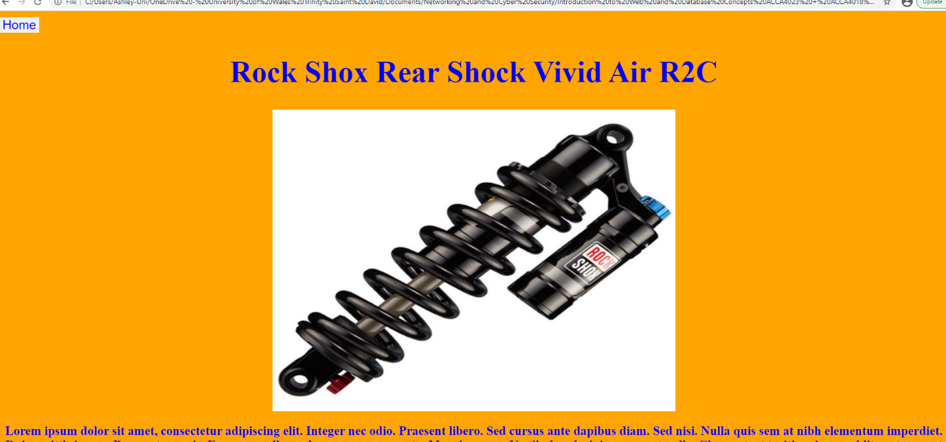

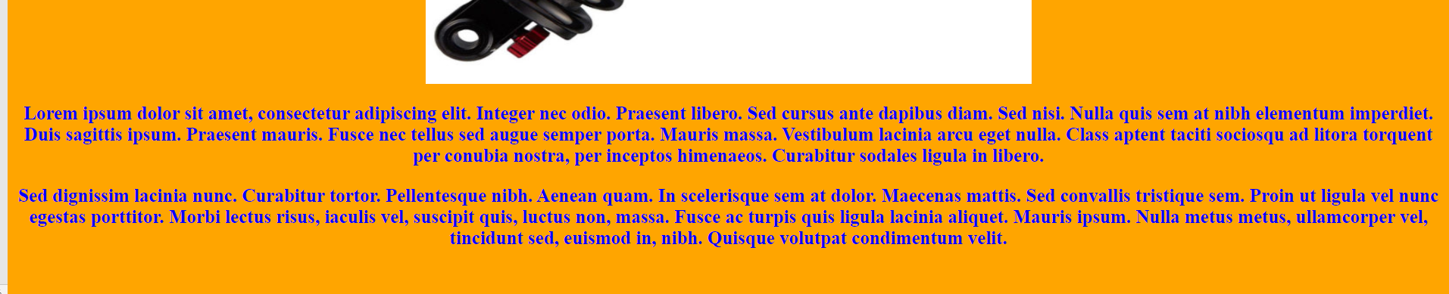

Validation
Please see below for my Validated index page HTML and CSS code.
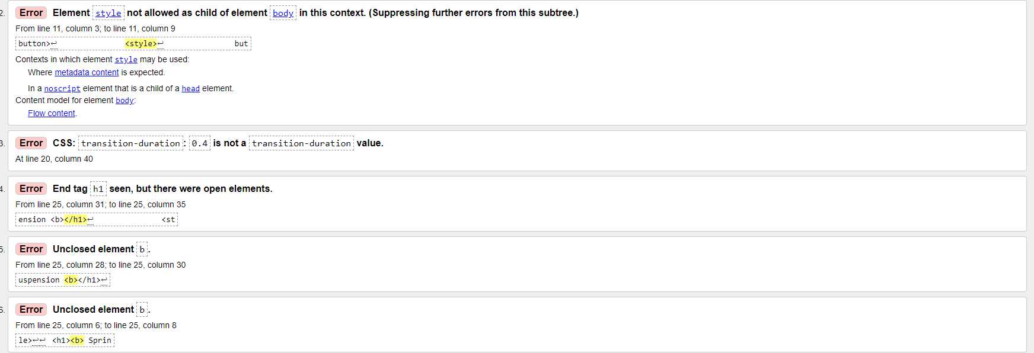
Most of my errors were leaving elements open, I therefore went back to my code and closed them, the number 2 error above states I needed to close the style tag with</style> which resolved that error.
Another error I came across were values not being recognised, I then went back in and entered a value that was accepted. This resolved that issue.
Other errors were careless and that I had forgot to close functions or simply forgot to put a <.

Evaluation

[1] Website usability – Web usability is supported in research focus on human-computer interaction (HCI). Usability is identified as the degree to which people can perform a set of certain tasks. Highly usable websites are intuitive and transparent to the people using them. This type of user orientated design makes it straightforward and easy to use for people to accomplish their goals without having to deal with complex websites.
[2] Website accessibility – Web accessibility allows people with a range of different disabilities to use the web, more accurately people with disabilities can understand, navigate, and interact with the web. This can also benefit people who do not have disabilities, as this often makes websites generally a lot more user friendly.
[3] Search engine optimisation – As search engines, such as ‘Google’ have become the most popular tool to find websites, user behaviour indicated that most users click on the search links on the first page of results, with decreasing results clicking on results on the second page and beyond. It is therefore important that achieving a high rank in search engines is crucial to website popularity and search engine companied to not publicly release algorithms. Which makes this difficult.
Two major processes
Off page optimization – This involves creating backlinks on other well-established websites.
On page optimisation – This uses keywords in the title, snippets and in the URL.

After competing my website, I believe my website is very functional, it is easy to navigate and its user intuitive. It has a good colour scheme which is easy on the eyes but is not boring to look at. I have created a home button on each screen to easily go back to the index screen. I have a large image on each page with an equal number of words, I have kept blank space to a minimum. I have centred all images and word when possible, this is because you automatically look to the centre of the screen, which avoids needing to look all over the page.
I have tested my website on multiple browsers, including Google Chrome, FireFox and Edge. I have also tested it on a Desktop PC, a Laptop as well as mobile devices. Such as an Android phone and an Android Tablet.
The SEO techniques I have used are.
- Used keywords.
- Produce regular content.
- Social Media presence.
SEO, as the products I review are very popular, I have linked to the seller’s web pages as well as input YouTube links to videos.
Using the Web Content Accessibility Guidelines, my website is perceivable. It is operable, as it can be easily navigated by keyboard and mouse and keyboard and other peripherals. It is understandable, both content and the text are readable and understandable. Robust, as it is compatible with future user agents.

References
[1] Mackey, Thomas P and Ho, Jinwon, “Exploring the relationships between Web usability and students’ perceived learning in Web-based multimedia (WBMM) tutorials,” Computers and education, vol. 50, no. 1, pp. 386–409, 2008, doi: 10.1016/j.compedu.2006.08.006.
[2]R. Rutter et al., Web Accessibility Web Standards and Regulatory Compliance, 1st ed. 2006. 2006.
[3] Luh, Cheng-Jye, Yang, Sheng-An, and Huang, Ting-Li Dean, “Estimating Google’s search engine ranking function from a search engine optimization perspective,” Online information review, vol. 40, no. 2, pp. 239–255, 2016, doi: 10.1108/OIR-04-2015-0112.

Appendices
Index Page
<!DOCTYPE html>
<html>
<head>

<meta charset="utf-8" />
<title>Spring Suspension Home Page</title>
</head>
<body>

<button type="button"> Home</button>
<style>
button {
border: none;
color: blue;
text-align: center;
text-decoration: none;
display: inline-block;
font-size: 25px;
margin: 4px 2px;
transition-duration: 0.4;
cursor: pointer;
}
</style>

<h1><b> Spring Suspension <b></h1>
<style>
h1 {
text-align: center;
font-size: 60px;
}
</style>

<img src="images/capra_pro.jpg" alt="capra_pro" class="center" style=width:800px;height:600;">
<style>
img {
display:block;
margin: 0 auto;
}
</style>

<br/>
<br/>

<p> Welcome to Spring Suspension we are a local company based in South Wales who specialize in reviewing Mountain Bike Suspension from both Fox and Rock Shox, the leaders of the Suspension game.
We will look into both front and rear suspension.</p>

<p>Please see below for links to the products that we will be reviewing:</p>
<style>
p {
text-align: center;
font-size: 25px;
}
</style>

<br/>

<h2>Fox 38 Fork Suspension Float Factory Performance</h2>
<style>
h2 {
text-align: center;
font-size: 20px;
}
</style>

<a href="HTML/Fox_38.html">Fox 38 Fork Suspension Float Factory Performance</a>
<style>
a {
font-size: 20px;
text-align: center;
}
</style>

<h3>Fox Rear Shock Float DPX2 Factory 3 Position Trunnion Shock</h3>
<a href="HTML/Fox_DPX2.html">Fox Rear Shock Float DPX2 Factory 3 Position Trunnion Shock</a>
<style>
h3 {
text-align: center;
font-size: 20px;
}
</style>
<h4>Rock Shox Fork ZEB Ultimate</h4>
<a href="HTML/Rock_Shox_ZEB.html">Rock Shox Fork ZEB Ultimate</a>
<style>
h4 {
text-align: center;
font-size: 20px;
}
</style>
<h5>Rock Shox Rear Shock Vivid Air R2C</h5>
<a href="HTML/Rock_Shox_Vivid.html">Rock Shox Rear Shock Vivid Air R2C</a>
<style>
h5 {
text-align: center;
font-size: 20px;
}
</style>

<body style="background-color:orange;"></body>
<body text="blue"></body>
</body>
</html>
Page 1
<!DOCTYPE html>
<html>
<head>

<meta charset="utf-8" />
<title>Fox 38 Fork Suspension Float Factory Performance</title>
</head>
<body>
<a href="..\index.html"><button type="button"> Home</button><a/>
<style>
button {
border: none;
color: blue;
text-align: center;
text-decoration: none;
display: inline-block;
font-size: 25px;
margin: 4px 2px;
transition-duration: 0.4;
cursor: pointer;
}
</style>

<h1><b>Fox 38 Suspension Float Factory Performance<b></h1>
<style>
h1 {
text-align: center;
font-size: 60px;
}
</style>

<img src="images/Fox_Float_38.jpg" alt="Fox_Float_38" class="center" style=width:800px;height:600;">
<style>
img {
display:block;
margin: 0 auto;
}
</style>

<body style="background-color:orange;">

<body text="blue">

<br/>
<br/>

<p> Lorem ipsum dolor sit amet, consectetur adipiscing elit. Integer nec odio. Praesent libero. Sed cursus ante dapibus diam. Sed nisi.
Nulla quis sem at nibh elementum imperdiet. Duis sagittis ipsum. Praesent mauris. Fusce nec tellus sed augue semper porta. Mauris massa.
Vestibulum lacinia arcu eget nulla. Class aptent taciti sociosqu ad litora torquent per conubia nostra, per inceptos himenaeos.
Curabitur sodales ligula in libero.</p>

<p> Sed dignissim lacinia nunc. Curabitur tortor. Pellentesque nibh. Aenean quam. In scelerisque sem at dolor. Maecenas mattis.
Sed convallis tristique sem. Proin ut ligula vel nunc egestas porttitor. Morbi lectus risus, iaculis vel, suscipit quis, luctus non, massa.
Fusce ac turpis quis ligula lacinia aliquet. Mauris ipsum. Nulla metus metus, ullamcorper vel, tincidunt sed, euismod in, nibh. Quisque volutpat condimentum velit.</p>

<style>
p {
text-align: center;
font-size: 25px;
}
</style>
</body>
</html>
Page 2
<!DOCTYPE html>
<html>
<head>

<meta charset="utf-8" />
<title>Fox Rear Shock Float DPX2 Factory 3 Position Trunnion Shock</title>
</head>
<body>
<a href="..\index.html"><button type="button"> Home</button></a>
<style>
button {
border: none;
color: blue;
text-align: center;
text-decoration: none;
display: inline-block;
font-size: 25px;
margin: 4px 2px;
transition-duration: 0.4;
cursor: pointer;
}
</style>

<h1><b>Fox Rear Shock Float DPX2 Factory 3 Position Trunnion Shock<b></h1>
<style>
h1 {
text-align: center;
font-size: 60px;
}
</style>

<img src="images/Fox_Float_DPX2.jpg" alt="Fox_Float_38" class="center" style=width:800px;height:600;">
<style>
img {
display:block;
margin: 0 auto;
}
</style>

<body style="background-color:orange;">

<body text="blue">

<br/>
<br/>

<p> Lorem ipsum dolor sit amet, consectetur adipiscing elit. Integer nec odio. Praesent libero. Sed cursus ante dapibus diam. Sed nisi.
Nulla quis sem at nibh elementum imperdiet. Duis sagittis ipsum. Praesent mauris. Fusce nec tellus sed augue semper porta. Mauris massa.
Vestibulum lacinia arcu eget nulla. Class aptent taciti sociosqu ad litora torquent per conubia nostra, per inceptos himenaeos.
Curabitur sodales ligula in libero. </p>

<p> Sed dignissim lacinia nunc. Curabitur tortor. Pellentesque nibh. Aenean quam. In scelerisque sem at dolor. Maecenas mattis.
Sed convallis tristique sem. Proin ut ligula vel nunc egestas porttitor. Morbi lectus risus, iaculis vel, suscipit quis, luctus non, massa.
Fusce ac turpis quis ligula lacinia aliquet. Mauris ipsum. Nulla metus metus, ullamcorper vel, tincidunt sed, euismod in, nibh. Quisque volutpat condimentum velit.</p>
<style>
p {
text-align: center;
font-size: 25px;
}
</style>
</body>
</html>
Page 3
<!DOCTYPE html>
<html>
<head>

<meta charset="utf-8" />
<title>Rock Shox Fork ZEB Ultimate</title>
</head>
<body>
<a href="..\index.html"><button type="button"> Home</button></a>
<style>
button {
border: none;
color: blue;
text-align: center;
text-decoration: none;
display: inline-block;
font-size: 25px;
margin: 4px 2px;
transition-duration: 0.4;
cursor: pointer;
}
</style>

<h1><b>Rock Shox Fork ZEB Ultimate<b></h1>
<style>
h1 {
text-align: center;
font-size: 60px;
}
</style>

<img src="images/Rockshox_ZEB.jpg" alt="Fox_Float_38" class="center" style=width:800px;height:600;">
<style>
img {
display:block;
margin: 0 auto;
}
</style>

<body style="background-color:orange;">

<body text="blue">

<br/>
<br/>

<p> Lorem ipsum dolor sit amet, consectetur adipiscing elit. Integer nec odio. Praesent libero. Sed cursus ante dapibus diam. Sed nisi.
Nulla quis sem at nibh elementum imperdiet. Duis sagittis ipsum. Praesent mauris. Fusce nec tellus sed augue semper porta. Mauris massa.
Vestibulum lacinia arcu eget nulla. Class aptent taciti sociosqu ad litora torquent per conubia nostra, per inceptos himenaeos.
Curabitur sodales ligula in libero. </p>

<p> Sed dignissim lacinia nunc. Curabitur tortor. Pellentesque nibh. Aenean quam. In scelerisque sem at dolor. Maecenas mattis.
Sed convallis tristique sem. Proin ut ligula vel nunc egestas porttitor. Morbi lectus risus, iaculis vel, suscipit quis, luctus non, massa.
Fusce ac turpis quis ligula lacinia aliquet. Mauris ipsum. Nulla metus metus, ullamcorper vel, tincidunt sed, euismod in, nibh. Quisque volutpat condimentum velit.</p>
<style>
p {
text-align: center;
font-size: 25px;
}
</style>
</body>
</html>
Page 4
<!DOCTYPE html>
<html>
<head>

<meta charset="utf-8" />
<title>Rock Shox Rear Shock Vivid Air R2C</title>
</head>
<body>
<a href="..\index.html"><button type="button">Home</button></a>
<style>
button {
border: none;
color: blue;
text-align: center;
text-decoration: none;
display: inline-block;
font-size: 25px;
margin: 4px 2px;
transition-duration: 0.4;
cursor: pointer;
}
</style>

<h1><b>Rock Shox Rear Shock Vivid Air R2C<b></h1>
<style>
h1 {
text-align: center;
font-size: 60px;
}
</style>

<img src="images/Rockshox_Vivid.jpg" alt="Fox_Float_38" class="center" style=width:800px;height:600px;>
<style>
img {
display:block;
margin: 0 auto;
}
</style>

<body style="background-color:orange;">

<body text="blue">

<p> Lorem ipsum dolor sit amet, consectetur adipiscing elit. Integer nec odio. Praesent libero. Sed cursus ante dapibus diam. Sed nisi.
Nulla quis sem at nibh elementum imperdiet. Duis sagittis ipsum. Praesent mauris. Fusce nec tellus sed augue semper porta. Mauris massa.
Vestibulum lacinia arcu eget nulla. Class aptent taciti sociosqu ad litora torquent per conubia nostra, per inceptos himenaeos.
Curabitur sodales ligula in libero. </p>

<p> Sed dignissim lacinia nunc. Curabitur tortor. Pellentesque nibh. Aenean quam. In scelerisque sem at dolor. Maecenas mattis.
Sed convallis tristique sem. Proin ut ligula vel nunc egestas porttitor. Morbi lectus risus, iaculis vel, suscipit quis, luctus non, massa.
Fusce ac turpis quis ligula lacinia aliquet. Mauris ipsum. Nulla metus metus, ullamcorper vel, tincidunt sed, euismod in, nibh. Quisque volutpat condimentum velit.</p>
<style>
p {
text-align: center;
font-size: 25px;
}
</style>

<br/>
<br/>
</body>
</html>

