Industrial Placement Report and Diary
TSR Performance
6th May 2019 – 15th June 2019

James Smith
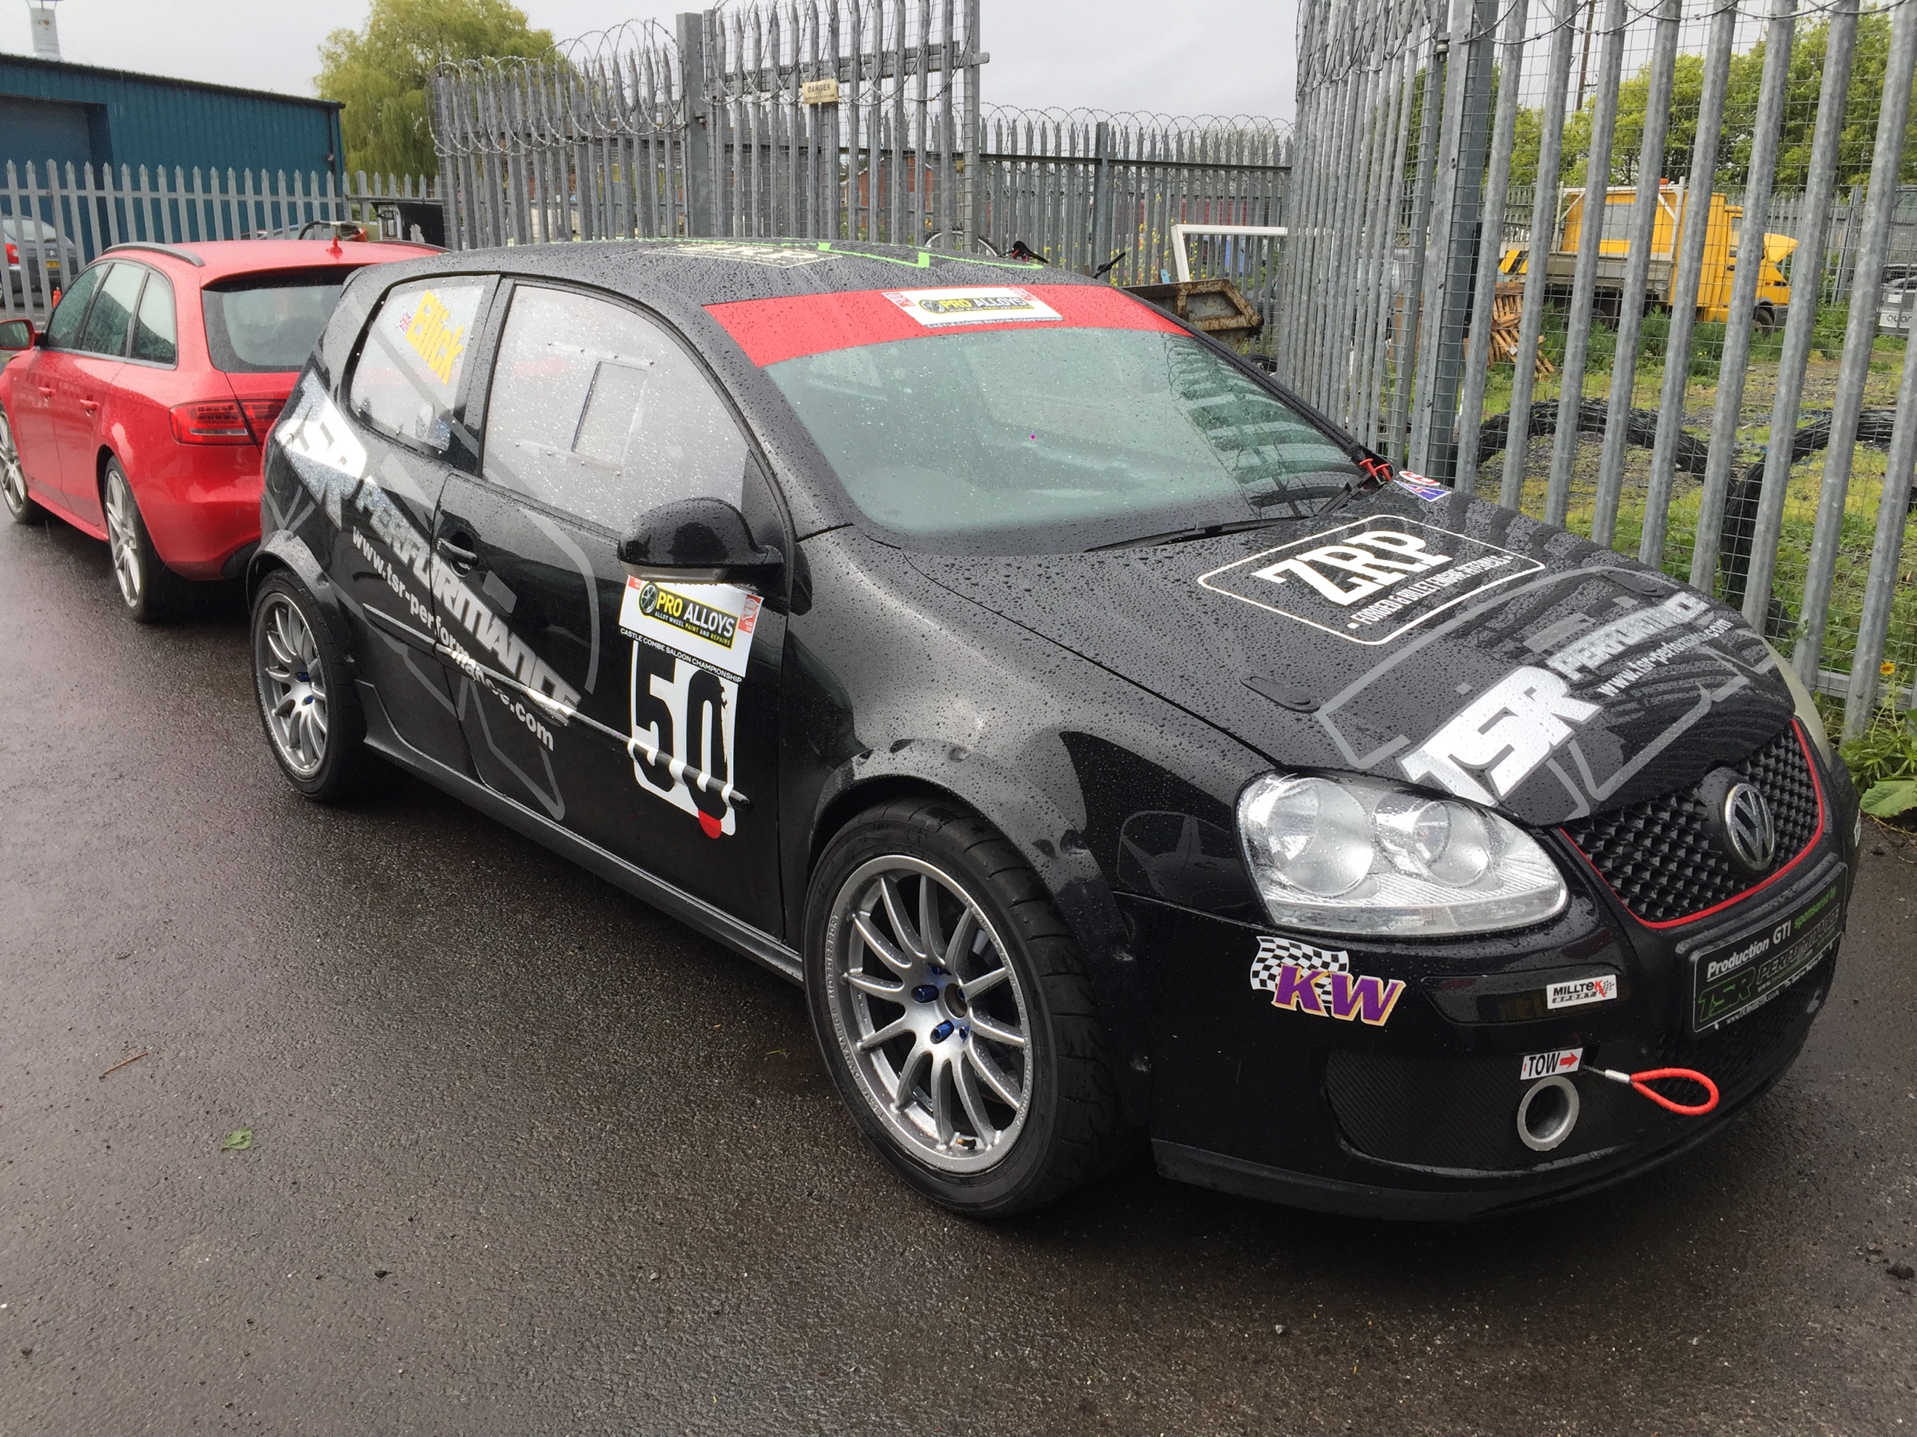
1801879

-Figure 1: TSR’S Race Car

Contents Page
Title Page………………………………………………………………………………………...……………….………… Page 1

Contents Page………………………………………………………………………………………………….……….... Page 2

1. Introduction………………………………………………………..………………………..……………..….……… Page 3

2. Research…………………………….……………………………………………………….…….…..……..…...……Page 4

3. Discussion……………………..……….…………………………………………………………..……….……..……Page 6

4. Conclusion……………………………….…………………………………………………………………..……..……Page 9

5. References………………………………………………………………..………………………………..…....……Page 12
6. Appendix 1………………………………………………………………………..……………….….………...……Page 13

1. Introduction

This industrial placment report is going to include a practical exercise that was carried out in the form of a six-week placement at an automotive / motorsport company. The company chosen to fulfil the placement with was found and organised by the student due to an interest in the company’s previous and ongoing work. Included in this report, will be a week by week diary, including pictures taken of the types of tasks and jobs fulfilled during the time spent on placement, creating the appendix of the report.

Research into the correct health and safety requirements will be carried out, this will include research into the correct Personal Protective Equipment needed for the type of work that the placment is involved with. Information on the structure and size of the chosen company will be researched before placement and enquired about during placment to gain information and an understanding of the history of the company. After this, background research into the company and their main rival competitors will be completed.

Subsequently, a discussion section will be included into the report, describing in brief an overview into the work carried out on placement. This overview will use details from the diary created on placement, to use actual experiences to be able to describe whether the placement has made a positive effect on my future in this industry. This will all be done whilst showing the relationship between an engineering organisation and the automotive / motorsport industry.

Finally, a conclusion section will then be included to talk about personal development during time on placement and whether the time on placement has made a positive effect on my view of the industry or changed any future career plans in this industry after my studies at University are completed. After this suggestions and evaluations will be made to determine whether a positive contribution was made by myself on placement.

2. Research

2.1. Health and Safety Regulations

While researching possible companies to contact about carrying out a work placement, I first carried out research into the correct and suitable clothing to arrive with at placement, to fit the correct health and safety regulations followed by the company. To find the correct health and safety regulations, research into the correct Personal Protective Equipment, also known as PPE, was carried out.

PPE should be used as a last resort. Wherever there are risks to health and safety that cannot be adequately controlled in other ways, the Personal Protective Equipment at Work Regulations 1992 require PPE to be supplied.

(Health and Safety Executive, 2013, p. 1)

As stated by Health and Safety Executive in the guide Personal Protective Equipment at Work, wherever any possible risks that cannot be controlled, protective equipment must be worn by all employees. After reviewing ‘The Hazards and Types of PPE’ section in the Health and Safety PPE guide, it is clear that work-wear trousers and a thick jumper will be suitable to fit the ‘Protecting the body’ requirements (Health and Safety Executive, 2013, p. 3). These requirements stated, suggests options such as overalls, boiler suits or specialist protective clothing. These requirements must be followed to prevent hazards of temperature extremes, spray guns, impact or penetration and excessive wear during work in the automotive industry.

Other PPE that must be worn whilst on my placement are steel toe cap boots. As shown in the ‘Protecting the body’ section (Health and Safety Executive, 2013, p. 4), the ‘Feet and Legs’ requirements state the correct PPE must be worn which includes safety boots or shoes with protective toe caps to prevent possible hazards such as slipping, falling objects, chemical splash or abrasion.

2.2. TSR Background Research

The company selected to fulfil my six-week placement with is TSR Performance in Bridgewater. This company was chosen because of their very interesting previous work shown on their website, online pages and their specialist work on Audi’s, Volkswagen, Seat and Porsche using their wide range of specialist tools including their own four-wheel drive rolling road and tracking facility.

Interest and main focus of TSR Performance is the tuning of high-performance German cars, which involves a workshop with the facilities to track prepare cars for car shows and competition circuit racing. The work they perform regularly includes fabrication, engine re-building and restoration builds. TSR also performs MOTs and Services to widen their clientele and increase the turnaround profit.

TSR Performance is a small to medium sized organisation with only one facility in Bridgewater but with a wide range of customers with high performance road and track cars. Over its time TSR has seen a lot of growth and improvement over their nearly 30 years of business within the VW, Audi and Seat etc performance market.

TSR was originally opened by Tim Stiles and was called Tim Stiles Racing, which all started as a small project in a garden shed working on MK2 VW Golf GTI’s. Throughout the 90s TSR gained and created a great following and a well-known name for the company. After this TSR was then sold to a new owner and closed due to financial problems. After this, TSR was reopened by the new and current owner Robert Ellick and his family in the early 2000s and Tim Stiles Racing was renamed to TSR Performance.

As an organisation, TSR is now recognised by the automotive and motorsport industry as an approved international supplier for the performance VAG market. Some of the work carried out at TSR has also been recognised by fifth gear, Performance VW and other tuning magazines. Due to this previous work they have been recognised for, they are now UK distributors of a wide range of leading automotive and motorsport brands such as Quaife, Powerflex, Superpro, Milltec, Z.R.P and Wossner (TSR Performance, 2019).
This recognition from big brands and companies in the industry has helped TSR to gain and expand their client base with customers always returning to TSR for future work due to their customer services, excellent engineering work performed and great facilities.

2.2.1. TSR Competitors Research

Research into TSR’s main competitors has been performed, before and during the placement with TSR. Speaking with the employees and the main boss, it is clear that local businesses that perform basic garage work in their surrounding areas are not their main rivals. This is due to most of their customers travelling to them from all around the country to use TSR’s specialist skill set, knowledge and facilities.

Subsequently after speaking with the TSR staff, it was clear that there are a few companies from around the country that customers have used before, instead of TSR. These companies include R Tek, ATS and Awesome GTI, which are all very similar companies to TSR Performance, which all perform specialist tuning and Modification work.

3. Discussion

This section of the report, will include the types of jobs that I was involved in at TSR, during the six-week placement. This will include an overview look at the placement diary shown in the appendix of the report, where examples of the jobs carried out on placement will be grouped together to discusses which section of TSR’s work was most preferred. Highlighted detail on certain moments and jobs during placement will be carried out, showing the relationship between an engineering organisation and the automotive industry, including details of my roles and experiences during the six-week placement.

During my time on placement a tour of the company’s facilities and an introduction to all staff members was carried out on the first day to help myself gain an understanding of the type of work that TSR normally performs and the team I am going to be working with whilst I am with them on placement.

Whilst on placement with TSR, a variety of skills and techniques were taught to me by a range of area specialists within the company. My time was spent with a range of these technicians, including the MOT and Servicing Technician, the engine re-builder, the performance specialist and the main boss of TSR, Rob who works mainly in the rolling-road area.

Over my time, I was involved in a lot of different areas within TSR, being shown new ways to use specialist tools to complete jobs quickly and efficiently. These types of jobs included; performing MOTs and services, brake pads and discs, changing and balancing tyres and fault finding using a multi metre with a range of old and new of cars, including a MK2 GTI that would not run after heating up to operating temperature. These types of jobs were performed throughout my placement and were always in the MOT bay area due to the nature of jobs performed. All jobs carried out in the MOT area were enjoyed, to be able to learn the correct ways to perform specific jobs for a customer. But the time during the six-weeks spent with the specialist members of staff was much more stimulating, due to being able to relate the work performed, to modules on the Motorsport Engineering Course I’m studying at University.

Whilst at TSR, the Four-Wheel Drive Rolling Road was often used to tune and map customer’s cars after having work performed. Some of the car’s that were dynode on the rolling road during my placement was an Aston Martin Vulcan, Ford Fiesta ST, VW Golf R and GTI MK2 and MK5. This range of cars stated shows the variety of work TSR performs making all the time spent around the rolling road greatly appreciated. Watching fast and slow power runs being performed was very interesting, being able to view the data recorded by the dyno before and after the work had been completed on a customer’s car.

Linking these jobs to testing exercises already carried out in a Powertrain module at University, using a Rolling Road and Dyno helped me to link together the practical information received at placement and the theoretical information received in the University lectures. Viewing how an engineering organisation uses the same facilities present in University was fascinating, to see how an organisation utilises this equipment to stand out in the industry.
TSR’s Rolling Road and Units were also used to hold a charity rolling road day event to generate money for charity and gain new customers through the advertisement and interest online on the website and through social media.

Over the six weeks at TSR, the most exciting and enjoyed jobs were carried out in the engine stripping and building room. These jobs included; testing injector cone patterns to determine the cause after a customer’s car had not been running properly. Helping the specialist engine technician re-build a customer’s engine fitting upgraded pistons, conrods and injectors, to be fitted into a seat touring race car. But one of the most interesting jobs was, stripping down a customer’s engine that had been built by another company to identify the causes for material found in the cylinders and damage on the cylinder wall.

When TSR was quiet over the six weeks, smaller jobs were carried out, such as; removing spots of rust from the underside of a BMW M3 using a wire drill piece, then applying rust protection paint to help on an ongoing restoration project. Using the sand blaster and air power sander to clean engine components, pipes and brake callipers to remove any corrosion to make them clean and refreshed. The air power sander was also used to strip the engine bay of a seat race car to bare metal, which was then sprayed and a heat shield added making the car ready for the engine to be fitted and then for the customer to pick up.

During my placement, TSR were competing in a racing series at Castle Combe Racing Circuit, called Castle Combe Saloon Car Championship, so during the week before the race weekend I helped an apprentice to set the correct toe and camber for TSR’s race car and a customer’s car. Then before the race, I travelled to Castle Combe to perform testing with TSR to prepare the car for the weekend. On the weekend after testing, on the race day TSR’s car had gearbox issues causing them to have to retire the car from the race. This week spent working with the race side of TSR was very fascinating to see how little tweaks at the track can change completely how the car will perform on the track.

Towards the end of my placement, time was spent fitting the interior carpets, seats and roof to a customer’s VW Golf MK1 convertible, that had undergone a full restoration performed by TSR on it over the past year. This job, performing the finishing touches on the restoration was very fascinating to see how the car has transformed during the six weeks, from a shell with an engine to fully complete car to be collected.

Overall throughout the six weeks, a range of skills were learnt and applied to practical working conditions which made the placement very worthy and rewarding to give myself an insight into the types of jobs and working environments that this area of the industry performs, also helping me gain further ideas into possible career options within the industry.

Hands-on experience cannot be imparted through lectures (Collins, 2002). It can only be gained through direct activity either from technical practices in workshops or real-world confrontation.
(Azodo, 2018, p. 89)

As stated by Azodo, hands on engineering experience through industrial work-placements and workshop testing and practices are the best and most effective way of enhancing skills and gaining an advantage over someone with less experience in the industry. This direct quote has been taken from a report showing the relatedness of students’ industrial experience work to the professional skills and competence developed.

4. Conclusion

To conclude this report, an evaluation will be carried out to conclude and explain whether this six-week placement carried out at TSR Performance has been beneficial and how it has influenced any future career goals set, after my studies have been completed. After this an evaluation into if my time spent in the automotive industry on my placement has changed my view of the industry will be completed. Finally, a self-reflection into if a positive contribution was made to TSR by myself whilst working with them will be explained.

4.1. Future career ideas influenced after placement

After completing the six-week work placement with TSR Performance, my time spent on the placment has positively influenced my future career ideas and has given me a clear view into certain sections of the industry and what areas within an automotive company intel’s. Time spent with TSR has made it clear that servicing work isn’t the field of work I would choose after my studies are completed, because the work is too repetitive and not enough interesting specialist work is carried out.

The most enjoyed experiences during my placement was the time spent in the engine fitting and building room. The time spent in this area of TSR was very interesting and appealing to me because it allowed me to able to link the work being performed at placement, with the work that I’ve learnt and tested in University during my powertrain design module and others.

4.2. View of the automotive industry after placement

Throughout placement my view on the automotive industry has stayed very similar, but the six completed weeks in the industry have shown me a lot of areas that exist within an automotive / motorsport engineering company, and has given me future preference in which of these areas I would prefer to have a career in.

This placement has been very beneficial to me and my future career after University because it has allowed me to see what working in this section of the industry intel’s and has given me a very realistic idea of what to expect when I enter the industry in a company similar to TSR Performance.

These six weeks have also shown me that I would be very interested and keen to join this industry in a company similar to that of TSR’s focus, but my time on placement has also shown me that I would prefer to work for a more motorsport related and focused company.

4.3. Self-reflection of contribution made at placement

Over the six weeks at TSR on placement, I feel that a positive contribution was constantly made by myself, including constantly being ready and enthusiastic to perform or help with any jobs given or instructed by a member of staff. By always being enthusiastic and showing a keen interest into the industry and the company, made my time at TSR very enjoyable and allowed me to show I could be trusted with more responsibilities throughout my placment because a good first impression was made.

Effective communication is essential when working in a team as good communication skill may assist in working with other people. In other words, communication is important in teamworking as this is a way to exchange the ideas and thoughts of the team members.

(Rodzalan, Saat, 2012, pp. 360-361)

As stated by Rodzalan and Saat in ‘The Effects of Industrial Training on Students’ Generic Skills
Development’ article, it is implied that the relationship between communication and team spirit in a working environment in an organisation is directly related. Meaning by carrying out an industrial placement a student’s communication and teamwork skills develop massively over the time on placement, meaning any extra industry experience in a team environment is very useful and worthy to collect for future work in the industry.

5. References

Azodo, Adinife Patrick. (2018) Relatedness of Students’ Work Industrial Experience to the Professional Skills and Competence Development in Engineering Career at Nigerian Universities [Online] Available: https://doi.org/10.2478/rpp-2018-0012
(Accessed 1st October 2019)

Health and Safety Executive. (2013) Personal protective equipment (PPE) at work [Online] Available: http://www.hse.gov.uk/pubns/indg174.pdf
(Accessed 6th October 2019)

Rodzalan, Shazaitul Azreen and Saat, Maisarah Mohamed. (2012) The Effects of Industrial Training on Students’ Generic Skills Development [Online]
Available: https://doi.org/10.1016/j.sbspro.2012.09.664
(Accessed 1st October 2019)

TSR Performance. (2019) History of TSR Performance [Online]
Available: https://tsr-performance.com/about-us/
(Accessed 3rd October 2019)

6. Appendix 1

6.1.1. Week One Diary Summary
Week Number: 1 | Week Start Date: 6th May 2019
Experience / Activity | Summary Description / Details
Tuesday 7th May:  -On the first day of placement the boss introduced me to all the members of staff at TSR and demonstrated the use of all the main areas of the company and facility.  Wednesday / Thursday 8-9th May:  -The first activities set were to help perform MOTs and Services in the MOT Testing Area with the Servicing Technician.  Friday 10th May:  -This day was spent with the Engine technician in the engine room, re-building a customer’s engine which is due to be fitted into a Seat Touring Race Car.  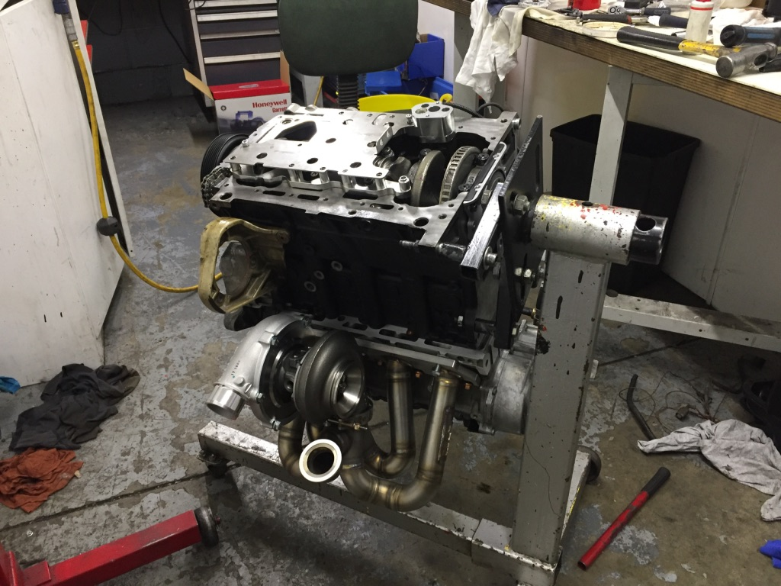 | Tuesday 7th May:  -Touring around the main TSR Units and outside Yard allowed an initial overview of the company, whilst introducing me to everyone who works within the company.  Wednesday / Thursday 8th May:  -During the first week, most of the time was spent in the MOT Bay with the MOT and Servicing Technician, helping perform services whilst being shown the appropriate use of tools and techniques used within the company.  Friday 10th May:  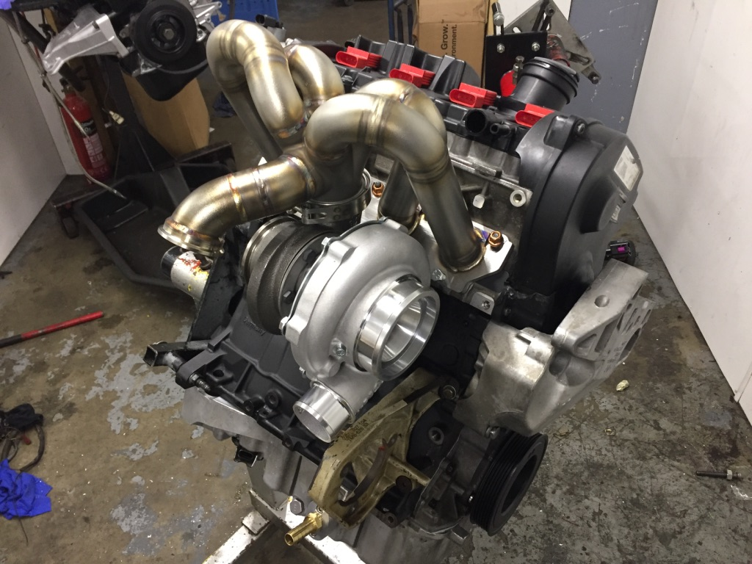  -The engine being re-built is a MK5 VW Golf GTI engine which has just been fully re-built due to previous problems, including poor maintenance and lack of oil in the engine.
6.1.2. Week Two Diary Summary
Week Number: 2 | Week Start Date: 13th May 2019
Experience / Activity | Summary Description / Details
Monday / Tuesday 13th-14th May:  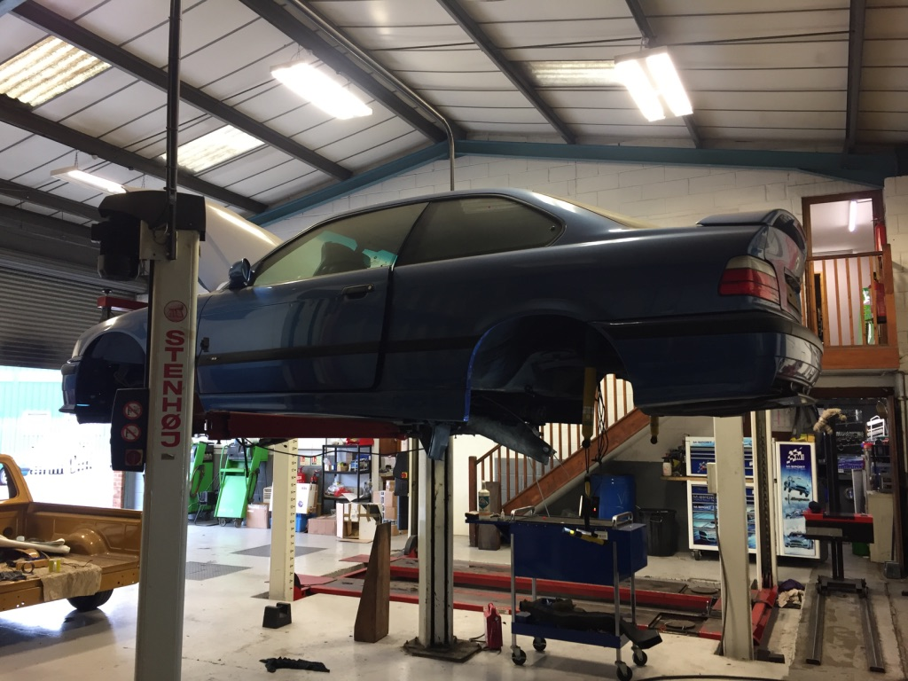  -Starting week two, the task was set to remove the rust from the underside of the company’s own BMW M3. This was done to help with the restoration being performed on the BMW.  Wednesday / Thursday 14th-15th May:  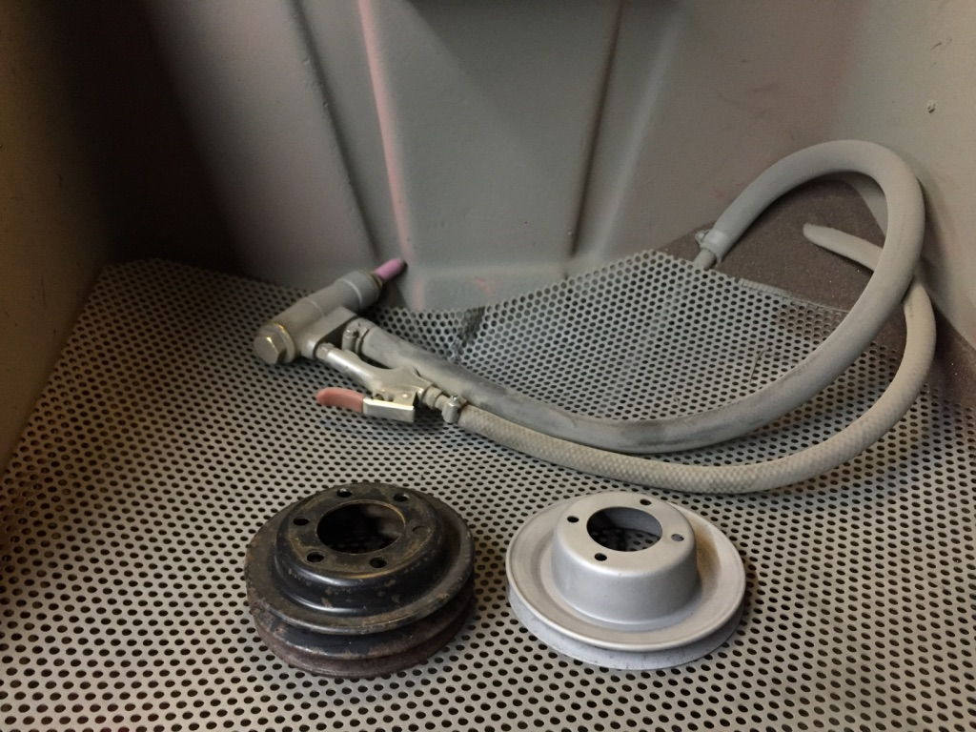  -The sand blaster and an air power sander were used to clean up engine components which had been removed for a restoration.  Friday 17th May:  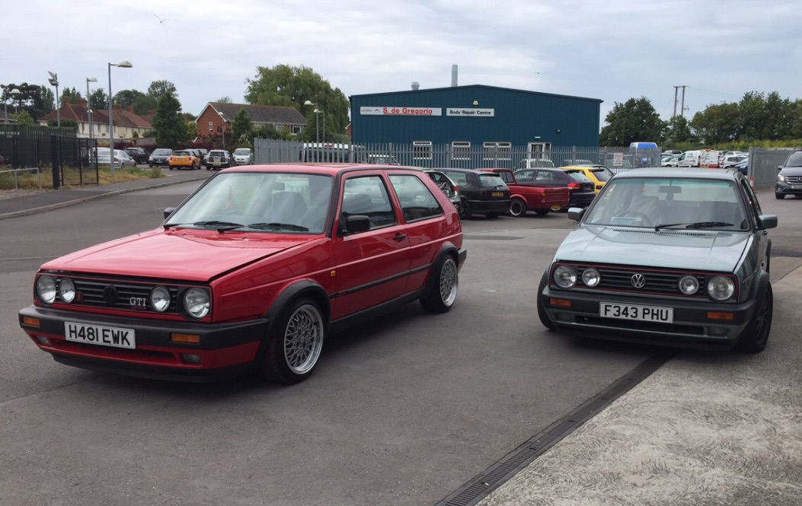  -Finishing off the second week, helping set up the units and clearing away tools around the workshops and the rolling road was done to get ready for the Charity Rolling Road Day heled at TSR on the upcoming weekend. | Monday / Tuesday 13th-14th May:  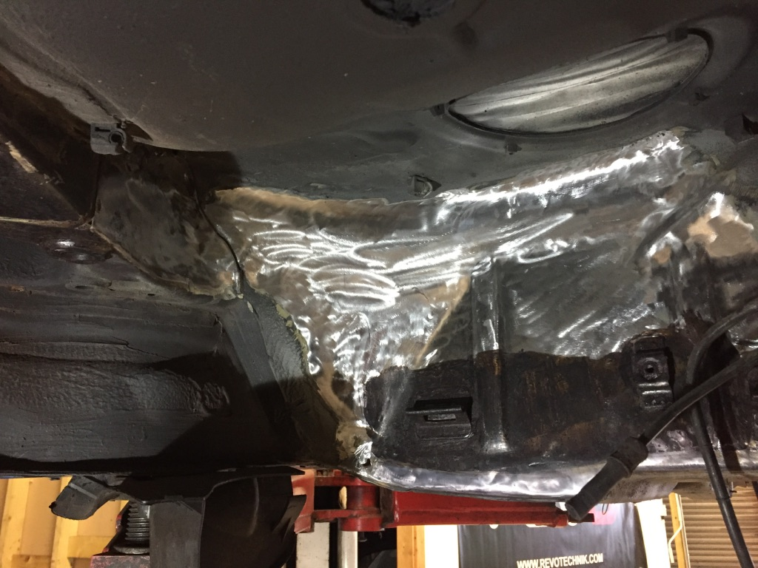  -Stripped down, removed and cleaned the protective coating from the bottom of the M3. A wire drill piece was then used to re-move all surface rust and a rust protection paint was applied because the car is undergoing a part restoration project.  Wednesday / Thursday 14th-15th May:  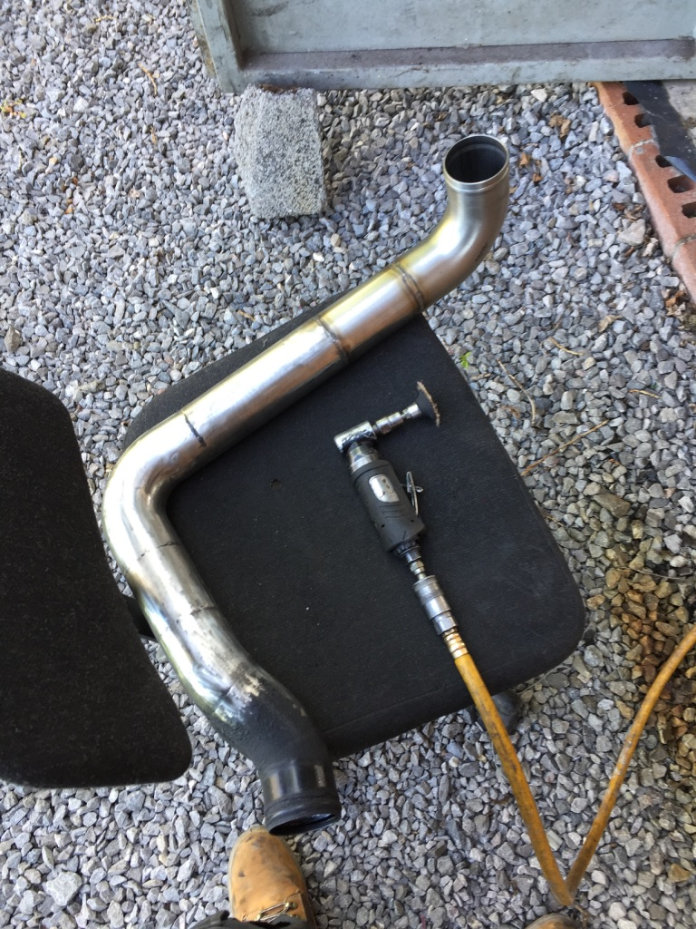  -The use of the sand blaster was used to strip down and clean the build-up of dirt and corrosion within engine components and turbo pipes for a BMW.  Friday 17th May:  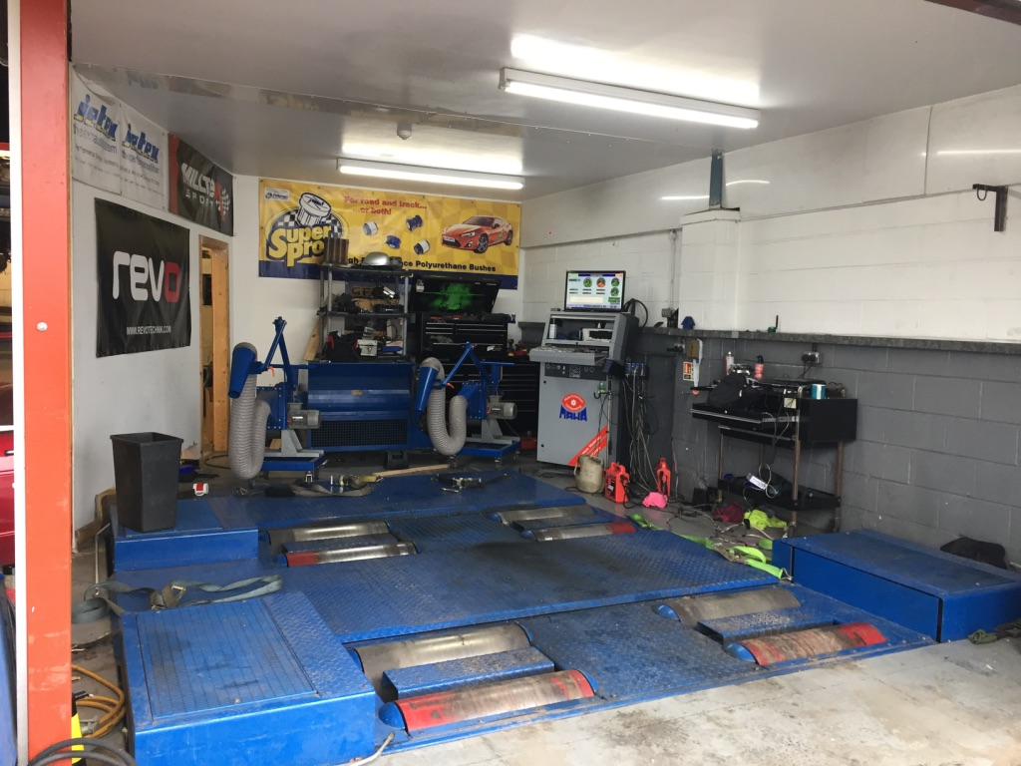  -This day was filled with sorting out and moving areas around including separating sections for public and setting up the TSR simulator. The Charity Rolling Road day is used to generate money for Charity and to generate interest in the company.

6.1.3. Week Three Diary Summary
Week Number: 3 | Week Start Date: 20th May 2019
Experience / Activity | Summary Description / Details
Monday / Tuesday 20th-21st May:  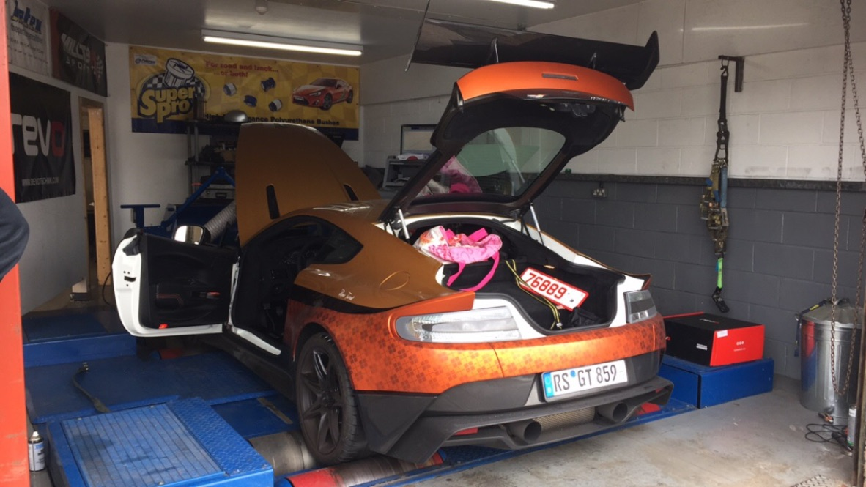  -This day was spent performing MOTs, but in-particular changing worn brake pads and discs. Whilst doing this I observed the rolling road test on a customer’s Race Aston Martin Vulcan.  Wednesday 23rd May:  -Went up to Castle Combe Race Circuit with the boss and a mechanic to test TSR’s MK5 GTI Race Car on track before it races on the Sunday coming up.  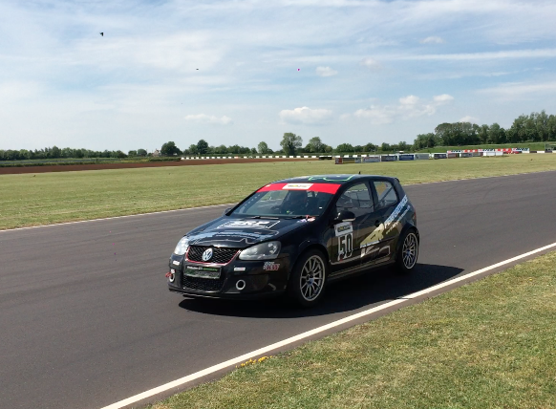  Sunday 27th May:  -On the Sunday TSR were competing in the championship race at Castle Combe Circuit that the testing was carried out earlier in the week for.  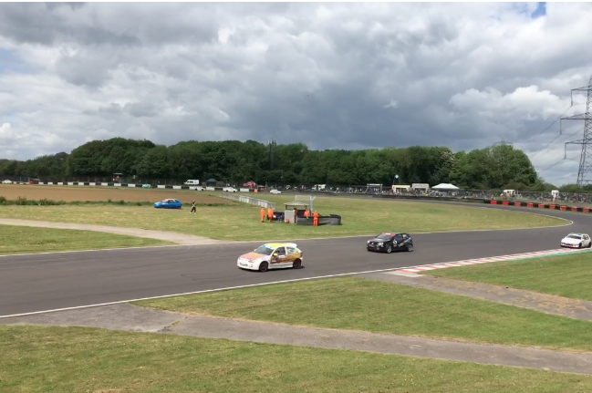 | Monday / Tuesday 20th-21st May:  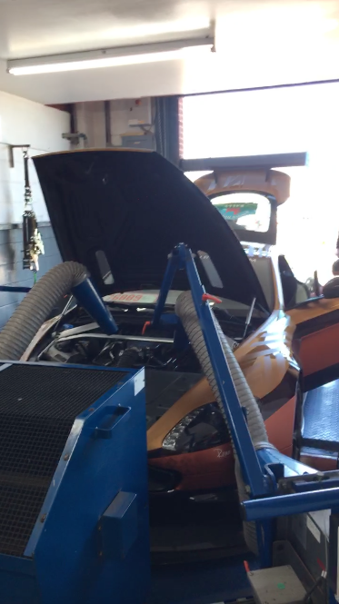  -The Aston was from a supercharging and tuning company and delivered the Vulcan to be mapped on the four-wheel drive dynamometer at TSR to then be further tuned.  Wednesday 23rd May:  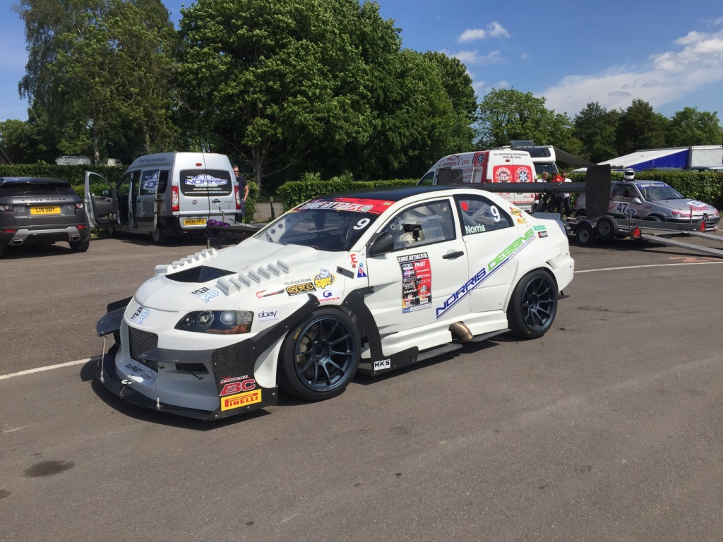  -During testing, I checked the tyre pressures before and after every practice lap removing or adding air. During the practice laps, Rob changed the power setting to reduce wheel spin when on full boost.  Sunday 27th May:  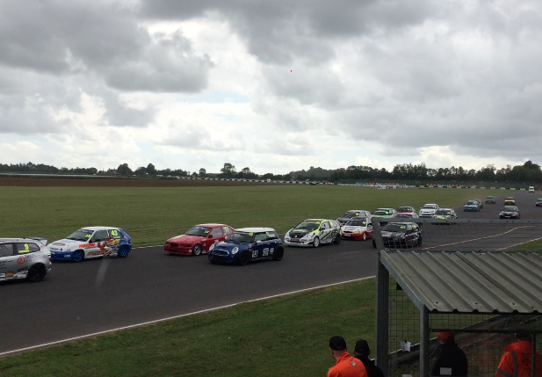  -At the track, there were a wide variation of race groups racing and were some very interesting races in the rain. During TSR’s race, they were in the lead at first but then they had to retire the car before the end of the last race.

6.1.4. Week Four Diary Summary
Week Number: 4 | Week Start Date: 27th May 2019
Experience / Activity | Summary Description / Details
Monday 27th May:  -Starting week four the task was set to strip down and use the sand blaster to remove corrosion and rust on the brake callipers and hubs. Which were then painted to be re-fitted.  Tuesday /Wednesday 28th-29th May:  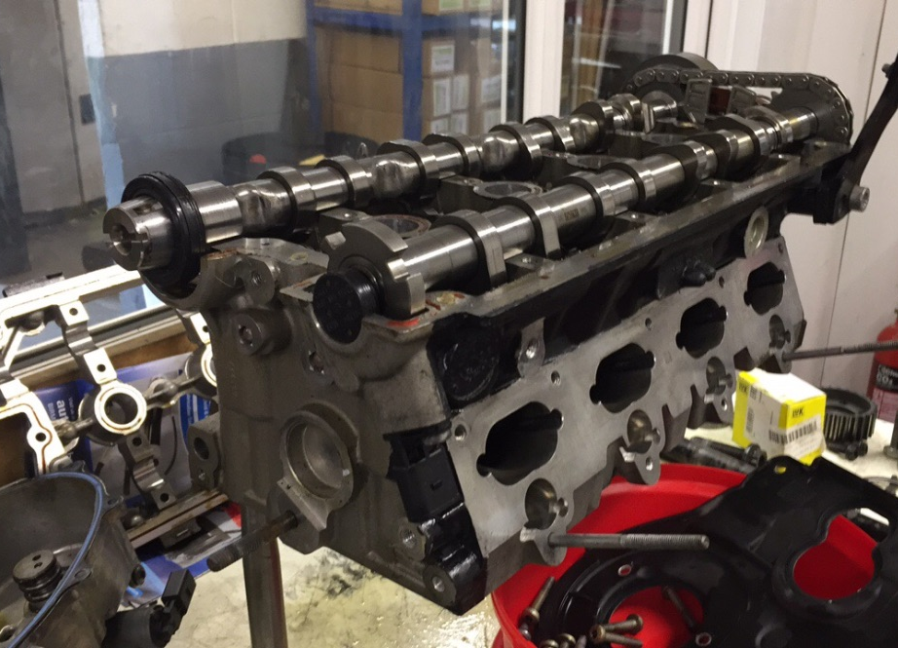  -Helping the engine mechanic to strip down a recently built engine to identify what caused the damage within the cylinders, after a customer had running problems after getting the engine built elsewhere.  Thursday / Friday 30th-31st May:  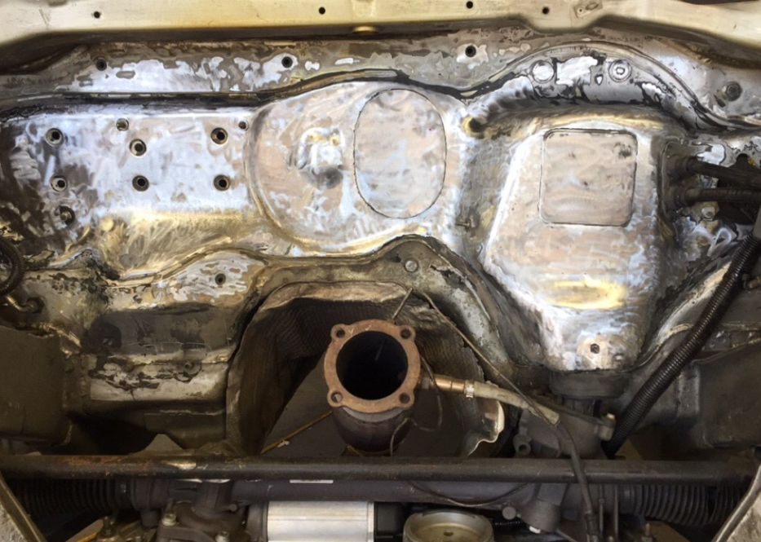  -Ending the week, the air power sander was used to strip the paint and heat protection to bare metal in the engine bay of a seat touring race car. | Monday 27th May:  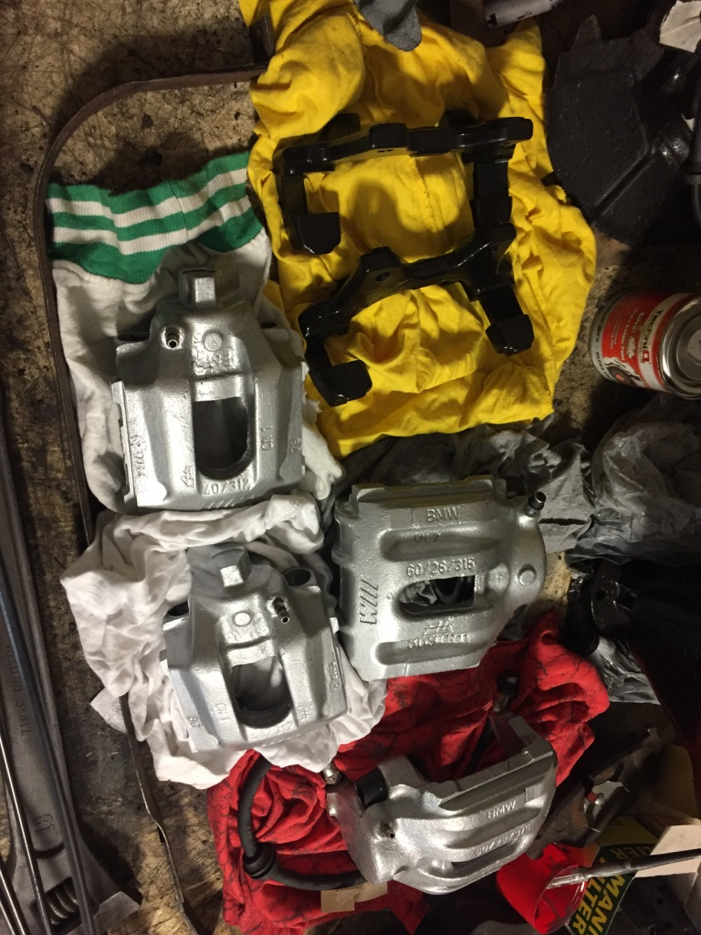  -The brake callipers and hubs de-assembled were from a BMW M3, which is being semi-restored so the sand blaster and re-painting is needed to be refitted to the restoration car.  Tuesday / Wednesday 28th-29th May:  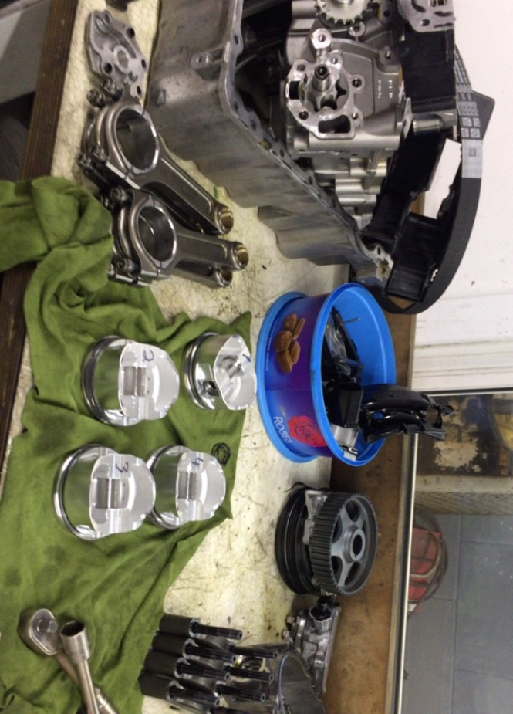  -Assisted in the stripping of an engine built by another company that had become damaged after weight had be incorrectly removed from all four pistons causing damage on the cylinder wall.  Thursday / Friday 30th-31st May:  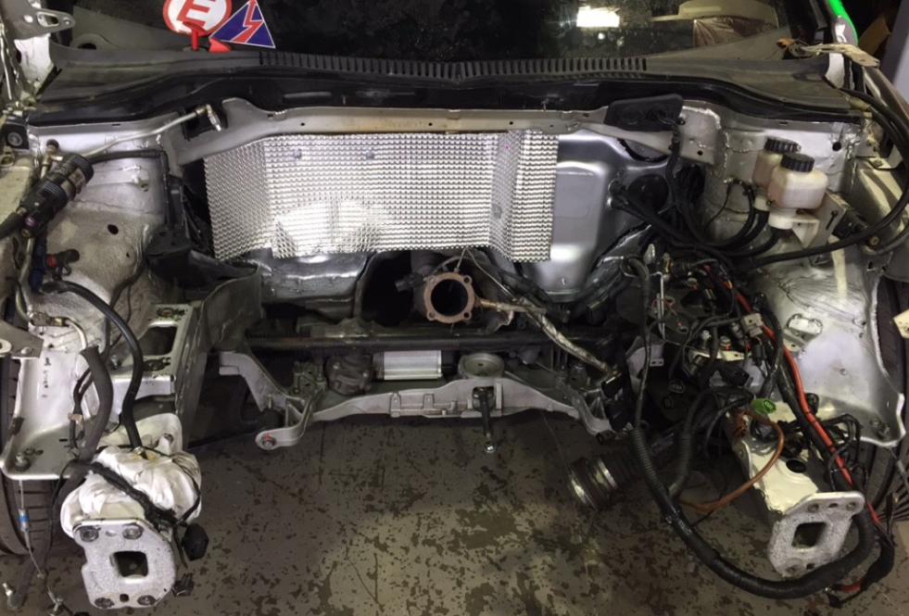  -The engine bay once stripped was then primed, painted and heat protection added so that once the freshly built engine is fitted the whole build is complete pleasing the customer.

6.1.5. Week Five Diary Summary
Week Number: 5 | Week Start Date: 3rd June 2019
Experience / Activity | Summary Description / Details
Monday 3rd June:  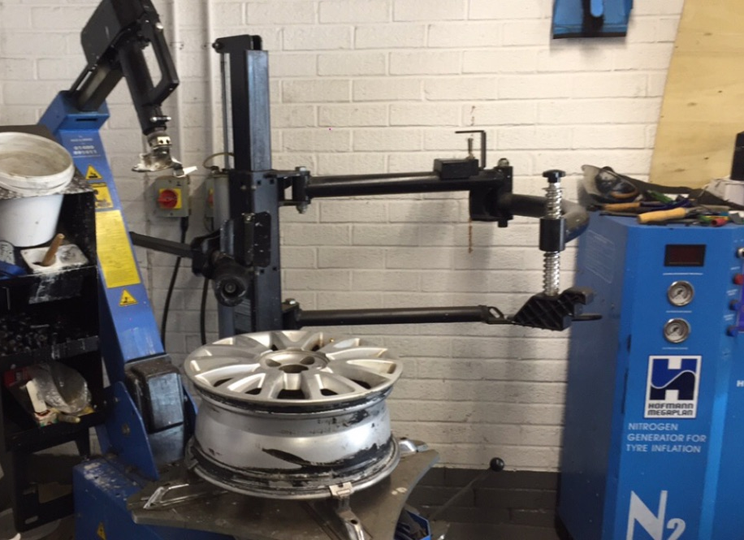  -This day was spent in the MOT area where I was changing tyres on customers cars and my own car using the tyre machine.  Tuesday / Wednesday 4th-5th June:  -Tuesday and Wednesday were spent fitting the interior carpet and dash components to a MK1 VW Golf Convertible.  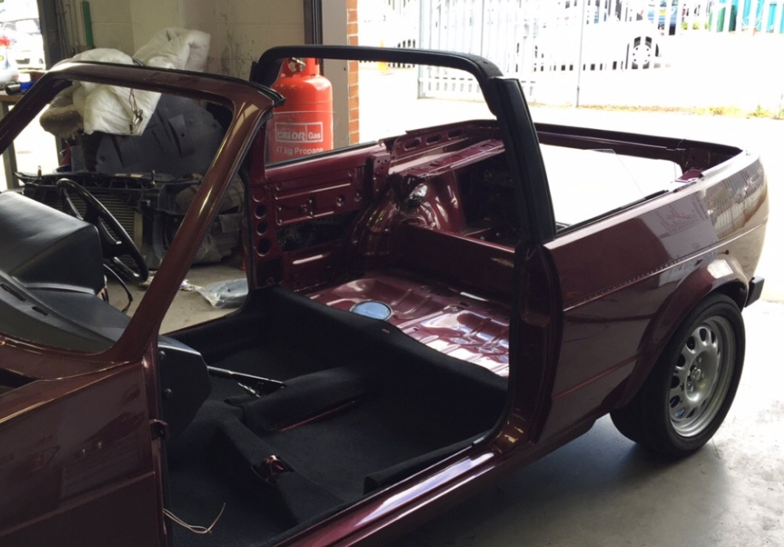  Thursday / Friday 6th-7th June:  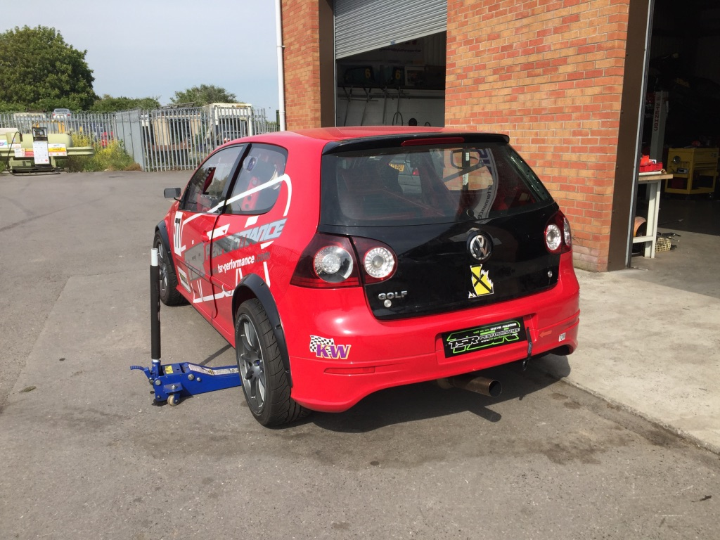  -Helped to set the correct toe and camber on a customer’s race car and TSR’s own race car. This was done with an apprentice to prepare the cars for the weekend of racing coming up. | Monday 3rd June:  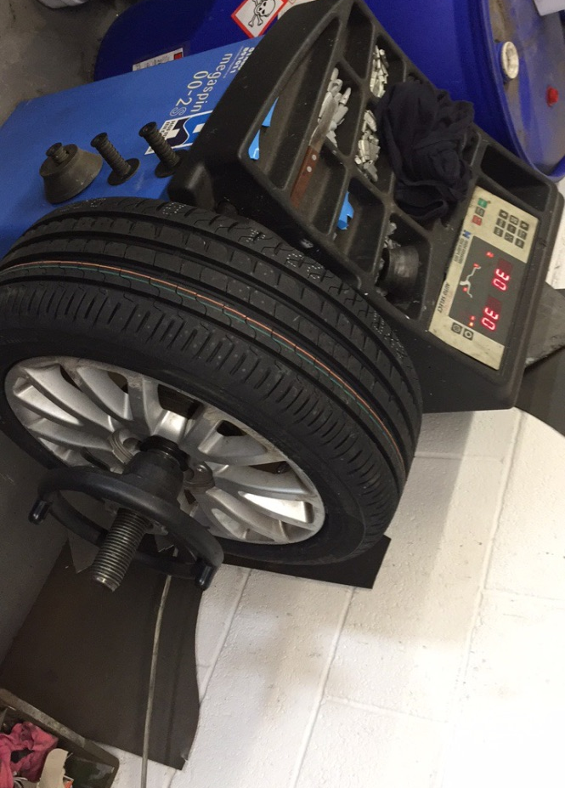  -Whilst using the tyre machine to change customer tyres, the wheel balancing machine was then used to balance the alloys.  Tuesday / Wednesday 4th-5th June:  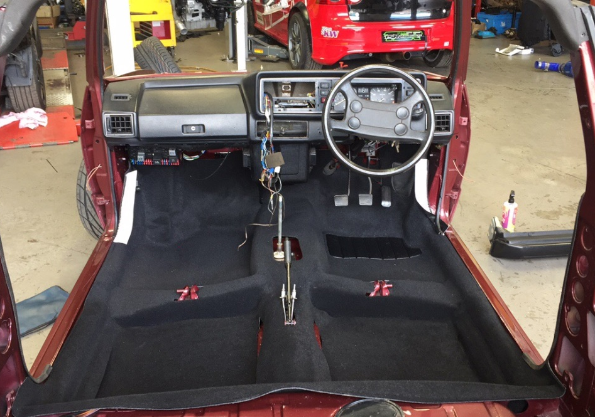  -The brand-new carpet and dash panels were fitted to this customer’s MK1 VW Golf Convertible because it has been undergoing a full restoration at TSR over the past months.  Thursday / Friday 6th-7th June:  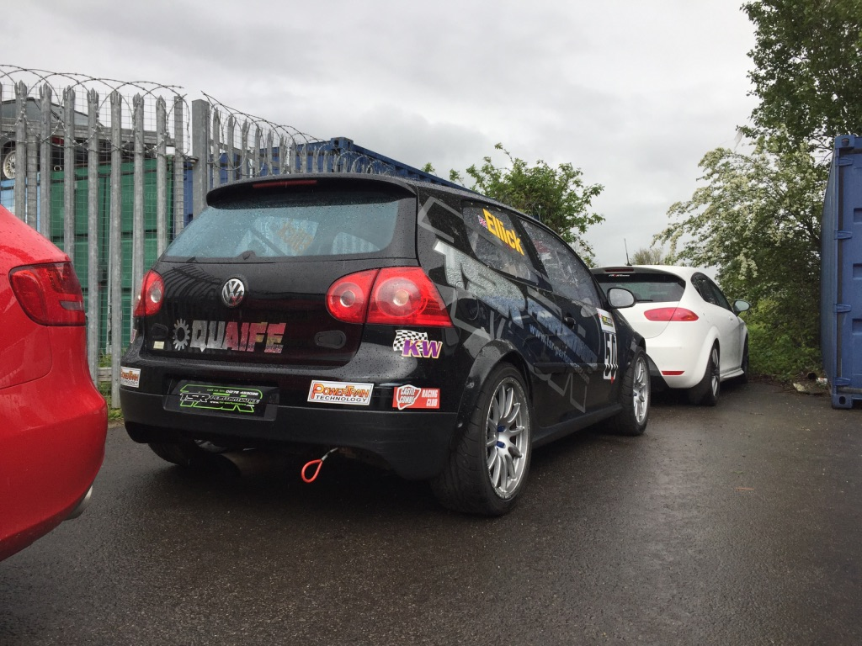  -Working with an apprentice at TSR, the use of the four-wheel drive wheel alignment was used to set the correct toe and camber for two of the race cars that will be racing on the weekend upcoming.

6.1.6. Week Six Diary Summary
Week Number: 6 | Week Start Date: 10th June 2019
Experience / Activity | Summary Description / Details
Monday 10th June:  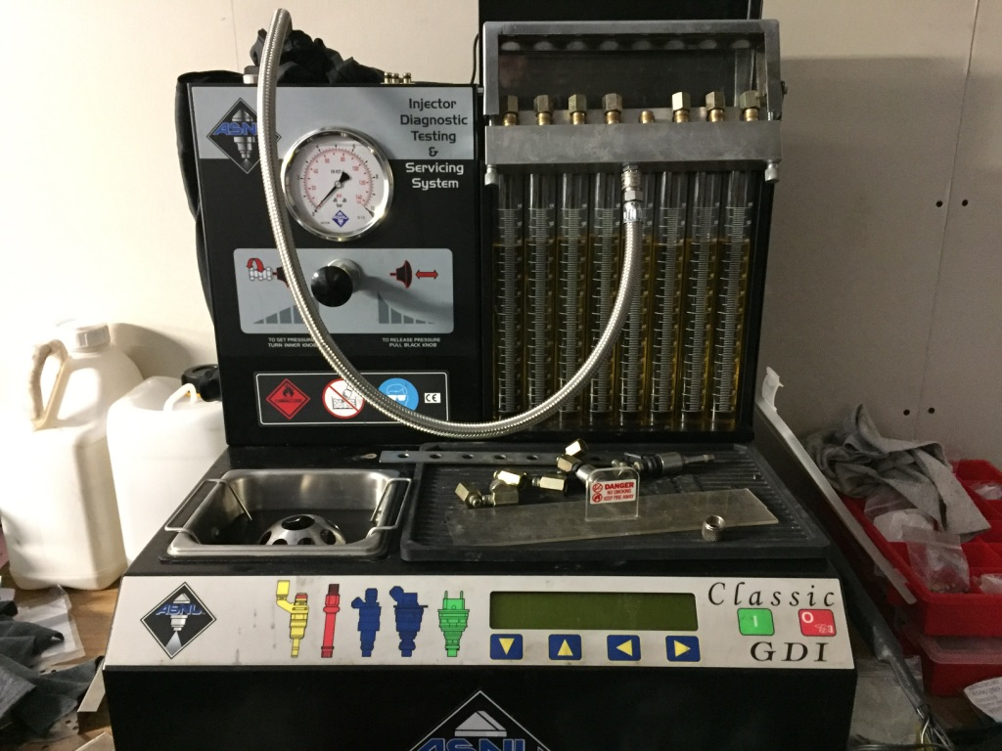  -Used the injector checking machine to check the injector flow cone shape pattern of all injectors from a car that hasn’t been running properly.  Tuesday 11th June:  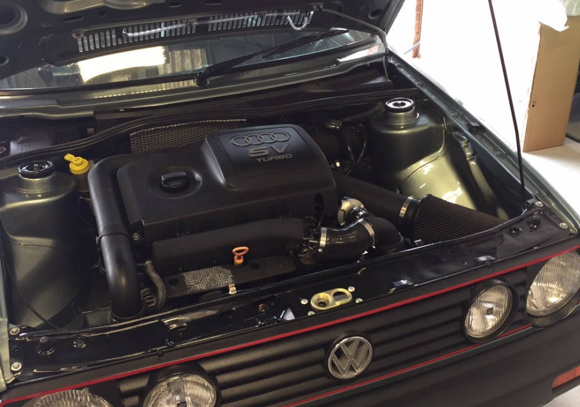  -Fault finding with a multi-metre was carried out on a customer’s MK2 VW Golf GTI which is not running properly.  Wednesday / Thursday 12th-13th June:  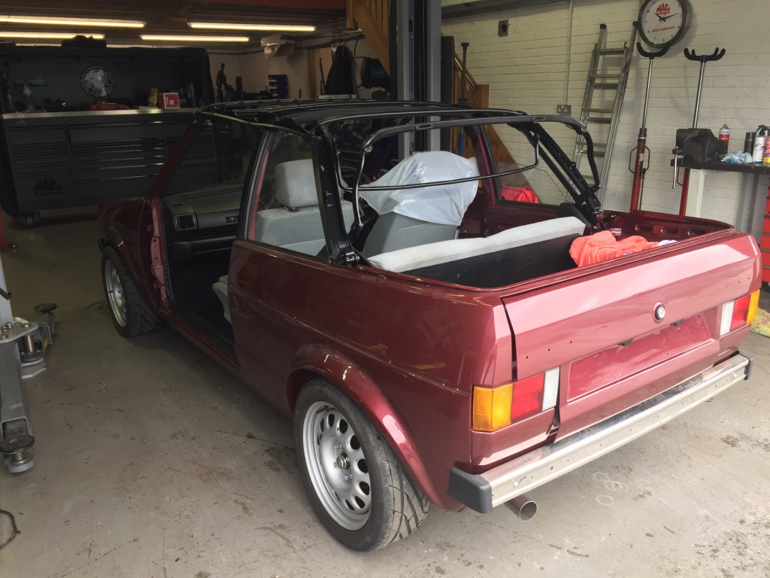  -These days were spent fitting the finishing touches to the MK1 VW Golf, including the front and rear seats and the soft top roof frame. | Monday 10th June:  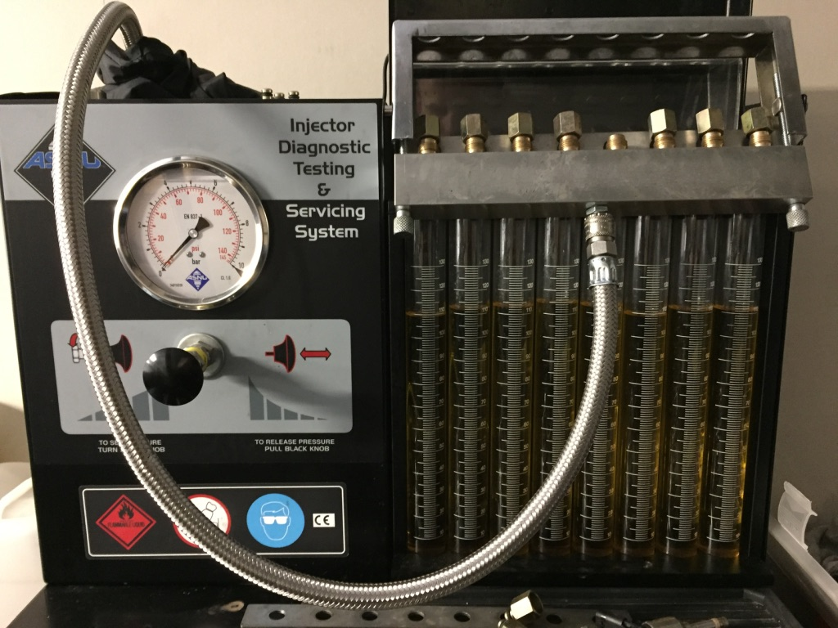  -This machine was used because after fault finding it was clear that there is a problem with one of the injectors, so by checking all injectors we will see which injectors pattern is incorrect.  Tuesday 11th June:  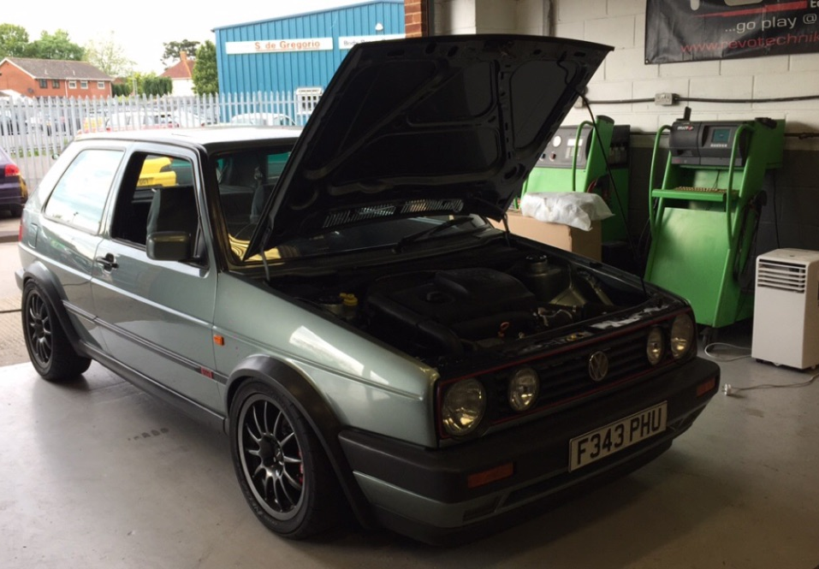  -The problem with the customer’s car was that it would cut out once running, the multi-metre was used to find that the fan was not coming on once running.  Wednesday / Thursday 12th-13th June:  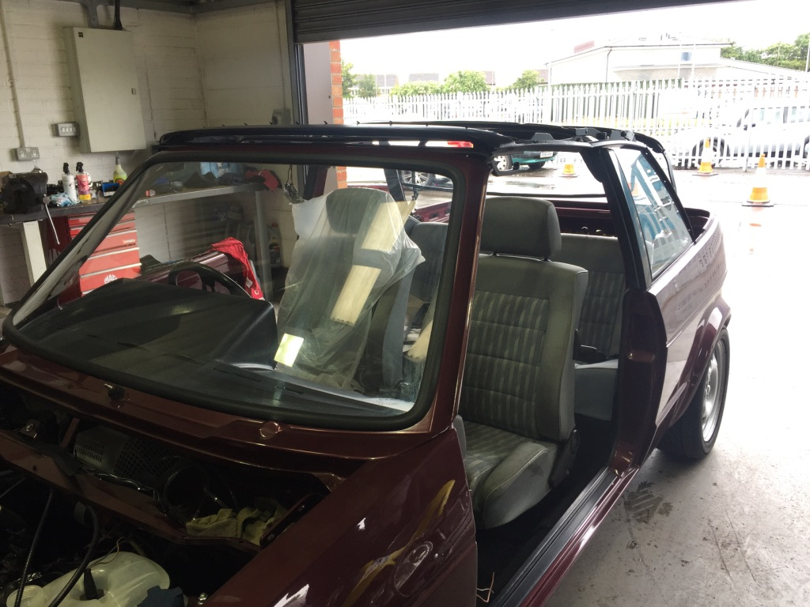  -This included cleaning and respraying the roof frame to be ready for collection by the customer. Fitted the roof and front and rear seats to the Golf Convertible.

