CSO - CONFISCATION OF ALCOHOL, TOBACCO, AND DRUGS

A young person: is someone who is NOT YET 18 (Anyone is regarded as a ‘young person’ up to midnight of the day before their 18th birthday).

A relevant place: Is somewhere the public has access to (paid or unpaid), and a place where the offender has unlawfully gained access.
A designated place: Is an area under the authority of the local council that has a restriction on it (such as a PSPO, DPPO, etc…)

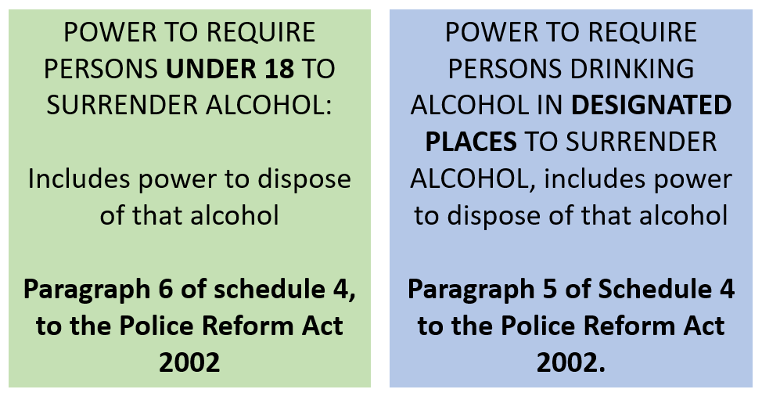
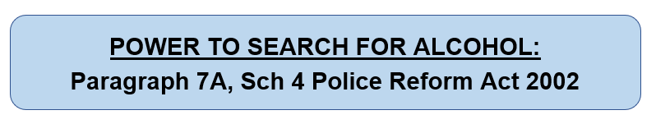
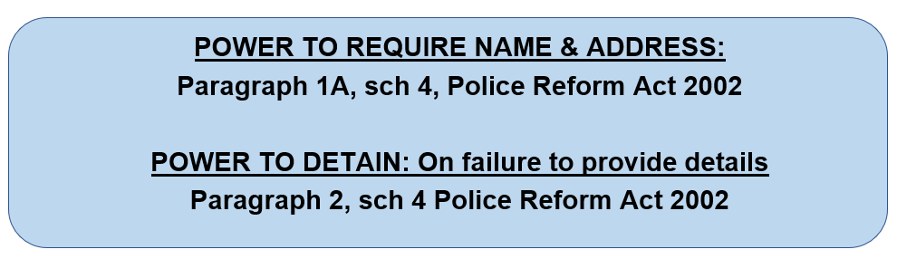
SEIZURE OF ALCOHOL:

SEIZURE OF TOBACCO AND PRODUCTS UNDER 16, you can ONLY seize:
- TOBACCO
- CIGARETTES
- CIGARS
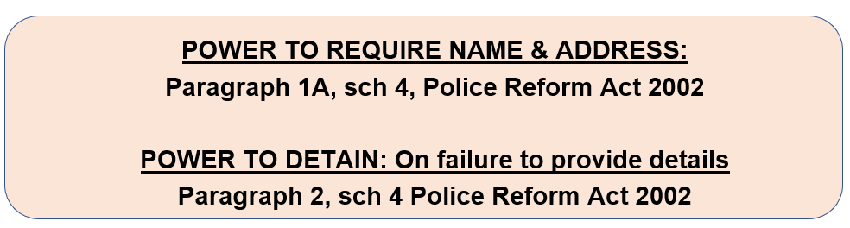
- CIGARETTE PAPERS



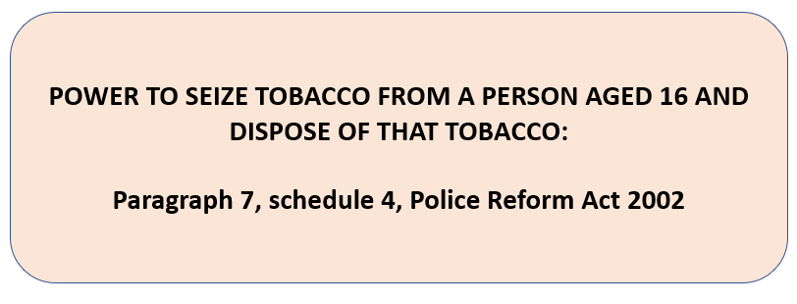

SEIZURE OF DRUGS:
CANNOT SEARCH FOR DRUGS!
CAN ONLY SEIZE DURING JOG SEARCH FOR ALCOHOL AND TOBACCO (and when searching for dangerous item that assist escape whilst person is already detained)
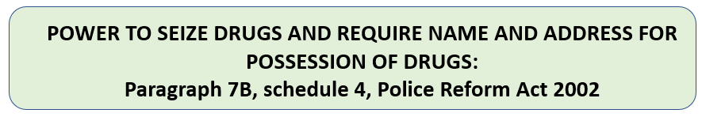
Must call a Police Officer and retain the drugs until instructed by the Police Officer on what to do with them.

POINTS TO PROVE DURING SEARCH AND SEIZURE:
- That you found or see alcohol/tobacco in the persons possession
- Circumstances of finding; that you were using your powers to search for alcohol, tobacco, (or dangerous items to assist escape during detention)
- That you reasonably believed the person was in unlawful possession of a the alcohol/tobacco/drugs
- That you requested the person's name and address
- That the person refused to give you the name and address
- That you made a note of the description of the suspect (using ADVOKATE) in your ePNB.

VAPES:
Must be over 18 to buy a VAPE, E-CIG or VAPE JUICE
Possession of any of these products that contain nicotine is illegal for under 18s IN PUBLIC
Minors can possess nicotine-free vape pens.
‘Alternative nicotine’ products are illegal.
*Vape cartridges must not hold more than 2 millilitres of liquid or contain more than 20 millilitres of nicotine per ml*
*If seized must be stored in an outside storage unit (e.g. Bike store) due to risk of combustion*

Seize and book into property system. Speak to parents and make an ASB referral.
Give the parents the option to collect from the station.

CONFISCATION OF ALCOHOL & TOBACCO FROM YOUNG PERSONS IN RELEVANT PLACE:

POWER TO SEIZE ALCOHOL:

“I have reason to suspect that you are under 18 years of age and you (are/or have been) drinking intoxicating
(liquor/alcohol/beer)”

“You must stop drinking immediately, I am seizing it under the Paragraph 6, Schedule 4 of The Police Reform Act 2002
Please give me that can/bottle etc…”

What is your name and address?”
(if refused – use detention powers and ask for a PC to attend)

POWER TO SEIZE TOBACCO:

“I have reason to suspect that you are under 18 years of age and you (are/or have been) smoking tobacco/cigarettes”

“You must stop immediately; I am seizing it under the
Paragraph 7, Schedule 4 of The Police Reform Act 2002
Please give me that tobacco…”

What is your name and address?”
(if refused – use detention powers and ask for a PC to attend)

CONFISCATION OF ALCOHOL, TOBACCO & DRUGS
- KNOWLEDGE CHECK (Trainer only)

- What is the legislation that allows a CSO to seize alcohol from a young person?
Paragraph 6 of Schedule 4 to the Police Reform Act 2002

- What is the legislation that allows a CSO to seize tobacco from a young person?
Paragraph 7, schedule 4, Police Reform Act 2002

- What is the definition of a young person?
A person under 18 (up until midnight on the day before their 18th birthday)

- What is a relevant place?
Public place, and a place the possessor has unlawfully gained access.

- When searching for tobacco, what other three items are you allowed to seize?
Cigarettes
Cigars
Cigarette papers

- When can a CSO seize drugs?
When they are located during a search for alcohol and tobacco

