

TERM -1
Programme: Master of Business Administration
Module: Marketing Management
Module code: LCMB7024
Student Name: Mohit Kamboj
Student ID: 2422941
Lecturer’s Name: Dr. Laila Maazouz
Submission Date: 28/03/2025
Word Count: 2,510

Table of Contents
Introduction 3
The advantages of being a pioneer company 3
The advantages of being a follower company 6
PLC Strategies in the Growth and Maturity Stages 8
Conclusion 10
References 12

Introduction
In marketing strategy, firms enter into foreign markets with a certain strategy different than when introducing the same product back in their home country (Hong et al., 2023). The pioneer strategy and follower strategy are two of the most commonly used methods. Pioneer strategy companies are those that are the first to come into the market with a unique product and benefit early with brand exposure, brand loyalty, supremacy and consumer preference. On the other hand, a follower strategy consists of businesses that come after the pioneers, noting their successes and blunders, and tightening up their products to gain an upper hand.
The timing of entering the market is one of the crucial factors that determines the success of a business or product. While early market entry is risky due to uncertain demand, late entry may involve lost opportunities or intensified competition (Klingebiel et al., 2022). Therefore, a careful analysis of market conditions, end-user trends, and competition should play a major role in determining when is the right time to enter the market.
This essay considers the advantages and disadvantages of pioneer and follower strategies, by reference to varying market conditions. It argues that newcomers have late-mover advantages that allow them to leverage the first-mover advantages enjoyed by innovators. Based on a review of key factors such as innovation, market demand, and competitive responses, the discussion suggests that both strategies can be valuable as long as the context and situation in the given industry are taken into account.

The advantages of being a pioneer company
In terms of business strategy and marketing, first-mover advantage (FMA) is the advantage gained by a company that first enters (or specializes in) a new market (Armstrong et al., 2014). Pioneer firms can achieve strong brand recognition, gain technological leadership, create entry barriers and establish industry-wide standards. However, these benefits are compelling at the expense of a high cost of market education and uncertainty when it comes to technology (Cirik and Makadok, 2023). But there are specific characteristics of first-movers and their applications, which provide great evidence, of why it is good to be a pioneer company.
First-Mover Advantage: Some Theoretical Considerations in Econometrics
First mover firms’ theory is based on the concept of strategic marketing and competitive position (Hooley et al, 2008). Kotler et al. (2014), describe how first movers can shape consumer preferences, establish brand recognition, and develop industry standards, all of which contribute to long-lived competitive advantages. However, the ability of lead firms to successfully contribute depends on their ability to maintain a first-mover advantage, continue to innovate, and overcome the associated challenges of entering the market early.
One of the most important advantages of being first is the opportunity to develop market leadership. Simply put, first movers are able to create product categories and become king of the hill. Such leadership allows firms to establish prices, control distribution, and build customer loyalty, all of which make it hard for competitors who come in later.
Pioneer Advantages
- Market Visibility and Leadership Position: Pioneers enjoy high levels of brand awareness, so they get the default business in their industry. For instance, early in e-commerce, Amazon became synonymous with online shopping. Amazon retains a high market share, despite growing competition, through constant innovation and product expansion (Rikap, 2022).
- Ability to Define Category Reference Points with Brand: They say, that in the case of a strongly successful pioneer, it can become impossible even for competitors to redefine the market. Apple made back-to-back history with the launch of the iPhone and iPad which became the new industry standard whereby Apple became the standard for innovation and design (Verma et al., 2025).
- Technological Leadership: The first mover of innovation creates a unique position in technology leadership that can offer a sustainable competitive edge. Additionally, within the first-mover category: proprietary knowledge, learning curve advantages, and patent protections all help to keep pioneers on top. By investing in mobile technology and design patents, Apple established itself as a market leader.
- Customer Switching Costs: Pioneer can ring-fence customers psychologically and financially, making it expensive for them to switch to competitors. The best example of that is Microsoft with its Windows operating system, where users have to deal with compatibility issues and learning costs when switching to alternative platforms like macOS or Linux (Aladdin et al., 2018).
- Setting Industry Standards: Pioneer companies gain a foothold on industry standards, formats, or procedures that competitors must follow. Innovations in Google’s search algorithm determined the framework for competitor SEO and digital marketing strategies.
While there are benefits, pioneering firms can also face major hurdles, including:
- Pioneer Costs: Creating a market means consumers usually aren't familiar with your product or your technology and will require substantial time, effort, and expense on your part to educate them.
- Technological Uncertainties: The adoption of new technology carries risks, such as uncertainty around potential obsolescence or unexpected shifts in the competitive market (Eggers and Park, 2018).
- Regulatory Challenges: Trailblazers often have to navigate untested regulatory waters, which can delay product acceptance and market penetration.
First Mover is referenced to an advantage or a piece of knowledge which has a company or an individual which other companies or individuals do not have yet. Yet, these advantages are accompanied by obstacles like high initial investment costs and market uncertainties. At the same time, some pioneer firms do successfully balance entrepreneurship with innovation, adaptation, and customer engagement e.g., Amazon, Apple, Microsoft, Google Tesla etc., which further prove that first-mover advantages can be sustained over time through strategic positioning and by dominating the media space.

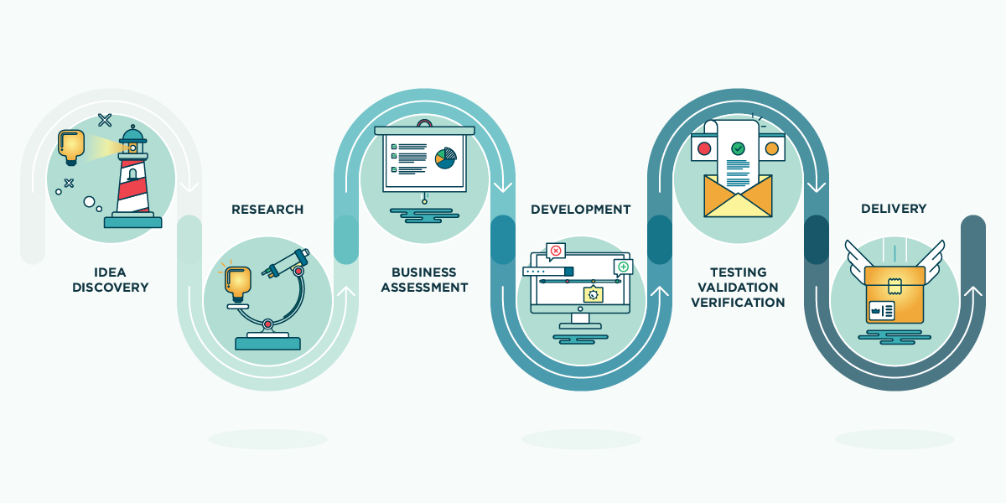
Figure 1: Innovation roadmap is a comprehensive strategy
(Source : innovation, 2025)

The advantages of being a follower company
The positioning of companies strongly within a market, like a follow-up rather than a first mover if you will, can present several benefits themselves with 2nd wave advantages sum up here. According to Hooley et al. (2008), in Marketing Strategy and Competitive Positioning, by learning from pioneer companies' mistakes, follower companies can lower R&D costs, and launch polished products that are better received in the market. This article reviews these benefits, supported with examples.
Lessons from the Missteps of Innovators
Pioneer companies typically make large investments in creating these new product categories but must navigate various uncertainties, such as unforeseen technological challenges, regulatory issues, and changing consumer preferences. Follower companies analyze these pitfalls and improve their offerings. Samsung seized the initiative from Apple when it came to early smartphone innovations like superior hardware implementations, open-source software (Android) and diverse pricing strategies that avoided Apple’s exclusivity restrictions (Prabhu and Bhat, 2020).
Reduced R&D Costs
Pioneers invest heavily in R&D, shouldering the costs and risks associated with innovation. Followers, by contrast, utilize already available technologies and improve upon them at a lower cost. They learn from the initial iterations and can leverage the supercharged features without the cost of development being absurdly high. The videoconferencing industry is a classic case in point, with Zoom innovating on top of legacy players Skype and Webex by simplifying setup and clouding services while eliminating the need for investment in infrastructure (Khasawneh, 2021).
Fulfilling With Innovations in Product Designs
Follower companies use market feedback to finesse their products for better consumer experience. Apple’s iPad, for example, competed against Microsoft Surface, which addressed shortcomings, such as lack of multitasking and stylus support. Microsoft’s later entry into the market allowed it to fill these gaps and dominate a more niche market.
Lower Market Education Costs
The process of market education and category awareness is long and expensive. Pioneers have to spend money convincing consumers of the value of a new product; followers take advantage of this awareness, significantly cutting down on marketing spending. The streaming services industry is a prime example of this; Netflix was the first player to offer subscription-based streaming and entrants like Disney+ and HBO Max profited from an already educated consumer (Sandsgaard and Sem, 2025).
Technological Leapfrogging
Follower firms can skip some initial limitations of technology enabled by innovation technology based on the innovation technology. Google did the same way, the search engines like Yahoo, and AltaVista came first, and later Google improved the search algorithm with the best AI-powered functions (Johnsen, 2024). This allowed Google to crush the search engine competition even though they were a latecomer.
Follower strategies flourish in fast-paced industries, where the pioneering players are grappling with the technological limitations of the early stages. Moreover, as industries mature, entry barriers get lower, enabling the followers to capture market share effectively.
To summarize, the follower strategy has many benefits such as lower costs, better products and risk reduction. Pioneers create marketplaces, while settlers optimize and monetize existing successes, creating a strategic positioning ready for long-owned competitive advantage.



Figure 2: Technological Leapfrogging

(Source: cdotrends, 2025)

PLC Strategies in the Growth and Maturity Stages
Strategies of Product Life Cycle for Pioneer & Follower Companies
The Product Life Cycle (PLC) concept is a basic framework of marketing strategy and describes the stages a product goes through from introduction to decline. The PLC is critical for companies since it is the exact thing they should use to develop suitable strategies as the market environment changes (Kotler et al., 2014). In the introduction stage, costs are high and sales grow slowly, as the pioneers create awareness and build distribution for the new market. At the other extreme, the decline stage offers diminishing returns and requires decisions on harvesting, maintenance or elimination as consumer preferences change and technologies age (Fahy and Jobber, 2019).
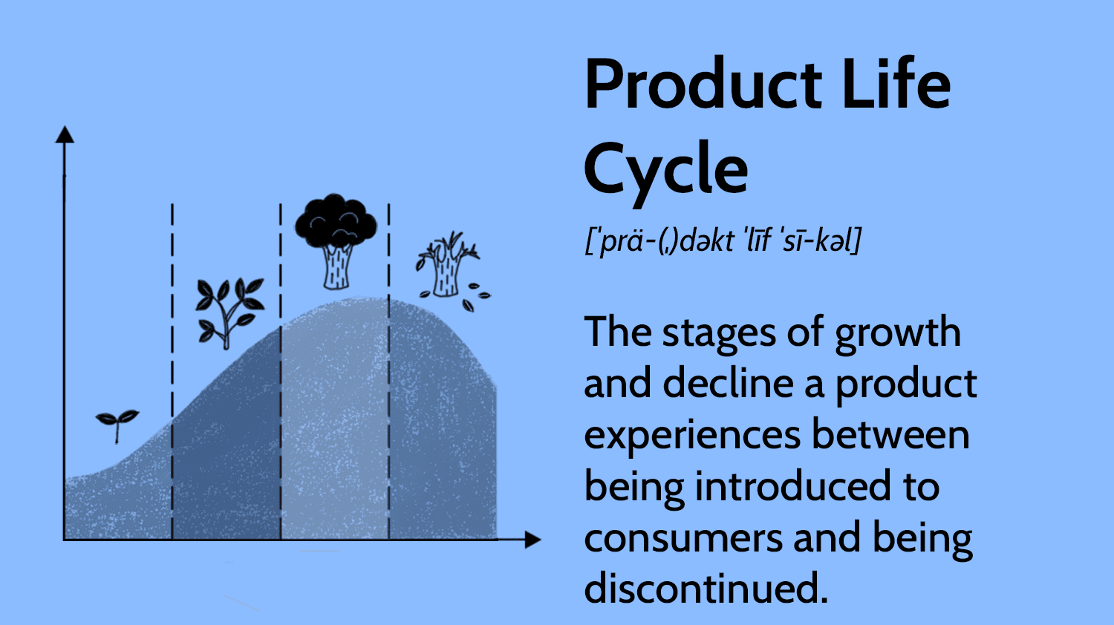
Figure 3: Product Life Cycle
(Source: Fahy and Jobber, 2019)
The growth and maturity phases are important points of strategic decision-making back to build competitive advantage. Growth involves faster market expansion that attracts new customers and competitors, and the maturity stage is characterized by peak sales, market saturation, and increased competition. As Hooley et al. (2008), these middle stages require complex strategic responses to optimize profit and defend market position, which is why they are especially critical for both innovators and imitators.
Growth Stage Strategies
Companies that are pioneers generally go through a growth stage where they use aggressive market penetration strategies to leverage their first-mover advantage. A classic example is Apple — after launching an iPhone ecosystem, they iteratively added functionalities to their devices while equally working to expand its ecosystem of apps and services. According to Drummond et al. (2010), this ecosystem strategy inflicted high switching costs on consumers and cemented Apple as the first mover. Netflix used a similar strategy when it grew its streaming service and spent billions on original programming to differentiate and create barriers to entry. Netflix's response, as described by Temporal (2019), is an example of how innovators use their position to shape consumer expectations and promote higher levels of adoption.
Above expansion, pioneers usually place great emphasis on enhancing product quality, to consolidate their leadership. Meta, for example, exemplifies this approach with platform capabilities inherent to its platform and its acquisition strategy (Instagram, WhatsApp) that leveraged competitive advantages as social media was emerging. According to Kaličanin (2008), strategies that emphasize quality allow market pioneers to ensure they become market leaders while followers fail to create a relevant differentiation.
Growth stage follower companies often pursue differentiation strategies to create unique market positions. This strategy can be seen in the phone market, where Samsung, after initially doing whatever Apple did, started offering the same phone with different price points and screen sizes. According to Dibb (1998), Samsung's approach illustrates how the follower can spot gaps in the pioneer's market coverage and exploit those. Similarly, while Amazon Prime Video entered the streaming space after Netflix, they did so much differently with their integration into the greater e-commerce ecosystem and original content strategy. This is consistent with Hooley et al. (2008) that successful followers build upon existing organizational strengths to create differentiated value propositions accordingly instead of replicating pioneers directly.
Maturity Stage Strategies
After a few years, as the market plateaus or matures, as pioneer companies, they commonly lay their efforts more towards market modification techniques and product line extension methods to help sustain growth. Coca-Cola illustrates this strategy by constantly expanding its pool of flavour variants, package sizes, and adjacencies (Buckhaven, 2021). These strategies allow their pioneers to secure both shelf space and consumer relevance as they operate within more competitive environments (Kotler et al., 2014). In a similar vein, the evolution of Microsoft's Office products shows how pioneers can extend their life cycle through subscription models, integration with the cloud and continual feature add-ons. Pioneers innovate business models to revitalize mature products As Sheehan (2010), points out, the evolution of Microsoft from borderless standalone software to the cohesive and integrated Microsoft 365 ecosystem outlines a path of product revival through mobile business model innovation.
In mature markets, competitive defending tactics gain importance for pioneers. As for Google's ongoing changes to its algorithm and its entry into adjacent services (e.g., Gmail, Maps, Chrome), these are examples of defensive mechanisms that ensure Google's supremacy in search engines over decade after decade in the face of countless competitors. As Wang (2014), such defensive innovation enables pioneers to maintain their lead in the market through persistent entry barrier increases against potential entrants.
In mature industries, follower companies pursue market niche focus strategies in a free market to make good use that not directly competing against well-established pioneers. Xiaomi made this strategy work in the mobile phone space, by first catering to cash-strapped consumers offering great value for money with feature-rich hardware at aggressive price tags and latterly working further upmarket (Sun and Fah, 2020). This approach helped Xiaomi to capture a share of the market without directly competing with Apple's high-end products (Sood, 2017). Generic pharmaceutical companies, such as Teva Pharmaceutical Industries (TEVA), are another example of followers making a killing by capturing a far below-cost edge over the firm as they patiently wait for patents to elapse and quickly roll out for all intents and purposes.
This is especially true for companies that are either pioneers or followers during the growth and maturity phases, as their market position, timing, and leverage of competitive advantage will shape their overall strategy. As Samanta (2014), reports, the most successful companies do not act the same regardless of changing market conditions or competitors but rather, adjust their strategies based on such changes, highlighting the critical role of strategic flexibility across the product life cycle.

Conclusion
Pioneer and follower strategies both have benefits and drawbacks, and success is case-dependent on the company's resources, market conditions, and competitiveness. First-movers enjoy competitive advantages such as brand recognition, technology leadership, high switching costs, and user loyalty, but also face risks of excessive R&D costs and unclear demand. In contrast, followers gain opportunities from reducing uncertainty, refinement, and learning from pioneers, but they must have a clear identification of brands and saturation to work against.
Pioneers and followers also utilize very different PLC strategies. Pioneers push market education, early adopter incentives, and innovation to stay ahead, whereas followers tend to push cost efficiencies, product differentiation, and aggressive marketing. The selection among these strategies is not dichotomous but should be harmonized with a firm’s capacities, risk appetite, and industry evolutions.
From a marketing strategy point of view, firms should carefully consider the timing and method of market entry. Pioneer vs. Follower Strategy Varying Effectiveness With New Developments As an industry matures, and as more and more firms adopt these strategies, factors such as digital transformation, disruptive innovation, and changing consumer behaviours will continue to play a crucial role in the effectiveness of pioneer vs. follower strategies. In the future, we may see hybrid strategies where companies balance early mover advantage with nimble adaptation to preserve sustainable competitive advantage over the long haul.

References
Aladdin, A.M., Bakir, Y.N. and Saeed, S.I., 2018. The effects to trend the suitable os platform. Journal: Journal of Advances in Natural Sciences, 5(01).
Armstrong, G., Adam, S., Denize, S. and Kotler, P., 2014. Principles of marketing. Pearson Australia.
Buckhaven, R., 2021. The Alcorithm: A revolutionary flavour guide to find the drinks you’ll love. Penguin UK.
cdotrends, 2025. The Time for Technological Leapfrogging Is Here. Available at https://www.cdotrends.com/story/15298/time-technological-leapfrogging-here. [ Accessed on 18.03.25]
Cirik, K. and Makadok, R., 2023. First-mover advantages versus first-mover benefits: What’s the difference and why does it matter?. Academy of Management Review, 48(3), pp.409-431.
Dibb, S., 1998. Market segmentation: strategies for success. Marketing Intelligence & Planning, 16(7), pp.394-406.
Drummond, G., Ensor, J. and Ashford, R., 2010. Strategic marketing. Routledge.
Eggers, J.P. and Park, K.F., 2018. Incumbent adaptation to technological change: The past, present, and future of research on heterogeneous incumbent response. Academy of Management Annals, 12(1), pp.357-389.
Fahy, J. and Jobber, D., 2019. Ebook: Foundations of marketing, 6e. McGraw Hill.
Hong, R., Zhang, Z., Zhang, C. and Hu, Z., 2023. Is brand globalness compatible with brand country-of-origin? An investigation of hybrid brand positioning strategies for emerging market brands. International Marketing Review, 40(1), pp.49-79.
Hooley, G.J., Piercy, N. and Nicoulaud, B., 2008. Marketing strategy and competitive positioning. Pearson Education.
innovationcloud, 2025. Innovation roadmap. Available at https://innovationcloud.com/blog/innovation-roadmap-pave-your-path-to-successful-innovation.html.[ Accessed on 18.03.25]
Johnsen, M., 2024. The Search Engine Revolution: From Past to Present and Beyond. Maria Johnsen.
Kaličanin, Đ., 2008. A question of strategy: To be a pioneer or a follower?. Economic Annals, 53(177), pp.89-102.
Khasawneh, K.I., 2021. The Use of Virtual Conference Software (VCS) in the Workplace during COVID-19 in North America: An Empirical Validation of Innovation Diffusion Theory. The University of Texas Rio Grande Valley.
Klingebiel, R., Joseph, J. and Machoba, V., 2022. Sequencing innovation rollout: Learning opportunity versus entry speed. Strategic Management Journal, 43(9), pp.1763-1792.
Prabhu, S. and Bhat, S., 2020. Application of Artificial Intelligence in Samsung–A Case Study. Prabhu, Sangeetha, & Bhat, Subrahmanya, 2020. Application of Artificial Intelligence in Samsung–A Case Study. International Journal of Case Studies in Business, IT, and Education (IJCSBE), 4(2), pp.280-292.
Rikap, C., 2022. Amazon: A story of accumulation through intellectual rentiership and predation. Competition & Change, 26(3-4), pp.436-466.
Samanta, I. ed., 2014. Strategic marketing in fragile economic conditions. IGI Global.
Sandsgaard, E.A. and Sem, K., Competitive Advantages in the Video Streaming Industry.
Sheehan, B., 2010. Basics marketing 02: Online marketing. Bloomsbury Publishing.
Sood, T. ed., 2017. Strategic marketing management and tactics in the service industry. Igi Global.
Sun, L. and Fah, C.T., 2020. Xiaomi-transforming the competitive smartphone market to become a major player. Eurasian journal of social sciences, 8(3), pp.96-110.
Temporal, P., 2019. ADVANCED BRAND MANAGEMENT-: Building and activating a powerful brand strategy. Harriman House Limited.
Verma, R., Ahmad, S. and Saini, T.C., THE POWER OF PSYCHOLOGICAL CONDITIONING IN APPLE'S MARKETING STRATEGIES.
Wang, C.L. ed., 2014. Brand Management in Emerging Markets: Theories and Practices: Theories and Practices. IGI global.

