HND Cyber Security & Networking

L4 - Introduction to Web and Database Concepts

Orin McGinn
2304621

23/1/2024
Table of Contents
Introduction 3
Requirements 4
Implementation 5
Evaluation 11
References 13
Appendices 14

Introduction

In this report you will find all my HTML and CSS code Along with a brief introduction to my website and its purpose, as well as its intended targets. Clearing up error codes as well as. Explanations behind how to do it My evaluation of my website, what I could have added along with references

Requirements

Welcome to my portfolio. This website is here to show you what type of skills I have as a esports manager and what projects I’ve probably worked on in the past and looked to work on in the future. The type of people who would look at this portfolio are maybe eager clients or Companies looking for. A good, talented manager to take over some work. Or just some people who want to know a little bit more about me.

Implementation

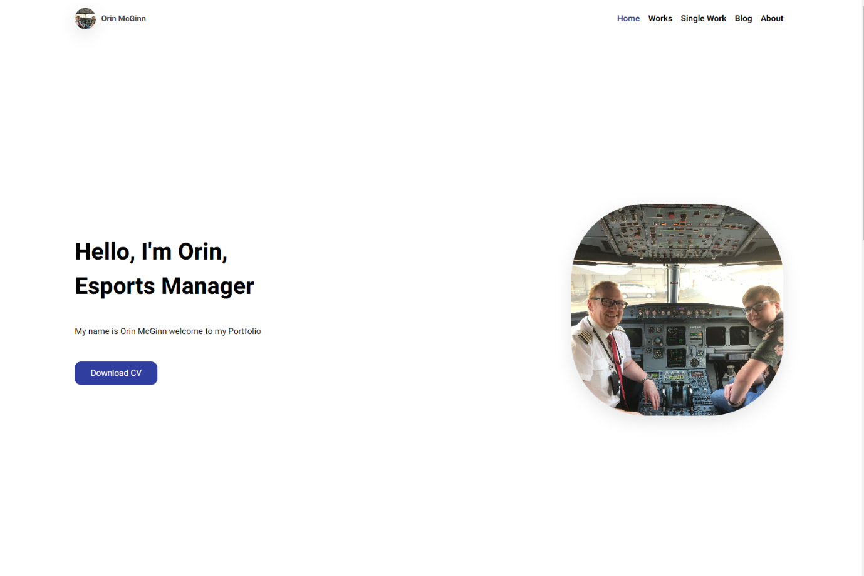
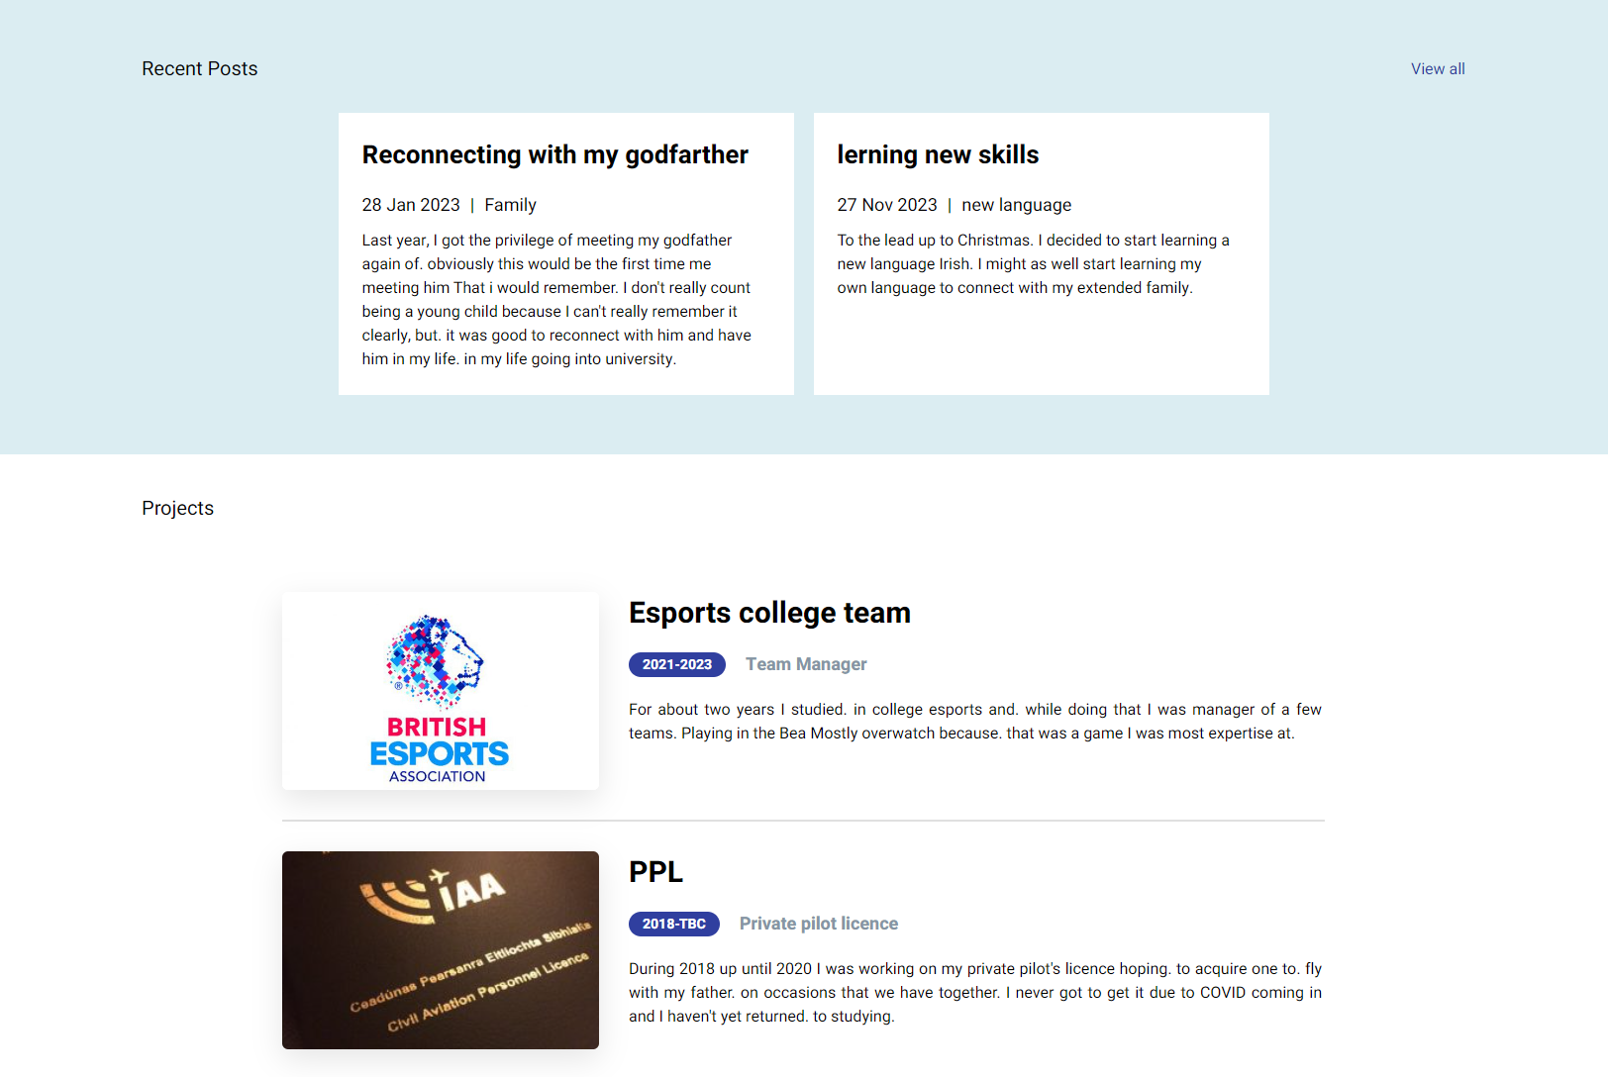
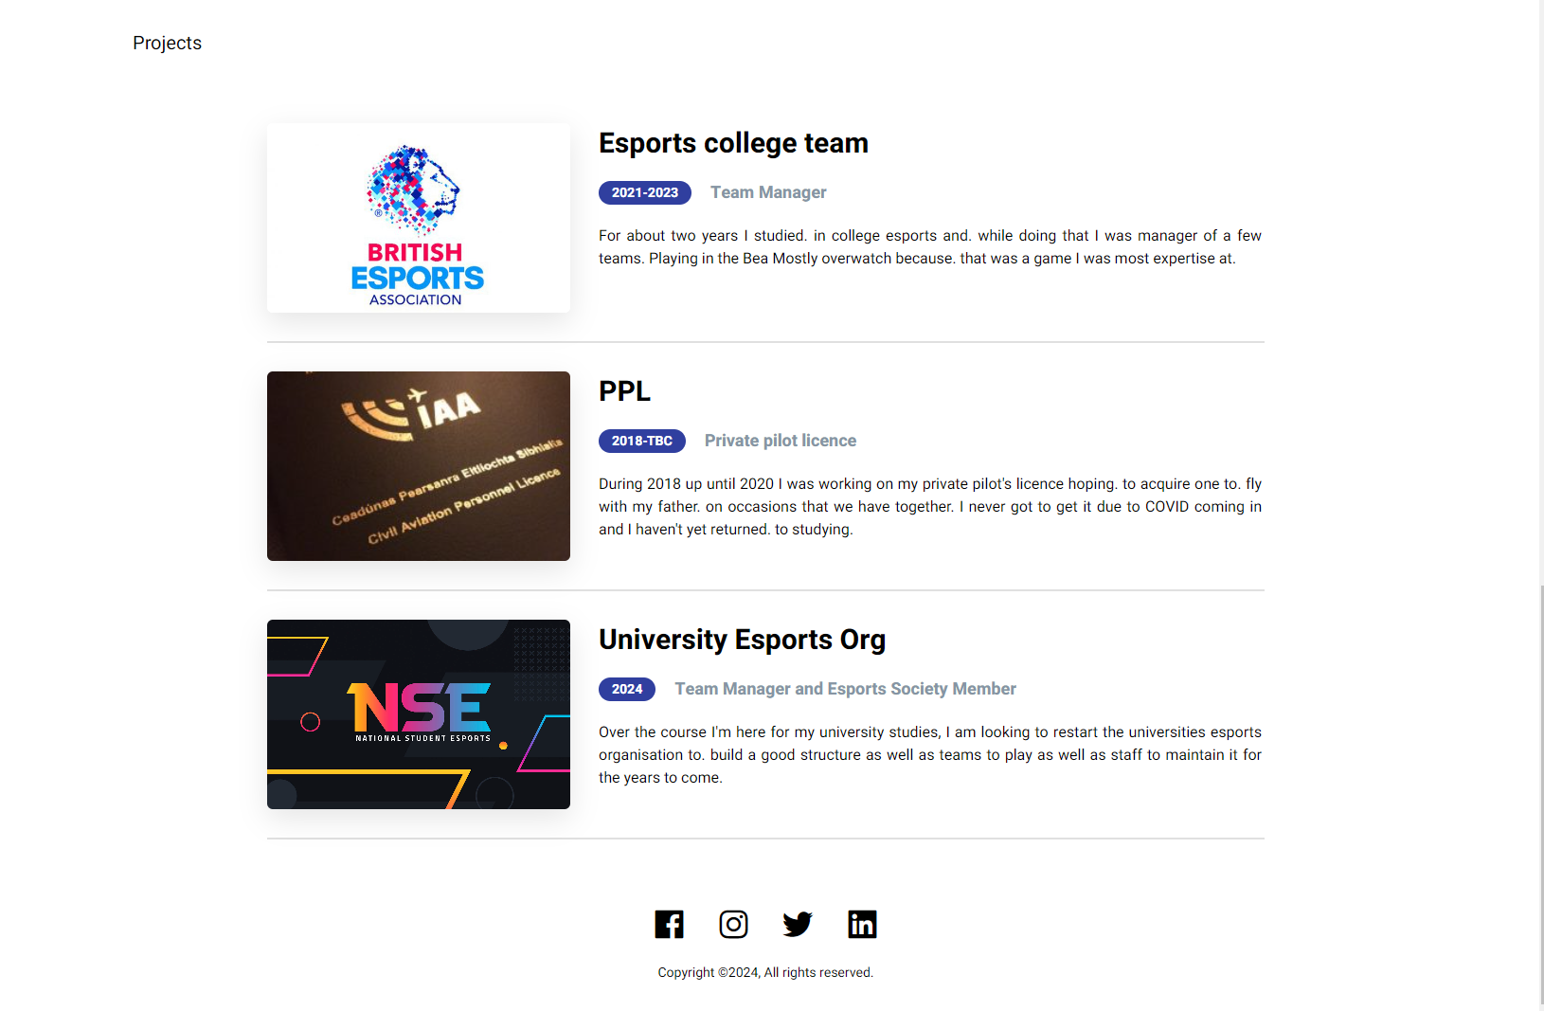
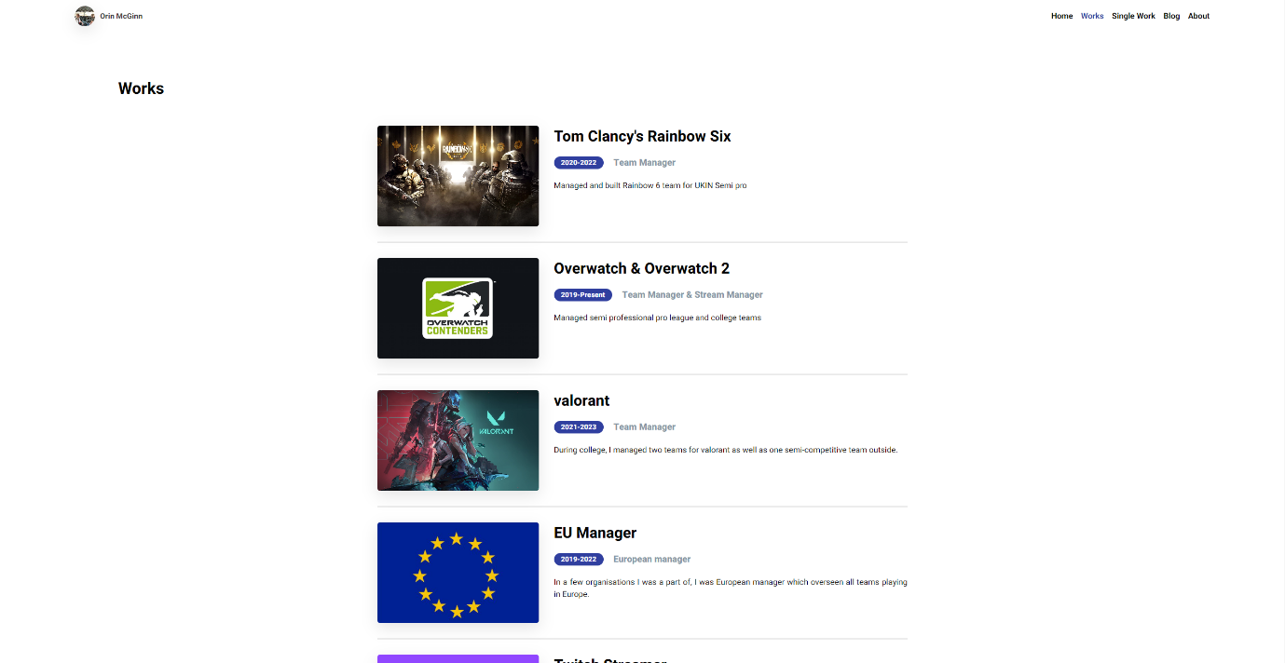
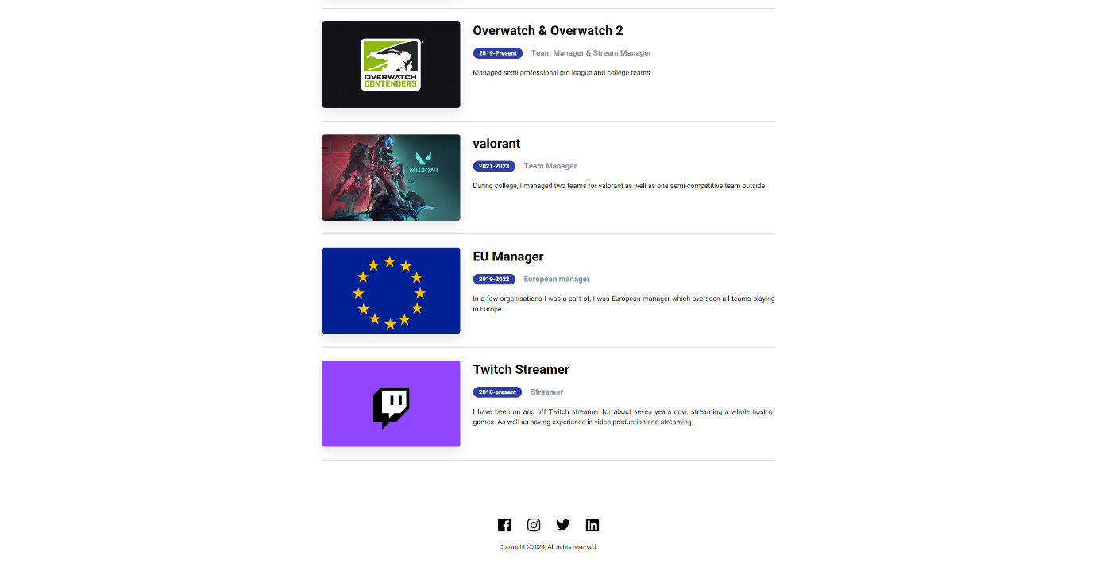
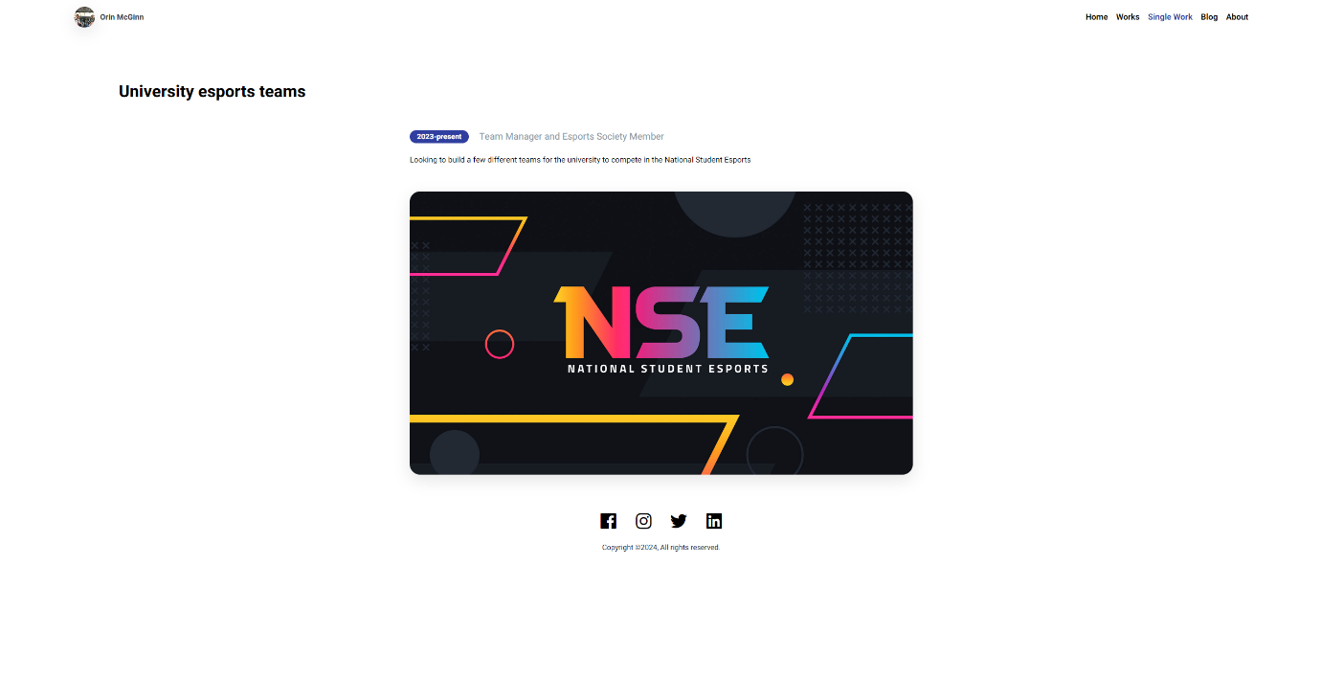
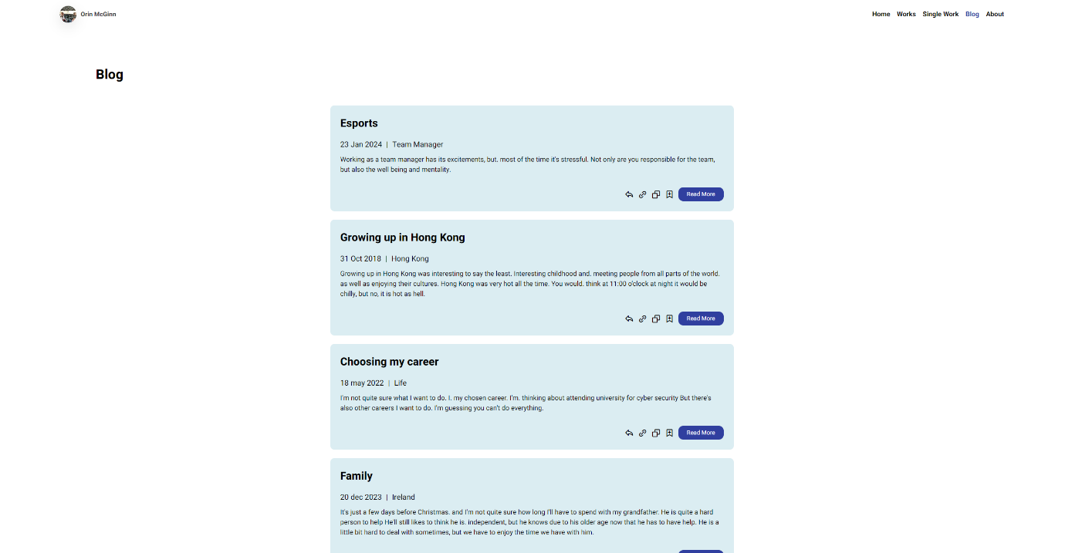
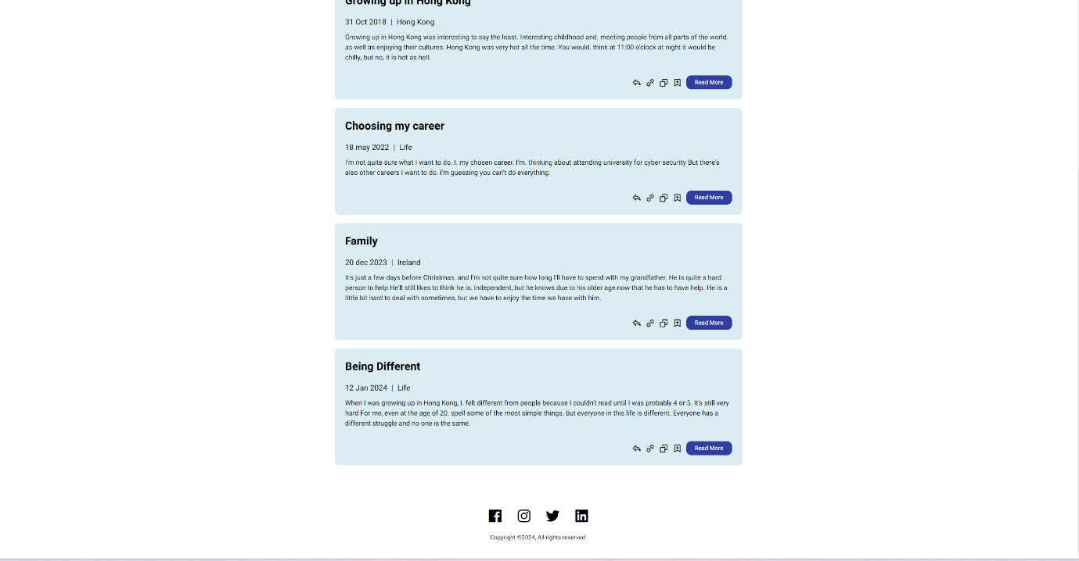
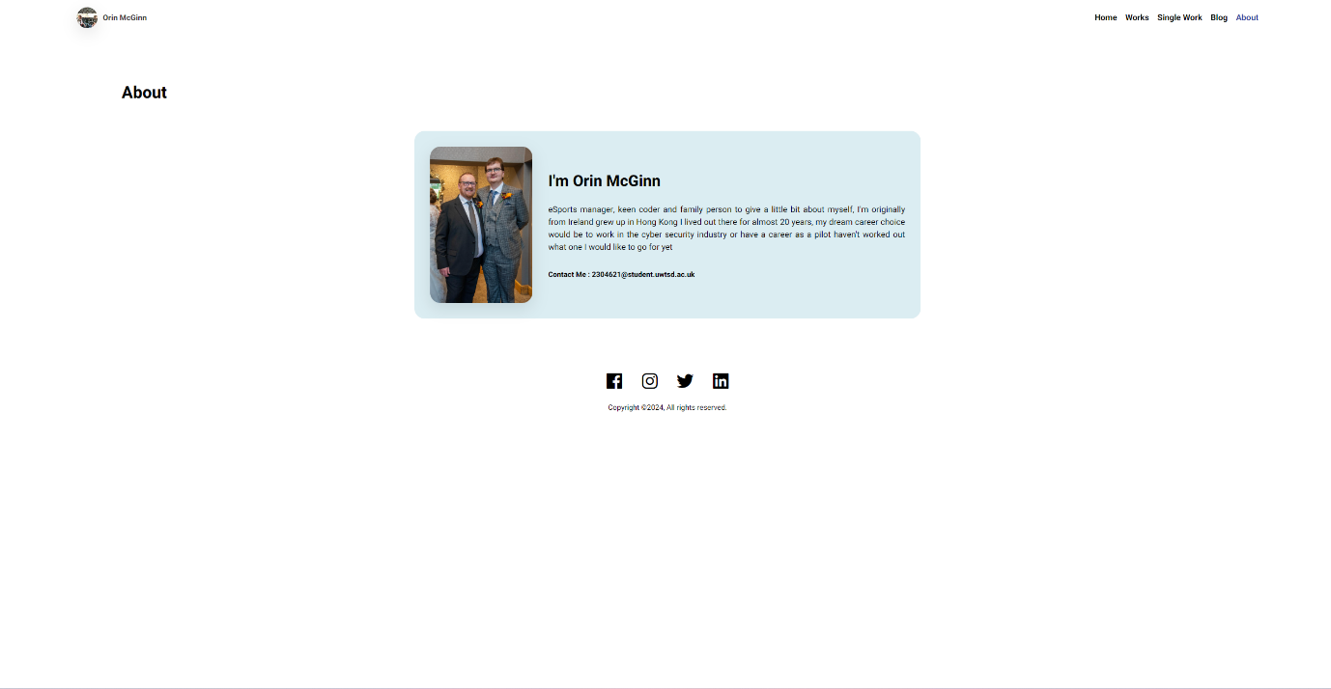

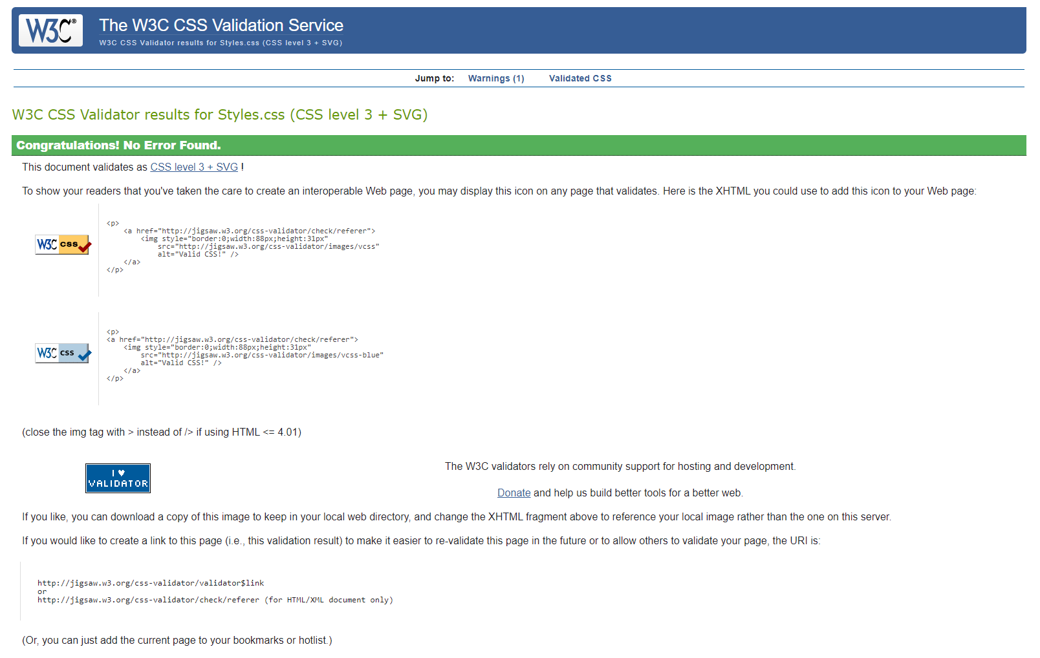
My css code has no errors and I didn’t have to edit anything.

With this error here, it states that. Illegal Character in pathway segment, meaning that I have spaces. Within the text for the image. What I do is rename the image and take out spaces. And then the error corrects itself. When saved.

For this error here, it states. That I must add alt Along with details for the image to consolidate with guidelines.
This is what it should look like after it is saved. The error disappears.

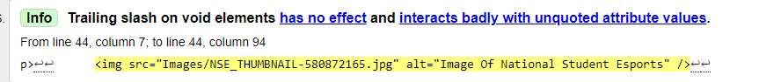
Even though this is not an error after I take away the slash and I save the Slash comes back It’s a visual feature to do with studio.

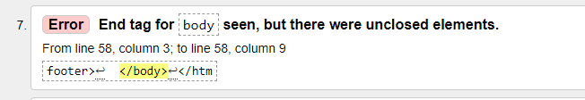
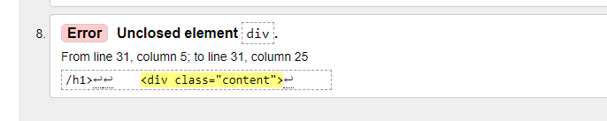
With these two codes here. There is a way to fix it. All you have to do is add one more div But I don’t have enough time to edit the CSS code to find. The correct way to reorientate the image. Because when you add the extra division, it fixes the coding issue but bloats the image and does not look nice on the website.

Evaluation

Website Useability
Website usefulness refers to the degree to which a website fulfils the needs and expectations of its users, providing valuable content and functionality that meets their goals effectively its role is usefulness of a website is a fundamental aspect of user experience and directly impacts user satisfaction, engagement, and the likelihood of users achieving their objectives.

“The impact of website quality on customer satisfaction and purchase intentions: Evidence from Chinese online visitors."
Summary: This study investigated the relationship between website quality, customer satisfaction, and purchase intentions in the context of Chinese online visitors. Findings indicated that usability factors significantly influenced both satisfaction and purchase intentions.

Website Accessibility
Accessibility should be considered from the beginning of the web development process. Designers and developers need to create interfaces that are inclusive by default, considering diverse user needs and abilities.

Following established accessibility standards, such as WCAG, is essential. These standards provide guidelines for making web content more accessible, covering areas like text alternatives for non-text content, keyboard navigation, and accommodating various assistive technologies.

"Web Content Accessibility Guidelines (WCAG) 2.0 and 2.1 Conformance among Fortune 1000 Companies’ Websites."
In summary, website accessibility is a critical consideration in web development to create an inclusive digital environment, and adherence to established standards is key to achieving this goal.

Website Search Engine Optimistion
Search Engine Optimization (SEO) is a means of improving websites rankings, improving its ability to be found easily from search engines so when someone searches for your company or site the internet can easily match their request with the data it has on your site.

SEO is built into websites by using keywords or other methods, thus allowing traffic to be directed to the site.
"Search engine optimization: What drives organic traffic to retail websites?"
Summary: This study investigated the factors influencing organic traffic to retail websites through SEO. Key findings highlighted the importance of content relevance, keyword optimization, and link-building strategies in driving organic traffic.

I feel like the usefulness of my website is easy to use and easy to look around for what you need to find. I also feel like it’s easy on the eyes, not so much bold colours. As well as information about myself and content

References

[1]
R. Allison, C. Hayes, C. A. M. McNulty, V. Young, and G. Eysenbach, “A Comprehensive Framework to Evaluate Websites: Literature Review and Development of GoodWeb,” JMIR Formative Research, vol. 3, no. 4, Oct. 2019, doi: https://doi.org/10.2196/14372.
[2]
S. Gartland et al., “The State of Web Accessibility for People with Cognitive Disabilities: A Rapid Evidence Assessment,” Behavioral Sciences, vol. 12, no. 2, p. 26, Jan. 2022, doi: https://doi.org/10.3390/bs12020026.
[3]
M. R. Baye, B. De los Santos, and M. R. Wildenbeest, “Search Engine Optimization: What Drives Organic Traffic to Retail Sites?,” Journal of Economics & Management Strategy, vol. 25, no. 1, pp. 6–31, Dec. 2015, doi: https://doi.org/10.1111/jems.12141.

Appendices

<!DOCTYPE html>
<html lang="en">
<head>
<meta charset="UTF-8" />
<meta name="viewport" content="width=device-width, initial-scale=1.0" />
<link
href="https://unpkg.com/boxicons@2.1.4/css/boxicons.min.css"
rel="stylesheet"
/>
<link rel="stylesheet" href="Styles.css" />
<title>Personal Portfolio | Orin McGinn</title>
</head>

<body>
<nav>
<div class="logo">
<img
src="Images/WhatsAppImage2024-01-22at21.43.48_366c8e06.jpg"
alt="Image Of Orin McGinn"
/>
<a href="#">Orin McGinn</a>
</div>
<div class="nav-links">
<a class="selected" href="index.html">Home</a>
<a href="works.html">Works</a>
<a href="single-work.html">Single Work</a>
<a href="blog.html">Blog</a>
<a href="about.html">About</a>
</div>
</nav>

<div class="main">
<div class="info">
<h1>Hello, I'm Orin, <br />Esports Manager</h1>
<p>My name is Orin McGinn welcome to my Portfolio</p>
<button type="button" data-download="CV">Download CV</button>
</div>
<img
src="Images/WhatsAppImage2024-01-22at21.43.48_366c8e06.jpg"
alt="Image Of Orin McGinn"
/>
</div>

<div class="recent">
<div class="header">
<h4>Recent Posts</h4>
<a href="blog.html">View all</a>
</div>
<div class="posts">
<div class="post-item">
<h3>Reconnecting with my godfarther</h3>
<div class="info">
<h5>28 Jan 2023</h5>
<h5>|</h5>
<h5>Family</h5>
</div>
<p>
Last year, I got the privilege of meeting my godfather again of.
obviously this would be the first time me meeting him That i would
remember. I don't really count being a young child because I can't
really remember it clearly, but. it was good to reconnect with him
and have him in my life. in my life going into university.
</p>
</div>
<div class="post-item">
<h3>lerning new skills</h3>
<div class="info">
<h5>27 Nov 2023</h5>
<h5>|</h5>
<h5>new language</h5>
</div>
<p>
To the lead up to Christmas. I decided to start learning a new
language Irish. I might as well start learning my own language to
connect with my extended family.
</p>
</div>
</div>
</div>

<div class="separator">
<h4>Projects</h4>
</div>

<div class="featured">
<div class="item">
<img
src="Images/BEA-e1566377697814-1002798342.jpg"
alt="Image Of British ESports Association"
/>
<div class="details">
<h3>Esports college team</h3>
<div class="item-info">
<div class="year-badge">2021-2023</div>
<h4>Team Manager</h4>
</div>
<p>
For about two years I studied. in college esports and. while doing
that I was manager of a few teams. Playing in the Bea Mostly
overwatch because. that was a game I was most expertise at.
</p>
</div>
</div>
<div class="item">
<img
src="Images/Licences_Cover_Photo-300x169-2123422832.jpg"
alt="Image Of Private pilot licence"
/>
<div class="details">
<h3>PPL</h3>
<div class="item-info">
<div class="year-badge">2018-TBC</div>
<h4>Private pilot licence</h4>
</div>
<p>
During 2018 up until 2020 I was working on my private pilot's
licence hoping. to acquire one to. fly with my father. on occasions
that we have together. I never got to get it due to COVID coming in
and I haven't yet returned. to studying.
</p>
</div>
</div>
<div class="item">
<img
src="Images/NSE_THUMBNAIL-580872165.jpg"
alt="Image Of National Student Esports"
/>
<div class="details">
<h3>University Esports Org</h3>
<div class="item-info">
<div class="year-badge">2024</div>
<h4>Team Manager and Esports Society Member</h4>
</div>
<p>
Over the course I'm here for my university studies, I am looking to
restart the universities esports organisation to. build a good
structure as well as teams to play as well as staff to maintain it
for the years to come.
</p>
</div>
</div>
</div>

<footer>
<div class="socials">
<i class="bx bxl-facebook-square"></i>
<i class="bx bxl-instagram"></i>
<i class="bx bxl-twitter"></i>
<i class="bx bxl-linkedin-square"></i>
</div>
<p>Copyright ©2024, All rights reserved.</p>
</footer>
</body>
</html>

<!DOCTYPE html>
<html lang="en">
<head>
<meta charset="UTF-8" />
<meta name="viewport" content="width=device-width, initial-scale=1.0" />
<link
href="https://unpkg.com/boxicons@2.1.4/css/boxicons.min.css"
rel="stylesheet"
/>
<link rel="stylesheet" href="Styles.css" />
<title>Works Page | Orin McGinn</title>
</head>

<body>
<nav>
<div class="logo">
<img
src="Images/WhatsAppImage2024-01-22at21.43.48_366c8e06.jpg"
alt="Image Of Orin McGinn"
/>
<a href="#">Orin McGinn</a>
</div>
<div class="nav-links">
<a href="index.html">Home</a>
<a class="selected" href="works.html">Works</a>
<a href="single-work.html">Single Work</a>
<a href="blog.html">Blog</a>
<a href="about.html">About</a>
</div>
</nav>

<h1 class="page-title">Works</h1>

<div class="content">
<div class="works-list">
<div class="item">
<img
src="Images/tom-clancy-s-rainbow-six-siege-pro-league-3331-1424509916.jpg"
alt="Image Of Tom Clancy's Rainbow Six"
/>
<div class="details">
<h3>Tom Clancy's Rainbow Six</h3>
<div class="item-info">
<div class="year-badge">2020-2022</div>
<h4>Team Manager</h4>
</div>
<p>Managed and built Rainbow 6 team for UKIN Semi pro</p>
</div>
</div>
<div class="item">
<img
src="Images/ow_contenders_logo-1024x576-387279327.jpg"
alt="Image Of Overwatch Contenders"
/>
<div class="details">
<h3>Overwatch & Overwatch 2</h3>
<div class="item-info">
<div class="year-badge">2019-Present</div>
<h4>Team Manager & Stream Manager</h4>
</div>
<p>Managed semi professional pro league and college teams</p>
</div>
</div>
<div class="item">
<img
src="Images/kay-o-x-jett-valorant-game-hd-poster_bG1pZm6UmZqaraWkpJRnbW1lrWZqbGs-604162513.jpg"
alt="Image Of valorant"
/>
<div class="details">
<h3>valorant</h3>
<div class="item-info">
<div class="year-badge">2021-2023</div>
<h4>Team Manager</h4>
</div>
<p>
During college, I managed two teams for valorant as well as one
semi-competitive team outside.
</p>
</div>
</div>
<div class="item">
<img src="Images/th.png" alt="Image Of flag of Europe" />
<div class="details">
<h3>EU Manager</h3>
<div class="item-info">
<div class="year-badge">2019-2022</div>
<h4>European manager</h4>
</div>
<p>
In a few organisations I was a part of, I was European manager
which overseen all teams playing in Europe.
</p>
</div>
</div>
<div class="item">
<img src="Images/twitch.png" alt="Image Of logo twitch" />
<div class="details">
<h3>Twitch Streamer</h3>
<div class="item-info">
<div class="year-badge">2018-present</div>
<h4>Streamer</h4>
</div>
<p>
I have been on and off Twitch streamer for about seven years now.
streaming a whole host of games. As well as having experience in
video production and streaming
</p>
</div>
</div>
</div>
</div>

<footer>
<div class="socials">
<i class="bx bxl-facebook-square"></i>
<i class="bx bxl-instagram"></i>
<i class="bx bxl-twitter"></i>
<i class="bx bxl-linkedin-square"></i>
</div>
<p>Copyright ©2024, All rights reserved.</p>
</footer>
</body>
</html>

<!DOCTYPE html>
<html lang="en">
<head>
<meta charset="UTF-8" />
<meta name="viewport" content="width=device-width, initial-scale=1.0" />
<link
href="https://unpkg.com/boxicons@2.1.4/css/boxicons.min.css"
rel="stylesheet"
/>
<link rel="stylesheet" href="Styles.css" />
<title>Single Work Page | Orin McGinn</title>
</head>

<body>
<nav>
<div class="logo">
<img
src="Images/WhatsAppImage2024-01-22at21.43.48_366c8e06.jpg"
alt="Image Of Orin McGinn"
/>
<a href="#">Orin McGinn</a>
</div>
<div class="nav-links">
<a href="index.html">Home</a>
<a href="works.html">Works</a>
<a class="selected" href="single-work.html">Single Work</a>
<a href="blog.html">Blog</a>
<a href="about.html">About</a>
</div>
</nav>

<h1 class="page-title">University esports teams</h1>

<div class="content">
<div class="work-info">
<div class="year-badge">2023-present</div>
<div class="category">
<p>Team Manager and Esports Society Member</p>
</div>
</div>
</div>
<p>
Looking to build a few different teams for the university to compete in
the National Student Esports
</p>

<img
src="Images/NSE_THUMBNAIL-580872165.jpg"
alt="Image Of National Student Esports"
/>

<footer>
<div class="socials">
<i class="bx bxl-facebook-square"></i>
<i class="bx bxl-instagram"></i>
<i class="bx bxl-twitter"></i>
<i class="bx bxl-linkedin-square"></i>
</div>
<p>Copyright ©2024, All rights reserved.</p>
</footer>
</body>
</html>

<!DOCTYPE html>
<html lang="en">
<head>
<meta charset="UTF-8" />
<meta name="viewport" content="width=device-width, initial-scale=1.0" />
<link
href="https://unpkg.com/boxicons@2.1.4/css/boxicons.min.css"
rel="stylesheet"
/>
<link rel="stylesheet" href="Styles.css" />
<title>Blog Page | Orin McGinn</title>
</head>

<body>
<nav>
<div class="logo">
<img
src="Images/WhatsAppImage2024-01-22at21.43.48_366c8e06.jpg"
alt="Image Of Orin McGinn"
/>
<a href="#">Orin McGinn</a>
</div>
<div class="nav-links">
<a href="index.html">Home</a>
<a href="works.html">Works</a>
<a href="single-work.html">Single Work</a>
<a class="selected" href="blog.html">Blog</a>
<a href="about.html">About</a>
</div>
</nav>

<h1 class="page-title">Blog</h1>

<div class="content">
<div class="post-list">
<div class="post-item">
<h3>Esports</h3>
<div class="info">
<h5>23 Jan 2024</h5>
<h5>|</h5>
<h5>Team Manager</h5>
</div>
<p>
Working as a team manager has its excitements, but. most of the time
it's stressful. Not only are you responsible for the team, but also
the well being and mentality.
</p>

<div class="buttons">
<i class="bx bx-share"></i>
<i class="bx bx-link-alt"></i>
<i class="bx bx-copy"></i>
<i class="bx bx-bookmark-plus"></i>
<button>Read More</button>
</div>
</div>
<div class="post-item">
<h3>Growing up in Hong Kong</h3>
<div class="info">
<h5>31 Oct 2018</h5>
<h5>|</h5>
<h5>Hong Kong</h5>
</div>
<p>
Growing up in Hong Kong was interesting to say the least.
Interesting childhood and. meeting people from all parts of the
world. as well as enjoying their cultures. Hong Kong was very hot
all the time. You would. think at 11:00 o'clock at night it would be
chilly, but no, it is hot as hell.
</p>
<div class="buttons">
<i class="bx bx-share"></i>
<i class="bx bx-link-alt"></i>
<i class="bx bx-copy"></i>
<i class="bx bx-bookmark-plus"></i>
<button>Read More</button>
</div>
</div>

<div class="post-item">
<h3>Choosing my career</h3>
<div class="info">
<h5>18 may 2022</h5>
<h5>|</h5>
<h5>Life</h5>
</div>
<p>
I'm not quite sure what I want to do. I. my chosen career. I'm.
thinking about attending university for cyber security But there's
also other careers I want to do. I'm guessing you can't do
everything.
</p>
<div class="buttons">
<i class="bx bx-share"></i>
<i class="bx bx-link-alt"></i>
<i class="bx bx-copy"></i>
<i class="bx bx-bookmark-plus"></i>
<button>Read More</button>
</div>
</div>

<div class="post-item">
<h3>Family</h3>
<div class="info">
<h5>20 dec 2023</h5>
<h5>|</h5>
<h5>Ireland</h5>
</div>
<p>
It's just a few days before Christmas. and I'm not quite sure how
long I'll have to spend with my grandfather. He is quite a hard
person to help He'll still likes to think he is. independent, but he
knows due to his older age now that he has to have help. He is a
little bit hard to deal with sometimes, but we have to enjoy the
time we have with him.
</p>
<div class="buttons">
<i class="bx bx-share"></i>
<i class="bx bx-link-alt"></i>
<i class="bx bx-copy"></i>
<i class="bx bx-bookmark-plus"></i>
<button>Read More</button>
</div>
</div>

<div class="post-item">
<h3>Being Different</h3>
<div class="info">
<h5>12 Jan 2024</h5>
<h5>|</h5>
<h5>Life</h5>
</div>
<p>
When I was growing up in Hong Kong, I. felt different from people
because I couldn't read until I was probably 4 or 5. It's still very
hard For me, even at the age of 20. spell some of the most simple
things. but everyone in this life is different. Everyone has a
different struggle and no one is the same.
</p>
<div class="buttons">
<i class="bx bx-share"></i>
<i class="bx bx-link-alt"></i>
<i class="bx bx-copy"></i>
<i class="bx bx-bookmark-plus"></i>
<button>Read More</button>
</div>
</div>
</div>
</div>

<footer>
<div class="socials">
<i class="bx bxl-facebook-square"></i>
<i class="bx bxl-instagram"></i>
<i class="bx bxl-twitter"></i>
<i class="bx bxl-linkedin-square"></i>
</div>
<p>Copyright ©2024, All rights reserved.</p>
</footer>
</body>
</html>

<!DOCTYPE html>
<html lang="en">
<head>
<meta charset="UTF-8" />
<meta name="viewport" content="width=device-width, initial-scale=1.0" />
<link
href="https://unpkg.com/boxicons@2.1.4/css/boxicons.min.css"
rel="stylesheet"
/>
<link rel="stylesheet" href="Styles.css" />
<title>About Page | Orin McGinn</title>
</head>

<body>
<nav>
<div class="logo">
<img
src="Images/WhatsAppImage2024-01-22at21.43.48_366c8e06.jpg"
alt="Image Of Orin McGinn"
/>
<a href="#">Orin McGinn</a>
</div>
<div class="nav-links">
<a href="index.html">Home</a>
<a href="works.html">Works</a>
<a href="single-work.html">Single Work</a>
<a href="blog.html">Blog</a>
<a class="selected" href="about.html">About</a>
</div>
</nav>

<h1 class="page-title">About</h1>

<div class="content">
<div class="container">
<img
src="Images/WhatsAppImage2024-01-22at21.51.36_4c5bbb61.jpg"
alt="Image Of Orin McGinn"
/>
<div class="about">
<h2>I'm Orin McGinn</h2>
<p>
eSports manager, keen coder and family person to give a little bit
about myself, I'm originally from Ireland grew up in Hong Kong I
lived out there for almost 20 years, my dream career choice would be
to work in the cyber security industry or have a career as a pilot
haven't worked out what one I would like to go for yet
</p>
<p class="email">Contact Me : 2304621@student.uwtsd.ac.uk</p>
</div>
</div>
</div>

<footer>
<div class="socials">
<i class="bx bxl-facebook-square"></i>
<i class="bx bxl-instagram"></i>
<i class="bx bxl-twitter"></i>
<i class="bx bxl-linkedin-square"></i>
</div>
<p>Copyright ©2024, All rights reserved.</p>
</footer>
</body>
</html>

@import url('https://fonts.googleapis.com/css2?family=Heebo:wght@300;400;500;600;700;800&display=swap');

*{
margin: 0;
padding: 0;
box-sizing: border-box;
font-family: 'Heebo', sans-serif;
}

a{
text-decoration: none;
color: #000;
}

img{
object-fit: cover;
object-position: top;
box-shadow: 0 10px 30px rgba(0, 0, 0, 0.1);
}

nav{
padding: 20px 148px;
background-color: #fff;
display: flex;
align-items: center;
justify-content: space-between;
font-weight: 600;
}

nav .logo{
display: flex;
align-items: center;
gap: 10px;
}

nav .logo img{
width: 40px;
height: 40px;
border-radius: 50%;
}

nav .logo a{
font-size: 15px;
color: #3e3e3e;
font-weight: bold;
}

nav .nav-links{
display: flex;
gap: 16px;
}

nav .nav-links a{
transition: color 0.3s ease;
}

nav .nav-links a:hover,
nav .nav-links a.selected{
color: #303f9f;
}

.main {
padding: 0 148px;
display: flex;
align-items: center;
justify-content: space-between;
gap: 50px;
height: calc(100vh - 80px);
}

.main .info h1{
font-size: 44px;
margin-bottom: 40px;
}

.main .info p{
font-size: 16px;
margin-bottom: 45px;
width: 100%;
}

.main .info button,
.content .post-list .post-item .buttons button{
padding: 10px 30px;
background: #303f9f;
border: none;
color: #fff;
font-size: 16px;
border-radius: 12px;
cursor: pointer;
transition: background 0.3s ease;
}

.main .info button:hover,
.content .post-list .post-item .buttons button:hover{
background: #1a237e;
}

.main img{
width: 400px;
height: 400px;
border-radius: 140px;
}

.recent{
padding: 60px 148px;
background-color: #dbedf2;
}

.recent .header{
display: flex;
align-items: center;
justify-content: space-between;
margin-bottom: 30px;
}

.recent .header h4,
.separator h4{
font-size: 20px;
font-weight: 400;
}

.recent .header a{
color: #303f9f;
}

.recent .posts{
display: flex;
justify-content: center;
gap: 20px;
}

.recent .posts .post-item{
background-color: #fff;
padding: 24px;
width: 460px;
}

.recent .posts .post-item h3,
.content .post-list .post-item h3{
font-size: 26px;
margin-bottom: 18px;
}

.recent .posts .post-item .info,
.content .post-list .post-item .info{
display: flex;
gap: 10px;
margin-bottom: 10px;
}

.recent .posts .post-item .info h5,
.content .post-list .post-item h5{
font-size: 18px;
font-weight: 400;
}

.recent .posts .post-item p{
width: 400px;
}

.separator{
padding: 40px 148px 0;
}

.separator h4{
margin-bottom: 30px;
}

.featured{
padding: 40px 290px 0;
}

.featured .item,
.works-list .item{
display: flex;
gap: 30px;
margin-bottom: 30px;
padding-bottom: 30px;
border-bottom: 2px solid #e0e0e0;
}

.featured .item img,
.works-list .item img{
width: 320px;
height: 200px;
border-radius: 6px;
}

.featured .item .details h3,
.works-list .item h3{
font-size: 30px;
margin-bottom: 16px;
}

.featured .item .details .item-info,
.works-list .item .details .item-info{
display: flex;
align-items: center;
gap: 20px;
margin-bottom: 20px;
}

.featured .item .details .item-info .year-badge,
.works-list .item .details .item-info .year-badge,
.content .work-info .year-badge{
background-color: #303f9f;
padding: 2px 14px;
color: #fff;
border-radius: 16px;
font-size: 14px;
font-weight: bold;
}

.featured .item .details .item-info h4,
.works-list .item .details .item-info h4{
color: #8695a4;
font-size: 18px;
}

.featured .item .details p,
.works-list .item .details p{
width: 700px;
text-align: justify;
}

footer{
padding: 40px 0;
display: flex;
flex-direction: column;
align-items: center;
}

footer .socials{
display: flex;
align-items: center;
gap: 28px;
margin-bottom: 20px;
}

footer .socials i{
font-size: 40px;
cursor: pointer;
transition: color 0.3s ease;
}

footer .socials i:hover{
color: #303f9f;
}

footer p{
font-size: 14px;
}

.page-title{
padding: 80px 234px 20px;
width: 100%;
}

.content{
padding: 30px 148px 60px;
display: flex;
flex-direction: column;
align-items: center;
}

.content .work-info{
display: flex;
align-items: center;
justify-content: flex-start;
gap: 20px;
width: 970px;
}

.content .work-info .category{
color: #8695a4;
font-size: 18px;
}

.content>p{
width: 970px;
font-size: 15px;
margin: 20px 0;
}

.content>img{
width: 970px;
margin: 30px 0;
border-radius: 20px;
}

.content>h1,
.content>h2,
.content>h3{
width: 970px;
}

.content .post-list{
display: flex;
flex-direction: column;
gap: 20px;
}

.content .post-list .post-item{
background-color: #dbedf2;
padding: 24px;
width: 960px;
border-radius: 10px;
}

.content .post-list .post-item .buttons{
margin-top: 30px;
display: flex;
align-items: center;
justify-content: flex-end;
gap: 10px;
}

.content .post-list .post-item .buttons button{
font-size: 14px;
padding: 6px 20px;
}

.content .post-list .post-item .buttons i{
font-size: 22px;
cursor: pointer;
transition: color 0.3s ease;
}

.content .post-list .post-item .buttons i:hover{
color: #303f9f;
}

.content .container{
background-color: #dbedf2;
padding: 30px;
display: flex;
align-items: center;
gap: 30px;
width: 970px;
border-radius: 20px;
}

.content .container img{
width: 300px;
height: 300px;
border-radius: 20px;
}

.content .container h2{
margin-bottom: 20px;
font-size: 30px;
}

.content .container .about>p{
text-align: justify;
}

.content .container .about .email{
font-weight: bold;
margin-top: 30px;
font-size: 14px;
}

@media screen and (max-width: 1400px) {

nav{
padding: 20px 60px;
}

.main{
padding: 0 60px;
}

.recent{
padding: 60px;
}

.featured,
.separator{
padding: 40px 60px 0;
}

.page-title{
padding: 80px 60px 20px;
}

}

@media screen and (max-width: 1200px) {

nav{
padding: 20px 40px;
}

.main{
padding: 0 40px;
}

.main img{
width: 340px;
height: 340px;
}

.recent{
padding: 40px;
}

.featured,
.separator{
padding: 40px 40px 0;
}

.featured .item .details p,
.works-list .item .details p{
width: 100%;
}

.page-title{
padding: 80px 40px 20px;
}

.content .work-info,
.content>p,
.content>img,
.content>h1,
.content>h2,
.content>h3,
.content .post-list .post-item,
.content .container{
width: 100%;
}

.content .container img{
width: 250px;
height: 250px;
}

.content .container h2{
font-size: 24px;
margin-bottom: 10px;
}

.content .container .about>p{
font-size: 14px;
}

}

@media screen and (max-width: 992px) {

nav{
padding: 20px;
}

.main{
padding: 0 20px;
}

.main img{
width: 300px;
height: 300px;
}

.main .info h1{
font-size: 34px;
}

.main .info p{
font-size: 15px;
}

.main .info button{
font-size: 15px;
padding: 8px 22px;
}

.recent{
padding: 40px 20px;
}

.recent .posts .post-item{
width: 100%;
}

.recent .posts .post-item h3,
.content .post-list .post-item h3{
font-size: 20px;
}

.recent .posts .post-item .info h5,
.content .post-list .post-item .info h5{
font-size: 14px;
}

.recent .posts .post-item p{
width: 100%;
font-size: 14px;
}

.featured,
.separator{
padding: 40px 20px 0;
}

.featured .item,
.works-list .item{
flex-direction: column;
padding: 0 20px 30px;
}

.featured .item img,
.works-list .item img{
width: 100%;
height: auto;
}

.featured .item .details h3,
.works-list .details .item h3{
font-size: 24px;
margin-bottom: 12px;
}

.featured .item .details .item-info .year-badge,
.works-list .item .details .item-info .year-badge{
font-size: 12px;
}

.featured .item .details .item-info h4,
.works-list .item .details .item-info h4{
font-size: 15px;
}

.featured .item .details p,
.works-list .item .details p{
font-size: 14px;
}

.content{
padding: 30px 20px 60px;
}

.content .container h2{
font-size: 20px;
}

.content .container .about>p{
font-size: 13px;
}

}

@media screen and (max-width: 768px) {

nav{
justify-content: center;
}

nav .logo{
display: none;
}

.main{
flex-direction: column;
justify-content: space-around;
margin: 40px 0;
height: auto;
}

.main .info h1{
font-size: 30px;
margin-bottom: 16px;
}

.main .info p{
margin-bottom: 16px;
}

.main .info button{
padding: 6px 20px;
font-size: 13px;
}

.main img{
margin-top: 20px;
width: 100%;
height: auto;
border-radius: 50px;
}

.recent .posts,
.content .container{
flex-direction: column;
}

.content .container img{
width: 100%;
height: auto;
}

}

