

Introduction to Physiology
Assessment 2

Student Name: Modou Mbacke
Student ID: 1916151
Module Code BMHP5003_LON
Module Name: Introduction to Physiology
Lecturer Name: Eleni Koutsogeorgou

Contents Page:
Introduction -------------------------------------------------------------------2
Case study ---------------------------------------------------------------------3-4
Health assessment ----------------------------------------------------------4-5
Recommendations-----------------------------------------------------------6
Conclusion---------------------------------------------------------------------7
Reference----------------------------------------------------------------------8
Appendix----------------------------------------------------------------------9-10

Introduction
In this report will be analysis the case of patient A who suffer from obesity according to BMI. According parliament.uk (2020) the health survey for England 2019 estimates that 28.0 % of adults in England are obese and the further 36.2% are overweight but not obese. Health assessment will be made to have a relevant information need to help patient A to change her lifestyle. Furthermore, to recommend the Patient A which is the best way to change his life and daily routine like foods, drink, and exercise. The report will identify the risk Patient A face if she is continuing in this way. Health assessment, risk factors, case study and recommendation will be made in this report. Additionally, appendix will be attached at the end of this report. All data use in this report will be referenced to have a reliable information base in genuine sources. Lifestyle is one of the main causes of obesity in United Kingdom and other developed countries.

Case study
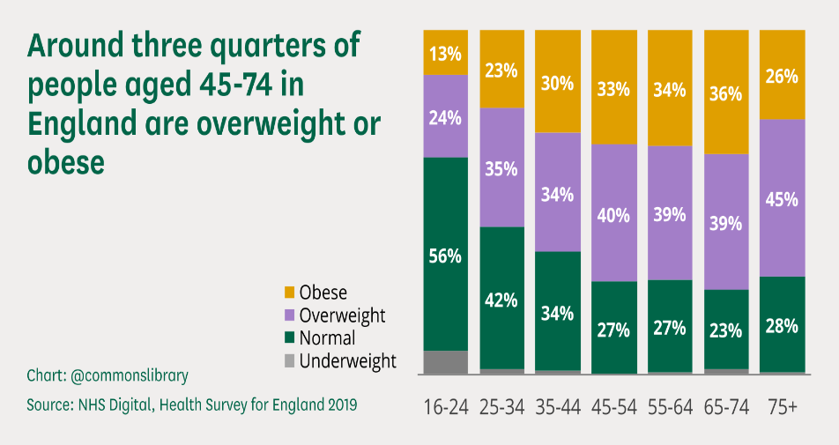
Patient A is 48 years of age and heavy alcohol drinker and smoke higher number of cigarettes a day which is mean she a hight risk of developing some diseases, furthermore, she is obese and does not do any exercise also her family background have some history of high blood pressure and heart attack. Patient A is 86kg and 165cm height according to body mass index (BMI) Patient A is obese which has put her in more risk of developing some diseases, like type 2 diabetes, heart attack, stroke etc. according to WHO (2021) body mass index (BMI) is a simple index of weight-for-height that is commonly used overweight and obesity in adults. It is defined as a person’s weight in kilograms divide by the square of his height in meters (km/m3). Poor diet and little movement are the cause of obesity. Patient A have is drinking 3 and 6 units of alcohol a day which is very high. According to NHS (2018) men and women are not advised to drink more 14 units a week on a regular basis. Patient A drink 21 to 42 units a week which is well higher than recommended amount of alcohol consumptions a week for men and women. “Obesity does not happen overnight. It develops gradually over time, because of poor diet and lifestyle choice such as: eating large amounts of processed or fast foods- that is high in fat and sugar, drinking a too much alcohol which contain a lot of calories” NHS, (2021). Patient A lifestyle maybe due to her living condition because she does not have a time to exercise at all which is the main reason why she is gaining weight. Time management maybe is contributing to her lack of exercise because she does not have a time to do some exercise. In addition, it may contribute to her poor diet as well because she maybe does not have time to cook a health food for herself. Because Patient A having a meat and chips everyday as a meal. Meat and chip are very high in calories and bad in health particularly for obese for a person like Patient A who is her weight are higher than normal according to BMI.
According to V Patel et al (2017) short and long sleep and work were associated with increase of BMI. On weekdays, individuals with obesity were more likely to be working at night and sleeping during the day. They were lees likely to participate in sports/exercise/recreation, but those that participated did so for amounts of time not different than normal BMI individuals. The amounts of cigarettes she smokes daily is moderate and it contributing to worsen her health situation and it can lead to lung disease also it can worsen her obesity however she a moderate smoker because she smokes between 10-19 cigarettes a day which indicate she not above 20 cigarettes a day which is considerate heavy. However Patient A smoking habit may get worse, and it may lead to her increase the number of cigarettes she smokes a day and become a heavy smoker which can accelerate some disease. Environment maybe one of the factors of her obesity because people live in the environment where processed and fast foods are common, they are likely to get obese and people who live in this environment are unlikely to have a healthy diet.

Health Assessment
Patient A lifestyle put her in very high risk of developing some health issue because she is drinking very high amount of alcohol and she also is a moderate smoker. This two will worsen her situation and put her in high risk of developing other diseases regarding to her lifestyle and body weight. According to body mass index (BMI) Patient A is obese which is mean she is a high risk of suffering from some type of diseases cause by obesity. According to NHS (2021) being obese can also increase your risk of developing many potentially serious health conditions, including type 2 diabetes, high blood pressure, high cholesterol, bowel cancer, breast cancer and respiratory diseases. According to case study of Patient A she in high risk of developing one of these diseases, and she is already suffering from high blood pressure. Person with obesity is more likely to develop insulin resistance or type 2 diabetes. According to diabetes.co.uk (2019) abdominal fat causes fat cells to release ‘pro-inflammatory’ chemicals, which can make the body less sensitive to the insulin it produces by disrupting the function of insulin responsive cells and their ability to respond to insulin. Patient A is risk because she has a high blood pressure and living with obesity which can make condition worse and can lead to cardiovascular diseases which can be fatal for the Patient A.
Risk of cardiovascular diseases is high for Patient A because her family health history particularly her father had a heart attack at age of 68 years which is mean Patient A is at risk.
“Genetic play a big role in how you and your family are built. You inherit not only features from your parents, but also unique things about how your body work and functions. These are all passed down from generation eventually arriving to you” (Health Partners 2020). High blood pressure also called hypertension increase risk of serious and potentially life-threatening health conditions such as vascular dementia, heart failure, kidney disease, stroke, and heart attacks. This risk is higher in people with extra weight which is the case with Patient A. Not only alcohol and cigarettes are contributing badly to her physical health condition but these two can affect Patient A mental health because alcohol and tabaco can lead to difficult financial situation to the people who abusing it and financial difficulties can lead to anxiety and stress even very bad mental health conditions.
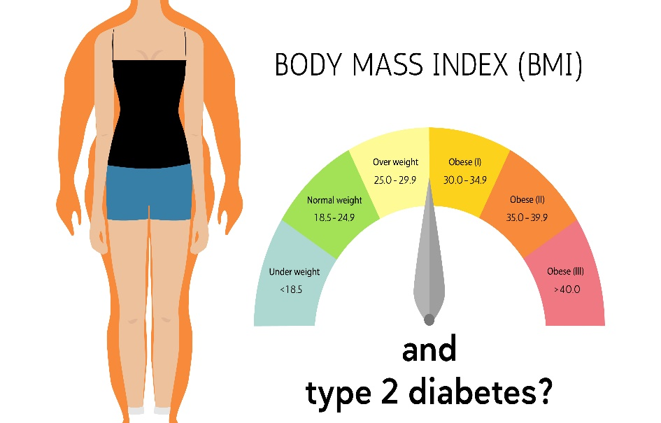
According to K Bond et al (2015) people with debt were three times more likely to have a depressive or anxiety disorder than those without debt. If this scenario is happening it will deteriorate her situation because anxiety will put her in vary bad position and unable to manage her health condition and diets which can worsen her obesity condition. Patient an age combine with high consumption of alcohol and obesity could be a risk factor. Because in certain age human are starting to develop some chronic health issue particularly if you are obese. In certain age is very difficult to lost weight particularly women going through menopause and sometime genetic role in weight gain. Age is a major risk factor for triggering metabolic syndrome, which is a combination of insulin resistance or diabetes, high blood pressure and hight cholesterol and this common combination is likely the main cause of cardiovascular disease which is the biggest killer of modern life in UK and developed countries.

Recommendation
The recommendation to Patient A is to change her lifestyle particularly the way she thinks about foods and swap high-energy and unhealthy food choice such as alcohol, sugary drinks, processed and fast food to healthy food such as fruit and vegetables. The best way to achieve this is to seek some help from a doctor or dietician who can recommend Patient A which diet is suitable for her to follow according to her condition. Poor diet and lack of exercise is contributing to Patient A weight condition. According to NHS (2021) if you consume high amount of energy particularly fat and sugar, but do not burn off the energy through exercise and physical activity, much of the surplus energy will be stored by the body as fat. Patient A need to cut her alcohol consumption because 3 to 6 units a day is higher than recommend number of units a day Patient A need to set a budget for alcohol fixed amount of money to spend on alcohol. Furthermore, can seek help from specialist to reduce her alcohol consumption. Patient A is smoking moderately a day however, she on risk of increase the number of cigarettes she smokes a day and become heavy smoker to avoid it she need to cut on smoking even stop it if it possible to do. Lack of exercise for patient A is one of the main contributor to her obesity.” Recommend that adults should do a minimum of 150 minutes moderate-intensity activity a week for example, 5 sessions 30- minute exercise a week” NHS (2021). Regarding patient A condition the best exercises for her is walking, jogging, swimming, and cycling because these exercises does not need intensive physical activity and financially maybe affordable for her. If it necessary, she may join weight loss club and monitor her weight and setting realistic goals to achieve. Patient A need to have her self-confident back and stop thinking about how people look at her because of her body size. Self-confident can help her to change her lifestyle and move on to improve her health condition.

Conclusion
According to world health organisation (WHO) 2021) obesity has reached epidemic proportions globally, with at least 2.8 million people dying each year as result of being overweight or obese. Patient A is obese and health condition put her in high risk of developing some diseases which can be fatal for her. In this report you can see the proportion f obesity in UK and how it can affect families and public health. Alcohol is one of the main factors of obesity because of its high calories. In addition, exercise is one the main treatment obesity which is nit the case for patient A because she does not do any exercise at all. After studies Patient A case and made a health assessment the report recommend Patient A to join a weight loss club, change her and make some exercise such as swimming, walking, jogging, and cycling. Furthermore, Patient A need to reduce the number of cigarettes she smokes a day. Joining a weight loos club not only will help Patient A to reduce her weight but can help her to gain more confident about her body.

Reference
K Bond et al (2015)’ Assisting Australian with mental health problems d financial difficulties: a Delphi study to develop guideline for financial counsellors, financial institution staff’ BMC service research 15 (1) pp 1-10 [online] available at: https://scholar.google.co.uk/scholar?q=financial+difficulties+and+mental+health&hl=en&as_sdt=0&as_vis=1&oi=scholart#d=gs_qabs&u=%23p%3DCz_zduUc_wAJ (accessed 27 August 2021)
NHS (2018) ‘alcohol misuse ‘[online] available at https://www.nhs.uk/conditions/alcohol-misuse/ (accessed 23 August 2021)
NHS (2019)’ treatment obesity’ [online] available at: https://www.nhs.uk/conditions/obesity/treatment/ (accessed 26 August 2021)
NHS (2019) ‘overview obesity’ [online] available at: https://www.nhs.uk/conditions/obesity/ (accessed 28 August 2021)
Parliament UK (2021) ‘obesity statistics’ [online] available at: https://commonslibrary.parliament.uk/research-briefings/sn03336/ (accessed 21 August 2021)
V Patel et al (2016) ‘Relationship between time use and obesity in representative sample of America’ HHs public access 24 (10) pp 1164-1175 [ online] available at: https://www.ncbi.nlm.nih.gov/pmc/articles/PMC5039068/#!po=2.58621 (accessed 26 August 2021)
WHO (2021) ‘obesity’ [online] available at: https://www.who.int/health-topics/obesity#tab=tab_1 (accessed 24 august 2021)

Appendix LIFESTYLE QUESTIONNAIRE
Introduction:
In order to help us focus our Health Promotion activities in the practice, we would be grateful if you could fill in this short questionnaire. If you have already completed one on a previous visit, please return this questionnaire to the receptionist.

Name Patient A Date of Birth 01 / 01/ 1973

Do you smoke? Yes [ ]  If Yes, do you –  smoke less than 1 cigarette/day [ ] |  |  | No[ ]
1 – 9 cigarettes/day [ ] 10-19 cigarettes/day [ ] 20-39 cigarettes/day [ ] more than 40 cigarettes/day smoke a pipe [ ] smoke cigars [ ]  If No, have you –  never ever smoked [ ] given up smoking in the last year [ ] not smoked for more than 1 year [ ]  Do you have high blood pressure? Yes [ ]  Have you ever had a heart attack  or suffered from angina? Yes [ ] No []  Have you ever had a stroke, “shock” or any weakness down one side? Yes [ ] No []  Have any of the following – mother, father,  brothers or sisters had – Yes [] No []  a heart attack below the age of 60 Yes [ ] a heart attack above the age of 60 Yes [ ] a stroke Yes [ ] trouble with very high cholesterol Yes [ ]  (hyperlipidaemia) |  |  | No[]
-------------------------------------------------------------------------------------------------------Practice Use Only
Health Education Smoking yes
BP 180 / 90
Height 165 Weight 86kg

EXERCISE
Healthy exercise usually involves activity that lasts for at least 20 minutes, raises your pulse and produces hard breathing. In younger people this might be running, cycling or sport, or brisk walking for older people.

Do you take this type of exercise –

daily []
3 times weekly [] once weekly [ ] once monthly[] seldom []

I cannot take exercise because of disability [ ]

DIET
Please tick the one category which is closest to your usual eating pattern.

I eat no meat, fish or dairy produce [ ]
I eat no meat [ ]
I eat a mixture including daily fruit and vegetables [ ] I eat a mixture including
regular chips and fries []
I eat frozen meals (eg TV dinners) 3 or 4 times/week [ ]
I eat mainly snacks [ ]
I eat a special medical diet [ ]

Please specify ………………………………………………………………………

ALCOHOL
Please tick the statement which most closely describes your usual average alcohol intake. (1 unit is 1 glass wine, ½ pint beer or a single measure of spirit.)

I never drink alcohol |  | [ ]
I drink less than 1 unit per day |  | [ ]
I drink between 1 and 2 units a day |  | [ ]
I drink between 3 and 6 units a day |  | []
I drink between 7 and 9 units a day |  | [ ]
I drink more than 9 units a day on average |  | [ ]

------------------------------------------------------------------------------------------------------
Practice Use Only
Health Education Alcohol [] Alcohol Brief Intervention [ ]

