

Student name -Elena Goranova
Student number -2122365
Module code-LCBB6004
Dr Jaya Gopalkrishnan

STRATEGIC MANAGEMENT & SUSTAINABILITY
Table of Contents
Introduction 3
The key business and corporate strategies of AstraZeneca PLC 3
SWOT Analysis 4
The way this company has aligned its resources and capabilities to its current business/ corporate strategies 5
VRIO Analysis 7
Successful implementation of the business and corporate strategies to compete in the market and create competitive advantages over rivals 7
Porter's Five Forces 8
The way AstraZeneca PLC has tried to become more competitive 9
The choices available for the company’s strategic direction in the future 10
Recommendations 10
Conclusion 11
References 13
Appendices 15
Appendix 1: SWOT 15
Appendix 2: VRIO 16
Appendix 3: PORTER'S FIVE FORCES 17

Introduction
An effective business strategy mainly focuses on the way an organisation plans to compete in a particular market and the corporate strategy helps in identifying the new market and also the business that this organisation can compete with. In this regard, AstraZeneca PLC, a British company which is listed on the London Stock Exchange is selected for this analysis. The study focuses on identifying the key business and corporate strategies of the organisation additionally a SWOT analysis will be performed. Moreover, the company's resources and capabilities will be identified along with the VRIO framework. It will also evaluate the way this company implement different strategies in order to compete in this competitive marketplace and it will also identify different ways that can help this organisation to be more competitive. Here, Porter's 5 forces framework will be presented. Furthermore, different choices that are available for the strategic direction of this company in the future will be recommended in order to gain competitive advantages.

The key business and corporate strategies of AstraZeneca PLC
AstraZeneca PLC is one of the leading biopharmaceutical companies (AstraZeneca, 2024a). It implements different business and corporate strategies in order to enhance its market position. This organisation focuses on investing in research and development in order to innovate and also develop new drugs. It shows that this company wants to be at the forefront of medical advancement, in this context, different therapeutic areas including cardiovascular, renal and metabolism, oncology as well as respiratory and immunology are focused. This organisation also expand its presence in different countries to diversify the revenue stream and also to meet health care demands.

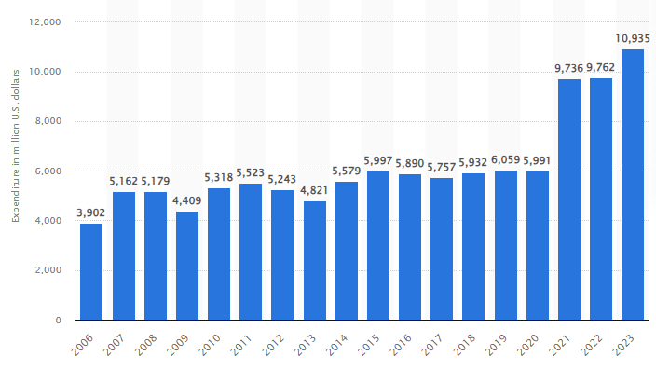
Figure 1: AstraZeneca's expenditure on R&D
(Source: Mikulic, 2024b)
As per this figure in 2023, AstraZeneca PLC paint 10.9 billion USD on research and development. The report also highlights that this organisation is considered one of the top 10 pharmaceutical companies that also develop effective COVID-19 vaccines. Additionally, the successful development of drugs including Farxiga and Tagrisso highlights this focus. This organisation also collaborates University of Oxford in the time of developing and distributing the vaccine for COVID-19 (Mikulic, 2024b). Strategic alliances also help this organisation to share risks, accelerate drug development and leverage external expertise.

SWOT Analysis
Strengths
AstraZeneca PLC has a positive reputation in the marketplace. This organisation invested in research and development expertise for better outcomes. The revenue of this organisation in 2023 was 44 billion USD. (Statista, 2024). Strong partnerships with the University of Oxford along with Daiichi Sankyo place effective development and commercialisation.
Weaknesses
High cost is one of the most significant weaknesses of the organisation that prevents it from enhancing its business activities and expected outcomes. The report shows that this organisation also battles supply chain issues (Hart, 2021). Regulatory changes also cause delays in approval as well as market entry activities that further affect revenue streams.
Opportunities
AstraZeneca PLC must focus on expanding its presence in other markets which helps in driving sales and market revenue. Jaami and Abulrub (2023) identified that entering new markets gives more revenue opportunities. Diversification into new therapeutic areas reduces dependency on the existing ones while providing new revenue opportunities. Product innovation and implementation of advanced technology can enhance the overall productivity and performance of the company.
Threats
The intense market competition of competitors including Cigna, CVS Health, and Merck & Co.Inc hampers the business activities of AstraZeneca PLC (Statista Research Department, 2024). Changes in healthcare regulation, as well as policies, also pose various risks to the drug approval process along with market access.

The way this company has aligned its resources and capabilities to its current business/ corporate strategies
AstraZeneca PLC processes a wide range of resources and capabilities that help this organisation with strategic success. The financial health of this organisation is evident from the investment in research and development that the aligned with the strategy of focusing on therapeutic areas. This statistical report shows the revenue of AstraZeneca in 2023 was 44 billion USD (Statista, 2022). That also highlights the capability of this organisation to invest more in research and development initiatives. Recognition and implementation of technological advancement in order to effective drug development Additionally, the global network also facilitates the company with innovation and collaboration that is effective to stay competitive in this marketplace. This organisation involved a skilled workforce including researchers, industry experts and scientists’ health is an organisation its significant growth and development. The company further aligned its resources and capability with business as well as corporate strategies. Financial investment in research and development is also linked to a strategy of focusing on innovation.
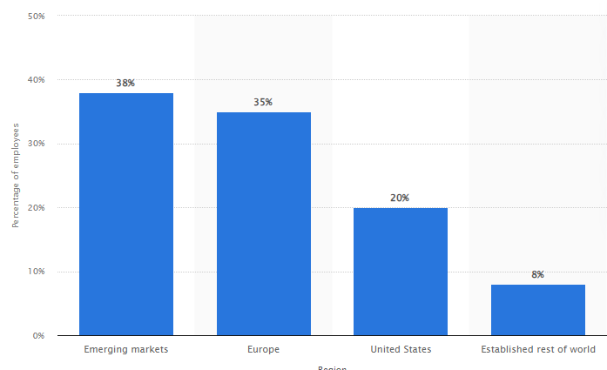
Figure 2: AstraZeneca's employees by region
(Source: Mikulic, 2024a)
The figure highlights that 38% of the total employees of the organisation are from emerging markets 35% of them are from the European market 20% are from the US and 8% are from the rest of the world (Mikulic, 2024a). Apart from that this organisation also can attract and retain top talents. A strategic partnership such as collaboration with other form of pharmaceutical companies, academic institutions as well as research organisations enhances the research and development capabilities of the particular company. The alignment of the intellectual property with an effective differentiation strategy further ensures competitive advantages. Moreover, the geographic expansion plan is also supported by financial strengths and the partnership of this company allowing it to penetrate the emerging market and also diversify its revenue streams.

VRIO Analysis
The strategic resources as well as capabilities offer sustained competitive advantage to AstraZeneca PLC. The financial resources of the company highlight its investment that helps it to get temporary competitive advantages. The technological platforms and state-of-the-earth facilities contribute to sustaining competitive advantages. Farida and Setiawan, (2022) stated that competitive advantages can be gained from effective business strategies. Business strategies have positive and negative impacts on competitive advantages. High-quality human resources along with high creativity, innovation and the ability to handle competition in the global market are very important for competitive advantages. The skilled workforce of this organisation is valuable and further offers sustained competitive advantages. Competitive advantages stream from an organisation's strategic choices to get market opportunities. Effective collaboration with other organisations such as the University of Oxford also offers sustained competitive advantages. Furthermore, intellectual property highlights competitive disadvantages.

Successful implementation of the business and corporate strategies to compete in the market and create competitive advantages over rivals
AstraZeneca PLC implemented the business and corporate strategy successfully resulting in competitive advantages over its rivals. This organisation focuses only on research and development in different areas that further made it to develop drugs for non-small cell lung cancer. The high-impact therapeutic areas are the main focus. (Mikulic, 2024d). Additionally, collaboration with other organisations helps it to innovate cancer treatments that introduce new therapies through this marketplace. For example, its partnership with the University of Oxford demonstrates the capability of the organisation to quickly respond to global health crises and enhances its branch reputation along with market reach. Financial performance also indicates strategic success. The increment of this revenue mainly drives and by is strong sales in the emerging market.
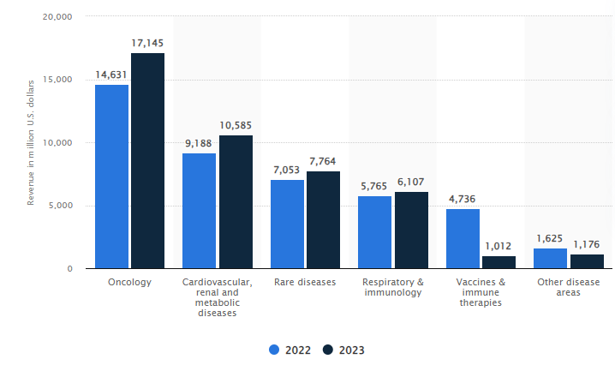
Figure 3: AstraZeneca's revenue by therapy area
(Source: Mikulic, 2024c)
As for this figure in 2023, the revenue of this organisation in oncology was 17.147 million USD additionally in rare diseases it was 7.764 million USD and in cardiovascular renal and metabolic diseases it was 10.585 million USD. In 2023 this organisation spent 25% of its total revenue on research and development (Mikulic, 2024c). Additionally, the financial strength of the organisation allows it for additional investment in the strategic initiative that further helps it to gain competitive advantages. Effective implementation of the strategic partnership, geography extension research and development drove significant revenue growth and also established this organisation as the global leader in this biopharmaceutical industry.

Porter's five forces
The threat of New Entrants in this pharmaceutical industry is considered low as there was a high barrier to entry. AstraZeneca is considered one of the largest stabiliser organisations that has strong brand recognition along with large companies of scale. The significant investment in research and development expenditure also allowed the organisation to be more innovative with its business outcomes further preventing new entrances from entering in this particular field. Therefore there is low pressure at the new entrance. As per this report in 2023, the brand value of the organisation was 5.6 billion USD (Statista, 2023). In this regard development and definitely have the organisation to avoid the impact of any new entrance. The bargaining Power of Suppliers is indicated as moderate in this particular industry as there are many suppliers related to specialised chemicals, raw materials, advanced technology and biological materials that further can exert more influence on the basis of the limited number of observations natural to the product.
AstraZeneca is an international organisation that can easily negotiate and secure multiple resource options that reduce the supplier's power. It is seen that the effective partnership and collaboration also allowed the company to manage and maintain the supply chain as well as financial stability. The bargaining Power of Buyers is considered high as in the pharmaceutical industry buyers such as the government, healthcare providers as well as insurance companies have significant power as they can negotiate to reduce the prices in critical situations. The report shows that the company paid 36 billion USD in 2020 in out-front cash along with equity for the merger as well as acquisition deals (Mikulic, 2022). In this regard, this organisation faces pressure in order to justify its pricing strategy in a competitive marketplace. Therefore, it is seen that the high bargaining power of buyers influences the innovation of the company.
The threat of Substitutes is margin as moderate to high It is seen that alternative health therapies including personalised machines, are considered substitutes for traditional pharmaceuticals. In this regard, organisations must introduce the best and first-class medicines in order to reduce the risk of the substitute. Industry Rivalry in this particular industry is considered very high as there are other companies including Cigna, CVS Health, and Merck & Co. Inc. investing heavily in innovation and development (Statista Research Department, 2024). This organisation must include an effective marketing strategy in order to differentiate its products.

The way AstraZeneca PLC has tried to become more competitive
AstraZeneca already focuses on enhancing its competitiveness. This company implemented a sustainability strategy such as “ambition zero carbon” that mainly focuses on achieving zero carbon emissions by 2025 (AstraZeneca, 2024b). Additionally, the company also invested in renewable energy sources. It has also considered sustainability in supply chain management hair effective collaboration with the suppliers has been taken into account for enhanced weekend biometric performance and also encourages the option of different sustainable practices. In this context, different programs have been held that help in monitoring compliance reduce potential risk and enhance organisational reputation. Adoption of green chemistry along with sustainable research and development processes can help the company to reduce waste and encourage the use of renewable energy that leads to effectiveness which later boosts competitiveness. The organisation invests in a community development program that focuses on enhancing community wellbeing. Integration of sustainability also here this company to enhance brand loyalty, attract socially responsible investors and reduce operation and cost.

The choices available for the company’s strategic direction in the future
AstraZeneca PLC must maintain its focus on research and development as it will definitely ensure suspended growth. The potential for break thoughts in the targeted therapies as well as personalised medicine will revolutionise treatment options. Additionally, accelerating digital transformation in the business operation can enhance speciality and patient engagement which also produces cost. The report shows that at the present time, there are 116 million users of online doctor consultations across the world. And this number is expected to grow by more in this upcoming year (Statista Research Department, 2024). In this context, the implementation of telemedicine platform digital health solutions allows them to get valuable information which can be used for effective decision-making. Moreover, sustainability initiatives that help this organisation to align its goal with viral mental and social government help to reduce environmental impact on socially conscious customers and investors. The collaborative aspect of this company with other partners must be continued that drive competitive advantages as well as innovation.

Recommendations
Expansion of Green Manufacturing Technologies
AstraZeneca must focus on investing in green manufacturing technology that helps in reducing carbon footprint along with opportunity cost that further provides a sustainable competitive advantage. This organisation must invest in advanced energy efficiency technology including LED lighting, smart energy management systems, and high-efficiency boilers that help in minimising energy consumption. “Adoption of green technology helps in mitigating the significant negative impact of human society on the planet” (Williams, 2024). Green manufacturing mainly includes different activities such as reducing water and energy consumption using renewable energy sources and reducing emissions and wastage in the production process. To expand the use of renewable energy this organisation can use solar, hydroelectric and wind power across the manufacturing sites. Adoption of such technology further can lead to cost savings as well as operational efficiency. This effective approach to sustainability also can enhance stakeholder relationships and further help in developing a loyal customer base.
Implementation of Circular Economy Principles
AstraZeneca also can focus on enhancing sustainability practices mainly by adopting the “circular economic principle”. In this regard is organisation must include product life cycle management here it should use biodegradable materials that later help in minimising packaging waste. Additionally, it must include an effective process that promotes the reuse, and recycling of raw material consumption. Positive regulation by the supplier also helps in rearing with supply chain integration here it is important to encourage them to adopt a recycling initiative that leads to waste reduction. Suárez-Eiroa et al. (2019), identify that the circular economy helps with resources in food as well as waste emission. Moreover, the organisation must establish different programs that focus on recycling and recovering materials which are used in manufacturing processes. Adoption of search practices enhances the brand reputation of the organisation as an environment-conscious company. That father reduces wastage which improves financial performance and also helps it to differentiate its product and services from other competitors.

Conclusion
AstraZeneca operates in a competitive environment which is influenced by different external factors. The strategies of this organisation mainly focus on strategic personal shaped research and development along with geographic expansion which has also been driven by various strengths and opportunities in the time of addressing weakness and threats. The effective alignment with the resources also has provided the company with competitive advantages in this competitive marketplace. These strategies further ensure enhanced market presence, sustained innovation as well a diversified revenue stream that also helps this organisation to position itself for long-term success. It is seen the air force of the organisation can become more competitive through environmental initiatives and sustainability that can be also aligned between business success and corporate responsibility. The expansion of green manufacturing technology along with the implementation of circular economy practices can help this organisation with long-term success. This initiative also enhances the organisational reputation in this environment-conscious market.

References
AstraZeneca (2024a). AstraZeneca. [online] Astrazeneca.com. Available at: https://www.astrazeneca.com/.
AstraZeneca (2024b). AstraZeneca’s ‘Ambition Zero Carbon’ strategy is to eliminate emissions by 2025 and be carbon negative across the entire value chain by 2030. [online] www.astrazeneca.com. Available at: https://www.astrazeneca.com/media-centre/press-releases/2020/astrazenecas-ambition-zero-carbon-strategy-to-eliminate-emissions-by-2025-and-be-carbon-negative-across-the-entire-value-chain-by-2030-22012020.html.
Farida, I. and Setiawan, D. (2022). Business Strategies and Competitive Advantage: The Role of Performance and Innovation. Journal of Open Innovation: Technology, Market, and Complexity, 8(3), p.163. doi:https://doi.org/10.3390/joitmc8030163.
Hart, R. (2021). AstraZeneca Battles Supply Chain Issues, Denies Claims Its Covid-19 Vaccine Is Largely Ineffective In Seniors. [online] Forbes. Available at: https://www.forbes.com/sites/roberthart/2021/01/26/astrazeneca-battles-supply-chain-issues-denies-claims-its-covid-19-vaccine-is-largely-ineffective-in-seniors/.
Jaami, U. and Abulrub, A.-H.G. (2023). Navigating Global Markets: The Strategic Role of Roadmaps in International Market Expansion. European Conference on Management Leadership and Governance, [online] 19(1), pp.156–163. doi:https://doi.org/10.34190/ecmlg.19.1.1878.
Mikulic (2022). Top buyers in biopharma M&A deals by upfront cash worldwide 2020. [online] Statista. Available at: https://www.statista.com/statistics/1240320/top-buyers-biopharma-ma-deals-by-upfront-cash-and-equity-paid/ [Accessed 30 Jul. 2024].
Mikulic (2024a). AstraZeneca employees by region 2020. [online] Statista. Available at: https://www.statista.com/statistics/266558/astrazenecas-employee-distribution-by-region-since-2008/.
Mikulic (2024b). AstraZeneca R&D expenditure 2006-2023. [online] Statista. Available at: https://www.statista.com/statistics/266556/expenditure-on-research-and-development-of-astrazeneca-since-2006/#:~:text=In%202023%2C%20AstraZeneca%20spent%20some.
Mikulic (2024c). AstraZeneca R&D expenditure as share of revenue 2018. [online] Statista. Available at: https://www.statista.com/statistics/266561/rundd-expenditure-of-astrazeneca-as-percentage-of-revenue-since-2006/.
Mikulic (2024d). AstraZeneca revenue by therapeutic area 2016-2019. [online] Statista. Available at: https://www.statista.com/statistics/293056/astrazeneca-revenue-by-therapeutic-area/.
Statista (2022). AstraZeneca revenue 2006-2019. [online] Statista. Available at: https://www.statista.com/statistics/266542/revenue-of-astrazeneca-since-2006/.
Statista (2023). Astra Zeneca brand value 2022. [online] Statista. Available at: https://www.statista.com/statistics/1246100/covid-vaccine-brand-value/.
Statista Research Department (2024). Topic: Telemedicine. [online] Statista. Available at: https://www.statista.com/topics/12106/telemedicine/#:~:text=How%20is%20telemedicine%20used%3F.
Statista Research Department (2024). Statista - The Statistics Portal. [online] Statista. Available at: https://www.statista.com/companies/ranking/5/top-100-health-and-pharmaceutical-companies.
Statista. (2024). Topic: AstraZeneca. [online] Available at: https://www.statista.com/topics/7584/astrazeneca/.
Suárez-Eiroa, B., Fernández, E., Méndez-Martínez, G. and Soto-Oñate, D. (2019). Operational principles of circular economy for sustainable development: Linking theory and practice. Journal of Cleaner Production, 214, pp.952–961. doi:https://doi.org/10.1016/j.jclepro.2018.12.271.
Williams, A. (2024). What Is Green Technology? Green Tech Companies To Watch. [online] Forbes. Available at: https://www.forbes.com/sites/technology/article/green-tech/.

Appendices

Appendix 1: SWOT
Strengths | Weaknesses
- Strong brand reputation is the most significant strength of the organisation  - A wide range of innovative drugs can help to satisfy more customers  - Strategic partnerships  - R&D capabilities | - High dependency on single markets surprises the market growth and opportunity of the company  - High R&D costs also hamper the organisational activities  - Regulatory challenges can hamper the business activities of the company
Opportunities | Threats
- Expansion in emerging markets can help the organisation to gain opportunities  -Advancements in personalised medicine  - Sustainable initiatives  - Digital transformation | - Intense competition from other pharma companies put pressure on this company to make changes to its existing business activities  - Price pressures  - Poor management  - Geopolitical as well as economic uncertainties

Appendix 2: VRIO
Resource/Capability | Valuable | Rare | Inimitable | Organized | Competitive Implication
Financial Resources | Yes | Yes | No | Yes | Temporary Competitive Advantage
Human Capital | Yes | Yes | Yes | Yes | Sustained Competitive Advantage
R&D Infrastructure | Yes | Yes | Yes | Yes | Sustained Competitive Advantage
Intellectual Property | Yes | Yes | Yes | Yes | Sustained Competitive Advantage
Strategic Partnerships | No | No | No | No | Competitive disadvantage

Appendix 3: PORTER'S FIVE FORCES
Force | Description | Impact
Threat of New Entrants | This industry involves significant R&D costs along with regulatory approvals, and effective protections that create high barriers to entry | Low
Bargaining Power of Suppliers | The specialised suppliers play a vital role in high-quality raw materials, however, the strategic partnerships of this company mitigate supplier power | Moderate
Bargaining Power of Buyers | The high purchasing power of governments, and healthcare providers further creates pressure on the company to lower drug prices. | High
Threat of Substitutes | The generic alternative therapies and patents expire. In this sentence, this organisation must include additional activities in order to differentiate its product from the other competitors. | Moderate to High
Industry Rivalry | It is mainly driven by intense competition where the company must focus on investing in R&D and innovation. | Very High

