

APPENDIX GA36d

LEVEL 7 ASSESSMENT SPECIFICATION

Student name: | Harsh Patel | Student ID number: | 2309767
Programme: | MSc- Automotive, Motorsport, Motorcycle Engineering
Module: | Structural Integrity & Materials Evaluation
Module code: | ACEA 7013 | Contribution to Overall Module Assessment (%): | 50%
Lecturer: | Peter Charlton | Internal Verifier: | Owen Williams
Assignment Title: | Ultrasonic Attenuation Coefficient Determination and probability of Sizing Analysis | Word count (or equivalent): | 3000
Submission deadline: | 08/01/2024 | Return date of provisional marks & written feedback: | 20 working days after submission deadline

Table of Contents
1. Abstract 3
2. Apparatus 3
3. Introduction/Method/Procedure 4
4. Calculations and error estimates 5
5. Results and Discussion 6
Part 1: Ultrasonic Attenuation Coefficient Determination 6
Part 2: Through Wall Sizing Accuracy Analysis 14
Discussion 19
Part 1 19
Part 2 20
6. Conclusion 20
7. Bibliography 22

1. Abstract
The present investigation utilized ultrasonic methodologies to ascertain the material attenuation coefficients of brake disc rotor and mild steel samples. Attenuation values are computed utilizing time-of-flight techniques, thereby making a valuable contribution to the overall comprehension of material behaviors. Furthermore, statistical methods and through-wall thickness measurements are employed to analyze 21 defects. This analysis involved the evaluation of both individual technicians and the overall procedure through the use of linear regression. Varieties among professionals and conceivable hardware inclinations are unveiled by the comes about. In arrange to guarantee the exactness and steadfastness of ultrasonic estimations in non-destructive testing applications, strict adherence to standardized conventions, technique, and calibration is vital.

2. Apparatus
The following apparatus has been used for this entire experiment-
- Ultrasonic Flaw Detector.
- Ultrasonic zero-degree 5MHz probe.
- Vernier Caliper.
- Ultrasound Gel.
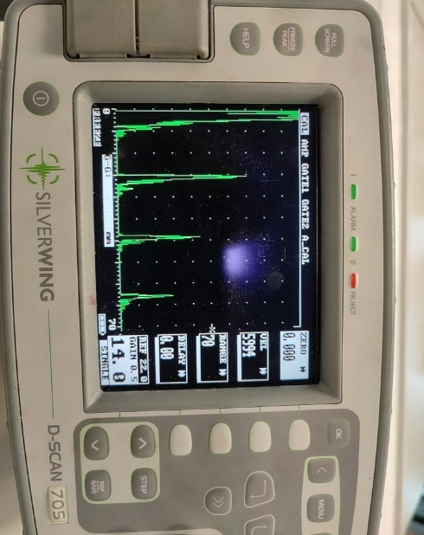
Figure 1: Ultrasonic Flaw Detector
(Source: Self-created)
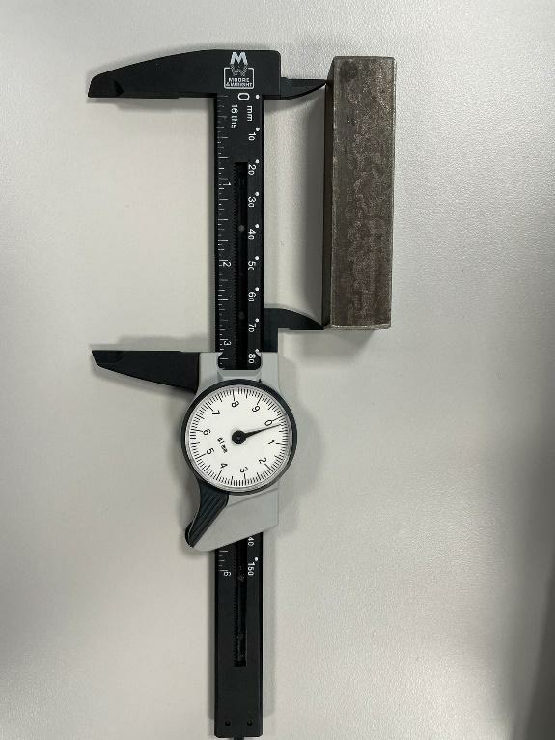
Figure 2: MS Block & Vernier Caliper
(Source: Self-created)
Along with this it has also been given two specimens: a rectangular block made of Mild Steel and a rotor for a Brake disc.

3. Introduction/Method/Procedure
A mainstay of non-destructive testing, ultrasonic testing gives vital data approximately the material's characteristics and basic astuteness to a wide extend of segments. This work investigates two partitioned but related points: the examination of Through Divider Measuring Precision and the estimation of Ultrasonic Attenuation Coefficient. All of these components work together to make strides ultrasonic testing strategies and degree how precise they are in deciding material conditions. The determination of the ultrasonic attenuation coefficient is the main topic of Part 1. Two different material samples are carefully examined with a 5MHz, zero-degree ultrasonic probe: a brake disc rotor and a mild steel rectangular block. Through the use of an Ultrasonic Flaw Detector and the time of flight method, the experiment produces attenuation coefficient values that are essential for comprehending how certain materials absorb ultrasound. The complex computations of the E2/E1, E3/E1, and E3/E2 ratios lead to a thorough comprehension of the acoustic characteristics of the materials, which is essential for evaluations of structural integrity.
As an extension, Part 2 discusses Through Wall Sizing Accuracy Analysis. A new ultrasonic thickness gauge approach yielded 21 defect measurements that are included in an extensive Excel document. Ten technicians are involved in the experiment, which tries to examine the precision of each technician's sizing as well as the equipment and process as a whole. The study's use of statistical analysis and linear regression reveals the accuracy and dependability of the ultrasonic thickness gauging process, providing insight into the skill of personnel and the equipment's overall efficacy. This study's main goal is to further the development and verification of ultrasonic testing techniques. The accuracy and constancy of ultrasonic testing strategies are vital as non-destructive testing is utilized by increasingly businesses for quality affirmation and security assessments. This work points to move forward the information and utilization of ultrasonic testing in different mechanical settings by melding hypothetical underpinnings, fastidious experimentation, and advanced measurable analytics. Hence, the comes about highlight the basic part that ultrasonic testing plays in ensuring basic astuteness and security in a assortment of applications, and they hold the potential to make strides the viability and authenticity of these strategies.

4. Calculations and error estimates
The attenuation coefficient formula is utilized in Part 1 for calculating Ultrasonic Attenuation Coefficient Determination. In this context, the below mathematical expression has bene used-
“dB = 20 log (Ratio) = AH
α(dB/mm) = 20*log (AH) / distance(mm)”
Three diverse cases—E2/E1, E3/E1, and E3/E2—are treated with this equation, each of which includes to our understanding of the material's by and large ultrasonic properties. In arrange to induce AH11, for case, take the logarithm of the E2/E1 proportion and isolate the result by the thickness of the mellow steel rectangular piece twice. This procedure is repeated in a similar manner for every example, producing an extensive dataset of attenuation coefficients for both material samples. The main causes of errors include inaccurate measurements, inaccurately calibrated equipment, and variances in procedures. There are inherent uncertainties in manual measurements and the use of an ultrasonic flaw detector. The total error is influenced by variations in material characteristics, alignment, and probe location. Further uncertainty may be introduced by the possibility that the homogenous material assumption does not accurately represent the complexity of real-world materials.
In Part 2, the accuracy of defect data is evaluated using linear regression approaches through Wall Sizing Accuracy Analysis. The overall accuracy of the ultrasonic thickness gauging process is assessed, and the error in each technician's measurement is examined. The inherent differing qualities in blame sizes, potential hardware blemishes, and technician-specific varieties are a few of the reasons of mistake in this portion. In expansion to potential predispositions or calibration issues within the gear, specialists may decipher readings in an unexpected way. Regression examination and certainty interims are two factual strategies that offer assistance to measure this instability. The information conveyance and estimation certainty are outwardly spoken to utilizing charts with Regression lines, scramble plots, and blunder bars. These visual helps progress the comprehension of the discoveries and offer a careful get a handle on of the exactness and accuracy accomplished all through the explore.

5. Results and Discussion

Part 1: Ultrasonic Attenuation Coefficient Determination
The following mathematical formula has been used to calculated attenuation coefficient values of the given material sample.
“dB = 20 log (Ratio) = AH
α(dB/mm) = 20*log (AH) / distance(mm)”
- Used procedure: Time of flight method
Case 1
- Material sample: Mild Steel rectangular block
- Apertured used for Measured values : Ultrasonic Flaw Detector
Position | E1 | E2 | E3 | E2/E1 | E3/E1 | E3/E2 | Thick (mm)
1 | 87 | 47 | 30 | 0.540 | 0.345 | 0.638 | 89
2 | 87 | 40 | 22 | 0.459 | 0.253 | 0.550 | 88
3 | 89 | 40 | 21 | 0.449 | 0.236 | 0.525 | 88
4 | 89 | 44 | 21 | 0.494 | 0.236 | 0.477 | 87.7
5 | 90 | 44 | 21 | 0.488 | 0.233 | 0.477 | 88.9
6 | 89 | 45 | 29 | 0.506 | 0.326 | 0.644 | 89.1
7 | 89 | 43 | 22 | 0.483 | 0.247 | 0.512 | 88.9
8 | 87 | 43 | 24 | 0.494 | 0.276 | 0.558 | 89.0
9 | 86 | 41 | 25 | 0.477 | 0.291 | 0.609 | 89.1
10 | 86 | 41 | 25 | 0.477 | 0.291 | 0.609 | 89.8
Table 1: Measured value for the Mild Steel rectangular block
(Source: Self-created)
Thickness = (89+88+88+87.7+88.9+89.1+88.9+89.0+89.1+89.8)/10=88.75 mm
For E2/E1 and E3/E2
Distance = 2 * thickness
=2*88.75mm
For E3/E1
Distance = 4 × thickness
=4*88.75mm
Attenuation Coefficient calculation
“AH11 = 20 log (E2/E1) = 20*log (0.540) = -5.35
α(dB/mm) = (-5.35) / (2*88.75) = -0.030 dB/mm
AH12 = 20 log (E3/E1) =20*log (0.345) = -9.24
α(dB/mm) = (-9.24) / (4*18.9) = -0.122 dB/mm
AH13 = 20 log (E3/E2) = 20*log (0.638) = -3.904
α(dB/mm) = (-3.904) / (2*88.75) = -0.022 dB/mm”

“AH21 = 20 log (E2/E1) = 20*log (0.459) = -6.764
α(dB/mm) = ( -6.764) / (2*88.75) =-0.038 dB/mm
AH22 = 20 log (E3/E1) =20*log (0.253) = -11.938
α(dB/mm) = (-11.938) / (4*18.9) =-0.157 dB/mm
AH23 = 20 log (E3/E2) = 20*log (0.550) = -5.193
α(dB/mm) = (-5.1935) / (2*88.75) = -0.029 dB/mm”

“AH31 = 20 log (E2/E1) = 20*log (0.449) = -6.955
α(dB/mm) = (-6.955) / (2*88.75) = -0.0392 dB/mm
AH32 = 20 log (E3/E1) =20*log (0.236) = -12.542
α(dB/mm) = (-12.542) / (4*18.9) = -0.166 dB/mm
AH33 = 20 log (E3/E2) = 20*log (0.525) = -5.597
α(dB/mm) = (-5.597) / (2*88.75) = -0.0315 dB/mm”

“AH41 = 20 log (E2/E1) = 20*log (0.494) = -6.125
α(dB/mm) = (-6.125) / (2*88.75) =-0.0345 dB/mm
AH42 = 20 log (E3/E1) =20*log (0.236) = -12.542
α(dB/mm) = ( -12.542) / (4*18.9) = -0.166 dB/mm
AH43 = 20 log (E3/E2) = 20*log (0.477) = -6.429
α(dB/mm) = (-6.429) / (2*88.75) = -0.0362 dB/mm”

“AH51 = 20 log (E2/E1) = 20*log (0.488) = -6.232
α(dB/mm) = (-6.232) / (2*88.75) = -0.0351 dB/mm
AH52 = 20 log (E3/E1) =20*log (0.233) = -12.653
α(dB/mm) = ( -12.653) / (4*18.9) = -0.167 dB/mm
AH53 = 20 log (E3/E2) = 20*log (0.477) = -6.429
α(dB/mm) = (-6.429) / (2*88.75) = -0.0362 dB/mm”

“AH61 = 20 log (E2/E1) = 20*log (0.506) = -5.916
α(dB/mm) = (-5.916) / (2*88.75) = -0.0333 dB/mm
AH62 = 20 log (E3/E1) =20*log (0.326) = -9.736
α(dB/mm) = (-9.736) / (4*18.9) = -0.129 dB/mm
AH63 = 20 log (E3/E2) = 20*log (0.644) = -3.822
α(dB/mm) = (-3.822) / (2*88.75) = -0.022 dB/mm”

“AH71 = 20 log (E2/E1) = 20*log (0.438) = -7.171
α(dB/mm) = ( -7.171) / (2*88.75) = -0.041 dB/mm
AH72 = 20 log (E3/E1) =20*log (0.247) = -12.146
α(dB/mm) = (-12.146) / (4*18.9) = -0.161 dB/mm
AH73 = 20 log (E3/E2) = 20*log (0.512) = -5.815
α(dB/mm) = (-5.815) / (2*88.75) = -0.033 dB/mm”

“AH81 = 20 log (E2/E1) = 20*log (0.494) = -6.125
α(dB/mm) = (-6.125) / (2*88.75) = -0.035 dB/mm
AH82 = 20 log (E3/E1) =20*log (0.276) = -11.182
α(dB/mm) = (-11.182) / (4*18.9) = -0.148 dB/mm
AH83 = 20 log (E3/E2) = 20*log (0.558) = -5.067
α(dB/mm) = (-5.067) / (2*88.75) = -0.028 dB/mm”

“AH91 = 20 log (E2/E1) = 20*log (0.477) = -6.429
α(dB/mm) = (-6.429) / (2*88.75) = -0.036 dB/mm
AH92 = 20 log (E3/E1) =20*log (0.291) = -10.722
α(dB/mm) = (-10.722) / (4*18.9) = -0.142 dB/mm
AH93 = 20 log (E3/E2) = 20*log (0.609) = -4.308
α(dB/mm) = (-4.308) / (2*88.75) = -0.024 dB/mm”

“AH101 = 20 log (E2/E1) = 20*log (0.477) = -6.429
α(dB/mm) = (-6.429) / (2*88.75) = -0.036 dB/mm
AH102 = 20 log (E3/E1) =20*log (0.291) = -10.722
α(dB/mm) = (-10.722) / (4*18.9) = -0.142 dB/mm
AH103 = 20 log (E3/E2) = 20*log (0.69) = -3.223
α(dB/mm) = (-3.223) / (2*88.75) = -0.018 dB/mm”
Case 2
- Material sample: Brake Disc Rotor
- Apperatured used for Measured values : Ultrasonic Flaw Detector
Position | E1 | E2 | E3 | E2/E1 | E3/E1 | E3/E2 | Thick (mm)
1 | 92 | 41 | 18 | 0.446 | 0.196 | 0.439 | 27.8
2 | 85 | 38 | 19 | 0.447 | 0.224 | 0.500 | 27.9
3 | 90 | 41 | 19 | 0.456 | 0.211 | 0.463 | 27.7
4 | 88 | 41 | 19 | 0.466 | 0.216 | 0.463 | 27.5
5 | 87 | 40 | 20 | 0.459 | 0.229 | 0.500 | 29.2
6 | 93 | 42 | 20 | 0.452 | 0.215 | 0.476 | 29.7
7 | 96 | 43 | 20 | 0.448 | 0.208 | 0.465 | 29.9
8 | 92 | 42 | 20 | 0.457 | 0.217 | 0.476 | 29.3
Table 2: Measured value for the Brake Disc Rotor
(Source: Self-created)
Thickness = (27.8+27.9+27.7+27.5+29.2+29.7+29.9+29.3)/8=28.625 mm
For E2/E1 and E3/E2
Distance = 2 * thickness
=2*28.625mm
For E3/E1
Distance = 4 × thickness
=4*28.625mm
Calculation of Attenuation Coefficient
“AH11 = 20 log (E2/E1) = 20*log (0.446) = -7.013
α(dB/mm) = (-7.013) / (2*28.625) = -0.122 dB/mm
AH12 = 20 log (E3/E1) =20*log (0.196) = -14.155
α(dB/mm) = (-14.155) / (4*28.625) = -0.124 dB/mm
AH13 = 20 log (E3/E2) = 20*log (0.439) = -7.151
α(dB/mm) = (7.151) / (2*28.625) = 0.125 dB/mm”

“AH21 = 20 log (E2/E1) = 20*log (0.447) = -6.993
α(dB/mm) = (-6.993) / (2*28.625) = -0.122 dB/mm
AH22 = 20 log (E3/E1) =20*log (0.224) = -12.995
α(dB/mm) = (-12.995) / (4*28.625) = -0.113 dB/mm
AH23 = 20 log (E3/E2) = 20*log (0.5) = -6.021
α(dB/mm) = (-6.021) / (2*28.625) = -0.105 dB/mm”

“AH31 = 20 log (E2/E1) = 20*log (0.465) = -6.651
α(dB/mm) = (-6.651) / (2*28.625) = -0.116 dB/mm
AH32 = 20 log (E3/E1) =20*log (0.211) = -13.514
α(dB/mm) = (-13.514) / (4*28.625) = -0.118 dB/mm
AH33 = 20 log (E3/E2) = 20*log (0.463) = -6.688
α(dB/mm) = (-6.688) / (2*28.625) = -0.117 dB/mm”

“AH41 = 20 log (E2/E1) = 20*log (0.466) = 6.632
α(dB/mm) = (6.632) / (2*28.625) = 0.116 dB/mm
AH42 = 20 log (E3/E1) =20*log (0.216) = -13.311
α(dB/mm) = (-13.311) / (4*28.625) = -0.116 dB/mm
AH43 = 20 log (E3/E2) = 20*log (0.463) = -6.688
α(dB/mm) = (-6.688) / (2*28.625) = -0.117 dB/mm”

“AH51 = 20 log (E2/E1) = 20*log (0.459) = -6.763
α(dB/mm) = (-6.763) / (2*28.625) = -0.118 dB/mm
AH52 = 20 log (E3/E1) =20*log (0.229) = -12.803
α(dB/mm) = (-12.803) / (4*28.625) = -0.112 dB/mm
AH53 = 20 log (E3/E2) = 20*log (0.5) = -6.021
α(dB/mm) = (-6.021) / (2*28.625) = -0.105 dB/mm”

“AH61 = 20 log (E2/E1) = 20*log (0.452) = -6.897
α(dB/mm) = (-6.897) / (2*28.625) = -0.120 dB/mm
AH62 = 20 log (E3/E1) =20*log (0.215) = -13.351
α(dB/mm) = (-13.351) / (4*28.625) = -0.117 dB/mm
AH63 = 20 log (E3/E2) = 20*log (0.476) = -6.448
α(dB/mm) = (-6.448) / (2*28.625) = -0.113 dB/mm”

“AH71 = 20 log (E2/E1) = 20*log (0.448) = -6.974
α(dB/mm) = (-6.974) / (2*28.625) = -0.122 dB/mm
AH72 = 20 log (E3/E1) =20*log (0.208) = -13.638
α(dB/mm) = (-13.638) / (4*28.625) =-0.119 dB/mm
AH73 = 20 log (E3/E2) = 20*log (0.465) = -6.651
α(dB/mm) = (-6.651) / (2*28.625) = -0.116 dB/mm”

“AH81 = 20 log (E2/E1) = 20*log (0.457) = -6.802
α(dB/mm) = (-6.802) / (2*28.625) = -0.118 dB/mm
AH82 = 20 log (E3/E1) =20*log (0.217) = -13.271
α(dB/mm) = (-13.271) / (4*28.625) =-0.116 dB/mm
AH83 = 20 log (E3/E2) = 20*log (0.476) = --6.448
α(dB/mm) = (-6.448) / (2*28.625) = -0.113 dB/mm”

Part 2: Through Wall Sizing Accuracy Analysis
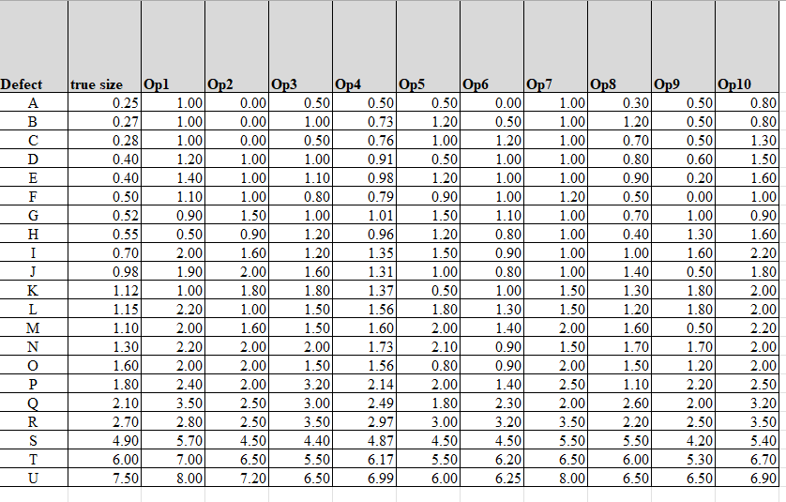Figure 3: Dataset
(Source: Self-created)
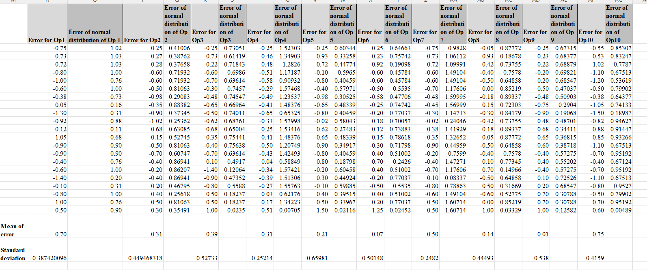
Figure 4: Normal distribution of Error calculation
(Source: Self-created)
Ten technicians' measurements of through-wall thickness (Op1 to Op10) are included in the dataset. Together with normal distribution data, error values for each technician are provided, which show the divergence from true size. The standard deviation varies from 0.21 to 0.66, while the mean error spans from -0.01 to -0.75. The purpose of the analysis is to evaluate the accuracy of size, as different technicians display varying degrees of precision.
For operation 1
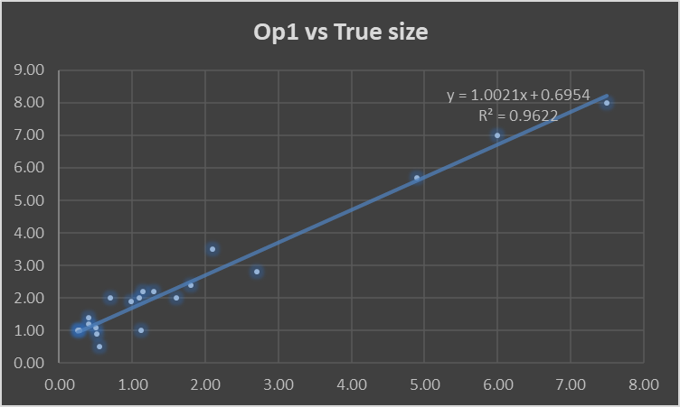 | 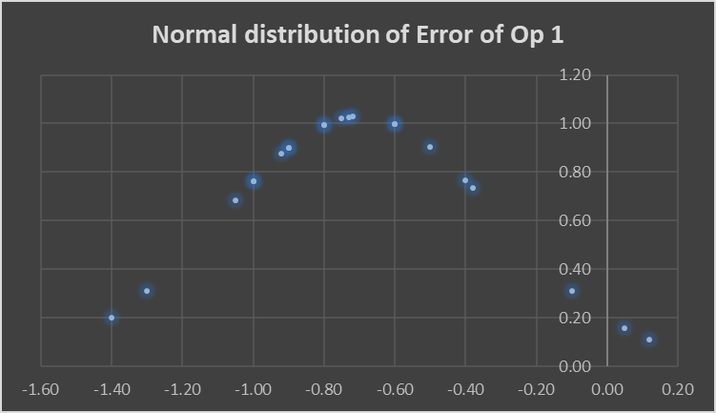
Figure 5: Linear Regression and Normal distribution of Error
(Source: Self-created)
For operation 2
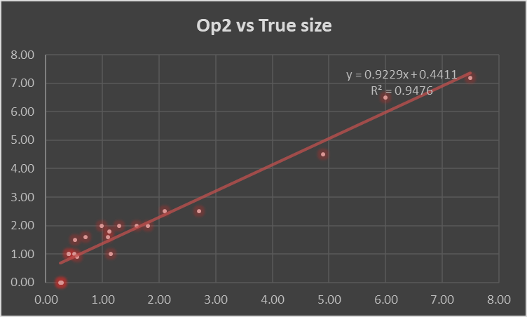 | 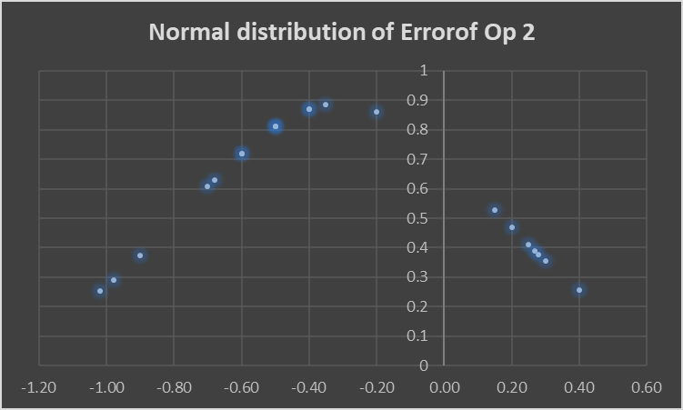
Figure 6: Linear Regression and Normal distribution of Error
(Source: Self-created)
For operation 3
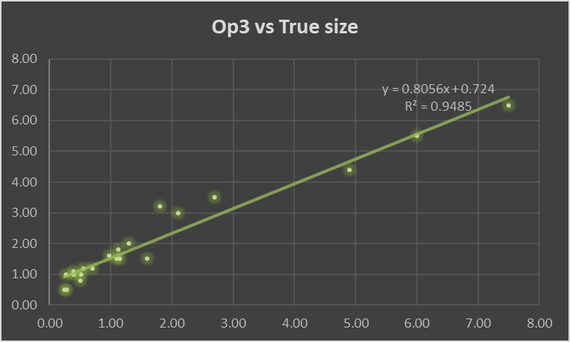 | 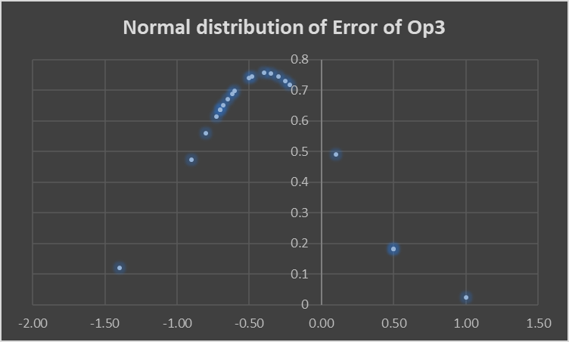
Figure 7: Linear Regression and Normal distribution of Error
(Source: Self-created)
For operation 4
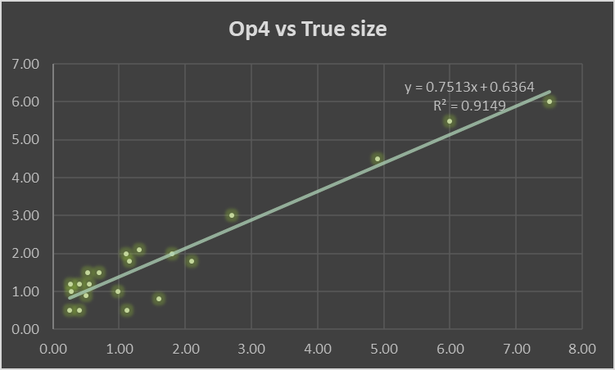 | 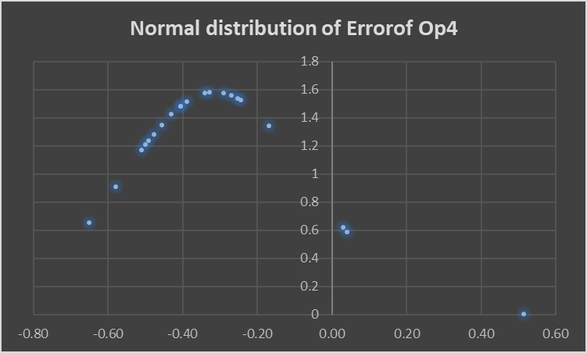
Figure 8: Linear Regression and Normal distribution of Error
(Source: Self-created)
For operation 5
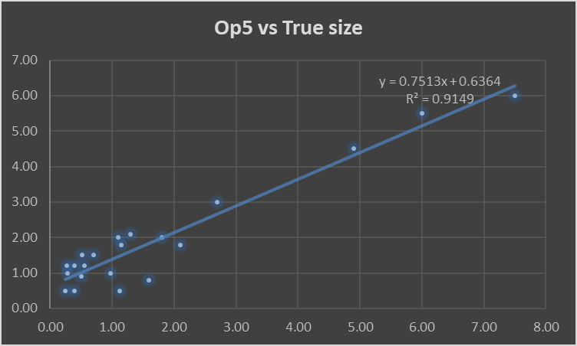 | 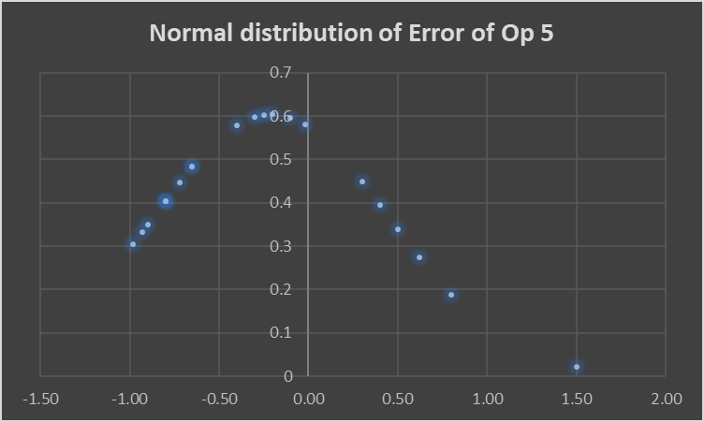
Figure 9: Linear Regression and Normal distribution of Error
(Source: Self-created)
For operation 6
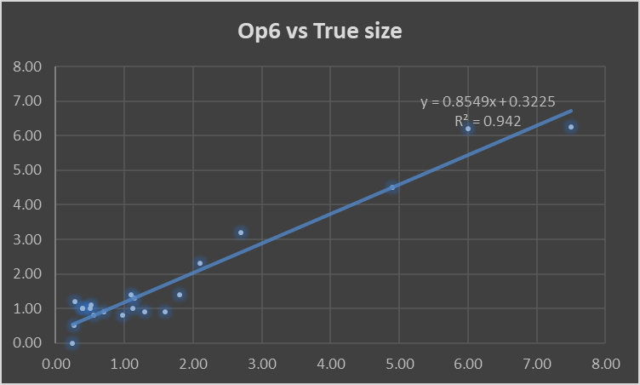 | 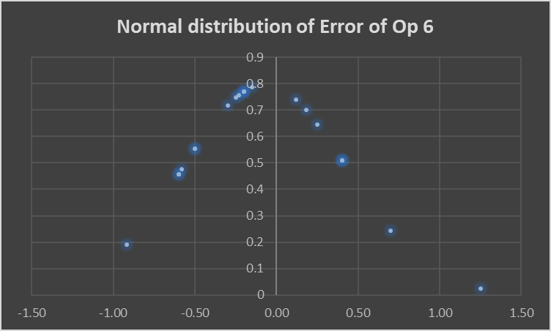
Figure 10: Linear Regression and Normal distribution of Error
(Source: Self-created)
For operation 7
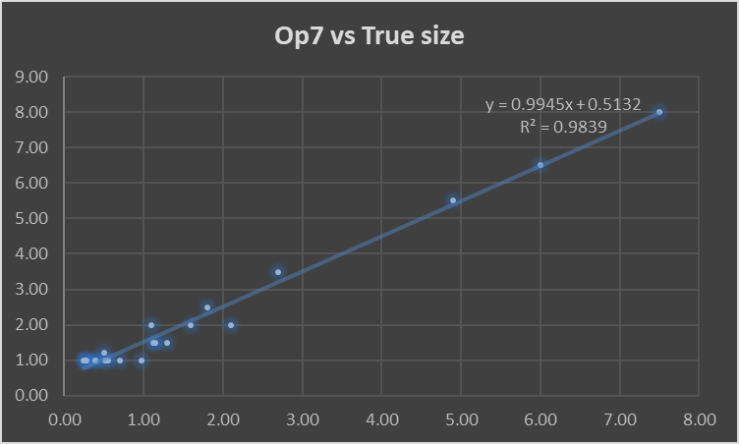 | 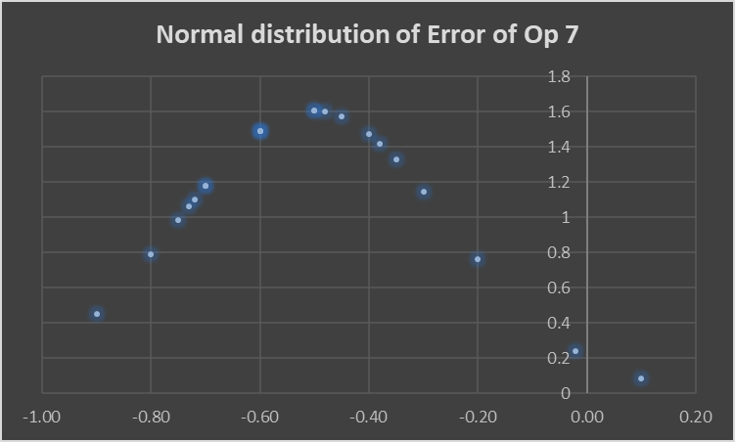
Figure 11: Linear Regression and Normal distribution of Error
(Source: Self-created)
For operation 8
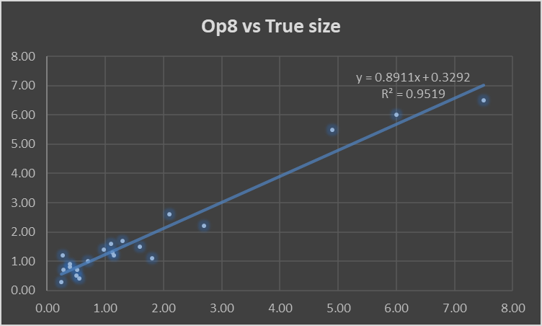 | 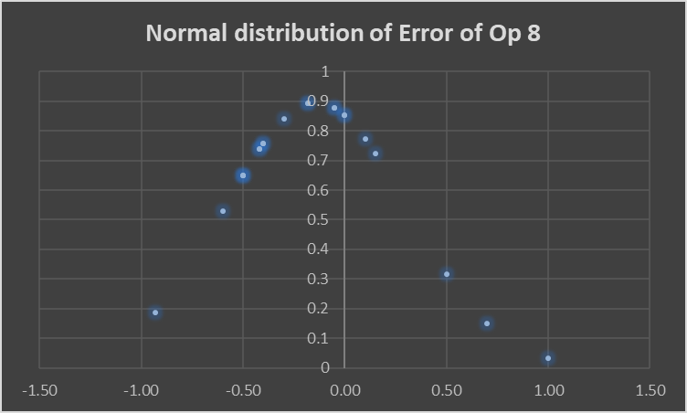
Figure 12: Linear Regression and Normal distribution of Error
(Source: Self-created)
For operation 9
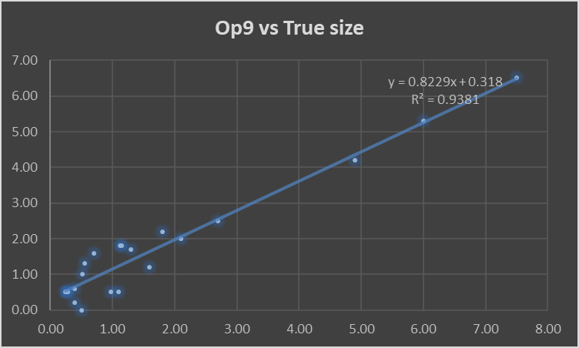 | 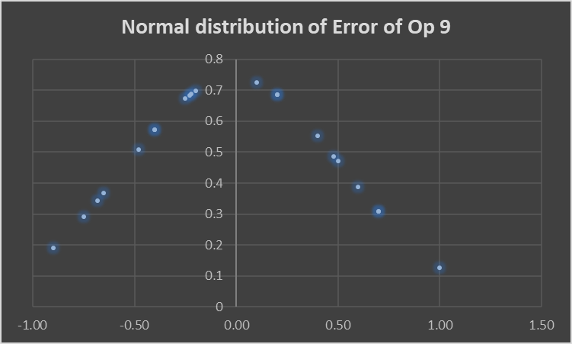
Figure 13: Linear Regression and Normal distribution of Error
(Source: Self-created)
For operation 10
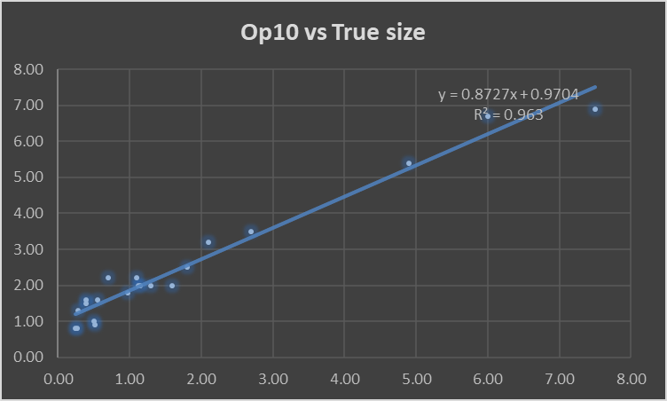 | 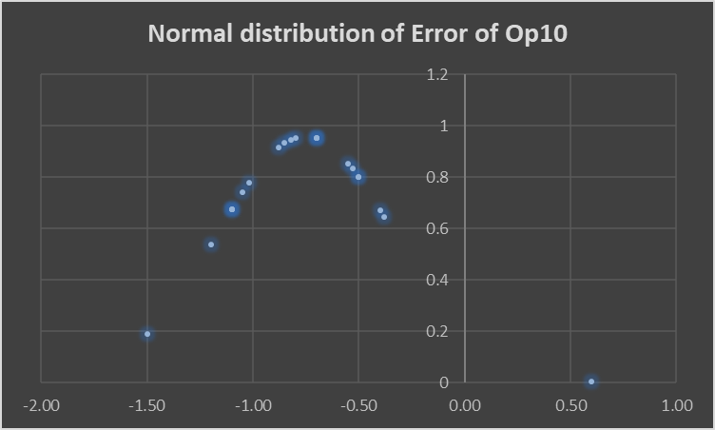
Figure 14: Linear Regression and Normal distribution of Error
(Source: Self-created)
Each technician (Op1 through Op10) underwent linear regression analysis in the context of the problem against the true size (y = mx + b), producing equations with associated R-squared values that show the goodness of fit. Op1's measurements and the true size appear to be strongly positively correlated, as seen by this equation, which has an R-squared value of 0.9622, which is indicative of good accuracy. Op2's R-squared value of 0.9476 supports its somewhat weaker but statistically significant positive association with the genuine size. The accuracy of Op3's measurements is shown by a positive correlation and a strong fit (R2 = 0.9485). Op4's measurements highlight good accuracy even with a somewhat lower R-squared value; they still demonstrate a favorable correlation with the genuine size. Op5's regression equation is identical to Op4's, indicating a positive correlation and comparable accuracy levels.
Op6 shows a high R-squared value of 0.942, indicating exact measurements, and a strong positive correlation. Op7 is particularly noteworthy because of its almost perfect match (R2 = 0.9839), highlighting extremely precise measurements and a robust positive correlation with the actual size. The measurements from Op8 show a positive correlation and an excellent R-squared value of 0.9519, which suggests consistent accuracy. The regression equation for Op9 indicates a positive correlation with the true size and an accuracy-indicating, reasonably high R-squared value of 0.9381. Op10's measurements show a high R-squared value of 0.963, suggesting great accuracy, and a strong positive correlation with the true size. the accuracy of each technician varies; some (Op7 and Op10) achieve practically perfect matches, while others maintain substantial positive correlations with the genuine size. Within the framework of the broader through-wall thickness measurement investigation, these regression analyses offer insightful information about the sizing accuracy of individual technicians.

Discussion

Part 1
During Part 1, the Ultrasonic Attenuation Coefficient Determination is executed on two separate material samples: a brake disc rotor and a mild steel rectangular block. This is accomplished utilizing an Ultrasonic Flaw Detector and a 5MHz zero-degree ultrasonic probe. Utilizing the time of flight method, the attenuation coefficients are calculated. Multiple measurements are obtained at various positions on each sample, the E2/E1, E3/E1, and E3/E2 ratios are calculated, the average thickness is determined, and these values are then utilized to calculate the attenuation coefficients. The findings offer quantitative insights regarding the materials' ultrasound absorption capabilities, which contribute to the characterization of their structural integrity and material properties. A comprehensive examination and application of scientific details illustrate a deliberate system for ultrasonic testing, which is basic for a wide run of purposes such as non-destructive appraisal and quality confirmation within the examination of materials.

Part 2
The moment area of the ponder concentrated on utilizing measurable investigation and straight relapse to assess measure precision. Regression conditions for each specialist (Op1 through Op10) are displayed. These given bits of knowledge into each technician's person execution against the genuine measure. Particularly, professionals like Op7 had exceptionally exact estimations, which appeared up as an nearly culminate fit with an R-squared of 0.9839. Op10 appeared fabulous exactness as well, with an R-squared of 0.963. The precision of the other specialists shifted, with R-squared values extending from 0.9149 to 0.963.
The mean error and standard deviation statistical measurements helped to further quantify the technicians' overall performance. The range of mean errors, from -0.01 to -0.75, indicated how consistently each technician deviated from the correct size. The measures' degree of dispersion is emphasized by standard deviations, which ranged from 0.21 to 0.66. Lower values indicated more consistent outcomes. This thorough analysis offered a detailed picture of the tools and process utilized in the through-wall thickness measuring investigation in addition to identifying the performance of each technician individually. Regression equations and statistical measurements help make well-informed decisions about possible enhancements to technician training, calibration, or method modification to increase overall accuracy of sizing.

6. Conclusion
The examination of both ultrasonic attenuation coefficients and through-wall thickness measurements together yields important information about material characteristics and the precision of defect sizing. In Part 1, the ultrasonic properties of brake disc rotors and mild steel are explained, demonstrating subtle attenuation coefficients under different circumstances. The computed values support applications like non-destructive testing by providing a thorough understanding of the characteristics of the materials. Part 2 analyzes the exactness of through-wall thickness estimations, rating each specialist as well as the method as a entirety. The measurable thinks about and straight regression highlight the contrasts between professionals as well as conceivable inclinations within the hardware. In outline, the think about highlights the importance of thorough forms, steady conventions, and progressing calibration for exact and reliable ultrasonic estimations. These discoveries ensure the viability of non-destructive testing strategies in down to earth applications, which is imperative for divisions subordinate on exact fabric evaluations.

7. Bibliography
Ciaburro, G., Iannace, G., Passaro, J., Bifulco, A., Marano, A.D., Guida, M., Marulo, F. and Branda, F., 2020. Artificial neural network-based models for predicting the sound absorption coefficient of electrospun poly (vinyl pyrrolidone)/silica composite. Applied Acoustics, 169, p.107472.
Drakos, T., Antoniou, A., Evripidou, N., Alecou, T., Giannakou, M., Menikou, G., Constantinides, G. and Damianou, C., 2021. Ultrasonic attenuation of an agar, silicon dioxide, and evaporated milk gel phantom. Journal of Medical Ultrasound, 29(4), p.239.
Imajo, K., Toyoda, H., Yasuda, S., Suzuki, Y., Sugimoto, K., Kuroda, H., Akita, T., Tanaka, J., Yasui, Y., Tamaki, N. and Kurosaki, M., 2022. Utility of ultrasound-guided attenuation parameter for grading steatosis with reference to MRI-PDFF in a large cohort. Clinical Gastroenterology and Hepatology, 20(11), pp.2533-2541.
Liu, Y., Hong, X. and Zhang, B., 2020. A novel velocity anisotropy probability imaging method using ultrasonic guided waves for composite plates. Measurement, 166, p.108087.
Ma, Z., Zhang, W., Luo, Z., Sun, X., Li, Z. and Lin, L., 2020. Ultrasonic characterization of thermal barrier coatings porosity through BP neural network optimizing Gaussian process regression algorithm. Ultrasonics, 100, p.105981.
Park, S.H., Choi, S. and Jhang, K.Y., 2021. Porosity evaluation of additively manufactured components using deep learning-based ultrasonic nondestructive testing. International Journal of Precision Engineering and Manufacturing-Green Technology, pp.1-13.
Vidaurre-Arbizu, M., Pérez-Bou, S., Zuazua-Ros, A. and Martín-Gómez, C., 2021. From the leather industry to building sector: Exploration of potential applications of discarded solid wastes. Journal of Cleaner Production, 291, p.125960.
Zhang, Y., Li, H., Abdelhady, A. and Du, H., 2020. Laboratorial investigation on sound absorption property of porous concrete with different mixtures. Construction and Building Materials, 259, p.120414.

