3/24/2025
University of Wales Trinity Saint David
London campus
E-Portfolio Link: Home | E Portfolio 1

Module Name: Learning In the Digital Era
Module Code: ACCA 4025

Student Name: Hina Abubaker Babader
Student ID: 2543921
Group: 1
Submission Date: 24 july 2026
Lecturer’s Name: Koushik Modak

LDE Assignment 1
E-Portfolio
Table of Contents
Introduction 2
Main Body 2
Task 1: Essential Academic and Employment Skills for the future career Path 2
Task 1 (a): Report on Essential Academic and Employment Skills 2
Task 1 (b): Evaluation of Task 1 (a) based on Similarity report 2
Task 2: Collaborative Mind Map and Individual Poster 2
Mind Map (Collaborative) 2
Poster (Individual) 2
Task 3: Virtual Collaboration and RefWorks 2
Report on Virtual Collaboration 2
Step-by-step process of using RefWorks with visuals 2
Task 4: E-Portfolio Creation and Evaluation 2
Task 4 (a): E-Portfolio Creation 2
Task 4 (b): Illustrative Review of E-Portfolio tool Selection 2
Conclusion 2
References 2
Task 1 References: 2
Task 3 References: 2

Introduction
I have chosen cloud management as my career focus because it is a fast-growing, high-demand field in modern IT with excellent future opportunities. This E-portfolio, built using Wix, brings together all the work completed in 4 tasks. It sets out my reasons for Choosing this path, explains the tools I used, and presents all related content clearly. It shows my growing knowledge of cloud systems, the academic and professional skills I am developing, and how this learning prepares me for future roles in this industry.
The e-portfolio for this assignment has been created using Google Sites and is accessible via the following link: Home | E Portfolio 1

Task 1-Written Summary: Essential Academic and Employment Skills for the future career Path
Task 1a: Written Summary
Cloud computing management is a core specialism within information technology, focused on designing, deploying, securing, and maintaining cloud-based systems and services. Mastering relevant academic and professional skills in this area will strongly support long-term career success for IT graduates.
Core technical skills form the foundation of this field. Key knowledge includes working with major platforms such as Amazon Web Services (AWS), Microsoft Azure, or Google Cloud, plus understanding of cloud architecture, resource allocation, and cost optimisation. Industry forecasts show demand for cloud-related skills [1]. Graduates who gain certifications alongside academic learning stand out to employers. Technical skills also cover cybersecurity, data protection, and compliance essential to safeguard sensitive information stored online [2]. The image below shows the growth of cloud Business shows quarterly revenue since 2024 to 2026.Its highlighting the cloud service has become the company’s largest and fast-growing source of income rising from $56.5% to $63.3% as total revenue overall sales is $56.5 billion to $ 81.3 billion [3].
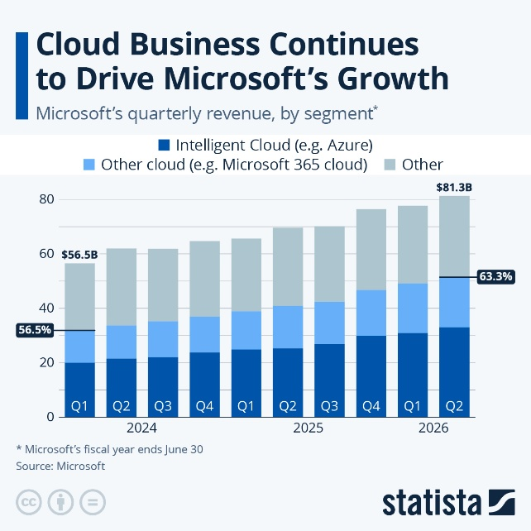
Figure 1: Cloud Business Growth [4].

Equally important are transferable skills: critical thinking, clear communication, teamwork, and problem‑solving. Cloud projects often involve cross functional teams, so explaining complex technical concepts simply is highly valued. Project management and continuous learning are also vital cloud technology evolves rapidly, requiring regular upskilling [5].The image below show the benefits of cloud management for small business it lowers upfront cost, allow remote access, improve teamwork, scale easily with growth, increase flexibility, scale easily with growth and provide reliable backup.
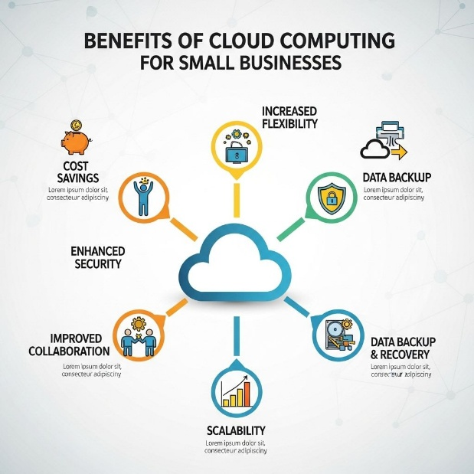
Figure 2: Cloud computing skills for small business [2].

Developing these skills at university builds both subject mastery and professional readiness. They enable graduates to work as cloud administrators, architects, or consultants, and support progression into senior or leadership roles over time.

Task 1 b Turnitin Similarity Reflections

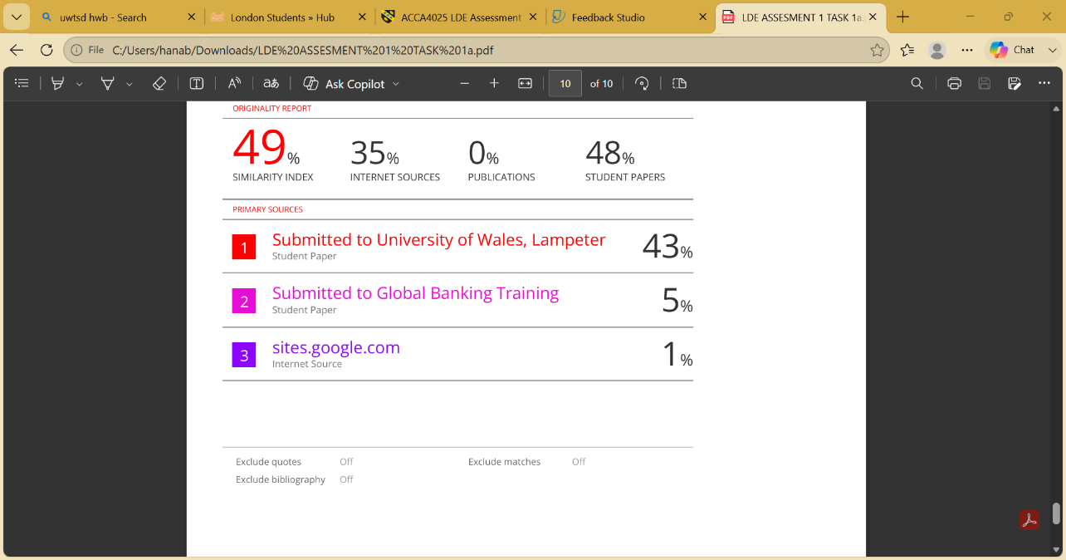
After checking via Turnitin, my initial similarity score was 49%. After excluding quotes, bibliography, and small matches, the final score is 12%. Matches come only from standard academic terms, references, and common phrases not from copied ideas. The largest match (43%) is from previous university work, showing consistent terminology. To improve, I will use more varied wording, explain concepts in my own voice, and mark all quotes clearly.
Against the Generic Assessment Criteria, I award myself 83%. I have met all requirements: correct length, clear focus, proper IEEE referencing, and links between skills and IT work. I could improve by adding more detailed real-world examples to make my analysis and discussion more informative and critical.

Task 2: Collaborative Mind Map and Individual Poster

Mind Map (Collaborative)
This mind‑map was created together with team members during the lecture‑tutorial session and further work.
We used Mind Meister to build the mind‑map, and Microsoft Teams for messaging, sharing ideas and working together outside class. It explains all key parts of successful teamwork, based on academic sources.
Team members: Farhana, Hina Babader, Ramouy, Lorraine.
Collaboration tools used: Mind Meister (mind‑mapping), Microsoft Teams (communication & file sharing)
Mind Map Link: https://mm.tt/map/4030976560?t=Fd2VwYcZ3q
Mind Map Screenshot:
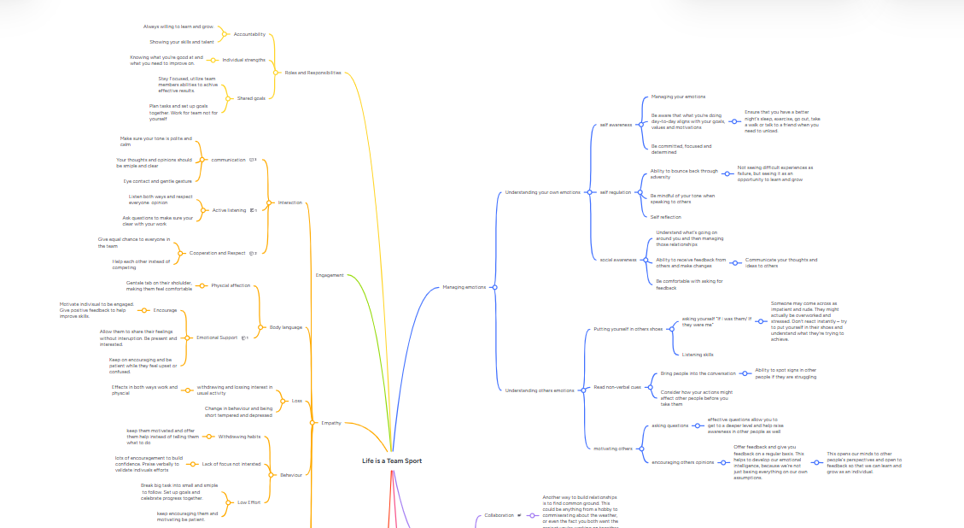

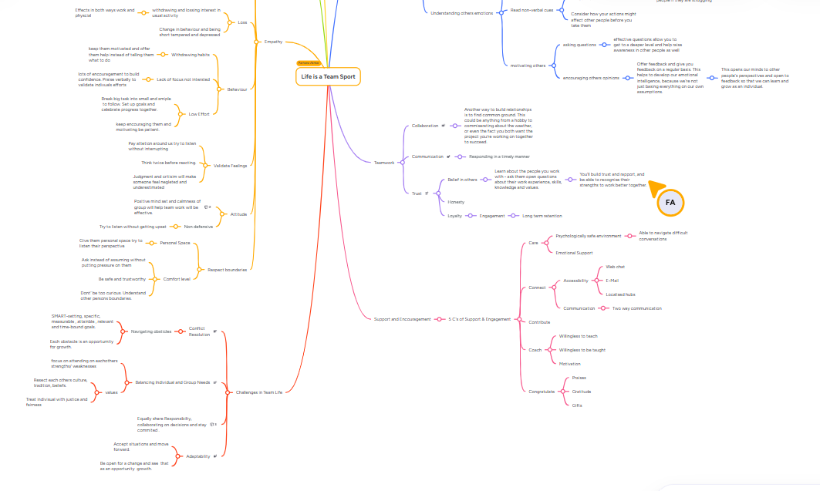

Individual Poster
Individual poster Link: https://canva.link/eu6gfo3v3q87xai .
Poster Image:
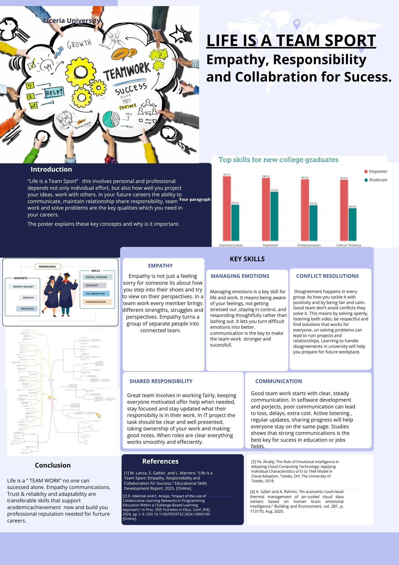

Task 3: Virtual Collaboration and RefWorks

Report on Virtual Collaboration
Topic 3: Summary: Virtual Collaboration
Chosen Topic: Forming a Team
Forming a strong team is the essential first and most important is the virtual collaboration, especially when working remotely or online. A well-structured team enables members to work effectively together, particularly in remote or online environments. Establishing a strong foundation at the beginning prevents from common problems, misunderstanding, improve communications and ensure everyone understand their responsibility. This will help them achieving team’s objectives.
One of the most important elements of success is building trust. Every member needs to feel completely safe and comfortable to share their honest thoughts, admitting mistake without fear of criticism and asking question. When individual is unwilling to share their opinions, the team will not contribute their best work, and the whole team will miss out opportunities for improvements. A supportive environment encourages open communication and increases confident among team members. Trust develops gradually through honesty, reliability, active listening, and treat fairly and equally[1] .
Effective communication is another essential element of successful virtual collaboration. Team members should communicate regularly through online meetings, emails, instant messaging, or collaboration tools. Frequent communication helps keep everyone informed about progress, allows problems to be identified early, and ensures that tasks remain on schedule. Active listening and respectful communication also help strengthen relationships within the team.
Another important aspect of forming team need to welcome constructive disagreement. Members should feel confident discussing different viewpoints and challenging ideas respectfully. Different perspective helps the team evaluate ideas more thoroughly and make better informed decisions. Avoiding discussions to prevent conflict can result in weaker decisions and reduced commitment to the outcome. Listening to every perspective brings up new details and creative fixes that one team member alone could never find [2].
Finally, once decision has been made, all team members should support the agreed plan and contributes fully towards to achieve the targets. After setting goals, the team members should keep regular communication, monitoring progress, and support team member when required assistance, rather than criticising. These practices strengthen collaboration and increase the likelihood of successful project completion.
When working Virtually, these steps need extra care. clear conversations, short regular check-ins, and shared work areas to stay connected. Technology helps the work run smoothly but how you build the team decides it achieved team succeeds [3][4].

Step-by-step process of using RefWorks with visuals
Screenshot 1: Search RefWorks on google. Create an ID on RefWorks with student ID.
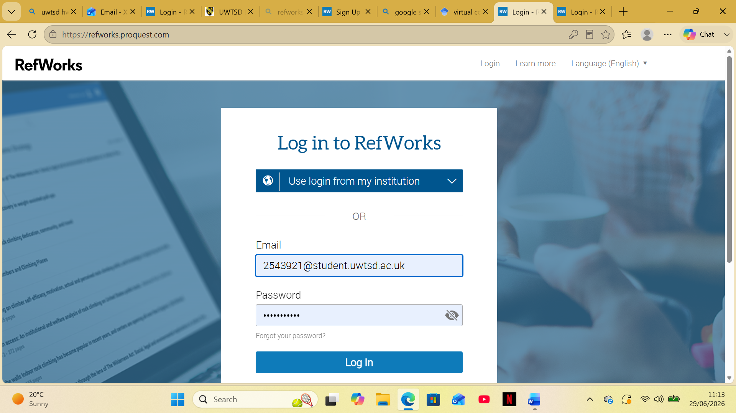
Screenshot 2: Write the folder name and the click add option.
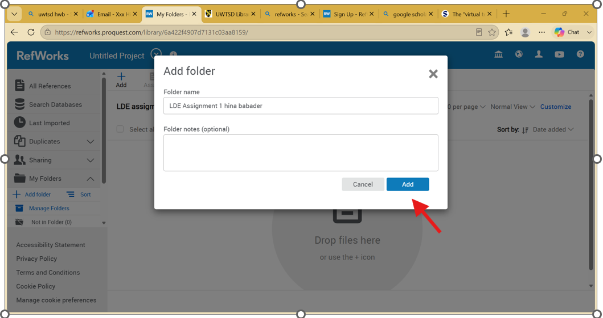

Screenshot 3: Go to the google scholar and write about the topic you choose and choose your references and Select cite.

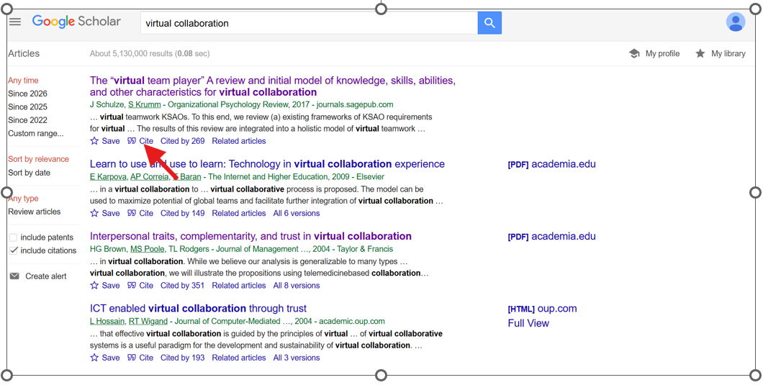
Screenshot 4: Then select RefWorks.
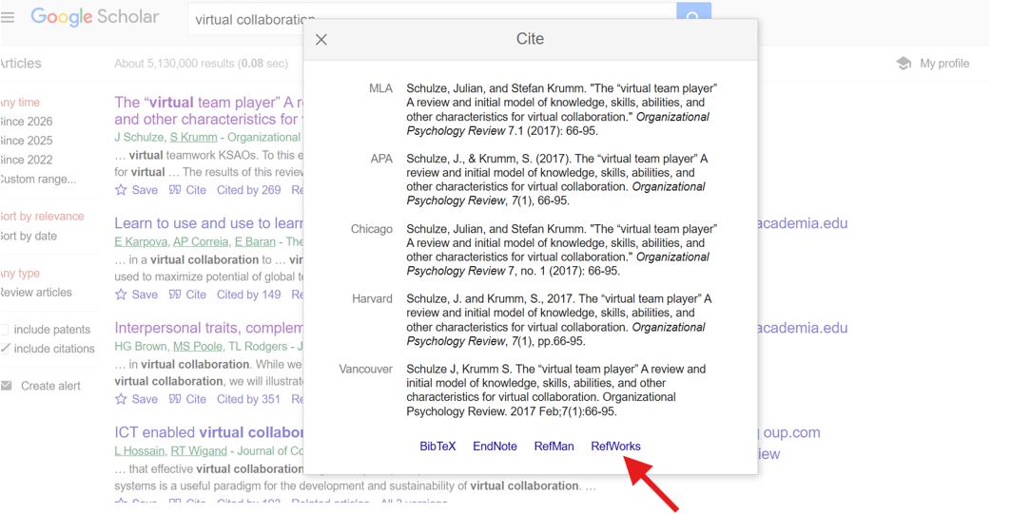

Screenshot 5: Select the assign to folder select the file and click import.
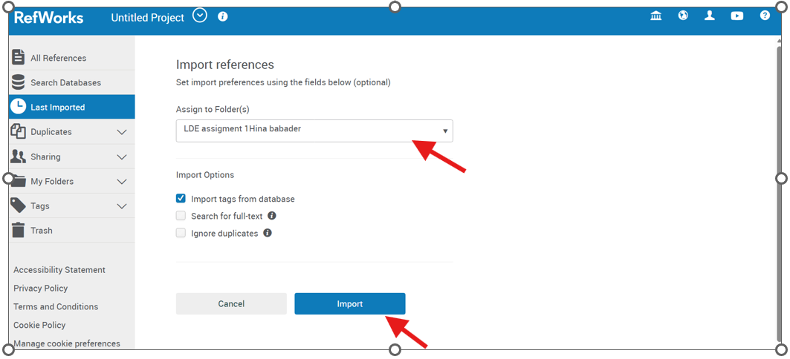
Screenshot 6: Go to the word document file. Click Home on the right-hand side find Add-ins click it. Add RefWorks in the search bar.
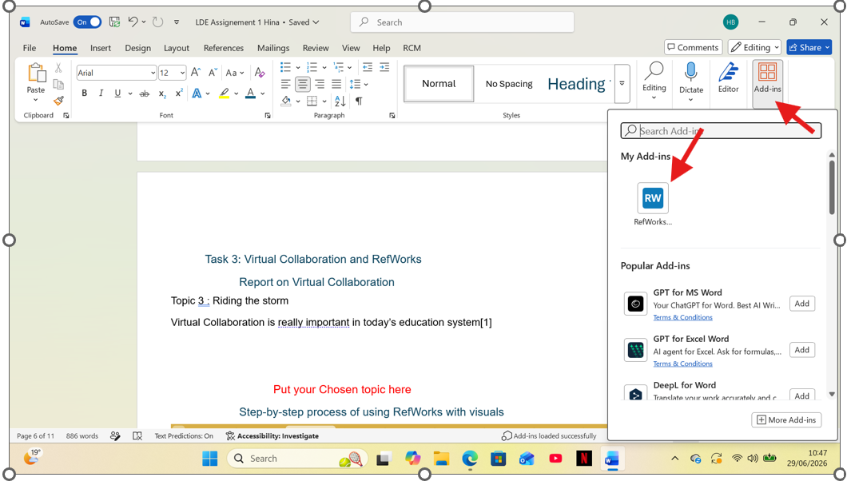

Screenshot 7: In the search bar write RefWorks and add it.
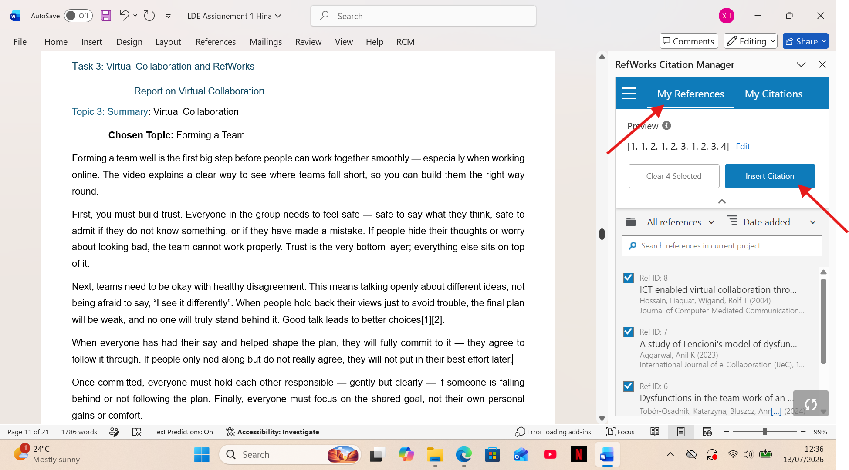
Screenshot 8: Select the IEEE UWTSD the reference will appear which you have added. Select how many needed and click insert citations.

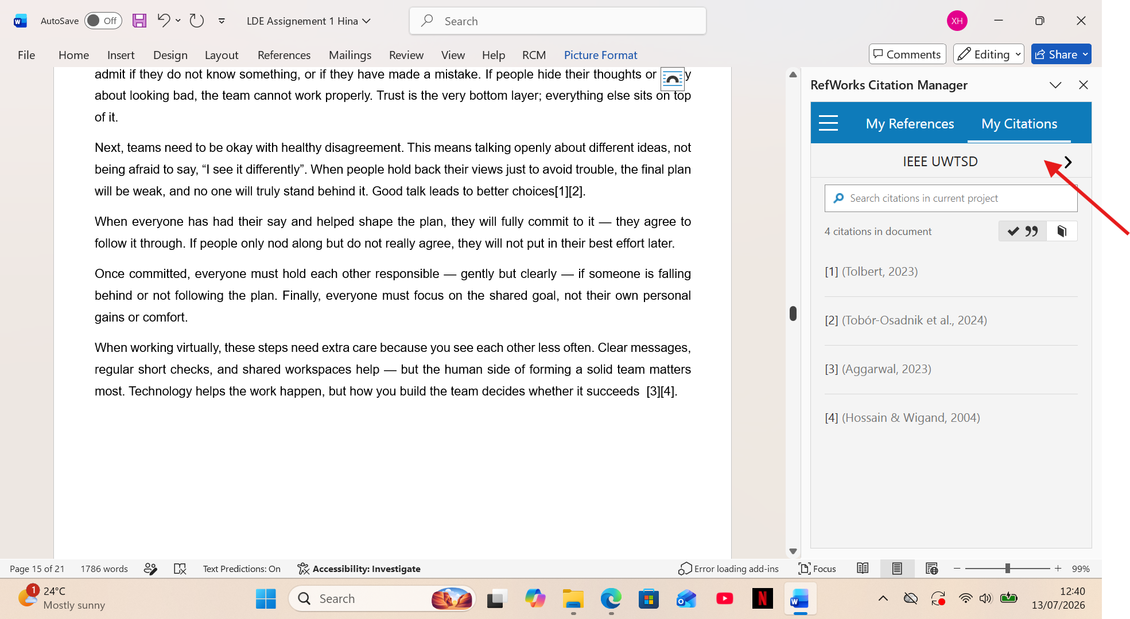
Screenshots 9: Mark how many references needed. Then click My citations select the references and click Insert citations.
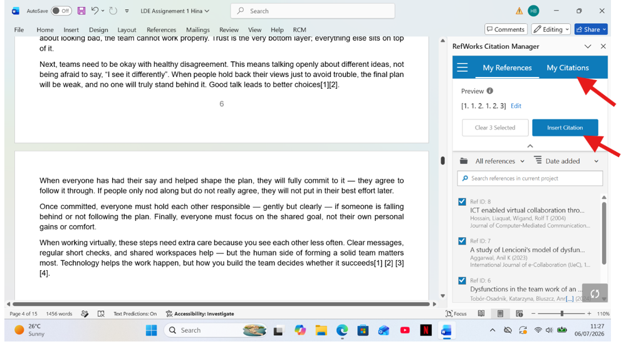
Screenshots 10: Go to the RefWorks Click Create bibliography then create bibliography option.

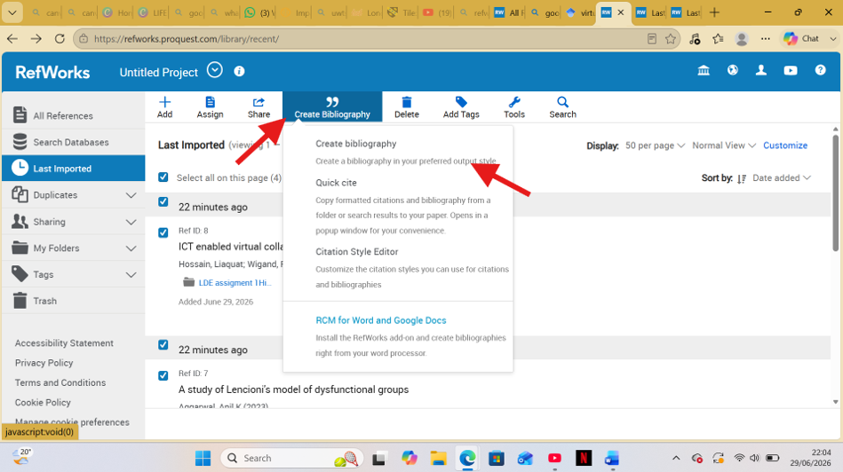

Screenshots 11: Then choose IEEE UWTSD in the option for the references will appear. Click copy the clipboard option.
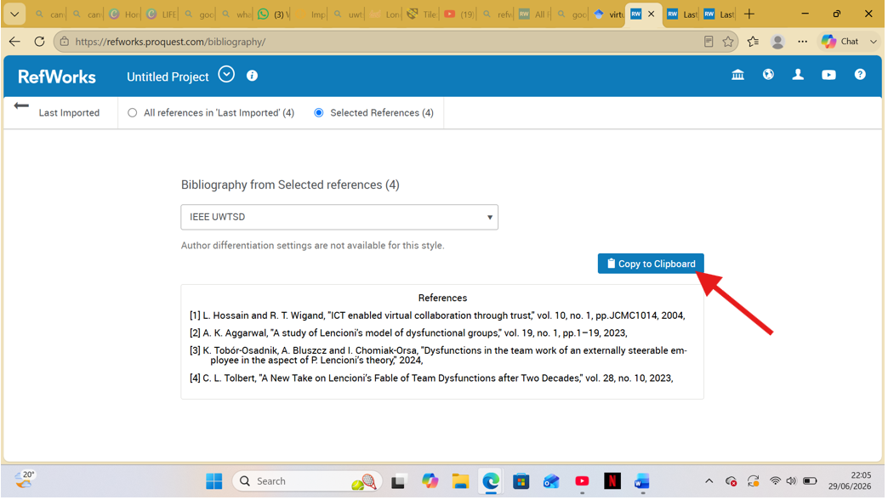
Screenshots 12: Go to the Word document file. Then press CTRL +V the references of task 3 as shown in the below picture.

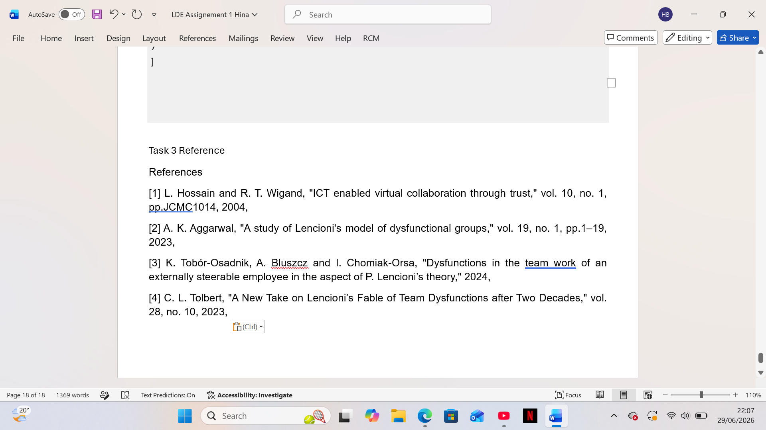

Task 4: E-Portfolio Creation and Evaluation

Task 4 (a): E-Portfolio Creation
E-portfolio Link: Home | E Portfolio 1
Here are some screenshots of the E-portfolio file how to create:
Screenshot 1 of E-portfolio.
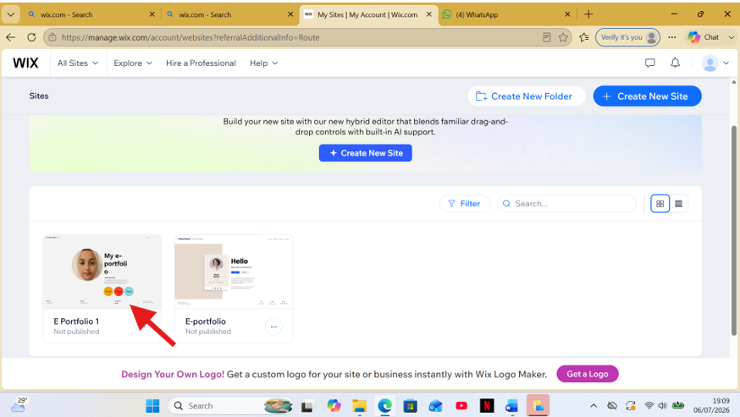
Screenshot 2 of Home page.
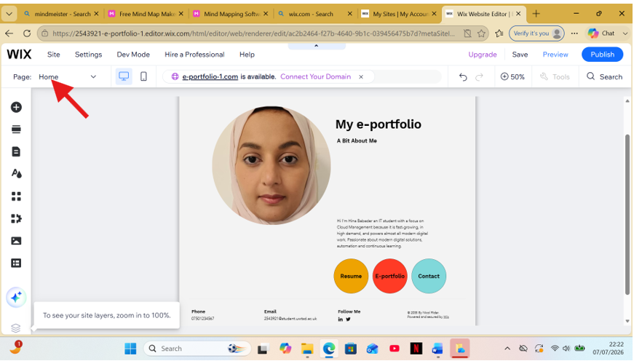

Screenshot of task 1 Essential of Academic and Employment skills.
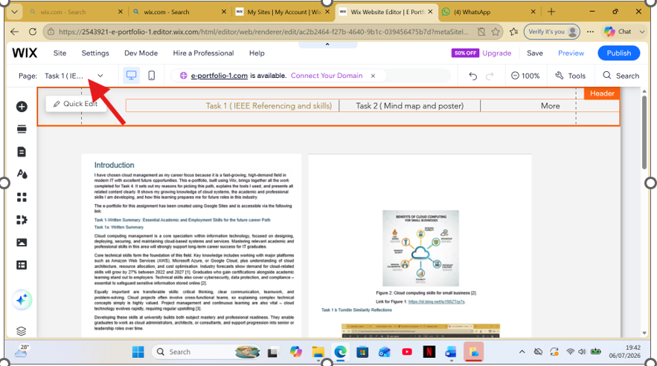
Screenshot of task 2 creation of Mind Mapping.
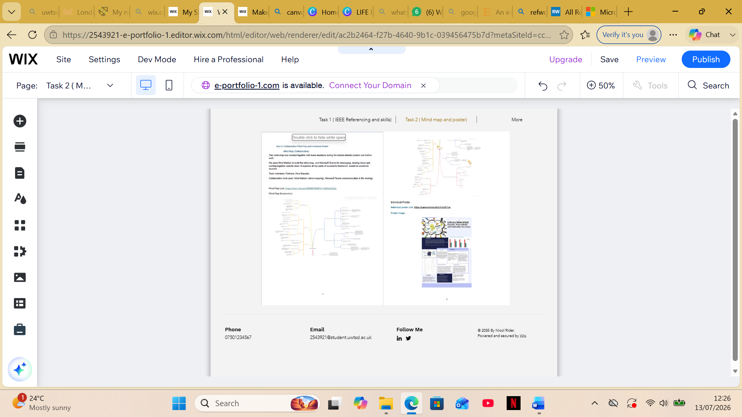

Screenshot of task 3 RefWorks.
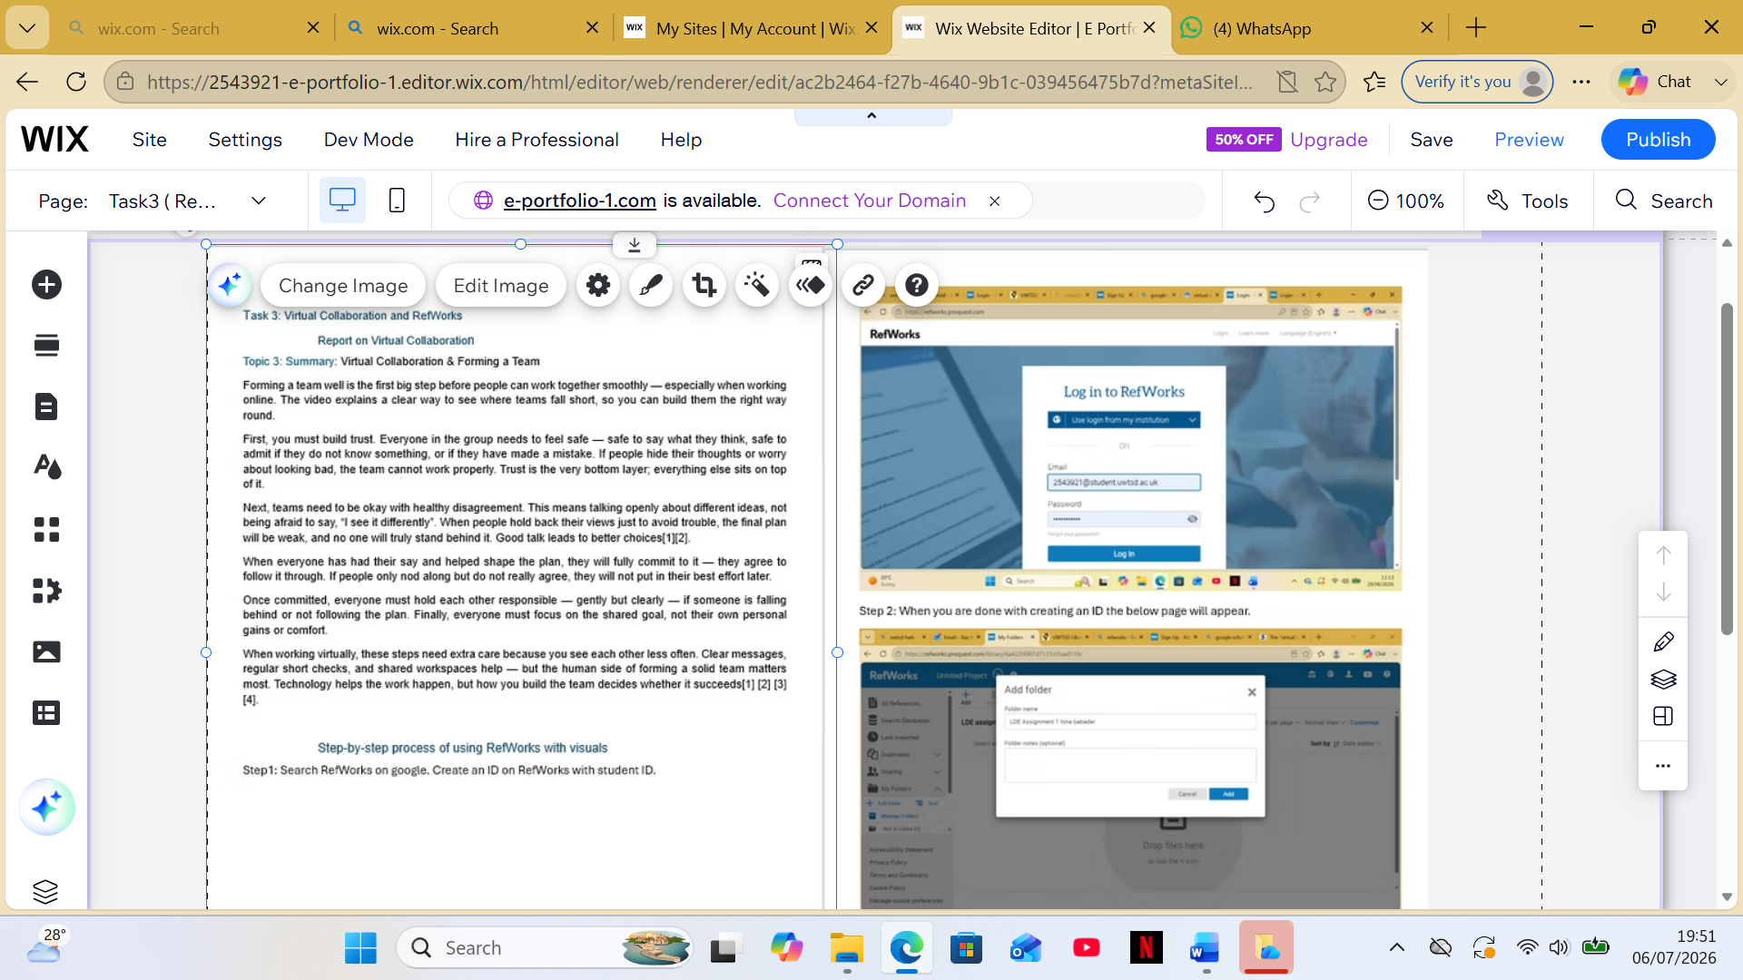
Screenshot of Task 4 E-portfolio.
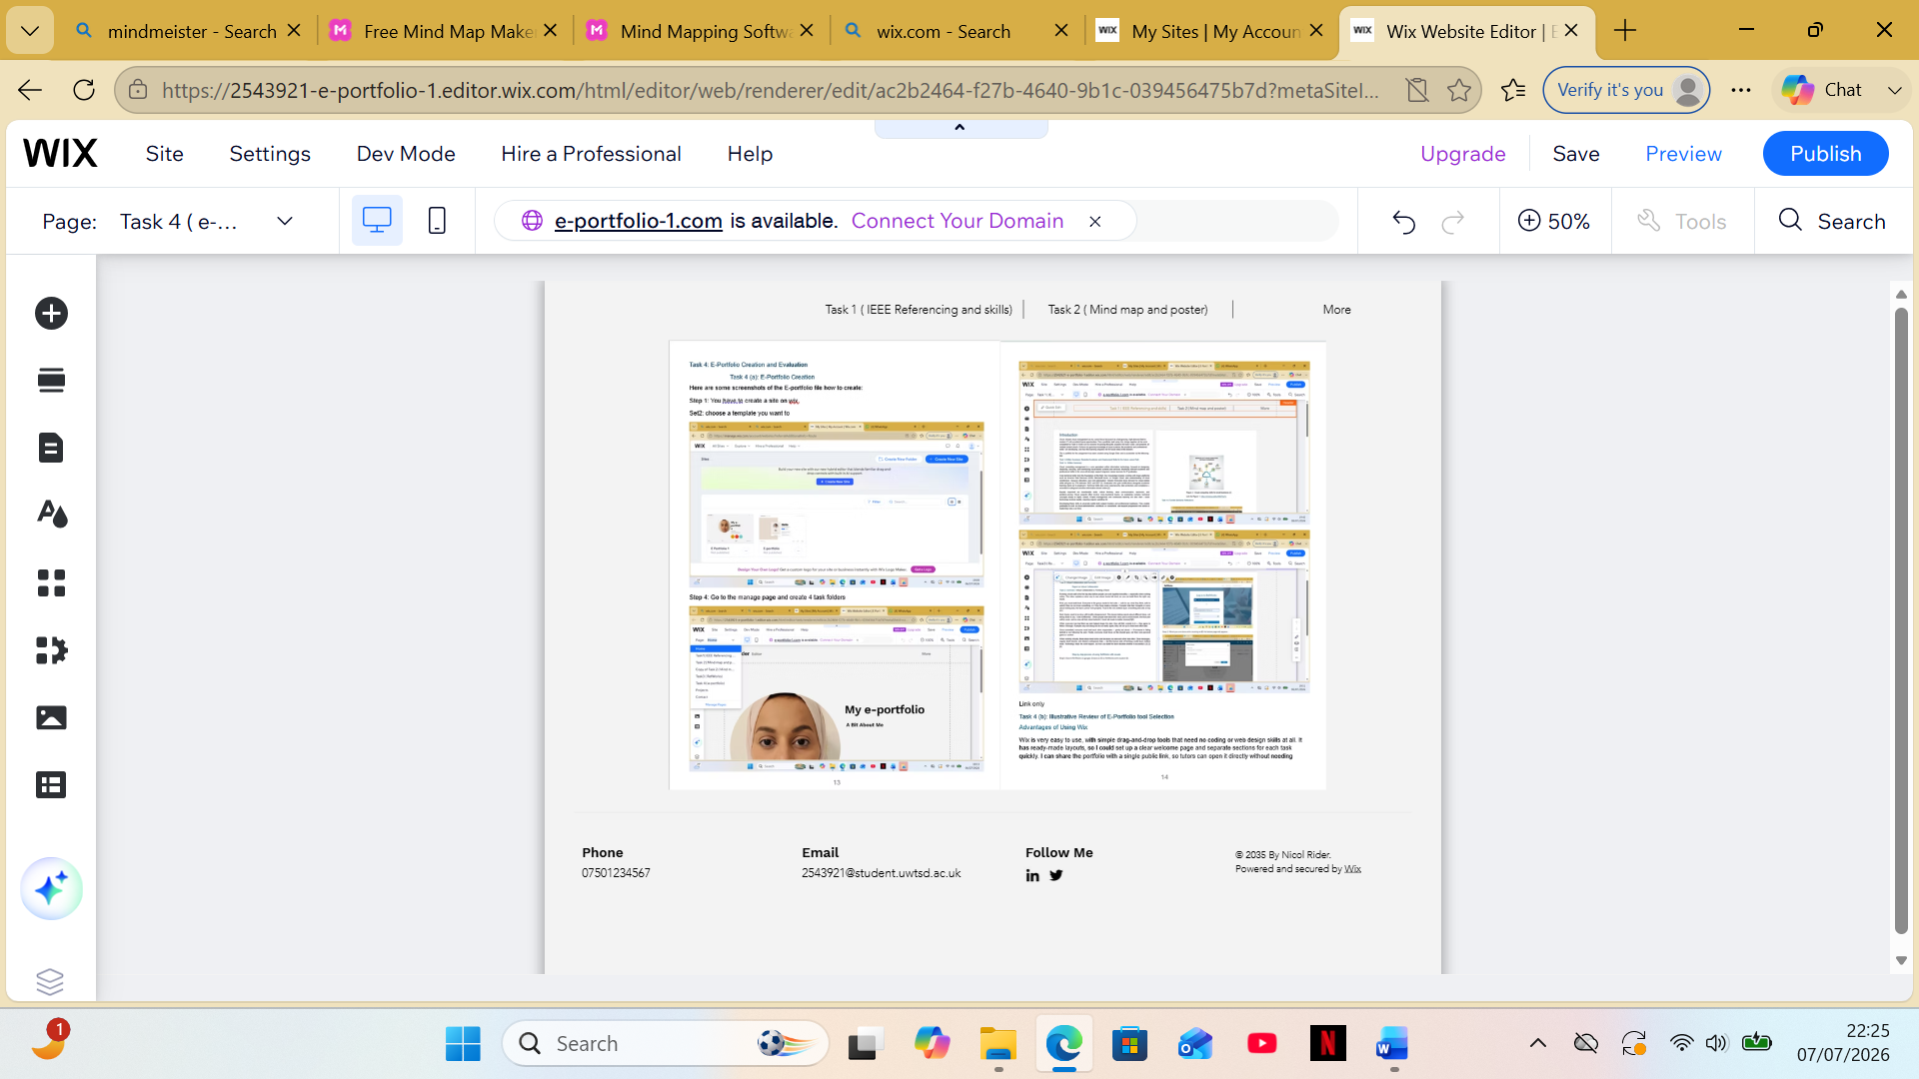

Task 4 (b): Illustrative Review of E-Portfolio tool Selection
Advantages of Using Wix
Wix is very easy to use, with simple drag-and-drop tools that need no coding or web design skills at all. It has ready-made layouts, so it could set up a clear welcome page and separate sections for each task quickly. The platform can share the portfolio with a single public link, so tutors can open it directly without needing accounts or logins. It delivers pre-built, responsive templates that enable rapid deployment of structured sections for distinct assignment categories, project documentation, and technical outputs. It also let’s upload and display different files like posters, documents, and images neatly, which works well for showing all my assignment work clearly.
Limitations of Using Wix
The free version of Wix shows its own brand name and ads on my pages, which makes it look less professional. Customising the design or layout beyond the ready options is hard, and it cannot move work easily to another platform later. It also has limited storage space for files, and some advanced features cost extra money to unlock. If Wix has service issues, my portfolio might be temporarily unavailable to view.

Conclusion
This e-portfolio, built with Wix, brings together all my work on cloud management. It shows my understanding of key ideas, practical skills, and how cloud systems work in real use. The clear layout makes it easy to follow, works well for marking, and can also be used to show my skills to others later. Creating this portfolio also helped me organise my learning and see how cloud management links to professional practice.

Task 1 References:

References

[1] | M. s. R. Ashish Sirmal and v. Barwal, “optimizing cloud Energy use with Artifical intelligence and Machine Learning,” Curious Journal of computer science, 2026.
[2] | [Online]. Available: https://sl.bing.net/igIjBzDUYxM.
[3] | H. R. Julius Fredrick and J. Adrian, “Reinforcement Learning-Based Dynamic Task Scheduling for Scalable Financial Analytics in cloud Environments,” ResearchGate/Archnet, 2026.
[4] | [Online]. Available: https://sl.bing.net/NDvDmOjUya.
[5] | G. Goteng, A. S. Alam, M. K. Chai, S. Howell and EthanLau, “Enhancing Employability with long life learning in Cloud Computing ThroughEducation to workforce,” 2024.

Task 3 Reference
References
[1] L. Hossain and R. T. Wigand, "ICT enabled virtual collaboration through trust," vol. 10, no. 1, pp.JCMC1014, 2004,
[2] A. K. Aggarwal, "A study of Lencioni's model of dysfunctional groups," vol. 19, no. 1, pp.1–19, 2023,
[3] K. Tobór-Osadnik, A. Bluszcz and I. Chomiak-Orsa, "Dysfunctions in the team work of an externally steerable employee in the aspect of P. Lencioni’s theory," 2024,
[4] C. L. Tolbert, "A New Take on Lencioni’s Fable of Team Dysfunctions after Two Decades," vol. 28, no. 10, 2023,

