Biomechanical Analysis on an athlete
Summary
This analysis is aimed at identifying the characteristics of both the left and right side of the lower extremity, as individuals, to help the athlete and coach understand what needs to be enhanced to aid performance. Through postural and linear analysis, the two different sides of the lower half of the body can be broken down into separate control groups to be more easily translated into training for improvement. The postural analysis showed little to no issues or major imbalances, but maintenance of skeletal structure should be carried on. The linear analysis has shown that small adjustments should be made to strength and endurance training to minimize the difference between the two.
Introduction
The purpose of this report is to analyse an athlete on a biomechanical basis, this is to aid in understanding and identifying how movement and postural structure should function, to maximise performance and reduce injury risks. Biomechanics is defined by Hatze in 1974, as the “study of the structure and function of biological systems by means of the methods of mechanics” and is further defined as a study of “forces and their effects on living systems” by McGinnis (2013). The reason for this analysis is to almost directly compare the participant’s mechanical movements with what the “normal” phases of movement should be, noting any absence of range of movement or linear movement. The outcome of the report is to determine whether the participant can improve performance during games, if the “weaker” side of the body, right leg, is improved through specific training. The client chosen to participate in this study is a female university student, who plays for a Welsh division women’s football team, on contract. She is a 5-foot 8 winger and prefers to utilize the left side of her body during performance. This analysis is aimed at differentiating the left side of the body to the right side, exploring any possible deformities between the two when postural aligned and when performing physical based tests. The tests that may be used within a biomechanical analysis include, but not limited to, gait analysis testing, postural analysis, movement analysis, muscle balance and symmetry, and range of motion. Postural analysis and linear displacement are being focused on within this analysis to personalize this study for what the participant wishes to understand and improve. It is suggested through a systematic review by Teferi and Endalew (2020) that “athletes and coaches can recall 30% of performance correctly” further stating that “performance analysis fills the remaining 70% by providing accurate data”, this should therefore be beneficial for the participant to understand how performance translates when being recorded and examined. Identifying what muscles are being required when performing specific tasks is essential, especially when strengthening and performance enhancing is the intended outcome. Kuo and Zajac (1993) used a linear program between postural and muscular strength, they found that to best suit their model and therefore cause the greatest increase in generating basic acceleration factors within the body. The muscle groups of hamstrings, tibialis anterior, rectus femoris, and gastrocnemius, closely correlated with cases of reduced muscular strength and even seemed to be related to risk factors of falling when not strengthened. Analysis within biomechanics may also directly transfer into training methods to further improve and develop muscular movements and strength. The participant may be limited to certain peak performances, including limitations in muscular strength and endurance of specific muscle groups (McGinnis, 2013). This is where the analysis can be used by athlete and coach to remove these limitations to eventually achieve a breakthrough into different movement patterns and boosted structure.

Analysis
Postural Analysis
Posture is the alignment and maintenance of body segments in certain positions, and is an important indicator of the musculoskeletal health (Discobolul, 2015). Postural analysis is an area of interest for many researchers as it provides insight into potential relations between body asymmetry and unilateral loading, as well as injury specific outcomes (Zuk et al., 2019). After assessing the athlete’s posture from the figure below (Figure 1), it is understood that they have shown very little to no imbalances and are able to hold correct anatomical position when standing in a relaxed manor. There was shown to be no tilting or protrusions from the head in relation to the shoulders, seen to be directly above them, with ears in line with the middle of the shoulders. The shoulders showed as level, in both anterior and posterior view, without one appearing higher than the other. The roundedness of the shoulders seemed to be nothing of note, and there was no major internal rotation (Physiopedia, 2025). The four natural curves of the spine (cervical, thoracic, lumbar, and sacral) were maintained when relaxed, suggesting an ‘S’ shape in the athletes body (Cedars Sinai, 2025). The pelvis of the athlete is aligned, showing no signs of an anterior or posterior tilt, ensuring weight is distributed evenly over both sides of the lower extremity. Knees face forward when standing still, in line with the ankles without enhanced pronation or supination. This posture analysis is directly compared to the athlete in motion, where they translate the postural symmetry into movements. The athlete shows even ranges in stride length and ROM, to minimalize unfair forces and impacts on individual muscle groups, reducing the risk of injury and augmenting functional performance.

Linear analysis
Keiser leg press
The athlete recorded a peak power performance of 295 Watts on the right leg and 297 Watts on the left leg during the Keiser leg press. In preparation for the analysis, the athlete stated that they knew their right leg was weaker, strength wise, than their preferred left leg. The results of this Keiser press suggest that on peak power performance there is very little to no variation in ability between the two, only showing a peak Watt power discrepancy of two (Figure 2). The results do however show a difference in the two legs after the fifth repetition, where in comparison between the two legs, working individually, there starts to become a change in peak power. The sixth attempt shows about a 15-Watt difference, where the left leg is producing more power, and the seventh attempt records a 10-Watt difference, where the left leg is once again more influential. This suggests that the muscles surrounding the area of movement in the left leg are able to withstand high excursions of power over a longer period of time, or able to fatigue less as repetitions increase. It also shows the reaction time between the machine green light and the movement of the athlete, every repetition is more or less in favour of the left leg (Figure 3). It also shows the same correlation of a more positive difference between the two legs towards the later bouts, nearing the end of the test. The sixth showing a visible gap between the two, and then finally, the seventh attempt having a 0.25-second faster reaction from the left leg. This data could possibly imply that the athlete has a stronger connection to the leg with a more developed neuromuscular junction (NMJ), which according to Engel (2008) is the transmission of signal from the motor nerve to the muscle fibre. Finally, the software used in relation to the Keiser machine has recorded the active range of motion (ROM) of both legs during each movement. The data shown suggests that this athlete has a greater ROM in the right leg over every repetition (Figure 4). This could possibly mean that although the right leg is not as powerful as the left, it is being taken through ROM slower and more appropriately to avoid any damaging of peripherals in the area. The athlete may want to seek improving reaction time and ROM in both legs to be more similarly matched, to avoid any force imbalances when performing physical activity.

Force platform
The force platform was used to analyse the athlete’s force distribution while balancing on individual legs. Figure 4 shows the athlete’s left leg does not have much sway when balanced solely on the foot, it shows a slight compensation between the movement of force from the body and the change in force from the sides of the foot to balance it out. This can be directly compared to the test on the right leg (Figure 5), where there is a more visible change in forces from the leading foot. It is shown to result in more force being distributed to the front and back of the foot while balancing, suggesting that there is a lot more back and forth sway in the body while standing on the platform. This could suggest that the left leg provides more of a structurally sound base than the right leg, possibly indicating a slight muscle imbalance between the two, or maybe just being a result due to habituation, where the right leg is used, by itself, much less.

Recommendations
The athlete within this analysis shows great similarities between both sides of the lower body, with no major imbalances. Recommendations to be made include forms of sport specific training, such as unilateral movements and power exercises to more closely resemble the movements on the pitch. It is suggested that athletes in most sports move with force that is unilateral, but is not mirrored when training, implying that the majority of training tools always work bilateral (Boyle, 2003. Cited in Zhang et al., 2023). Therefore, it is recommended that the athlete partake in some unilateral exercises to increase the strength of various muscle groups working individually.

WORD COUNT: 1600

Figures and References
Figure 1: Athlete in anatomical position
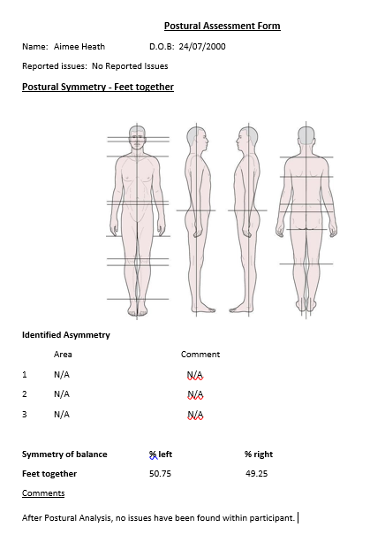
Figure 2: Peak Power during Keiser leg press Test
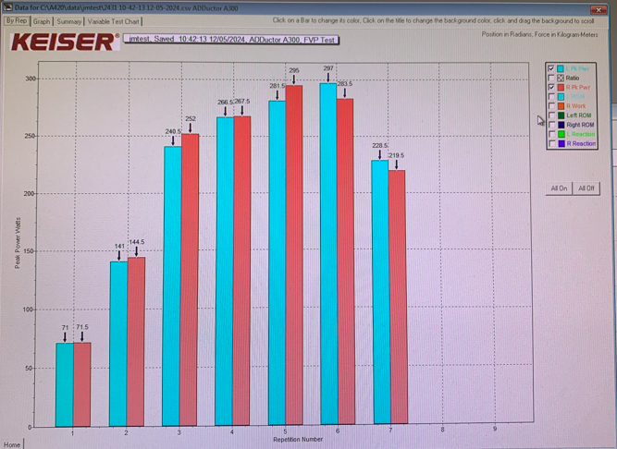

Figure 3: Reaction time during Keiser leg press test
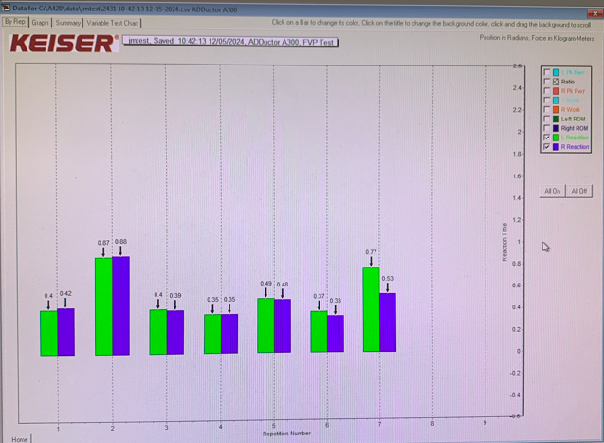

Figure 4: Range of Motion during Keiser leg press test
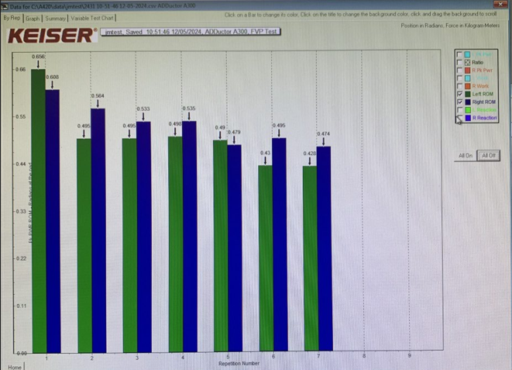

Figure 5: Force platform, Romberg 30s one-legged test (Left foot)
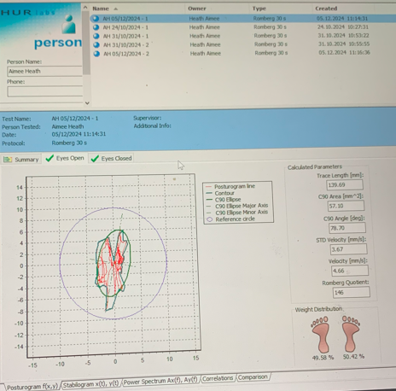

Figure 6: Force platform, Romberg 20s one-legged test (Right foot)
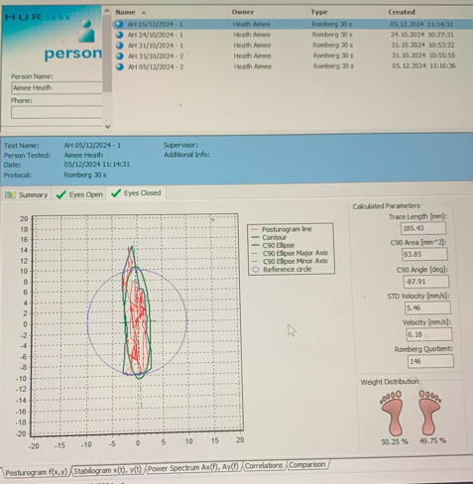

McGinnis, P. (2013.) ‘Biomechanics of Sport and Exercise’, Biomechanics of Sport and Exercise, (3), pp. 1-37. Available at: https://books.google.co.uk/books?hl=en&lr=&id=awmprqGqFo4C&oi=fnd&pg=PP2&dq=biomechanical+analysis+in+sport&ots=0zfYxle7Og&sig=Nh8qKYZGJ3JGuEEpjfAqayE3aXs&redir_esc=y#v=onepage&q&f=false

Teferi, G., & Endalew, D. (2020). ‘Methods of Biomechanical Performance Analysis in Sport: Systematic Review’. American Journal of Sports Science and Medicine, 8(2), 47-52. DOI: 10.12691/ajssm-8-2-2

Kuo, A. D., & Zajac, F. E. (1993). A biomechanical analysis of muscle strength as a limiting factor in standing posture. Journal of biomechanics, 26 Suppl 1, 137–150. https://doi.org/10.1016/0021-9290(93)90085-s

Engel, A. (2008). ‘Handbook of Clinical Neurology’. The Neuromuscular Junction, 91, 103-148. https://doi.org/10.1016/S0072-9752(07)01503-5

Discobolul (2015). ‘National University of Physical Education and Sports’. Physical Education, Sport and Kinetotherapy Journal, Year XI, 1(39). Available at: https://discobolulunefs.ro/Reviste/2015/DISCOBOLUL_XI_1_39_2015_v1.pdf#page=58

Cedars Sinai (2025). Available at: https://www.cedars-sinai.org/health-library/diseases-and-conditions/c/curves-of-the-spine.html#:~:text=About%20Curves%20of%20the%20Spine,lordotic%20or%20backward%20C-shape (Accessed: 13/02/2025).

Physiopedia (2025). Available at: https://www.physio-pedia.com/Sports_Screening:_Postural_Assessment (Accessed: 13/02/2025).

Zuk, B., Sutkowski, M., Pasko, S. et al. (2019). ‘Postural Correctness of Young Female Soccer Players’. Scientific Reports, 9, 11179. Available at: https://www.nature.com/articles/s41598-019-47619-1#citeas

Zhang, W., Chen, X., Xu, K. et al. (2023). ‘Effects of Unilateral Training and Bilateral Training on Physical Performance: A Meta-Analysis’. Exercise Psychology, 14. Available at: https://doi.org/10.3389/fphys.2023.1128250

