Student name: Farah Deeba
Student no.: 2325143
Teacher’s name: Precious Igbinigie
Submission Date: 20th July 2026
Comparing Local Authority Websites: How Early Help is Communicated to Families
A comparative evaluation of Leicestershire County Council, Norfolk County Council and Southwark Council
BMHP5021 – Protecting and Supporting Families in Health and Care

Table of Contents
Introduction 2
Explanation of Multi-Agency Working 3
Evaluation of Three Local Authority Websites 4
Leicestershire County Council 4
Norfolk County Council 5
Southwark Council 5
Comparative Analysis 5
Conclusion and Recommendations 8
Reference List 8

Introduction
Early Help refers to the support extended towards or offered to children, young people, and their families at the first sign of an occurring issue, before it becomes serious enough to require legal intervention of children’s social care (DLUHC and DfE, 2022). It is a preventative approach involving multiple agencies that aim to strengthen family resilience and minimise the escalation of needs while safeguarding long-term welfare of children. Moreover, Early Help is organised and delivered in local areas, therefore, local authorities contact information serves as the first point of contact for the family. The information thus obtained from the authorities’ platform influences the actions of the struggling family that they might either seek Early Help due to clarity, accessibility, and comprehensiveness of the information. Contrarily, if the stated attributes are not adequate, family might reach a point of crises before support is identified (Fearnley, 2022).
This document includes a report examining and comparing the information communication concerning Early Help, as observed by three English local authorities, namely, Leicestershire County Council, Norfolk County Council, and Southwark Council, through their websites. The three aforementioned attributes of communication (i.e., clarity, accessibility, and comprehensiveness) associated with the Early Help content on each website is evaluated before framing concluding remarks thereby revealing the judgement concerning the authority that provides the most effective information. The analysis and conclusion are based upon Early Help System Guide (DLUHC and DfE, 2022) and Working Together to Safeguard Children 2023 (HM Government, 2023) which serve as reference points defining what an effective and family-centred Early Help offer should appear like online.
The considered report is structured in five sections including an explanation of the Early Help system and role in wider safeguarding framework, an elaborative discussion on multi-agency working, an evaluation of the aforementioned websites, a comparative analysis, and a conclusion that also provides practical recommendations concerning the improving the ways of signposting Early Help online.
Explanation of the Early Help System
Early Help is defined as the total support for improving resilience and outcomes for a family or reducing the chances of problem becoming more adverse (DLUHC and DfE, 2022; Research in Practice, 2022). It is not a single service, instead, it involves a network of universal, community, and acute or targeted services that function in combination develop an Early Help offer for a local area. Universal services include schools, GPs, early years sittings and family hubs while community support includes social networks, voluntary and faith organisations, and online support. Moreover, acute or targeted services include social care, mental health services, housing support, and substance misuse services (DLUHC and DfE, 2022).
The core purpose of Early Help is to prevent adversities. It includes identification of difficulties at the point of emergence and provision of support to whole family. It is coordinated by a single Lead Practitioner and a team associated with the family so that the affected are not required to repeat their story to multiple services and that escalation of the issue requiring costly legal intervention is avoided wherever possible (DLUHC and DfE, 2022). It is also intended to develop support networks and community connections for the family so that they remain resilient even after the termination of formal support contracts.
Early Help is aligned adequately with the broader safeguarding framework of England. It is recognised by Working Together to Safeguard Children 2023 as the first response to an issue and is made a legal obligation upon agencies under the Children Act 2004 to cooperatively consider improvement of children’s wellbeing (HM Government, 2023). Upon the failure of local partnerships concerning the identification and addressing of the need in early stages, families are likely to reach higher thresholds concerning the child in need or his/her protection intervention. The wider Supporting Families programme and investment in Family Hubs by the government provide a single means to access the universal and early help services for families with children aged between 0-19 (or up to 25 in case of special needs). it forms the delivery infrastructure through which many local authorities are able to implement the considered vision (DLUHC and DfE, 2022).

Explanation of Multi-Agency Working
Multi-agency working includes a collaborative involvement of individuals with different professional backgrounds such as social workers, teachers, health visitors, police, and voluntary sector employees. They collectively operate to share information, responsibility, and decision-making (HM Government, 2023). The expectations from multi-agencies are identified by the Working Together to Safeguard Children 2023 at three levels of local partnership including strategic leaders, managers, and direct practice. Moreover, the guidance describes that successful outcomes for children depend upon child centricity and strong partnership between guardians and practitioners (HM Government, 2023).
Multi-agency involvement enjoys core value with Early Help system because the needs of families are not limited to a single life aspect. For instance, if a family experiences domestic abuse, support related to child’s school attendance, parents’ mental health, and housing matters is also needed. The Early Help System Guide (DLUHC and DfE, 2022) defines the contribution of different practitioner according to their frequency of likeliness of acting as Lead Practitioner (see table 1)
Table 1. Practitioners
Frequency of Lead Practitioner Role | Practitioners | Their Functions
Frequently | Children's social workers; Family/early help workers | Act often as Lead Practitioner and model whole-family working
Regularly | School-based staff; Health visitors; Children's centre workers | Identify need and promote access to support
Targeted / As needed | Housing officers; Midwives; Youth offending staff | Contribute when their specialist expertise is specifically required
It implies that a Lead Practitioner coordinates an assessment and a family plan including the views and requirements of every family member when they are referred to the system. The wider team around the family then contributes their specialist knowledge to the very shared plan (DLUHC and DfE, 2022). The collaborative approach intends to avoid families being passed between services, ensures that professional develop complete picture of circumstances, and reflects the legal expectations of agencies working together and not in parallel to promote welfare (HM Government, 2023; Machura, 2016).

Evaluation of Three Local Authority Websites
The three selected authorities have each made Early Help information publicly available online, however, the information usability, accessibility, presentation, and comprehensiveness continues to vary. It reflects wider research findings that considerable number of English council websites do not meet guidelines for being completely accessible (Wharton et al., 2026). The websites’ evaluation included the assessment of the ease of locating the relevant page, language clarity, information coverage comprehensiveness, and accessibility of available contact and referral routes.

Leicestershire County Council
Leicestershire offers Early Help branded as ‘Family Help’. It had previously been known as the Children and Family Wellbeing Service and is accessed through navigating the website, leicestershire.gov.uk, as Education and children > Social care and supporting families. The very page explains that the service includes targeted early help including Child in Need services for families in need that cannot be met through universal services (i.e., schools or GPs) alone. It also provides a dedicated phone number for families to contact (LCC, no date a). Another page hosted on the resources.leicestershire.gov.uk subdomain describes the origins of service and concrete group-work programmes such as ‘Feeling Safe’ for the children suffering from domestic abuse and a ‘Young Carer’s Group’ (LCC, no date b). This page is aimed largely at professionals. The stated level of detail is adequately strong such that it provides the families and referrers an understandable sense of how a support service is expected to be. However, the site can be viewed as less intuitive for a parent searching directly for early help due to the split between two separate domains and the shift of terminology from ‘Early Help’ to ‘Family Help’ as observed in midway during navigation. Moreover, no video or visual content was found that could support families with lower literacy or non-native speakers of English.

Norfolk County Council
The Early Help page of Norfolk County Council is found under Children and families on norfolk.gov.uk. It uses a simple and empathetic language, ‘‘If you have difficulties in your family or are worried about your children, there are people who can offer help and support’ (NCC, no date a). The page provides concrete and relatable examples explaining when to seek help which include domestic abuse, substance abuse, school refusal, financial issues, and housing worries which assists families in recognising their own situation as per the text. Norfolk also provides an online self-referral form, i.e., ‘Request for support’, a central contact number, and describes complementary services including the Best Start Family Hubs and the Home-Start Norfolk volunteer scheme (NCC, no date b). However, the main limitation is information fragmentation where it is spread across several separate sites which include a Community Directory entry and a further Family Information Service subdomain. This fragmentation creates a risk for a family that they may find one page without being able to discover the others leading to an incomplete information. A consolidated single stop hub for Early Help is needed.

Southwark Council
The Early Help content at Southwark’s council can be accessed through a short and clear website navigation path, i.e., Children, young people and families > Children’s social care > Early help. It is divided into two pages, namely, ‘About Early Help’ and ‘Extra Early Help’. The former covers universal services including health visitors, school nurses, GPs and youth clubs. The latter describes the targeted Family Early Help (FEH) service (SC, no date a; SC, no date b). This very structure aligns with the continuum of need that is described within the Early Help System Guide, thereby, making self-identification easy concerning the level of required support. The page also displays a clear date for the last update and provides an email address for referral along with a phone line with menu options that are described. Moreover, there are links to a downloadable referral form at the website (SC, no date b). However, there exists a weakness that menu options for the phone are structured around professional categories for consultation and referral. Therefore, it does not reassure first-time family contact. Moreover, the visible content that explains the proceedings after the referral is made, is limited.

Comparative Analysis
It is observed that all three of the councils provide a freely accessible, and clearly presented information on Early Help. However, a difference exists concerning the ease of locating and practicality for implementation by a family (See Table 2).
Table 2. Comparative Analysis
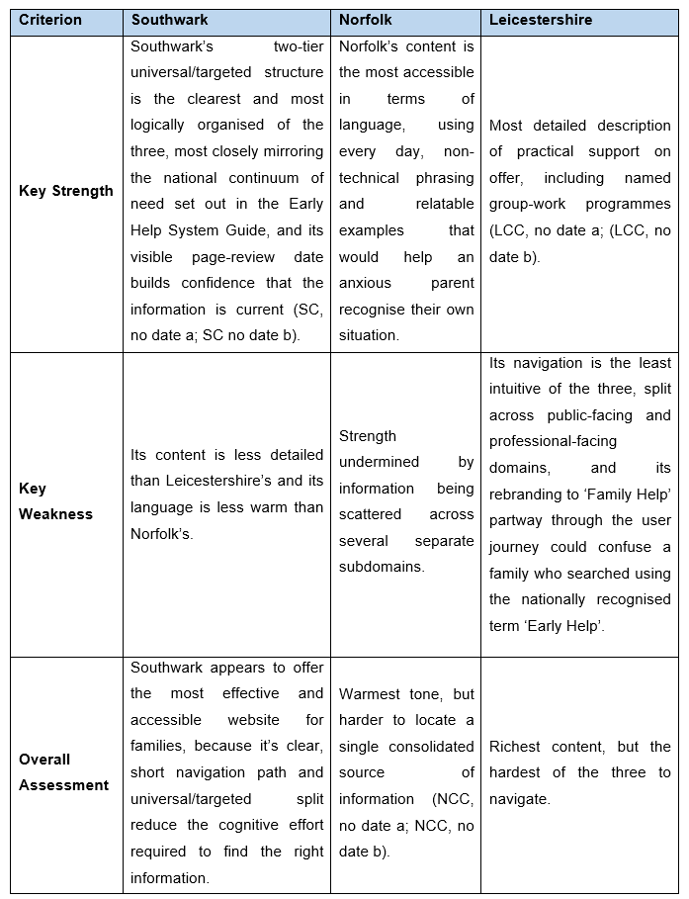
All the three websites can improve their user experience and information accessibility by consolidating Early Help content onto a single page that is consistently branded, instead of splitting it across subdomains. Further recommendations are provided in next section.

Conclusion and Recommendations
The considered report compared the online communication of information concerning Early Help as observed by the Leicestershire County Council, Norfolk County Council and Southwark Council. All of the three websites provide a genuine offer for Early Help that complies with the national Early Help System Guide and the legal expectations of Working Together to Safeguard Children 2023. However, the online presentation of the offer encounters variance concerning clarity, structure, and consistency. It is observed that Southwark’s clear structure related to universal and targeted services information is the most effective and accessible. Whereas, the plain language approach observed by Norfolk is the most family-friendly. Meanwhile, Leicestershire’s content is the most detailed however, it is the least easy to navigate.
It is recommended that all of the three councils should present a consolidated information regarding Early Help onto a single webpage thereby making it consistently branded page. The nationally recognised term ‘Early Help’ must be used on consistent basis even in place where a local service brand exists. Moreover, it is recommended to add a short visual or video explainer of the details concerning the proceedings commencing from first contact through to a family plan. Furthermore, it must also be ensured that the content is available in translated or easily readable formats to support families with additional needs of communication. Southwark’s example of displaying ‘last updated’ dates is also recommended so that families can trust if the information is current.
It is to be noted that online information accessibility is not merely an issue of peripheral or presentational nature. Rather, it is a functional aspect being part of the Early Help system itself. The reason for such is that Early help is intended to reach families as early as possible in order to prevent escalation, thus making information access crucial. A family unable to find or comprehend online information may not be able to ask for and receive support in time leading to worsening of their situation which will undermine the core purpose of Early Help which is designed to be preventative in nature.

Reference List
DLUHC and DfE (Department for Levelling Up, Housing and Communities and Department for Education), (2022). Early Help System Guide: A toolkit to assist local strategic partnerships responsible for their Early Help System. Available at: https://www.gov.uk/government/publications/supporting-families-early-help-system-guide (Accessed: 17 July 2026).
Fearnley, B. (2022) Developing Knowledge and Skills for Child and Family Social Work. London: Learning Matters (SAGE).
HM Government, (2023). Working Together to Safeguard Children 2023: Statutory guidance on multi-agency working to help, protect and promote the welfare of children. London: Department for Education. Available at: https://www.gov.uk/government/publications/working-together-to-safeguard-children--2 (Accessed: 17 July 2026).
LCC, (no date a). Help for children and families. Available at: https://www.leicestershire.gov.uk/education-and-children/social-care-and-supporting-families/help-for-children-and-families (Accessed: 17 July 2026).
LCC, (no date b). Early Help. Available at: https://resources.leicestershire.gov.uk/education-and-children/child-protection-and-safeguarding/early-help (Accessed: 17 July 2026).
Machura, S. (2016) 'Inter- and Intra-Agency Co-operation in Safeguarding Children: A Staff Survey', British Journal of Social Work, 46(3), pp. 652–668. https://doi.org/10.1093/bjsw/bcu101
NCC, (no date a). Early help. Available at: https://www.norfolk.gov.uk/children-and-families/early-help-and-family-support (Accessed: 17 July 2026).
NCC, (no date b). Request for support. Available at: https://www.norfolk.gov.uk/article/60983/Request-for-support (Accessed: 17 July 2026).
Research in Practice. (2022) What is Early Help? Concepts, Policy Directions and Multi-Agency Perspectives. Manchester: Ofsted. Available at: https://assets.publishing.service.gov.uk/media/6203e0848fa8f5109c7f136e/Early_help_Research_in_Practice_2022.pdf (Accessed: 17 July 2026).
SC, (no date a). About early help. Available at: https://www.southwark.gov.uk/children-and-families/childrens-social-care/early-help/about-early-help (Accessed: 17 July 2026).
SC, (no date b). Extra early help. Available at: https://www.southwark.gov.uk/children-and-families/childrens-social-care/early-help/extra-early-help (Accessed: 17 July 2026).
Wharton, K., Kavanagh-Smith, L. and Douce, C. (2026) 'Evaluating the accessibility of local authority public-facing websites in England', Universal Access in the Information Society. https://doi.org/10.1007/s10209-025-01269-5

