

Digital Management (LCMB7010)
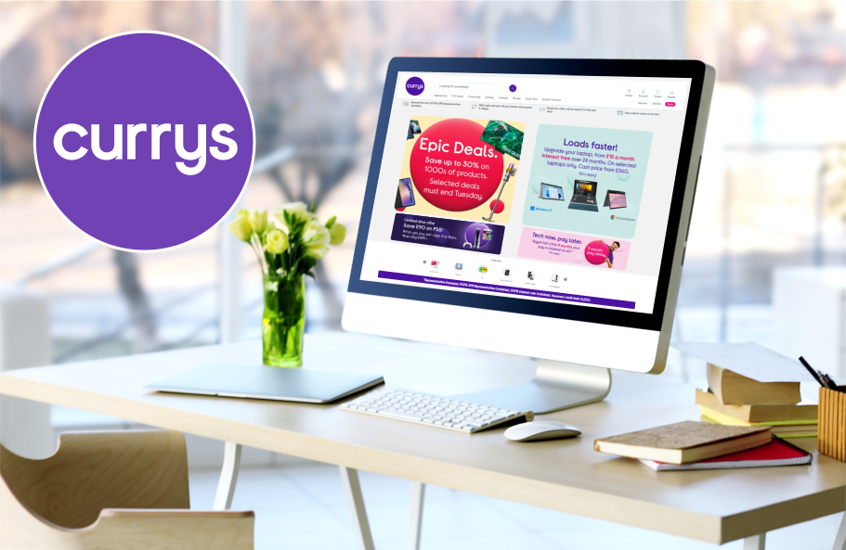

Student name: Alison Faucher
Student Number: 2236800
Lecturer: Dr Jaya Gopalkrishnan
Word count: 5000
Table of Contents
Introduction 2
- Rationale 2
- Company background 2
Part 1: Organisational Analysis and its Current Digital Strategy 3
- Organisational Strategy 3
- PESTLE analysis 3
- Customer Insights in the UK 5
- RACE Marketing Tool 10
- POEM Marketing Tool 11
- Customer Journey Map 13
- Buyer Persona 14
- Customer Analysis - Competitive Comparison and SWOT Analysis 17
Part 2: Digital Marketing Strategy 19
- SMART Objectives 19
- Overarching Strategy TOWS 21
- Online and Offline Tools 21
- Effective Digital Marketing Strategy 24
- STP Analysis 26
- Key Metrics and KPI’s 29
- Strategy Costs 35
Recommendation 36
Conclusion 37
Bibliography 38
Appendix 43

Introduction

Rationale
This report will demonstrate the use of digital marketing and the utilisation of pertaining analytical tools to build an effective marketing strategy in the digital environment for Currys, a B2C (business to customer) organisation.

Company background
In 1884, Michael Curry founded the Curry Cycle co. It initially made bicycles, then diversified into selling gramophones, radios and toys, then eventually went public by floating their shares on the stock market in 1927. (Currys plc, 2023)
Ten years later, Charles Kalm opened the first Dixon Store in Southend and they too went public by floating their shares on the stock market in 1962. Currys was acquired by Dixons in 1984 and following the acquisition of Carphone Warehouse, in 2014 Dixons became known as Currys Plc with companies including Currys PC World and Dixons Travel shops, located at airports. This increased their reputation of being the UK’s premier tech company. (Currys plc, 2023)
In 2001 Currys went online with its website with the domain currys.co.uk, offering over 600 on-line offers.
The Currys Business Model is to primarily help everyone to choose, afford and enjoy technology. They achieve this by offering the right product, expert advice, utilising an omnichannel approach with customers, demonstrations and simplifying customer’s seeking their products, or services.
Currys state that its competitive advantage is their omnichannel network, a large and flexible infrastructure, the availability of well-loved and established brands, a strong supplier network and their staff that they proudly boast as being capable and committed. (Currys PLC, 2023)

Part 1: Organisational Analysis and its Current Digital Strategy

Organisational Strategy
The strategy used by Currys, as stated on their website, is one that employs a growth profit through increased investment in its staff and customers as well as initiate distributions to its shareholders. Currys have embedded their growing profits at the heart of its strategy which influenced their vision to help everyone enjoy amazing technology, and have identified a Big Four priorities consisting of Capable & Committed Colleagues, Easy to Shop and Customers for Life
Vision Statement
Currys Plc’s strategy is generated from their company’s Vision Statement, which can be found on their annual statement. It states that it helps everyone enjoy amazing technology, however they choose to shop. Currys vision perpetuates a powerful social purpose at its core. Currys believe the power of technology should be employed to improve lives and assist in allowing people to stay connected, productive, healthy, and entertained (Currys, Plc, 2023) and is the focus behind all of their company’s ventures. They also state on their website ‘Our vision is to help everyone enjoy amazing technology’, as their company's primary products and service is in the technology market. (Currys PLC, 2023)

PESTLE analysis
Currys PESTLE analysis examines the external factors affecting its business, concentrating on the political, economic, social, technological, legal and environmental factors in a brief summary of Currys plc, as a leading UK retailer of electrical, electronic and household products:
Political
Brexit tax regulations affected Currys due to the altering duties required when operating internationally regarding their imports and exports.
Economical
Currys is affected by the variable economic factors such as the recent Bank of England interest rates, inflation rates and consumer spending.
Recently Currys was forced to close their physical shops, due to the COVID19 government lockdowns and went from a B&C (Brick & Click) to an e-commerce store only, until their retail shops were re-opened, which affected its income.
It is the 3rd largest electronics e-commerce company with approximately £9.5 billion in sales in 2022, behind Amazon and Apple, (Statista, 2023) although Currys claim to be the number 1 tech retailer in all the markets that they operate in. (Currys, 2023)
Social
Currys is committed to being an inclusive organisation with 28,000+ colleagues from different backgrounds, experiences, ethnicities, disabilities, sexualities and genders and is a founding member of Diversity in Retail. (Currys, 2023) Currys uses multiple social media platforms to promote themselves, with their YouTube channel being its most engaged and watched. (Appendix 5) (SimilarWeb, 2023).
Technical
According to Statista, Currys is the 3rd electronic e-commerce business in the UK (Statista, 2023), although Currys dispute this placing themselves as the number 1 at selling electronic/computer products from phone chargers to large screen TV’s and household white goods (Currys, 2023) while Simplyweb placed them 4th behind Amazon, eBay and Argos. (SimilarWeb, 2023) They are known for their computer products with showrooms/displays in their retail stores.
Legal
Currys is bound by the UK and any and all relevant governmental laws affecting their trading via their online and retail stores and main operations.
Environmental
Currys has created their emissions reduction targets to reduce greenhouse gas (GHG) emissions by 50% across the Group by 2030. The Science Based Targets initiative have approved these levels, as they meet the goals of the Paris Agreement. Currys is committing to the UK retail industry to be net zero by at least 2040 through its support of the British Retail Consortium's Climate Action Roadmap. (Currys, 2023)
Overall, the PESTLE analysis of Currys’ business environment shows that it faces significant challenges from all the six external forces that affect its performance and competitiveness.

Customer Insights in the UK
Currys utilises its online presence through its social media and e-commerce website to facilitate the growth of its customer base by employing the Emerging Trends in Online Marketing (Jaya, Mary. Jaya, Marla. 2016), as it engages in e-commerce, online advertising via its website and social media marketing.

Currys actively interacts with its customers via social media through its posts and communication via the comments and direct messaging. Linked in and Twitter are mainly utilised to showcase Curries corporate side, while TikTok, Facebook, Instagram and YouTube are primarily where the focus is initiated with its customers.

Social Media
- Twitter
twitter.com/currysplc

- LinkedIn
linkedin.com/company/currysplc

LinkedIn allows customers to write comments on posts and DM (Direct message)
Twitter allows customers to write comments on posts
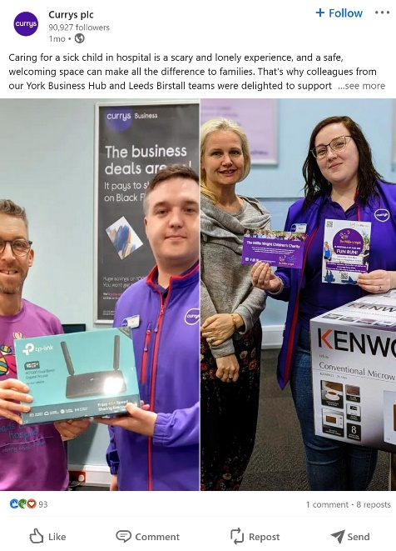
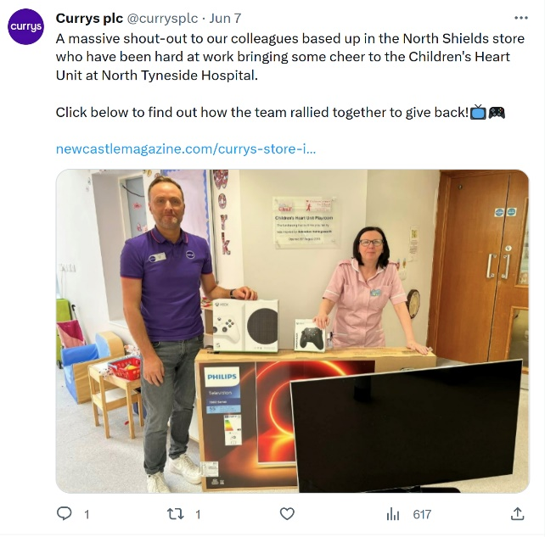
Facebook allows customers to write comments on posts and DM (Direct message)
Instagram allows customers to write comments on posts and DM (Direct message)

- Instagram
instagram.com/currys

- Facebook
facebook.com/currys

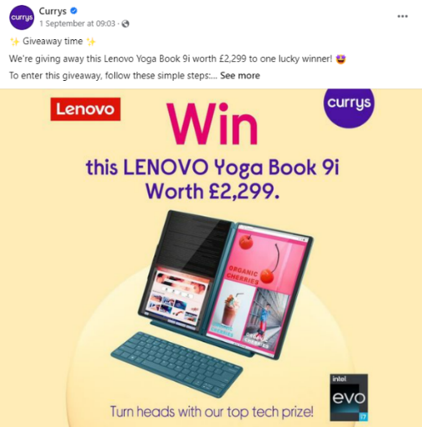
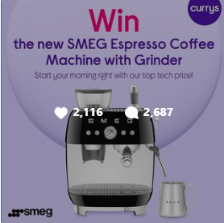
- TikTok
https://www.tiktok.com/@currys

TikToK allows customers to write comments on posts and DM (Direct message)
Instagram allows customers to write comments on posts and DM (Direct message)

- Youtube
youtube.com/c/currys


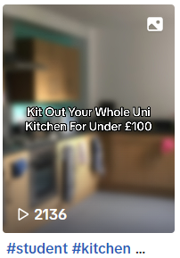

Currys uses multiple platform primarily in the advertising of their products, upcoming and recent deals, as well as community and corporate community involvement.

Online E-Commerce Store - Currys Website
currys.co.uk
Currys e-commerce website also allows customers to interact with the customer service by engaging via its:
  - ChatBots
  - Live Chat
  - Customer support Q&A
(online FAQ database)

RACE Marketing Tool
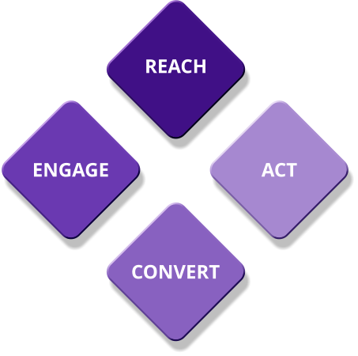
(Source created by learner, 2023)
Reach
Currys needs to employ the REACH Marketing Tool, through its utilisation of its online media platforms, to increase traffic by focusing visits to its multiple online platforms, including its social media and e-commerce website. Currys attempts to maximise its scope, through its engagement with its customers, by its creation of digital adverts, videos online offers and discounts across multiple platforms including digital new sites.
Act (short for interact)
Currys interacts with its customers via its touchpoints at each stage along the customer journey. Each is designed to foster customer interactions using their websites and social media to generate leads. Currys employ tactics such as, short term offers and price reductions, on discontinued products, to encourage customer interaction with their products with the hope of engaging prospective customers through the customer journey to eventually making a purchase. (Currys, 2023).

Convert
This is conversion to sale - either online or offline. Currys email customers that have started, but not completed their product purchase leaving their baskets with products.
Engage
Currys encourage long-term engagement form its customer through offering discounts such as 0% over 2 years repayment plans. This aids in the developing of the long-term relationship with first-time buyers in order to attract customer loyalty. Currys customer loyalty generates repeat custom and advocacy. This can be quantified through the registered purchase activity as repeat purchases and customer communications through its e-commerce website and social media comments, online presence, email and direct interactions to boost customer lifetime value. It can be measured by repeat actions such as repeat sale and sharing content through social media. (Smart Insights, 2022; Chaffey, 2019)

POEM Marketing Tool


(Source created by learner, 2023)
The POEM tool, is utilised for marketing purposes, through various media platforms to identify the ways media is utilised and its usage could be initiated and improved .

Paid
Currys pays for its video advertising on terrestrial TV and on streaming platforms, newspaper adverts and traditional posters both in-store and billboard advertisements.
Owned
The use of Currys various owned platforms, including both online and offline, such as their e-commerce website, social media, retail stores, are combined, through advertising campaigns, to increase the online traffic and face to face customer to produce an increase in customer purchases.
Earned
Currys utilises influencers across social media platforms and utilises its affiliate marketing programme to generate custom through their targeted audiences, by increasing awareness of their brand and products.
This also includes advocacy, where satisfied customers promote Currys products, but a poor customer service anywhere on the customer journey touchpoints, can negatively affect the free customer promotion with their friends and family.
It’s useful to think of earned media as developed through different types of partners such as publishers, bloggers and other influencers including customer advocates. Earned media can be envisioned as different forms of conversations occurring both online and offline.

Customer Journey Map
The customer journey for a Currys customer can be via their online (click - C) and retail stores (Brick - B) once the customer becomes aware of a product to purchasing and advocating for Currys to potential customers through friends and family.
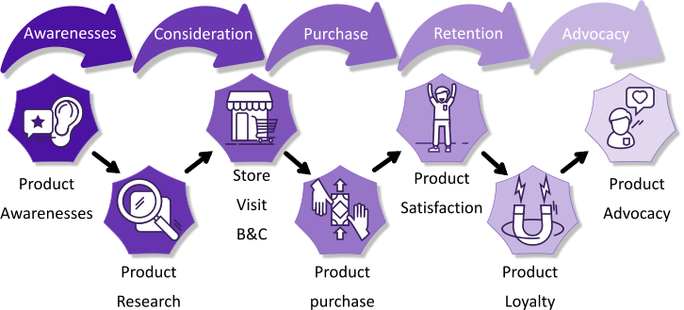
(Source created by learner, 2023)
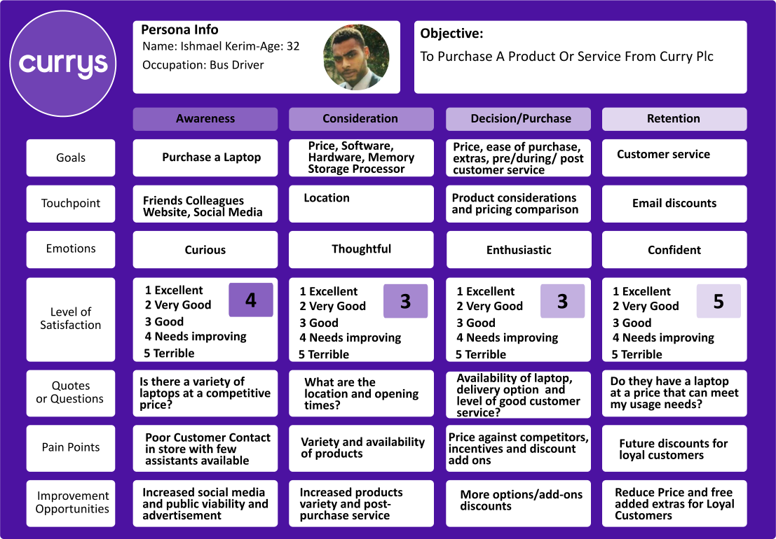
(Source created by learner, 2023)

Buyer Persona
Three typical Currys customers (see STP Analysis) consist of a student aged 19 from Manchester, a bus driver aged 32 from London and a teacher aged 44 from Eastbourne. Each lives within a town, or city with access to a retail store. All have internet access via their mobile phones, tablets or laptops. Due to their busy schedules, the student and bus driver prefer to access and purchase their products via the internet on Currys e-commerce online store. Unfortunately, the Currys app is not available, reducing their ease of access to Currys products.

The teacher prefers to go into the store and browse the products and speak to a shop floor customer service assistant, although this is one of the pain points where Currys can implement improvements of their customers' journeys, due to the limited staff available to answer their customers’ queries. Although the teacher can use a computer, she is not very technically minded and requires the assistance from a more informed customer service assistant when making her purchase in store for computing products. When purchasing other products sold by Currys, she prefers to use their online store.

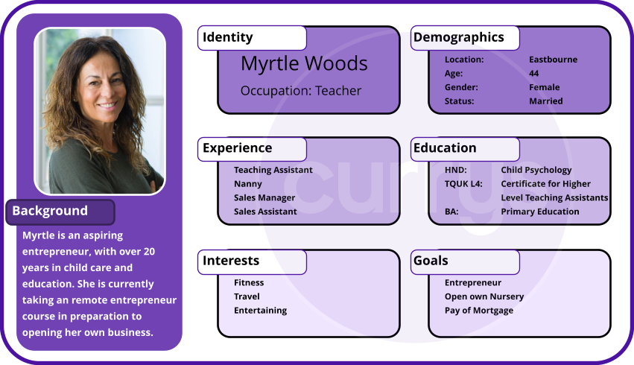(Source created by learner, 2023)

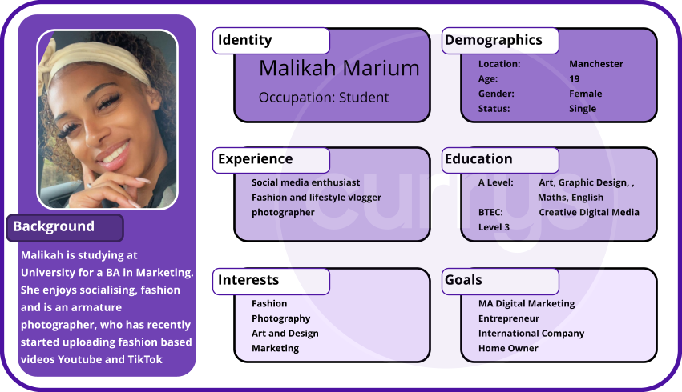
(Source created by learner, 2023)
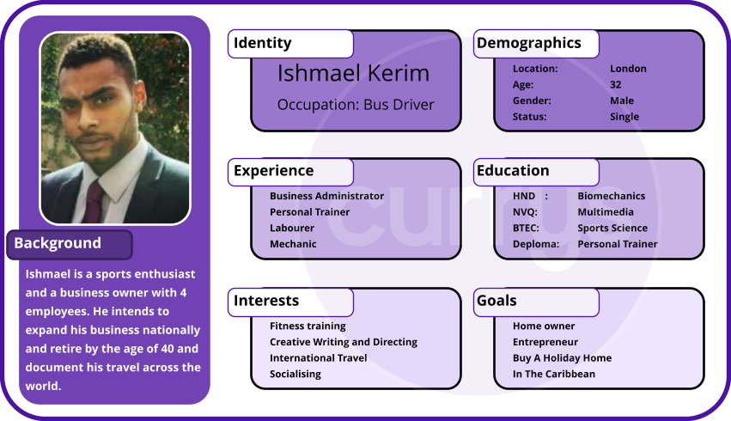
(Source created by learner, 2023)
The customer experience through the implementation of customer personas in conjunction with a customer journey map, can be a logical indicator of the main requirements of the overall satisfaction levels of the majority of customers. However, focusing on minimising customer dissatisfaction alone, the customer journey can level individual customers satisfactory experiences with a view toward a more holistic and systemic satisfaction. (Bradley, et al., 2021)

Customer Analysis - Competitive Comparison and SWOT Analysis
Currys PLC’s main competitor, also trading in a Brick & Click environment, in the UK is Argos, which was acquired by Sainsbury’s Plc. The two companies share prices as of 03.08.23 was £271 for Sainsburys PLC (J Sainsbury's PLC, 2023), whereas Currys PLC was £52.55. (Currys PLC, 2023; London Stock Exchange, 2023)
Although they are both trading within the Brick & Click environment, Currys has an advantage over Argos, as the customer can browse their products on display on the shop floor, where Argos has a more streamlined approach, allowing customers to search their electronic catalogue, place and pay for their orders, then pick up their products in store. The more streamlined approach is more economical for the business, due to less staff and shop floor space and is more timely for the customers that are satisfied to view their potential purchases as an image only.
SWOT Analysis
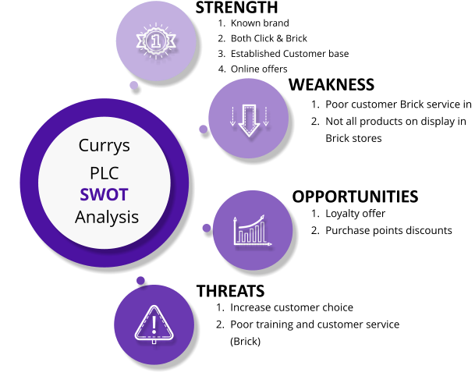
(Source created by learner, 2023)
The SWOT Analysis for Currys, demonstrates its internal strengths and weaknesses, its external opportunities and any threats that they exhibit. Once these are identified, such as their retail store customer service, they can be addressed to create strategies to eradicate any weaknesses and build on their strengths, to allow for the upward growth of Currys brand and market position, both nationally and internationally. This will encourage Currys to be secure that their competitors do not gain a competitive advantage, as they secure any presenting opportunities for growth. (Smart Insights, 2022; Chaffey, 2019)
Competitive Positioning Map
Currys PLC state that their competitive advantage is their omnichannel network, a large and flexible infrastructure, the availability of well-loved and established brands, a strong supplier network and their staff that they proudly boast as being capable and committed. (Currys PLC, 2023)
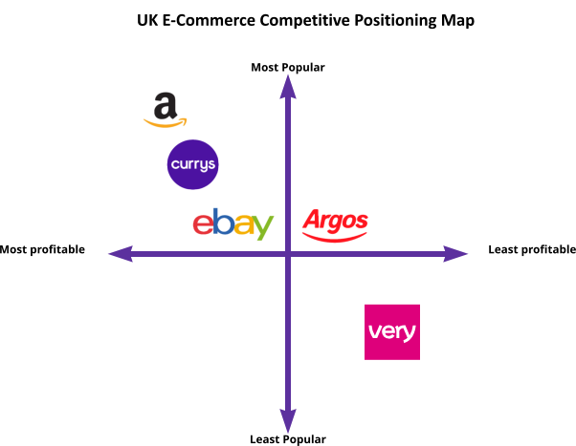
According to Statista, the leading consumer electronics online store in the United Kingdom in 2022 was Amazon.co.uk with an estimated sales of $5.2 billion in that segment, Currys plc with an estimated $1.8 billion, eBay UK. $1.58B, Argos, $1.2 billion and Very with $2.3148 (Ecommercedb For Statista, 2023) in e-commerce net sales. (Statista, 2023) According to these UK sales figures, Currys is the 2nd most profitable e-commerce business among their competitors with Amazon placing 1st and Argos and eBay behind.
(Source created by learner, 2023)
Semrush Competitive Position Map places Currys 2nd behind Argos, although their data is based on paid search results (Semrush, 2023). Similarweb positions both eBay and Amazon above Currys (see Appendix 04) (SimilarWeb, 2023)
Semrush’s Competitive Position Map (Appendix 1) is based on organic search traffic and keywords, and places Argos above Currys (Semrush, 2023).

Part 2: Digital Marketing Strategy

SMART Objectives
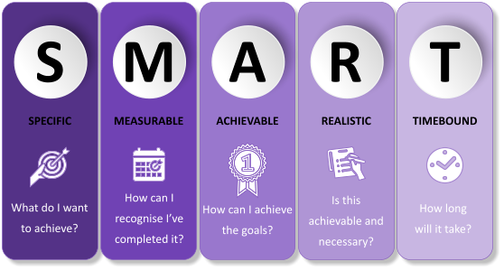
(Source created by learner, 2023)

Specific
Currys aim to enable access to the best and latest electronic products and electrical appliances for everyone to use at affordable prices for all demographics depending on the individual needs and wants within their price range.
Measurable
Currys employs the collection of qualitive and quantitative data captured on purchases, payment plans and customer feedback, to inform their strategic procedures.
Achievable/Actionable
Currys has implemented environmental targets to reduce their greenhouse emissions over the next 7 years and is committed to achieving 0% by 2040. (Currys, 2023)
Realistic/Relevant
Currys needs to improve their customer service levels in the retail stores, which can be obtained through relevant and specialised training and an increase in shop floor staff, in addition to the implementation of digital catalogues with payment facilities. These would increase their customer satisfaction and reduce their pain points through the customer journey.
Timebound
If Currys introduce the digital catalogues with payment facilities in retail stores it can decrease the customer waiting times and increase the customer satisfaction level.

Overarching Strategy TOWS
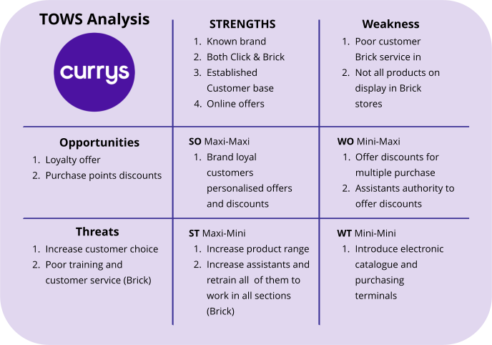
(Source created by learner, 2023)
The TOWS Matrix (appendix 003) is based on and builds on the SWOT analysis. It is a powerful analytical tool that combines the internal and external factors of SWOT to create additional analytic factors (ST maxi-mini, SO maxi-maxi, WO mini-maxi, WT mini-mini) and in doing so extend the capabilities of SWOT into the TOWS Matrix. It can be employed (Chaffey, Dave, et al, 2018)

Online and Offline Tools
Online Tools
Currys employs the use of
- e-commerce
- social media
- online advertising
- affiliate programme
- Streaming advertising
- Apps (removed from use due to updating)
- Direct marketing
Offline Tools
- Display advertising (Billboard)
- Traditional print advertising
- Trade show
- Traditional terrestrial television advertising
As technology evolves at a rapid rate, it challenges more and more sectors within multiple fields to adapt and keep up with it, and acclimatise to the increasing advances in technology. This produces opportunities for businesses to enhance their digital footprint on multi-layer online platforms, such as social media websites and blogs.
These can, and have been utilised to persuade and influence the customer to make a purchase, regardless of their absolute need, or want for the products purchased.
Tracking the analytics of the customer digital foot print through their online engagement, can be immediate and has become a significant route to obtaining quantitative data to inform marketing strategies. (Bengel, et al., 2015)
Currys e-commerce website achieved a bounce back rate of 45.1%, while eBay, their competitor achieving 29.82% and a page conversion rate of less than 2% (Yeo, et al., 2020). Their monthly visits reached 359.1m while the average time that the customer spends on the Currys website 00:04.44, below that of its competitors, (SimilarWeb, 2023)

SEO
The collection and track of specific metrics to inform Currys on their online presence:
- Page views
- Bounce rates
- Customer conversions
- Page ranking against competitors
- Conversion rate optimisation
- Page speed
- Site’s crawlability
- Website performance in terms of architecture, content curation, and user behaviour
- Leads
- Engagement metrics
(Appendix 4&5) (SimilarWeb, 2023)
SEO data can help you analyse and understand mistakes, create new ideas, strategies, and adjust existing goals. Datasets related to website performance in terms of architecture, content curation, and user behaviour
The SEO qualitative and quantitative data can be used to inform performance related analytical marketing tools to create pertinent performance-enhancing strategies and negate any negative areas that are affecting the company's customer interaction, performance and profit.

Direct Marketing
Emails or text messages
Currys adheres to the governmental mandated law for email marketing where they must clearly state:
- Their organisations name is legible and evident
- Purchasable products, or service
- Any and all promotions, discounts and all relative conditions
- Only send emails to names that are on the companies Email Preference List/Database
- Permission is obtained before sending marketing emails to individuals
- Ensure that any rented, or purchased email lists have the permission to be used for email marketing purposes
- An unsubscribe, or opt out option must be included in all emails
- Inform any and all individuals that you have placed on a no email list
(UK Government, 2023)

Effective Digital Marketing Strategy
The most effective Digital Strategy is one that is relevant to the organisation it is created for. There is not a one-size-fits-all template that can be utilised to fit any and all businesses, as every business has different organisational structures, whether they are a brick, click, brick and click, such as Currys. Utilising tool such as the IMC model and TOWS/SWOT analysis informs the areas where a company works well and needs improvement and where the advertisements should be most beneficial on both the online and offline environment.
The Digital Strategy should be aware and make allowances for new and upcoming technologies that can enhance the companies digital marketing planning, such as AI with its speed and unique ability to adapt to environments and consume and develop copious data. (Sterne, 2017)
The content must successfully align with the company’s principles and goals, such as increase annual profit by 10%, raise awareness of the companies improvement of its integration of environmentally sensitive products and infrastructure, utilising the relevant strategies that best, inform, demonstrate and detail the necessary data. (Kingsnorth, 2022)
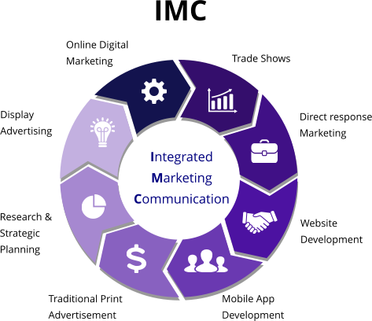
Integrated Marketing Communication

(Source created by learner, 2023)

The IMC model combines the offline and online traditional and the expanding modern forms of marketing, with trade shows to mobile app development and the use of AI in marketing, IMC is influential too when utilising creating a profitable marketing plan.
The six categories of digital communications tools, or media channels (Appendix 4) and the IMC Model can be used to ascertain the best marketing strategy on multiple platforms using both online and off line marketing. The Digital marketing has the potential to have a far wider reach in a shorter timeframe, such as the use of social media, using own and brand ambassador platforms.

STP Analysis
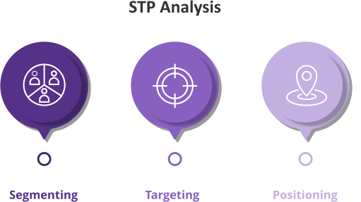
(Source created by learner, 2023)
STP analysis separates and selects specific categories belonging to the specified customer base. The market segmentation provides the fundamental basis for the identification of the Currys main customer group. The grouping of the customer similarities and preferred characteristics aid in the final preferred customer profiles. STP can also lead to the identification to new and underserved customers sections. (Jobber & Ellis-Chadwick, 2019)
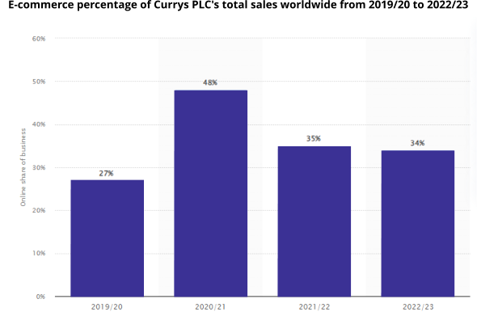
(Statista, 2023)
Segmentation
Segmentation segregation of STP will usually consist on one, or more of the following areas
- Demographics - Who Currys Customers are?
This section is usually segmented by age, gender, highest education level achieved, location of home or work, choice of profession, income
- Psychographics - Why become a customer of Currys?
This section is usually highlights the customers by priorities in life, personality traits, beliefs set, life values,
- Lifestyle traits - Reasons customers likely to purchase products
Social gatherings, entertainment choices, time constraints
- Behaviour – Voluntary actions undertaken by Currys customers
Brand loyalty, recognition, shopping habits (Hubspot, 2021)

Currys should focus on the segmentation students, young to older working adults (Appendix 10) that prefer both online and in-person shopping with a low to high/middle income wage that, demonstrate brand loyalty through repeat purchases.
Targeting
Used to strategically identify the targeted area of the Currys customer demographic and focusing on utilising specified questioning:
- Does the focused targeted section consist of enough potential customers to support targeting?
- How likely is the profit margin to rise with focused targeting?
- Is the focused targeted group easily separated from the other focused sections?
- Can the access to the focused target area be accessed easily?
- Does Currys have the capability to direct their sales towards the focused target group?
- Has Currys generated enough efforts to clarify any and all social, legal, physical, or technological obstacles that could eliminate the targeted areas?
The target group should focus on adults ages 18 – 54 as they have a higher interaction on the Currys e-commerce website and tend to have a better understanding of the technical advances and utilise the internet at a higher frequency. (Appendix 7) (Hubspot, 2021)

Positioning
The focus for Currys should concentrate on customers from all social backgrounds, with differing product knowledge, medium to high internet usage at places of education, work and home between the ages of 18 – 54 (Appendix 7)

The best market solution for Currys is to build on their present online market position to one of the most recognised international e-commerce electric and electronic retailers, not including any of their digital mediums or their retail stores. Currys were placed at a ranking of 128, with Amazon number at 4 (SimilarWeb, 2023). (Appendix 4)
Currys should focus on strengthening their market position by incorporating the latest digital retail equipment, improving customer service, product range and increasing its brand visibility. .

Key Metrics and KPI’s
The importance of the implementation of the quantitative KPI’s is largely due to the results feeding the potential of increased product sale and future profits. The customer needs to be identified and targeted to become aware and influenced to travel along the customer journey to its successful product purchase completion with advocacy. Various e-commerce KPI’s can be measure against Currys main competitors and can be used to create marketing goals. (Appendix 9 &10)
The results from the Currys STP Analysis needs to be address and incorporated in to a targeted marketing approach to drive the potential increase of product purchases at the POS (Point Of Sale).
The use of Currys social media in their Digital Marketing Strategy is one that allows the Currys community at large to interact with Currys, on multiple platforms to access information, view advertisements, direct message and take part in community conversations on posts and gain further information via Currys social media customer servicer operatives.
The measurement of the influence of social media, as a communication tool, is a challenging endeavour that tackles the effect of the rise of the Social Media Influencers (SMIs). The social media variable can be complicated, while many companies, both large and small have adapted to incorporate affiliate marketing, paid advertisement embedded withing social media videos and paid product reviews. The results of the utilisation of SMI’s can be difficult to quantify with a limited control over the final content, so insisting on contracts where the SMI’s posts have to be evaluated prior to any uploading of content.

The quantitative and qualitative KPI’s such as number of views, comments, likes and followers during the specified collaboration, can be adapted to measure the popularity of the SMI’s posts and the use associated of affiliate links clicks, it can be difficult to measure when the SMI’s uses multiple social platforms.
The amount and the positive or negative comments indicate trends and popularity of a product, especially if other SMI’s create posts that are unpaid and completely voluntary. YouTube is a popular platform that displays paid and unpaid SMI’s collaborative posts. (Gräve, 2019) (Appendix 6)

The bounce back rate for Currys is 45.1%, while eBay, their competitor achieves 29.82%. As Currys page views by customers reached 67.14m, Amazon managed 2.869b and their monthly visits hit 359.1m while Currys reached over 16.01m. The average time that the customer spends on the Currys website 00:04.44, below that of its competitors, Argos, Amazon, eBay, with eBay having the longest customer visiting/viewing time of 00:08:51. (SimilarWeb, 2023)

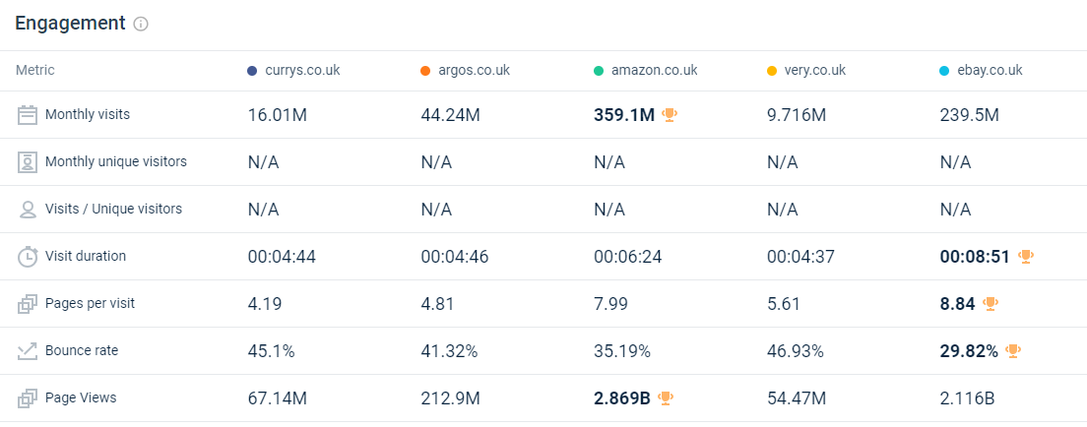 (SimilarWeb, 2023)
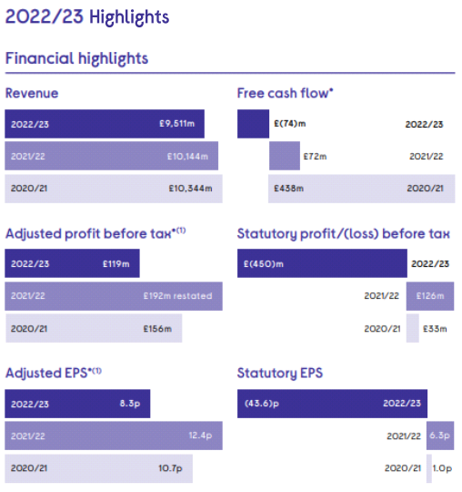
The total revenue generated
by the Currys with sustainable growth being
measures their brand appeal
and competitive position.
Performance in 2022/23
Group Revenue declined (6)% on a reported
basis due to the LFL decline.

Utilise to measure the inherent trading performance of
the Currys on a year-on-year basis.
Performance in 2022/23
(Like for Like) LFL revenue decline due to weak consumer
demand across most markets together with
a moderate market share loss.

(Currys PLC, 2023)

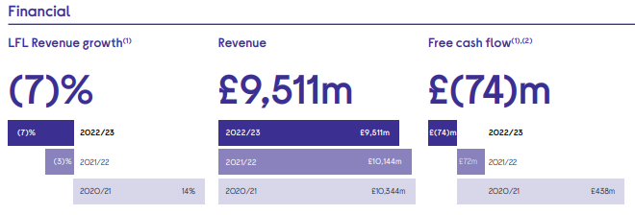
The Like-for-like (LFL) revenue growth for Currys is adjusted for new and closed stores and other changes in its business enabling the
Measurement of the underlying trading execution of Currys on a year-on-year basis.

In 2022/23 the LFL revenue declined due to weak consumer
demand with modest market share losses.
Currys free cash flow represents available finance post its operational cash outflows, cash tax and interest paid and capital investment prior to any pension
contributions. Currys utilise it to measure of its ability to produce finance and effectively manage its working capital that optimises cash resources available to invest in its future growth and to generate shareholder return.

In 2022/23 Currys Lower operating profits in the Nordics, and a working capital outflow due to sales
decline led to a free cash outflow during
the year.
Currys revenue details its total revenue generated by sustainable growth
measuring their brands appeal
and competitive position.
In 2022/23 Currys Revenue declined by (6)% on a due to the LFL decline.

(Currys PLC, 2023)

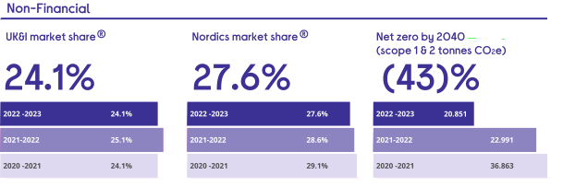
Currys calculated the decrease in Scope 1 and 2 greenhouse gas emissions productions, within the
the agreed Green House Gas Protocol standards. It utilised the employment of the methodology set out in Defra’s Environmental Reporting Guidelines, in reference to the Groups total emissions in financial year of 2019/20 (36,863 tonnes), as the best form to achieve an accurate measure of Currys progress to achieving net zero emissions by 2040.

In 2022/23 Currys has achieved a reduction in its energy consumption and Scope 1 and 2 emissions for this year.
Currys market share is the best indicator that its intention to deliver to its customers successfully is much more attractive than its competition from its competitors within the same market. Its market share is characterised as Currys product sales relative to its total consumer sales of technology products in each market it has entered.

In 2022/23 Currys maintained its leading market share the UK and the Nordics even though its increased its competitive pressure in the Nordics, resulting in an increase in the excess of product stock.

In the UK market Currys share has turned down (100)bps compared to the same period last year. Currys reduced its market share in the consumer electronics and computing sectors, but gained a footing in the share in major domestic appliances.

In the Nordics, Currys market share was down (100)bps compared to the similar period last year.

(Currys PLC, 2023)
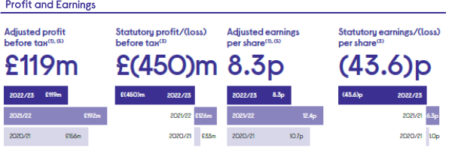
Currys adjusted basic EPS details the profit after tax, but before adjusting items, pertaining to each share after taking into account the alteration in volume of shares in issue from year to year. Its level of growth delivers a clear measure of the financial health of Currys and its capability to distribute returns to each if its shareholders each year.

In 2022/23 Currys decrease in EPS was pushed by the reduction in its profit.
Currys achieved sustainable growth of profit before tax and adjusting items details an excellent measurement of its performance against its strategic priorities and
an demonstrates of how they foster long term value for all of its stakeholders.

In 2022/23 Currys Adjusted profit before tax decreased during the year prior to the unfortunate deterioration in Nordics performance. Its statutory profit before tax was
additionally impacted by the non-cash write-down of goodwill.

(Currys PLC, 2023)

Strategy Costs
The majority of customers do not make a purchased on their initial visit to an e-commerce website, such as Currys, so with a 98%, rate the conversion rate needs to be lowered. This can be achieved with a robust marketing plan incorporating strategies developed from the employment of a variety of analytical marketing tools. The results are assessed and incorporated to create the most effective marketing plan to entice customers to stay on the e-commerce website and view more products and initiate and finalise a purchase on their first visit. (Yeo, et al., 2020)

In 2022, it was recognised that the results from surveys detailing the financial costs for business marketing budgets, recovered from their average financial spends, immediately post the pandemic era. The average financial spend on marketing was approximately 6.4% - 9.5% of a company’s annual revenue irrespective of the industry and markets that they are in. Although this is an improvement from the previous year, it is definitely a notable drop from the pre-pandemic years levels, where the average financial spend was approximately 10.9% during 2021 and 2022 respectively.

While the customer journey develops with the new and evolving technology being integrated into all areas of the everyday lives of the average customer, the economical budget spend of businesses throughout all marketing areas, the financial allocation of marketing funds preferred the core marketing capabilities. Business stated that their marketing budgets are being utilised on programme and operational areas withing their organisations.

The CMO’s top three financial investments were as follows:
- Campaign creation and management (10.1%)
- Brand strategy (9.7%)
- Marketing operations (9.6%) (Gartner, 2022)
With Currys 2022 revenue at £ £9,511m and employing the surveyed average financial spend on marketing being approximately 6.4% to 9.5%, their budget for their annual marketing strategy costs should approximately total between £608,704m to £903,545m. (Gartner, 2022)

Recommendation
With the data gathered from the marketing analytic tools and the online digital analytics, Currys would improve their customer position in the electric and electronic markets through the implementation of the results from the marketing analytical tools, such as SWOT, TOWS, STP Analysis , IMO, POEM, RACE and the SMART matrixes.
Currys market position and customer interaction needs to be swiftly addressed in order to increase its financial position and customer purchase rate.
A Digital Marketing Plan is required to facilitate the change identified with KPI’s and any additional analytical tools utilised to identify the targeted demographic group.
An increased customer interaction in both the brick and click environments and the poor customer service in the retail brick sector, must be addressed to improve satisfaction level to remove the possibility of the severing of the customer along their product purchase journey.
The implementation of a digital catalogue and pay point standalone system in all locations will reduce the poor face-to face customer service touchpoints. Incorporating benefits and up-selling at the point of sale will increase Currys potential sales and profit margins.

Conclusion
The employment of the marketing analytical tools, such as SWOT, TOWS, STP Analysis, IMO, POEM, RACE, SMART matrixes and their findings have been utilised in order to ascertain the importance in creating a Digital Marketing Plan. The incorporating of various strategies within the Digital Marketing Plan, enables Currys to implement any and all necessary procedures that facilitate the growth in its financial standing with a greater profit target coupled with an increase customer interaction.
The increased customer interaction will be based on a multi-facetted approach in both the brick and click environments. Customer satisfaction levels must rise in order to drive the bounce back rate and customer advocacy. The product sales is essential in the elevation of profit, but all areas need to be address that have been identified as requiring essential attention across the e-commerce and retail environments.
Customer service in the retail brick sector, needs to be improved through education in all product areas with an increased presence in addition to the implementation of a digital catalogue and pay point standalone system in all locations, is required to assist in the reduction of need in any potential unnecessary staff interactions, where possible and also to increase the customer product interaction and an increase in sales driven up-selling at the point of purchase.
Once these have been attained the Brand power will improve along with the market position and strength compared to Currys competitors.

Bibliography

Bengel, A., Shawki, A. & Aggarwal, D., (2015). Simplifying web analytics for digital marketing. IEEE International Conference on Big Data , pp. 1917-1918.
Bradley, C., Oliveira, L. & Birrell, S., (2021). A new perspective on personas and customer journey maps: Proposing systemic UX. International Journal of Human-Computer Studies, 148(102583).
Chaffey, D., (2019). DIgital Marleting. 7 ed. s.l.:Pearson Education.
Chaffey, D., Hemphill, T. & Edmundson-Bird, D., (2018). DIGITAL BUSINESS AND E-COMMERCE MANAGEMENT. 8 ed. s.l.:Pearson.
Currys plc, (2023). About Us. [Online] Available at: https://www.currysplc.com/about-us/history/ [Accessed 03 August 2023].
Currys PLC, (2023). Annual Report 2011 - 2023. [Online]
Available at: https://www.currysplc.com/media/fa4dn4ef/41183-currys-ar-2022-23-web.pdf [Accessed 1 8 2023].
Currys PLC, (2023). business-model. [Online] Available at: https://www.currysplc.com/about-us/business-model/ [Accessed 03 August 2023].
Currys PLC, 2023. Share Price Chart. [Online]
Available at: https://www.currysplc.com/investors/share-price-tools/share-price-chart/
[Accessed 03 August 2023].
Currys PLC, (2023). Strategy. [Online]
Available at: https://www.currysplc.com/about-us/strategy/ [Accessed 03 August 2023].
Currys, Plc, (2023). Results, Reports & Presentations. [Online]
Available at: www.currysplc.com/media/fa4dn4ef/41183-currys-ar-2022-23-web.pdf
[Accessed 1 August 2023].
Currys, 2023. Circular Economy. [Online]
Available at: https://www.currysplc.com/sustainable-business/circular-economy/
[Accessed 05 08 2023].
Currys, (2023). People & Careers. [Online]
Available at: https://www.currysplc.com/people-careers/
[Accessed 9 08 2023].
Doyle, P. & Stern, P., (2006). Marketing Management and Strategy. 4 ed. Essex: Pearson Education Limited.
Ecommercedb For Statista, (2023). eCommerce net sales development of very.co.uk. [Online]
Available at: https://ecommercedb.com/store/very.co.uk [Accessed 28 8 2023].
Gartner, (2022). What Marketing Budgets Look Like in 2022. [Online]
Available at: https://www.gartner.com/en/articles/what-marketing-budgets-look-like-in-2022 [Accessed 20 8 2023].
Gräve, J.-F., (2019). What KPIs Are Key? Evaluating Performance Metrics for Social Media Influencers. Social Media + Society, 5(3).
Hubspot, 2021. The Marketer's Guide to Segmentation, Targeting, & Positioning (STP Marketing). [Online]
Available at: https://blog.hubspot.com/marketing/segmentation-targeting-positioning
[Accessed 28 07 2023].
J Sainsbury's PLC, (2023). Share Price Information Chart. [Online]
Available at: https://about.sainsburys.co.uk/investors/share-price-information/chart
[Accessed 03 August 2023].
Jaya, M. A. & Jaya, M. P., 2016. Innovative digital marketing trends 2016. IEEE, pp. 4882-4888.
Jobber, D. & Ellis-Chadwick, F., (2019). PRINCIPLES AND PRACTICE OF MARKETING. 9 ed. s.l.:McGraw-Hill Education.
Kingsnorth, S., 2022. Digital Marketing Strategy An Integrated Approach To Online Marketing. s.l.:Kogan Page Limited.
London Stock Exchange, (2023). CURRYS PLC. [Online]
Available at: https://www.londonstockexchange.com/stock/CURY/currys-plc/analysis
[Accessed August 2023].
Marks And Spencer, (2023.) Finacial Statement and Annual Report. [Online]
Available at: https://corporate.marksandspencer.com/sites/marksandspencer/files/marks-spencer/investor/Annual%20Report%202023/M%26S_AR23_Strategic_report.pdf
[Accessed 09 August 2023].
Semrush, (2023). Domain Overview Currys.co.uk. [Online]
Available at: https://www.semrush.com/analytics/overview/?searchType=domain&q=currys.co.uk&db=uk [Accessed 25 07 2023].
SimilarWeb, (2023). Website Performance. [Online]
Available at: ttps://pro.similarweb.com/#/digitalsuite/websiteanalysis/overview/website-performance/*/999/3m?webSource=Total&key=currys.co.uk,argos.co.uk,amazon.co.uk,very.co.uk,ebay.co.uk [Accessed 10 08 2023].
Smart Insights, (2022). Introducing The RACE Growth System and RACE Planning Framework: practical tools to improve your digital marketing. [Online]
Available at: https://www.smartinsights.com/digital-marketing-strategy/race-a-practical-framework-to-improve-your-digital-marketing/ [Accessed 03 08 2023].
Statista, (2023). E-commerce percentage of Currys PLC's total sales worldwide from 2019/20 to 2022/23. [Online]
Available at: https://www.statista.com/statistics/1325982/ecommerce-sales-share-currys/#:~:text=Currys%20PLC%3A%20company%20profile&text=In%202022%2F23%2C%20the%20company,industry%20heavyweights%20Amazon%20and%20Apple. [Accessed 03 08 2023].
Statista, (2023). Leading consumer electronics online stores in the United Kingdom in 2022, by e-commerce net sales. [Online]
Available at: https://www.statista.com/forecasts/870870/top-online-stores-consumer-electronics-united-kingdom-ecommercedb [Accessed 17 08 2023].
Sterne, J., (2017). Artificial Intelligence for Marketing: Practical Applications. s.l.:Wiley .
UK Government, (2023). Marketing and advertising: the law. [Online]
Available at: https://www.gov.uk/marketing-advertising-law/direct-marketing
[Accessed 14 8 2023].
Wood, M. B., (2013). Essential Guide to Marketing Planning. 3 ed. Harlow: Pearson Education Limited.
Yeo, J. et al., (2020). Conversion Prediction from Clickstream: Modeling Market Prediction and Customer Predictability. IEEE Transactions on Knowledge and Data Engineering, 32(2).

Appendix
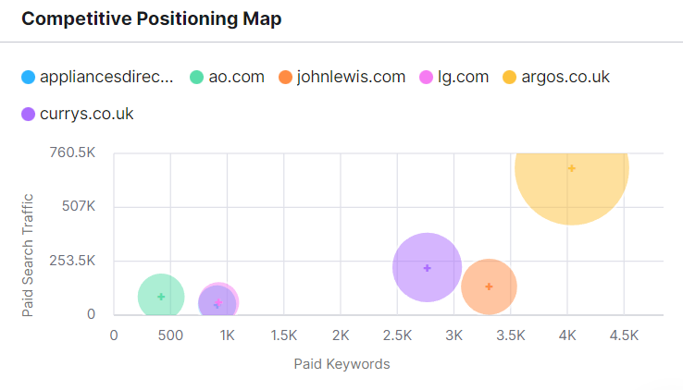
Appendix 1
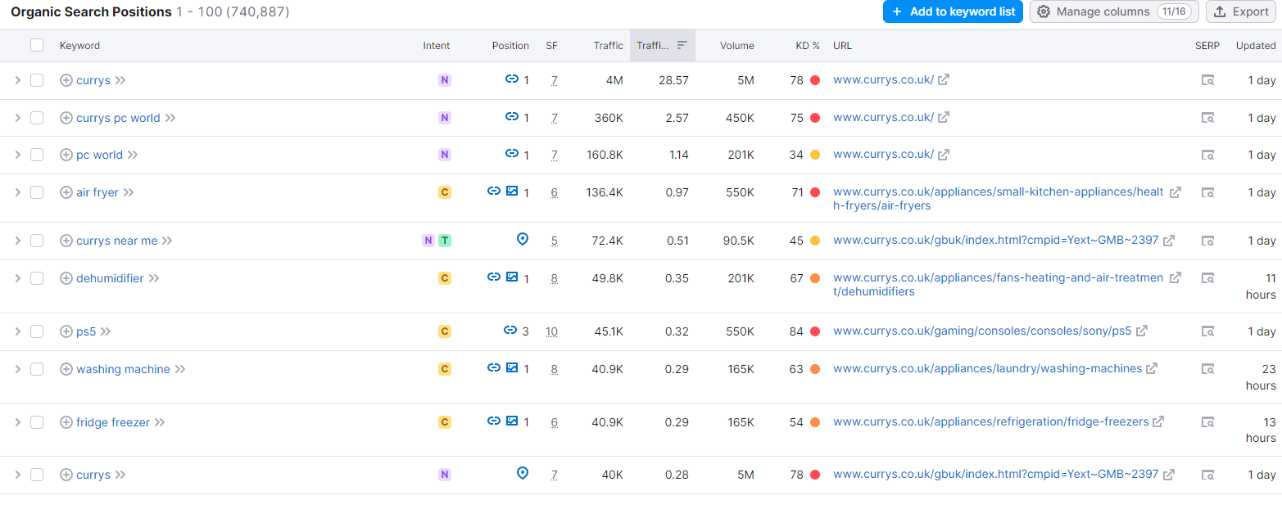 Appendix 2

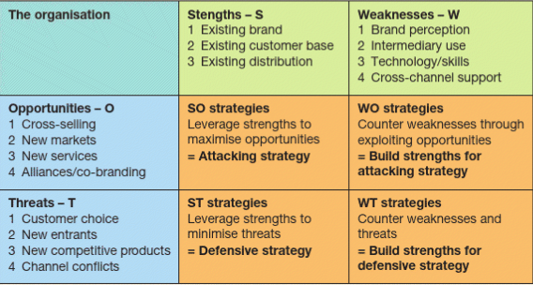 Appendix 3
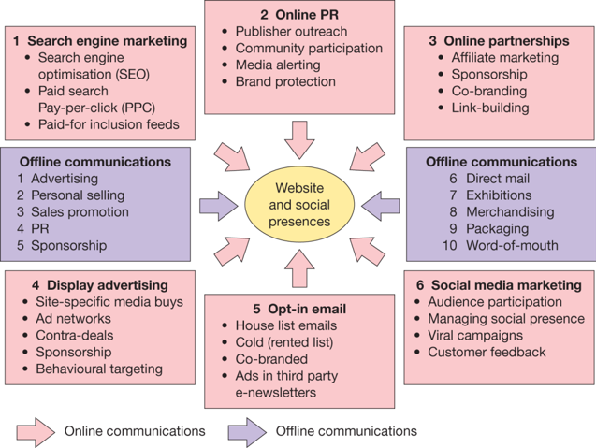

Appendix 4
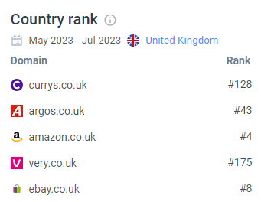
Appendix 5

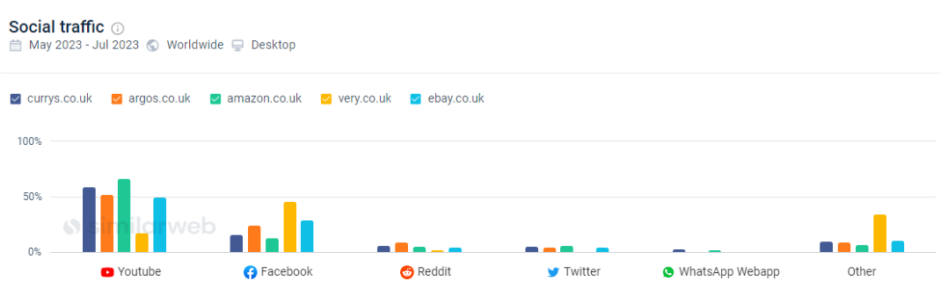
Appendix 6

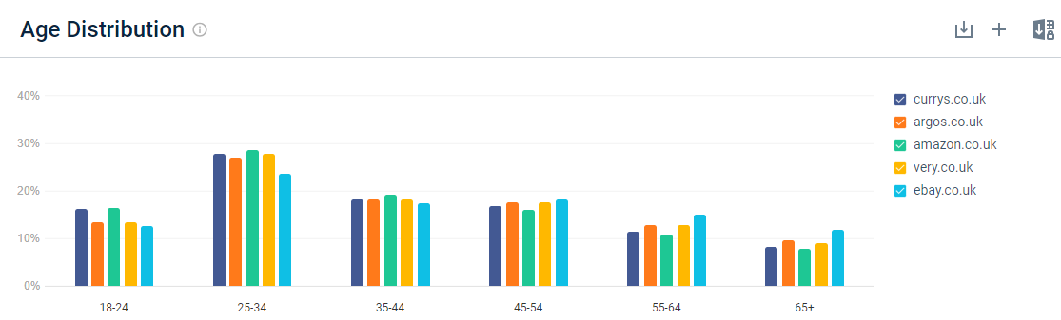
Appendix 7

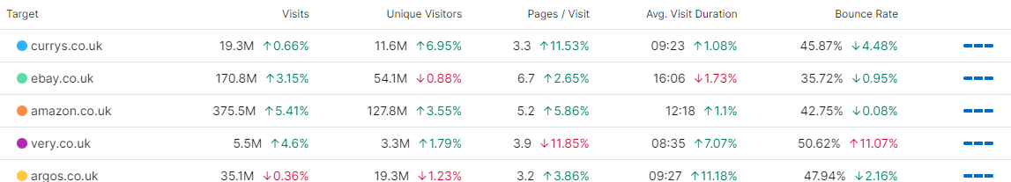
Appendix 8

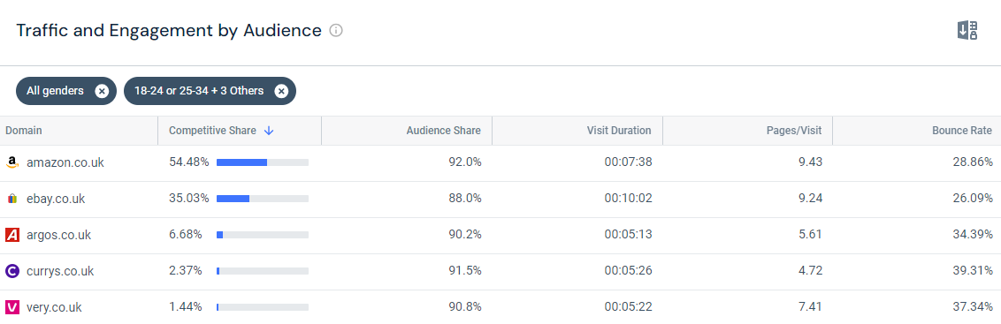
Appendix 9

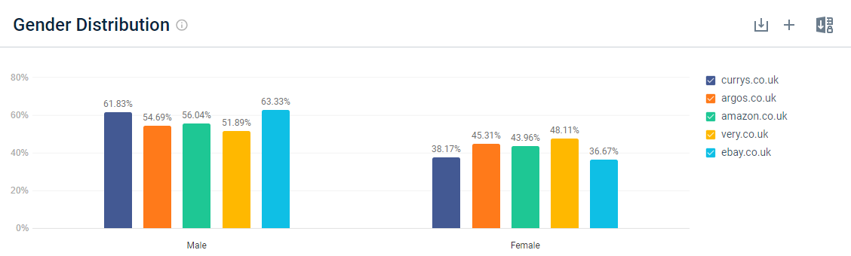
Appendix 10

