
APPENDIX GA36d

LEVEL 7 ASSESSMENT SPECIFICATION

Student name: | Bryony Hopkins | Student ID number: | 1300244
Programme: | Secondary PGCE
Module: | Investigating Contemporary Issues in Secondary Education
Module code: | ECSP7001 | Contribution to Overall Module Assessment (%): | 100%
Lecturer: | Stephen Hadley | Internal Verifier:
Assignment Title: | Investigating Contemporary Issues in Secondary Education | Word count (or equivalent): | 4,949 words
Submission deadline: | January 28th 2019 | Return date of provisional marks & written feedback: | February 19th 2019
Submission method: | All written assessments, where practical and possible, must be submitted via Turnitin unless otherwise instructed by the Lecturer. (Please DO NOT put this assessment specification into Turnitin or it will match many similarities with other students’ submissions.)  Alternative submission method (if applicable):  Late submission of the assessment will result in a late penalty mark. Penalties for late submission: Up to one week late, maximum mark of 50%. Over one week late, 0%. Only the Extenuating Circumstances Panel may approve a change to submission dates.
Academic honesty / referencing: | Academic honesty is required. In the main body of your submission you must give credit to authors on whose research and ideas your work is based. Append to your submission a reference list that indicates the books, articles, etc. that you have used, cited or quoted in order to complete this assessment.

Assignment 2: Investigating Contemporary Issues in Secondary Education
This assignment focuses on pupils eligible for free school meals (FSM) and considers various methods and strategies in place to improve their grade attainment at Key Stage 4 (KS4). Research shows that poverty amongst children in the UK can have an adverse effect on attainment during their formative years of education (McKinney, 2013). There is an obvious gap between learners in receipt of FSM in comparison to non-FSM pupils; this paper explores the possible reasons why these pupils often fail to meet similar levels of attainment to their peers. The current development plans employed by School A will be reviewed and analysed through the use of professional documents and academic literature, and suggestions will be made, with an aim to improve the attainment of learners in receipt of FSM.
The Departmental Improvement Plan for School A (see Appendix A) highlights the improvements the Humanities Department aims to focus on over the current academic year (2018-2019). The department has selected two priorities from the School Development Plan (see Appendix B) and created a suitable success criteria. The first priority aims to ‘improve standards at the end of KS4 for all pupils.’ To achieve this, the department has chosen the three areas it believes it can focus on, including: improving standards of pupils in receipt of FSM; boys in comparison to girls; and the literacy and numeracy skills of all pupils. To meet these standards, each subject within the department has listed actions that it will follow with intent to improve overall KS4 results. For geography, a target has been set to 50% of pupils to achieve an A* - C grade in GCSE Geography and to meet this target, some of the actions in place include: reviewing mock exam results; discussions with Head of Year regarding underperforming pupils and the actions they can take to improve results; and ensuring controlled assessment tasks are completed to a standard that is at least equal to their predicted grade. It is also stated that pupils should only select the subject from the options list if they are in set 1 or 2 for humanities. This is due to the challenging nature of the course and the appropriate target grades of the pupils within these sets. The other priority that the department is focusing on is to ‘improve the quality of teaching and learning within the faculty.’ The staff aim to achieve this by continuing to attend meetings to share good practice and resources throughout the academic year. The use of peer support and sharing practice can be extremely beneficial especially in the application of a new scheme or idea that the school wishes to introduce. Having the opportunity to meet and discuss possible issues and successful strategies with one another can also be constructive as teachers can aid peers by answering each other’s questions and highlighting practice that worked well within their classroom (Lesaux et al., 2013).
The overall School Development Plan is currently focusing on five priorities over this academic year. The first priority - which could also be considered the humanities department’s main focal point - is to ‘improve standards at the end of KS4 for all pupils.’ As already discussed, this standard will be achieved through a number of actions put in place. The action that will be addressed within this paper will be the attainment of pupils in receipt of FSM. This can be considered a challenging area to gain sufficient improvement in, due to the high percentage of pupils who receive FSM. Statistics show that currently 49.8% of pupils attending School A are classed as recipients of FSM, which is significantly below the Local Authority that currently stands at 18.3% and the Welsh average of 16.6% (Welsh Government, 2017).
The second priority is the importance of wellbeing and attitudes to learning. This includes improving attendance and building pupils’ life skills in readiness to prepare them for life after secondary education. Thirdly, School A shifts its attention to teaching and learning experiences. This is highlighted in the Departmental Improvement Plan for humanities, and School A intends to encourage teachers to use a variety of teaching approaches to engage all learners and create interesting and exciting lessons. School A also places a significant emphasis on the importance of developing literacy and numeracy skills in accordance to the National Literacy and Numeracy Framework (Welsh Government, 2013) and ensuring that every subject contributes to the progression of these skills. The fourth priority titled ‘Care, support and guidance’, aims to identify individuals’ needs and provide training that could help benefit pupils with additional learning needs (ALN). The school intends to develop Person-Centred Practice (PCP) across the whole school, encompassing building partnerships with parents and giving each individual a voice through the creation of a One Page Profile. This can help each pupil identify their needs from their own perspective and, as a result, allows staff to have an insight into each pupils’ personality and educational needs.
It is extremely important for the school to provide essential training for ALN, as the school’s current percentages of School Action, School Action Plus and Statemented pupils are much higher than the Local Authority and Wales on average. For example, the percentage of Statemented pupils in School A is currently at 13.2% in comparison to the Local Authority at 4.2% and Wales on average at 2.3% (Welsh Government, 2017). Subsequently, the focus on providing appropriate aid to make learning accessible is fundamental to ensuring the progression of each individual pupil. The final priority targets the improvement of leadership and management. This priority looks at the overall functioning of the school through methods such as teacher self-evaluations, Learning Walks and book scrutiny. The purpose of this priority is to maintain and improve the standards School A is currently meeting. It can help identify areas that teachers may need to develop and provides them with the opportunity to reflect on their teaching. McGregor (2011) alludes to the importance of reflective practice as a teacher for a number of reasons: it is a skill that can aid lesson planning, decision making, questioning within the classroom and, most importantly, development as an educator.
Although the Humanities Department recognises that the school has five overall priorities, it is concentrating on providing the most support to two in particular. School A’s high percentage of pupils in receipt of FSM could be an indicator as to why KS4 grades are generally lower than the national and local average. This paper looks at the correlation between grade attainment and pupils eligible for FSM and suggests how School A could improve their results.
It is evident that School A has identified the areas it needs to improve upon in the form of priorities and has divided these further into actions. However, to make these changes and improvements within this academic year, each department will have to work as effectively and efficiently as possible to meet these targets. To achieve this, the school will need to consider the importance of strategic planning, so each staff member is aware of the steps that must be taken to contribute to the overall results for each priority. Davies (1998) suggests strategic planning is a method of preparing for the future through the use of managing and organising ideas to aid the school’s progress. He recognises that to create an appropriate plan, data must be collected to recognise past trends, which can then be used to identify areas to develop in forthcoming years. He claims that the use of effective planning is dependent on whether there is a ‘predictable environment’ (Davies 1998, 462): data and information collected to form the plan could be irrelevant in unforeseen circumstances. For example, the plan’s original relevance, purpose and usefulness may be questioned and challenged if an unforeseen change were to arise subsequent to the plan being put in place.
On the other hand, Fullan (2016) argues that the issue with strategic planning is that plans can become too detailed and, as a result, can cause confusion. The concept of dedicating time and effort to research information and current issues with an aim to benefit a school, to then produce a plan that is too complicated for staff to undertake can only be seen as counterproductive. Further, akin to Davies, Fullan also recognises that the future can be unpredictable and notes the advantages of having alternative plans in place. In some circumstances, Fullan even alludes to the approach of prioritising realistic intuitive ideas when the plan will no longer be relevant to the current climate. Similarly, Halsall (1998) highlights that schools can generally make the mistake of creating too many long-term plans which staff can be easily lose sight of. He theorises that long-term plans should be bolstered by short-term plans that focus on the school’s effective daily operations.
There are a number of elements that must be accounted for when discussing strategic planning. Firstly, to best ensure a plan will be successful, it is vital that numerous individuals are actively involved and considered in the formation of the plan. This could include teachers, governors, pupils’ voice and any other stakeholders that are relevant and purposeful to the school. The application and overseeing of priorities require each individual affected to understand their responsibilities, so that the school can function in line with the new plan (Fidler, 1996). If there is a distinct strategic plan to follow, staff can synchronise with each other to reach the end goal. Further, this will also assist newly employed teachers through providing clear direction by outlining the school’s targets and expectations for the year. However, it is worth considering that contrary to Fildler’s theory that a plan is dependent on all stakeholders being involved within the formation process, Halsall (1998) argues that ‘it is not the case that all staff have to be directly involved’ in the plan’s formation, but they should be aware of how the plan will be implemented and delivered (Halsall, 1998, 43).
Fidler (1996) suggests that an important factor to consider when planning is the effective use of available resources. It is crucial that the school’s budget is focused on identifying areas in need of additional resources, even if this results in reallocating current financial support to another priority. The school will have to decide which actions to prioritise and distribute their budget accordingly. One of the main findings in Financial Efficiency in Schools (Dawson, 2010) shows that school budgets are becoming increasingly more difficult to share amongst the departments that require further improvement. Consequently, there will always be areas that are going to gain more aid and support than others in school improvement plans.
Another aspect to consider when developing a strategic plan is the current culture and how it needs to be addressed. Halsall (1998) alludes to the idea that often targets are not met because the priorities focused on have not been interpreted into clear manageable goals. This can occur when staff have difficulty in coordinating with one another, and prior to focusing on these priorities, the culture should be adapted to an environment where people can work together. Furthermore, Fidler (1996) highlights that schools may either need to slightly alter their culture to achieve their targeted outcomes or, adversely, completely reform their culture to become a school capable of attaining the desired objectives. This could be a difficult concept to achieve as teachers can be inflexible when involuntarily taking on extra responsibilities (Carter, 1998). If a teacher’s mindset can be changed to adhere to a new and more effective culture, the school will be in a stronger position to complete the actions set.
To conclude, teachers must be able adjust their behaviour and teaching methods to suit any changes that need to be carried out (Hopkins & Levin, 2000). Sometimes to overcome and embrace the change, teachers must face the ‘implementation dip’. This can occur in the trial of a new policy or change, when a teacher will enter a period of difficulty before emerging comfortably with the new-found ethos of teaching required to contribute to the targets set within the school development plan. Finally, it is worth considering that even with strategic planning in place, there is no guarantee that the desired pupil progress will be achieved (Hopkins 1996, cited in Halsall, 1998).
When exploring the topic of pupils in receipt of FSM, it is paramount that the factors influencing this are taken into consideration. Research shows that roughly 70% of School A’s students live in the 20% most deprived areas of Wales (Estyn, 2016). In result, a large proportion of pupils attending School A are in receipt of FSM. To improve the first priority stated in the School Development Plan (see Appendix B), an action has been put in place to specifically target these pupils with the aim of improving their KS4 grades. Since 2016, pupils in receipt of FSM have attained similar results for the Level 1 threshold and the Level 2 threshold (Welsh Government, 2017) in comparison with their non-FSM peers. Level 1 threshold accounts for students achieving five GCSEs grades A*- G, whereas Level 2 threshold accounts for students achieving five GCSEs grades A*-C. However, when examining the Level 2 threshold including English/Welsh and Maths, there is a distinct difference between the two. The graph shows that this difference was greatest in 2016, with non-FSM pupils achieving 47.1%, differing to pupils in receipt of FSM only 23.7%. Although the contrast between the two decreased in 2017, the overall results for all pupils also declined with pupils in attainment of FSM reaching 15.4%. These statistics show that although School A are producing good grades in some subjects, it is evident that pupils are not reaching the desired outcomes for core subjects. It is important to question the reasons why pupils in attainment of FSM are producing lower KS4 grades than their peers.
The location of School A could be considered an influential reason as to why pupils on FSM are achieving a lower standard of results. Place can be a prominent feature in the life of a child or teenager. Bradshaw & Main (2016) suggest that deprived areas are linked with poor levels of education. They recognise a pattern in pupils receiving FSM are not as likely to achieve five or more GCSE grades. They believe that the issue begins with a lack of good quality pre-schooling which is common in deprived areas. In result, pupils will leave education with few skill sets which will regularly result in a minimum wage job or unemployment. Contrastingly, Wrigley (2014) argues that the current problem is that there is an urgency to solve the issue of this achievement ‘gap’. With this urgency brings a rushed and inattentive method of labelling individual pupils with titles such as ‘FSM’, instead of understanding the needs that ought to be met to truly benefit the pupil. He highlights that because of pupils being classed in this manner, even from early year, these pupils are set easier, ineffective classwork and are being entered into lower sets during their later years in education. These pupils are often more likely to lack confidence and tend to have lower self-esteem, and often can be hesitant to participate in tasks for fear of any hindrance on their path to succeed.
Another aspect to consider in relation to pupils eligible for FSM and their KS4 grades attained is their background and home life. The involvement of parents in a child’s education can be fundamental in aiding the individual to achieve a desired outcome during KS4 (Grigg et al., 2014). Also, children from low-income homes are less likely to receive educational support from their parents during their pre-school years, such as reading and teaching nursery rhymes in comparison with a high-income home (Grigg et al., 2014). Further, a child with at least one parent who has attended higher education is estimated to be nine months ahead in mathematics and eleven months ahead in reading in comparison to a child whose parents have no qualifications (Grigg et al., 2014). In contrast, Kidd (2018) argues that this is not necessarily true. Pupils labelled with the title FSM does not automatically mean that they have no parental support. She agrees that the encouragement and backing of parents has a positive impact on the child’s education and that eligibility of FSM can be irrelevant to grade attainment in certain situations. Kidd mentions that some families can find themselves in ‘situational poverty’ and uses the example of immigrants. These families have usually relocated in hope to find a better standard of living and more opportunities. With this mindset, it is feasible that these parents want their children to succeed academically, and even if they are considered ‘poor’ and are eligible for FSM, this is not a reflection on their child’s abilities.
Pupils in schools that are categorised into eligibility for FSM are often labelled elsewhere too. For example, a student may be labelled with FSM, ALN and English as an Additional Language (EAL). To grasp a genuine understanding of what ‘eligible’ for FSM means, other factors should be acknowledged. For example, a young Asylum Seeker of schooling age is entitled to attend school and is eligible for FSM in the UK (Rutter, 2003). It would be highly likely that the individual will also be classed as an EAL student and have a different first language. In this situation, attainment of KS4 GCSE grades will be dependent on a number of variables. One being the current level of English the child possesses. If the child’s English is very basic at an entry level, they may find it extremely difficult to access the curriculum set. Another is the age of the child. If the child is younger, at a primary school age, they may be more likely to merge with a class of a suitable age and develop their English skills at a faster rate. If they are younger, and remain in the UK, by the time they reach KS4, their English may be advanced and at a similar level to their peers. Evidently, it is not as simplistic as once thought to class a group of pupils as eligible for FSM and suggest that the pupils within this group will achieve similar outcomes at GCSE level.
The statistics previously highlighted concerning School A demonstrates the obvious difference in attainment between pupils in receipt of FSM and non-FSM pupils. This shows that evidently, to improve the attainment of pupils eligible for FSM, a change must be made. Estyn (2014) has stated that although there has been an improvement between pupils in receipt of FSM and non-FSM pupils in Wales, the gap between the two needs to be reduced further. Estyn focuses on areas that schools could develop to best support these disadvantaged learners. Examples include: identifying learners in need of support and implementing strategies to aid their education; promoting the involvement of parents; and having a senior member of staff in place to manage the role of overseeing underachieving pupils. The report on School A (Estyn, 2016) states that the School is a recipient of a ‘good’ as the results received by pupils eligible for FSM at KS4 were significantly above the family average. However, since this report, statistics show a dramatic change in results at KS4 and since 2016, the pupils’ achieving the level 2 threshold at KS4 in receipt of FSM has decreased (Welsh Government, 2017). Subsequently, the family average has surpassed School A in attainment of grades at this level.
The Departmental Improvement Plan for School A recognises the need to improve the attainment of grades of pupils in receipt of FSM (see Appendix A). This has been extracted from the School Development Plan, from priority 1 (see Appendix B). The school have put a number of strategies in place, with the intention of improving these grades. Firstly, pupils eligible for FSM and bordering on the required levels to pass their GCSEs are targeted and assigned ‘support packages’. This is to aid pupils to obtain the desired grades at end of KS4. However, it would be fair to question why these targeted pupils are benefitting from additional support to receive their GCSE qualifications, when pupils who are deemed to be unable to attain a pass result are not included to the same degree as the borderline students. Clearly, it is common knowledge that all pupils living in deprivation need support, but the level and type of support depends on the individual. Ampaw-Farr (2018), draws attention to how lack of support can cause great difficulties. She shares an experience of her childhood -when she was in receipt of FSM - and how she had to exchange her meal coupon in order to purchase equipment needed to complete her assigned homework. Although the marginal pupils are considered to be targeted, additional support is offered to the majority of pupils throughout the school in various forms.
Secondly, School A offers a literacy programme to develop pupils’ literary skills. The use of the SOUND programme enables learners to progress in this area through the use of understanding phonetics and the study of lexicology to find the root of a word. This intervention will continue for six weeks and is believed to improve reading ages by an average of 27 months within this timeframe (Lexonik, 2019). Pupils involved in the programme are withdrawn from classes each week to participate. Reading skills are developed through phonological recognition of words to aid learners in understanding how to sound out each root word, suffix, and prefix they read. To develop an understanding of the meaning of challenging words that learners may not have been exposed to, learners are taught to decode words and separate the root of the words from any prefix or suffix that it may include. From this, learners are able to form an understanding of each section of the word and therefore will be better equipped to provide a more informed understanding of the whole word. This idea of developing a decoding method is favoured by Stuart et al., (2009). They draw attention to the importance of the ability to interpret words in this manner, and by aiding learners to use this strategy, the development of reading will follow. The School Development Plan states that this programme is aimed at pupils eligible for FSM that have weak literacy skills. A similar programme is also offered to these students to develop their numeracy skills. This action has been put in place as a direct response to the most recent Estyn report (2016). The report draws attention to the need for teachers in School A to develop lessons that involve specific literacy and numeracy skills. In return, School A have put the current intervention programmes in place. However, even though the plan specifies that they target pupils eligible for FSM that are in need of this support, it is evident that it also targets other groups of learners, including More Able and Talented (MAT) pupils. This is to ensure MAT learners are equipped with the skills needed to reach the highest grades they can at KS4. The main concern with this intervention is that learners are being extracted from their classes to participate in the programme and are therefore not present in their timetabled classes. For example, if a pupil is being withdrawn from geography for both literacy and numeracy at KS3, said pupil may only be attending one geography class a fortnight. This could result in the pupil being behind their peers and missing a significant part of the curriculum.
The School Development Plan also includes the different sources of funding the school receives and within this is the Pupil Deprivation Grant (see Appendix C). The purpose of this grant is to aid pupils in their grade attainment and to reduce the divide between pupils in receipt of FSM and non-FSM pupils. The grant is currently invested in a number of initiatives including programmes already mentioned to develop literacy and numeracy skills. Another area that is benefitting from the grant is the use of Pastoral Support Officers. Estyn (2016) highlighted that there is an issue with some learners focusing in lessons and in result are disrupting their own and others’ learning. In response, School A are focusing on the wellbeing of their pupils and ensuring they receive the support they need emotionally and socially. Today, more attention is being drawn to the importance of mental well-being and if the education system can support children and teenagers during this period in their lives it could be extremely beneficial. Bradshaw (2016) appears to acknowledge this idea and emphasises how relevant their well-being is to society. He fears that society focuses on the well-being of its economy, whereas society should be overseeing the well-being of its children. If children are being provided with the appropriate support and resources, realistically, both their attendance and grade attainment could improve.
Although many of these actions mentioned in the School Development Plan are in current operation, they are not necessarily directed at pupils eligible for FSM as stated in the plan. This may be due to the high percentage of learners in receipt of FSM, and that it is simply easier for staff to target the whole school in attempt to improve attainment. For example, School A expects teachers to help learners review their work every half-term with a ‘closing the gap’ lesson. This provides pupils with the opportunity to read their teachers’ responses to their classwork, and to complete any missing work, correct spellings or add any relevant information needed. It would be counterproductive to exclude learners who are not eligible for FSM in this practice, as all learners can benefit from the activity, and it is unrealistic to expect a teacher to provide an alternative task. In this scenario, the teacher cannot fully support neither the intended targeted group nor the other pupils. This is due to the teacher as a resource being stretched amongst the two groups. Some strategies in place - such as the SOUND literacy programme – are not only offered to these targeted FSM pupils. As mentioned before, MAT pupils are also entered into the programme to raise their attainment during KS4. It can be argued that this strategy - originally in place to help lower ability pupils with their literacy and reading skills - is now shared with higher achievers that do not need the support in the same manner. It is difficult to target pupils eligible for FSM as well as other groups of pupils including MAT pupils, ALN pupils, EAL pupils and even low ability pupils who are not eligible for FSM, especially when they are categorised into more than one of these groups.
It is evident that School A has developed and implemented an appropriate plan that can aid the school in areas of improvement. Reflecting on academic and professional research, it is clear that the school is benefitting from the strategic planning put in place. One area that appears to be successful is the use of the Pastoral Support Officers. It is evident that learners feel comfortable in their learning environment and any concerns they have can be brought to the PSO. Similarly, the school has started to establish a school council to develop the ‘pupil voice’ throughout the school. The school council currently hold meetings with the sup ort of a staff member and have the opportunity to raise any issues or suggest any changes they believe the school need to make. However, the use of the ‘pupil voice’ could be developed even further. Stoll et al. (2001) draws attention to the importance of learners having a voice within the classroom. For example, when new technology is implemented within the classroom, often, the pupils have more experience with said technology than the teacher. To reap the benefits of this scenario, the teacher should take time to listen to the pupils. This will not only develop a greater understanding of how to use the technology in the classroom but will also provide pupils with an opportunity to contribute to their learning and, as a result, build rapport and confidence. All pupils could profit from this, especially pupils with low self-esteem, which as previously mentioned has a common link with pupils eligible for FSM.
Another suggestion that the school could implement is adapting the curriculum to suit the needs of disadvantaged pupils (Estyn, 2012). This idea has been highlighted by Estyn and has already been implemented in other schools. Having the ability to involve learners in the development of the scheme of work will ensure pupils are aware of the topics they will cover and the skills they can progress in. A tailored curriculum to suit the needs of a class can benefit a mixed ability of learners, including MAT pupils and FSM pupils, for example. This would be effective in School A, as from my experience and observations, differentiation is vital to the success of a lesson.
In conclusion, research displays how difficult it can be to target a group of learners in receipt of FSM. It is evident that each pupil is different and therefore requires a different level of support. This is recognised by Creasy (2018) and he focuses on the issue that nobody benefits from being grouped together in this manner when each individual pupil is so different. However, we must also consider that many pupils who are eligible for FSM will require some sort of support due to financial disadvantage which research shows can be linked to lower grade attainment. With strategic planning in place and the use of past data, School A are currently on track to make the changes needed to best support these learners.

Reference List
Ampaw- Farr, J. (2018) ‘A Message to My Teachers’, in Gilbert, I. (eds.) The Working Class. Carmarthen, Wales: Crown House Publishing.

Bradshaw, J. (2016) The Well-Being of Children in the UK (4th edn.) Bristol, England; Chicago, Illinois: Policy Press.
Bradshaw, J. & Main, G. (2016) ‘Child poverty and deprivation’, in Bradshaw, J., (ed.) The Well-Being of Children in the UK (4th edn.) Bristol, England.
Carter, K. (1998) ‘School effectiveness and school improvement: meanings and traditions’ in Halsall, R., (ed.) Teacher Research and School Improvement: Opening Doors from the Inside, Buckingham: Open University Press.
Creasy, M. (2018) ‘If It’s Not Good Enough for My Daughter…’, in Gilbert, I. (eds.) The Working Class. Carmarthen, Wales: Crown House Publishing.
Davies, B. (1998) “Strategic Planning in Schools: an Oxymoron?”, School Leadership & Management, 18, (4), 461-473.
Dawson, C. (2010) Financial efficiency in schools [www] https://assets.publishing.service.gov.uk/government/uploads/system/uploads/attachment_data/file/182501/DFE-RR007.pdf (Date accessed: 3 Jan 2019)
Estyn (2014) Pupil Deprivation [www] https://moodle.uwtsd.ac.uk/pluginfile.php/189670/mod_book/chapter/5247/Reading%201%20ESTYN%20Pupil%20deprivation.pdf (Date accessed: 5 Jan. 2019)

Estyn (2016) A Report on School A by Estyn, Her Majesty’s Inspectorate for Education and Training in Wales. Cardiff: Estyn.

Estyn. (2012) Effective Practice in Tackling Poverty and Disadvantage in Schools. [www] https://www.estyn.gov.wales/thematic-reports/effective-practice-tackling-poverty-and-disadvantage-schools-november-2012 (Date accessed 5 Jan. 2019)
Fidler, B. (1996) Strategic Planning for School Improvement, London: Pitman Publishing.
Fullan, M. (2016) The New Meaning of Educational Change (5th edn.) New York: Routledge.
Grigg, R., Egan, D., McConnon, L., & Swaffield, L. (2014) The Good News…What schools in Wales are doing to reduce the impact of poverty on pupils’ achievement, Wales Centre for Equity in Education [www] https://moodle.uwtsd.ac.uk/pluginfile.php/189670/mod_book/chapter/5247/Good-News-What-schools-in-Wales-are-doing-to-reduce-the-effect-of-poverty-on-pupils-achievement.pdf (Date accessed 2 Jan. 2019)
Halsall, R. (1998). ‘School improvement: An overview of key findings and messages’ in Halsall, R., (ed.) Teacher Research and School Improvement: Opening Doors from the Inside, Buckingham: Open University Press.
Hopkins, D. (1996) Towards a Theory for improvement, in J. Gray, D. Reynolds, C. Fitz-Gibbon and D. Jesson (eds) Merging Traditions: The Future of Research on School Effectiveness and School Improvement. London: Cassell.
Hopkins, D. & Levin, B. (2000) “Educational Reform and School Improvement”, NIRA Review Journal., 7, (3), 21-26.
Kidd, D. (2018) ‘Lifting Heads, Not Ripping Up Roots’, in Gilbert, I. (eds.) The Working Class. Carmarthen, Wales: Crown House Publishing.
Lesaux, N., Burkhauser, M. & Kelley, J. (2013) “Supporting Teachers”, Principal Leadership, 14, (2), 40–44.
Lexonik (2019) Lexonik: UK Schools [www] https://www.lexonik.co.uk/uk-schools/ (Date accessed 1. January 2019]

McGregor, D. (2011) ‘What can reflective practice mean for you… and why should you engage in it?’, in McGregor, D., and Cartwright, L., (eds.) Developing Reflective Practice: A Guide for Beginning Teachers, Maidenhead [U.K.]: Open University Press.
McKinney, S., Hall, S., Lowden, K., McClung, M., & Cameron, L. (2013) “Supporting school leavers in areas of deprivation into initial positive leaver destinations”, Improving Schools., 16, (1), 67–83.

Rutter, J., (2003) Supporting Refugee Children in 21st Century Britain: A Compendium of Essential Information. Stoke on Trent: Trentham Books.

Stoll, L., MacBeath, J., and Smith, I. (2001) ‘Beyond 2000: where next for effectiveness and improvement?’, in Macbeath, J., and Mortimore, P. (eds.) Improving School Effectiveness, Berkshire, England: Open University Press.

Stuart, M., Stainthorp, R., and Snowling, M. (2009) ‘Literacy as a Complex Activity: Deconstructing the Simple View of Reading’, in Soler, J., Fletcher-Campbell, F., and Reid, G., (eds.) Understanding Difficulties in Literacy Development: Issues and Concepts, Milton Keynes, UK: SAGE Publications.
Welsh Government (2013) National Literacy and Numeracy Framework [www] http://learning.gov.wales/resources/browse-all/nlnf/framework?lang=en (Date accessed: 1 Jan. 2019).
Welsh Government (2017) My Local School [www] http://mylocalschool.wales.gov.uk/School/6704076?lang=en (Date accessed 1. Jan 2019).
Wrigley, T. (2014) “Poverty and underachievement: False trials and new directions”, Improving Schools., 17, (3), 197-202.

Appendices

Appendix A

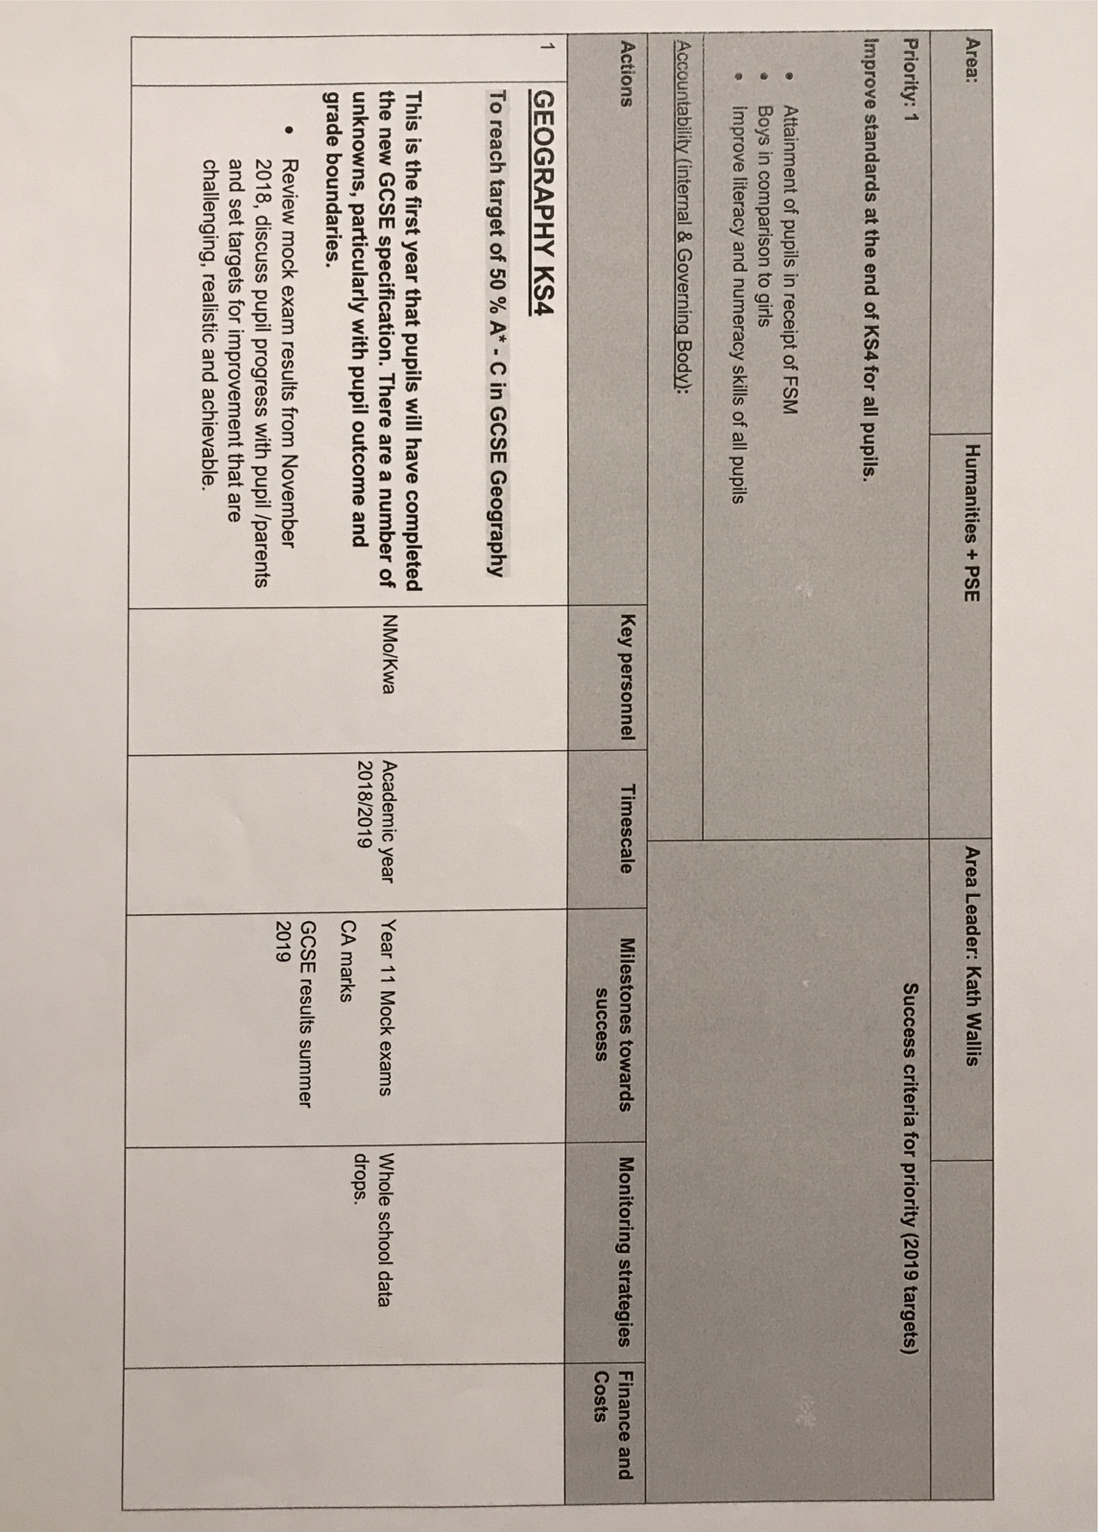
Departmental Improvement Plan
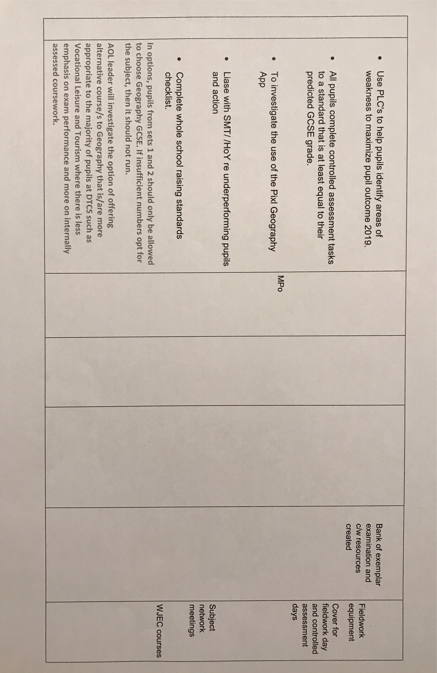
Appendix B

School Development Plan – Priorities/Priority 1
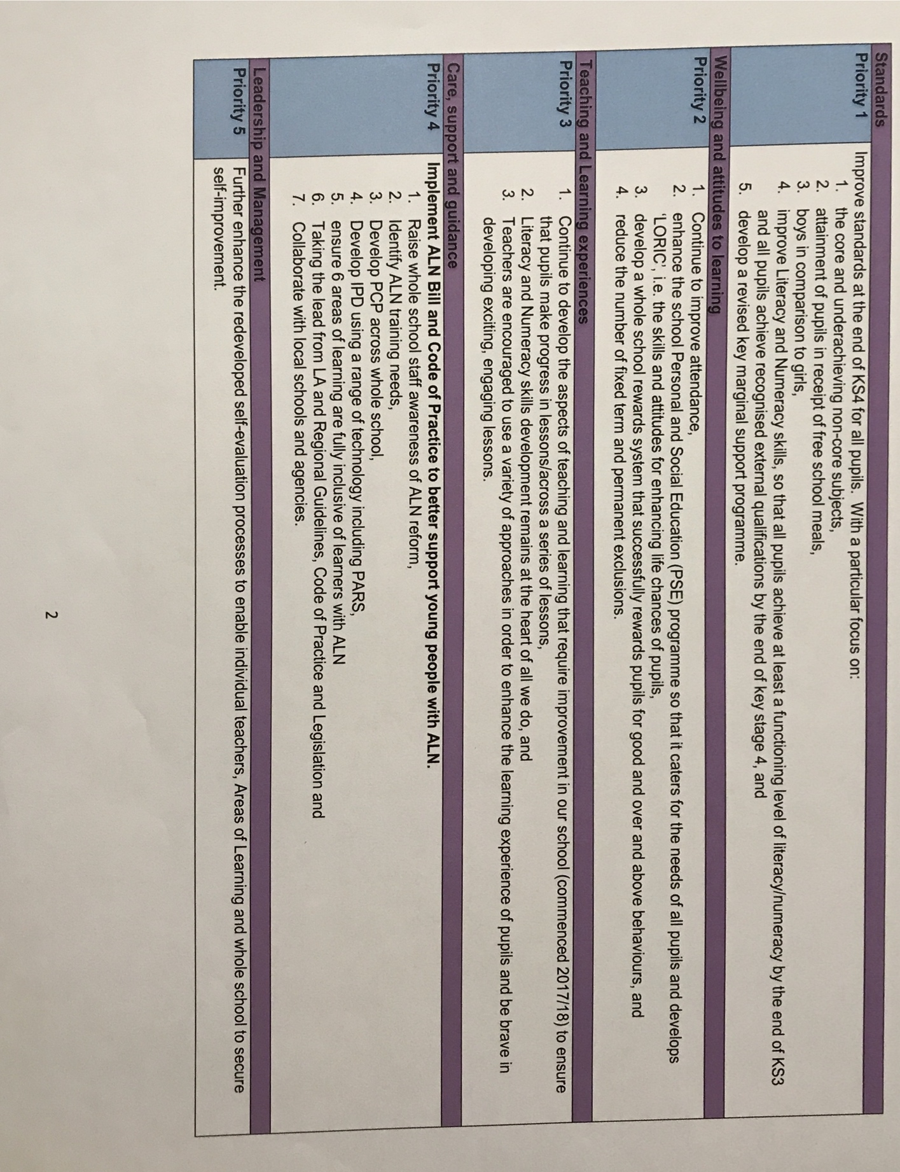

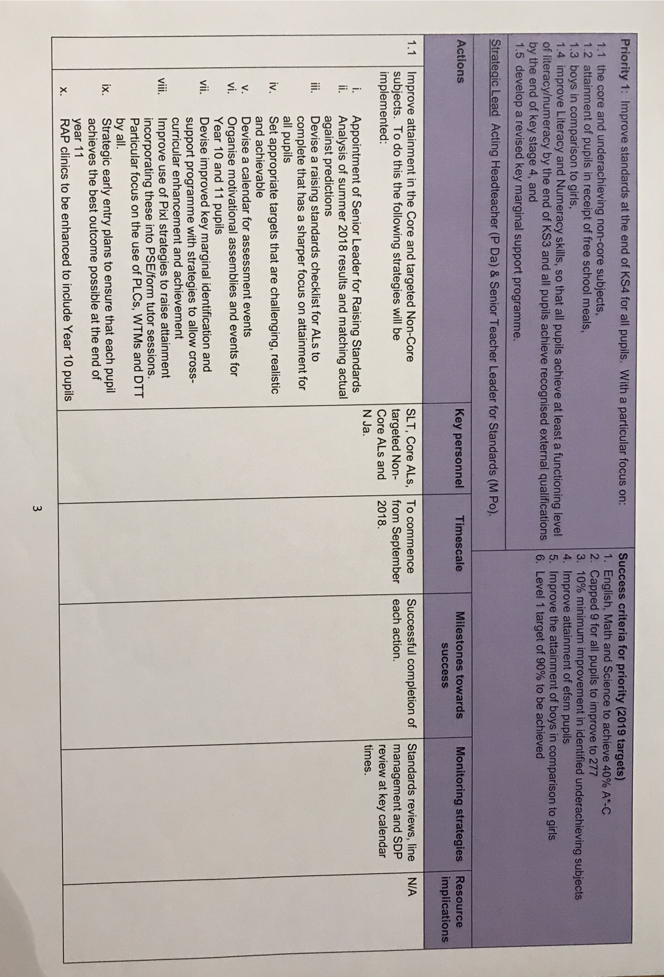

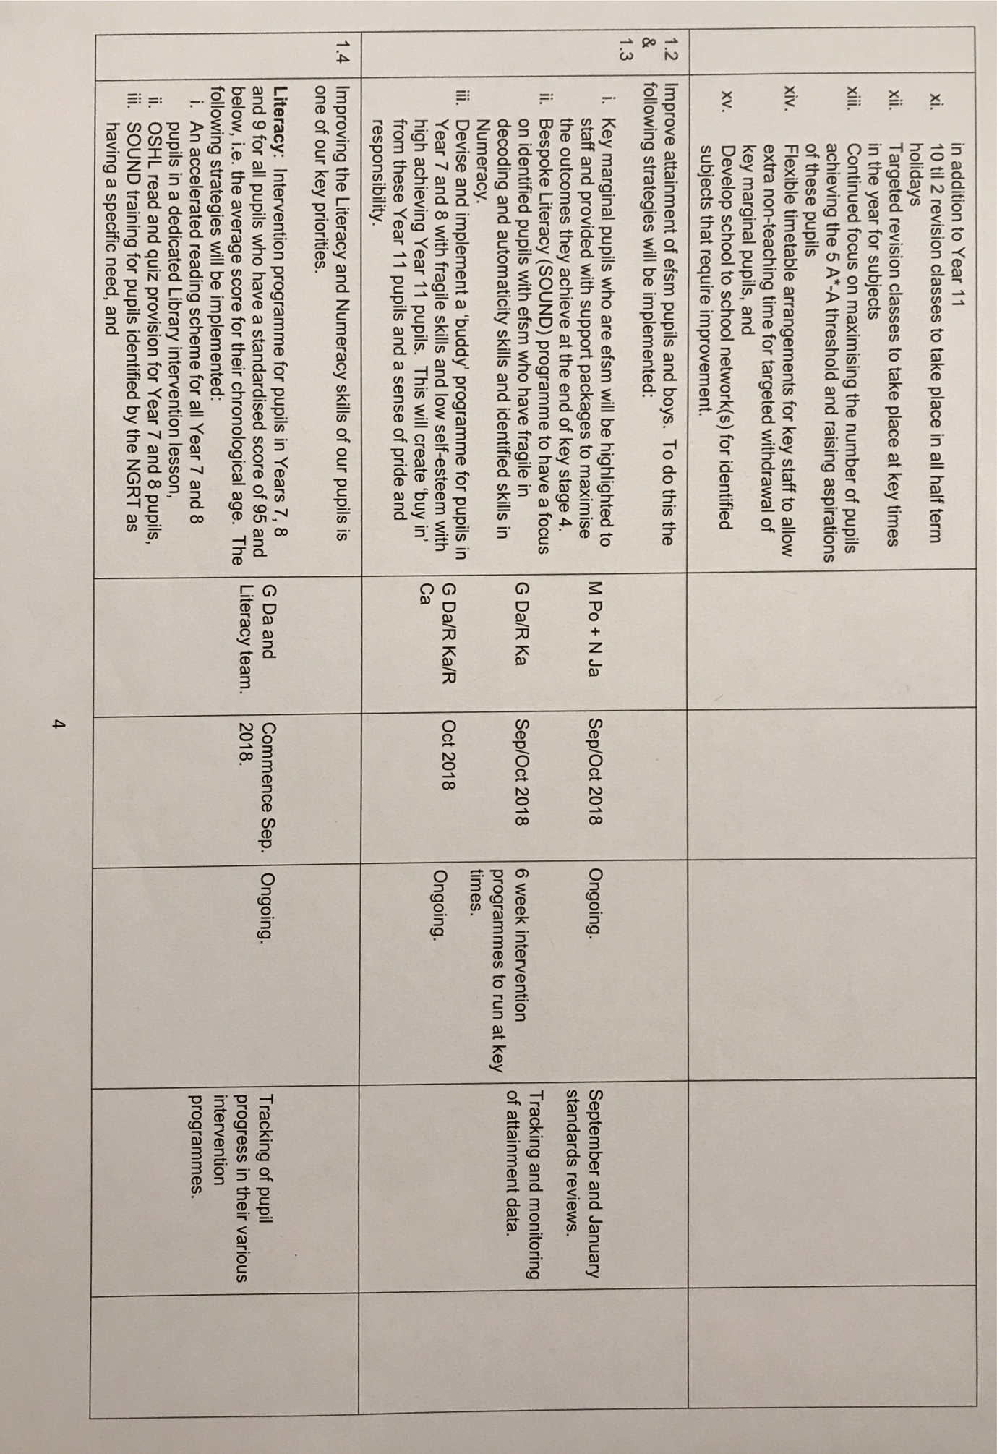
Appendix C

Grant Spending


