

Inhale, Exhale, Relax

The Effects of Guided Breathwork on Levels of State Anxiety

2219390
Psychology Empirical Project

March 2025
University of Wales Trinity St David

Dissertation submitted in partial fulfilment of the requirements for the Degree of Bachelor of Science (Hons) in Psychology and Counselling

DECLARATION

This work has not previously been accepted in substance for any degrees and is not being concurrently submitted in candidature for any degrees.
Signed ...Shaheena Kenyon..............................
Date ........15 April 2025.................................
STATEMENT 1
This dissertation is being submitted in partial fulfilment of the BSc Applied Psychology/BSc Psychology/BSc Psychology and Counselling degree requirements.
Signed ...Shaheena Kenyon..............................
Date ........15 April 2025.................................
STATEMENT 2
This dissertation is the result of my own independent work/investigation, except where
otherwise stated.
Other sources are acknowledged by giving explicit references. A reference list is appended.
Signed ...Shaheena Kenyon..............................
Date ........15 April 2025.................................
STATEMENT 3
I hereby give consent for my dissertation, if accepted, to be available for photocopying and for inter-library loan, and for the title and summary to be made available to outside
organisations.
Signed ...Shaheena Kenyon..............................
Date ........15 April 2025.................................

AI Acknowledgement

I acknowledge the use of Grammarly (https://www.grammarly.com/) to check my work using the prompt(s):
1. Please check the following text for readability, grammar and spelling.
I confirm that I have not presented any AI-generated text as my own work. I confirm I
have copies of my drafts, notes, and other resources I used before and after the use of
AI tools which I may be asked to provide in evidence

I acknowledge the use of Google Scholar https://scholar.google.com on throughout to support my research using the prompt(s):
Please provide me with materials on
- State anxiety measurement
- Guided breathwork intervention
- Anxiety reduction techniques
- Galvanic skin response state anxiety
- STAI-6 anxiety assessment
- Physiological arousal breathwork
- Controlled breathing anxiety management
- Breathwork and emotional regulation
- Psychophysiology of anxiety
- Cost-effective mental health interventions
- CBT as an intervention for anxiety
- Types of Breathwork

Acknowledgements
I would like to express my sincere gratitude to my dissertation supervisor, Stacey Coleman, for her invaluable guidance and support, not only throughout the completion of this dissertation but consistently over the past three years. Her encouragement, expertise, and kindness during particularly challenging moments have been deeply appreciated.
I am also grateful to the academic staff whose dedication and willingness to support students have greatly enriched my learning experience. I want to thank Dr. Kate Williams, Dr. Judith Marshall, Lymarie Rodriguez, Dr. Zoë Cooke, and Katie Sullivan for their continued support and generosity with their time and knowledge.
My heartfelt thanks also go to Laura Taylor and Jane Masters, whose compassionate support and encouragement helped me to remain resilient during moments of difficulty. Your reassurance and presence have been genuinely grounding.
I would like to thank Chris Davies for providing the audio of the breathwork used in this study, which significantly enhanced the quality and depth of the intervention. I am also sincerely grateful to Nathan Chaplin for his technical assistance in setting up the immersive room and his ever-positive attitude and willingness to help. I would also like to thank all participants whose contributions made this research possible.
To Matt Wilson, thank you for your constant support, patience, and humour over the past three years. Your presence has made a lasting difference, and I cannot express my gratitude in words for all that you have done for me. To Angharad Kissick, I am especially thankful for your friendship, encouragement, and support throughout this academic journey.
Lastly, I would like to thank my family for their unconditional support, understanding, and belief in me. I especially thank my children, Yushua and Zayn, for their patience and consistently making me proud with their resilience. They have brought more joy into my life than I ever imagined. Their encouragement has been essential in helping me pursue and complete my studies.
Table of Contents
DECLARATION 2
AI Acknowledgement 3
Acknowledgements 4
Abstract 6
Introduction 7
Method 20
2.1 Participants 20
2.2 Design 20
2.3 Materials 20
2.3.1 Guided Breathwork 20
2.3.2 Physiological arousal 21
2.3.3 State Anxiety 21
2.4 Procedure 22
2.4.1 Pilot study 22
2.4.2 Ethical Considerations 22
2.4.3 Study Procedure 23
Results 25
Physiological Anxiety Assessment 25
State Anxiety 27
Discussion 29
References 37
Appendices 44
Appendix A – Breathwork Facilitator Consent 44
Appendix B – Breathwork Audio 45
Appendix C- YouTube video link 46
Appendix D - Room set up 47
Appendix E – GSR set up 48
Appendix F – State Trait Anxiety Inventory Short form (STAI-6 49
Appendix G – SPSS Output 50
Appendix H – Ethical Approval 54
Appendix I – EMS Study Sign up 92
Appendix J – Information Sheet (Qualtrics) 94
Appendix K – Consent Form 97
Appendix L – Debrief Sheet 99

Abstract
The objective of the study was to investigate whether participation in guided breathwork has an effect on levels of State Anxiety. It was hypothesised that engaging in guided breathwork would lead to a reduction in arousal levels. To assess how participants felt in the current moment, the State Anxiety Inventory STAI-6 (Marteau & Bekker, 1992) was administered before and after the breathwork session. Additionally, galvanic skin response was measured to evaluate physiological arousal, indicated by sweat levels on the palms, to determine if there was a decrease in sweating, which would reflect lower levels of state anxiety. A total of 22 students from the University of Wales Trinity Saint David, studying Psychology, participated in the study (n = 22), with a demographic distribution of 27% male and 73% female, ages ranging from 19 to 59. (M = 30.95, SD = 11.40). A within-subjects design was employed to assess self-reported levels of state anxiety, and a one-way ANOVA was conducted to compare galvanic skin response levels. The results indicated that there was a significant effect on levels of arousal, with both STAI-6 scores and levels of arousal lowering. The hypothesis that the practice of breathwork can lower state anxiety and levels of arousal was accepted.

Introduction
Anxiety is recognised as the most prevalent mental health condition worldwide, affecting approximately one in every 14 individuals globally (Baxter et al., 2012). The rates of anxiety surged from 7.3% to 25%, three times higher after the COVID-19 pandemic (Santabarbara et al., 2020). While generalised anxiety disorders are a significant concern, state anxiety, a temporary form of anxiety which can be situation specific (Spielberger, 1983), is equally as concerning and debilitating (Vytal et al., 2016). According to Spielberger’s (1983) State-Trait Anxiety theory, anxiety can manifest in two forms: trait anxiety, which is an individual’s baseline susceptibility to perceive situations as threatening, while state anxiety refers to a situational experience of stress or apprehension.
State anxiety can be characterised by feeling threatened or experiencing unpleasant thoughts, which may be due to a specific situation. In contrast, trait anxiety reflects an individual’s consistent way of experiencing state anxiety, influenced by their personal characteristics and differences when faced with stress (Spielberger, 2013). State anxiety tends to escalate more quickly in stressful situations, particularly for those who have high trait anxiety. This relationship can adversely affect cognitive performance (Eysenck, 2013).
A systematic review by Saeed et al. (2022) revealed differing levels of anxiety among Different groups, such as medical personnel, students, the wider community, educators, caregivers, expectant mothers, and law enforcement officers, in the aftermath of the COVID-19 pandemic. Medical personnel displayed the highest anxiety rates at 36%, with students closely behind at 34.7%. Beiter et al. (2014) reported that 40% of students report elevated levels of state anxiety, which has an impact on their concentration levels, performance and overall wellbeing, highlighting the need for interventions to address and relieve anxiety symptoms and conditions.
While state anxiety is typically associated with impairment in cognitive functions, a study conducted by Ursache and Raver (2014) involving children aged 9 to 12 revealed that higher levels of state anxiety were associated with improved performance on the Stroop task. This finding suggests a more nuanced relationship between anxiety and cognitive control mechanisms, showing that in some contexts, anxiety may help attentional processes rather than impair them. Understanding the mechanisms underlying state anxiety is crucial for developing effective interventions (Forrest et al., 2021).
State anxiety is a temporary and situationally induced emotional response characterised by feelings of apprehension and fear. It manifests in response to specific stressors, such as public speaking (Behnke & Sawyer, 2001) or taking standardised tests (Roos et al., 2020). It is marked by an elevated state of intensified physiological reactions, like increased heart rate. This construct is distinct from trait anxiety, which displays a longer-lasting response to perceived threats and responds with anxiety across multiple contexts (Spielberger, 2013).
The situational specificity of state anxiety underscores its transitory nature, as it tends to diminish upon the resolution of the stress-inducing circumstance (Endler & Kocovski, 2001). A study by Saviola et al. (2020) conducted on 42 participants used the State-Trait Anxiety Inventory questionnaire (STAI-Y2) (Spielberger, 2013) and then investigated the relationship with Magnetic Resonance Imaging (MRI), found that state and trait anxiety have distinct neural pathways. This finding can contribute to a better understanding of anxiety disorders and their treatments. However, the study was conducted on a very small sample, which limits generalisability.
State anxiety, along with having psychological effects, also manifests physiologically through heightened arousal, which is observable in changes to heart rate, blood pressure, and other indicators of emotional shifts (Hoehn-Saric & McLeod, 2000). It encompasses not only psychological symptoms, such as worry and nervousness, but also measurable physical responses like increased heart rate or sweating that signify acute autonomic arousal. When a stressor is encountered, the sympathetic nervous system is activated, triggering a series of bodily changes commonly referred to as the fight or flight response (Ziegler, 2011).
The physiological responses in an individual's body, manifesting as elevated levels of heart rate and blood pressure, dilated pupils, increased sweating on the palms, and altered breathing pattern, enable the monitoring of behavioural states, particularly anxiety (Lader, 1983). The author contributed to research by examining anxiety through a psychophysiological lens, highlighting how arousal levels can be measured through skin conductance, electroencephalogram, and pupil size in response to anxiety. There is robust research that shows that electrodermal activity EDA, through sweat glands, is a reliable method to measure levels of arousal (Boucsein, 2011; Dao et al., 2024).
Ding et al. (2022) utilised a multi-modal approach in their study, incorporating machine learning to develop a high temporal resolution model for tracking state anxiety. The researchers induced state anxiety in participants by exposing them to aversive images or the threat of electric shocks, all while recording various data types, including dimensional emotion ratings, electrocardiogram (ECG) readings, and galvanic skin response (GSR). They paired these physiological and psychological measures with self-reported state anxiety levels assessed through the STAI questionnaire. By training and validating machine learning models, the researchers were able to predict anxiety levels effectively. The findings highlighted a strong correlation between the predicted anxiety levels and self-reported measures, showcasing the model's capability to provide nuanced and sensitive assessments of state anxiety. This innovative approach holds considerable promise for future applications in affective brain-computer interaction and studies focused on anxiety modulation. This study demonstrates that the combination of STAI and GSR provides a reliable method for measuring self-reported state anxiety and levels of arousal. A systematic review by Ba and Hu (2023) suggests that electrodermal activity (EDA) and skin conductance, which are influenced by sweat levels, are reliable measures for assessing changes in arousal levels and Marteau and Bekker's (1992) short form version of the STAI-6 is a robust and reliable measure of current emotional states.
Bentley et al. (2023) found that an individual's psychological and physiological well-being, which can be affected by state anxiety, is often linked to elevated stress hormones, such as cortisol, which can contribute to chronic stress and undermine the immune system. In addition, state anxiety can negatively impact cognitive functions, including attention and memory, and may lead to an increased risk of developing mental health issues that can lead to disorders such as depression or generalised anxiety disorders.
The Polyvagal Theory, developed by Stephen Porges in 2006, provides a framework for understanding the physiological underpinnings of emotions, social behaviour, and self-regulation, with significant implications for understanding state anxiety (Porges, 2006). This theory suggests that the autonomic nervous system (ANS), particularly the vagus nerve, plays a crucial role in modulating emotional responses and social interactions, subsequently influencing state anxiety levels. This theoretical framework has been utilised to examine a range of psychological disorders, particularly anxiety disorders (Levine et al., 2016). It underscores the significance of autonomic regulation, how our bodies automatically manage functions like heart rate and breathing. It also explores how our physiological responses, such as an increased heart rate due to emotions like fear, influence our behaviour and contribute to feelings of anxiety (Porges, 2022).
State anxiety can significantly affect both mental and physical health over time. Chronic stress is closely linked to numerous health issues, such as high blood pressure, heart disease, anxiety, and depression (Mariotti, 2015), highlighting the need for effective anxiety management to support overall well-being.
Cognitive Behavioural Therapy (CBT) is widely researched and recognised as an effective treatment for anxiety disorders, supported by strong empirical evidence across various diagnoses. A meta-analysis conducted by Carpenter et al. (2018) assessed 41 randomised placebo-controlled trials and found that CBT produced significant effect sizes in alleviating symptoms of generalised anxiety disorder, panic disorder, social anxiety disorder, and post-traumatic stress disorder, indicating a substantial reduction in symptoms following treatment. Importantly, at follow-up, it was noted that the effects of CBT were maintained, underscoring the therapeutic benefits of CBT as long-term.
Despite the substantial evidence supporting CBT as an effective treatment for anxiety disorders, several barriers hinder access to this therapy. According to Punton et al. (2022), prolonged waiting times can worsen psychological health, highlighting the necessity for alternative support methods for mental health conditions, which serve as a barrier within the mental healthcare system. CBT may not serve as an appropriate intervention for all individuals, as variations in cognitive styles, cultural backgrounds, and the specific symptoms may influence both engagement with the therapeutic process and the overall efficacy of the treatment (Cuijpers et al., 2016). CBT is a highly regarded and evidence-based treatment for a range of mental health concerns. However, it requires significant resources, such as time, qualified professionals, and customised treatment plans tailored to the unique needs of each individual. This intensive nature can create barriers to access for some people seeking CBT (Carpenter et al., 2018).
In contrast, breathwork techniques, such as controlled breathing exercises and meditation, are easily accessible and can be practiced with minimal resources. These methods effectively address stress, anxiety, and various emotional challenges, often serving as a complementary intervention alongside traditional therapies (Fincham et al., 2023; Ma et al., 2017). By promoting relaxation and mindfulness, breathwork provides a practical solution for individuals seeking immediate support or for those who may find structured therapy sessions hard to access.
Given these limitations, there is an increasing interest in alternative or complementary interventions that are low-cost, accessible, and easy to implement without the need for professional oversight. One such approach is guided breathwork. Unlike CBT, which requires structured sessions with trained therapists, breathwork techniques can be self-administered and taught in group settings or digital platforms (Fincham et al., 2023). There is also insufficient research on treating various types of anxiety disorders, and medications such as Selective Serotonin Reuptake Inhibitors (SSRIs) are commonly used as treatment options. However, relapse can occur if the medication is not continued for a duration of 6 to 12 months. Additionally, these medications can have unwanted side effects, which may lead to their discontinuation (Bandelow et al., 2017)
Studies show that diaphragmatic and slow-paced breathing can reduce state anxiety by influencing the ANS and increasing parasympathetic activity (Zaccaro et al., 2018; Ma et al., 2017). Zaccaro et al. (2018) noted that a key limitation in their meta-analysis was the absence of standardisation across studies, as varying methodologies hindered the ability to compare results effectively. The authors recommended that breathwork techniques be standardised to facilitate the identification of psychophysiological correlates and enhance research methodologies.
Another recent study conducted by Serrano-Ibáñez et al. (2024) found that engaging in a single session of diaphragmatic breathing significantly reduced both state anxiety and the perception of pain in individuals with chronic pain. Notably, these benefits were more pronounced among participants with higher baseline anxiety, suggesting that this technique may be particularly beneficial for those more prone to heightened stress responses. The researchers proposed that attentional processes, such as redirecting focus away from anxious thoughts or discomfort, could enhance the effectiveness of the intervention. These findings highlight the potential of diaphragmatic breathing as a valuable and accessible method for managing acute anxiety. These findings indicate that breathwork may serve as a beneficial practice to complement CBT or as an alternative for individuals awaiting therapy, seeking immediate symptom relief, or preferring non-verbal, body-based regulation strategies.
Breathwork activates the parasympathetic nervous system, bringing both the mind and body back to their natural state of recovery or relaxation (Aideyan et al., 2020). This relaxation response may help to alleviate symptoms of distress and reduce the fight or flight response. In recent years, the technique that has captured the interest of researchers and health professionals for its numerous health benefits is slow-paced breathing, which is characterised by a respiratory rate of 4 to 10 breaths per minute. This rate is significantly slower than the average human respiratory rate, which typically ranges from 10 to 20 breaths per minute (Russo et al., 2017). The slow breathing practice has its roots in the old Eastern Yogic practice of Pranayama breathing, which is the controlled inhalation, retention and exhalation of breath (Fogerite & Goldberg, 2008).
Controlled diaphragmatic breathing, often referred to as belly breathing, is a fundamental technique designed to reduce negative emotional states, including anxiety and stress. This method involves fully engaging the diaphragm, allowing for deep inhalation and exhalation, which can promote a sense of calm and relaxation (Ma et al., 2017). By focusing on the breath, individuals can create a physiological response that decreases heart rate and lowers blood pressure, contributing to an overall feeling of relaxation. This technique is not only beneficial for managing anxiety but is also widely applied in various non-pharmacological interventions, such as relaxation therapies, mindfulness practices, and yoga. In these contexts, controlled diaphragmatic breathing serves as a foundational skill that enhances emotional resilience, fostering a mind-body connection that is essential for overall wellness. The practice can be easily integrated into daily routines, making it a practical tool for anyone seeking to improve their emotional well-being (Chen et al., 2017).
Numerous peer-reviewed studies have examined box breathing, also known as square breathing, which involves equal durations of inhalation, breath retention, and exhalation, as well as cyclic sighing, a technique where a breath is taken in deeply and then a second breath is taken to fully fill the lungs before exhaling slowly and audibly. These methods have been explored as clinical interventions for anxiety and stress (Balban et al., 2023). In their randomised controlled trial comparing various breathwork techniques, the authors found that all methods resulted in reductions of negative emotions, including state anxiety. While cyclic sighing demonstrated the most significant improvements in mood and a decrease in respiratory rate, box breathing also played a role in lowering physiological arousal.
Magnon et al. (2021) found that the deep slow breathing (DSB) technique proved to be effective across a wide range of populations, especially for adults experiencing depressive and anxiety disorders. Their findings highlighted the therapeutic potential of this practice in alleviating emotional distress and enhancing well-being among diverse groups of individuals. The authors conducted a study that employed a within-subjects design to assess the effects of DSB on physiological stress and anxiety by measuring heart rate variability (HRV) and Spielberger’s State Anxiety Inventory (STAI-Y) scale to measure state anxiety. The study found that DSB significantly reduced anxiety, especially in older adults compared to younger ones. This shows that breathing exercises can be helpful as an intervention to lower anxiety levels.
Recent studies have progressively established breathwork as an effective complementary approach for alleviating anxiety, especially in settings where traditional therapies might not be readily available. A systematic review conducted by Morgan et al. (2024) evaluated 19 studies on the impact of breathing exercises on anxiety and stress among adults. Among these studies, 12 demonstrated statistically significant reductions in anxiety symptoms following breath-based interventions, with no adverse effects reported. The reviewed techniques included diaphragmatic breathing, slow-paced breathing, box breathing, and mindfulness-integrated approaches.
The authors suggested that breathwork produces its anxiety-reducing effects by influencing the activity of the autonomic nervous system, particularly by boosting parasympathetic tone and diminishing sympathetic arousal, as well as by lowering amygdala activity and the function of the hypothalamic-pituitary-adrenal (HPA) axis. These biological processes closely correspond with the immediate psychophysiological alterations seen in state anxiety, which makes breathwork a particularly pertinent and easily accessible method for addressing these symptoms (Morgan et al., 2024). With the increasing pressure on mental health services, particularly the lengthy NHS waiting times (NHS, 2024) for CBT, breathwork could act as a prompt, non-medicated support option for those facing acute anxiety.
An increasing body of empirical research underscores the effectiveness of breathwork as a viable intervention for state anxiety by demonstrating its direct impact on the autonomic nervous system (ANS). The ANS, which governs involuntary physiological functions, is comprised of the sympathetic nervous system (SNS), which is responsible for the body's acute stress response, and the parasympathetic nervous system (PNS), which promotes recovery and relaxation (Porges, 2006, 2022). State anxiety is believed to stem from excessive sympathetic arousal, manifesting in symptoms such as elevated heart rate, rapid breathing, and muscular tension. These symptoms can be alleviated through various Breathwork techniques, especially slow-paced and diaphragmatic breathing, which have been demonstrated to activate the vagus nerve and enhance parasympathetic activity. This effectively reduces the physiological indicators of anxiety (Ma et al., 2017).
Zaccaro et al. (2018) conducted a systematic review demonstrating that slow breathing techniques improve autonomic balance, heart rate variability (HRV), and emotional regulation which align with the studies by Fincham et al. (2023) where in a meta-analysis of 26 randomised controlled trials, the authors found that breathwork significantly reduced anxiety, stress, and depression, primarily due to its capacity to modulate autonomic activity and restore physiological equilibrium. Morgan et al. (2024) further reinforced this by identifying breathwork as a safe, non-pharmacological strategy that downregulates amygdala activity, key systems involved in the anxiety response. Together, these findings underscore the ability of the practice of breathwork to counteract the physiological hyperarousal characteristic of state anxiety, offering an accessible and body-based intervention that complements or serves as an alternative to traditional psychological therapies.
Building upon the evidence previously mentioned, additional studies highlight the practicality and effectiveness of breathwork interventions in mental health care settings. Banushi et al. (2023) conducted a comprehensive analysis of various breathwork techniques, revealing that practices such as diaphragmatic breathing, box breathing, and alternate nostril breathing significantly reduce anxiety symptoms in adults diagnosed with anxiety disorders. Their findings underscore the efficacy of these techniques and their accessibility, highlighting that individuals with limited mental health resources can easily adopt these methods. This reinforces the notion that breathing exercises are not only universally accessible but also cost-effective, making them suitable for broad public health applications and community mental health programs.
In a complementary study, Morgan et al. (2024) explored the scalability of breathwork interventions, identifying successful delivery methods through diverse platforms such as mobile applications, online workshops, and telehealth services. Their research indicated that such remote and digital interventions have the potential to reach underserved populations who might otherwise lack access to traditional psychotherapy. Collectively, these findings advocate for the integration of breathwork into mental health strategies, especially in contexts where conventional therapies may be constrained by financial, geographic, or systemic barriers. Implementing these techniques can enhance patient care and empower individuals to take proactive steps in managing their mental health.
Based on the two-factor model of emotion proposed by Schachter and Singer (1962), which asserts that emotions arise from physiological arousal and the cognitive interpretation of that arousal, anxiety can be more thoroughly understood using a dual-measure approach, incorporating both Galvanic Skin Response (GSR) as an objective indicator of physiological arousal and the STAI-6 to assess the cognitive and emotional interpretation of that arousal. This method reinforces the notion that anxiety is not solely a physical condition. Instead, it is a contextual experience shaped by various factors, including attention, environmental influences, and even fatigue. These elements can amplify arousal responses and impact how individuals perceive their feelings as anxiety. Consequently, this complex experience cannot be fully understood through physiological measures alone (Kantor et al., 2001). By integrating both types of data, this approach offers a more comprehensive evaluation of state anxiety that aligns with the principles of this foundational theory of emotion.
Finally, while breathwork offers promising benefits for alleviating state anxiety, cultural and socioeconomic factors may influence its effectiveness and accessibility. Since breathwork has roots in Eastern traditions, particularly in India and China, individuals from these cultural backgrounds may be more receptive to and engaged in these breathing practices. In contrast, within Western contexts, where emphasis is often placed on empirical evidence, breathwork may be undervalued unless supported by scientific rationale. The studies presented above show that clinical acceptance of breathwork is growing and slowly gaining legitimacy beyond the spiritual practices.
While breathwork is relatively low-cost and theoretically accessible, researchers have underscored the importance of tailoring interventions to address the specific needs of diverse communities. They advocate for flexible delivery methods to include populations from lower socioeconomic backgrounds, who may encounter barriers such as limited access to digital platforms or lower literacy levels (Banushi et al., 2023; Morgan et al., 2024).
The objective of this study was to determine whether guided breathwork practices can effectively reduce levels of state anxiety. A review of existing research highlighted a notable gap in the literature regarding the integration of both objective and subjective measures to evaluate the efficacy of breathwork as an intervention, either independently or in conjunction with other therapeutic approaches. To address this gap, a self-report questionnaire was implemented that participants completed both before and after the breathwork sessions. This measure was intended to capture individuals' perceived anxiety levels in the current moment.
In addition to the subjective assessments, a Galvanic Skin Response (GSR) device affixed to participants' palms to objectively measure physiological responses throughout the breathwork sessions was utilised. The GSR device gauges sweat production, serving as an indicator of arousal and stress response. This dual methodology allows for a more nuanced understanding of the effects of breathwork on anxiety levels.
It was hypothesised that participation in breathwork sessions would lead to a significant reduction in state anxiety, as evidenced by both the self-reported measures and the objective GSR data. By combining these approaches, the study seeks to provide valuable insights into the effectiveness of breathwork as a tool for anxiety reduction.

Method

2.1 Participants
Undergraduate students studying Psychology at the University of Wales Trinity Saint David UWTSD were recruited through the Experiment Management System (EMS). 25 participants took part in the study. However, data was collected from 22 participants. 6 males (27%) and 16 females (73%) took part in the study, ages ranging from 18 to 59 (M = 30.95, SD = 11.40). Questions prompting participants to avoid signing up if they had specific health conditions were used in EMS to screen individuals before signing up.

2.2 Design
A within-subjects design was utilised for this study. The first dependent variable was levels of self-reported stress, which were measured before and after the breathwork session using the State-Trait Anxiety Inventory (six-item short form: STAI-6) (Marteau & Bekker, 1992). The second dependent variable was the levels of electrodermal (physiological) arousal recorded using a Galvanic Skin Response (GSR) device whilst participants worked through a guided breathwork session, with pre-test arousal levels included as the covariate. Arousal was averaged across three time-points throughout the breathwork session: before, during and after. A one-way repeated measures analysis of variance (ANOVA) was conducted to determine whether guided breathwork led to significant changes in arousal levels.

2.3 Materials

2.3.1 Guided Breathwork
The instructions for the guided breathwork were provided by a qualified breathwork practitioner, Chris Davies and consent (see Appendix A) was given to use the audio for the study, in an audio-only format (see Appendix B). The study took place in the immersive room in the Y Fforrwm building, and a video obtained via YouTube of a beach scene (see Appendix C) was played on the 360⁰ screen to create a relaxing environment (see Appendix D).

2.3.2 Physiological arousal
A Galvanic Skin Response (GSR) device was used to measure physiological arousal whilst the participants took part in the guided breathwork session. The GSR recorded skin conductance (SC) relating to sweat gland activity, which increases with arousal levels. This was done by applying two electrodes, prepared with gel, to the participant’s non-dominant hand and secured with micropore tape. Participants were asked to wear the GSR pads whilst they completed the study (see Appendix E).

2.3.3 State Anxiety
To assess participants’ levels of state anxiety, a six-item short-form version of the State-Trait Anxiety Inventory (STAI-6) was utilised (Marteau & Bekker, 1992; see Appendix F). This abbreviated six-item scale, derived from the original 20-item STAI-S (State Anxiety) questionnaire (Spielberger et al., 1983), provides a brief yet valid measure of temporary anxiety states. Participants were asked to rate how they felt “at that moment” on a 4-point Likert scale ranging from ‘Not at all’, ‘Somewhat’, ‘Moderately’ to ‘Very much’. Example items included “I feel calm” and “I feel tense.” Items reflecting positive affect (e.g., “I feel calm,” “I feel relaxed,” “I feel content”) were reverse-scored so that higher total scores indicated higher levels of state anxiety. Scores were calculated by summing all items after reverse coding, resulting in a total score range between 6 and 24.
The researcher tested the reliability of the scale using participant data prior to the main statistical analysis. Data were entered into SPSS (see Appendix G) and assessed for internal consistency using Cronbach’s alpha. A Cronbach’s alpha of .70 or above indicates good internal consistency. The STAI-6 has demonstrated good psychometric properties in previous research, with Cronbach’s alpha values typically ranging between .82 and .89 in similar samples (Tluczek et al., 2009). In the current study, the STAI-6 demonstrated acceptable reliability at the pre-breathwork stage (α = .82), though internal consistency was lower following the breathwork session (α = .68).

2.4 Procedure

2.4.1 Pilot study
A pilot study was conducted to verify that Qualtrics, GSR, and the breathwork audio and video on the immersive screen functioned properly. The appropriate time points for measuring arousal markers were identified to ensure consistent recording of participants' levels during the analysis of physiological data. Following the completion of the pilot, the study was advertised through the EMS to recruit participants.

2.4.2 Ethical Considerations
A dissertation proposal and an application for ethical approval (see Appendix H) were completed by the researcher prior to the commencement of data collection, ensuring that the welfare of both the participants and the researcher was thoroughly assessed. This proposal underwent evaluation by the University of Wales Trinity Saint David (UWTSD), and approval was subsequently granted by the School Research Ethics Committee (SREC).
The ethical considerations were thoroughly identified by the researcher before undertaking the study, given the nature of the research that involved participants engaging in a cyclic breathing pattern. This practice could potentially have exacerbated pre-existing respiratory or heart conditions, as well as severe anxiety and Post-Traumatic Stress Disorder (PTSD). Additionally, the use of an immersive 360⁰ screen might have posed risks for participants with photosensitivity. To address these concerns, participants were advised during the EMS (see Appendix I) sign-up process to refrain from participating if they had any of these conditions that may cause any risk of harm. Furthermore, prior to the study's commencement, participants completed a risk assessment section on Qualtrics. To further alleviate any potential issues, the supervisor was present alongside the researcher throughout the course of the experiment.

2.4.3 Study Procedure
Participants signed up for the study through EMS. They completed an information sheet (see Appendix J) on a laptop using Qualtrics, followed by a consent form (see Appendix K). As a precautionary measure, if any participant responded ‘No’ to any of the questions, the system would prevent them from advancing further. After consent was obtained, GSR electrodes were attached to the participant’s non-dominant hand, secured with micropore tape to avoid disruption to the GSR readings in case of movement, and the participants were asked to complete the STAI-6 on the laptop. Once this task was finished, the researcher guided them into the immersive room, where verbal instructions previously outlined in the information sheet were reiterated, including details about their right to withdraw at any time and information regarding the immersive screen, video, and breathwork instructional audio. The researcher tried to have a standardised script for the instructions to ensure all participants received the same information. Participants were encouraged to make themselves comfortable on a provided bean bag, along with a blanket and a bottle of water for added comfort. The breathwork instructions commenced after allowing participants to acclimate to the immersive environment for approximately three minutes. These guided breathwork instructions lasted around 20 minutes. Upon completion of the breathwork, participants were asked to remain in the room until the researchers guided them out and brought them back to the seating area to complete the STAI-6 questionnaire on the laptop to allow the researcher to compare the scores before and after the breathwork session. Once the questionnaire was completed, the participants were taken to the debrief sheet (see Appendix L) on the screen. The electrodes were removed, and the researcher verbally debriefed the participants and welcomed questions about the study. Finally, the participants were thanked for their participation.

Results
A total of 25 participants signed up to take part in this study. All participants completed all elements of the study. However, data for three participants were removed due to a failure in the GSR equipment. Therefore, data is reported on a total of 22 participants.

Physiological Anxiety Assessment
To assess the changes in physiological arousal responses, skin conductance (SC) was measured throughout the duration of the study. GSR data was recorded in microsiemens (µS) for a duration of between 30 and 33 minutes across the participant sample. To analyse GSR data, the software Mindware EDA 3.1.0 was used. First, each individual data file was converted from mwx to the appropriate mwi format, with settings adapted to display a period of 300 seconds per segment. Once each file had been converted, averages for each participant were calculated from the corresponding segments, and specifically, the mean skin conductance (SC) reading was reported. To ensure standardisation of GSR readings, the mean score for three time periods were calculated and recorded. To account for baseline SC levels, the mean SC was recorded from Segment 1 (0-5 minutes), which equated to the period of time where participants had the electrodes attached to their palm and engaged with the consent form and the first completion of the STAI-6. Prior to the main elements of the guided breathwork session, there was a three-minute practice section for participants to relax and become acclimated to the immersive room and its environment. This period of time equated approximately to segment 2 for each participant; therefore, the data from segment 2 was not included to report average levels of skin conductance. Segments 3, 4, and 5 (10-25 minutes) covered the main engagement in the guided breathwork session, and therefore, an average was taken across all three segments to record the average skin conductance level while participants were fully immersed in the breathwork session.

Table 1
Descriptive Information for GSR Levels
 |  | M | SD
Baseline | Segment 1 | 12.45 | 8.97
 | Segment 2
 | Segment 3 | 7.18 | 7.62
 | Segment 4 | 6.70 | 7.54
 | Segment 5 | 7.60 | 8.37
Average SC during Breathwork Session |  | 7.16 | 7.77
Average SC after breathwork completion | Segment 6 | 14.18 | 10.63

As can be seen in Table 1. SC levels lowered between baseline and engagement in the breathwork session, thus implying the physiological arousal, and therefore levels of anxiety, decreased during the breathwork session. SC levels then increase again after the completion of the breathwork session, and the average GSR reading is higher than that at baseline.
To explore whether the difference between baseline skin conductance whilst engaging in the breathwork session were significant, a one-way repeated measures analysis of variance (ANOVA) was conducted. It was found that there was a significant main effect of the timing of GSR measurement; F (2.42) = 16.29, p < .001. The effect size, partial eta squared, was 0.44, indicating a large effect.
Post-hoc pairwise comparisons with Bonferroni adjustment indicate that there was a significant difference between baseline GSR and GSR recorded during the breathwork session, with skin conductance levels during engagement in guided breathwork being significantly lower (M = 7.16, SD = 7.77) than at baseline (M = 12.45, SD = 8.97; p = .003). A significant difference was also observed between readings taken during the breathwork session and at the end of the study (post-breathwork session), with GSR readings increasing significantly when participants left the immersive space (M = 14.18, SD = 10.63; p < .001). There was no significant difference between baseline skin conductance levels and those recorded following completion of the breathwork session (p = .48).
The initial hypothesis that engagement in a guided breathwork session would significantly reduce levels of physiological arousal, attributed to levels of anxiety, can be accepted. It is proposed from the findings that participants were significantly less anxious whilst engaging with the guided breathwork than they were before or after the session.

State Anxiety
Participants were asked to complete the STAI-6 before and after engagement in the breathwork session in order to assess self-reported levels of state anxiety. Total scores for STAI-6 responses were calculated before and after for each participant, and means and standard deviations are presented in Table 2
Table 2
Descriptive Statistics for Self-Reported STAI-6 Scores
 | M | SD
STAI-6; Pre-Breathwork | 12.27 | 3.13
STAI-6; Post-Breathwork | 7.14 | 1.7

The descriptive statistics indicate that participants were reporting lower levels of state anxiety following engagement in the breathwork session. To explore whether there was a significant difference between pre and post STAI-6 scores, a paired samples t-test was conducted. The results of the t-test indicate that there was a significant difference (t (21) = 6.66, p < .001 [one-tailed]) with state anxiety levels being significantly lower post-breathwork session (M = 7.14, SD = 1.70) than pre-breathwork (M = 12.27, SD = 3.13). It was hypothesised that engagement in the guided breathwork session would significantly reduce state anxiety scores, and this hypothesis can be accepted.

Discussion
This study examined the effects of guided breathwork on state anxiety levels through a dual-measure approach, integrating both psychological and physiological indicators. To gain a more comprehensive understanding of participants’ psychological and physiological responses, the study utilised both subjective and objective measures to assess state anxiety. Subjective data were gathered through the STAI-6, a self-report questionnaire that captures individuals' personal experiences of anxiety, including feelings of worry or tension (Spielberger et al., 1970) at the present moment. Additionally, objective data were collected using Galvanic Skin Response (GSR), which measures electrodermal activity associated with sympathetic nervous system arousal (Critchley, 2002).
GSR serves as a physiological marker of anxiety-related arousal, operating independently of participants' conscious awareness or self-report (Kreibig, 2010). The skin conductance levels were recorded at three crucial time points: pre-intervention (baseline), during the breathwork session, and post-intervention. This combined methodology was used to provide a more comprehensive understanding of how breathwork affects both the subjective experience and the physiological manifestations of anxiety in real-time. By integrating both types of data, the study was able to evaluate not only participants’ feelings but also their physiological responses during the breathwork session.
The physiological data results support the hypothesis that engaging in a guided breathwork session can significantly reduce the physiological arousal associated with state anxiety. Measurements of galvanic skin response (GSR) indicated a significant decline in skin conductance levels during the breathwork session compared to baseline readings. This suggests that participants experienced a reduction in autonomic arousal, which is closely linked to anxious states (Critchley, 2002; Kreibig, 2010). Additionally, the observed decrease in sweat levels during the session provides compelling evidence that breathwork effectively mitigated arousal levels, inducing a calming effect in real-time. This finding is consistent with a randomised controlled study conducted by Balban et al. (2023), which demonstrated that breathing exercises significantly lower levels of state anxiety.
The skin conductance levels increased following the breathwork session, indicating that the calming effects were likely temporary; participants only experienced reduced arousal while actively engaged in the breathwork practice. It is possible that following unfamiliar instructions during the session introduced a mild stressor for some participants, which may have led to a temporary elevation in physiological arousal, potentially affecting the accuracy of baseline measurements. Although a three-minute acclimatisation period was included at the beginning of the session to mitigate this effect, participants might have required more time or repeated exposure to the format and environment in order to fully relax. The rise in arousal levels post-breathwork could be attributed to participants transitioning out of the relaxation state and being prompted to proceed to the next phase of the study. Future research might consider employing longitudinal or multi-session designs, enabling participants to engage in breathwork across several sessions. This approach would facilitate greater familiarity with the instructions and environment, potentially enhancing the precision and consistency of physiological measurements (Ma et al., 2017).
A limitation of this study is the possible influence of individual differences in reactions to breathwork. Elements like initial anxiety levels, personality characteristics, previous experience with relaxation methods, or even gender may affect how each participant felt about the intervention. Although such variability might impact results, the implementation of a within-subjects design allowed each participant to act as their own control, minimising the effect of differences between groups (Field, 2018). The consistent reductions observed at the group level in both the results of STAI-6 and GSR measures suggest that the intervention had a strong overall effect despite individual variations. However, future research could investigate these differences more thoroughly, perhaps by categorising participants according to trait anxiety, gender, or mindfulness experience, as prior studies have indicated that these factors can influence responses to breathing-based interventions (Ma et al., 2017; Zaccaro et al., 2018).
Environmental factors, including the immersive setting and participants' initial states, may have influenced levels of physiological arousal. To mitigate this risk, a three-minute familiarisation period was implemented and excluded from analysis, allowing participants to acclimate to the environment without impacting the data. Although the setting may have contributed to a naturally calming atmosphere, the sharp and statistically significant decrease in GSR during the breathwork session, followed by a rebound increase afterwards, indicates that the reduction in arousal was primarily a result of active engagement in the breathwork rather than the environment itself. This pattern is consistent with prior research showing that slow, controlled breathing elicits a parasympathetic response that can be measured independently of external conditions (Lehrer et al., 2020; Critchley, 2002). Future research could include a control group exposed to the same setting without active breathwork practice to further clarify the role of environmental factors.
There was a variation in ambient temperature between the environment where participants completed the STAI-6 questionnaire and the immersive room where the breathwork session and GSR reading were recorded. The immersive room that contains the technical equipment must be maintained at cooler temperatures to ensure optimal performance. Although blankets were provided to reduce potential discomfort, the actual temperature difference between the two spaces was neither measured nor controlled. Previous research indicates that EDA sensitivity to emotional stimuli is heightened in environments below 25°C (Vila, 2004; Boucsein, 2012), as lower temperatures reduce baseline sweat gland activity, thereby increasing the relative visibility of arousal-related changes. Given that the immersive room used for GSR recordings was maintained at a cooler temperature due to technical requirements, it is possible that this setting may have enhanced participants’ physiological responsiveness independently of the breathwork intervention. While this may have contributed to a clearer GSR signal, it also introduces a potential confounding variable. The observed changes in skin conductance could, therefore, reflect not only the effects of breathwork but also the influence of a temperature-induced increase in EDA sensitivity.
Despite the potential influence of ambient temperature on Galvanic Skin Response (GSR) readings, the self-reported results from the STAI-6 provide evidence supporting the effectiveness of breathwork. Compared to pre-breathwork levels, the significant reduction in state anxiety scores following breathwork indicates that the decrease in arousal levels was not solely attributable to environmental factors. The alignment between subjective reports and physiological indicators strengthens the interpretation that engaging in breathwork effectively reduces state anxiety. While it is acknowledged that temperature might have affected the lower GSR readings, the consistent decrease observed in the overall STAI-6 scores serves as supportive evidence for breathwork as an intervention capable of lowering state anxiety, aligning with previous research findings (Fincham et al., 2023). There was no significant effect on levels of skin conductance before and after breathwork, which also supports that, despite the environmental factors, breathwork is an effective intervention in lowering levels of anxiety. Future research could monitor and control environmental factors more rigorously when measuring psychophysiological responses.
The potential influence of placebo effects on the results, particularly regarding the self-reported STAI-6 scores, cannot be entirely dismissed. It is plausible that participants anticipated feeling more relaxed after participating in the study, which may have affected their reported anxiety levels. However, the incorporation of GSR data, an objective physiological measure, enhances the robustness of the findings as skin conductance is unlikely to be influenced by expectation alone (Kreibig, 2010). Furthermore, participants were not told what to expect from the breathwork, and no therapeutic claims were made during recruitment, reducing the likelihood of demand characteristics (Nichols & Maner, 2008). Future research could benefit from incorporating placebo-controlled conditions, such as implementing non-breath-based relaxation tasks, to effectively differentiate the distinct effects of breathwork from other interventions. This approach would enhance the understanding of how breathwork specifically contributes to lowering arousal levels compared to other methods.
The majority of participants identified as female, which may reflect a greater willingness among women to engage in wellbeing-focused research or breathwork practices. However, this also limits the generalisability of the findings to male or more gender-diverse populations. Previous studies have indicated that gender may influence both baseline anxiety levels and responses to relaxation techniques, with some evidence suggesting that women may report higher levels of state anxiety and may respond more favourably to emotional regulation interventions (Matud, 2004). Future research should aim to achieve a more balanced sample to explore whether breathwork has different effects across gender identities.
The number of men who participated in the study was considerably lower than the women; this could be due to more females on the course than the males. However, research conducted by Smith and Hebdon (2023) shows that the primary factors influencing men's and women's willingness to seek help for mental health conditions include stigma, traditional gender roles, and differing levels of mental health literacy. Men often experience societal pressures to adhere to masculine norms, which can create a reluctance to seek help due to fears of appearing weak. In contrast, women tend to be more open to consulting health professionals. Furthermore, lower mental health literacy among men can hinder their ability to recognise mental health challenges, significantly affecting their help-seeking behaviour in comparison to women. Although fewer men participated in the current study, the observed reduction in state anxiety across all participants suggests that breathwork may also be a beneficial intervention for male populations. This is particularly important given that men are statistically less likely to seek help for mental health issues (Seidler et al., 2016), often due to factors such as stigma, gender norms, or a lack of accessible interventions. Breathwork, as a self-regulated practice, may provide a more acceptable and approachable method for men who are hesitant to engage with traditional therapeutic services. Although further research is necessary to investigate gender differences in response to breathwork, the preliminary findings of this study underscore its potential as an inclusive and low-barrier intervention for reducing anxiety across diverse populations.
The results showed that the arousal levels increased after the completion of breathwork. Building on the findings of this study, future research could explore how the delivery format and frequency of breathwork may influence its short and long-term effects. For example, while this study used a single, pre-recorded guided breathwork session, live facilitation may enhance participant engagement through real-time interaction, feedback, and co-regulation, potentially amplifying the anxiolytic effects (Fincham et al., 2023). Similarly, conducting breathwork in a group setting may produce additional benefits through social connectedness, shared intention, or increased motivation, all known to influence psychological outcomes (Balban et al., 2023; Gerbarg et al., 2019). Some research has shown that engagement in breathwork practice over a period of time promotes lower levels of anxiety. Further research could focus on longitudinal studies to assess the impact of breathwork practices on arousal levels. Measurements taken immediately after the practice, one hour later, or one day later would provide a comprehensive understanding of the effects of breathing exercises on arousal. This approach could significantly enhance accessibility and benefit mental well-being for a diverse population.
The findings of this study support the idea that guided breathwork can effectively reduce state anxiety, potentially enhancing overall emotional regulation. However, as highlighted by Ursache and Raver (2014), a certain level of anxiety may actually improve executive functioning in specific populations or contexts. The results of this study underscore the complexity of the effects of state anxiety on cognition and support the view that interventions should aim to regulate rather than entirely eliminate levels of arousal. An intervention like guided breathwork offers a promising intervention to modulate physiological and psychological responses to anxiety by encouraging autonomic regulation to maintain optimal arousal levels and potentially enhancing cognitive performance (Zaccaro et al., 2018).
This study not only provides evidence supporting breathwork as an effective short-term intervention for anxiety but also makes significant contributions to both theoretical understanding and practical application. The relation between decreases in physiological arousal, as measured by Galvanic Skin Response (GSR), and self-reported anxiety levels (STAI-6) further substantiates the principles of Polyvagal Theory and ANS Regulation Theory, both of which emphasise the connection between autonomic state and emotional experience (Porges, 2007; Thayer et al., 2012). This dual-measure approach effectively addresses a significant gap in the literature, where research frequently depends solely on either subjective or objective data.
From a practical standpoint, the findings highlight the potential for incorporating guided breathwork into real-world environments, such as schools, therapy sessions, or high-stress workplaces like health care or corporate settings, where brief and accessible interventions are urgently required. This positions breathwork as an intervention accessible to a diverse range of populations from varying backgrounds. Breathwork has the potential to be a standalone intervention and can also be incorporated with other interventions. It can be practised individually in the comfort of one’s environment or utilised in group therapy settings, fostering community and providing support for individuals facing various anxiety disorders.

References
Aideyan, B., Martin, G. C., & Beeson, E. T. (2020). A Practitioner’s guide to breathwork in clinical mental health counseling. Journal of Mental Health Counseling, 42(1), 78–94. https://doi.org/10.17744/mehc.42.1.06
Ba, S., & Hu, X. (2023). Measuring emotions in education using wearable devices: A systematic review. Computers & Education, 200, 104797. https://doi.org/10.1016/j.compedu.2023.104797
Balban, M. Y., Neri, E., Kogon, M. M., Weed, L., Nouriani, B., Jo, B., Holl, G., Zeitzer, J. M., Spiegel, D., & Huberman, A. D. (2023). Brief structured respiration practices enhance mood and reduce physiological arousal. Cell Reports Medicine, 4(1), 100895. https://doi.org/10.1016/j.xcrm.2022.100895
Bandelow, B., Michaelis, S., & Wedekind, D. (2017). Treatment of anxiety disorders. Dialogues in Clinical Neuroscience, 19(2), 93–107. https://doi.org/10.31887/dcns.2017.19.2/bbandelow
Banushi, B., Brendle, M., Ragnhildstveit, A., Murphy, T., Moore, C., Egberts, J., & Robison, R. (2023). Breathwork Interventions for Adults with Clinically Diagnosed Anxiety Disorders: A Scoping Review. Brain Sciences, 13(2), 256. https://doi.org/10.3390/brainsci13020256
Baxter, A. J., Scott, K. M., Vos, T., & Whiteford, H. A. (2012). Global prevalence of anxiety disorders: a systematic review and meta-regression. Psychological Medicine, 43(5), 897–910. https://doi.org/10.1017/s003329171200147x
Behnke, R. R., & Sawyer, C. R. (2001). Patterns of psychological state anxiety in public speaking as a function of anxiety sensitivity. Communication Quarterly, 49(1), 84–94. https://doi.org/10.1080/01463370109385616
Beiter, R., Nash, R., McCrady, M., Rhoades, D., Linscomb, M., Clarahan, M., & Sammut, S. (2014). The prevalence and correlates of depression, anxiety, and stress in a sample of college students. Journal of Affective Disorders, 173, 90–96. https://doi.org/10.1016/j.jad.2014.10.054
Boucsein, W. (2011). Principles of Electrodermal Phenomena. In Springer eBooks (pp. 1–86). https://doi.org/10.1007/978-1-4614-1126-0_1
Critchley, H. D. (2002). Review: Electrodermal Responses: What happens in the brain. The Neuroscientist, 8(2), 132–142. https://doi.org/10.1177/107385840200800209
Dao, J., Liu, R., Solomon, S., & Solomon, S. (2024). State anxiety biomarker discovery: Electrooculography and Electrodermal Activity in Stress Monitoring. https://doi.org/10.32388/bxs1oq
Ding, Y., Liu, J., Zhang, X., & Yang, Z. (2022). Dynamic Tracking of State Anxiety via Multi-Modal Data and Machine Learning. Frontiers in Psychiatry, 13. https://doi.org/10.3389/fpsyt.2022.757961
Endler, N. S., & Kocovski, N. L. (2001). State and trait anxiety revisited. Journal of Anxiety Disorders, 15(3), 231–245. https://doi.org/10.1016/s0887-6185(01)00060-3
Eysenck, M. W. (2013). Anxiety: The Cognitive Perspective. Psychology Press.
Fogerite, S. G., & Goldberg, G. L. (2008). Overview of Mind-Body therapies. In Elsevier eBooks (pp. 84–120). https://doi.org/10.1016/b978-072160111-3.50013-0
Forrest, S. J., Siegert, R. J., Krägeloh, C. U., Landon, J., & Medvedev, O. N. (2021). Generalizability theory distinguishes between state and trait anxiety. Psychological Assessment, 33(11), 1080–1088. https://doi.org/10.1037/pas0001060
Gerbarg, P. L., Brown, R. P., Streeter, C. C., Katzman, M., & Vermani, M. (2019). Breath practices for survivor and caregiver stress, depression, and post-traumatic stress disorder: connection, co-regulation, compassion. OBM Integrative and Complementary Medicine, 4(3), 1. https://doi.org/10.21926/obm.icm.1903045
Hoehn-Saric, R., & McLeod, D. R. (2000). Anxiety and arousal: physiological changes and their perception. Journal of Affective Disorders, 61(3), 217–224. https://doi.org/10.1016/s0165-0327(00)00339-6
Kantor, L., Endler, N. S., Heslegrave, R. J., & Kocovski, N. L. (2001). Validating self-report measures of state and trait anxiety against a physiological measure. Current Psychological Research & Reviews, 20(3), 207–215. https://doi.org/10.1007/s12144-001-1007-2
Kreibig, S. D. (2010). Autonomic nervous system activity in emotion: A review. Biological Psychology, 84(3), 394–421. https://doi.org/10.1016/j.biopsycho.2010.03.010
Lader, M. (1983). The Psychophysiology of anxiety. PubMed. Retrieved April 1, 2025, from https://pubmed.ncbi.nlm.nih.gov/6144515/
Lehrer, P., Kaur, K., Sharma, A., Shah, K., Huseby, R., Bhavsar, J., Sgobba, P., & Zhang, Y. (2020). Heart rate variability Biofeedback Improves emotional and physical health and Performance: A Systematic review and meta analysis. Applied Psychophysiology and Biofeedback, 45(3), 109–129. https://doi.org/10.1007/s10484-020-09466-z
Levine, J. C., Fleming, R., Piedmont, J. I., Cain, S. M., & Chen, W. (2016). Heart rate variability and generalized anxiety disorder during laboratory-induced worry and aversive imagery. Journal of Affective Disorders, 205, 207–215. https://doi.org/10.1016/j.jad.2016.07.019
Magnon, V., Dutheil, F., & Vallet, G. T. (2021). Benefits from one session of deep and slow breathing on vagal tone and anxiety in young and older adults. Scientific Reports, 11(1). https://doi.org/10.1038/s41598-021-98736-9
Mariotti, A. (2015). The Effects of Chronic stress on Health: New insights into the molecular mechanisms of Brain–Body Communication. Future Science OA, 1(3). https://doi.org/10.4155/fso.15.21
Marteau, T. M., & Bekker, H. (1992). The development of a six‐item short‐form of the state scale of the Spielberger State—Trait Anxiety Inventory (STAI). British Journal of Clinical Psychology, 31(3), 301–306. https://doi.org/10.1111/j.2044-8260.1992.tb00997.x
Matud, M. (2004). Gender differences in stress and coping styles. Personality and Individual Differences, 37(7), 1401–1415. https://doi.org/10.1016/j.paid.2004.01.010
NHS. (2024, July). NHS England Monthly operational statistics – July 2024. Retrieved April 5, 2024, from https://www.england.nhs.uk/long-read/monthly-operational-statistics-july-2024/
Nichols, A. L., & Maner, J. K. (2008). The Good-Subject effect: Investigating participant demand characteristics. The Journal of General Psychology, 135(2), 151–166. https://doi.org/10.3200/genp.135.2.151-166
Porges, S. W. (2006). The polyvagal perspective. Biological Psychology, 74(2), 116–143. https://doi.org/10.1016/j.biopsycho.2006.06.009
Porges, S. W. (2022). Polyvagal Theory: A Science of safety. Frontiers in Integrative Neuroscience, 16. https://doi.org/10.3389/fnint.2022.871227
Punton, G., Dodd, A. L., & McNeill, A. (2022). ‘You’re on the waiting list’: An interpretive phenomenological analysis of young adults’ experiences of waiting lists within mental health services in the UK. PLoS ONE, 17(3), e0265542. https://doi.org/10.1371/journal.pone.0265542
Roos, A., Goetz, T., Voracek, M., Krannich, M., Bieg, M., Jarrell, A., & Pekrun, R. (2020). Test Anxiety and Physiological Arousal: A Systematic Review and Meta-Analysis. Educational Psychology Review, 33(2), 579–618. https://doi.org/10.1007/s10648-020-09543-z
Russo, M. A., Santarelli, D. M., & O’Rourke, D. (2017). The physiological effects of slow breathing in the healthy human. Breathe, 13(4), 298–309. https://doi.org/10.1183/20734735.009817
Saeed, H., Eslami, A., Nassif, N. T., Simpson, A. M., & Lal, S. (2022). Anxiety linked to COVID-19: A systematic review comparing anxiety rates in different populations. International Journal of Environmental Research and Public Health, 19(4), 2189. https://doi.org/10.3390/ijerph19042189
Santabárbara, J., Lasheras, I., Lipnicki, D. M., Bueno-Notivol, J., Pérez-Moreno, M., López-Antón, R., De La Cámara, C., Lobo, A., & Gracia-García, P. (2020). Prevalence of anxiety in the COVID-19 pandemic: An updated meta-analysis of community-based studies. Progress in Neuro-Psychopharmacology and Biological Psychiatry, 109, 110207. https://doi.org/10.1016/j.pnpbp.2020.110207
Satpute, A. B., Mumford, J. A., Naliboff, B. D., & Poldrack, R. A. (2012). Human anterior and posterior hippocampus respond distinctly to state and trait anxiety. Emotion, 12(1), 58–68. https://doi.org/10.1037/a0026517
Saviola, F., Pappaianni, E., Monti, A., Grecucci, A., Jovicich, J., & De Pisapia, N. (2020). Trait and state anxiety are mapped differently in the human brain. Scientific Reports, 10(1). https://doi.org/10.1038/s41598-020-68008-z
Schachter, S., & Singer, J. (1962). Cognitive, social, and physiological determinants of emotional state. Psychological Review, 69(5), 379–399. https://doi.org/10.1037/h0046234
Seidler, Z. E., Dawes, A. J., Rice, S. M., Oliffe, J. L., & Dhillon, H. M. (2016). The role of masculinity in men’s help-seeking for depression: A systematic review. Clinical Psychology Review, 49, 106–118. https://doi.org/10.1016/j.cpr.2016.09.002
Serrano-Ibáñez, E. R., Czub, M., Cordero, C. O., López-Martínez, A. E., Ramírez-Maestre, C., Piskorz, J., & Zarazaga, R. E. (2024). Effect of a controlled diaphragmatic breathing session on perceived pain and state anxiety in people with chronic pain. Current Psychology. https://doi.org/10.1007/s12144-024-06745-4
Smith, G. D., & Hebdon, M. (2023). Mental health help‐seeking behaviour in men. Journal of Advanced Nursing, 80(3), 851–853. https://doi.org/10.1111/jan.15869
Spielberger, C. D. (1983). Manual for the State-trait anxiety inventory (form Y) (“self-evaluation questionnaire”).
Spielberger, C. D. (2013). Anxiety and behavior. Academic Press.
Thayer, J. F., Åhs, F., Fredrikson, M., Sollers, J. J., & Wager, T. D. (2011). A meta-analysis of heart rate variability and neuroimaging studies: Implications for heart rate variability as a marker of stress and health. Neuroscience & Biobehavioral Reviews, 36(2), 747–756. https://doi.org/10.1016/j.neubiorev.2011.11.009
Tluczek, A., Henriques, J. B., & Brown, R. L. (2009). Support for the Reliability and Validity of a Six-Item State Anxiety Scale Derived From the State-Trait Anxiety Inventory. Journal of Nursing Measurement, 17(1), 19–28. https://doi.org/10.1891/1061-3749.17.1.19
Ursache, A., & Raver, C. C. (2013). Trait and state anxiety: Relations to executive functioning in an at-risk sample. Cognition & Emotion, 28(5), 845–855. https://doi.org/10.1080/02699931.2013.855173
Vila, J. (2004). Psychophysiological assessment. In Elsevier eBooks (pp. 197–203). https://doi.org/10.1016/b0-12-657410-3/00512-2
Vytal, K. E., Arkin, N. E., Overstreet, C., Lieberman, L., & Grillon, C. (2016). Induced anxiety differentially disrupts working memory in generalized anxiety disorder. BMC Psychiatry, 16(1). https://doi.org/10.1186/s12888-016-0748-2
Ziegler, M. G. (2011). Psychological stress and the autonomic nervous system. In Elsevier eBooks (pp. 291–293). https://doi.org/10.1016/b978-0-12-386525-0.00061-5

Appendices

Appendix A – Breathwork Facilitator Consent
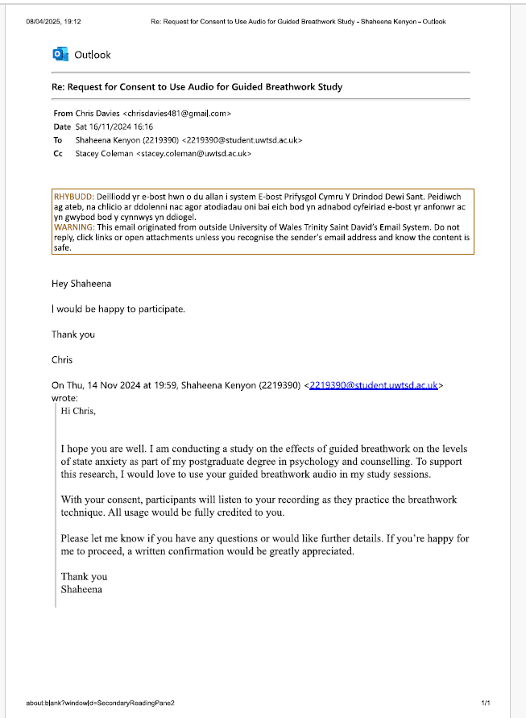

Appendix B – Breathwork Audio
Breathwork Audio

Appendix C- YouTube video link
immersive video

Appendix D - Room set up


Appendix E – GSR set up
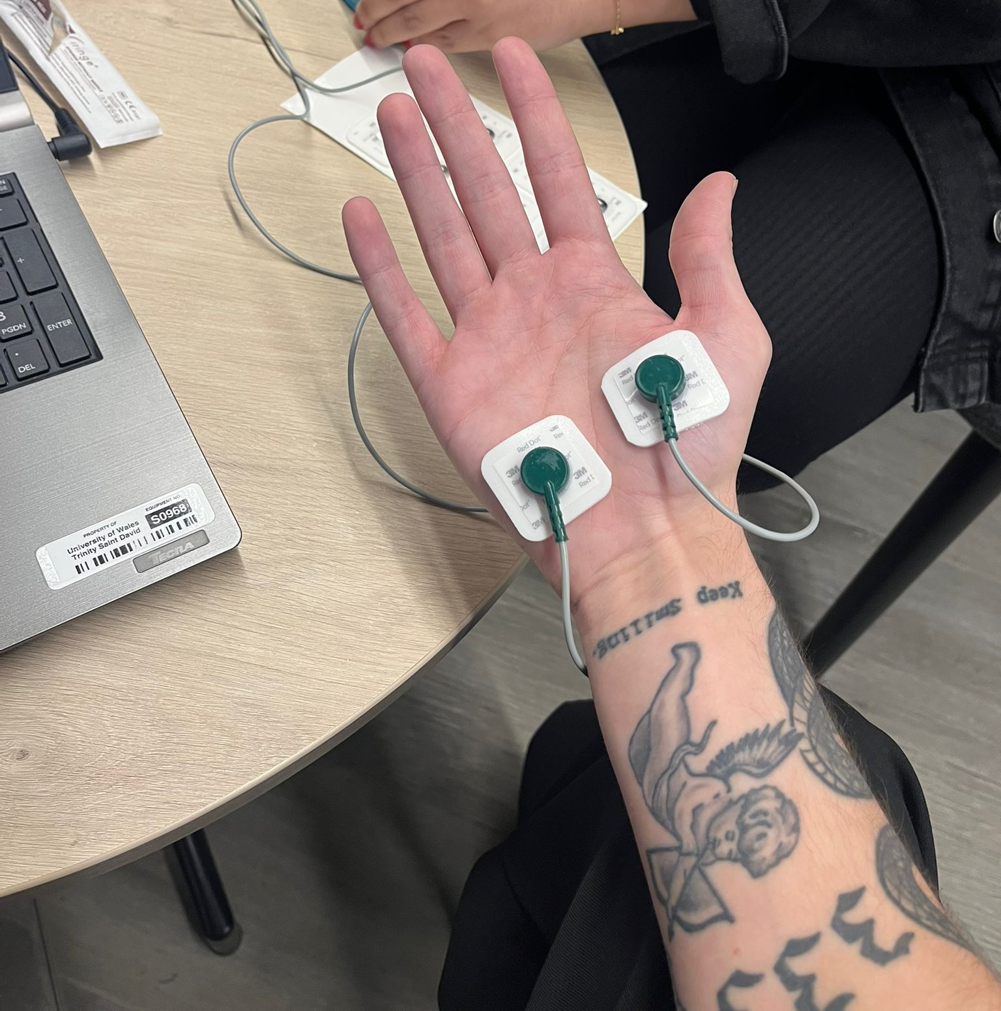
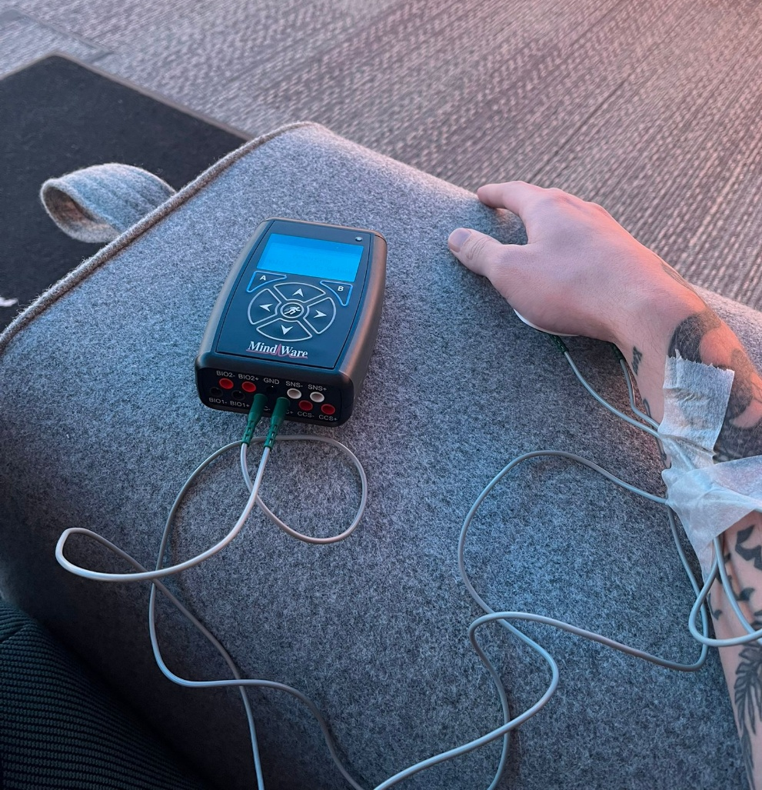
Appendix F – State Trait Anxiety Inventory Short form (STAI-6)

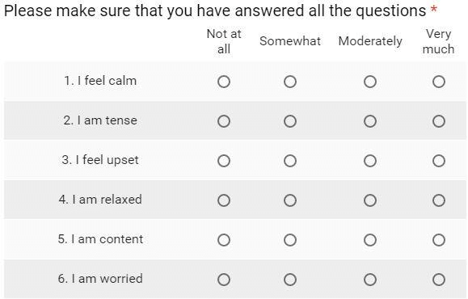

Appendix G – SPSS Output
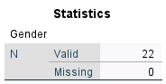
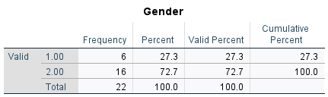

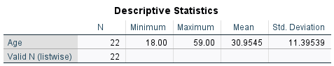

Descriptive for GSR Levels
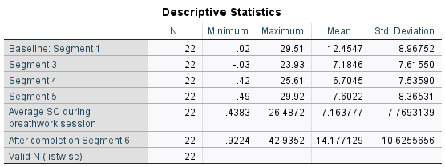
Descriptive Statistics for Self-reported STAI-6 Scores
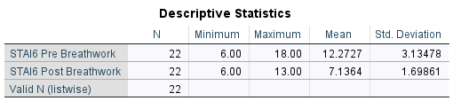
T-Test
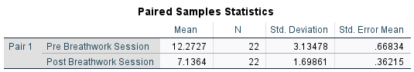
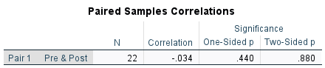

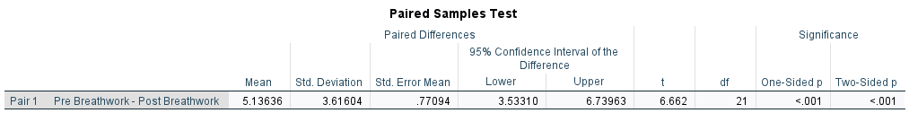
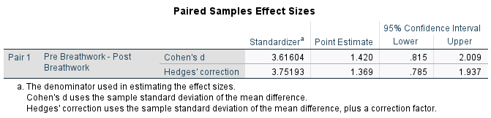

General Linear Model
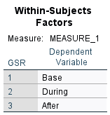

Descriptive Statistics
 | Mean | Std. Deviation | N
Base | 12.454695 | 8.9675164 | 22
During | 7.163777 | 7.7693139 | 22
After | 14.177129 | 10.6255656 | 22

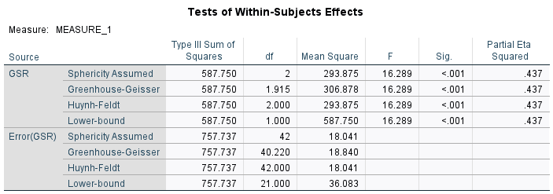
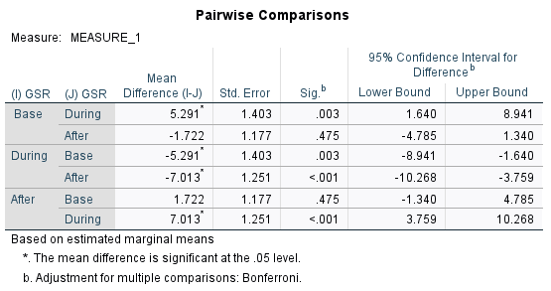
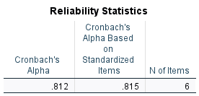
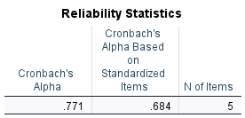

Appendix H – Ethical Approval
APPLICATION FOR ETHICAL APPROVAL

RESEARCH STUDENTS
This form is to be completed by the student within SIX months for full-time students and TWELVE months for part time students, after the commencement of the research degree or following progression to Part Two of your course.

Once complete, submit this form via the MyTSD Doctoral College Portal at (https://mytsd.uwtsd.ac.uk).

This document is also available in Welsh.

RESEARCH STAFF ONLY
All communications relating to this application during its processing must be in writing and emailed to pgresearch@uwtsd.ac.uk , with the title ‘Ethical Approval’ followed by your name.

STUDENTS ON UNDERGRADUATE OR TAUGHT MASTERS PROGRAMMES should submit this form (and receive the outcome) via systems explained to you by the supervisor/module leader.

In order for research to result in benefit and minimise risk of harm, it must be conducted ethically. A researcher may not be covered by the University’s insurance if ethical approval has not been obtained prior to commencement.

The University follows the OECD Frascati manual definition of research activity: “creative work undertaken on a systematic basis in order to increase the stock of knowledge, including knowledge of man, culture and society, and the use of this stock of knowledge to devise new applications”. As such this covers activities undertaken by members of staff, postgraduate research students, and both taught postgraduate and undergraduate students working on dissertations/projects.

The individual undertaking the research activity is known as the “principal researcher”.

Ethical approval is not required for routine audits, performance reviews, quality assurance studies, testing within normal educational requirements, and literary or artistic criticism.

Please read the notes for guidance before completing ALL sections of the form.

This form must be completed and approved prior to undertaking any research activity. Please see Checklist for details of process for different categories of application.

SECTION A: About You (Principal Researcher)
1 | Full Name: |  | Shaheena Kenyon
2 | Tick all boxes that apply: |  | Member of staff: | ☐ | Honorary research fellow: | ☐
 | Undergraduate Student | ☒ | Taught Postgraduate Student | ☐ | Postgraduate Research Student | ☐

3 | Institute/Academic Discipline/Centre: | Yr Athrofa: Psychology and Counselling
4 | Campus: | IQ, SA1 Campus, Swansea
5 | E-mail address: | 2219390@student.uwtsd.ac.uk
6 | Contact Telephone Number: | 07447006102
 | For students:
7 | Student Number: | 2219390
8 | Programme of Study: | BSc Psychology and Counselling
9 | Director of Studies/Supervisor: | Stacey Coleman

SECTION B: Approval for Research Activity
1 | Has the research activity received approval in principle?  (please check the Guidance Notes as to the appropriate approval process for different levels of research by different categories of individual) |  | YES | ☒ | NO | ☐
 |  |  |  |  | Date
2 | If Yes, please indicate source of approval (and date where known): Approval in principle must be obtained from the relevant source prior to seeking ethical approval | Research Degrees Committee |  | ☐
2 |  | Institute Research Committee |  | ☐
2 |  | Other (write in) Stacev Coleman (Dissertation supervisor) |  | ☒ | 14/08/2024

SECTION C: Internal and External Ethical Guidance Materials
 | Please list the core ethical guidance documents that have been referred to during the completion of this form (including any discipline-specific codes of research ethics, location-specific codes of research ethics, and also any specific ethical guidance relating to the proposed methodology). Please tick to confirm that your research proposal adheres to these codes and guidelines. You may add rows to this table if needed.
1 | UWTSD Research Ethics & Integrity Code of Practice | ☒
2 | UWTSD Research Data Management Policy | ☒
3 | BPS Code of Human Research Ethics (2021) | ☒
4 | BPS Code of Ethics and Conduct (2021) | ☒
5 | UWTSD Student Code of Conduct | ☒
6 | BPS Ethics Guidelines for Internet-Mediated Research (2021) | ☒

SECTION D: External Collaborative Research Activity
If there are external collaborators then you should gain consent from the contact persons to share their personal data with the university. If there are no external collaborators then leave this section blank and continue to section E.
1 | Institution
2 | Contact person name
3 | Contact person e-mail address
4 | Is your research externally funded? |  | YES | ☐ | NO |  | ☐
5 | Are you in receipt of a KESS scholarship? |  | YES | ☐ | NO |  | ☐
6 | Are you specifically employed to undertake this research in either a paid or voluntary capacity? | Voluntary | YES | ☐ | NO | ☐
7 |  | Employed | YES | ☐ | NO | ☐
8 | Is the research being undertaken within an existing UWTSD Athrofa Professional Learning Partnership (APLP)? | If YES then the permission question below does not need to be answered. | YES | ☐ | NO |  | ☐
9 | Has permission to undertake the research has been provided by the partner organisation? | (If YES attach copy)  If NO the application cannot continue | YES | ☐ | NO |  | ☐

Where research activity is carried out in collaboration with an external organisation
10 | Does this organisation have its own ethics approval system? | YES | ☐ | NO | ☐
 | If Yes, please attach a copy of any final approval (or interim approval) from the organisation (this may be a copy of an email if appropriate).

SECTION E: Details of Research Activity
1 | Indicative title: | Inhale, exhale, relax: The effect of guided breathwork on state anxiety in individuals
2 | Proposed start date: | November 2024 | Proposed end date: | May 2025
Introduction to the Research (maximum 300 words per section)
Ensure that you write for a Non-Specialist Audience when outlining your response to the points below:
- Purpose of Research Activity
- Proposed Research Question
- Aims of Research Activity
- Objectives of Research Activity
Demonstrate, briefly, how Existing Research has informed the proposed activity and explain
- What the research activity will add to the body of knowledge
- How it addresses an area of importance.
3 | Purpose of Research Activity  The purpose of the research activity is to explore whether cyclic breathing practices can help alleviate levels of anxiety in individuals. Recent studies have shown that engaging in controlled breathing exercises can significantly reduce arousal levels in individuals by consciously regulating the rate, depth, and pattern of breaths (Magnon et al., 2021); the application of this technique has garnered significant attention due to its straightforward approach and exceptional efficacy in mitigating stress and promoting mental well-being. Gerbarg et al. (2019) suggest that there is often difficulty in accessing psychological therapies and that accessible and affordable techniques such as breathwork can aid in reducing stress levels in individuals. Further research in this area will be valuable because practices such as standardised breathwork that can be delivered without direct interaction with a therapist hold promise as a potential solution to alleviate levels of stress in individuals from all walks of life (Lavretsky & Feldman, 2021).  A meta-analysis conducted to examine the impact of breathwork on mental health and stress found that breathwork was effective in reducing self-reported stress levels in comparison to those who did not use breathwork. Leyro et al. (2021) summarise research conducted into the effects of respiratory therapies, including controlled breathing, on anxiety and stress reduction and it was concluded that respiratory techniques yield significant improvements in anxiety reduction.  Fincham, G. W., Strauss, C., Montero-Marín, J., & Cavanagh, K. (2023). Effect of breathwork on stress and mental health: A meta-analysis of randomised controlled trials. Scientific Reports, 13(1). https://doi.org/10.1038/s41598-022-27247-y  Gerbarg, P. L., Brown, R. P., Streeter, C. C., Katzman, M. A., & Vermani, M. (2019). Breath practices for survivor and caregiver stress, depression, and post-traumatic stress disorder: connection, co-regulation, compassion. OBM Integrative and Complimentary Medicine, 4(3), 1. https://doi.org/10.21926/obm.icm.1903045  Lavretsky, H., & Feldman, J. L. (2021). Precision Medicine for Breath-Focused Mind-Body Therapies for Stress and Anxiety: Are we ready yet? Global Advances in Health and Medicine, 10, 216495612098612. https://doi.org/10.1177/2164956120986129  Leyro, T. M., Versella, M. V., Yang, M. J., Brinkman, H. R., Hoyt, D. L., & Lehrer, P. (2021). Respiratory therapy for the treatment of anxiety: Meta-analytic review and regression. Clinical Psychology Review, 84, 101980. https://doi.org/10.1016/j.cpr.2021.101980  Magnon, V., Dutheil, F., & Vallet, G. T. (2021). Benefits from one session of deep and slow breathing on vagal tone and anxiety in young and older adults. Scientific Reports, 11(1). https://doi.org/10.1038/s41598-021-98736-9  (this box should expand as you type)
4 | Research Question  Does engagement in guided breathwork help to reduce levels of arousal in individuals?  - Are there differences in the levels of self-reported state-anxiety before and after a breathwork session?  - Do levels of physiological arousal decrease after engagement in a guided breathwork session?  (this box should expand as you type)
5 | Aims of Research Activity  The research aims to investigate:  - To investigate whether the practice of guided breathwork has an effect on the levels of arousal of state anxiety in participants.  (this box should expand as you type)
6 | Objectives of Research Activity  The objectives of the research activity are to  - Assess participants’ baseline arousal levels  - Assess differences in arousal levels before, during and after the guided breathwork session  - To explore whether guided breathwork will reduce levels of arousal  - To explore if there are differences in levels of self-reported state anxiety before and after the breathwork session  (this box should expand as you type)
Proposed methods (maximum 600 words)
Provide a brief summary of all the methods that may be used in the research activity, making it clear what specific techniques may be used. If methods other than those listed in this section are deemed appropriate later, additional ethical approval for those methods will be needed. You do not need to justify the methods here but should instead describe how you intend to collect the data necessary for you to complete your project.
7 | Participants  Undergraduate students studying at UWTSD will be recruited via the EMS system. Due to the study's design, 12-15 participants are expected to be sufficient for the quantitative analysis. Questions to screen participants prior to signing up will include asking about respiratory, heart, or photosensitivity conditions.  Design  A within-subjects multi-factorial design with a control variable will be utilised. The first independent variable will be levels of self-reported stress which will be measured before and after the breathwork session using the State-Trait Anxiety Inventory (six item short form: STAI-6). The second independent variable will be levels of electrodermal (physiological) arousal recorded using a Galvanic Skin Response (GSR) device whilst participants work through a guided breathwork session, with pre-test arousal levels included as the covariate. Arousal will be averaged across three time points throughout the breathwork session. The dependent variable is the level of reported arousal/stress.  Materials  A six-item short form of the State-Trait Anxiety Inventory (STAI-6) of the self-report questionnaire will be utilised to measure the participants’ evaluation of how they are feeling at the current moment. The STAI-6 scale contains 6 items from the full 20 items from the State-Trait Anxiety Inventory Questionnaire (Spielberger, 1983). Participants will be asked to assess how they feel right now on a 4-point Likert scale, ranging from 'not at all', ‘somewhat’, ‘moderately to 'very much'. A higher score suggests higher levels of state anxiety.  A Galvanic Skin Response (GSR) device will be used to measure physiological arousal whilst the participants are taking part in the guided breathwork session. Participants will be asked to wear the GSR pads on their non-dominant hand whilst they complete the consent form and the STAI-6 via Qualtrics to ascertain baseline levels of arousal. When they are guided into the immersive room, participants will continue to wear the GSR pads / device which will continuously assess levels of arousal throughout the duration of engagement with the breathwork video. Whilst in the immersive room, participants will be guided through the breathwork session. There will be a (silent) nature video playing on the 360 screens (obtained via YouTube), with audio playing at the same time which will be created by a qualified breathwork facilitator. The breathwork session will last for around 20 minutes.  A pilot study with a small number of participants will be conducted to ascertain appropriate timepoints for markers of arousal, and all participants arousals levels will be recorded during analysis of the physiological data for consistency.  Procedure  Participants recruited via EMS will complete the study in the immersive room in Y Fforwm. An information sheet will be provided via Qualtrics (on a laptop) to the participants prior to the consent form (also displayed via Qualtrics). The GSR monitor will be attached to the palms of the participants’ non-dominant hand to measure the arousal levels at different points of the study, including during the breathwork session and 5 minutes after completion of the breathwork session. The participants will be asked to complete the STAI-6 questionnaire using the laptop provided before beginning the breathwork session. After completing the questionnaire, the participants will have 5 minutes to comfortably sit or lie down to start the guided breathwork session, which will last for a total of 20 minutes. At the end of the session, the participants will be asked to keep the GSR pads on whilst exiting the immersive room. They will be asked to complete the STAI-6 a second time to allow for comparison of scores before and after the guided breathwork. At the end of the study, a debrief will be provided and participants will be thanked for taking part.
Location of research activity
Identify all locations where research activity will take place.
8 | Immersive room  Y Fforwm, SA1 campus  (this box should expand as you type)
Research activity outside of the UK
If research activity will take place overseas, you are responsible for ensuring that local ethical considerations are complied with and that the relevant permissions are sought. Specify any local guidelines (e.g. from local professional associations/learned societies/universities) that exist and whether these involve any ethical stipulations beyond those usual in the UK (provide details of any licenses or permissions required). Also specify whether there are any specific ethical issues raised by the local context in which the research activity is taking place, for example, particular cultural and/or legal sensitivities or vulnerabilities of participants. If you live in the country where you will do the research then please state this.
9 | N/A  (this box should expand as you type)

10 | Use of documentation not in the public domain: Are any documents NOT publicly available? | NO | ☒
10 |  | YES | ☐
11 | If Yes, please provide details here of how you will gain access to specific documentation that is not in the public domain and that this is in accordance with the current data protection law of the country in question and that of England and Wales.  (this box should expand as you type)

 | Does your research relate to one or more of the seven aims of the Well-being of Future Generations (Wales) Act 2015? | YES | NO
12 | A prosperous Wales | ☐ | ☒
13 | A resilient Wales | ☒ | ☐
14 | A healthier Wales | ☒ | ☐
15 | A more equal Wales | ☐ | ☒
16 | A Wales of cohesive communities | ☐ | ☒
17 | A Wales of vibrant culture and thriving Welsh language | ☐ | ☒
18 | A globally responsible Wales | ☐ | ☒
19 | If YES to any of the above, please give details:
The proposed study will help promote healthier living in Wales. By introducing breath work into daily life, it aims to reduce state anxiety and create a more resilient community.

(this box should expand as you type)

SECTION F: Scope of Research Activity
 | Will the research activity include: | YES | NO
1 | Use of a questionnaire or similar research instrument? | ☒ | ☐
2 | Use of interviews? | ☐ | ☒
3 | Use of focus groups? | ☐ | ☒
4 | Use of participant diaries? | ☐ | ☒
5 | Use of video or audio recording? | ☐ | ☒
6 | Use of computer-generated log files? | ☐ | ☒
7 | Participant observation with their knowledge? | ☐ | ☒
8 | Participant observation without their knowledge? | ☐ | ☒
9 | Access to personal or confidential information without the participants’ specific consent? | ☐ | ☒
10 | Administration of any questions, test stimuli, presentation that may be experienced as physically, mentally or emotionally harmful / offensive? | ☐ | ☒
11 | Performance of any acts which may cause embarrassment or affect self-esteem? | ☐ | ☒
12 | Investigation of participants involved in illegal activities? | ☐ | ☒
13 | Use of procedures that involve deception? | ☐ | ☒
14 | Administration of any substance, agent or placebo? | ☐ | ☒
15 | Working with live vertebrate animals? | ☐ | ☒
16 | Procedures that may have a negative impact on the environment? | ☐ | ☒
17 | Other primary data collection methods. Please indicate the type of data collection method(s) below. | ☒ | ☐
 | Details of any other primary data collection method:  Data will be collected using an electrodermal activity device. When the ANS (sympathetic branch) is highly aroused, sweat gland activity also increases which makes the skin more conductive. Skin conductance can be an indicator of physiological or psychological arousal, therefore an EDA/GSR device is the most appropriate tool to use to assess arousal in this study.  (this box should expand as you type) | ☒ | ☐
If NO to every question, then the research activity is (ethically) low risk and may be exempt from some of the following sections (please refer to Guidance Notes).

If YES to any question, then no research activity should be undertaken until full ethical approval has been obtained.

SECTION G: Intended Participants
If there are no participants then do not complete this section, but go directly to section H.

 | Who are the intended participants: | YES | NO
1 | Students or staff at the University? | ☒ | ☐
2 | Adults (over the age of 18 and competent to give consent)? | ☐ | ☒
3 | Vulnerable adults? | ☐ | ☒
4 | Children and Young People under the age of 18? (Consent from Parent, Carer or Guardian will be required) | ☐ | ☒
5 | Prisoners? | ☐ | ☒
6 | Young offenders? | ☐ | ☒
7 | Those who could be considered to have a particularly dependent relationship with the investigator or a gatekeeper? | ☐ | ☒
8 | People engaged in illegal activities? | ☐ | ☒
9 | Others. Please indicate the participants below, and specifically any group who may be unable to give consent. | ☐ | ☒
 | Details of any other participant groups:  (this box should expand as you type) | ☐ | ☒

Participant numbers and source
Provide an estimate of the expected number of participants. How will you identify participants and how will they be recruited?
10 | How many participants are expected? | Based on the design and length of the study, it is expected that approximately 15-20 participants will be sufficient to conduct an appropriate analysis.  (this box should expand as you type)
11 | Who will the participants be? | UWTSD University students enrolled on a psychology related degree  As the study will require participants to follow a cyclic breathing pattern, and therefore participants will be advised not to sign up to take part in the study if they have any of the following health conditions.  -Respiratory disorders: Asthma, Bronchitis  -Cardiovascular disorders: Arrhythmias, Hypertension, history of heart attacks or stroke  -Photosensitivity/epilepsy  -Mental health disorders: PTSD, severe anxiety, schizophrenia,  -Pregnancy  -Recent surgery abdominal or thoracic injury  -Physical injuries: that could be exacerbated by breathing exercises or sitting, standing or laying too long  To ensure no issues, participants will again be asked to confirm they do not have any of the disorders listed above before taking part in the study.  (this box should expand as you type)
12 | How will you identify the participants? | The participants will be recruited via the Experiment Management System (EMS). Students will be provided with a detailed description of the study which they are recommended to read as it includes important information explaining the exclusion criteria for the study.  (this box should expand as you type)

 | Information for participants: | YES | NO | N/A
13 | Will you describe the main research procedures to participants in advance, so that they are informed about what to expect? | ☒ | ☐ | ☐
14 | Will you tell participants that their participation is voluntary? | ☒ | ☐ | ☐
15 | Will you obtain written consent for participation? | ☐ | ☒ | ☐
16 | Will you explain to participants that refusal to participate in the research will not affect their treatment or education (if relevant)? | ☒ | ☐ | ☐
17 | If the research is observational, will you ask participants for their consent to being observed? | ☐ | ☐ | ☒
18 | Will you tell participants that they may withdraw from the research at any time and for any reason? | ☒ | ☐ | ☐
19 | With questionnaires, will you give participants the option of omitting questions they do not want to answer? | ☒ | ☐ | ☐
20 | Will you tell participants that their data will be treated with full confidentiality and that, if published, it will not be identifiable as theirs? | ☒ | ☐ | ☐
21 | Will you debrief participants at the end of their participation, in a way appropriate to the type of research undertaken? | ☒ | ☐ | ☐
22 | If NO to any of above questions, please give an explanation
The consent form will be displayed via Qualtrics; therefore, consent will be obtained online, and consent responses will be stored anonymously via the Qualtrics server

(this box should expand as you type)

 | Information for participants: | YES | NO | N/A
24 | Will participants be paid? | ☐ | ☒ | ☐
25 | Is specialist electrical or other equipment to be used with participants? | ☒ | ☐ | ☐
26 | Are there any financial or other interests to the investigator or University arising from this study? | ☐ | ☒ | ☐
27 | Will the research activity involve deliberately misleading participants in any way, or the partial or full concealment of the specific study aims? | ☐ | ☒ | ☐
28 | If YES to any question, please provide full details
The study will take place in the Immersive room within Y Fforwm (IQ SA1 campus). A prepared video of a guided breathwork session will be displayed on the 360 screens. Additionally, the GSR device will be used to assess arousal throughout the study.

(this box should expand as you type)

SECTION H: Anticipated Risks

Outline any anticipated risks that may adversely affect any of the participants, the researchers and/or the University, and the steps that will be taken to address them.

If you have completed a full risk assessment (for example as required by a laboratory, or external research collaborator) you may append that to this form.
1 | Full risk assessment completed and appended? |  | Yes | ☐
1 |  |  | No | ☒
2 | Risks to participants  For example: sector-specific health & safety, emotional distress, financial disclosure, physical harm, transfer of personal data, sensitive organisational information
 | Risk to participants:  - The study requires the participants to follow a cyclic breathing pattern, which may exacerbate heart or lung conditions.  - The participants will be viewing a video on the 360-degree screen in the immersive room, which could potentially be dangerous to people with photosensitivity, motion sensitivity, severe migraines or headaches.  - The study will take place in the immersive room within Y Fforwm, and the doors to the room will be closed to minimise distraction. Being in an immersive set-up can create a sensation of enclosure or confinement and may exacerbate feelings of claustrophobia or anxiety.  - The study requires the participants to follow a guided breathwork session, and they will be required to sit or lie down for the duration of the session.  - The GSR device requires the electrodes to be attached to the palms of the participants' hands. The electrodes are pre-moistened with a conducting gel, and alcohol wipes will be used to clean the skin before attaching them to the hand. There is also a requirement to secure the GSR wires to the participants wrist to ensure mitigation of ‘noise’ whilst the data collection is taking place. These will be secured in a double loop with micropore tape. There is a potential for minimal physical discomfort as a result of wearing the GSR pads or tape, or a participant having an allergic reaction.  - The participants may feel distressed answering the questions on the state anxiety questionnaire or feel more stress knowing that their arousal levels are being measured whilst engaging in the breathwork session.  - Confidentiality of self-reported and physiological data.  (this box should expand as you type) | How you will mitigate the risk to participants:  - Upon viewing the study information on EMS, participants will be advised to read the guidance in full as this will contain a list of exclusion criteria, including respiratory or cardiovascular disorders, photosensitivity or epilepsy, pregnancy, diagnoses of mental health disorders such as PTSD, severe anxiety, or schizophrenia, recent surgery, or physical injury that could be exacerbated by breathing exercises or sitting, standing or laying too long. To ensure double insurance that participants have considered any of the above disorders prior to taking part, they will be asked to complete a short questionnaire indicating ‘yes’ or ‘no’ to these disorders. If participants respond ‘yes’ to the question asked, it will be explained that it is recommended they do not take part in the study due to the requirements for engaging in a breathwork session.  - As above, participants will be provided with information in the description placed on EMS, and the additional questions included prior to participants taking part in the breathwork session will ask participants to, again, confirm that they do not have any sensitivity concerns, or headaches/migraines.  - Participants will have the opportunity to view the setup of the room prior to providing consent to take part in the study. The door to enter/exit the room can be left open and participants can view the layout of the room as well as their distance from the screens when inside the room. The visuals on the screen will be open nature spaces or skies or horizons, which should reduce the sense of confinement. Participants will be reminded that they can leave the study at any point without any penalty.  - Participants will be informed of this at the sign-up, and a chair, cushions, and blankets will be provided for the duration of the study. Participants will have a choice to sit on the floor, lie down, or use a chair depending on their level of required comfort. Information will be provided within the information sheet that explains what guided breathwork is and how it works. The researcher will verbally ask each participant if they have any questions about engaging in guided breathwork before they begin the study, to ensure that any concerns participants may have can be alleviated with an appropriate explanation of what they will be doing whilst in the immersive room.  - It will be explained on the EMS that there is a requirement to wear the electrode pads for the duration of this study to allow participants to make an informed decision to sign up to take part in the study. If a participant becomes uncomfortable during the study, they will be given the opportunity to remove the device. Clear instructions on how the GSR device works, how it will be positioned, and any effects that may occur will be provided within the information sheet. All participants will be fully informed of the procedure of the study and the measures being used before starting and will be asked to confirm that they are not knowingly allergic to the materials contained within the pads.  - To mitigate this, participants will be informed that they do not have to answer any questions they do not want to on the STAI-6 questionnaire. As noted above, a full description will be provided on EMS to ensure participants are able to make a fully informed decision to sign up to take part in this study, and this will involve information on the purpose of guided breathwork, the requirement of wearing the GSR electrode pads, and the use of the immersive room. Participants will also be informed that they can stop the breathwork exercises or withdraw from the study at any time if they feel uncomfortable or distressed with any part of the study. If there are any concerns following completion of the study, participants will be encouraged to contact the researcher or research supervisor in the first instance (contact details will be provided on the debrief form). If there are further concerns, participants will be reminded that there is support available via Student Support Services within UWTSD. A link to the Student Support Services department website will be provided within the debrief form.  - Self-reporting anxiety levels, and the physiological data that is related to arousal, will remain confidential. The STAI-6 will be completed online, with the researcher ensuring that there is a unique identifier used only to ensure GSR data can be matched to the correct participant. Participants will be informed that they have the right to request that their data is withdrawn up until a date specified by the researcher in the debrief form. After this point, all data will be anonymised and transferred in preparation for analysis.  (this box should expand as you type)
3 | If research activity may include sensitive, embarrassing or upsetting topics (e.g. sexual activity, drug use) or issues likely to disclose information requiring further action (e.g. criminal activity), give details of the procedures to deal with these issues, including any support/advice (e.g. helpline numbers) to be offered to participants. Note that where applicable, consent procedures should make it clear that if something potentially or actually illegal is discovered in the course of a project, it may need to be disclosed to the proper authorities
N/A

(this box should expand as you type)
4 | Risks to the investigator  For example: personal health & safety, physical harm, emotional distress, risk of accusation of harm/impropriety, conflict of interest
 | - The participants will be provided researcher’s email and there is a potential risk of receiving negative or unwelcome emails from the participant.  - The student researcher might be asked for information outside the scope of their knowledge.  - There is a physical risk involved due to the requirements for placing electrodes on to participants.  - Additionally, the student researcher may face accusations of harm or impropriety if a participant feels dissatisfied with any aspect of the research process.  - There is a risk of researcher fatigue due to the length of data collection sessions and the potential for collecting data from multiple participants simultaneously.  (this box should expand as you type) | How you will mitigate the risk to the investigator:  - The participants will only be provided with university students’ email addresses and any unwelcomed emails from the participant will be reported the dissertation supervisor immediately.  - The researcher will pass any queries they are unable to deal with to their dissertation supervisor.  - The student researcher will be required to be in close proximity with each participant in order to place electrodes on their hands and secure the wires to the participants’ wrist. Appropriate PPE has been made available (gloves, alcohol wipes, and masks if required), and the researcher will be adhering to a research protocol set up and agreed between themselves and the research supervisor. The student will ensure to follow all UWTSD and BPS codes of conduct and research guidelines regarding integrity when conducting the research and respect for participants. The study will not take place until all elements have been approved by the dissertation supervisor.  - To mitigate the concern of fatigue, it will be ensured that participants booked are spaced out and research is carried out over a period of several days/weeks.  (this box should expand as you type)
5 | University/institutional risks  For example: adverse publicity, financial loss, data protection
 | Risk to the University:  - The reputation and integrity of UWTSD and the discipline of Psychology could be endangered if researchers do not adhere to codes of ethics and research protocols.  - Data could be leaked, exposed or used for other purposes.  (this box should expand as you type) | How you will mitigate the risk to the University:  - The University Ethics and Integrity Code of Practice and the BPS Code of Ethics and Conduct will be followed at every stage of the proposed study to minimise any potential risks to the Institution from arising. The researcher will always act with professionalism and will adhere to the research protocol agreed upon by the dissertation supervisor. Due to the GSR device being used, it is imperative that the research supervisor be present during data collection, and this has also been agreed upon with the supervisor.  - The data collected will be stored in accordance with the UWTSD Research Data Management (RDM) rules and will only be used for its intended purpose. This follows the ethical guidelines outlined in the UWTSD Research Ethics & Integrity Code of Practice and the British Psychological Society (BPS) Code of Ethics. To minimise any risk to UWTSD and the psychology department, all data collected using the STAI-6 will be securely stored using the Qualtrics platform. It is imperative that an identifier be used initially to ensure correct matching up of self-report and physiological data, but all data will remain confidential at all times and only aggregated, anonymised data will be used following completion of the study’s data collection period. Physiological data will be stored on the GSR device and will be electronically transferred to the researcher's personal memory stick and saved within a password-protected folder allocated for raw data. Each participant’s GSR data will be analysed individually at first using the appropriate MindWare software to reduce noise and clutter, and to identify the appropriate data required based on previously determined markers (time markers). These ‘marked’ data will then be put into SPSS for analysis.  (this box should expand as you type)
6 | Environmental risks  For example: accidental spillage of pollutants, damage to local ecosystems
 | Risk to the environment:  - The use of immersive room  - Use of GSR device  - Waste from materials used to secure GSR electrodes and wires.  - Use of paper-based materials  (this box should expand as you type) | How you will mitigate the risk to environment:  - The immersive space is located within Y Fforwm, IQ campus and participants will be instructed that no food or drink is to be taken into the room whilst taking part in the study.  - An agreed research protocol will be followed in placing electrodes on to participants and in removing them. The research supervisor will be present during data collection to maintain responsibility for the GSR device. As this is an electronic device, it will require regular charging which will contribute to energy use, however charging will occur as little as possible.  - Alcohol wipes and sensor pads will be disposed off in the designated yellow waste bins There are a number of single-use items required for this research including the adhesive electrode pads, alcohol cleaning wipes, micropore tape and disposable gloves.These items do generate non-biodegradable waste however they are required due to the inappropriateness of reusing materials for multiple participants (in terms of hygiene and effectiveness of items such as electrodes). As the researcher will be solely responsible for preparing the participant, it will be ensured that only one pair of gloves will be used per day to limit this waste. Electrodes, alcohol wipes and micropore tape will be disposed of safely via medical waste. A designated medical waste bin will be used daily (that is provided by PsychLabs) and this will be returned to PsychLabs after each data collection session to ensure proper disposal of medical waste.  - The information sheet, consent form, demographic questionnaire, STAI-6 questionnaire, and debrief form will all be presented via Qualtrics, thus eliminating the requirement for any printing of paper-based materials for this study.  (this box should expand as you type)

 | Disclosure and Barring Service
 | If the research activity involves children or vulnerable adults, a Disclosure and Barring Service (DBS) certificate must be obtained before any contact with such participants. | YES | NO | N/A
7 | Does your research require you to hold a current DBS Certificate? | ☐ | ☒ | ☐
8 | If YES, please give the certificate number. If the certificate number is not available please write “Pending”; in this case any ethical approval will be subject to providing the appropriate certificate number.

SECTION I: Feedback, Consent and Confidentiality

1 | Feedback  What de-briefing and feedback will be provided to participants, how will this be done and when?
At the end of the study, participants will receive a debrief sheet that will be displayed on Qualtrics which will outline the purpose and aims of the study, as well as the participants right to withdraw at that point. It will also be explained that participants have the opportunity to ask the researcher questions or express any concerns they may have about the study. The debrief sheet will include the contact details of both the researcher and the supervisor. Participants will be informed that they can request a copy of the debrief form to keep for their own records and, If a copy of the debrief form is requested, it will be sent via the EMS (through the sign-up process) after the study is completed. To do this, the researcher will require the participants EMS ID number to locate their sign-up timeslot and communicate via EMS.

(this box should expand as you type)
2 | Informed consent  Describe the arrangements to inform potential participants, before providing consent, of what is involved in participating. Describe the arrangements for participants to provide full consent before data collection begins. If gaining consent in this way is inappropriate, explain how consent will be obtained and recorded in accordance with prevailing data protection legislation.
Prior to signing up to take part, a full description of the study will be provided on the EMS to ensure participants are aware of what will be required of them before they sign up. This description will clearly outline the list of medical conditions that would exclude a participant from taking part in the study in order to allow them to make a fully informed decision to sign-up to take part based upon their own physical and/or mental health. Furthermore, it will be explained that there will be a requirement to wear electrodes on the surface of the skin (hands) and engage in a guided breathwork session for around 20 minutes.

Once participants arrive to take part in the study, an information sheet will be displayed on a laptop (on Qualtrics) which will provide clear instructions and information on what the participant will be expected to do whilst taking part in the study. Following this, a consent form will be shown which will clearly outline the aims and objectives of the research, confirm the participants' right to withdraw at any time, and provide information regarding the storage and confidentiality of all data collected. The contact details of the researcher will be provided on the consent form. Participants will verbally be reminded that taking part in the study is voluntary and that, during all elements of the study, they can stop at any time and request to leave without penalty, and have their data removed.

(this box should expand as you type)
3 | Confidentiality / Anonymity  Set out how anonymity of participants and confidentiality will be ensured in any outputs. If anonymity is not being offered, explain why this is the case.
The information sheet and consent form will outline that participants have a right to expect that any data collected from them as a result of taking part in this study will be treated confidentially in line with the General Data Protection Regulation (GDPR, 2016), Data Protection Act (2018) and UWTSD Data Management Policy. Questionnaire data from the STAI-6 will be collected online via Qualtrics, and this will be stored anonymously on the Qualtrics cloud server. In order to ensure accurate matching of two different sets of data (STAI-6 responses and GSR data), the researcher will manually input a random ID number within the demographics page on Qualtrics (e.g., 001) to ensure that data can be matched accurately in preparation for analysis.

GSR data will be stored on the GSR device initially until it is transferred to the researcher’s personal memory stick and saved within a dedicated, password-protected data folder. The only identifier here will be the unique/random ID number that allows for physiological data to be matched with questionnaire data.

(this box should expand as you type)

SECTION J: Data Protection and Storage

 | Does the research activity involve personal data (as defined by the General Data Protection Regulation 2016 “GDPR” and the Data Protection Act 2018 “DPA”)? | YES | NO
1 | “Personal data” means any information relating to an identified or identifiable natural person (‘data subject’). An identifiable natural person is one who can be identified, directly or indirectly, in particular by reference to an identifier such as a name, an identification number, location data, an online identifier or to one or more factors specific to the physical, physiological, genetic, mental, economic, cultural or social identity of that natural person. Any video or audio recordings of participants is considered to be personal data. | ☒ | ☐
 | If YES, provide a description of the data and explain why this data needs to be collected:
2 | Demographic data will be collected as this is a standard reporting measure in psychology reports within the participant's subsection of the method. This according to the UWTSD Research Data Management Policy constitutes as personal data. None of the identifying data will be attached to the participants' data. The GSR readings will be transferred to the researcher's personal memory stick for the purpose of analysis and only used for statistical purposes and not attached to any identifiable data from any participant.  (this box should expand as you type)
 | Does it involve special category data (as defined by the GDPR)? | YES | NO
3 | “Special category data” means sensitive personal data consisting of information as to the data subjects’ –  (a) racial or ethnic origin,  (b) political opinions,  (c ) religious beliefs or other beliefs of a similar nature,  (d) membership of a trade union (within the meaning of the Trade Union and Labour Relations (Consolidation) Act 1992),  (e) physical or mental health or condition,  (f) sexual life,  (g) genetics,  (h) biometric data (as used for ID purposes), | ☒ | ☐
 | If YES, provide a description of the special category data and explain why this data needs to be collected:
4 | Technically, Galvanic Skin Response (Conductance) is a form of biometric data. Whilst GSR is not used for personal identification of any person, it does measure a physiological characteristic (changes in electrical conductance of the skin) that can provide information about an individual’s current emotional/physiological state that is involuntary. This data is essential as it will provide information on arousal levels of participants whilst taking part in the study. It is imperative that baseline arousal levels are assessed, thus the GSR electrodes will be placed on to participants from the beginning of the study and not just during the guided breathwork session. Participants will be required to provide fully informed consent to take part as they will be fully informed of the nature of collecting skin conductance data, and the purpose of the study.  (this box should expand as you type)

 | Will data from the research activity (collected data, drafts of the thesis, or materials for publication) be stored in any of the following ways? | YES | NO
5 | Manual files (i.e. in paper form)? | ☐ | ☒
6 | University computers? | ☒ | ☐
7 | Private company computers? | ☐ | ☒
8 | Home or other personal computers? | ☐ | ☒
9 | Laptop computers/ CDs/ Portable disk-drives/ memory sticks? | ☒ | ☐
10 | “Cloud” storage or websites? | ☒ | ☐
11 | Other – specify:  GSR device – this will initially hold data collected until it is electronically transferred to the researchers personal device. | ☒ | ☐
12 | For all stored data, explain the measures in place to ensure the security of the data collected, data confidentiality, including details of backup procedures, password protection, encryption, anonymisation and pseudonymisation:
University computers:

A laptop will be used to cast the video and audio to the 360 screen in the immersive room, which is registered to the psychology department and, therefore, the university. Whilst no data will be collected and stored on the laptop, it will be used during the data collection period.

Furthermore, the software required to analyse the GSR data is located on the lab computers within the Psych Labs. Therefore, data will temporarily be looked at on a university computer, but data will remain to be stored/saved on the researcher's personal memory stick.

Laptop computers / memory sticks:

Drafts of the dissertation, along with draft chapters will be stored on a personal laptop within a password protected folder.

Once downloaded, Qualtrics (STAI-6) data will be saved within a dedicated and password-protected data folder on a memory stick. GSR data for each participant will also be stored within this folder on the researcher's memory stick.

Cloud storage:

The data collected from participants from the STAI-6 questionnaire will be stored on the Qualtrics server until it is required to be downloaded and analysed. Only the researcher has direct access to the data stored on Qualtrics which is accessible only via a personal password, thus ensuring the data remains confidential. Data in its raw form will be saved to SPSS, and this will also be saved within a personal password protected folder on the researcher’s memory stick. All identifying information, including GPS location identifiers and IP address, will be removed.

GSR data will initially be stored on the GSR device until it is transferred to the researcher's personal memory stick. Once transferred, the data files will be saved within a dedicated and password-protected data folder. As noted previously, each individual data file will require analysis prior to data being added to SPSS in its ‘raw’ format.

(this box should expand as you type)

 | Data Protection
 | Will the research activity involve any of the following activities: | YES | NO
13 | Electronic transfer of data in any form? | ☒ | ☐
14 | Sharing of data with others at the University outside of the immediate research team? | ☐ | ☒
15 | Sharing of data with other organisations? | ☐ | ☒
16 | Export of data outside the UK or importing of data from outside the UK? | ☐ | ☒
17 | Use of personal addresses, postcodes, faxes, emails or telephone numbers? | ☐ | ☒
18 | Publication of data that might allow identification of individuals? | ☐ | ☒
19 | Use of data management system? | ☐ | ☒
20 | Data archiving? | ☐ | ☒
21 | If YES to any question, please provide full details, explaining how this will be conducted in accordance with the GDPR and Data Protection Act (2018) (and any international equivalents, where appropriate):
As noted above, data collection from participants on their state anxiety levels (STAI-6 questionnaire) will be transferred from the Qualtrics cloud system to SPSS once all data has been collected and is ready for analysis. The data from the GSR device will be transferred to the researcher's personal memory stick at the end of each data collection period (e.g., each day that data collection has taken place). Once this data has been transferred, there is a requirement to use a university computer (located within the Psychology Labs to analyse GSR data and identify the correct data to be placed on to SPSS (using time markers, etc).

(this box should expand as you type)
22 | List all who will have access to the data generated by the research activity:
Shaheena Kenyon and Stacey Coleman

(this box should expand as you type)
23 | List who will have control of, and act as custodian(s) for, data generated by the research activity:
Shaheena Kenyon

(this box should expand as you type)
24 | Give details of data storage arrangements, including security measures in place to protect the data, where data will be stored, how long for, and in what form. Will data be archived – if so how and if not why not.
GSR data will initially be stored on the GSR device until it is transferred to the researcher's personal memory stick. Once transferred, the data files will be saved within a dedicated and password-protected data folder. As noted previously, each individual data file will require analysis prior to data being added to SPSS in its ‘raw’ format.

Data on state anxiety will be collected and stored on the Qualtrics cloud server until the point that it is required to be downloaded for analysis. Following electronic transfer of the raw data, it will be saved in a dedicated folder on the researcher's memory stick. This memory stick, and each appropriate folder, will be password protected. All data will be kept until the end of the exam board in case it is required to be viewed by any academic staff members for examining purposes.

(this box should expand as you type)
25 | Please indicate if your data will be stored in the UWTSD Research Data Repository (see https://researchdata.uwtsd.ac.uk/ ). If so please explain. (Most relevant to academic staff)
No data will be stored on the Research Data Repository.

(this box should expand as you type)
26 | Confirm that you have read the UWTSD guidance on data management (see https://www.uwtsd.ac.uk/library/research-data-management/) | YES | ☒
27 | Confirm that you are aware that you need to keep all data until after your research has completed or the end of your funding | YES | ☒

SECTION K: Declaration
The information which I have provided is correct and complete to the best of my knowledge. I have attempted to identify any risks and issues related to the research activity and acknowledge my obligations and the rights of the participants.

In submitting this application I hereby confirm that I undertake to ensure that the above named research activity will meet the University’s Research Ethics and Integrity Code of Practice which is published on the website: https://www.uwtsd.ac.uk/research/research-ethics/
1 | Signature of applicant: | Shaheena Kenyon | Date:  29/11/24

For STUDENT Submissions:
2 | Director of Studies/Supervisor: | Stacey Coleman | Date: 02/12/24
3 | Signature: | SL Coleman | Date: 02/12/24

For STAFF Submissions:
4 | Academic Director/ Assistant Dean: |  | Date:
5 | Signature: |  | Date:

Checklist: Please complete the checklist below to ensure that you have completed the form according to the guidelines and attached any required documentation:
☒ | I have read the guidance notes supplied before completing the form.
☒ | I have completed ALL RELEVANT sections of the form in full.
☒ | I confirm that the research activity has received approval in principle
☐ | I have attached a copy of final/interim approval from external organisation (where appropriate)
☐ | I have attached a full risk assessment (where appropriate) ONLY TICK IF YOU HAVE ATTACHED A FULL RISK ASSESSMENT
☒ | I understand that it is my responsibility to ensure that the above named research activity will meet the University’s Research Ethics and Integrity Code of Practice.
☒ | I understand that before commencing data collection all documents aimed at respondents (including information sheets, consent forms, questionnaires, interview schedules etc.) must be confirmed by the DoS/Supervisor, module tutor or Academic Director.

RESEARCH STUDENTS ONLY
Once complete, submit this form via the MyTSD Doctoral College Portal at (https://mytsd.uwtsd.ac.uk).

RESEARCH STAFF ONLY
All communications relating to this application during its processing must be in writing and emailed to pgresearch@uwtsd.ac.uk , with the title ‘Ethical Approval’ followed by your name.

STUDENTS ON UNDERGRADUATE OR TAUGHT MASTERS PROGRAMMES should submit this form (and receive the outcome) via systems explained to you by the supervisor/module leader.

Participant Consent Form

Title of Study: Inhale, exhale, relax: The effects of guided breathwork on levels of state anxiety
Research Team: Shaheena Kenyon (2219390@student.uwtsd.ac.uk) and dissertation supervisor, Stacey Coleman (stacey.coleman@uwtsd.ac.uk)
Date:
- I confirm that I have read and understand the Information Sheet for the above study. | Yes | No
- I had an opportunity to ask questions and have them answered satisfactorily. | Yes | No
- I understand that I may ask further questions at any time. | Yes | No
- I understand that my participation is voluntary, and I am free to withdraw from the study at any time without penalty or giving any reason. | Yes | No
- I understand that my fully anonymised data will be utilised for only this research study, which is being conducted by a third-year Psychology student for the purpose of their undergraduate dissertation and will be deleted once external examiner approval for the project has been obtained. | Yes | No
- I have been informed that if I feel I would be uncomfortable answering questions, doing the guided breathwork, watching a video on the immersive screens, or have any of the conditions mentioned in the pre-screening, that I should not take part in this study. | Yes | No
- I understand that I will be required to wear the Galvanic Response Sensors on my hand for the duration of the study. | Yes | No
- I understand that I may decline to answer any questions. | Yes | No
- I understand that any data collected will be anonymised and stored in an anonymous format and once I leave the data collection area it will not be possible to trace the data back to me to withdraw. | Yes | No
- I understand that the anonymised data provided will be securely stored and accessible only to the members of the research team directly involved in the study, and that confidentiality will be maintained. | Yes | No
- I confirm that I am over 18 years old | Yes | No
- I consent to take part in the above study. | Yes | No

This form will be completed on Qualtrics and stored on the researcher's laptop and will be password protected, and participants can request an email copy for their records.
Participant Information Sheet

Title of Study: Inhale, exhale, relax: The effects of guided breathwork on the levels of state anxiety

Research Team: Shaheena Kenyon (2219390@student.uwtsd.ac.uk) and dissertation supervisor, Stacey Coleman (stacey.coleman@uwtsd.ac.uk)

Date:

Invitation Paragraph:
You are being invited to take part in a research project being conducted by a third-year dissertation student within the Psychology and Counselling department at The University of Wales Trinity Saint David (UWTSD). Before you decide to take part, it is important for you to understand why the research is being conducted and what participation will involve.

Please read the following information carefully and feel free to discuss it with the researcher if you have any questions. Please ask the researcher if anything is unclear or if you would like more information. Take your time to decide whether you would like to participate. Thank you for reading this.

Purpose of Research:

The aim of this study is to explore whether the practice of guided breathwork has an effect on levels of arousal. The participants will be invited to follow a guided breathwork session in an immersive room located in Y Fforwm of the UWTSD Waterfront Campus.

What does taking part involve:
This study will involve you taking part in a range of tasks, and you will be required to do the following:

- Provide demographic information of age and gender.
- Complete a short questionnaire that aims to measure state anxiety before and after your engagement in the study.
- Wear a skin conductance device to measure a physiological response known as Electrodermal Activity (EDA). EDA is a measurement of changes in the electrical properties of your skin, and our EDA changes based upon activation of the sympathetic nervous system.
    - The researcher will ensure your hands are free of dirt and debris by wiping your non-dominant hand with an alcohol wipe.
    - The researcher will then attach the two EDA pads (see image 1 below) to the palm of your non-dominant hand (see configuration 1 in image 2 below), and you will be required to wear this throughout the duration of your engagement in the study.

Figure 1.  Pre-moistened EDA pads.  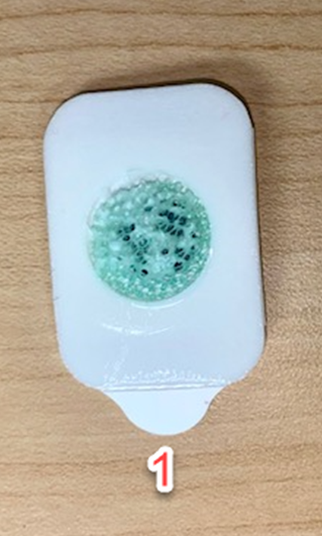 | Figure 2.  Demonstration of configuration of EDA pads (Configuration 1).  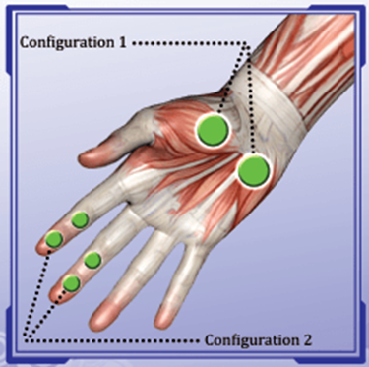

- Take part in a guided breathwork session within the immersive room.
    - This will involve you following a series of instructions and engaging in the breathwork session. Please be advised that there are specific exclusion criteria for partaking in this study which can be found in the “Risks of participating” section below.
  - At the end of the study, the researcher will debrief you, and you will be provided with the study debrief sheet.

How long will the study take:
This study is expected to take around 40 minutes to complete. If you have signed up via the EMS, you can expect to receive 4 credits.

Benefits of participating:
Whilst there are no immediate benefits for those people participating in the study, this work will likely contribute to the existing body of knowledge on how the practice of breathwork can ease the effects of anxiety and physiological arousal, and further studies may help in using breathwork as an effective intervention.

Risks of participating:
As the study requires participants to follow a cyclic breathing pattern in an immersive room, exclusion criteria will include the following:

- Any history of cardiovascular or respiratory conditions
- Photosensitivity or epilepsy
- Diagnoses of mental health conditions; PTSD, severe anxiety, schizophrenia
- Recent injury or surgery that could be exacerbated by breathing exercises or by sitting, standing or laying down for too long
- Pregnancy
- Claustrophobia

Participation and withdrawal:
Participation in this study is entirely voluntary, and you also have the option of not answering any questions you do not feel comfortable answering. You can withdraw at any point during the study without penalty. If you wish to withdraw during the study, please inform the researcher. You do not need to give a reason for withdrawing and any data that has been collected up until that point will be deleted. Please note that once you leave the data collection environment upon completion of the study, it will not be possible to withdraw your data, as it will be anonymised.

How will your data be used and processed:
Your data will only be used for the purpose of the research activity. No directly identifiable information will be collected due to the consent process being conducted online via Qualtrics. You will be asked to provide information on your gender and age, but these demographic characteristics form the standard reporting measures in psychology. Once the data is collected, we will aggregate the data for presentation purposes by calculating the mean age and total gender numbers only. This data will not be linked to you as an individual and the researcher will not disclose any data or use it for any purposes other than outlined within this information sheet.

How will your data be collected and stored:
All collected raw data will be kept in a raw format and then aggregated for analysis purposes. Qualtrics is being used to stored consent responses and questionnaire data, and to provide you with debrief information following completion of the study. All data stored on Qualtrics is stored anonymously, so there is a requirement for the researcher to provide you with a random ID number to ensure appropriate matching of your questionnaire and EDA data.

Data collected via the EDA device will be stored on the device until the end of the day that your data is collected, at which point it will be transferred on to the researcher’s personal memory stick and saved within a dedicated, password-protected data folder. The only identifier here will be the file name of the data file which will be the unique/random ID number that allows for physiological data to be matched with questionnaire data.

How can you contact the researchers if you have any questions:
You can contact the research student via email: Shaheena Kenyon (2219390@student.uwtsd.ac.uk)

You can also contact the research supervisor via email: (stacey.coleman@uwtsd.ac.uk)

If you have any immediate questions, please ask the researcher now. If you are happy to continue, please read the following consent form in full and respond to each of the consent options presented.

Participant Debrief Sheet

Title of Study: Inhale, exhale, relax: The effects of guided breathwork on the levels of state anxiety

Research Team: Shaheena Kenyon (2219390@student.uwtsd.ac.uk) and dissertation supervisor, Stacey Coleman (stacey.coleman@uwtsd.ac.uk)

Date:

Thank you for taking part in this study.

The aim of this study was to explore whether guided breathwork has an effect on levels of levels of arousal. Physiological arousal can be indicative of levels of anxiety. Anxiety is a natural response characterised by feelings of worry and heightened awareness in anticipation of uncertain dangers or potential threats to an individual's well-being (Grillon, 2008). State anxiety refers to the temporary feelings of tension, nervousness, and worry that individuals may experience in specific situations .

To evaluate the impact of guided breathwork on anxiety levels, we employed the following methods: The State-Trait Anxiety Inventory-6 (STAI-6) (Marteau & Bekker, 1992) questionnaire was administered both before and after the breathwork session to assess any changes in state anxiety levels that were explicitly recorded by yourself. During the breathwork session, the sweat levels on the palms of your hand were measured using the Galvanic Skin Response device, which served as an indicator of physiological arousal, as sweat gland activity typically increases with heightened emotional states such as anxiety.

Guided breathwork was chosen as the intervention for its simplicity, cost-effectiveness, and accessibility. It can be practised anytime, either with a trained facilitator or by following instructional videos. The findings of this study will enhance our understanding of whether guided breathwork is an effective strategy for reducing anxiety and regulating emotional states.

If you wish to withdraw your data from the study, you must tell the researcher before leaving the lab. After leaving the lab, all your data will be anonymised, and we will not be able to trace it back to you.

If taking part in this study has raised any questions or concerns, please contact the researcher, Shaheena Kenyon (2219390@student.uwtsd.ac.uk) or contact the dissertation supervisor, Stacey Coleman (stacey.coleman@uwtsd.ac.uk)

If you have found any part of this experience to be distressing, please consider speaking with someone that you trust such as a family member or friend. You may also consider speaking with one of the organisations below for additional support:

Within UWTSD:

- UWSTD Wellbeing Support - https://www.uwtsd.ac.uk/student-services/wellbeing-support/
- Student Assistance Support – Free 24-hour confidential helpline 0800 028 3766

Outside UWTSD

- TogetherAll: https://account.v2.togetherall.com/register/student
- Feeling Good App: https://www.feelinggood.app/onboarding/uwtsd-en/
- Student Union Student Minds (support groups): https://www.studentminds.org.uk/findsupport.html

Grillon, C. (2008). Models and mechanisms of anxiety: evidence from startle studies. Psychopharmacology, 199(3), 421–437. https://doi.org/10.1007/s00213-007-1019-1

Marteau, T. M., & Bekker, H. (1992). The development of a six-item short-form of the state scale of the Spielberger State-Trait Anxiety Inventory (STAI). The British Journal of Clinical Psychology, 31(3), 301–306. https://doi.org/10.1111/j.2044-8260.1992.tb00997.x

Appendix I – EMS Study Sign up
Study Information
Study Name | SWAN_credit_SKS
Study Type | Standard (lab) study  This is a standard lab study. To participate, sign up, and go to the specified location at the chosen time.
Study Status | Visible to participants : Approved  Active study : Appears on list of available studies
Duration | 40 minutes
Credits | 4 Credits
Abstract | This study involves the completion of two online questionnaires and a guided breathwork session, within the immersive room in the Y Fforwm bulding, SA1 campus.
Description | The study involves completing two questionnaires via Qualtrics and participating in a guided breathwork session in the immersive room. During the study, you will be required to have a Galvanic Skin Response device attached to your palm to measure electrodermal activity changes.  Please note that if you have any of the following conditions, you are advised not to sign up to take part in this study.  o Claustrophobia  o Pregnancy  o Any history of cardiovascular or respiratory conditions  o Photosensitivity or epilepsy  o Diagnoses of mental health conditions: PTSD, severe anxiety, schizophrenia  o Recent injury or surgery that could be exacerbated by breathing exercises or by sitting, standing or laying down for too long
Eligibility Requirements | Participants who have any of the conditions listed above should refrain from signing up to take part in this study.
Restrictions
Prescreen Restrictions | No Restrictions  View/Modify Restrictions  Set Prescreen Response Distribution
Additional Study Information
Timeslot Usage Limit | 100 hours (approximately 150 signups)
Participant Sign-Up Deadline | 24 hours before the study is to occur
SREC Approval Code | SREC_Appr_SC
Direct Study Link | This is a direct URL for participants to access the study. You may use this in an email or study advertisement.
Date Created | 15 January 2025
Researcher Information
Researcher | Shaheena Kenyon
Principal Investigator | Stacey Coleman

Appendix J – Information Sheet (Qualtrics)

Participant Information Sheet
Title of Study: Inhale, exhale, relax: The effects of guided breathwork on the levels of state anxiety
Research Team: Shaheena Kenyon (2219390@student.uwtsd.ac.uk) and dissertation supervisor, Stacey Coleman (stacey.coleman@uwtsd.ac.uk)
Date:
Invitation Paragraph
You are being invited to take part in a research project being conducted by a third-year dissertation student within the Psychology and Counselling department at The University of Wales Trinity Saint David (UWTSD). Before you decide to take part, it is important for you to understand why the research is being conducted and what participation will involve. Please read the following information carefully and feel free to discuss it with the researcher if you have any questions. Please ask the researcher if anything is unclear or if you would like more information. Take your time to decide whether you would like to participate. Thank you for reading this.
Purpose of Research
The aim of this study is to explore whether the practice of guided breathwork has an effect on levels of arousal. The participants will be invited to follow a guided breathwork session in an immersive room located in Y Fforwm of the UWTSD Waterfront Campus.
What does taking part involve?
This study will involve you taking part in a range of tasks, and you will be required to do the following:
- Provide demographic information of age and gender.
- Complete a short questionnaire that aims to measure state anxiety before and after your engagement in the study.
- Wear a skin conductance device to measure a physiological response known as Electrodermal Activity (EDA).
  - EDA is a measurement of changes in the electrical properties of your skin, and our EDA changes based upon activation of the sympathetic nervous system.
  - The researcher will ensure your hands are free of dirt and debris by wiping your non-dominant hand with an alcohol wipe.
  - The researcher will then attach the two EDA pads (see image 1 below) to the palm of your non-dominant hand (see configuration 1 in image 2 below), and you will be required to wear this throughout the duration of your engagement in the study.
Figure 1. Pre-moistened EDA pads.
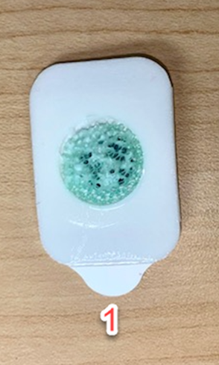
Figure 2. Demonstration of configuration of EDA pads (Configuration 1).
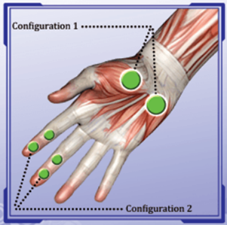
- Take part in a guided breathwork session within the immersive room.
  - This will involve you following a series of instructions and engaging in the breathwork session. Please be advised that there are specific exclusion criteria for partaking in this study which can be found in the “Risks of participating” section below.
- At the end of the study, the researcher will debrief you, and you will be provided with the study debrief sheet.
How long will the study take?
This study is expected to take around 40 minutes to complete. If you have signed up via the EMS, you can expect to receive 4 credits.
Benefits of participating
hilst there are no immediate benefits for those people participating in the study, this work will likely contribute to the existing body of knowledge on how the practice of breathwork can ease the effects of anxiety and physiological arousal, and further studies may help in using breathwork as an effective intervention.
Risks of participating
As the study requires participants to follow a cyclic breathing pattern in an immersive room, exclusion criteria will include the following:
- Any history of cardiovascular or respiratory conditions
- Photosensitivity or epilepsy
- Diagnoses of mental health conditions; PTSD, severe anxiety, schizophrenia
- Recent injury or surgery that could be exacerbated by breathing exercises or by sitting, standing or laying down for too long
- Pregnancy
- Claustrophobia
Participation and withdrawal
Participation in this study is entirely voluntary, and you also have the option of not answering any questions you do not feel comfortable answering. You can withdraw at any point during the study without penalty. If you wish to withdraw during the study, please inform the researcher. You do not need to give a reason for withdrawing and any data that has been collected up until that point will be deleted. Please note that once you leave the data collection environment upon completion of the study, it will not be possible to withdraw your data, as it will be anonymised.
How will my data be used and processed?
Your data will only be used for the purpose of the research activity. No directly identifiable information will be collected due to the consent process being conducted online via Qualtrics. You will be asked to provide information on your gender and age, but these demographic characteristics form the standard reporting measures in psychology. Once the data is collected, we will aggregate the data for presentation purposes by calculating the mean age and total gender numbers only. This data will not be linked to you as an individual and the researcher will not disclose any data or use it for any purposes other than outlined within this information sheet.
How will my data be collected and stored?
All collected raw data will be kept in a raw format and then aggregated for analysis purposes. Qualtrics is being used to stored consent responses and questionnaire data, and to provide you with debrief information following completion of the study. All data stored on Qualtrics is stored anonymously, so there is a requirement for the researcher to provide you with a random ID number to ensure appropriate matching of your questionnaire and EDA data. Data collected via the EDA device will be stored on the device until the end of the day that your data is collected, at which point it will be transferred on to the researcher’s personal memory stick and saved within a dedicated, password-protected data folder. The only identifier here will be the file name of the data file which will be the unique/random ID number that allows for physiological data to be matched with questionnaire data.
How can I contact the researchers if I have any questions?
you can contact the research student via email: Shaheena Kenyon (2219390@student.uwtsd.ac.uk) You can also contact the research supervisor via email: (stacey.coleman@uwtsd.ac.uk). If you have any immediate questions, please ask the researcher now. If you are happy to continue, please read the following consent form in full and respond to each of the consent options presented.

Appendix K – Consent Form

Participant Consent Form
Title of Study: Inhale, exhale, relax: The effects of guided breathwork on levels of state anxiety
Research Team: Shaheena Kenyon (2219390@student.uwtsd.ac.uk) and dissertation supervisor, Stacey Coleman (stacey.coleman@uwtsd.ac.uk)
Please select a response for each statement below to provide fully informed consent to take part in this study.
 | Yes | No
I confirm that I am over 18 years old.
I have had an opportunity to ask questions and have them answered satisfactorily.
I understand that I may ask further questions at any time.
I understand that my participation is voluntary, and I am free to withdraw from the study at any time without penalty or giving any reason.
I understand that my fully anonymised data will be utilised for only this research study, which is being conducted by a third-year Psychology student for the purpose of their undergraduate dissertation and will be deleted once external examiner approval for the project has been obtained.
I have been informed that if I feel I would be uncomfortable answering questions, doing the guided breathwork, watching a video on the immersive screens, or have any of the conditions mentioned in the pre-screening, that I should not take part in this study.
I understand that I will be required to wear the Galvanic Response Sensors on my hand for the duration of the study.
I understand that I may decline to answer any questions.
I understand that any data collected will be anonymised and stored in an anonymous format and once I leave the data collection area it will not be possible to trace the data back to me to withdraw.
I understand that the anonymised data provided will be securely stored and accessible only to the members of the research team directly involved in the study, and that confidentiality will be maintained.
I consent to take part in the above study.

Please now stop and inform the researcher that you have completed the consent form.
The researcher will now put the electrode pads on to your hand and secure in place.

Please indicate your gender below.
- Male
- Female
- Non-binary / Third gender
- Prefer not to say
Please provide your age.
Please confirm that you do not have any of the following concerns:
- Any history of cardiovascular or respiratory conditions
- Photosensitivity or epilepsy
- Diagnoses of mental health conditions; PTSD, severe anxiety, schizophrenia
- Recent injury or surgery that could be exacerbated by breathing exercises or by sitting, standing or laying down for too long
- Pregnancy
- Claustrophobia

- I do not have any of the above named conditions
- I do have one or more of the above name conditions

Appendix L – Debrief Sheet
Participant Debrief Sheet
Title of Study: Inhale, exhale, relax: The effects of guided breathwork on the levels of state anxiety
Research Team: Shaheena Kenyon (2219390@student.uwtsd.ac.uk) and dissertation supervisor, Stacey Coleman (stacey.coleman@uwtsd.ac.uk)
Thank you for taking part in this study.
The aim of this study was to explore whether guided breathwork has an effect on levels of levels of arousal. Physiological arousal can be indicative of levels of anxiety. Anxiety is a natural response characterised by feelings of worry and heightened awareness in anticipation of uncertain dangers or potential threats to an individual's well-being (Grillon, 2008). State anxiety refers to the temporary feelings of tension, nervousness, and worry that individuals may experience in specific situations .
To evaluate the impact of guided breathwork on anxiety levels, we employed the following methods: The State-Trait Anxiety Inventory-6 (STAI-6) (Marteau & Bekker, 1992) questionnaire was administered both before and after the breathwork session to assess any changes in state anxiety levels that were explicitly recorded by yourself. During the breathwork session, the sweat levels on the palms of your hand were measured using the Galvanic Skin Response device, which served as an indicator of physiological arousal, as sweat gland activity typically increases with heightened emotional states such as anxiety.
Guided breathwork was chosen as the intervention for its simplicity, cost-effectiveness, and accessibility. It can be practised anytime, either with a trained facilitator or by following instructional videos. The findings of this study will enhance our understanding of whether guided breathwork is an effective strategy for reducing anxiety and regulating emotional states.
If you wish to withdraw your data from the study, you must tell the researcher before leaving the lab. After leaving the lab, all your data will be anonymised, and we will not be able to trace it back to you.
If taking part in this study has raised any questions or concerns, please contact the researcher, Shaheena Kenyon (2219390@student.uwtsd.ac.uk) or contact the dissertation supervisor, Stacey Coleman (stacey.coleman@uwtsd.ac.uk)
If you have found any part of this experience to be distressing, please consider speaking with someone that you trust such as a family member or friend. You may also consider speaking with one of the organisations below for additional support:
Within UWTSD:
- UWSTD Wellbeing Support - https://www.uwtsd.ac.uk/student-services/wellbeing-support/
- Student Assistance Support – Free 24-hour confidential helpline 0800 028 3766
Outside UWTSD
- TogetherAll: https://account.v2.togetherall.com/register/student
- Feeling Good App: https://www.feelinggood.app/onboarding/uwtsd-en/
- Student Union Student Minds (support groups): https://www.studentminds.org.uk/findsupport.html
Grillon, C. (2008). Models and mechanisms of anxiety: evidence from startle studies. Psychopharmacology, 199(3), 421–437. https://doi.org/10.1007/s00213-007-1019-1
Marteau, T. M., & Bekker, H. (1992). The development of a six-item short-form of the state scale of the Spielberger State-Trait Anxiety Inventory (STAI). The British Journal of Clinical Psychology, 31(3), 301–306. https://doi.org/10.1111/j.2044-8260.1992.tb00997.x

