Katherine Fischer-Jenkins 2507285 BMDS7007 CW1

A Critical Evaluation of the Digital Strategy of Cardiff and Vale University Health Board.

- Executive Summary
Cardiff and Vale University Health Board (CAVUHB) is a large and complex organisation which faces many challenges shared across the NHS as a whole; including increasing demands and costs, aging infrastructures and the lasting effects of the Covid-19 pandemic. Strategic drivers in Wales point to digital as a key enabler of clinical transformation and service recovery but progress has been hampered by historical under-investment and lack of clarity around national digital structures and systems. The health board has a low level of digital maturity, in common with its counterparts across Wales, achieving only level 1 of the 7 level EMRAM maturity scale (Welsh Government, 2025a). Most clinical documentation within the health board remains paper-based and several of the digital systems in use are outdated and requiring replacement. National directives from Welsh Government have led to the implementation of some isolated modern systems however there is currently limited integration between these and wider health board systems which limits their useability and benefits. Whilst the Covid-19 pandemic accelerated the adoption of some digital technologies, the lasting impact on service demands and national financial pressures are proving a significant barrier to digital transformation progress.

In this context, the CAVUHB digital strategy (CAVUHB, 2020) is unrealistic in the scale of what it promises to deliver over a five-year period. True digital transformation must involve the whole organisation and takes time to achieve; it must also start with ensuring the digital foundations are in place to support before moving on to the next stages of development. The CAVUHB strategy acknowledges historical under-funding of basic infrastructure but moves on to promise the development and implementation of advanced systems such as an electronic patient record (EPR) within its timescale (CAVUHB, 2021b). The strategy demonstrates very little alignment or integration with the strategy of the organisation as a whole and is focussed, in its language and content, on the digital teams and technical plans. Whilst the long-term goal of becoming a ‘learning health system’ (Platt, Raj and Wienroth, 2020) is admirable, the steps necessary to achieve this are not clearly stated and there is much discussion of the collection and use of data without mention of the end user systems where this data will be generated. Overall, the guiding principles named in the strategy are appropriate, but their usefulness is hindered by a lack of clarity throughout the document and a failure to address the many and varied barriers to digital transformation.

- Business Drivers
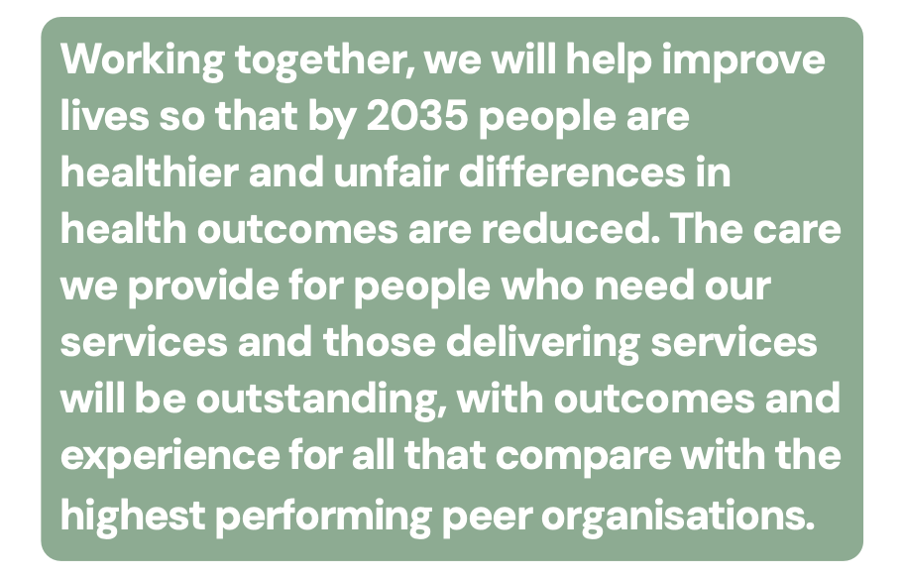
Cardiff and Vale University Health Board (CAVUHB) is one of the largest organisations in the UK National Health Service (NHS), serving a population of almost 500,000 people in Cardiff and the Vale of Glamorgan and employing over 18,000 staff (CAVUHB, 2025). It provides all health services for the local communities and a range of specialist care for people from across Wales; delivered from seven hospital sites, 57 General Practice (GP) surgeries and around 300 other community sites such as pharmacies, optometry and dental practices (CAVUHB, 2023). The maternity services support 5,000 births per year whilst the health board’s only emergency department, at the University Hospital of Wales, has 150,000 visits per year (CAVUHB, 2023). The organisation’s vision (Figure 1) is underpinned by four strategic objectives (Figure 2) and a commitment to embed the principles of the Wellbeing of Future Generations Act (Figure 3), a legal framework unique to Wales which requires public bodies to consider the needs of future generations in their decision-making (Welsh Government, 2015).
Figure 1: CAVUHB strategic vision for 2035 (CAVUHB, 2023).

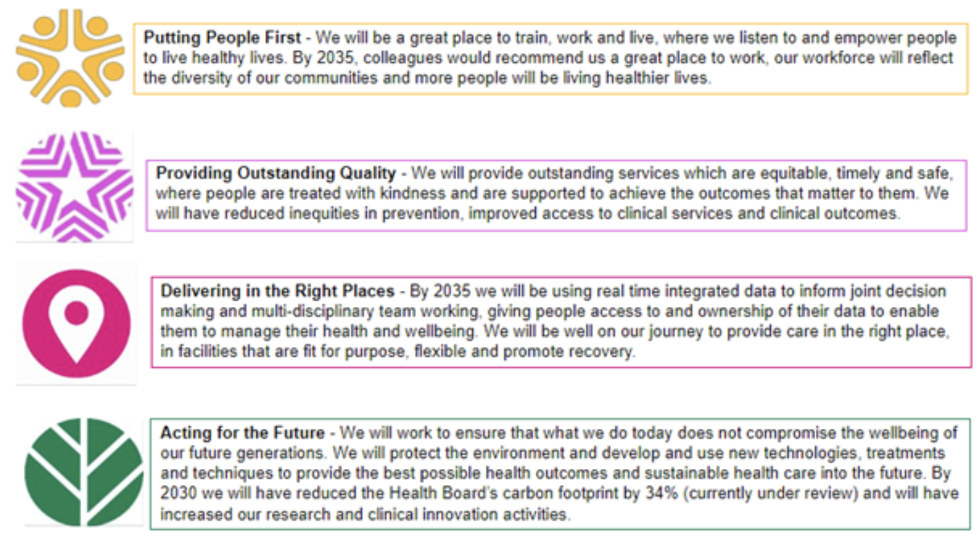
Figure 2: CAVUHB strategic objectives (CAVUHB, 2025).

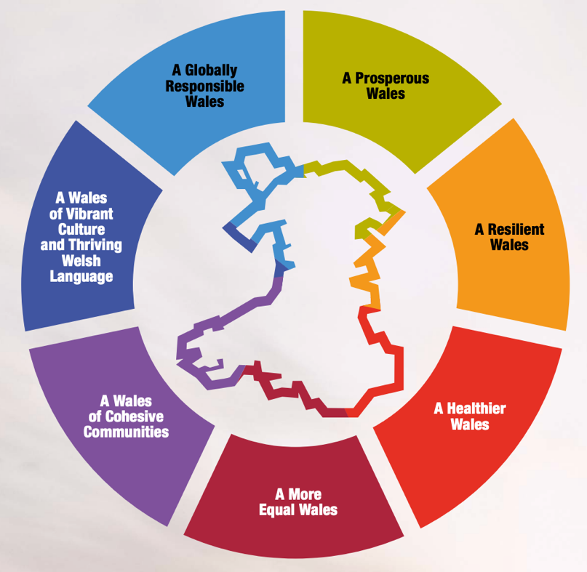
Figure 3: The Wellbeing Goals which underpin the Wellbeing of Future Generations Act (Welsh Government, 2015).
The work of CAVUHB is overseen by a board made up of executive directors from within the organisation and independent members appointed by the Minister for Health and Social Services in the Welsh Government (CAVUHB, 2025). Clinical services are provided by seven distinct clinical boards and supported by a range of corporate and planning services, one of which is the Digital Health Intelligence service (CAVUHB, 2025).

Challenges faced by the organisation include increasing demand for healthcare services, in part due to an aging population, which must be delivered within significant financial constraints and a physical infrastructure which is also aging (CAVUHB, 2025). The Welsh Government has increased the percentage of its budget spent on health and social care to almost 50% in 2024-25 (NHS Confederation, 2024), however, rising demands and costs have still left all seven health boards in Wales having to make savings to remain within their budgets and all failed to do so in 2023-24 (Audit Wales, 2024). Monitoring of organisational performance has led CAVUHB to be placed on level 4 of the 5-point scale of Welsh Government escalation and intervention for all areas of the organisation including financial management, strategy, planning, governance, performance and safety of care (Welsh Government, 2025b). In addition, plans for significant capital expenditure on the development of a replacement site for the University Hospital of Wales (UHW) were delayed due to the Covid-19 pandemic and the current site, largely built in the 1960s, is increasingly costly to maintain to even basic safety standards (Fenton and Lewis, 2026). In order to improve upon the current position, the Welsh Government has mandated that CAVUHB follow the sustainable development principles (Figure 4) of the Wellbeing of Future Generations Act (Welsh Government, 2015) (CAVUHB, 2025), further adding to the regulatory and strategic demands on the organisation.
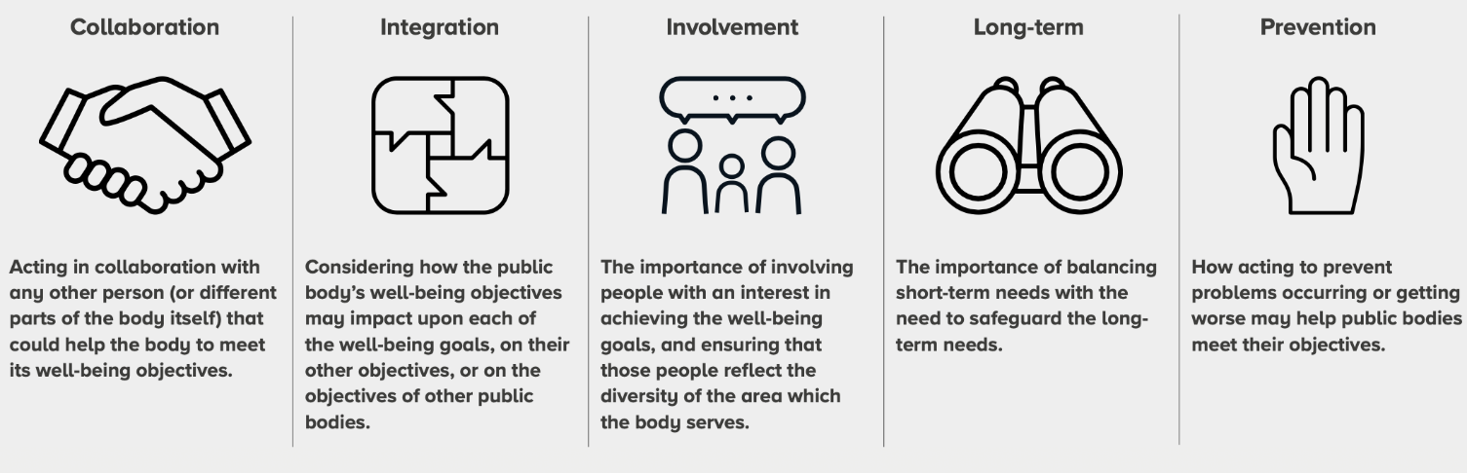
Figure 4: Five ‘ways of working’ for sustainable development from the Wellbeing of Future Generations Act (Welsh Government, 2015)

- Technology & Digital Transformation
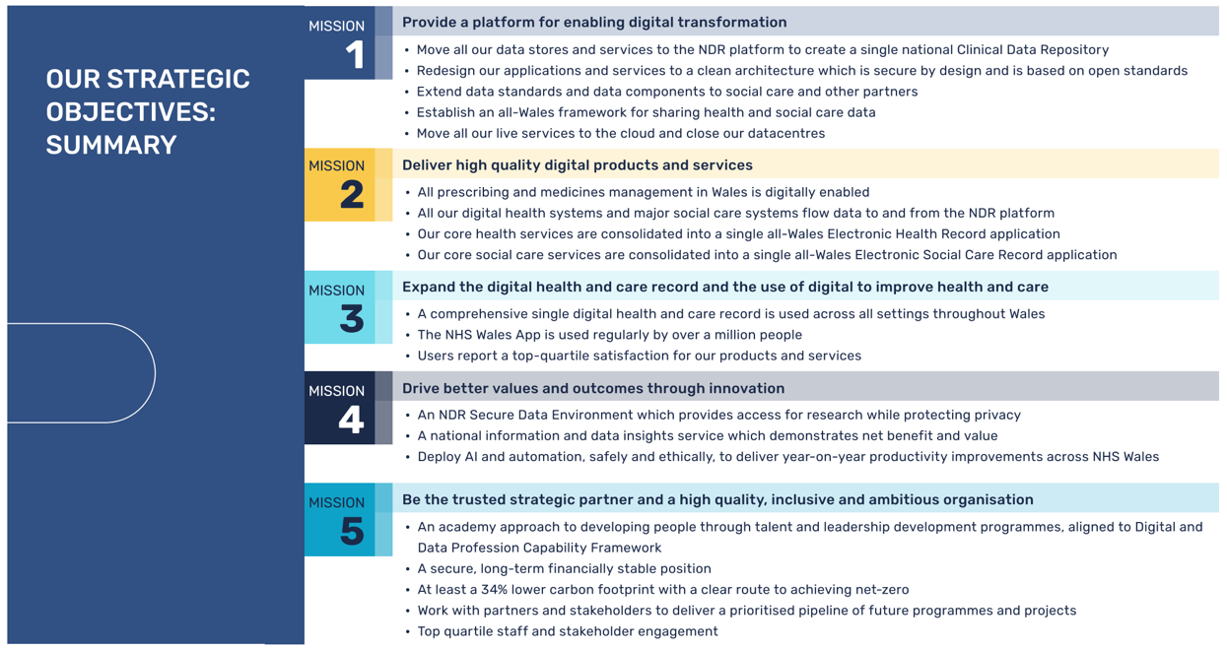
There is a clear national strategic focus in Wales on digital transformation, with Welsh Government (2023) aiming to make health services ‘digital-first’ and Digital Health and Care Wales (DHCW) outlining a number of ambitious strategic objectives (Digital Health and Care Wales, 2024) (Figure 5).
Figure 5: Strategic objectives of Digital Health and Care Wales 2024-2030 (Digital Health and Care Wales, 2024).
Many of these strategic objectives are echoed in the CAVUHB Integrated Medium Term Plan (IMTP) as far back as 2019 (CAVUHB, 2019) however progress of this plan was inevitably affected by the Covid-19 pandemic and the strain it placed on health services (CAVUHB, 2021a). Whilst some digital technologies such as video consultation were implemented at speed in response to the pandemic (CAVUHB, 2021a) and remain in use, its greater legacy is one of sustained financial and service pressures from which the health board is still recovering (CAVUHB, 2025). Additionally, the national objectives have not been so clear historically, leading to a lack of structure for health boards to work within which prompted intervention from Welsh Government and the establishment of DHCW as a result (Welsh Government, 2023).

A digital strategy for the health board entitled “Delivering Digital. Building a learning health and care system. A Five Year Strategy.” (CAVUHB, 2020) was formally approved in July 2021 and a road map published outlining how it would be achieved (CAVUHB, 2021b). The core vision of the strategy is to create a learning health and care system (CAVUHB, 2020), a term that describes the use of data generated by health care organisations to enable continuous and rapid cycles of change and improvement (Platt, Raj and Wienroth, 2020). It is said that this will be achieved by making better use of the data that is collected and turning it into knowledge with which to change practice (CAVUHB, 2020). Although no specific plans are outlined in the strategy, the accompanying roadmap lists capacity management, data repositories and interoperability within the items to be delivered by 2025 (CAVUHB, 2021b). The core vision of the strategy is underpinned by high level aims of ‘digital-first’ for patients and staff, combined with seamless sharing of information between professionals and with other organisations (CAVUHB, 2020). The strategy acknowledges that the organisation has a history of significant under-investment in the foundations of digital infrastructure; including desktop and mobile devices, WiFi connectivity and communication platforms; and that this must be an initial focus of investment (CAVUHB, 2020). Addressing the planned architecture of health board systems, the strategy considers historical approaches in Wales and compares these with organisations in NHS England before advocating what it calls an ‘open platform’ approach to maximise interoperability and use of data (CAVUHB, 2020). The accompanying roadmap details extensive plans for digital transformation by 2025 (Figure 6); covering areas as diverse as upgrading computer infrastructure, creating data repositories, automation with artificial intelligence, patient portals, staff rostering and interoperability both internal and external to the health board (CAVUHB, 2021b).
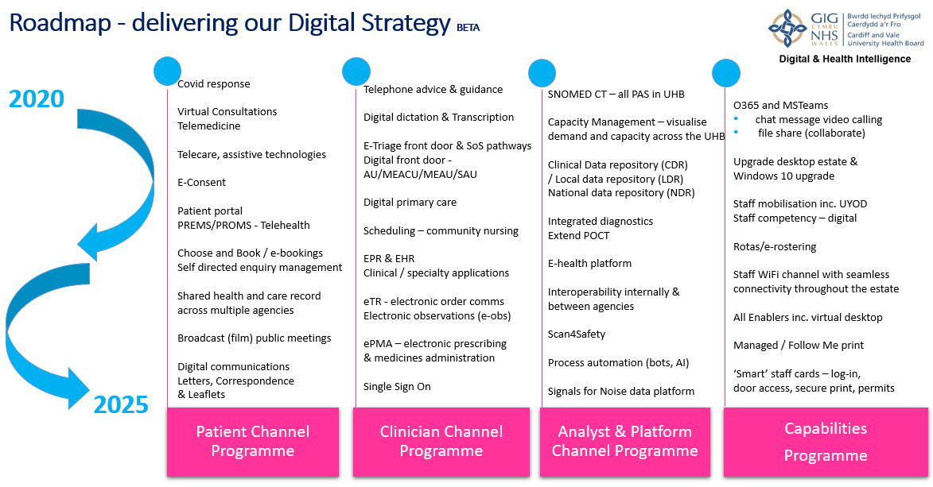
Figure 6: CAVUHB Roadmap for delivery of the digital strategy 2020 - 2025 (CAVUHB, 2021b).

Despite these ambitious plans, and in common with all NHS organisations in Wales, the digital maturity of CAVUHB lags behind comparable organisations across the UK and internationally (Welsh Government, 2025a). A recent self-assessment by the health board, using the 7 stage Electronic Medical Record Adoption Model (EMRAM) (HIMSS, 2026), found CAVUHB to be at stage 1 and behind all other health boards in its progress towards achieving stage 2 (Welsh Government, 2025a). Stage 1 indicates the use of ancillary digital systems such as laboratory, pharmacy and radiology information systems, which form the foundation for future electronic medical record developments (HIMSS, 2026). CAVUHB has digital systems in these areas however they do not meet modern standards for interoperability, and the radiology system features on the organisation’s risk register as a result (CAVUHB, 2026b). National programmes are underway to replace all three of these systems across Wales with new solutions although these programmes have experienced significant delays (Welsh Government, 2023). In addition, CAVUHB is an outlier in Wales as it does not use the Welsh Patient Administration System (WPAS), instead using a local Patient Management System (PMS) built using Oracle Database software (NHSWSSP, 2026). This limits interoperability with other health boards and sharing of information which requires extensive technical development to overcome (DHCW, 2026a). Cyber security risks are also recognised internally, especially in relation to the decentralised management of around 300 critical systems across the health board without adequate oversight and management possible by the cyber security team (Virgill and Lewis, 2025).

Notwithstanding the overall level of digital maturity, digital transformation has reached a higher level in some parts of CAVUHB, with the implementation of the fully-digital Badgernet Maternity record (Welsh Government, 2024) and ongoing roll-out of an Electronic Prescribing and Medicines Administration (ePMA) system (CAVUHB, 2026c). The full potential benefits of the data that can be generated and used by these systems will not be realised, however, until the plans for interoperability and advanced data management are achieved. Historical implementation of individual digital systems for specific use cases, both locally and nationally, has led to many ‘silos’ of information which remain separate due to a lack of capacity for interoperability (CAVUHB, 2020). Achieving stage 2 on the EMRAM includes implementation of a Clinical Data Repository, a centralised way to store and use clinical data from multiple systems across an organisation which supports modern interoperability standards (O’Leary, 2025). This is a key aim of DHCW in developing a National Data Resource for Wales (DHCW, 2026b) which will receive data from a CAVUHB Local Data Repository (LDR) using the Fast Healthcare Interoperability Resources (FHIR) standards. These include SNOMED CT, an international standardised clinical terminology and categorisation system (SNOMED, 2026) which CAVUHB committed to use in all patient administration systems by 2025 (CAVUHB, 2020). However, progress in the development of the LDR within CAVUHB has faced challenges around funding, scope, information governance and technical infrastructure (Virgill and Lewis, 2024).

- Strategic Analysis
Analysis of the CAVUHB Digital Strategy (CAVUHB, 2020) will be undertaken using the ‘Signs of a good digital strategy’ framework produced by NHS Providers (2024), an organisation representing providers of NHS services in England. The framework was produced by experts in the field as part of NHS England’s approach to developing leadership in digital transformation and supporting organisations to review their digital strategies following the rapid changes resulting from the Covid-19 pandemic (NHS Providers, 2024). The six signs of a good digital strategy (Table 1) will be used to analyse the CAVUHB digital strategy and assess to what extent it meets these recommendations.
Table 1: Six signs of a good digital strategy (NHS Providers, 2024).
Title | Description
Integrated | To succeed, digital transformation can't just be a bolt-on. Digital should be integral to system and trust-level strategies and business plans. It is an enabler for wider improvement.
User centred | Digital transformation should address the most important needs of patients, service users and staff.
Useful to teams | Digital strategies can't detail everything you're planning to deliver. Instead, focus on providing guiding principles to help people make the right decisions.
Mainstream | The best strategies are widely understood and widely adopted. Successful digital transformation in healthcare depends on close alignment across many teams, not just the IT department.
Realistic | It is important to build trust - many staff have experience of being let down by the promise of new technology. Talk about what you've already delivered and set realistic goals.
Focused | A good digital strategy is selective. Making trade-offs is difficult but essential to free up the bandwidth required for digital transformation.

A summary of the findings will then be presented using a SWOT Analysis; an examination of positive and negative factors, both internal and external to an organisation, that will affect its ability to achieve its goals (CIPD, 2025). SWOT is an acronym for Strengths, Weaknesses, Opportunities, Threats and is often presented in a matrix to illustrate the key findings arising from a strategic analysis (Harrison, 2010), as shown in Table 2.
Table 2: SWOT analysis definitions from CIPD (2025), presented in a matrix format.
 | Positive factors | Negative factors
Internal | Strengths  Positive tangible and intangible attributes, internal to an organisation and within the organisation’s control | Weaknesses  Internal factors within an organisation’s control that detract from the organisation’s ability to attain the desired goal. Which areas might the organisation improve?
External | Opportunities  External attractive factors that represent the reason for an organisation to exist and develop. What opportunities exist in the environment, which will propel the organisation? | Threats  External factors beyond the organisation’s control which could place the organisation mission or operation at risk. The organisation may benefit from having contingency plans to address them if they should occur.

4.1 Integrated
The CAVUHB digital strategy refers in its introduction to the wider aims of the organisation and NHS Wales in relation to health and social care system changes and describes digital technology as an enabler of clinical service transformation (CAVUHB, 2020). There is limited detail, however, of what this will mean in practice or which specific transformations are planned and the document is attributed to senior staff in the digital field with no mention of other executive involvement. Similarly, the organisational strategy for the health board as a whole (CAVUHB, 2023) mentions digital transformation as one aspect of achieving one of its four strategic priorities but makes no mention of it elsewhere in the document. This type of disconnection between the digital and wider organisational strategies can result in a lack of focus on the ultimate goals of digital transformation which should relate to patient care and population health rather than digitisation being seen as the end goal in itself (Wachter, 2016). Wachter (2016) highlighted that digital transformation in healthcare settings rarely leads to immediate financial savings or efficiency improvements, therefore highlighting clinical improvements can help leaders to make a compelling case for investment in digital technology.

4.2 User Centred
User centred design is one of the guiding principles outlined in the CAVUHB digital strategy, with a commitment to involve patients and clinicians when introducing new digital solutions (CAVUHB, 2020). The strategy itself, however, contains little evidence of user engagement in its creation and the shaping of its aims. Whilst there is a brief summary of the ways in which patients and staff may use digital technologies in future, a large majority of the document contains details of technical and infrastructure plans with limited reference to the end users of the health board systems. Wachter (2016) outlined the importance of user centred design that takes account of the specific context of a planned system and in-depth knowledge of local processes. This is echoed by the NHS Providers (2024) guidance which emphasises the importance of thoroughly understanding the needs of users rather than relying on assumptions or the views of a narrow range of people with an interest in digital transformation.

4.3 Useful to Teams
The CAVUHB digital strategy contains a list of ‘guiding principles’ although these appear after eight other pages of information, rather that prominently at the start of the document, and are themselves each accompanied by several sentences of explanation (CAVUHB, 2020). There are many pages of detail relating to technical architecture and data usage; even the pages relating to clinicians’ use of digital systems focus on the construction of the systems and storage of their data rather than the experience and functionality for the end user (CAVUHB, 2020). Indeed, the development of an electronic patient record (EPR) is framed primarily as a means of data entering the LDR, with no mention of the potentially transformative nature of such a system for the teams providing and documenting clinical care (CAVUHB, 2020). These factors combine to produce a strategy that would prove difficult to use as a guide for decision making and offers no measurable objectives with which to measure success, a sign of a bad digital strategy as outlined by NHS Providers (2024).

4.4 Mainstream
Widespread understanding of a digital strategy helps to ensure that it is adopted across many teams and that digital transformation includes and benefits all parts of the organisation (NHS Providers, 2024). The language used in the CAVUHB strategy is fairly specialist to the digital field and it does not provide a clear message of what the strategy will mean for those working outside of the digital sphere, be that in clinical or corporate roles. It contains very detailed descriptions of current and future technical architectures, data analysis processes and approaches to system development, without discussion of how these decisions and priorities will improve the experience of the end user or the quality of healthcare provided (CAVUHB, 2020). Wachter (2016) cautioned against viewing healthcare information technology as simply a technical change and concluded that engagement with front-line users of the technology is crucial for the adaptive change across a whole organisation which is necessary for success. This engagement and embedding of the digital strategy will be hampered in CAVUHB by the document’s inaccessible language and focus on concepts which are not widely understood.

4.5 Realistic
Whilst the CAVUHB digital strategy begins with an acknowledgement of past issues with delivering digital transformation, both locally and on a Wales-wide level (CAVUHB, 2020), it then promises an extraordinary amount of transformation over the following five-year period (CAVUHB, 2021b). Investment in the foundations of basic infrastructure after years of under-funding is mentioned briefly but is overshadowed by the promise of becoming a learning health system (CAVUHB, 2020), a state typically associated with a much higher level of digital maturity (The Health Foundation, 2022). Over-promising extensive transformations which cannot be delivered will harm the building of trust from staff who may have felt let down previously (NHS Providers, 2024) and unfortunately the CAVUHB strategy appears to make this mistake. The key principles for digitalisation of healthcare as reported by Wachter (2016) are quoted verbatim in the CAVUHB strategy, including the importance of focussing on getting it right rather than doing it quickly, however this approach is absent in the strategy itself.

4.6 Focused
A good digital strategy should acknowledge that it is not possible to solve all issues at the same time and should clarify which items are prioritised and which are not possible within the given timescale (NHS Providers, 2024). The CAVUHB strategy and its accompanying roadmap promise changes across a vast array of systems and services with no mention of which are to be prioritised or any other items which will not be achievable (CAVUHB, 2020). There is no mention of barriers or challenges which may hamper the plans for digital transformation, such as the Covid-19 pandemic during which the strategy was published. A good strategy should set out how challenges will be approached and adjustments made, rather than detailing every change in a wish-list which may quickly prove to be unachievable (NHS Providers, 2024). The CAVUHB strategy does not follow this model; it is extremely detailed, and in some cases very prescriptive, such as in its description of the plan to develop an EPR without acknowledging that the plans may need to adapt (CAVUHB, 2020). This leads to a document which does not remain accurate or relevant beyond the immediate time in which it was written and does not support the organisation in making difficult decisions around digital transformation (NHS Providers, 2024).

4.7 Summary and SWOT analysis
Table 3 shows a SWOT matrix to summarise the findings of this analysis of the CAVUHB digital strategy.
Table 3: A SWOT matrix summarising findings relating to the CAVUHB digital strategy.
 | Positive factors | Negative factors
Internal | Strengths  - Ambitious aim of becoming a learning health system.  - Guiding principles suitable for modern digital healthcare. | Weaknesses  - Lack of explicit integration with wider organisation strategy.  - No clear plan of necessary steps to achieve the stated aims.  - Unrealistic plans for the five-year timescale.  - Complex and technical language and concepts.
External | Opportunities  - National strategy from DHCW is broadly in line with CAVUHB aims.  - Future replacement of the UHW site is an opportunity for extensive modernisation. | Threats  - Aging infrastructure, both physical and technological.  - Increasing demand on healthcare services, leading to financial pressures and scrutiny.  - Lack of clarity around future plans for local / national control of digital systems in Wales.

In summary, while the CAVUHB digital strategy has laudable aims and an ambitious end goal of becoming a learning health system, it is hampered by unrealistic timescales and an apparent focus on a digitally knowledgeable audience. To function as a useful document for the organisation, it would require more focus on a smaller set of achievable priorities and a style which is accessible and relatable for those outside of the digital teams. This strategy is now reaching the end of its five-year term and, while there has been no announcement of a new strategy publication, the health board’s Digital Foundations Programme was created in 2025 and is developing a new set of digital priorities and roadmap for 2026 – 2031 (CAVUHB, 2026a). Whilst it may be uncomfortable for the organisation to reflect on how little has changed digitally since 2020, an honest appraisal of this reality and setting of realistic goals for the next five years will be essential if progress is to be made.

- References
I confirm this essay is my own original work and does not include text created by a generative artificial intelligence tool.

Audit Wales (2024) All Health Boards breach break even duty amid deepening financial pressures | Audit Wales. Available at: https://www.audit.wales/news/all-health-boards-breach-break-even-duty-amid-deepening-financial-pressures?utm_campaign=1801557_Welsh%20NHS%20Confederation%20Press%20Release%3A%20Response%20to%20Audit%20Wales%202023%2F24%20NHS%20accounts&utm_medium=email&utm_source=NHS%20Confederation&dm_i=6OI9,12M39,2DA06K,4WOTK,1,0,0,0 (Accessed: March 22, 2026).
CAVUHB (2019) “Cardiff and Vale UHB IMTP 2019 to 2022.” Available at: https://cavuhb.nhs.wales/about-us/publications1/cardiff-and-vale-integrated-medium-term-plan/integrated-medium-term-plan/integrated-medium-term-plan-2019-2022/?ts=1774904967382 (Accessed: March 23, 2026).
CAVUHB (2020) Delivering Digital. Building a learning health and care system. A Five Year Strategy. Cardiff and Vale University Health Board. Available at: https://cavuhb.nhs.wales/files/publications/cardiff-and-vale-uhb-digital-strategy/ (Accessed: February 22, 2026).
CAVUHB (2021a) “Cardiff and Vale UHB Annual Report 2020 - 2021.” Available at: https://cavuhb.nhs.wales/files/publications/annual-report-2020-21-pdf/ (Accessed: March 13, 2026).
CAVUHB (2021b) Digital and Data Road Map. Available at: https://view.officeapps.live.com/op/view.aspx?src=https%3A%2F%2Fcavuhb.nhs.wales%2Fabout-us%2Fgovernance-and-assurance%2Ffreedom-of-information%2Fdisclosure-log%2F2021%2Fmonths%2Foctober-2021%2Ffoi-21-464-digital-and-data-roadmap-pptx%2F&wdOrigin=BROWSELINK (Accessed: March 5, 2026).
CAVUHB (2023) “Shaping Our Future Wellbeing. Cardiff and Vale University Health Board Strategy to 2035.” Available at: https://shapingourfuturewellbeing.com/app/uploads/2023/09/SHAPING-OUR-FUTURE-WELLBEING-STRATEGY_FINAL.pdf (Accessed: March 12, 2026).
CAVUHB (2025) Cardiff and Vale UHB Annual Report 2024 – 2025. Available at: https://cavuhb.nhs.wales/files/publications/cardiff-and-vale-uhb-annual-report-2025-certified-pdf/ (Accessed: March 13, 2026).
CAVUHB (2026a) Cardiff & Vale University Health Board Public Digital & Infrastructure Committee Meeting 10.02.2026 - YouTube. Available at: https://www.youtube.com/watch?v=DfmXzLn50j4&t=3767s (Accessed: March 5, 2026).
CAVUHB (2026b) Corporate Risk Register Jan 2026. Available at: https://nhswales365.sharepoint.com/sites/CAV_Compliance%20%26%20Risk%20Management/Shared%20Documents/Forms/AllItems.aspx?id=%2Fsites%2FCAV%5FCompliance%20%26%20Risk%20Management%2FShared%20Documents%2FRisk%20Management%2FCorporate%20Risk%20Register%20Jan%202026%2Epdf&parent=%2Fsites%2FCAV%5FCompliance%20%26%20Risk%20Management%2FShared%20Documents%2FRisk%20Management (Accessed: March 24, 2026).
CAVUHB (2026c) Electronic Prescribing (ePMA) - Cardiff and Vale University Health Board. Available at: https://cavuhb.nhs.wales/patient-advice/electronic-prescribing-epma/ (Accessed: February 22, 2026).
CIPD (2025) SWOT analysis | Factsheets | CIPD. Available at: https://www.cipd.org/uk/knowledge/factsheets/swot-analysis-factsheet/ (Accessed: March 25, 2026).
DHCW (2026a) Digital solution provides unified view of patient administration system - Digital Health and Care Wales. Available at: https://dhcw.nhs.wales/news/latest-news/digital-solution-provides-unified-view-of-patient-administration-system/ (Accessed: March 24, 2026).
DHCW (2026b) National Data Resource - Digital Health and Care Wales. Available at: https://dhcw.nhs.wales/our-programmes/national-data-resource1/ (Accessed: March 24, 2026).
Digital Health and Care Wales (2024) Organisational Strategy 2024-2030. Available at: https://dhcw.nhs.wales/files/dhcw-strategies-and-frameworks/digital-health-and-care-wales-organisational-strategy-2024-2030/?ts=1774905204824 (Accessed: March 3, 2026).
Fenton, K. and Lewis, F. (2026) “Not fit for purpose”: Consultant at Cardiff’s UHW says state of building is impacting patient care | ITV News Wales. Available at: https://www.itv.com/news/wales/2026-03-17/not-fit-for-purpose-doctor-says-hospitals-condition-is-impacting-care (Accessed: March 22, 2026).
Harrison, J.P. (2010) “STRATEGIC PLANNING AND SWOT ANALYSIS,” Essentials of Strategic Planning in Healthcare. Health Administration Press, pp. 91–97. Available at: https://d1wqtxts1xzle7.cloudfront.net/48999112/SWOT_in_Healthcare-libre.pdf?1474417889=&response-content-disposition=inline%3B+filename%3DSTRATEGIC_PLANNING_AND_SWOT_ANALYSIS.pdf&Expires=1774476041&Signature=T1Ij8AwczqiBDj5c6UYO66sAdjfRaIkol67oi6T27xDSMYcq~8U1~~qX0VslJU9C~SqU0i9zBC8dgj9jLMku0kIADnwDJar0mf~WfA51yDT4T~kXyawPe9zOQHdge83l~CrD2S51OIMIBlVgqUBmQm5hsfYOM~1t7HZbuPMO0A~CTbmN3XoW2YK-iNqbMUvlOMagffiQKjMHNc4a4BXAmMuppA4x1cG6pgAHJO9~MVxFBLmvYPLrqlB262gRezlh3yJCvrCyKh3ye46-zv37qiA9ICURqq36KvUWMSzBXlPvUevfkeSUulkYB0cjRLxctKFC8m9u7gPcX4cxnEJlRw__&Key-Pair-Id=APKAJLOHF5GGSLRBV4ZA (Accessed: March 23, 2026).
HIMSS (2026) Electronic Medical Record Adoption Model (EMRAM) | HIMSS. Available at: https://www.himss.org/maturity-models/emram/ (Accessed: March 22, 2026).
NHS Confederation (2024) How is the NHS in Wales funded? | NHS Confederation. Available at: https://www.nhsconfed.org/articles/how-nhs-wales-funded-0 (Accessed: March 22, 2026).
NHS Providers (2024) Building a digital strategy (2024). Available at: https://nhsproviders.org/resources/building-a-digital-strategy-2024 (Accessed: March 2, 2026).
NHSWSSP (2026) Database License Renewal – Patient Management System (PMS) - Find a Tender. Available at: https://www.find-tender.service.gov.uk/Notice/016462-2026 (Accessed: March 25, 2026).
O’Leary, B. (2025) The Critical Value Of Clinical Data Repositories in HIMSS EMRAM. Available at: https://www.bridgeheadsoftware.com/2025/03/the-role-of-clinical-data-repositories-in-the-himss-emr-adoption-model-emram/ (Accessed: March 24, 2026).
Platt, J.E., Raj, M. and Wienroth, M. (2020) “An analysis of the learning health system in its first decade in practice: Scoping review,” Journal of Medical Internet Research, 22(3), p. e17026. Available at: https://doi.org/10.2196/17026.
SNOMED (2026) What is SNOMED CT | SNOMED International. Available at: https://www.snomed.org/what-is-snomed-ct (Accessed: March 29, 2026).
The Health Foundation (2022) Developing learning health systems in the UK: Priorities for action. Available at: https://reader.health.org.uk/learning-health-systems (Accessed: March 24, 2026).
Virgill, I. and Lewis, M. (2024) “Local Data Repository Final Internal Audit Report 2024/25.” Available at: https://cavuhb.nhs.wales/files/board-and-committees/audit-and-assurance-committee-2025-26/2-1h-ldr-final-internal-audit-report-pdf/ (Accessed: March 24, 2026).
Virgill, I. and Lewis, M. (2025) “Cyber Security Draft Internal Audit Report 2025/26.” Available at: https://cavuhb.nhs.wales/files/board-and-committees/audit-and-assurance-committee-2025-26/2-1-k-cvu-2526-04-cyber-security-final-internal-audit-report-pdf/ (Accessed: March 24, 2026).
Wachter, R.M. (2016) Making IT Work: Harnessing the Power of Health Information Technology to Improve Care in England.
Welsh Government (2015) Well-being of Future Generations (Wales) Act 2015 Essentials Guide.
Welsh Government (2023) Digital and data strategy for health and social care in Wales. Available at: https://www.gov.wales/digital-and-data-strategy-health-and-social-care-wales-html.
Welsh Government (2024) New app to improve maternity care in Wales | GOV.WALES. Available at: https://www.gov.wales/new-app-improve-maternity-care-wales (Accessed: January 17, 2026).
Welsh Government (2025a) A report from the Ministerial Advisory Group on NHS Wales Performance and Productivity.
Welsh Government (2025b) Written Statement: Escalation and Intervention Arrangements (15 July 2025) | GOV.WALES. Available at: https://www.gov.wales/written-statement-escalation-and-intervention-arrangements-6 (Accessed: February 21, 2026).

