  - ACBA5000 – Modern and Traditional Construction

The Living Planet Centre (WWF-UK HQ), Woking
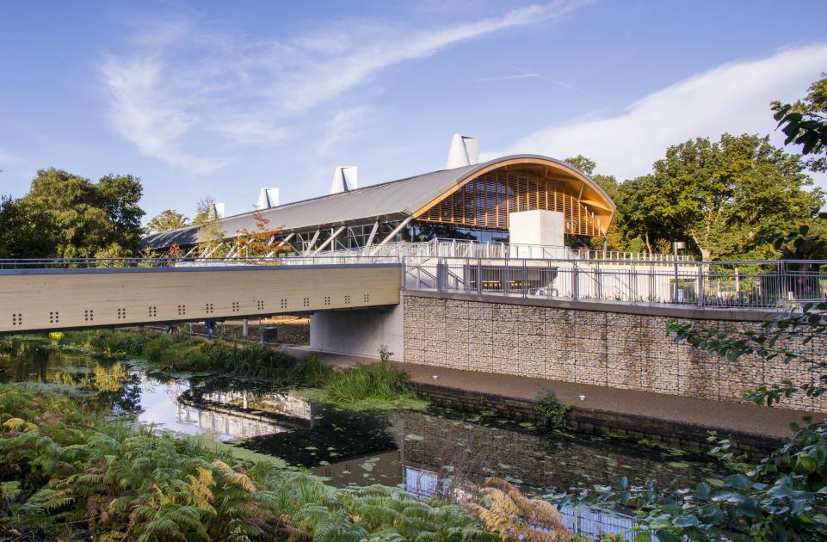
Owen Towell - 1903180

Brief
- Discuss the foundation requirements of the building, giving due consideration to the location. Estimate the foundation (excavation, concreting) works required based on the information given and any other reliable sources of information, for example the ground conditions in the local area.
- Discuss the choice of materials for the super-structure, giving consideration to design, structural strength, stability, fire safety, aesthetics and environmental impact and sustainability.

TABLE OF CONTENTS
1.0 SUBSTRUCUTRE 3
1.1 SITE SPECIFIC LIMITATIONS 4
1.1.1 LOCATION 4
1.1.2 ECOLOGY 6
1.1.3 ARCHAEOLOGY 7
1.1.4 GEOLOGY 8
1.2 FOUNDATION DESIGN 10
1.2.1 ESTIMATION OF WORKS REQUIRED 12
2.0 SUPERSTRUCUTRE 13
2.0.1 DESIGN #
2.0.2 FRAME #
2.0.3 FLOORS #
2.0.4 ROOF #
2.0.5 EXTERNAL AND INTERNAL WALLS #
2.0.6 WINDOWS AND DOORS
2.2 SUPERSTRUCTURE CHARACTERISTICS
2.2.1 STRUCTURAL STRENGTH
2.2.2 FIRE SAFETY
2.2.3 AESTHETICS
2.2.4 SUSTAINABILITY #
#
REFERENCES #
APPENDIX A #
APPENDIX B #
APPENDIX C #
APPENDIX D #

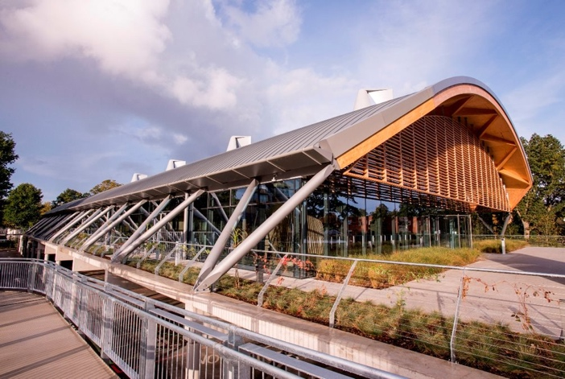
Project name: Living Planet Centre
Location: Woking, Surrey
Client: WWF-UK
Building Type: Office
Architect: Hopkins Architects
Structural Engineer: Expedition Engineering Ltd
Main Contractor: Wilmott Dixon
Project Manager: JEP
Building Type: Commercial
Size: 3580m²
Project Status: Completed
Completion Date: November 2013
Contract Value: £13,000,000

The Living Planet Centre, the current UK headquarters of the World Wildlife Fund (WWF), is an ‘ultra-green, energy-efficient’ building designed by Hopkins Architects. It earned a BREEAM ‘Outstanding' rating and achieved a 42 percent reduction in embodied carbon (WWF-UK HQ: Living Planet Centre, 2015). The project was awarded ‘best public service building’ during the LABC South East Regional Awards in Brighton. They were given the award for their outstanding performance in terms of design and technical construction. The award acknowledges not only buildings, but also the design and construction teams that overcame technological challenges, challenging locations, and came up with creative and imaginative solutions (WWF Living Planet Centre Wins Architecture Award, 2014)

- Substructure Requirements
The Royal Institute of Chartered Surveyors defines substructure as "all works below the lowest floor finishes, including excavations and foundations" (Elemental Standard Form of Cost Analysis, 2012). A foundation's primary function is to transfer and distribute loads from the superstructure above to the soil below in such a way that the site's subsoil does not spread and the structure does not experience uneven settlement (Magar, 2020). When designing the foundations for The Living Planet Centre, there were a multitude of factors to consider before a decision could be made (Gerrard, 2015).

  - Site-specific Limitations
NB: Site-specific constraints essentially govern the choice of substructure for any new development. These constraints must be recognised and evaluated during the early stages of design to ensure the structural integrity of the final product.

    - Location

The site is located in central Woking, between the Basingstoke Canal, to the south, and Brewery Road, to the north. To the west, there are houses with gardens, and to the east, there are residential flats. Brewery Road is bordered on the north by a wooded area, while the busy A320 Victoria Way runs south of the canal. In respect of nearby residential properties, considerations must be made to mitigate pollutants emitted from construction, as poorly managed projects can have an adverse impact on health and the local environment (Upton, 2003). Noise is possibly the most common pollutant brought about by construction. The noise generated by heavy machinery during construction activities can be disruptive to nearby residents (Jain, 2016). Noise pollution has the ability to increase sleep deprivation, eye irritation, high blood pressure, and stress. As a result, the foundation's effect on the natural environment and the local community must be carefully considered during design stages.
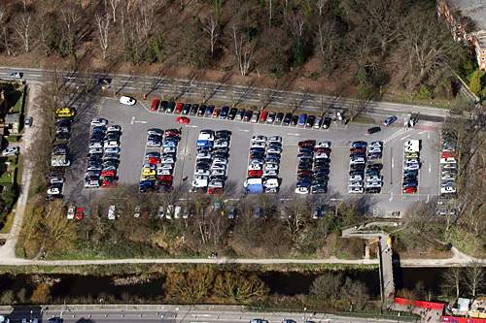
The site was formerly home to a local authority owned car park (Quinn, 2017), making it a brownfield site by definition. A brownfield site is defined by the National Planning Policy Framework (NPPF) as previously developed land that is, or was occupied by a permanent structure. Brownfield sites are appealing to developers as they mitigate sprawl and the destruction of virgin land (greenfield sites); however, development can be complicated by the discovery of contaminants in the ground. If not adequately dealt with, contaminated land can be detrimental to human health, property, and the surrounding environment. It has the potential to limit or prohibit new development and jeopardise compliance with the Water Environment Regulations of 2017 (Land affected by contamination, 2019).
Fig. 1 – The old council-run car park site on Brewery Road, Woking. Source: http://assets.wwf.org.uk/custom/stories/lpc/

As a result, WWF-UK commissioned Geotechnical & Environmental Associates to conduct a ground investigation on the site in 2010 (APPENDIX A). This entailed recovering six samples of the made ground and testing them for various industrial contaminants and contamination parameters (GEA, 2010). With the exception of occasional tarmac particles, which usually contain elevated concentrations of poly-aromatic hydrocarbons (PAH), no evidence of substantial pollution was found in these soils. However, according to a report published in the Egyptian Journal of Petroleum, many PAHs are toxic, mutagenic, and/or carcinogenic to animals, with a 'moderate to high' acute toxicity to aquatic life (Hussein, 2015). Given that the site is adjacent to the Basingstoke Canal, reducing the risk of water contamination was critical and influenced the selection of foundation type.

The Basingstoke canal – located less than 10m from the site boundary - had to be carefully considered for a variety of reasons - and not only for the pollution concerns. Surrey County Council declared Basingstoke Canal - and parts of the surrounding land - as a Conservation Area in 1985 (Basingstoke Canal – Planning Guidance Note, 2020), and a 10m buffer zone was established around the canal by Woking Borough Council in 2006 to ensure that no activities could take place within 10m of the canal that could pose a risk to the historic fabric (Planning Portal Woking, 2010). According to the Canal and River Trust, all work near a canal system must be undertaken with extreme caution and forethought, and proposals must demonstrate that there will be no significant impact on existing canal structure. Excavating along canals has the potential to cause dewatering and undermining, and since not all canals are lined, nearby construction can result in high seepage rates which potentially lead to permanent leakage or piping failure (Third Party Work Procedures – Code of Practice, 2012). The risk of a breached canal bank must also be considered, as a breach of the Basingstoke Canal in 1968 triggered flooding in Aldershot and Farnborough (History – The Baskingstoke Canal Society, 2010). Following floods, buildings can be susceptible to subsidence as the excess amount of water can cause foundations to "sink" and "heave," forcing foundations upwards, subsequently impacting the buildings structural integrity (Knight, 2014).
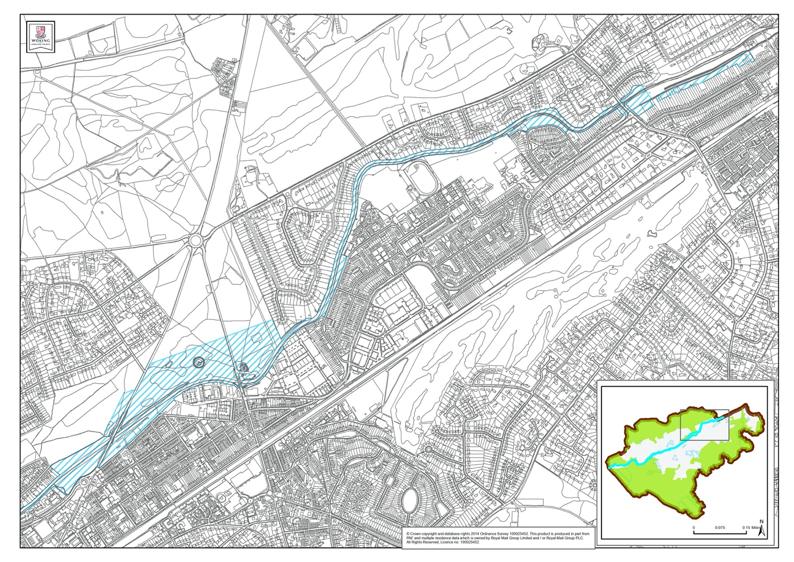
Fig. 2 – Basingstoke Canal, Woking (East) – Conservation Map Source: https://www.woking.gov.uk/sites/default/files/documents/planning-and-building-control/herritage/bcca3.pdf

    - Ecology
Prior to the commencement of works, WWF-UK commissioned ACS Consulting to conduct an arboricultural implication report of the site (ACS Consulting, 2010). They came to the conclusion that the site supports approximately fifty trees, the majority of which contribute significantly to the local landscape. According to their report, thirty of the fifty surrounding trees are classified as British Standards Category B, which suggests that these trees will provide a significant contribution to the surrounding environment for a minimum of 20 years (Tree Surveys, 2020). According to BS 5837:2012 "Trees in relation to design, demolition and construction - Recommendations", category B trees should be retained where possible, however, occasional specimen removal may be acceptable. ACS Consulting therefore requested that certain areas of the site remain free from construction to mitigate any disturbance to the trees and their roots. These areas are known as Root Protection Areas (RPA), and are measured using the following formula:

Number of Stems | Calculation
Single stem tree | RPA (m²) = ((Stem diameter(mm) @ 1.5m x 12) / 1000) x 12
Tree with one or more stem arising below 1.5m above ground level | RPA (m²) = ((Based diameter above root flare (mm) @ 1.5m x 12) / 1000) x 10
Table 1 – RPA Calculation. Source: BS 5837:2012 "Trees in relation to design, demolition and construction - Recommendations"

The RPAs implemented on site had a detrimental impact on the overall footprint, limiting the areas where development could take place. A survey conducted by AECOM Environmental on behalf of WWF-UK recommended that a number of trees be left in-situ, reducing the site's footprint even further. According to their report, thirteen trees on the site have been defined as having the potential to support bat roots, with six of them scheduled for removal or pollarding (AECOM Environmental, 2010). The removal or pollarding of any tree containing a bat roost would constitute an offence under the Conservation of Habitats and Species Regulations 2010 and the Wildlife and Countryside Act 1981 (AECOM Environmental, 2010).

Given the site's location, which is situated between the Baskingstoke Canal and ancient protected heathland (Inspiring Places: The Living Planet Centre, 2021), local wildlife encounters are likely. According to the Basingstoke Canal Authority, the canal is internationally recognised as a significant wildlife habitat and is home to more aquatic species than any other waterway in the United Kingdom. The canal also provides habitat for a variety of legally protected species, which, if discovered on site, may have a significant effect on development. According to an ecological assessment of the site undertaken by AECOM Environment in 2010 (APPENDIX B), a desk study conducted in 2003 discovered records for water voles along the Basingstoke canal (AECOM Environmental, 2010).This meant that any works to the canal, or in near proximity to the canal, are prohibited should they impact the habitat of water voles under the Wildlife and Countryside Act of 1981. The Wildlife and Countryside Act of 1981 stipulates that killing or injuring wildlife as a result of construction may result in a £5,000 fine, six months imprisonment, and the confiscation of the items used in the offense (Gent, 2021).
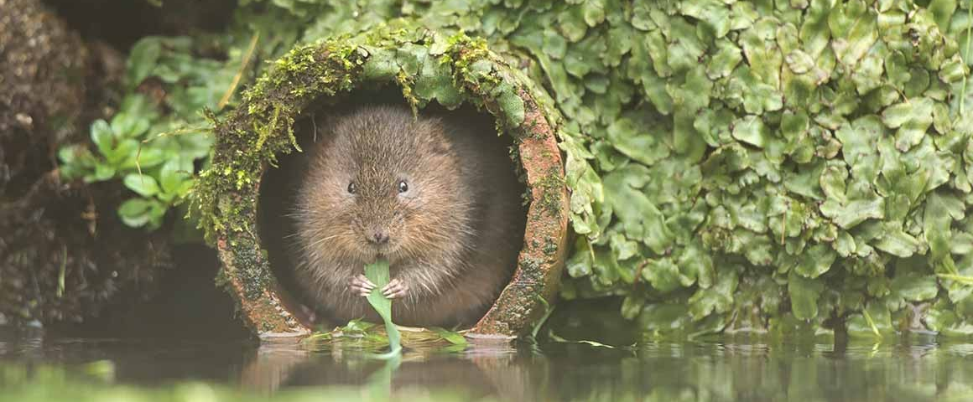
Fig. 3 –Water Vole Source: https://www.nhm.ac.uk/discover/news/2018/september/water-voles-return-to-exmoor-for-the-first-time-in-30-years.html

    - Archaeology
According to data from the British Archaeological Records, there are 13 archaeologically significant areas within a 10-kilometer radius of the site where Roman, Bronze Age, Medieval, Post-Medeival, and Neolithic artefacts were discovered (British Archaeological Sites Data Map, 2021). Any evidence, or possible evidence, of past human activity found on a site, according to the National Planning Policy Framework 2019 (NPPF), would pique archaeological interest. The archaeological investigation process is multi-staged and a time-consuming procedure that evidently brings work on the site to a halt (Howells, 2018).

Historic England has therefore issued a guidance note to assist planning authorities in making informed decisions about the foundation proposal, its impacts, and solutions for sustainable foundation construction, ensuring that all necessary precautions are taken to minimise any risk to potential archaeological remains (Historic England, 2007). As a result, Surrey County Archaeological Unit were commissioned by WWF-UK to conduct a preliminary archaeological assessment of the site (APPENDIX C). The archaeological potential of the site was best identified as low - based on the above - and archaeological investigations within close proximity of the area had also yielded a generally negative result. (Surrey County Archaeological Unit, 2010).
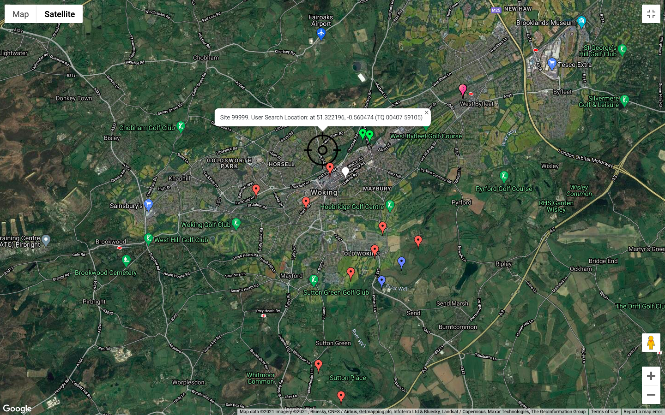
Fig. 4 – Distribution map of archaeological, historic and cultural sites. Source: https://www.archiuk.com/

    - Geology
The location and design of building foundations are ultimately determined by the geology of a site. The driving in and lateral pressure from the soil provide stability and load-bearing capacity to the foundation (Prakash, 2015). However, should the soil's load-bearing capacity be inadequate for the proposal, consideration must be given to the bedrock underneath. As a result, in 2010, WWF-UK appointed Geotechnical & Environmental Associates to conduct a desk study and ground investigation of the proposed site. The investigation consisted of three cable percussion boreholes, advanced to a depth of 15.0m (15.2m OD), a series of give machine dug trial pits, excavated to depths of 2.0-2.2m, a series of five in-situ California Bearing Ratio (CBR) tests, and laboratory testing of selected soil samples (GEA, 2010).

The study concluded that below the existing carpark's tarmac hard standing, rendered land consisting primarily of road-stone over brown to dark brown sandy clayey silt with gravel, asphalt, brick rubble, tarmac fragments, and rootlets were present and extended to depths of 0.4-0.6m (29m OD) (GEA, 2010). Bagshot beds were discovered below the nominal thickness of made ground and proved to the maximum extent of the investigation of 15.0m. A top layer of pale brown to yellowish brown slightly clayey silt over medium dense becoming very dense brown to yellowish brown and clayey sand made up the bagshot beds(GEA, 2010). These encounters occurred at depths of 2.0-2.2m (28.0m OD) and in the trial pits between 4.3m and 5.7m (24.8m OD) in the boreholes. The upper layers were accompanied by an initial layer of very dense, greenish grey, slightly clayey sand, which graded into medium dense, becoming dense greenish brown to greenish grey slightly clayey sand at depths of between 6.5m and 7.0m (23.m OD) and extending to depths of 9.1m to 11.4m (19.4 m OD) (GEA, 2010). A very stiff grey silty sandy clay with occasional black rounded gravel was encountered at depths of 12.7m to 13.8m (16.4m OD), followed by a very dense grey sand at depths of 15.m (15.2m OD) (GEA, 2010).

According to Expedition Engineers, the clayey sand or firm sandy clay of the Bagshot Beds will provide suitable bearing stratum for a spread foundation designed to apply a net allowable bearing pressure of 125 kN/m² at a minimum depth of 0.90m – assuming that planting of shrubs in the vicinity of the foundation is restricted. However, as there is unregulated shrub planting in the new development, foundation excavation to a minimum depth of 1.25m is required. (GEA, 2010) Should the loads of the proposed development be high - such that spread foundations become impractical - then piles foundations extending through the upper layers of the Bagshot Beds would provide a suitable solution.
Fig. 5 – Woking Geological survey. Source : https://www.bgs.ac.uk/map-viewers/geology-of-britain-viewer/

  - Foundation Type
Shallow and deep are the two main types of foundations. Deep foundations are a form of foundation that transfers building loads into the earth itself, while shallow foundations transfer the load of a structure into the earth's surface (Magar, 2020). The project team's choice of foundation was essentially governed by the limitations specified under item 1.1 "Site Specific Limitations." Based on the expert advice given and the aforementioned limitations, the project team eventually decided on pile foundations. These are typically collumns that are either driven into the ground or cast in situ, that transfer the weight of a structure into less secure sub-soils before reaching soils with sufficient weight bearing capacities. (Balfour Beatyy, 2020)

Justification for adopting this method of foundation can be shown in the below table:
Limitation | Risk | Conclusion
Neighboring Properties | Noise emissions at high levels can affect neighboring properties and cause a variety of health issues. | Piling is a relatively fast operation, and a shorter time on site with heavy plant is required to ensure that noise emission from substructure activities is limited.
Contaminated Ground | Risk of contaminating the nearby canal | Piling disturbs the least amount of soil during installation, which ensures that only a small amount of soil must be disposed of off-site, reducing the chance of the pollution of waterways.
Canal | Risk of bank breaches and damaging canal structures through excavation | Excessive water from a bank breach can cause shallow foundations to heave, but this risk is mitigated since pile foundations often hit bedrock.
Trees | Protected trees and roots limit the footprint of the site | The reduced footprint limits the overall area for development. By using piles, less than 1m² is used for each. During their ground investigation, GEA concluded that due allowance must be made for future tree growth, and therefore a deeper foundations are required.
Wildlife | Risk of unintentional damage to wildlife habitats | As above, limiting foundation to less than 1m² reduces the risk of disrupting or harming a natural habitat.
Archaeology | Potential risk of disturbing archaeologically significant artefacts | According to Historic England, the least intrusive method of foundation is required to lower the risk of lateral sediment displacement, moderate the risk of concrete mitigation, and a lower the risk of preferential pathway.
Geology | Made ground is not capable of withstanding the superstructure’s load | As the made ground is not suitable for withstanding heavy loads, Geotechnical & Environmental Associates recommend that the foundations reach the bagshot beds, which is only possible with deep foundations.
Table 2. Foundation Type Justification. Source: Owen Towell

According to Expedition Engineering's John Gerrard, much deliberation went into the choosing of pile type. Continuous flight augured piling, steel helical piling, and precast concrete driven piles were all explored. The use of steel helical piles were appealing to the team as they are completely reversible, allowing WWF to essentially leave the site in the same condition as they found it (Gerrard, 2015). Continuous flight augered piles were less appealing in that respect, however they did have the advantage of being widely used and being relatively inexpensive. While using pre-cast concrete driven piles was more cost-effective, concerns about noise and vibration levels among nearby residents needed to be addressed. Following a comprehensive study, pre-cast concrete driven piling with noise reduction strategies was adopted. Driven piles are typically engineered off-site and then hammered into place with a hydraulic hammer until the appropriate depth/resistance is reached. According to Expedition Engineering, this approach was the most sustainable, had the least amount of embodied carbon, had the shortest time on site, the least power to install, and zero soil to dispose of on site. According to reports, the piles were installed in under three weeks, with no complaints from the neighbours (Gerrard, 2015).
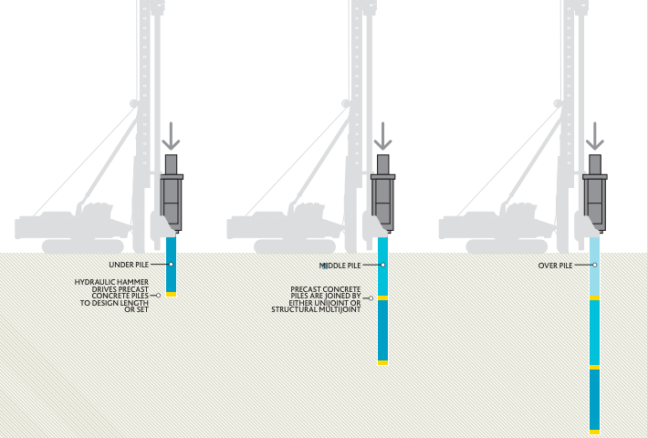
Fig. 6 – Driven Piles Installation Method. Source : https://www.balfourbeatty.com/media/318097/bbge-brochure.pdf

The use of concrete may have proven problematic given the client's environmental reputation, however Wilmott Dixon (the main contractor) devised a strategy of using concrete in the most sustainable manner possible (Quinn, 2017). Giving considerations to the embodied energy involved in the manufacture of concrete, Wilmott Dixon chose to source the materials from a local company and insisted that a minimum of 40% of the aggregates used be recycled. It was also noted that 98% of the steel used in the reinforcement were recycled, resulting in a net carbon reduction of approximately 250 tonnes (Quinn, 2017).

1.2.1 Estimation of Works Required

Based on the sites SPT / Depth graph produced by Geotechnical & Environmental Associates (GEA) in 2010 (APPENDIX A), the following table of ultimate coefficients may be used for the preliminary design of piles:
Ultimate Skin Friction | Depth | kN/m2
Made Ground | Ground Level to 1.0m | N/A
Bagshot Beds (Sand)  (Ks = 0.7, ϕ = 23º) | 1.0m to 2.5m | 10
Bagshot Beds (Sand)  (Ks = 0.7, ϕ = 24º) | 2.5m to 4.5m | 15
Bagshot Beds (Sand)  (Ks = 0.7, ϕ = 32º) | 4.5m to 7.0m | 30
Bagshot Beds (Sand)  (Ks = 0.7, ϕ = 27º) | 7.0m to 10.0m | 35
Bagshot Beds (Sand)  (α = 0.6) | 10.0 to 13.0m | Increasing linearly from 60 to 95
Bagshot Beds (Sand)  (Ks = 0.7, ϕ = 33º) | 13.0m to 15.0m | 70

Ultimate End Bearing | Depth | kN/m2
Bagshot Beds (Sand) | 13.0m to 15.0m | Limited to 10,500
Table 3. Site Specific Ultimate Coefficients. Source: Geotechnical & Environmental Associates.

In the absence of a pile test, GEA recommends adding a three-fold factor of safety to the above coefficients when calculating safe theoretical working loads. According to GEA, a 300mm diameter pile base at a depth of 15.0m should provide a secure working load of circa. 430kN with the inclusion of 3.0. Alternatively, at the same depth, 450mm and 600mm diameter piles can have secure working loads of circa. 830kN and 1350kN (GEA, 2010). Since the shaft friction would be completely mobilised at working load, a portion of the working load is likely to be carried by end bearing resistance, and checks on likely settlements should be made once the pile layout and loads have been finalized (GEA, 2010).
According to the approved, detailed construction drawings submitted to the Woking Borough Council Planning Portal (APPENDIX D), 275mm square pre-cast piles were installed in clusters of three to a depth of 5000mm, with pile caps installed on top. There are a total of 72no clusters of piles spaced at approximately 8m intervals across the full length of the building and at 7.5m intervals across the width of the building, totaling 216no x 275mm x 275mm x 5000mm piles. Each pile totals to approximately 0.38m3 of pre-cast concrete (81.7m3 in total). Considering the piles are driven, excavation is kept to a minimum and only the temporary removal of made topsoil is required.
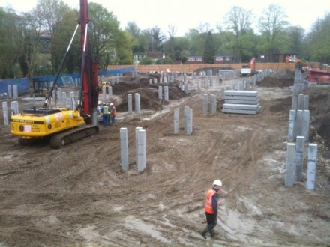
Fig. 7 – Driven Piles Installed on Site. Source : https://expeditionworkshed.org/workshed/wwf-living-planet-centre/

- Superstructure
A superstructure is classified by the Royal Institute of Chartered Surveyors as the above-ground components of a structure that typically serve the structure's intended function – these include, but aren’t limited to; roof structure, external and internal walls, floors, windows and doors. The foundations support and transfer the loads of these components into the ground, ensuring the final product's structural stability.

2.1 Design

Spectacular in its setting, The Living Planet Centre was carefully designed by Hopkins Architect with the client, the surrounding environment, practicality, sustainability, and full project lifecycle in mind. (WWF) The structure is intricate, with a large amount of glass on gables, elevations and ceilings, supported by both a timber and steel frame. The design ensures that all structural components are supported while the area below is enclosed (Gerrard, 2015). The openness of the structure allowed the designers to express the true structural form by displaying structural components that are typically concealed (Gerrard, 2015). According to reports, the project team decided early on that the steel and timber structural elements were to be exposed to eliminate the need for secondary finishes, therefore; reducing the project's embodied energy and maintenance requirements and ensuring that the projects’ sustainability expectations were achieved. (TRADA) A spectacular and structurally efficient convexed timber diagrid crowns the structure, which is lined with a zinc roof that incorporates photovoltaic panels for energy generation and large metal wind cowls that aid natural ventilation. (Gerrard, 2015).

2.2 Roof

Constructed from 828no 585x160mm glued laminated timber members and fitted with 7206no bolts, the roof structure of The Living Plane Centre is astounding. The structurally efficient FSC certified spruce grid shell offers a 37.5m wide office space without the requirement for any internal support columns. (WWF)

Glued laminated boards (Glulam) are an engineered wood product, manufactured from layers of parallel timber laminations. Laminates of timber are glued, under pressure and heat which result in a structurally sound building material. https://www.youtube.com/watch?v=OcV8fvUauX8 http://glulambeams.co.uk/#:~:text=Glulam%20Ltd%20has%20the%20largest,over%20structural%20steel%20and%20concrete.

2.2.1 Structural Strength

According to the COCIS research into glued laminated timber, the strength class of a glulam member is determined not only by the grade of the laminations, but also by the structure of the glulam component itself. Glulam can either be "homogenous", which implies that all of the laminations are of the same grade of timber, or "combined," meaning that the outer laminations are stronger than the inner ones. (GLULAM HANDBOOK BOLUME 1, 2017) Because knots, splits, and sloping grain - all of which reduce strength - are distributed in a random manner, glulam can be designed to withstand higher stresses than solid timber of the same grade. (STRUCTURAL TIMBER ASSOCIATION) A glulam member's load bearing capacity will on average be greater than an individual lamination of the same grade and dimension, and the strength difference between different parts will be less than with individual laminations. (DESIGN OF TIMBER STRUCTURES ACCORDING TO EC5) As a result, higher stresses can be applied to a glulam member than when the laminations are loaded individually. (GLULAM HANDBOOK BOLUME 1, 2017)

BS EN 1995-1-111-12 requires that the timber used to manufacture glulam is strength graded either visually or mechanically to either BS EN 1408113, BS 497814 for softwoods or BS 575615 for hardwoods (STRUCTURAL TIMBER ASSOCIATION). The glulam strength groups are also listed in this standard, and reading the strucural drawings provided by Expedition Engineering Ltd (APPENDIX E), the The Living Planet Centre glulam members were UK spruce with a strength class grade of GL28h.

 | 1 | 2 | 3 | 4 | 5 | 6 | 7 | 8
1 | Strength Class | GL24h | GL24c | GL28h | GL28c | GL32h | GL36h | GL36c
Strength Properties in N/mm²

2 | Bending fm,k | 24 | 24 | 28 | 28 | 32 | 36 | 36
3 | Tension Parrallel ft,0,k | 16,5 | 14 | 19,5 | 16,5 | 19,5 | 26 | 22,5
4 | Tension Rectangular ft,90,k | 0,5
5 | Pressure Parallel fc,0,k | 24 | 21 | 26,5 | 24 | 26,5 | 31 | 29
6 | Pressure Rectangular fc,90,k | 2,7 | 2,4 | 3,0 | 2,7 | 3,0 | 3,6 | 3,3
7 | Shear and Torsion fv,k | 2,5
Stiffness Properties in N/mm²

 | Mouldus of Elasticity
8 | Parallel E0,mean | 11600 | 11600 | 12600 | 12600 | 13700 | 14700 | 14700
9 | Rectangular E90,mean | 390 | 320 | 420 | 390 | 420 | 490 | 460
10 | Shear Modulus Gmean | 720 | 590 | 780 | 720 | 780 | 91- | 850
Molded Density Properties in kg/m³⁷²⁰

11 | Molded Densify | 380 | 350 | 410 | 380 | 410 | 450 | 430

Table 4 – Laminated Timber Strength, Stiffness and Molded Density Data. Source: DIN 1052:2004-08

The structural stability of this open frame structure is given by a system of triangulated diagonal bracing components. (STRUCTURAL TIMBER ASSOCIATION) Arches made of glulam are used to accommodate the large span, and therefore, if an arch can follow the pressure line (the line where the cross-section is subjected to continuous compression stress over the entire cross-section) it can perform at its best. (GLULAM HANDBOOK BOLUME 1, 2017) This system's efficiency means the design doesn't need any additional structural elements on the building's facade, which allows the interior to be free of internal columns and supports.

2.2.2 Fire Safety

Because of their broad homogeneous cross-sections, glulam structures are relatively fire resistant. (VOLUME 1 OF THE HANDBOOK) As the size of the object increases, so does its resistance to fire. While glulam, by nature, is a flammable material, because of its wide and homogeneous cross-sections, it is relatively resistant during the initial stages of a fire sequence. According to the Glulam Handbook 2017, the initial combustion is gradual and it burns slowly, and the layer of carbon that forms on the glulam surface during a fire protects the internal layers and helps the glulam maintain its load bearing capacity during subsequent fire stages. According to the Structural Timber Association, glulam members are engineered with UK Building Regulations Approved Document B – Volume 2 – Appendix A2 in mind. They claim that a 190 x 405mm Grade GL28H glulam beam exposed to fire on three sides will retain its load-bearing capacity for 60 minutes, with a fire penetration speed of about 0.6-1.0mm per minute. (STRUCTURAL TIMBER ASSOCIATION)

2.2.3 Aesthetics

The glulam roof was chosen not only for its structural qualities, but also for its aesthetic appeal, due to a series of repeated elements that shape the arch design. Because of the diagrid system's efficiency, the design does not include any additional structural elements on the building's facade, which improves the aesthetics of the structure, inside and out. With a roof such as this, the triangulated diagonal bracing components permitted Hopkins Architect to include parts of glass between joists, maximising natural light (WWF). Since the timber members are visible to building users, glulam members may be surface treated on site as standard timber, with staining, top-coat painting, clear varnishing, or oil treatment, giving the building a more natural feel. (HANDBOOK VOL 1)

