
Master of Business Administration
Human Capital Management
LCMB7023
Assessment Component 1:
Individual Report – HR Strategy
Integrated Human Capital Blueprint
Lecturer: Anupam mazumdar
Student Name : Abhishekkumar Vinubhai Pethani
Student ID : 2525424
Table of Contents
Introduction 3
Part 1: Building a Culture of Innovation & Future Work Practices (Option 2) 3
Current Practices in Culture and Work in Tech Companies 3
Recommend cultural and structural initiatives that embed innovation. 5
Propose a Future of Work model (hybrid/remote) that supports collaboration and creativity. 6
Demonstrate how the new approach would motivate and enable staff to perform optimally. 8
Part 2: Reflection 9
Reflective Learning Using Gibbs Reflective Cycle 9
AI and Future Career 12
Conclusion 13
Reference List 14

Introduction
Technology companies always focus on an innovation culture to make themselves more competitive in volatile digital markets. Despite that use of human resource practices that promote teamwork, innovativeness, and adaptability can help organisations to enhance employee satisfaction and customer performance. Aether Innovations needs to design a comprehensive HR-based approach to innovation.

Part 1: Building a Culture of Innovation & Future Work Practices (Option 2)

Current Practices in Culture and Work in Tech Companies
Innovation and employee behaviour in technology companies are based on organisational culture in a critical manner.
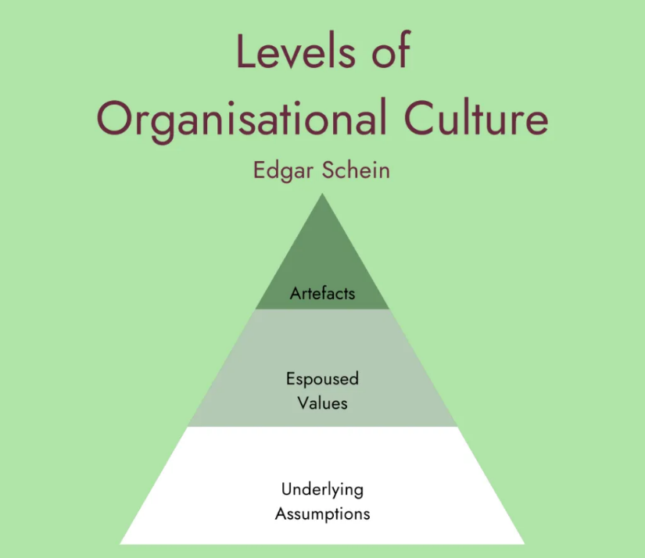
Figure 1: Organisational Culture Model
(Source: Geraghty, 2023)
From the perspective of Edgar Schein, organisational culture is a set of shared values, beliefs, and practices that can shape the way employees interact, solve problems and treat innovation (Singaram and Mayer, 2022). The culture of experimentation and teamwork is usually required in technology companies to keep up with the sometimes rapidly evolving markets. In that case, research of Yas et al. (2022) highlights that the top leading Tech companies, such as Google has created an organisational culture that fosters free communication, sharing of knowledge and employee freedom that helps staff members to bring creative ideas and innovative solutions. It will help develop innovation-oriented cultures that enable creativity, and they can also create uncertainty for employees who lack a clear strategic orientation or accountability for performance (Zhang, 2024). The existing problems of flat growth and a high rate of employee turnover at Aether Innovations indicate that the organisation might lack a conducive culture that promotes innovation without compromising the clarity of employee performance expectations.
In that case, following the Agile working practices is being used more and more by modern technology companies to facilitate collaboration and innovation. Agile workplaces focus on being flexible, cross-functional, and quick to experiment, which enables organisations to react to technology changes and customer needs at speed (Appoh et al., 2022). However, agile working practices also have their fair share of challenges; especially coordination between several teams can be tricky, as well as when employees are pressured by the workload, by being subjected to constant project cycles (Omachi and Ajewumi, 2024). In the case of Aether Innovations, the application of agile-inspired cultural practices may enhance the daily innovation and teamwork process, yet the leaders need to make sure that employees are provided with enough support, communication and vision of the organisational objectives.
Employee empowerment and psychological safety are the other key components of an innovation culture within technology companies. Psychological safety is the level of environment where employees feel free to share ideas, try new ways, and confront existing practices without dread of adverse effects (Sacramento et al., 2024). Empowerment initiatives can never produce significant results without proper HR systems. To improve organisational performance, Aether Innovations needs to create a well-organised culture that allows employee empowerment, innovation goals and encouragement leadership practices.

Recommend cultural and structural initiatives that embed innovation.

Figure 2: Cultural & Structural Initiatives for Innovation
(Source: Self-developed)
Innovation sprints are one of the most efficient methods since they are short, specific, and during these cycles, teams are working hard to create and test new ideas. Innovation sprints enable employees to develop solutions quickly and receive feedback about them, enhancing the rate of product development. In the rapid experimentation and innovation cycles, tech companies utilise very often utilise to pilot new services and enhance the experience of customers (Lizarelli et al., 2023). These practices allow organisations to act fast in response to the market opportunities. In the case of Aether Innovations, a culture of innovation sprints should be backed by specific goals, sufficient resources, and an attitude of experimentation instead of failure.
The other approach to incorporate innovation is intrapreneurship, in which employees are compelled to come up with new ways of doing business within the organisation. The intrapreneurship programs also offer employees a chance to behave as entrepreneurs, but with organisational resources and support. Tech companies, such as employees, are given the opportunity to devote some of their time to the investigation of innovative projects (Okofu et al., 2024). This venture has led to some successful product innovations. Although intrapreneurship promotes creativity and employee involvement, it can be costly to the organisation and may involve a major organisational investment and dedication on the part of the leadership. In the case of Aether Innovations, an intrapreneurship initiative may be a way of enabling employees to bring with them innovative ideas to the company, besides enhancing motivation and retention among employees, especially when there are well-defined evaluation and mentoring processes.
Another significant structural initiative that enhances the ability to innovate is cross-functional collaboration. This teamwork will enable organisations to integrate various skills and viewpoints, which will result in more innovative solutions. Following the cross-functional collaboration can also present a coordination problem, provided that the roles and responsibilities of a team are not well-established. Failure to communicate across departments may slow down the decision-making process and efficiency. Thus, in the case of Aether Innovations, cross-functional teams are to be assisted with effective communication systems, team cooperation, digital resources, and engaging leadership coordination to make sure that innovation projects add value to the organisational performance.

Propose a Future of Work model (hybrid/remote) that supports collaboration and creativity.

Figure 3: Future of Work Model for Aether Innovations
(Source: Self-developed)
A hybrid work model has the potential to increase collaboration and creativity within modern technology organisations to a considerable degree. Hybrid work is a flexible work model where workers spend their time working remotely and in the office in a flexible manner. This strategy will enable organisations to have it both ways by achieving the flexibility of working and the face-to-face interaction. The literature has indicated that effective implementation of hybrid models can enhance employee satisfaction, productivity and sharing of knowledge. Nevertheless, despite the fact that hybrid working offers more flexibility, it could also present communication gaps when employees are isolated or when they do not have access to collaborative technologies. In the case of Aether Innovations, adopting a work structure with hybrid work where employees will work part of the day in the office and the other part at home would enhance work-life balance and, at the same time, ensure close teamwork and innovation (Okofu et al., 2024).
The application of digital collaboration tools and organised communication processes is another key to the successful hybrid work model. Project management platform, virtual meeting, and shared online workspace are some of the technologies that enable employees to share ideas and organise work even when they are not physically in the office. Using remote collaborating channels facilitates brainstorming, sharing of knowledge and instant problem solving (Jamali et al., 2024). However, sometimes digital collaboration can lead to a lack of informal socialising that is valuable in being creative and bonding as a team. Aether Innovations must adopt the use of frequent virtual conferences, innovation exercises, and shared online offices so that employees are not isolated and bored at home during work.
Employee autonomy and flexible scheduling are other significant constituents of the future work model (Latos et al., 2024). The tech company has successfully operated on a remote-first policy, enabling high levels of autonomy and responsibility to employees who work in many technology companies. Therefore, Aether Innovations will have to reconcile flexibility and specific objectives, performance indicators, and leadership guidance in such a way that the hybrid work practices contribute to improved collaboration, innovation and the overall organisational performance.

Demonstrate how the new approach would motivate and enable staff to perform optimally
The suggested hybrid model of work and innovative nature of culture can greatly enhance the level of motivation and performance among employees, as it will take into consideration some of the fundamental psychological and organisational determinants. In the motivation theory formulated by Herzberg, the motivators are achievement, recognition, responsibility, and growth opportunities: these factors determine the satisfaction of the employees (Peramatzis and Galanakis, 2022). Tech company promotes innovation among employees by providing them with flexible work conditions and allowing them to come up with innovative projects. Thus, Aether Innovations should ensure that innovation projects are aligned with strategic goals and deliver quantifiable results.
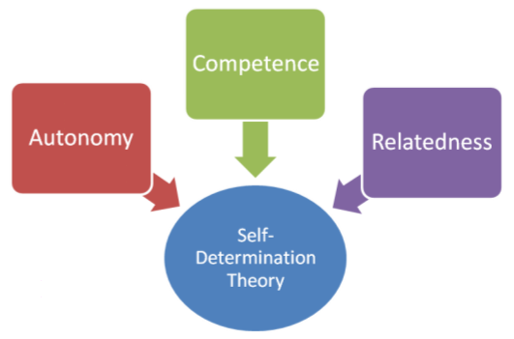
Figure 4: Self-Determination Theory
(Source: Human Performance, 2023)
Autonomy, competence, and collaboration are also factors that affect employee motivation at the workplace. According to Self-Determination Theory, people are better motivated when they have a feeling of control over their work, when they build their competence, and when they feel significant relationships with their employees (‌Gagné et al., 2022). These needs can be met by hybrid working and innovation programs like cross-functional teams, which provide workers with more autonomy and promote teamwork in solving problems. Firms have managed to inspire the staff by giving them the opportunity to commit their time to innovative projects that are of interest and specialisation to them (Alshemmari, 2023). However, independence will not necessarily provide better performance when the employees do not receive sufficient training, support, or resources.
Consequently, Aether Innovations ought to support the hybrid work model with effective leadership, learning, and recognition systems to appreciate innovative contributions. Employee engagement and commitment can also be enhanced through the provision of professional development programs, mentoring programs and performance recognition. With such a combination of HR practices, flexi-work model, and a culture focused on innovation, Aether Innovations will be able to motivate workers and allow them to deliver their best as they contribute to the organisational development and customer satisfaction.

Part 2: Reflection

Reflective Journey of the Module Using Gibbs Reflective Cycle
The process of reflective learning is also significant as it allows people to analyse their experience, improve their comprehension, and become better in their professional practice in the future. The reflective process enables the learner to be a critical analyst of what has been learned and how the knowledge can be put into real organisational situations. This reflection analyses the learning experience of the module in Human Capital Management through the Gibbs Reflective Cycle.
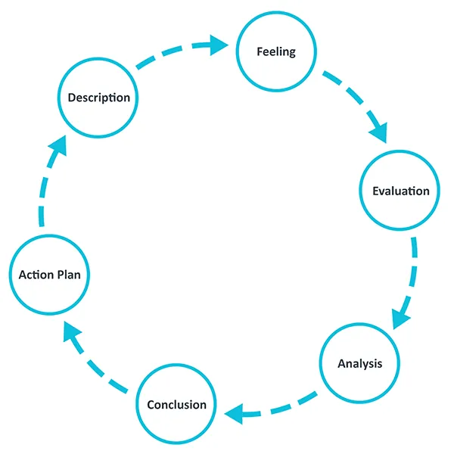
Figure 5: Gibbs’ Reflective Cycle
(Source: The University of Edinburgh, 2024)
Description
The initial point of the Gibbs model is devoted to the description of the learning experience. Through this module, I became familiar with a number of key concepts in the area of human capital management, such as organisational culture, motivation of employees, talent development and strategic HR practices. The module highlighted the role played by HR strategies in the alignment of people management to organisational performance. I acquired the knowledge of the ways companies can apply HR practices to build innovative working environments and improve employee engagement through lectures, readings, and job assignment activities. To illustrate, the topic of innovation culture and employee empowerment emphasised the way in which contemporary organisations engage employees to implement new ideas and take part in the process of solving problems. This learning experience has offered useful information about how HR practices can enhance the performance of the organisation, besides facilitating the growth of employees.
Feeling
The second stage is the reflection on the emotions that were experienced in the course of learning. At first, some of the ideas presented in the module looked difficult since they involved critical thinking and implementation in actual business scenarios. However, as I learned more of the material and read case studies of technology organisations, I started feeling much more confident about my ability to learn about the impact of HR practices on organisational outcomes. I also understood that human capital management is not restricted to administration HR activities, but it is strategic in determining success in organisations.
Evaluation
The evaluation stage entails establishing the positive and negative sides of the learning experience. A good thing about this module was that it stimulated critical thinking and practical implementation of HR theories. The emphasis on the practical problems in organisations enabled me to learn the application of theoretical approaches to real-life issues. Indicatively, the examination of innovation culture in technology companies revealed the importance of organisational culture on creativity, teamwork, and the motivation of employees. Nonetheless, a difficulty that I faced was in balancing the complexity of the fusion of several HR theories and concepts in the process of accomplishing a single assignment.
Analysis
The analysis phase is concerned with the reasons why the learning experience was meaningful and how it will be relevant to the development of the profession. The insight into innovation culture, employee motivation, and future work practices made me aware of the significance of coming up with people-centred leadership styles. Using a growth mindset will help people take challenges as a learning process and aids to get success (Nurlatifah et al., 2023). This is a viewpoint that is fundamental to the establishment of innovation and continual enhancement in organisations.
Conclusion
This reflection has helped me understand the need to form innovative thinking and constant learning habits to become successful in my career in the future. It has also emphasised the role of strategic thinking in HR management (Praveena et al., 2025). The learning experience has made me more aware of the role played by organisational culture, leadership practices, and employee development initiatives in ensuring that workplaces are high performing.
Action plan
The last part in the Gibbs model is the development of an action plan on how it can be improved in the future. Depending on the experience I have acquired kn, intend to keep on expanding my understanding of human resource management and organisational leadership. I am going to pay more attention to innovative management, employee motivation, and digital technologies in HR to boost my career progression as an HR professional. I will also strive to build my analytical and critical thinking through reading academic literature and career development opportunities. In addition, I will develop the growth mindset by taking on challenges and constantly trying to gain new opportunities to learn through experience.

AI and Future Career
The fast development of artificial intelligence (AI) is changing numerous factors in the contemporary working environments, such as human resource management, as well as organisational decision-making. Data analysis, recruitment screening, and workforce analytics are some of the routine activities that can be automated by AI technologies and may lead to an underutilisation of some of the traditional jobs (Yang et al., 2024). AI makes work more efficient, but it cannot completely substitute human abilities like creativity, emotional intelligence, human morality, and the ability to think strategically (Vishwanath and Vaddepalli, 2023). As a result, specialists should acquire new skills on a constant basis in order to become relevant in a world dominated by AI.
To stay competitive, one of the methods is to apply AI as an auxiliary tool and not as a substitute for human potential. Organisations are adopting AI-based HR analytics tools created by IBM and SAP in an attempt to analyse data on employee performance and use it to plan their workforce strategies (Sadok, 2022). These tools enable HR professionals to make better decisions by recognising direction, forecasting employee turnover, and measuring organisational performance.
To ensure that, I will be keen on ensuring that I develop skills that do not interfere with AI technologies but are complementary. Such competencies are critical thinking, leadership, communication, and innovation management. Also, the constant learning will play a crucial role in the adaptation to emerging technologies and development in the industry. Insight into the functioning of the AI systems and knowing how to use them productively, I will be able to enhance productivity without losing the individual human approach to strategic decision-making. This way, technological literacy coupled with human-centred leadership will enable professionals to use AI as a potent helper and make sure that human expertise is also at the core of organisational success.

Conclusion
It has been understood that innovation-oriented culture and future work practices are crucial to better performance of an organisation. Aether Innovations will try to increase employee engagement and foster creativity by introducing collaborative frameworks, hybrid work patterns, and HR practices based on motivation. Such combined strategies will help in ensuring sustainable growth, enhanced capability to innovate and enhanced customer satisfaction.

Reference List
Alshemmari, J.M.H.J., (2023). An empirical study on employee empowerment role in increasing efficiency of employee performance. Journal of Logistics, Informatics and Service Science, 10(1), pp.52-71. https://www.aasmr.org/liss/Vol.10/No.1%202023/Vol.10%20No.1.4.pdf
Appoh, M., Frempong, D., Akinboboye, O., Okoli, I., Afrihyia, E., Umar, M.O., Umana, A.U. and Omolayo, O., (2022). Agile-based project management strategies for enhancing collaboration in cross-functional software development teams. Journal of Frontiers in Multidisciplinary Research, 3(2), pp.49-64. https://www.researchgate.net/profile/Olasehinde-Omolayo/publication/393932031_Agile-Based_Project_Management_Strategies_for_Enhancing_Collaboration_in_Cross-Functional_Software_Development_Teams/links/68b6e00c7984e374aced043c/Agile-Based-Project-Management-Strategies-for-Enhancing-Collaboration-in-Cross-Functional-Software-Development-Teams.pdf
‌Gagné, M., Parker, S.K., Griffin, M.A., Dunlop, P.D., Knight, C., Klonek, F.E. and Parent-Rocheleau, X., (2022). Understanding and shaping the future of work with self-determination theory. Nature reviews psychology, 1(7), pp.378-392.https://www.nature.com/articles/s44159-022-00056-w.pdf
Geraghty, T. (2023). Edgar Schein’s Three Layers of Organisational Culture. [online] Psych Safety. Available at: https://psychsafety.com/psychological-safety-edgar-scheins-three-layers-of-organisational-culture/.
Human Performance (2023). What Is Self Determination Theory? [online] Human Performance. Available at: https://humanperformance.ie/what-is-self-determination-theory/.
Jamali, H., Dascalu, S.M. and Harris Jr, F.C., (2024, March). Fostering joint innovation: A global online platform for ideas sharing and collaboration. In International Conference on Information Technology-New Generations (pp. 305-312). Cham: Springer Nature Switzerland. https://arxiv.org/pdf/2402.12718
Latos, B., Buckhorst, A., Kalantar, P., Bentler, D., Gabriel, S., Dumitrescu, R., Minge, M., Steinmann, B. and Guhr, N., (2024). Time autonomy in personnel planning: Requirements and solution approaches in the context of intelligent scheduling from a holistic organisational perspective. Zeitschrift für Arbeitswissenschaft, 78(3), pp.277-298. https://link.springer.com/content/pdf/10.1007/s41449-024-00432-7.pdf
Lizarelli, F.L., Chakraborty, A., Antony, J., Jayaraman, R., Carneiro, M.B. and Furterer, S., (2023). Lean and its impact on sustainability performance in service companies: results from a pilot study. The TQM Journal, 35(3), pp.698-718. https://www.emerald.com/tqm/article-pdf/35/3/698/2363497/tqm-03-2022-0094.pdf
Nurlatifah, L., Purnawarman, P. and Sukyadi, D., (2023, December). The implementation of reflective assessment using Gibbs’ reflective cycle in assessing students’ writing skill. In AIP Conference Proceedings (Vol. 2621, No. 1, p. 070006). AIP Publishing LLC. https://pubs.aip.org/aip/acp/article-pdf/doi/10.1063/5.0143375/18237937/070006_1_5.0143375.pdf
Okofu, S.N., Anazia, K.E., Akazue, M.I., Okpor, M.D., Oweimieto, A.E., Asuai, C.E., Nwokolo, G.A., Ojugo, A.A. and Ojei, E.O., (2024). Pilot study on consumer preference, intentions and trust on purchasing-pattern for online virtual shops. Int. J. Adv. Comput. Sci. Appl, 15(7), pp.804-811. https://pdfs.semanticscholar.org/07f8/859abfe27939c1e62ff003cf494869877e24.pdf
Omachi, V.O. and Ajewumi, O.E., (2024). The influence of agile organisational design on employee engagement and performance in the digital age. International Journal of Research Publication and Reviews, 5(10), pp.25-39. https://www.academia.edu/download/122210915/IJRPR33803.pdf
Peramatzis, G. and Galanakis, M., (2022). Herzberg’s motivation theory in workplace. Psychology, 12(12), pp.971-978. https://www.davidpublisher.com/Public/uploads/Contribute/63c8ac817a47d.pdf
Praveena, K.S., Juslin, F., Patil, C.M. and Bhargavi, K., (2025). Using gibb's reflective model approach for enhancing project-based learning among students through reflective assessment. Journal of Engineering Education Transformations, pp.148-155. https://journaleet.in/index.php/jeet/article/download/2071/2016
Sacramento, C., Lyubovnikova, J., Martinaityte, I., Gomes, C., Curral, L. and Juhasz‐Wrench, A., (2024). Being open, feeling safe and getting creative: The role of team mean openness to experience in the emergence of team psychological safety and team creativity. Journal of Product Innovation Management, 41(1), pp.12-35. https://onlinelibrary.wiley.com/doi/pdf/10.1111/jpim.12699
Sadok, H., (2022). Human resource management in the era of artificial intelligence: future HR work practices, anticipated skill set, financial and legal implications. Academy of Strategic Management Journal. https://www.academia.edu/download/94768200/Human-resource-management-in-the-era-of-artificial-intelligence-future-hr-work-practices_-anticipated-skill-set-financial-and-legal-impl.pdf
Singaram, S. and Mayer, C.H., (2022). The influence of the Fourth Industrial Revolution on organisational culture: An empirical investigation. Frontiers in psychology, 13, p.919157.‌ https://www.frontiersin.org/journals/psychology/articles/10.3389/fpsyg.2022.919157/full
‌The University of Edinburgh (2024). Gibbs’ Reflective Cycle. [online] The University of Edinburgh. Available at: https://reflection.ed.ac.uk/reflectors-toolkit/reflecting-on-experience/gibbs-reflective-cycle.
Vishwanath, B. and Vaddepalli, S., (2023). The future of work: Implications of artificial intelligence on hr practices. Tuijin Jishu/Journal of Propulsion Technology, 44(3), pp.1711-1724. https://www.researchgate.net/profile/Surendar-Vaddepalli/publication/376186700_The_Future_of_Work_Implications_of_Artificial_Intelligence_on_Hr_Practices/links/659ab3646f6e450f19d45d60/The-Future-of-Work-Implications-of-Artificial-Intelligence-on-Hr-Practices.pdf
Yang, C., Luo, Z., Xu, N. and Tang, C., (2024). Fostering career crafting by developmental HR practices: The mediating role of future work self and moderating role of AI awareness. Career Development International, 29(6), pp.641-655. https://www.emerald.com/cdi/article-pdf/29/6/641/9536938/cdi-08-2023-0303.pdf
Yas, H., Othman, B., Mohammad, A.J. and Agala, S.R., (2022). Investigating the role of leadership and organisational culture in fostering innovation. International journal of health sciences, 6(S5), pp.2316-2334. https://pdfs.semanticscholar.org/b18d/8273bc1b4fed461d013712074250dd479d71.pdf
Zhang, Y., (2024). Cultivating a culture of innovation: The impact of leadership style on employee well-being and organisational creativity. International Journal of Global Economics and Management, 2(1), pp.202-210. https://pdfs.semanticscholar.org/a099/affa88e4ffe953272741c719703f9f4b7d0e.pdf

