A critical evaluation of the influence of Sustainable Relationship Marketing policies and practices and the impact on organisation performance` - A report for ‘Marketing Week’ an online journal produced by Sainsbury’s.

Shikder Sujan
Sainsbury’s
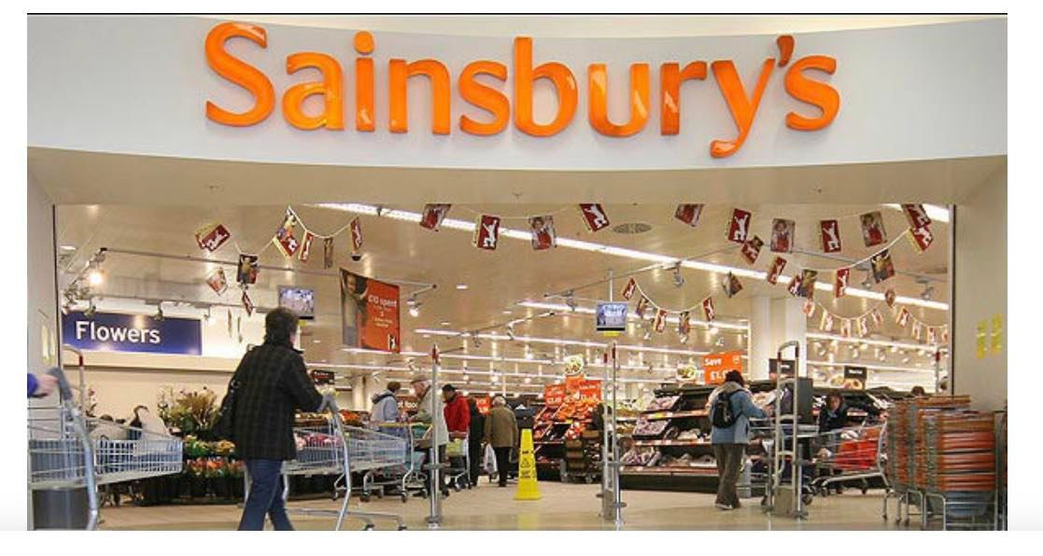
18th of November, 2022

Executive Summary
The study is demonstrating the marketing methods for the Sainsbury industry. It incorporates the relationship of the marketing manager with their customers. The researcher has demonstrated the different features and business activities of Sainsbury. It elaborates that multiple pricing strategies may help a manager to work on better business models. The pricing strategies are adopted by Sainsbury management for better product development. The research is also providing a brief knowledge of the market share with the profit and loss margins. Sainsbury's approach in the face of increasing competition is to deliver superior service and cultivate closer relationships with its customers than its competitors accomplish. It required a concentration on efficiency when close relationships with customers contributed little value to their experience and a concentration on strength where those customers placed the stronger importance.
The main purpose of this report is to critically review Sainsbury's historical development, market share, growth, profit & loss, marketing relationship and strategy. Also how Sainsbury applies its market segmentation, differentiation, ethical & sustainable policies and practices to achieve customer centrality.
This report explores how Sainsbury as a company is gradually expanding its business. Not just a supermarket, Sainsbury offers services and products like banks, petrol stations, restaurants, clothing, home ware etc.

Table of Contents

1.0 Introduction 1
2.0 Findings 1
Historical development of Sainsbury 1
2.1 Current market share 2
2.1.1 Profit and loss status 3
2.1.2 Mission statement 4
2.1.3 Importance of Relationship Marketing to Sainsbury's 4
2.1.4 Growth of customers 5
2.2 Data collection & evaluation 6
2.2.1 Customer market relationships 7
2.3 Segmentation, Pricing Strategies, and Differentiation 8
7p’s model of differentiation 11
2.4 Ethics and Sustainability 12
Tripple bottom line 13
Profit 14
People 14
The planet 15
3.0 Conclusion 15
4.0 Appendices 16
5.0 Reference List 20

1.0 Introduction
The proposed research aims to illustrate the business report of Sainsbury in detail. The report has been requested by the Marketing Executive officer of the marketing week who aim to discuss the fundamental features of the Sainsburys. The report was requested in 4th of October, 2022. The report is compiled by the researcher who has collected the data on the given business organisations from different resources. The researcher has elaborated on the history of Sainsbury which includes the current market share, growth, and decline process of the profit margins. The submission date of the report is 18th of November, 2022. While preparing this report research has been done by collecting information from academic books, journals, websites, newspapers etc.

2.0 Findings

Historical development of Sainsbury
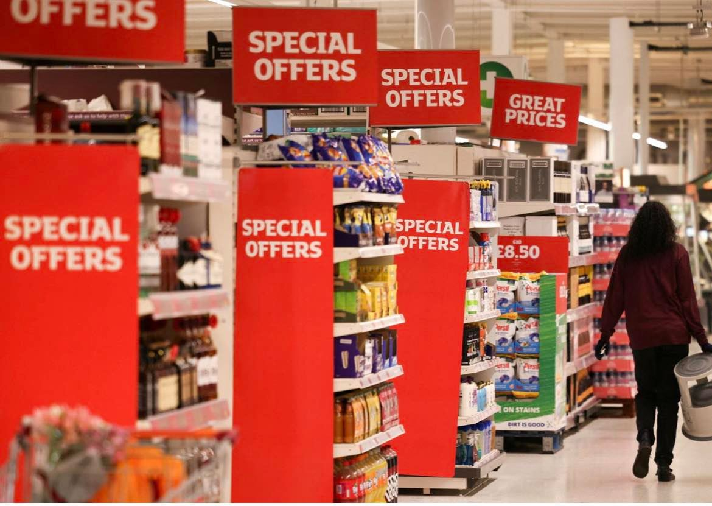
Ann Mary Sainsbury's and John James created and founded Sainsbury in 1869, and the company has grown ever since, eventually becoming the largest grocery store in the United Kingdom in 1922. Sainsbury's also pioneered the concept of self-service shopping in the UK during its heyday in the 1980s. It is observed that approximately 870 locations, 335 are convenience shops and 537 are supermarkets which are making it the third-largest grocery retailer in the United Kingdom. More than 19 million consumers shop at Sainsbury's every week, and they stock 30,000 items, 40% of which are on their labels (Kim et al., 2022).
Sainsbury's marketing strategy helps in developing the firm as a serious player in its industry and achieving the company's financial and other strategic aims and objectives. In compliance with its marketing mix product strategy, Sainsbury's provides its consumers with a diverse selection of goods and services (Renouf, et al., 2020). It takes care of creating new items and improving the present line in addition to concentrating on innovation and quality control. There are two types of stores owned by Sainsbury's: supermarkets and local convenience stores(Kritzer et al ., 2022).

2.1 Current market share
The current market share of Sainsbury can be understood with the help of different business operations run by the marketing manager of the company in the UK. The researcher has found that Sainsbury is one of the largest business chains that have produced high-quality products with low prices in 2022. In the last two years, the industry has increased its profit margins from its competitor company. With a comparable 'Aldi Price Match' selection, Sainsbury's, the second largest chain of the 'big four,' has also had success. Sainsbury's may have lost 0.6% of the grocery market share in 2022, but compared to competitors, its loss was significantly less because of its focus on sustainability, high-quality items, and low costs. Even in 2022, their proportion of the UK grocery business is truly massive at 15% (Amano et al., 2021).

2.1.1 Profit and loss status
Sainsbury's earned 854 million GBP in pre-tax profit in the fiscal year that ended March 5, 2022, and 677 million GBP in post-tax profit. From the loss the firm incurred the year before, this was a huge improvement.
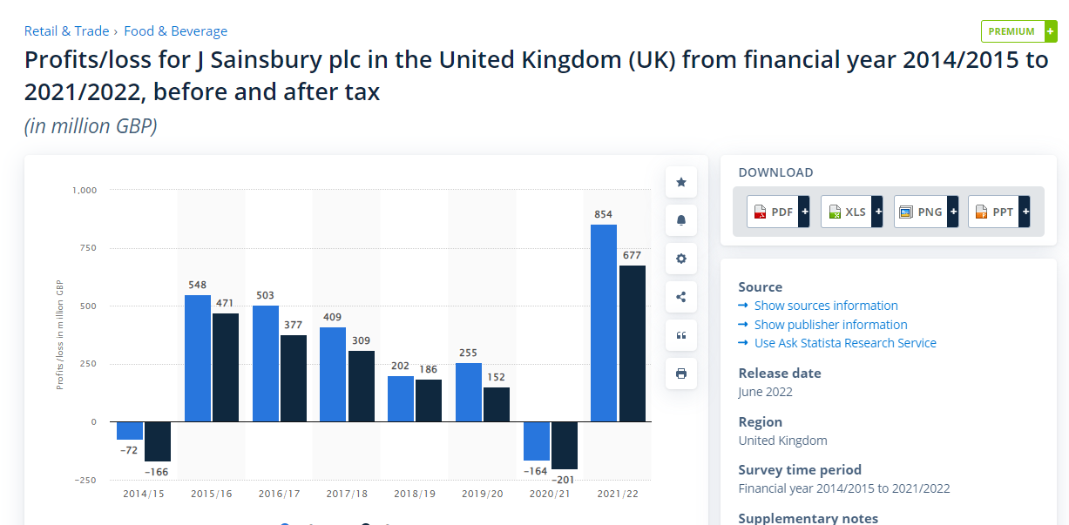
Source: https://www.statista.com/statistics/386446/sainsburys-profits-united-kingdom-uk/
Sainsbury's reported a loss for the 2020/21 fiscal year because of expected procedures expenditures and losses(Harris et al ., 2022). Sainsbury's has been experiencing difficulty with a gradual decline in sales in the market for the majority of the past decade. The development of the company's shop network has reduced as well.

2.1.2 Mission statement
The mission is relying on providing the fast, simple and reliable food option for the customers. It makes customer satisfy and also provide an opportunity to understand the nature of the food quality.

2.1.3 Importance of Relationship Marketing to Sainsbury's
Sainsbury's Omni - channel marketing strategy has been effectively implemented across all of the company's marketing channels. The firm has successfully innovated both its in-store and online purchasing options, and it has also successfully combined its numerous product lines with its shopping experience (Sun et al., 2022). The firm has invested in creating excellent recipes for a broad variety of cuisines, and they are then integrated with the company's online and in-store purchasing experiences. Product development, price strategy, promotional planning, and so on are all examples of marketing techniques. Sainsbury's marketing strategy helps in developing the firm as a serious player in its industry and realising the company's financial and other strategic aims and objectives (Hermansyah et al., 2018).
Sainsbury uses a comprehensive team of professionals and specialists that understand the complexity of customer preferences. New employees at Sainsbury's get on-the-job training to learn how to best meet the requirements of consumers and advance the company's mission. Sainsbury understands that a well-trained workforce may have a significant influence and offers courses in a variety of areas (Rychetnik et al., 2018). They have a brand-new college that is completely dedicated to leadership training for their Store Managers and Team Leaders, and they have also just implemented a Level 2 Craft skills Apprenticeship for bakers and fish markets.
The above marketing techniques have helped Sainsbury to increase the wide range of profit margins and reduce loss from their business. These kinds of marketing mix methods have helped the managers of the company to work on digital forums and improve a large number of marketing skills regarding their business. The researcher observed that relationship marketing may help to improve the relationship between the customer and the marketing manager (McGreevy et al., 2019).

2.1.4 Growth of customers
On the basis of the marketing strategies, the relationship between customers and marketing managers have been increased. The researcher has elaborated that Sainsbury's, a British grocery chain, has revealed that its first-quarter retail sales were up 1.6% year over year (excluding fuel sales). The retailer said that its quarterly sales of food, clothing and other general products were all above expectations.
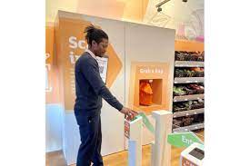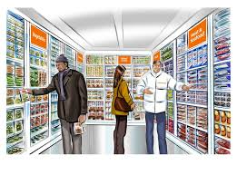
The restrictions imposed by Covid-19 resulted in an increase of 0.8% in the quarterly sales of groceries, as more consumers decided to cook their meals at home. Based on these expectations, the customers are understanding the marketing strategies of Sainsbury and provide their feedback regarding the development of their products (Maston et al., 2021). Sainsbury's said that the number of online orders had fallen from previous highs as more consumers decided to shop in-store. Although clothing sales were up by 57.6 percent, general product sales were down by 1.4 percent from the previous year.

2.2 Data collection & evaluation
In this study, the researcher has elaborated on the business domains and strategies of Sainsbury from a different perspective; therefore, the report has been compiled based on the information gathered from the secondary resources (Harris et al., 2022). The data collection and evaluation process depend on the customer market relationships for Sainsbury's products. In this process, the researcher has collected data from different resources which demonstrate the sustainable solutions and marketing plans of the business industry systematically. According to the research, it is found that customer market relationships can be built with a strong marketing strategy. Since the firm has activities in over a dozen countries, it inevitably faces political system risks of different types (Kritzer et al., 2018).
Companies and their marketing departments may profit from data analytics by obtaining deeper understanding of how they can distinguish themselves in highly saturated sectors. For any brand to succeed in today's crowded marketplace, uniqueness from the competition is essential. Customers have come to expect personalized messages and recommendations, which may be provided with the help of data you collect. The more visitors understand business consumers' requirements and wants, the better prepared company will be to offer them the items and services they are the most likely to buy. These methods may help Sainsbury to manage their working operations in a systematic manner, the data collection can be managed the better business plans.

2.2.1 Customer market relationships
On the basis of the data collected from different resources, it is found that the customer-market relationship is one of the important techniques used for the marketing method. Sainsbury has adopted these approaches to managing its business plans (Guirguis et al., 2019). Relationship management with customers is achieved through Customer relationship management (CRM) frameworks, methods, and practices. CRM software built on the Web and mobile apps enable businesses to learn about their clients' habits and customise their services to what they believe would encourage them to make a purchase or take a specific course of action (Stubbs et al ., 2021). The concept of CRM has been discussed in many arenas, including but not limited to commerce, medicine, science, and the service sector. A revaluation of the front-end viewpoint, in particular the management of client relationships, has been prompted by the increasing use of big data across all industries (Beauchamp et al., 2021). It is found that the CRM is one of the most important techniques which is used by Sainsbury for the purpose of multiple business tasks.
Sainsbury has reduced its supply times and the length of time it takes to deliver new products. Sainsbury provides both a fax and a website for its clients comfort. All of the staff members are competent and professional enough to help the clients. Sainsbury has a strategy for communication that guides the company's information and allows for channels of customer feedback (Guo et al., 2019). Sainsbury provides their personnel with education in interpersonal communication skills so they can effectively present products to customers. Sainsbury promotes and updates clients about upcoming events with the use of booklets. Sainsbury uses large indicators to explain to shoppers how certain items are classified.
While conducting the given research, the researcher understood that Sainsbury is working on the phenomenon of implementing technological solutions for the development of different solutions. In-store employees and customers both will recognize the time savings afforded by the IVR system's effortless integration with the rest of Sainsbury's operations. Concessions including Argos, Habitat, Starbucks, Timpsons, and Lloyds Pharmacy have been added to Sainsbury's in recent years to improve the shopping experience. However, this has increased the number of calls a shop receives and the complexity with which these calls are dealt. Customers had a hard time locating the information they needed, resulting in a loss of around 15% of calls each year for Sainsbury’s (Riley et al., 2020). Sainsbury's has spent a significant amount of money on its new contact centre, and we required a new IVR system so that we could get the most out of it. A comprehensive perspective of product availability is one advantage of driving more consumers to contact centres. If a regular shop doesn't carry a certain item, a contact centre representative can provide information about other locations in the area where the product is sold.

2.3 Segmentation, Pricing Strategies, and Differentiation
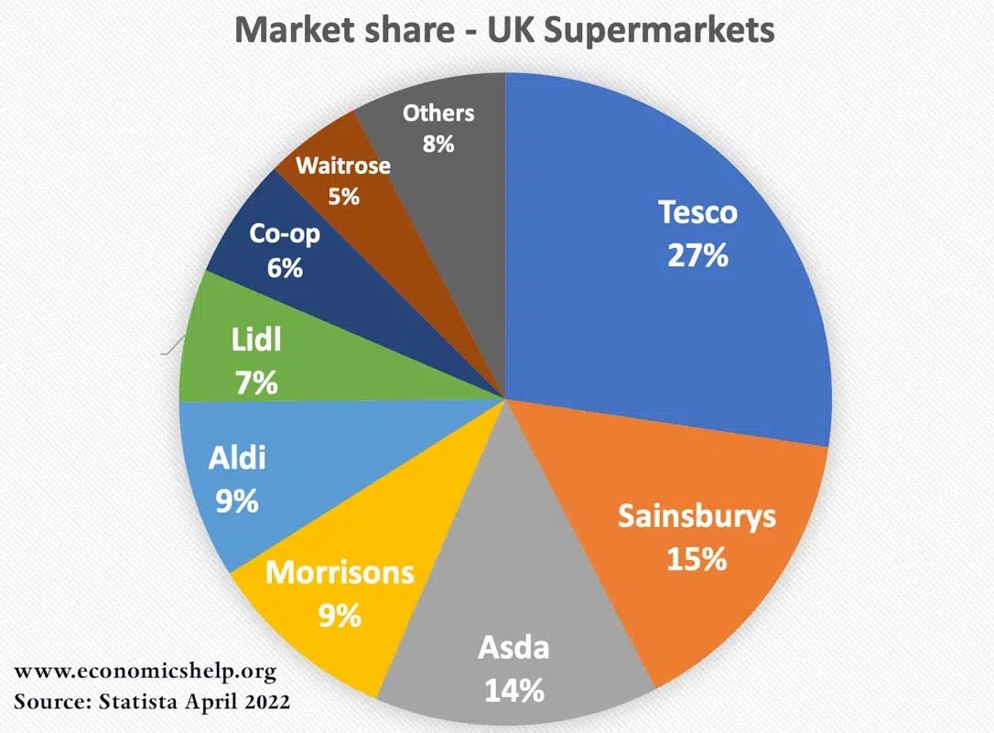
The marketing mix method of Sainsbury targets the 4Ps process such as product, price, place, and promotion. It is observed that Sainsbury is selling a large number of products from multiple platforms. "Great goods and services at reasonable pricing" is what Sainsbury's is known for. It is often recognized that a company's pricing tactics should mirror the goals of its market position. Sainsbury's is attracting people with moderate to high incomes. As a result, many of its products have a higher price tag (Sun et al., 2022). Sainsbury's prices on many basic products, Sainsbury's announced in 2016 that it will no longer be offering the price-cutting Brand Match promotion on staples including bread, cheese, and cleaning supplies. The company similarly participated in a pricing war with its competitors in October 2020 by reducing the prices of 300 of its own-brand items by up to 30% (Hornborg et al., 2019). Customers can do their grocery shopping in any of Sainsbury's supermarkets or outlets, or they can shop with the company entirely online. There are 600 supermarkets and 800 convenience stores under Sainsbury's brand. Over 250,000 orders are placed weekly on its website. For 1.7 million customers in certain areas of London, Sainsbury's introduced same-day delivery within one hour in October 2017. (IGD, 2017). The company's Chop Chop app plan from 2016 continues with this.
Figure : Grocery market industry
Former brand ambassadors for Sainsbury's include Jamie Oliver, David Beckham, and Daniel Sturridge. A £41 million ad campaign starring Jamie Oliver increased sales by £1.12 billion. In addition to serving as the first-ever Paralympic-only sponsor for the London 2012 Games, Sainsbury's also played a significant role in the Olympic Games. The grocery store chain Sainsbury's is no stranger to the power of sales promotion in enhancing product sales. To attract more customers, it often employs sales and discounts. In addition, many consumers like the company's "Nectar reward card" rewards program (Geia et al., 2020). Further, the researcher has elaborated that the Price segmentation strategies are appropriate if an individual operates a restricted product line and can identify groups of opportunities who would buy if the cost was lower or who would be willing to pay a greater price in return for a factor that they felt added value to the product. Prospects on a cost might be engaged by offering the same product in less flashy packaging or charging more for it on the website.
The pricing methods plays an important role for the purpose of managing the product scheme. Sainsbury has adopted the pricing method of the digital loyalty scheme and self-service scanner for their customers. It helps them to purchase their favourite item through the smart technology. The second biggest grocery store chain in the UK, Sainsbury's, has announced that it will begin offering personalised discounts through its Nectar plan. This follows similar focused initiatives by certain U.S. and French food stores.

7p’s model of differentiation
Company may reach customers and close more sales by following the 7 Ps of marketing. Successful businesses of all sizes may benefit from the 7 Ps of marketing. The 7p’s model of the Sainsbury is as follows:
Product
A company's product is its identity and the foundation of its brand's business model. As a supermarket, Sainsbury's naturally stocks a wide selection of items. However, in light of the new segmentation and positioning plan, the company must create a entirely new line of its best-selling products. The plan is to match inexpensive retailers without compromising quality by using a cost strategy with luxury goods.
Price
If the company wishes to fight with the discount stores, it will need to change its present price structure. For this purpose, it would be useful to use a pricing strategy that covers a wide range of prices, from the very low to very high. Because of this, the company's current market position could be improved, enabling it to attract customers.
Promotion
It drives the company's marketing approach. However, in order to reclaim lost market share, the company must gain a foothold in innovative forms of advertising.
Location
The location of the Sainsbury stores are on different places. It determines that the pricing aspect of the Sainsbury products is same; however, it may varies from place to place.
People
Human resources include everyone and anyone who helps create or provide product or service, as well as anybody who interacts with business customers. People is a key component of marketing that many businesses overlook: the people who interact with and represent the brand. The HR managers of the Sainsbury is working for the product quality and marketing methods.
Physical evidence
Service provider and client interactions are greatly impacted by the setting in which they take place. All the buildings, landscaping, cars, furniture, signs, brochures, social media profiles, websites, and equipment are all part of the service's physical proof of the Sainsbury.
Procedures
The term process is used to describe the methodical way in which the service is delivered. Most service providers keep track of the interactions they have with customers in an audit. A customer contact audit may be conceived of as a network diagram of the many contacts between the service provider and their clientele.

2.4 Ethics and Sustainability
The ethical and sustainable plans of Sainsbury determine the trading and sourcing of the products with positive integrity. To ensure long-term sustainability, companies emphasise ethical business practices. Each of their suppliers must follow the guidelines outlined in Sainsbury's Code of Conduct for Ethical Trade, which was developed with input from the Ethical Trading Initiative (ETI) Base Code. The 12 values in the Code include providing a clean and safe workplace as well as competitive remuneration. Sainsbury's requires all of its suppliers to demonstrate compliance with the company's Code of Conduct for Ethical Trading and to demonstrate ongoing efforts to better the lives of their employees (Beauchamp et al., 2021). To manage ethical commerce, suppliers need to have their code of conduct as well as relevant resources, policies, and processes in place. Sainsbury's wants its suppliers to keep close tabs on their performance and provide regular updates. There are mainly two key branches of ethics such as Descriptive and Normative. Descriptive ethics is about motivating social behavior and Normative ethics is about what really matters in determining how we should act.
On the other hand, the sustainable process plans of Sainsbury determine the marketing strategies of the products for the social, environmental, and economic procedures. By increasing the use of renewable energy, they have pledged to bring their carbon emissions down to zero. They will make it simpler for our customers and employees to recycle, and they will also increase the number of recycled materials used in our operations. The sustainable plans and ethical solutions may help the marketing manager of Sainsbury to increase the number of customers.

Tripple bottom line
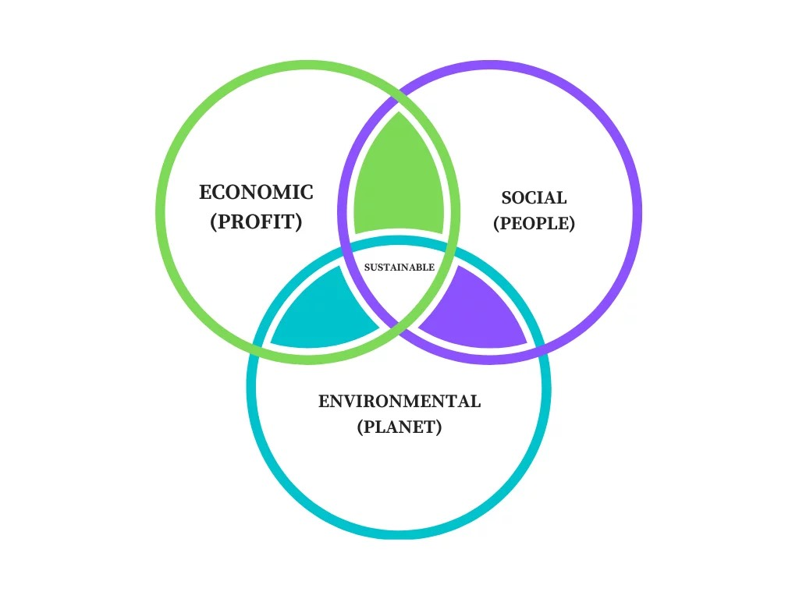
Instead of focusing just on generating profit, or the traditional "bottom line," the triple bottom line business idea suggests that organisations should committed to monitoring their social and environmental impact in addition to their financial success. There are "three Ps" that sum it up this concept: money, people, and the environment. Sainsbury can adopt this idea for the better strategic decisions.
Source : https://www.econposts.com/business-management/07-advantages-of-the-triple-bottom-line/

Profit
The success of the company depends on the financial performance and other kind of the strategic actions. It provides and opportunity to the business managers to increase their profit margins with the better decision making criteria.

People
The social effect and customer service commitment of a company are emphasized in the second part of the triple bottom line. There is a substantial difference between shareholders and other stakeholders. For a long time, companies have used the increase in their share price as a measure of their performance. As businesses have become more environmentally conscious, they have moved their attention to maximising benefits for everyone who stands to gain and lose as a result of their operations.

The planet
It provides a responsibility to the business leaders to work on the sustainable decisions and work on the better decision-making process.

3.0 Conclusion
It is concluded that the CRM techniques/methods can be used to improve the sustainable solutions and systematic approach of the business. During research, it is found that Sainsbury is working on advanced business technologies and marketing its plans with a better CRM system and advanced strategies (Silva et al., 2018). The research demonstrates that Effective teams are formed through relationship management in the workplace, where individuals show mutual respect, are open to new ideas, and work. A company's greatest workers should not be put off by a lack of passion in the workplace. Improving the customer service experience is a CRM's primary goal. If users follow through on this goal, it will almost certainly enhance the company as a whole (Nelms et al., 2022). The success of a customer relationship management system depends on making customer satisfaction the central target.

4.0 Appendices
In recent years, Sainsbury’s has seen the introduction of concessions such as Argos, Habitat, Starbucks, Timpsons, and Lloyds Pharmacy to enhance the in-store experience. But that has added complexity to the types of calls that come into a store, and how these calls are routed. Consequently, Sainsbury's found that it was losing around 15% of customer calls per annum, as customers struggled to find the information they were looking for.
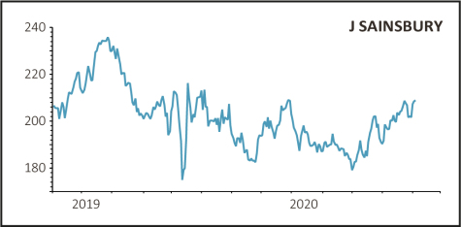
In order to continually optimize the customer experience, Sainsbury’s realized it needed real-time management information (MI) and reporting to gain deeper insight into each customer journey. Sainsbury’s also recognized that its new contact center could handle the majority of the calls coming into its superstores, but its existing, inflexible IVR system was still routing calls to in-store staff.
Source : https://www.sharesmagazine.co.uk/news/shares/sainsburys-slides-on-restructuring-and-covid-costs
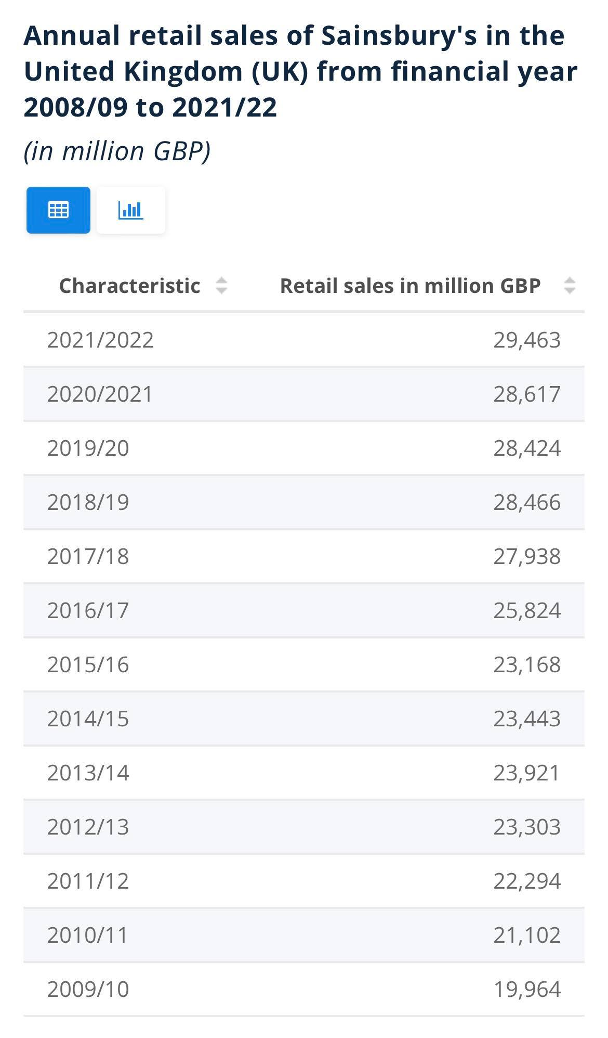
Source : https://www.statista.com/statistics/386342/sainsburys-retail-sales-united-kingdom-uk/

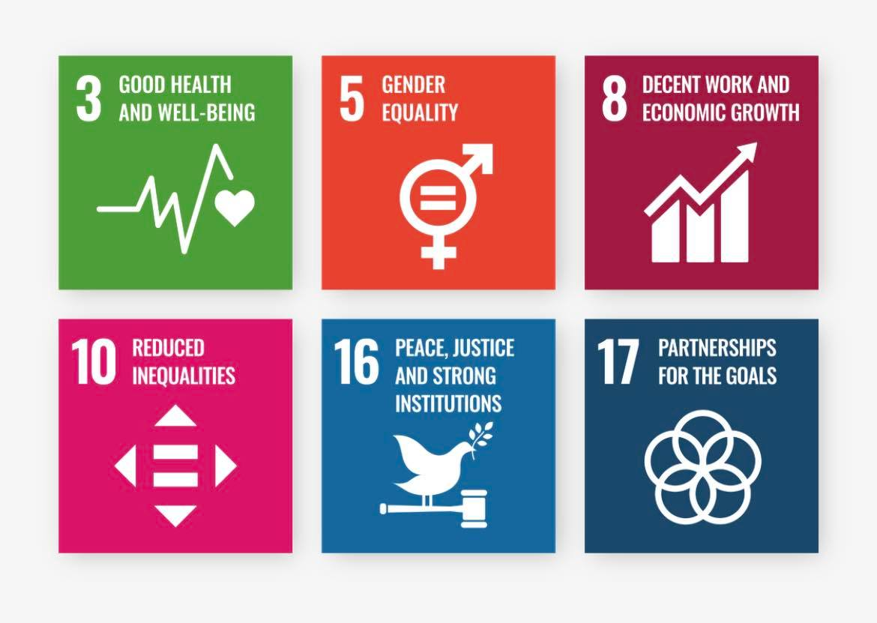
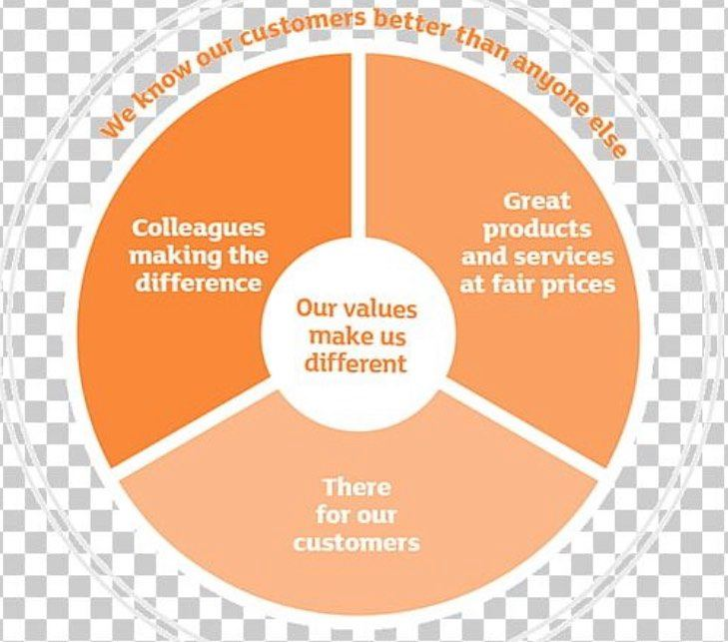
Source: https://www.about.sainsburys.co.uk/sustainability/better-for-everyone/diversity-and-inclusion
Source: https://imgbin.com/png/GmMPnxFh/sainsburys-organization-business-mission-statement-brand-png
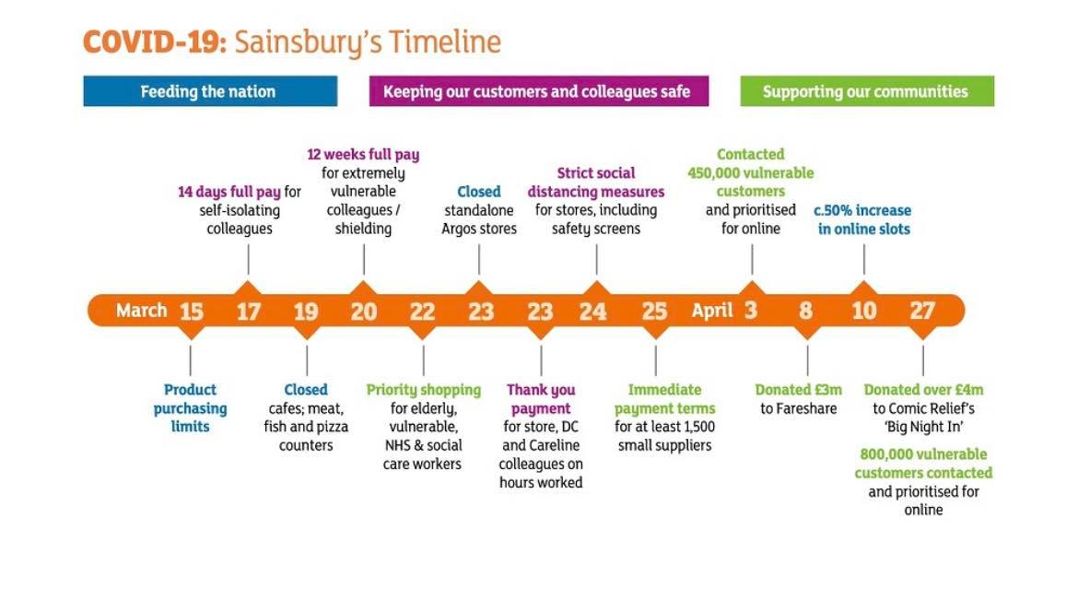
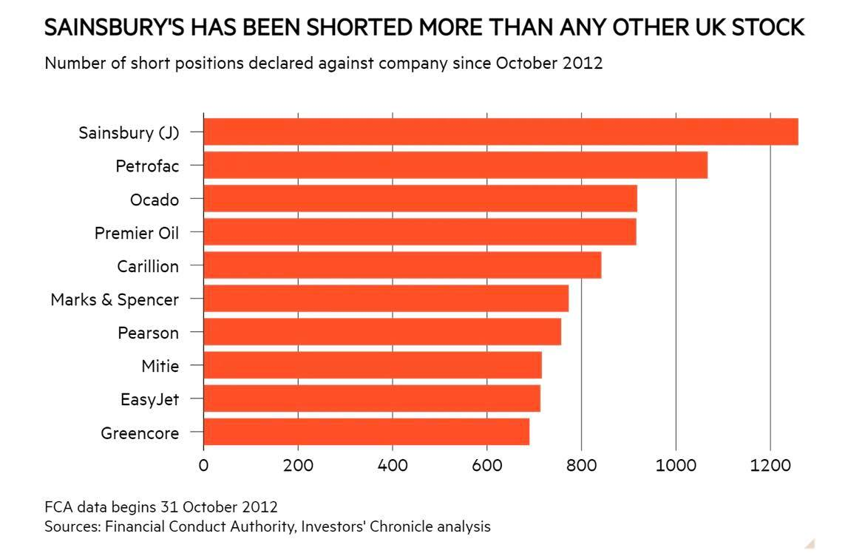
Source : https://www.about.sainsburys.co.uk/news/latest-news/2020/30-04-2020-prelims

5.0 Reference List
Books and Journals:
Amano, T., Berdejo-Espinola, V., Christie, A.P., Willott, K., Akasaka, M., Báldi, A., Berthinussen, A., Bertolino, S., Bladon, A.J., Chen, M. and Choi, C.Y., (2021). Tapping into non-English-language science for the conservation of global biodiversity. PLoS biology, 19(10), p.e3001296.
Beauchamp, E., Sainsbury, N.C., Greene, S. and Chaigneau, T., (2021). Aligning resilience and wellbeing outcomes for locally-led adaptation in Tanzania. Sustainability, 13(16), p.8976.
Geia, L., Baird, K., Bail, K., Barclay, L., Bennett, J., Best, O., Birks, M., Blackley, L., Blackman, R., Bonner, A. and Bryant Ao, R., (2020). A unified call to action from Australian nursing and midwifery leaders: ensuring that Black lives matter. Contemporary Nurse, 56(4), pp.297-308.
Guirguis, M., (2019). How the Product Structure and Distribution Channels Affect the Business Cycle of the UK Life and General Insurance Companies. Available at SSRN 3354631.
Guo, L. and Wang, Z., (2019). Ratio analysis of J Sainsbury plc Financial Performance between 2015 and 2018 in Comparison with Tesco and Morrisons. American Journal of Industrial and Business Management, 9(2), pp.325-341.
Harris, P., Fisher, M., Friel, S., Sainsbury, P., Harris, E., De Leeuw, E. and Baum, F., (2022). City deals and health equity in Sydney, Australia. Health & Place, 73, p.102711.
Hermansyah, A., Sainsbury, E. and Krass, I., (2018). Multiple policy approaches in improving community pharmacy practice: the case in Indonesia. BMC health services research, 18(1), pp.1-14.
Hornborg, S., van Putten, I., Novaglio, C., Fulton, E.A., Blanchard, J.L., Plagányi, É., Bulman, C. and Sainsbury, K., (2019). Ecosystem-based fisheries management requires broader performance indicators for the human dimension. Marine Policy, 108, p.103639.
Kim, J., de Leeuw, E., Harris-Roxas, B. and Sainsbury, P., (2022). Four urban health paradigms: The search for coherence. Cities, 128, p.103806.
Kritzer, J.P., Tang, Y., Chen, Y., Costello, C., Gaichas, S., Nies, T., Peñas, E., Sainsbury, K., Shen, C., Szuwalski, C. and Zhu, W., (2022). Advancing multispecies fishery management in China: Lessons from international experience. Aquaculture and Fisheries.
Maston, G., Franklin, J., Hocking, S., Swinbourne, J., Gibson, A., Manson, E., Sainsbury, A. and Markovic, T., (2021). Dietary adherence and program attrition during a severely energy-restricted diet among people with complex class III obesity: A qualitative exploration. Plos one, 16(6), p.e0253127.
McGreevy, M., Harris, P., Delany-Crowe, T., Fisher, M., Sainsbury, P. and Baum, F., (2019). Can health and health equity be advanced by urban planning strategies designed to advance global competitiveness? Lessons from two Australian case studies. Social science & medicine, 242, p.112594.
Nelms, S.E., Easman, E., Anderson, N., Berg, M., Coates, S., Crosby, A., Eisfeld-Pierantonio, S., Eyles, L., Flux, T., Gilford, E. and Giner, C., (2022). The role of citizen science in addressing plastic pollution: Challenges and opportunities. Environmental Science & Policy, 128, pp.14-23.
Renouf, M.A., Kenway, S.J., Bertram, N., London, G., Todorovic, T., Sainsbury, O., Nice, K., Moravej, M. and Sochacka, B., (2020). Water Sensitive Outcomes for Infill Development: Infill Performance Evaluation Framework. Melbourne, Australia: Cooperative Research Centre for Water Sensitive Cities. CRC for Water Sensitive Cities, 3, p.3.
Riley, E., Sainsbury, P., McManus, P., Colagiuri, R., Viliani, F., Dawson, A., Duncan, E., Stone, Y., Pham, T. and Harris, P., (2020). Including health impacts in environmental impact assessments for three Australian coal-mining projects: A documentary analysis. Health Promotion International, 35(3), pp.449-457.
Rychetnik, L., Sainsbury, P. and Stewart, G., (2018). How Local Health Districts can prepare for the effects of climate change: an adaptation model applied to metropolitan Sydney. Australian Health Review, 43(6), pp.601-610.
Silva, D., Guerreiro, S. and Sousa, P., (2018). Decentralized Enforcement of Business Process Control using Blockchain. In Enterprise Engineering Working Conference (pp. 69-87). Springer, Cham.
Sochacka, B., Kenway, S.J., Bertram, N., London, G., Renouf, M., Sainsbury, O., Surendran, S., Moravej, M., Nice, K., Todorovic, T. and Martin, D., (2021). Water Sensitive Outcomes for Infill Development. Project IRP4.

Stubbs, R.J., Duarte, C., Palmeira, A.L., Sniehotta, F.F., Horgan, G., Larsen, S.C., Marques, M.M., Evans, E.H., Ermes, M., Harjumaa, M. and Turicchi, J., (2021). Evidence-Based Digital Tools for Weight Loss Maintenance: The NoHoW Project. Obesity Facts, 14(3), pp.320-333.
Sun, B. and Sainsbury, A., (2022). Preface: 5th International Conference on e-Education, e-Business and Information Management (EEIM 2022). Journal of Education, Humanities and Social Sciences, 2, pp.I-I.

