12/9/2022
Ana Maria Georgiana Grosu Student Number: 2129789

The challenge faced by Energy Sector: Report
Problem Solving and Decision Making (BMSW4004_CARD)
EXECUTIVE SUMMARY

The challenge faced by the energy sector is caused thru many reasons, many of them being caused by the population as well as the government.
Challenges are now in any business, as well found in any person household, recommendations and help can be asked and made.
A very likely energy crisis in the next two or three decades will be caused by rising global energy consumption, problems with shortage and environmental damage connected with conventional sources, and other factors. The price and scarcity of petroleum will rise, and by that time, the climate repercussions of widespread usage of all fossil fuels will be evident. The usable lives of the current nuclear installations will have expired at the same time. Furthermore, it is unclear if new nuclear facilities will be able to replace them when they are shut down, particularly in Europe.
An essential component of human life is energy. No process, whether it be industrial, agricultural, medical, home, or otherwise, can function without some external energy.

CONTENTS

0.0 EXECUTIVE SUMMARY…………………………………………………………….01
- INTRODUCTION………………………………………………………………………02
- MAIN FINDINGS………………………………………………………………………03
2.1ENERGY SECTOR……………………………………………………………………03
2.1.1 NATURE…………………………………………………………………………….03
2.1.2 SCOPE………………………………………………………………………………04
2.1.3 IMPACT……………………………………………………………………………...04
2.2 SWOT ANALYSIS…………………………………………………………………….05
2.2.1 STRENGHTS………………………………………………………………………..06
2.2.2 WEAKNESSES……………………………………………………………………..06
2.2.3 OPPORTUNITIES…………………………………………………………………..06
2.2.4 THREATS…………………………………………………………………………....06
2.3 PESTLE ANALYSIS…………………………………………………………………..07
3.0 CONCLUSION…………………………………………………………………………07
4.0 RECOMMENDATIONS/OPTIONS …………………………………………………08
5.0 PLANNING, MONITORING AND REVIEWING THE SOLUTION……………….09
6.0 APPENDICES…………………………………………………………………………10
7.0 REFERENCE LIST……………………………………………………………………12

- INTRODUCTION.

The purpose of this report is to provide an analysis of the current problem faced by the energy sector and economic sector as well, this report will be provided by analytical tools such as a SWOT Analysis and PESTLE Analysis that will gather all the information together, this report will include a conclusion and recommendations as well.
This report is about all the persons, companies and businesses affected by the lack of the energy in the last two years as well as the scope, nature, problem and finding solutions regarding this problem, adding some solution and recommendations by the end of the assessment.

2.0 MAIN FINDINGS

2.1 IMPACT IN ENERGY SECTOR

In the past two years the energy sector was heavily affected by many factors like Brexit, Covid and Ukrainian War that is happening in the past six months.
The main factors that are affecting the energy sector now are Covid, Brexit, War, Economy, Suppliers, Production as well the lack of people in workplaces.

2.1.1 NATURE OF THE PROBLEM

The nature of the problem is starting from all the factors submitted above.
First factor is Covid, many things changed in the past three years since Covid, a lot of persons they were forced to work from home, many of them lost their job and a lot of them had to give up to their job just to go to stay with their families that they were sick.
Brexit is another reason that is worrying people now, a lot of persons had to leave the country, visa is now requested to work and to stay more than six months in this country, lorry drivers that they do transport resources need a visa to enter in this country and this is affecting everybody now.
Ukrainian war is another problem, many immigrants are leaving their country to find a safe place, a lot of energy resources they were coming from that side of the country and now is a lack of supply’s.
There are a lot of persons now without a job, many of them are waiting for government help, also there are a lot of persons that wish to work, and they do not have the possibilities to do so.
An article from BBC (2022) says that the price of the natural gas increased almost five-fold since the summer of 2020, also The International Energy Authority says that Russia invading Ukraine in February is the main factor behind this.

    - SCOPE OF THE PROBLEM

The scope in this situation is reflecting about all the main factors from above, raising the price of energy will go in a lack of supplies, as well as the persons will need to save energy, a lot of persons are struggling with paying the mortgage of the house, rent as well as the bills for surviving.
House mortgage went up almost with 2.5 than last year, a lot of persons are selling their houses because they cannot afford to pay.
Based on an article from 18 November 2018 from Nationwide says that Bank of England increases base rate, on 3 November 2022, the bank of England increased 0.75% from a rate 2.25% to 3%.
Reflecting on 5 WHY’S THEORY 1930, the root may come from different situations, one of the problems that affect the scope is people not saving energy, as well as the government requested people to pay more taxes than usual.
Main scope is reducing the energy, everybody needs to focus on saving the energy, energy crisis badly affects the education, all the buildings occupied by the student are requiring electricity.
Extremely high price of petrol and diesel is a problem for everybody that drives a car, as well as the persons who does not like people who use bus, taxis.

    - IMPACT OF THE PROBLEM

The impact of the problem is everywhere, every single person, building, car, bus, or train.
Electricity and gas bills increased in an unaffordable way for everybody, the number of unemployed people went high and as well as the taxes.
The increase in the cost of petrol and diesel is affecting everybody.
Covid has affected most of the population, furlough was a new option for the persons who could not work because of the pandemic, as well as a lot of options for work, new jobs for NHS were available in the last three years, many covid testing spaces appeared in the past years.
Ishikawa Diagram (1943) showed in the figure below shows the main problem and impacts in energy sector with many details about the subject.

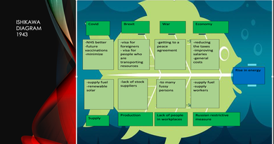

APPENDICES 1.

Strengths | Weaknesses
-investment in renewable  -efficient technologies  -increase in energy providers  -drive price down | -lack of renewable energy  -low income causes government  -costs of goods gone up  -rising cost of electrical grids
Opportunities | Threats
-NEW prime minister  -low carbon emissions (look at alternatives)  -government increasing tax inceptives  -helping households | -energy crisis  -war  -cost of living  -redundancy  -uncertainty + volatility
  - SWOT ANALYSIS

APPENDICES 2.
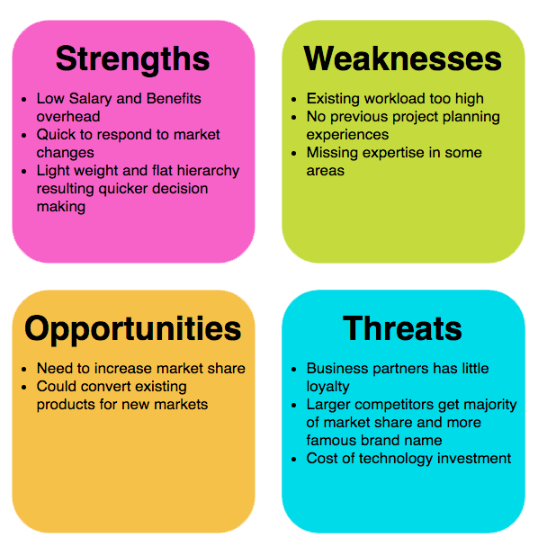

APPENDICES 3.

According to Visual Paradigm a Swot Analysis is a technique developed at Stanford in the 1970, mostly used in strategic planning.
As well it is a process where the management team identifies the internal and external factors that will affect the company’s future performance.

2.2.1 STRENGHTS

Like shown in the table above, some strengths in this subject are investment in renewable that is important for many of the organisations.
Efficient technologies are something that world can say that is really provided, increased in energy providers can be a strength because it provides improvement in this sector.

    - WEAKNESSES

As weaknesses, lack of renewable energy, low income caused by government, all the costs of good gone up and rising cost of electrical grids.

    - OPPORTUNITIES

Opportunities are important that is why in this subject new prime minister is one of them, a new point of view, new ideas.
Low carbon emissions, the government increasing tax incentives and helping the households with support.

    - THREATS
As threats the energy crisis is the main one, war is not helping this subject at all as the cost of living, redundancy, and uncertainty.

  - PESTLE ANALYSIS

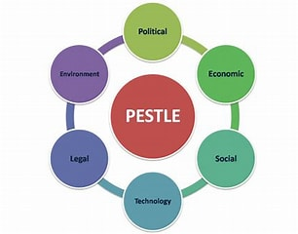 APPENDICES 4.

Like shown in the picture above Pestle is coming from:

P- POLITICAL
E-ECONOMIC
S-SOCIAL
T-TECHNLOGY
L-LEGAL
E-ENVIROMENTAL

Pestle Analysis is a concept in marketing principles according to Pestle Analysis.com.

Political, Economic, Socio-Cultural, and Technological (PEST) analysis is a business analysis term that refers to a framework of macro-environmental aspects utilised in the environmental scanning part of strategic management. When doing a strategic analysis or market analysis, it is a component of a various external study and provides a summary of the many macro-environmental aspects to be considered. It is a tactical instrument for determining market expansion or contraction, company position, potential, and operational direction.

From the political point of view BREXIT is the first factor, Tax Structure is changing a lot in the past two years, and it is still changing, Stability of Government in Far East,
Economic- Stability of Markets- Growth or Decline, Government and EU subsidy, Strong Pound, Price of Components, all of those are making are taking part from this factor.

From the Social point of view Unemployment, it is on a high level now, High level skills and qualification lost, many skills are not required as a lot of jobs are not requiring experience now.
Possible different demographic and social mobility profile in Far East to UK, Local jobs for local people.

From Technological point of view new products entering the market at lower cost it is an opportunity, Shortage of materials- computer chips, change to ‘robot’ technology to undertake production.

Legislation- Different laws, regulations in UK/Europe/Far East, many laws are changing every single year.

From an Environmental point of view all the persons need to comply with environment policies of UK/EU/Far East, Consumers want information on how ‘environmentally’ friendly products are, Consumers want organisations to be ‘Socially Responsible’ in the way they conduct their business- How they treat their employees, where they source their materials from.

3.0 CONCLUSION

In conclusion al the ideas presented in this report are based on the same ideas, saving energy needs to be present in everybody’s life now, taxes and bills process will increase every year and a lot of persons will struggle with paying all these as well as asking for support from government.

4.0 RECOMMENDATIONS AND OPTIONS

There are a lot of options and recommendations based on this subject.
First one is decreasing the price of petrol, petrol is affecting a lot of drivers as well as the rest of non-drivers, bus and train prices went high just because of the price of petrol.
Decreasing the taxes level should be a good idea or increase the salaries just to make a balance between those two.
Another idea is that the government should help all the persons, maybe giving more chances to work for the persons who cannot work as well as the persons that are waiting for help without wanting to work.
Other solutions for saving energy are:
Installing energy-efficient light bulbs can help any households as well as turning off lights when you leave a room.
Utilize natural light by opening curtains during the day can save a lot of energy, unplug unused chargers and appliances.
Investing in energy-efficient appliances, using your microwave to reduce cooking time and setting your thermostats at an optimal level.

5.0 PLANNING, MONITORING AND REVIEWING THE SOLUTION

Gannt Charts (1910) is a way of planning, scheduling, and reviewing activities, is a type of bar chart that illustrates a project schedule.
This chart helps visualizing the project and helps analyse and to ensure that is working.
The process of confirming that all your server hardware satisfies or exceeds the operational requirements of your solution is known as solution planning. Create a solution plan to make sure your system satisfies your needs before installing the hardware, software, and other equipment required to run your hardware solution. It is possible to plan for workloads, capacity, and performance using the System Planning Tool (SPT).
Planning is the first step in finding a solution, checking, or monitoring the solution will be the second and the last one is reviewing or checking the solution.
By offering support and knowledge, they guarantee you a solution that fuels the business process and operates at a reasonable cost. Monitoring is defined as the periodic oversight of a process so that timely action can be done to address the shortcomings found.

6.0 APPENDICES

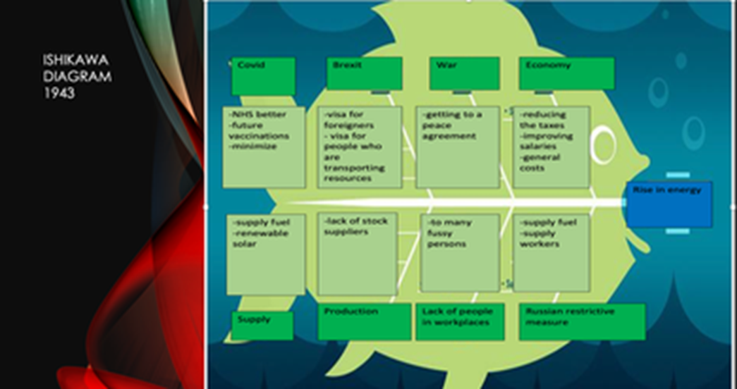

APPENDICES 1.

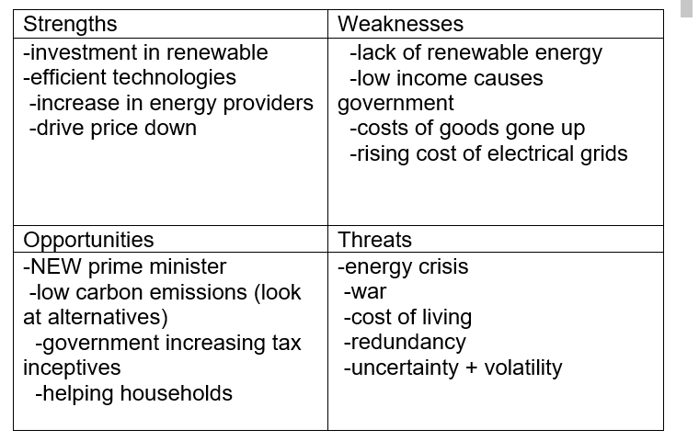
APPENDICES 2.

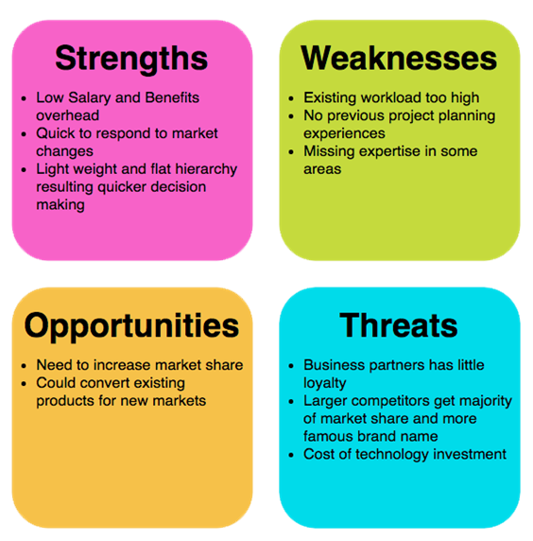

APPENDICES 3.

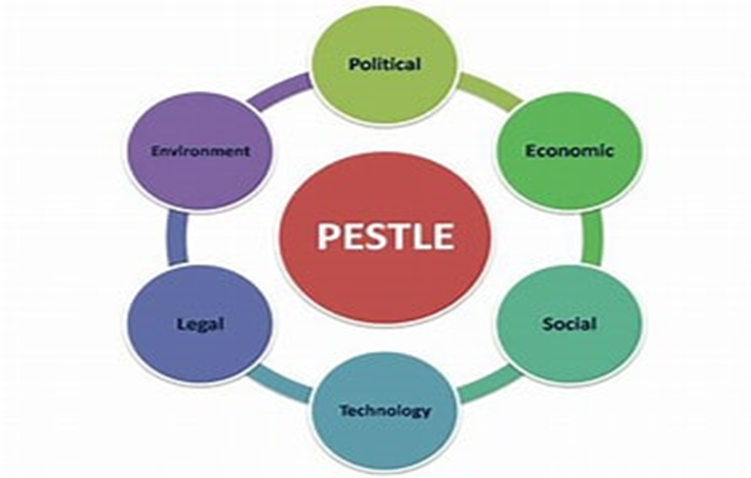

APPENDICES 4.

7.0 REFERENCE LIST

- Ally Weeks. (2022). PESTLE. [Online]. CIPDGo. Last Updated: 20. Available at: https://www.cipd.asia/knowledge/factsheets/pestle-analysis#:~:text=A%20PESTLE%20analysis%20is%20a%20 [Accessed 29 November 2022].

- ASQ EXCELENCE. (2021). What is a fishbone diagram. [Online]. Asq. Last Updated: 20 September. Available at: https://asq.org/quality-resources/fishbone [Accessed 18 October 2022].

- BBC. (2021). Why are global gas prices so high?. [Online]. BBC. Last Updated: 26 AUGUST. Available at: https://www.bbc.co.uk/news/explainers-62644537 [Accessed 29 November 2022].

- consuunt. (2021). What is the Ishikawa Fishbone Diagram?. [Online]. consuunt. Last Updated: 20 September. Available at: https://www.consuunt.com/ishikawa-fishbone-diagram/ [Accessed 29 November 2022].

- https://timera-energy.com. (2020). Eye of the storm. [Online]. https://timera-energy.com/. Last Updated: 2020. Available at: https://timera-energy.com/ [Accessed 18 October 2022].

- Ishikawa Fish Bone. (1943). What is Ishikawa Fishbone. [Online]. techtarget. Last Updated: 2021. Available at: https://www.techtarget.com/whatis/definition/fishbone-diagram [Accessed 18 October 2022].

- KANBANIZE. (2022). 5 Whys: The Ultimate Root Cause Analysis Tool. [Online]. KANBANIZE. Available at: https://kanbanize.com/lean-management/improvement/5-whys-analysis-tool [Accessed 29 November 2022].

- Kyle Peterdy. (2022). SWOT Analysis. [Online]. CFI. Last Updated: Updated November 26. Available at: https://corporatefinanceinstitute.com/resources/management/swot-analysis/ [Accessed 29 November 2022].

- Nationwide. (2022). Bank of England increases base rate. [Online]. Nationwide. Last Updated: 8 November. Available at: https://www.nationwide-intermediary.co.uk/news/other/base-rate-increase-november [Accessed 29 November 2022].

- TEAMGAANT. (2022). What Is a Gantt Chart? How to Use Gantt Charts in Project Management. [Online]. TEAMGAANT. Last Updated: 21. Available at: https://www.teamgantt.com/what-is-a-gantt-chart [Accessed 29 November 2022]

