Ryan Jones (2009252)
2009252@student.uwtsd.ac.uk
Assignment 2: Project Managment

Changemackers: Creativity and value creation
ACCA5033

Table of Contents
Introduction 1
E Portfolio Link 1
Screenshot Assignment 2 2
Screenshot Task1: What’s the Verdict? 3
Screenshot Task2: Project Management 4
Screenshot Task3: Project Reflection 5
References 6

Introduction
In today's technical world, mobile applications have become an integral part of our daily lives, from ordering food to monitoring our health, mobile apps serve a multitude of purposes and have revolutionized the way we interact with technology. The booming demand for mobile apps has led to a surge in mobile app development projects, making efficient project management more critical than ever. This project delves into the world of learning TaeKwon-Do via mobile app, this project will highlight its significance, challenges, and key principles to help the student to learn

E Portfolio Link

Link to Portfolio

Screenshot Assignment 2

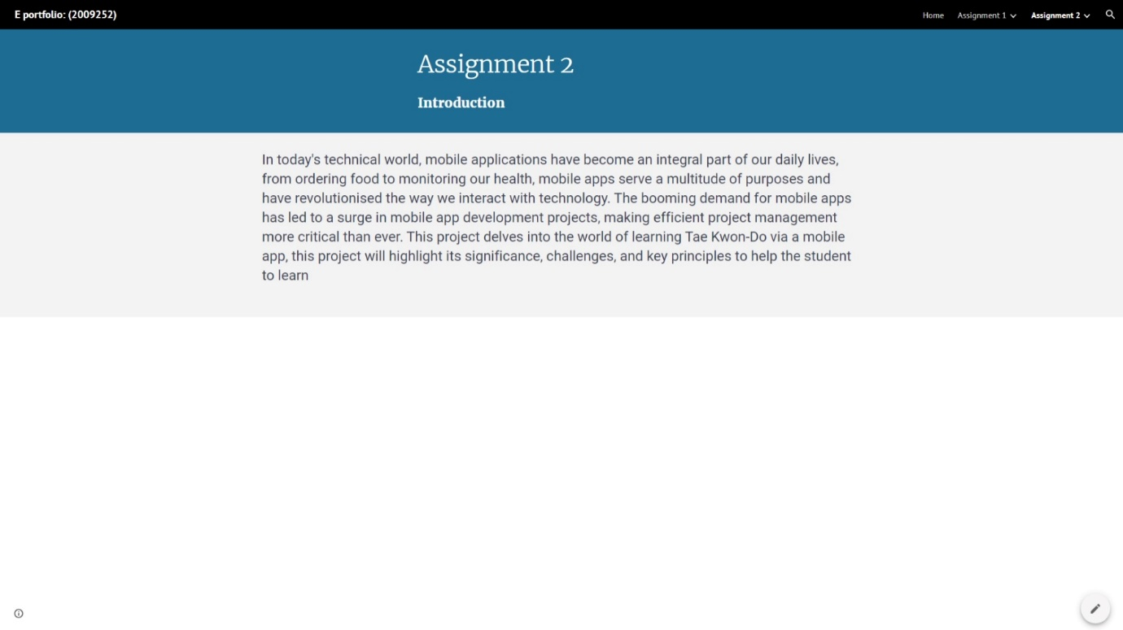

Screenshot Task1: What’s the Verdict?
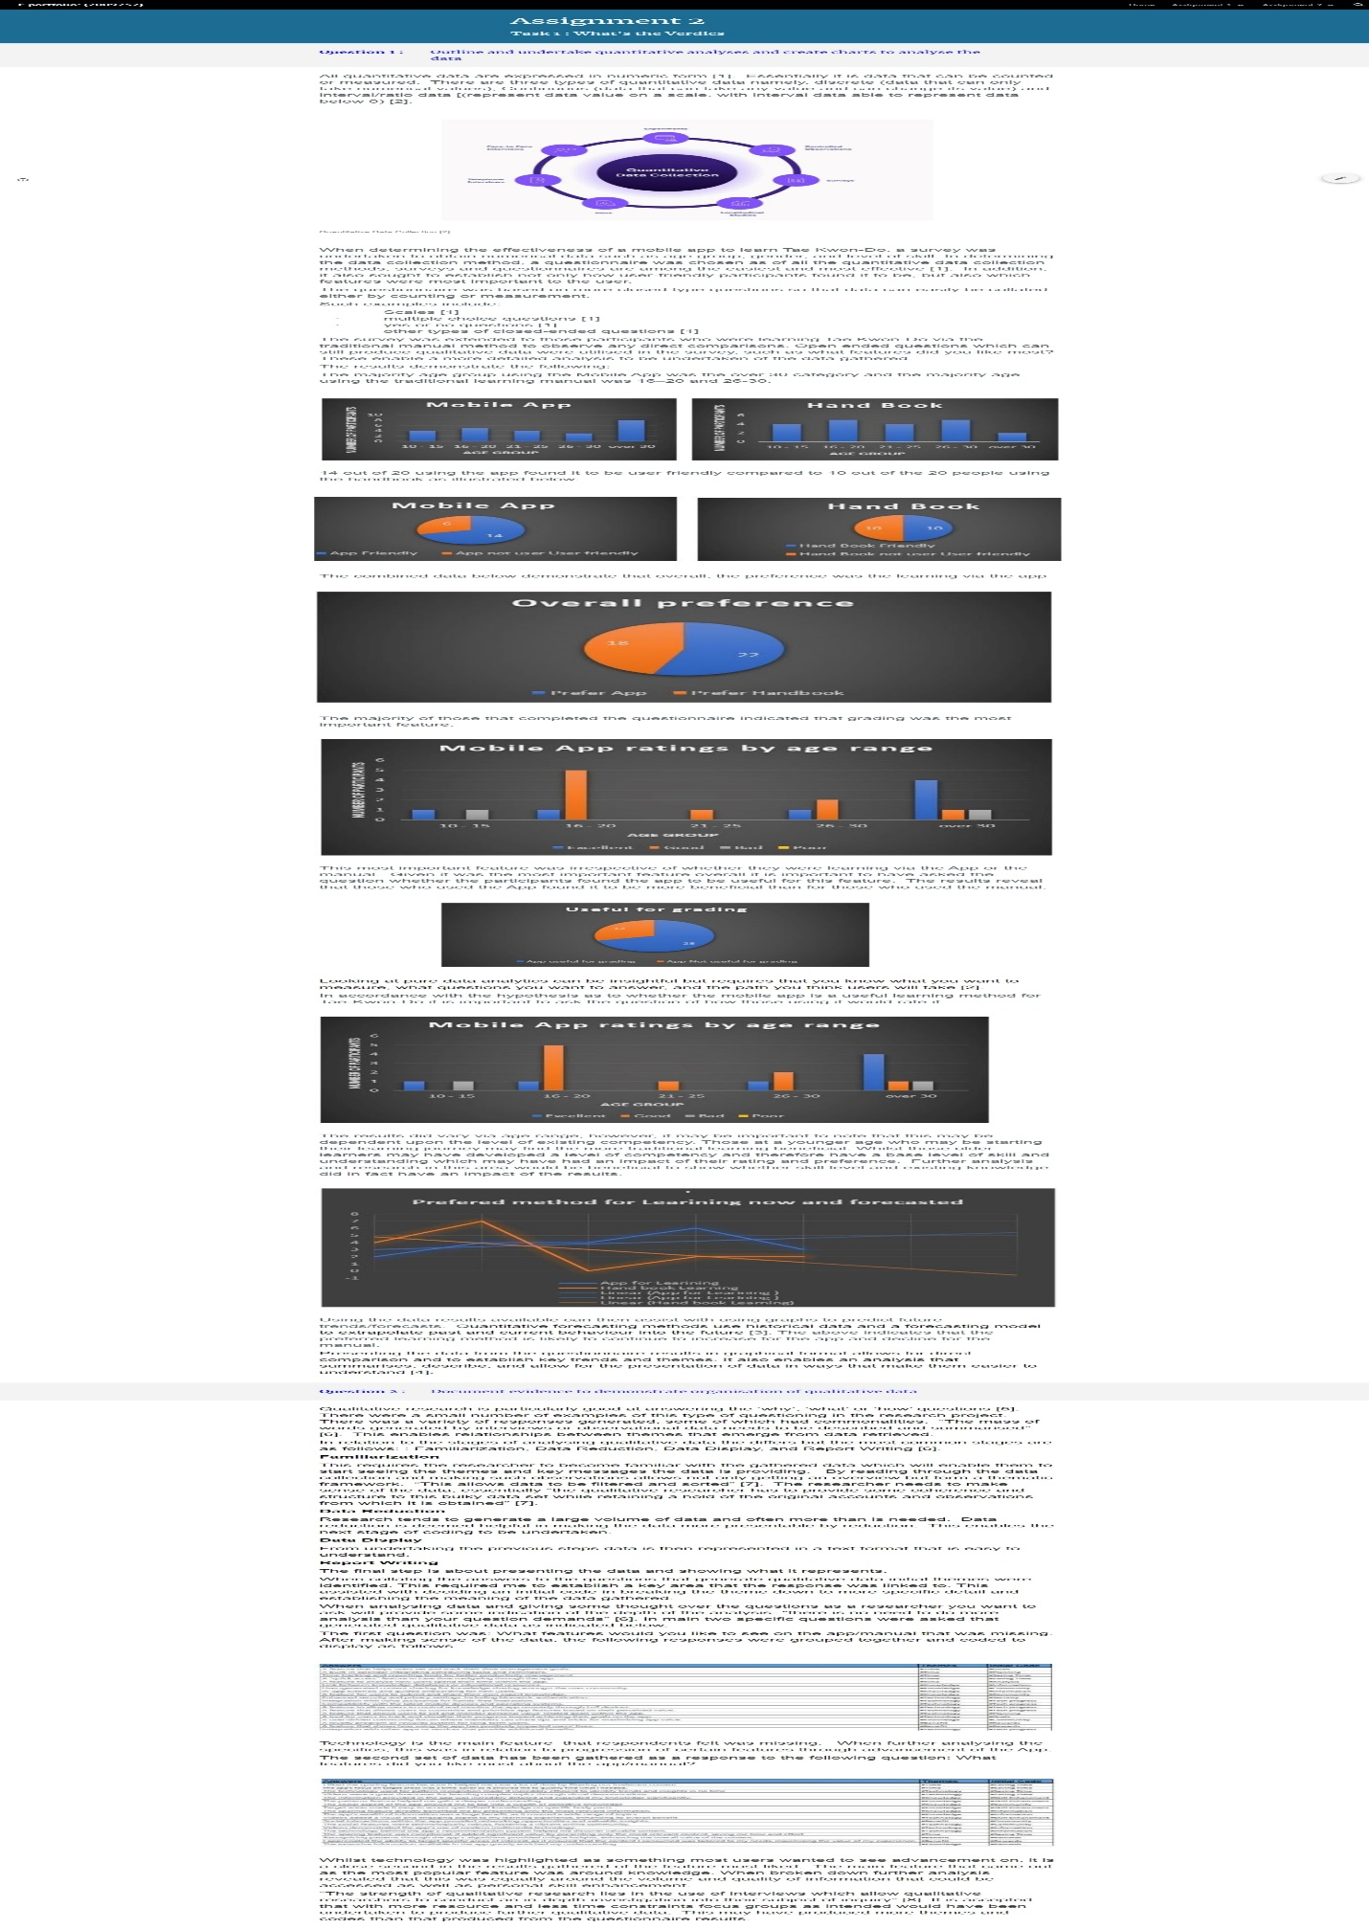

Screenshot Task2: Project Management

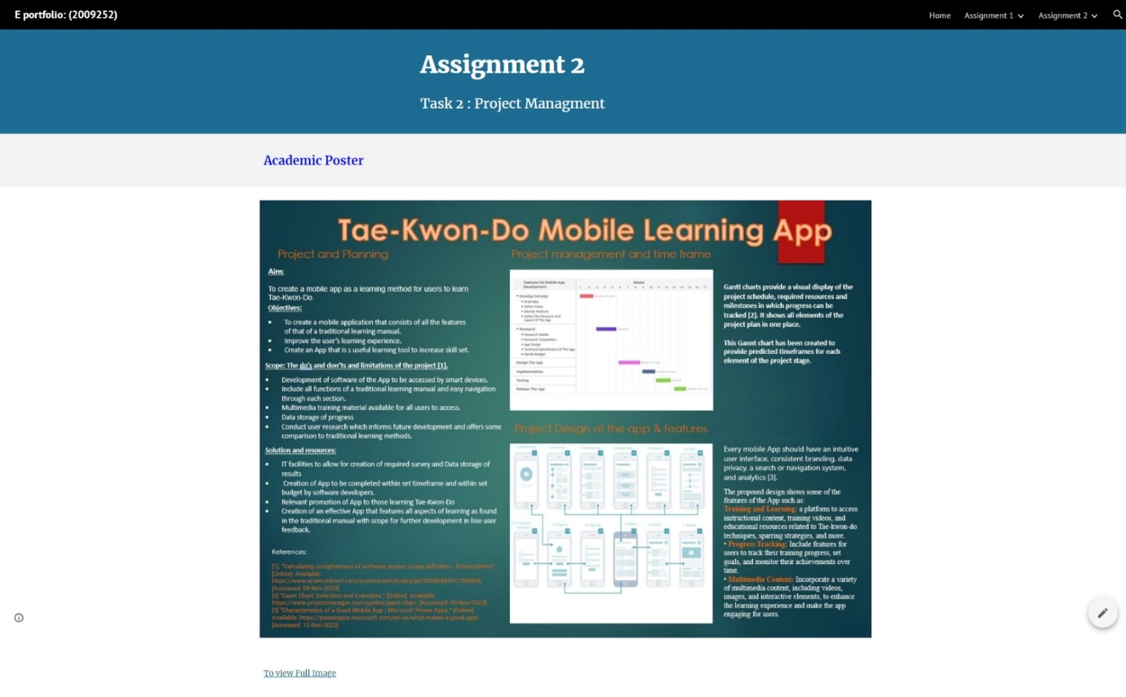

Screenshot Task3: Project Reflection

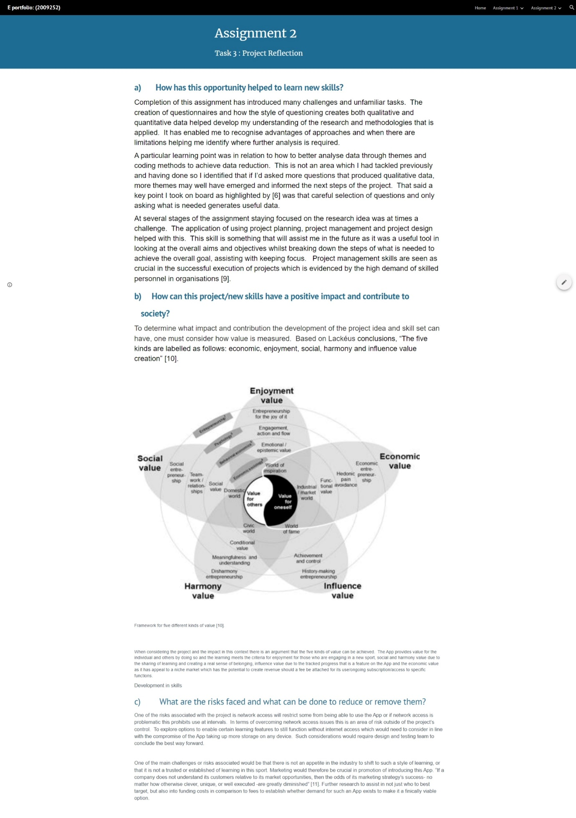

References



