TOURISM AND HOSPITALITY MANAGEMENT
BMIH6005
ORGANISATIONAL CONSULTANCY
CONSULTANCY REPORT
STUDENT NAME: IULIANA IONESCU
STUDENT ID: 2226406
CHOSEN COMPANY: CRYSTALBROOK KINGSLEY

‘’ I confirm that I have not used any AI tools in the research and creation of this assignment. I confirm that I have not presented any AI generated materials as my own work. I confirm I have copies of my drafts, notes , and other resources I used, which I may be asked to provide in evidence’’
Table of Contents
Executive Summary 3
1. Introduction 6
2. Analysis 9
2.1. Issue of the Hotel 9
2.2. STEEPLED Analysis 10
2.3. SOAR Analysis 13
2.4. TOWS Matrix 17
3. Recommendations and Change Management 21
3.1. Recommendation 21
3.2. Change Management 23
3.3. Measuring Impacts and Success Rates 29
3.4. Potential Benefits to the Hotel 30
3.5. Cost Analysis of Recommendations 31
4. Action Plan 32
5. Conclusion 35
References 37

Executive Summary
Issues
Crystalbrook Kingsley, which is a historical and prestigious hotel in New Castle, Australia and the organisation now faces the problem of incorporating sustainability into the company's processes. The hotel enjoys an excellent image and reputation for service and is considered a chronicler of important events in the country and the world, it cannot today escape challenges related to the environment, society, and its finances. The awareness of sustainability among the operators of establishments in the hospitality sector has become a reality that poses the need for Crystalbrook Kingsley to conform to but not surrender its luxury quotient. An elaborated analysis by the TBL model underpins the urgent call for action in terms of Planet, People, and Profit.
Findings
The social responsibilities highlighted at Crystalbrook Kingsley are large, attributed to its high energy and water use, waste production, and depend on non-renewable resources. Most notably, the absence of contemporary basic services and conservation technologies increases its carbon impact and distorts its green image. The lack of sufficient integration of social impacts into Crystalbrook Kingsley а stains its reputation for being a responsible and progressive company. More and more visitors demand ecological approaches implemented during their stay, including limiting waste products' usage, obtaining ingredients from local farmers, and applying waste management techniques. Any failure to effectively communicate or even implement such an initiative risks depriving a business of its customers and subsequent loss of customer faith. Besides, passive participation of the employees in carrying out the organisational sustainability initiatives may result in disengagement, which is unproductive in creating a sustainable organisational culture.
From the economic dimension, sustainability implies a twofold problem; first, there is a need for the accumulation of capital, while in the long term, it is cost-effective. Installing energy efficient systems, training employees, and acquiring sustainable materials cost a lot of money. Nevertheless, inertia could prove disastrous because environmentally sensitive tourists prefer green hotels. Also, costs related to operations, such as the high costs of energy and penalties from authorities for failure to implement sustainable measures, would reduce profitability.
Analysis
The analysis presented through the STEEPLED framework revealed the following external factors influencing sustainability at Crystalbrook Kingsley. Concerning the social front, there is pressure for ‘green’ from environmentally conscious tourists, while on the technical front, there is potential for increasing operational efficiency through energy efficiency technologies such as energy-efficient systems. The TOWS analysis builds up on internal and external factors in developing strategies. Areas of strength are Crystalbrook Kingsley's luxury image and location; therefore, to counterbalance low effectiveness, other large visible activities, such as guest-friendly, should be launched while addressing low cost (Crystalbrook Kingsley's weakness) through financial support from the authorities. By using the SOAR Model, Crystalbrook Kingsley can be identified as a leader in sustainable luxury since its brand image and good services can be utilised as superior catalysts for the goal. Promising areas that may aid the improvement of its public image include issues to do with green certifications, and guest engagement programs that have the potential of yielding tangible benefits such as low cost and high guest satisfaction.
Recommendations
Training and engagement of the employees are always of equal importance. Implementing both frequent workshops and a "Green Champions" program will help to have the staff engage with and take an active role in sustainability. Therefore, promoting environmental responsibility as an organisational culture will assist Crystalbrook Kingsley to realise that the workforce can be leveraged as the source of change. All the linens, furniture, food, and any products can be bought locally from organic suppliers to make it easier, which will also help the image of the hotel as being environmentally friendly. Additional opportunities for diversification of guest leisure can be developed through cooperation with organisations related to the sphere of ecotourism, providing services connected with the popularisation of environmental knowledge.
Customer-oriented sustainability initiatives will also be the centre stage. For example, in Hilton Worldwide’s new guest reward, labelled "Green Guest Rewards", guests are encouraged through positive reinforcement to save the environment by reusing their towels as well as participate in a voluntary carbon offsetting program. Disposable amenities must be changed to dispensers and guests should be offered reusable bottles as well as reusable bags. Guests can be educated throughout Crystalbrook Kingsley's digital displays and in-room programs regarding Crystalbrook Kingsley's sustainability policies and the part guests themselves can play in protecting the environment. Most of these measures will go a long way in improving the satisfaction of the guests while promoting an environmentally friendly practice among travellers.
Conclusion
Overall, systematic change at Crystalbrook Kingsley Hotel could well spearhead sustainable luxury hotel business development by responding to environmental, societal and economic perturbations. By integrating several modern tendencies of sustainable development with the desire to maintain the historical atmosphere of the hotel's premises, it will be possible to define the new, focused position within a competitive and constantly changing industry. Based on these strategies, Crystalbrook Kingsley should be able to realise sustainable costs, improve the competency of its brand image, and increase guest satisfaction. As sustainable development takes its place among fundamental values of extravagance tourism, Crystalbrook Kingsley is likely a perfect candidate to create a new vision in the framework of environmentally friendly luxury, which will pave the way for future generations.

1. Introduction
Crystalbrook Kingsley is a luxury hotel with high standards for both people on business and people who are here for leisure (Crystalbrook Collection, 2025a). Crystalbrook Kingsley is in Newcastle, Australia. The contemporary design meets with its high level of services, spacious and stylish rooms, as well as a range of high-end amenities. It aims to be a sustainable and environmentally friendly place, focused on sustainability and offering top-grade service. Crystalbrook Kingsley is one of Crystalbrook Collection's collections, characterised by eco-friendly practices. Also, the hotel provides sophisticated dining options, wellness facilities as well as an excellent location for people visiting the region. Crystalbrook Kingsley’s sustainability challenges are to reduce environmental impact while maintaining luxury service standards.
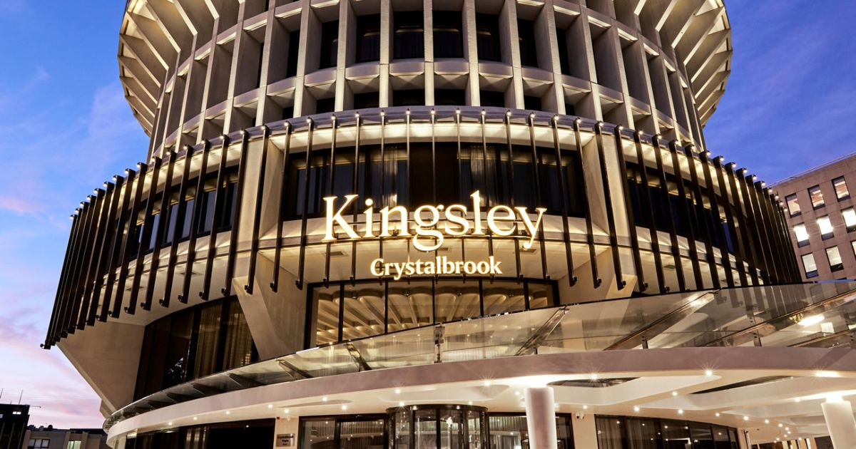
Figure 1: Crystalbrook Kingsley
Source: (Crystalbrook Collection, 2025a)
Crystalbrook aligns with #ResponsibleLuxury; the company further reduce greenhouse gas emissions, improves energy efficiency, undertakes zero waste projects in larger parts of its properties, and advances its conservation of ecosystems with a view to becoming an EarthCheck Certified Operator (Will TCD, 2022). The hotel’s luxury experience needs to be accompanied by efforts to reduce waste and incorporate energy efficient technologies. Finally, in a market that is fierce, it continues to be difficult to source sustainable food and materials. Furthermore, the hotel must also engage with the carbon footprint of its operations, particularly as it is in such a central position in such a central city as Newcastle. It remains important for Crystalbrook Kingsley to find the right balance between eco-centric practices and serving high-end guests.
Despite its illustrious history and global acclaim, Crystalbrook Kingsley faces a significant contemporary challenge, which is that the management has brought sustainability into practice in the firm. Therefore, sustainability has taken a significant leap over time when signing on to be more of a trend within the modern hospitality industry but rather a business necessity (Pereira, Silva and Dias, 2021). Consumers and clients demand environmentally friendly policies and standards which are in line with global sustainable development (Sourvinou and Filimonau, 2018). For a heritage hotel like Crystalbrook Kingsley, this really sets up an expectation that has its challenges. Large capital investments, long service delivery turnaround, and significant heritage make the upgrading of the physical structures challenging, as the charm of the place must never be lost.
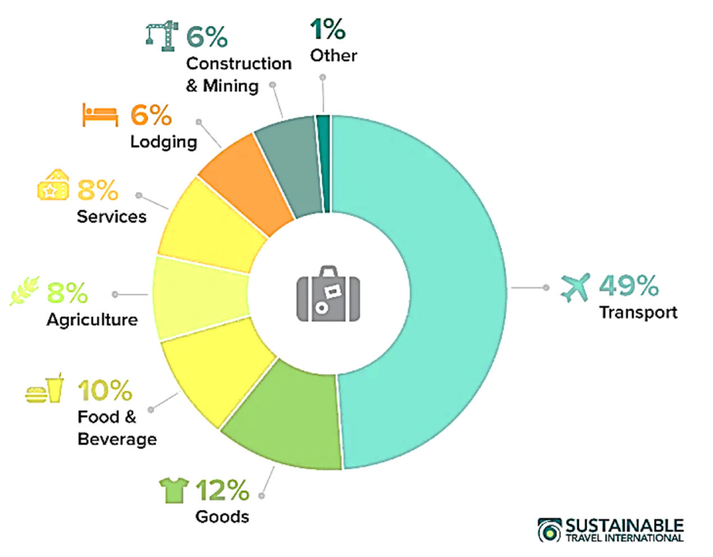
Figure 2: Sustainable activities of the hotel
Source: (Simões, Soares and Santos, 2023)
In terms of sustainable issues, there are several operations at Crystalbrook Kingsley. These are energy, waste, water and procurement, where a company must ensure that all resources it uses for its operations are sustainable (Veiga et al., 2018). Furthermore, the staff's awareness of sustainably as well as guests, and making them aware of sustainable issues and implementing sustainable practices which do not taste the luxury experience but rather add to the difficulty. It is a complex problem in which it is possible to find economic and social gains that would fulfil the demands of environmentalists without neglecting other stakeholders of the hotel industry, such as guests or historic building owners (Athwal et al., 2019).
Solving these issues requires the assistance of a professional consultancy company aiming at providing the customer with an extensive knowledge of sustainable development in the sphere of hospitality. At consultancy firms, they focus on offering issue and change management services for organisations affected by multifaceted sustainability changes. Experience in the hospitality industry allows me to work with clients and introduce the principles of sustainable development into the work successfully. It is based on a detailed analysis of the best practices, newly developed concepts and practical recommendations corresponding to the specifics of the clients (Marinakou and Giousmpasoglou, 2019).
Using this report to assess Crystalbrook Kingsley's sustainability issues, the following concepts will be utilised: The structure of the TBL will act as a theoretical framework that will facilitate an assessment of the hotel's performance in environmental, social and economic aspects. According to the TBL framework, all these three dimensions must be integrated to attain sustainable organisational success (Shim et al., 2021). Moreover, Kotter's Eight Step Change Model has been used to derive an effective plan that will be used in implementing sustainability initiatives. It stresses how best to develop insistence, coalition, and installation techniques, which are key successful components in instituting change on an enduring basis within an organisation (Kang et al., 2022).
Moreover, the report will integrate stakeholder theory for weighing on various concerns of the stakeholders of Crystalbrook Kingsley such as the guests, Workers, Investors, and society. From this theory, it is very clear that sustainability must incorporate the aim of stakeholders in each firm to be sustainable in the future. A sustainability strategy will also be adopted to ensure there is a systematic way of applying ecological concepts in management and organisational activities. Through a synthesis of these frameworks, the analysis will present a systemic perspective on the issues underpinning sustainability at Crystalbrook Kingsley.

2. Analysis

2.1. Issue of the Hotel
Crystalbrook Kingsley Hotel, a landmark in London, faces challenges in embedding sustainability into its daily operations. These challenges impact the hotel’s operations, reputation, and financial performance, highlighting issues across the Triple Bottom Line (TBL) framework: People, Planet, and Profit.
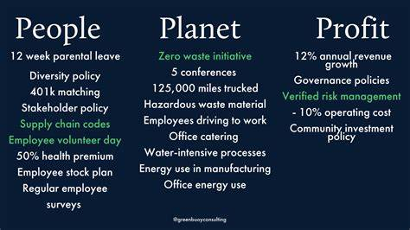
Figure 3: Example of Triple Bottom Line
Source: (Erskine, 2024)
Environmental Impact (Planet): The hospitality industry is marked by a high level of utilisation of resources in terms of energy and waste. Sustainability problems for Crystalbrook Kingsley may be ineffective utility usage, poor recycling system, and usage of material in their products that can barely be replenished. Some of these lead to the degradation of the environment, hence defeating the purpose of being an environmentally friendly hotel and thus, customers seeing it as a nonenvironmentally friendly hotel (Peters and Simaens, 2020).
Social Responsibility (People): Lack of incorporation of sustainability may prove disadvantageous to the reputation of Crystalbrook Kingsley as a socially responsible company. For employees, sustainability can turn into an object of perfunctory lip service if it is perceived as not being sincere (Yusoff et al., 2020). Furthermore, guests expect more conciseness, including less unnecessary disposable items and local produce instead of imported food. Ineffective implementation may lead to the revelation of poor quality service and products through social media (Farooq et al., 2022).
Economic Viability (Profit): In sustainability, there is a need to call for capital investment in certain aspects, such as efficient gadgets and clean sources of power (Nigri and Del Baldo, 2018). Crystalbrook Kingsley may have issues of increased costs if it does not achieve operational economies of cost within the shortest time. On the other hand, the lack of sustainability can chase away an environmentally conscious customer or cost business money in the long run.
Results from the hospitality industry reveal that 81 percent of the travellers are interested in sustainable accommodation proving the fact that sustainability makes business sense (Hotel Techreport, 2024). To this end, the following strategies need to be upgraded and implemented at Crystalbrook Kingsley which are more vigorous research studies that would have to involve external auditors, customer satisfaction surveys and benchmarking against other hotels. This comprehensive solution provides objective recommendations, which lead to significant changes.

2.2. STEEPLED Analysis
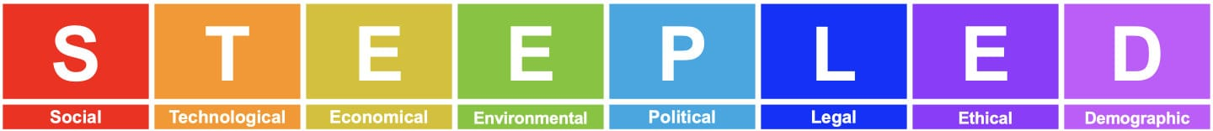
Figure 4: STEEPLED Analysis
Source: (Business Documents UK Ltd, 2024)
Factor | Analysis | Current Strengths | Opportunities for Improvement
Social | Guests increasingly value sustainability, eco-conscious experiences, and inclusivity. Negative feedback about insufficient green practices impacts reputation (Haldorai, Kim and Garcia, 2022). | Renowned for luxury and exceptional service; strong brand loyalty among traditional guests. | Introduce visible eco-friendly initiatives (reusable toiletries and waste reduction campaigns).
Technological | Emerging technologies in energy efficiency and waste management could streamline operations. The lack of modern sustainability tracking tools is evident. | Updated guest experience systems, such as digital check-ins, demonstrate tech-forward thinking. | Invest in energy efficient technologies and implement advanced monitoring for sustainability metrics.
Economic | Rising operational costs, including energy and water, are a significant challenge. Budget constraints limit large-scale changes (Abdou, Hassan and El Dief, 2020). | The hotel remains a sought-after destination for high net worth clients, ensuring stable revenue streams. | Evaluate ROI for sustainable investments, leveraging government subsidies or green financing.
Environmental | High energy consumption and waste output contribute to environmental challenges. Regulatory compliance is becoming stricter (Peng and Chen, 2019). | Iconic location with opportunities to promote local environmental initiatives. | Set tangible goals to reduce carbon footprint; promote water and energy conservation campaigns.
Political | UK government initiatives supporting green businesses and stricter sustainability regulations encourage action but add compliance pressure. | Access to grants or incentives for energy efficient upgrades. | Stay ahead of policy changes to avoid penalties; develop partnerships with green certified suppliers.
Legal | Hospitality laws require adherence to waste reduction, recycling, and carbon reporting. Noncompliance risks financial and reputational penalties. | Longstanding compliance with luxury hospitality standards and industry certifications. | Align with international eco-certifications (Green Key or EarthCheck).
Ethical | Ethical sourcing and treatment of staff are increasingly scrutinised. Customers demand transparent practices (Sheehan, Grant and Garavan, 2018). | Strong ethical foundation with established labour and supplier standards. | Expand ethical supply chain initiatives, ensuring visibility and sustainability in procurement.
Demographic | An increasingly diverse and eco-conscious traveller demographic is shaping preferences for sustainable stays. | Established appeal to affluent travellers worldwide. | Enhance marketing strategies to attract younger, eco-conscious travellers.
Table 1: STEEPLED Analysis
Source: (Developed by the author)
More specifically, Crystalbrook Kingsley Hotel has done well to uphold its image as one of the best hotels and so maintains the observed high standards of customer satisfaction. Built in 1889, this hotel remains one of the most popular ones, which provides guests with superior service and elegant rooms, desired by many people from all over the world. People enjoy privacy, professional warmth, and sophistication that is combined with modern technology and amenities, so it is correct that Crystalbrook Kingsley is an example of luxury hotel standards. It can be argued that complementing its luxurious attitude, Crystalbrook Kingsley has applied innovations to improve guest satisfaction. New technologies that include online check-in systems, as well as smart room systems, are additional bonuses to the modern traveller. All these adaptations show that the hotel can maintain its position in the market as an industry trendsetter by keeping up with changes that may facilitate efficiency in operations and enhancement of customers' comfort (Al-Aomar and Hussain, 2017).

2.3. SOAR Analysis
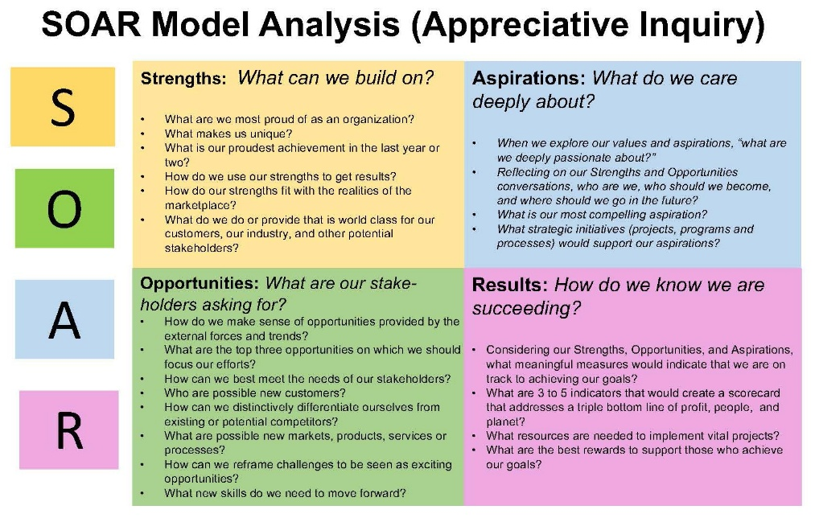
Figure 5: SOAR model
Source: (Library guides, 2025)
Category | Details
Strengths | - Premium Location: Situated in Newcastle, offering easy access to key attractions, business hubs, and the beach.  - Luxury Amenities: High-end accommodations, modern facilities, and services that cater to both leisure and business travelers (Guest reservations, 2025).  - Sustainability Commitment: Crystalbrook Collection’s focus on eco-friendly practices, including waste reduction and energy-efficient systems.  - Strong Brand Recognition: Crystalbrook Kingsley is part of the well-regarded Crystalbrook Collection, known for its luxury and quality standards.  - Exclusive Dining and Wellness: On-site dining options and wellness facilities offer a premium experience to guests.
Opportunities | - Expanding Eco-Friendly Initiatives: Continue integrating advanced sustainability solutions to reduce environmental impact, improving reputation.  - Local Partnerships: Collaborate with local businesses, farmers, and artisans to promote sustainable sourcing and boost the local economy.  - Increased Domestic Tourism: Capitalise on the growing trend of domestic tourism, especially post-pandemic, as travellers seek safe, local getaways.  - Technological Advancements: Implement cutting-edge technologies in guest services, such as AI concierge or smart room systems, to enhance the experience (Bilgihan and Ricci, 2024).  - Event Hosting and Conferences: Expand offerings for conferences, events, and business meetings to attract corporate clients.
Aspirations | - Achieving Sustainability Leadership: Aspire to become a recognised leader in sustainable luxury hospitality, setting new industry standards.  - Expanding Brand Reach: Increase brand presence nationally, enhancing recognition among travellers seeking eco-friendly luxury experiences.  - Enhanced Customer Experience: Continually innovate to offer unparalleled luxury and comfort while maintaining eco-consciousness.  - Global Recognition: Establish Crystalbrook Kingsley as an internationally renowned sustainable luxury destination.
Results | - Higher Guest Satisfaction: A focus on sustainability, luxury, and innovation leads to high customer satisfaction and repeat business.  - Increased Revenue: By tapping into the growing eco-conscious traveller market, the hotel has the potential for increased bookings and revenue.  - Industry Recognition: Through its commitment to sustainability, Crystalbrook Kingsley could gain recognition through awards and accolades.  - Reduced Environmental Impact: Successful implementation of sustainability practices results in measurable reductions in energy use, waste, and water consumption.
Table 2: SOAR analysis
Source: (Developed by the author)
Looking at these four important components we can ascertain the hotel’s position to successfully operate in the highly competitive luxury hospitality world while continuing to conquer sustainability and growth. The hotel’s long-term goals will be explored, and this evaluation will evaluate how the identified strengths, opportunities, aspirations, and results all line up with those of the long-term hotel goals. However, Crystalbrook Kingsley has a good foundation built upon a number of solid strengths. The company, in its location at the centre of Newcastle, has easy access to those local attractions and business districts, the key components for both leisure and business travellers. Besides that, the luxurious amenities of the hotel, such as high-end rooms, fine dining options, and wellness facilities, further distinguish it from the competition in the market (Crystalbrook Collection, 2025b). Crystalbrook Kingsley is one of the standout strengths and one of the things it commits to being sustainable. The hotel is part of the Crystalbrook Collection with an aim to do fully sustainable sourcing, reduce waste and use energy-efficient systems. Not only does this attract environmentally minded consumers, but it also places hotels in the position of being a leader in sustainable luxury tourism. Additionally, the strong brand recognition for Crystalbrook Kingsley, thanks to the Crystalbrook Collection's reputation, provides a foundation for trust and credibility. What makes it special is that the hotel's focus is on exclusive dining and wellness experience and appeals to high end clientele who would love to be pampered in a luxurious and holistic atmosphere.
The identified opportunities for Crystalbrook Kingsley are promising and are aligned with the industry. A perfect opportunity to develop eco-friendly programmes would boost a hotel's reputation in luxury hospitality with regard to executives, which will attract more customers (Iyengar and Venkatesh, 2024). Modernising energy efficiency through incorporating advanced technologies or seeking out renewable energy sources are other approaches to cope with growing environmental requirements. Another opportunity is local partnerships with sustainable suppliers, artisans, and partners. Supporting the local economy is not only the best thing to do but also fits in perfectly with a trend that is supporting local businesses and lowering the carbon emission caused when obtaining the source of materials and food.
Crystalbrook Kingsley aims to be a leading sustainable luxury hospitality entity. It lines up with its status as a sustainable hotel and provides it with a differentiator in a market that is already crowded. To make this happen, it will be required to invest in sustainable technologies, build stronger local partner relations and maintain innovation in eco-friendly services. Crystalbrook Kingsley is strongly aligned with its strengths and opportunities and, thus, the tangible results it strives to achieve. As a luxury, sustainable, and personal service focused brand, it will likely have higher guest satisfaction. Keeping work repeat business and increasing customer loyalty, the hotel must always deliver exceptional experiences to its customers. There is also a lot of potential increased revenue from what is otherwise a growing market of eco-conscious travellers. Crystalbrook Kingsley is well placed to fill that demand of offering the sustainable, luxury experiences. Awards or another type of industry recognition would be a boost to the hotel’s reputation and further cement its position as a market standard. Finally, there is the important measurable result of reduced environmental impact. By establishing sustainability in Crystalbrook Kingsley in waste management, energy consumption and water use, Crystalbrook Kingsley will achieve its sustainability goals, and make a positive impact on the environment and also its bottom line.

2.4. TOWS Matrix
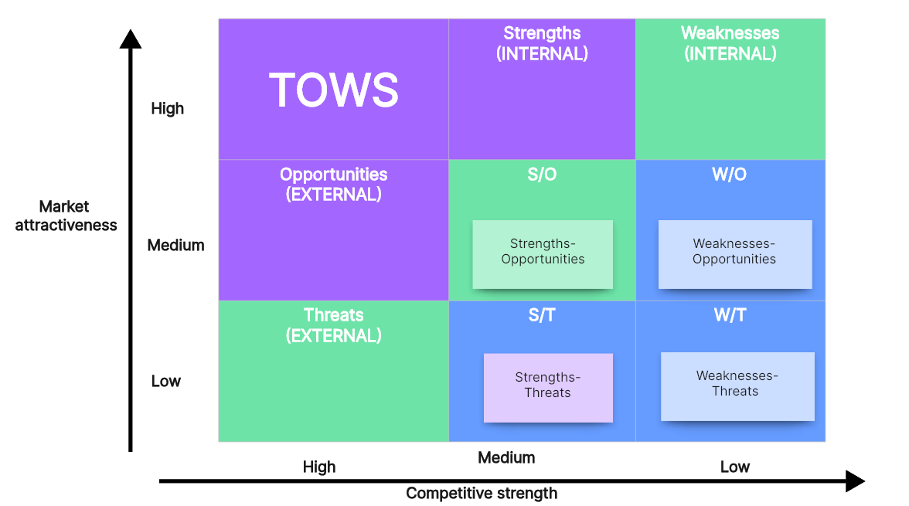
Figure 6: TOWS Matrix
Source: (Murphy, 2024)
Internal Factors | External Factors
Strengths (S) | Rich history and reputation for luxury; exceptional service; ethical practices; prime location in London; technological advancements.
Weaknesses (W) | Limited visible sustainability efforts; high operational costs; resistance to change among staff; reliance on traditional marketing strategies.
Opportunities (O) | Growing demand for sustainable travel, government grants for green initiatives, rising interest in ethical tourism, and partnerships with local ecotourism firms (Rodríguez Antón and Alonso Almeida, 2019).
Threats (T) | Increasing competition from eco-focused hotels; potential regulatory changes requiring sustainable practices; high cost of sustainability integration.

 | Strategies | Key Actions
Strengths + Opportunities (SO) | - Leverage the hotel’s reputation for luxury to position itself as a leader in sustainable hospitality.  - Use technological advancements to implement smart sustainability solutions, such as energy-efficient systems and guest-facing sustainability features (Mardani et al., 2017).  - Partner with local businesses to offer ecotourism experiences tailored to Crystalbrook Kingsley’s clientele. | - Develop a marketing campaign around "Sustainable Luxury," highlighting eco-friendly initiatives while maintaining premium standards.  - Introduce room control apps that allow guests to monitor and minimise their energy consumption during their stay.  - Curate exclusive packages, such as eco-friendly walking tours and dining at locally sourced restaurants.
Strengths + Threats (ST) | - Protect market share by exceeding competitors’ sustainability efforts through innovative practices.  - Use Crystalbrook Kingsley’s ethical practices to attract top talent and train staff to embrace sustainable operations.  - Offset rising operational costs by investing in technologies that reduce waste and energy usage while maintaining guest experience (Chan, Okumus and Chan, 2017). | - Pursue certifications like EarthCheck to signal leadership in green initiatives to guests and stakeholders.  - Implement ongoing staff training on sustainable practices and incentivise participation through recognition programs.  - Conduct a comprehensive energy audit to identify cost saving opportunities, such as transitioning to renewable energy sources.
Weaknesses + Opportunities (WO) | - Address sustainability gaps by launching visible, impactful green initiatives (e.g., waste reduction, carbon offsets).  - Leverage available grants to fund the initial costs of transitioning to more sustainable practices.  - Improve guest perceptions by introducing eco-friendly amenities without compromising on luxury (Font, Elgammal and Lamond, 2017). | - Establish a "Green Initiative Task Force" to lead projects like a composting program for food waste and partnerships with local recycling firms.  - Apply for Australia-based hospitality sustainability funding programs to cover the installation of energy-efficient systems like solar panels.  - Replace single use plastics with reusable options, such as glass water bottles, while maintaining a premium presentation.
Weaknesses + Threats (WT) | - Minimise reputational risks by implementing transparency in sustainability goals and achievements.  - Address staff resistance to change through engagement programs and clear communication on the benefits of sustainability initiatives (Nazir and Islam, 2020).  - Phase out unsustainable practices to ensure compliance with evolving environmental regulations and minimise potential penalties. | - Publish an annual sustainability report detailing progress toward environmental targets and invite guest feedback.  - Host workshops and involve employees in the decision-making process to foster a sense of ownership and accountability for green programs.  - Gradually replace outdated systems (HVAC) with energy efficient alternatives to align with future environmental standards.
Table 3: TOWS matrix
Source: (Developed by the author)

3. Recommendations and Change Management

3.1. Recommendation
1. Develop a Comprehensive Sustainability Strategy
Crystalbrook Kingsley should integrate a proper sustainability plan, to face the difficulties of incorporating sustainability in its operations. This strategy must be aimed at specific outcomes in fields of energy conservation, waste minimisation, water use efficiency, and carbon net zero (Jones and Wynn, 2019). Measures are deciding to institutionalise a Sustainability Officer to oversee the handling of green projects and forming a "Green Initiative Task Force" to guarantee the interjection of all divisions involved. SMART goals that should be put in place include Energy use reduction of 20% within the next five years and disposal of waste by 2030. Outsourcing firms for audits and consultation services will give tangible strategies that need to be followed to achieve conformity and a steady pace.
2. Invest in Sustainable Infrastructure and Technology
For environmental sustainability, Crystalbrook Kingsley must adopt modern energy-efficient systems inside its facilities together with sustainable infrastructure without lowering its luxury offerings. Efforts to save energy will focus on two key measures where staff will retrofit lights to LED bulbs and add motion detectors to spaces with low traffic flow. A complete installation of low-flow plumbing equipment in both public areas and guest areas must be introduced for water-saving purposes (MacKenzie and Gannon, 2019). Solar panels should be considered for the rooftop combined with renewable energy purchases from designated suppliers. A smart energy management system can track energy in real-time while optimising efficiency, thereby reducing costs so eco-minded tourists will find it more appealing (Chan, Okumus and Chan, 2020).
3. Enhance Employee Engagement and Training
Achieving the goals of sustainability in Crystalbrook Kingsley strongly relies on its employees, and therefore, staff engagement becomes vital in all the sustainability activities planned by the organisation. Conducting sustainability focused workshops will raise awareness of issues like waste disposal, energy saving, green hospitality and many others to the employees (Leidner, Baden and Ashleigh, 2019). It can also be used to motivate stakeholders towards making staff contributions, promoting ideas that could be ecological, or making specified progress towards sustainable goals. Education by newsletters and meetings should be used to keep the employees informed about progress and accomplishments. Substantial engagement from leaders is necessary, which results in leadership by example through sustainable behaviours (Thomas Francois, von Massow and Joppe, 2017).
4. Collaborate with Local Suppliers and EcoTourism Partners
Crystalbrook Kingsley should expand sustainability for supply chain and guest services, linking up with local suppliers and ecotourism associations. Organic linens and locally grown produce are examples of materials that may be bought from ethical suppliers to help minimise the hotel's impact on the environment. This will also make partnerships with bodies such as those for ecotourism effective in offering guests experiences in environmental conservation, including natural walks, cleaning of rivers and visiting community-social projects as embraced in sustainability. Transcending the regular menu with more plant-based foods and locally acquired foods also helps to support environmental sustainability (Rezapouraghdam, Alipour and Arasli, 2019). Supplier evaluations frequently will guarantee that all the supplier affairs run right relative to ethical and environmental concerns, strengthen the connection with the community, and make the hotel worth patronising.
5. Launch GuestFocused Sustainability Programs
Active guest engagement is prevalent so that Crystalbrook Kingsley can institutionalise the sustainability of the brand. For instance, the hotel may propose the Green Guest Rewards, which would give the guest various rewards such as free checkout time, complimentary continental breakfasts, late check-ins and early checkouts, free accommodation, light lunches, and continuing service for the guest's next visit if the guest reuses the towel, joins the activities or excursions. Singleuse toiletries will be replaced with dispensers because reusing them is an effective way to avoid creating waste; other reusable items like bottles and bags will also be provided for the guests. Specific guest engagements with tangible teaching, such as using digital displays or inroom TV programs or fliers, can be used to educate guests on the hotel's sustainability initiatives and the part that the guests can play in supporting them. Further, choosing carbon offset while making the booking indicates that everyone is equally responsible for the environmental cause (Oriade et al., 2021).

3.2. Change Management
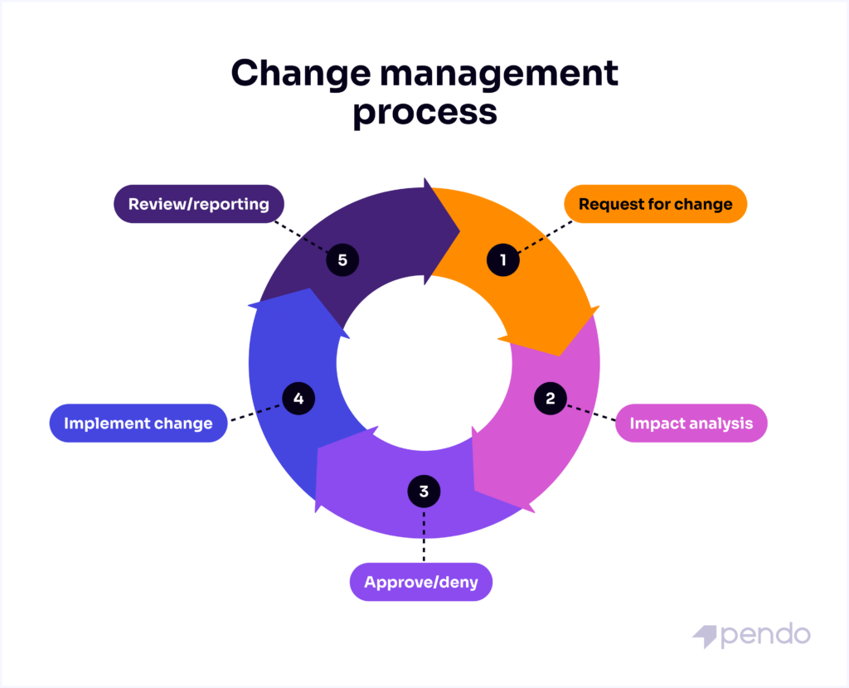
Figure 7: Change Management
Source: (Pendo, 2024)
Step | Explanation | Actions for Implementation | Expected Outcomes
1. Create a Sense of Urgency | - Generate awareness among stakeholders about the critical need for sustainability integration to maintain competitive advantage and meet regulatory standards. | - Share compelling data on environmental challenges and the growing demand for sustainable practices among luxury travellers.  - Host town hall meetings to communicate the risks of inaction, such as reputational damage and regulatory penalties. | - Increased buyin from stakeholders and employees.  - A shared understanding of the importance of sustainability for business success.
2. Build a Guiding Coalition | - Form a group of influential leaders and staff members who are committed to driving the change and can influence others effectively. | - Identify and involve key department heads, such as operations, marketing, and housekeeping, along with external sustainability consultants.  - Define clear roles and responsibilities for the coalition members.  - Schedule regular progress meetings to maintain alignment. | - A strong leadership team driving change collaboratively.  - Improved coordination and alignment across departments.
3. Develop a Vision and Strategy | - Create a clear vision for what sustainability integration looks like and develop a strategy for achieving it. | - Draft a sustainability vision statement, such as “Leading the way in sustainable luxury hospitality while preserving Crystalbrook Kingsley’s legacy.”  - Outline measurable goals (e.g., reducing energy use by 25% over 5 years).  - Ensure alignment with overall business objectives. | - Clear direction and purpose for sustainability efforts.  - Easier communication of goals to staff and stakeholders (Giousmpasoglou, Marinakou and Zopiatis, 2021).
4. Communicate the Change Vision | - Ensure the sustainability vision is communicated consistently and effectively to all employees and stakeholders. | - Use multiple communication channels (emails, newsletters, intranet, posters) to share the vision and strategy.  - Incorporate sustainability messaging into team meetings and leadership speeches.  - Encourage feedback to address concerns and suggestions. | - Enhanced understanding and support for the sustainability vision (Roxas, Rivera and Gutierrez, 2020).  - Reduced resistance to change.
5. Empower BroadBased Action | - Remove obstacles that may hinder progress and empower employees to contribute to sustainability initiatives. | - Provide training to employees on sustainable practices, such as waste segregation and energy conservation.  - Review policies and procedures to remove outdated practices that conflict with sustainability goals.  - Offer financial or nonfinancial incentives for innovation. | - Employees feel equipped and motivated to contribute to sustainability efforts (Wikhamn, 2019).  - Barriers to progress are minimised or eliminated.
6. Generate ShortTerm Wins | - Identify and celebrate early successes to build momentum and demonstrate the feasibility of longterm sustainability goals. | - Launch small, visible projects, such as reducing singleuse plastics in guest rooms.  - Share success stories through internal and external communication channels.  - Recognise and reward teams or individuals who contribute significantly to early wins. | - Boosted morale and confidence in the change process.  - Tangible evidence of progress to build trust and commitment.
7. Consolidate Gains and Produce More Change | - Build on early successes to drive larger, systemic changes and embed sustainability deeper into the organisation. | - Expand sustainability initiatives to include energy audits, supply chain sustainability, and eco-friendly guest programs.  - Use insights from shortterm wins to refine strategies.  - Encourage continuous improvement by gathering feedback and monitoring performance. | - Sustained momentum for change.  - Larger, organisationwide improvements in sustainability practices (Ibnou Laaroussi, Rjoub and Wong, 2020).
8. Anchor New Approaches in the Culture | - Ensure sustainability becomes a core value of Crystalbrook Kingsley’s culture and is reflected in daily operations and decision-making. | - Update mission and values statements to emphasise sustainability.  - Incorporate sustainability into performance appraisals and job descriptions.  - Highlight sustainability achievements in annual reports and marketing materials. | - Longterm commitment to sustainability.  - Recognition as a leader in sustainable luxury hospitality.
Table 4: Change management
Source: (Developed by the author)

3.3. Measuring Impacts and Success Rates
Active guest engagement is prevalent so that Crystalbrook Kingsley can institutionalise the sustainability of the brand. For instance, the hotel may propose the Green Guest Rewards, which would give the guest various rewards such as free checkout time, complimentary continental breakfasts, late check-ins and early checkouts, free accommodation, light lunches, and continuing service for the guest's next visit if the guest reuses the towel, joins the activities or excursions. Singleuse toiletries will be replaced with dispensers because reusing them is an effective way to avoid creating waste; other reusable items like bottles and bags will also be provided for the guests. Specific guest engagements with tangible teaching, such as using digital displays or inroom TV programs or fliers, can be used to educate guests on the hotel's sustainability initiatives and the part that the guests can play in supporting them. Further, choosing carbon offset while making the booking indicates that everyone is equally responsible for the environmental cause (Jallow, Renukappa and Suresh, 2020).
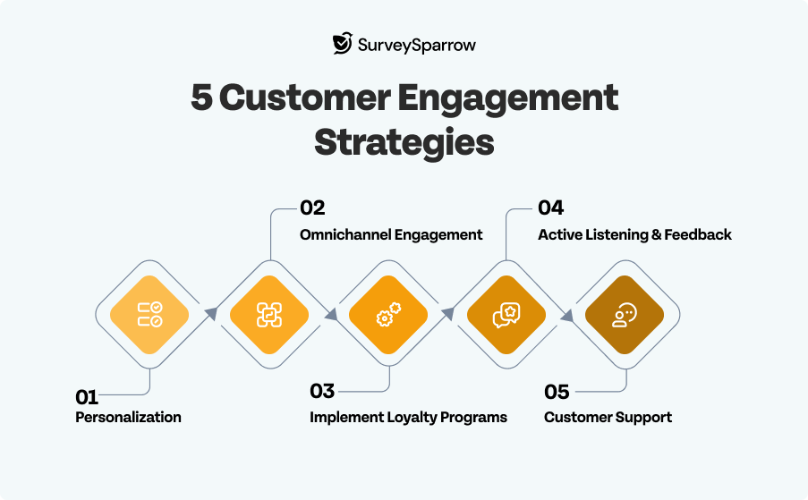
Figure 8: Customer engagement
Source: (Survey Sparrow, 2025)

3.4. Potential Benefits to the Hotel
Adopting these strategies will place Crystalbrook Kingsley amongst the premier green luxury accommodation providers and will, therefore, attract wealthy, motivated clients who are fascinated by environmental conservation. Given that sustainability is rapidly emerging as one of the drivers for change in the luxury sector, this change will only add to the hotel's image, designating it as a progressive, environmentally conscious facility (Grazzini et al., 2018). In the financial aspect, the hotel will be able to realise considerable savings because of decreased energy, water and waste consumption through projected systems. These cuts will result in longterm riding indefinite cost savings, and at the same time, the authorities will be as fiscally responsible as is required.
Better control over the operating conditions affecting sustainability and adequacy of training and incentives will lead to better motivation among the employees as well as higher productivity and better quality of service to the Guests (Elshaer et al., 2021). When the customers are satisfied, they will be regular consumers, making the revenue improve (Ettinger, GrabnerKräuter and Terlutter, 2018). Furthermore, relationships with local vendors and the support and sponsorship of ecotourism will help not only to solidify the existing connection with the community but also provide distinguishing factors that would make a hotel stand out in the eyes of the cherished clientèle (Kiesnere and Baumgartner, 2019).
By following globally accepted sustainability principles and meeting legal requirements, hotels will avoid damaging scandals or fines that endanger their operation in a highly competitive market (Nisar et al., 2021). In the long run, these strategies will increase occupancy rates, enhance customer loyalty and make Crystalbrook Kingsley the benchmark for sustainable luxury that warrants that it is in the hospitality business for the long term.

3.5. Cost Analysis of Recommendations
Recommendation | Cost Estimate | Details | Reasoning
Develop a Comprehensive Sustainability Strategy | £30,000 (initial) | Includes hiring a Sustainability Officer, external consultancy fees, and strategy development workshops. | Critical for creating a clear roadmap and aligning efforts across departments.
Invest in Sustainable Infrastructure & Technology | £500,000 (onetime) + £50,000/year | Covers LED retrofitting, smart energy systems, low-flow fixtures, and renewable energy procurement. | Longterm cost savings through reduced utility expenses align with luxury guest expectations.
Enhance Employee Engagement & Training | £25,000/year | Includes workshops, training programs, and incentives for sustainability contributions. | Essential for fostering a culture of sustainability and ensuring successful implementation.
Collaborate with Local Suppliers and partners | £10,000 (annual partnership costs) | Includes partnership development, audits, and integration of sustainable procurement practices. | Strengthens the hotel’s reputation and supports local economic development.
Launch GuestFocused Sustainability Programs | £50,000 (setup) + £10,000/year | Covers eco-friendly amenities, a guest rewards program, and carbon-offsetting platform development. | Enhances guest experience while aligning with sustainability goals.
Table 5: Cost analysis
Source: (Developed by the author)

4. Action Plan
SL No. | Problem | Solution | Desired Outcome | Time Scale | Completion Date | Planned Budget
1 | High energy consumption across hotel operations | Install energy efficient lighting (LEDs), smart energy management systems, and solar panels. | Reduce energy costs by 25% and significantly lower the hotel’s carbon footprint. | 12 months | January 2026 | £300,000 (initial)
2 | Excessive water usage in guest rooms and facilities | Install low flow faucets, showerheads, and water recycling systems for laundry and cleaning. | Achieve a 20% reduction in water consumption while maintaining guest comfort and service standards. | 8 months | September 2025 | £100,000 (initial)
3 | Limited awareness and engagement in sustainability practices among employees | Conduct training workshops and create sustainability champions within each department. | Improved employee awareness and active participation in sustainability initiatives. | 6 months | July 2025 | £25,000 (annually)
4 | Lack of collaboration with local, sustainable suppliers | Partner with local eco-friendly suppliers for food, amenities, and construction materials. | Strengthened ties with the local community and enhanced eco-friendly offerings for guests. | 4 months | May 2025 | £10,000 (annual cost)
5 | Minimal guest involvement in sustainability efforts | Launch a guest participation program, including incentives for eco-friendly behaviour and carbon offsets. | Increased guest satisfaction and loyalty through personalised, sustainable options. | 6 months | July 2025 | £50,000 (setup) + £10,000/year
6 | Inefficient waste management practices | Implement comprehensive waste segregation and recycling programs throughout hotel operations. | Achieve a 50% reduction in landfill waste and align with waste regulations and standards. | 8 months | September 2025 | £30,000 (initial)
7 | Lack of clear sustainability goals and strategy | Develop and implement a detailed sustainability roadmap with measurable Key Performance Indicators (KPIs). | Establish clear goals, improve monitoring, and align operational practices with sustainability targets. | 3 months | April 2025 | £30,000 (consultancy)
Table 5: Action plan
Source: (Developed by the author)
The critical operational areas of concern comprise energy, water, waste management, and people perspective, which includes employees and guests. The overall amount planned for the initial year is £545,000 and, for the years after that, £45,000. The first plan of completion to develop the sustainability roadmap is by April 2025, and the plan of completion for all the initiatives is to be completed before January 2026. This plan makes Crystalbrook Kingsley realise a tangible improvement in sustainability, raise its image as a sustainable luxury hotel and safeguard sustainable management and financial returns in the long term.

5. Conclusion
As per the above discussion the report has laid down detailed explanations of the problems faced by Crystalbrook Kingsley Hotel in implementing sustainability practices in its operations and how it can manage to solve such problems. The study reveals two areas where Crystalbrook Kingsley is most successful: it sustains its image of luxury as well as implements technologies and ethical activities; at the same time, it encounters major concerns about energy and water conservation, waste minimisation, staff and guest involvement in sustainability efforts. If these issues are not dealt with, they may drastically affect the hotel and its future in achieving success, providing guests with value for their money, and meeting society, customer needs and wants in an environmentally, socially responsible and competitive hospitality industry.
Applying the STEEPLED analysis, it was noted that the environmental legislation and customer scrutiny for sustainability now affect the hotel's dynamic considerably. Moreover, with the help of SOAR and TOWS strategies, such as historical image, technological opportunities, and a possibility of cooperation with local manufacturers, Crystalbrook Kingsley will be able to address the defined weaknesses and threats. The recommendations provided in this report were in view of these analyses to be in congruence with the established luxury and service values of Crystalbrook Kingsley.
The announced action plan is as follows: development of the large sustainability plan, the purchases of energy and water-saving technologies, training of the staff, cooperation with local suppliers, and the implementation of the ideas inspiring the guests. All these strategies have tangible objectives of decreased operational expenses, optimised use of resources, contented staff, and returning clientele. That is why the costs of these measures were measured with consideration of the size and revenue of Crystalbrook Kingsley while offering the recommendations.
It has also described the reporting process of these initiatives through viable metrics and the need to establish monitoring tools for evaluating their effectiveness. With concrete KPIs, Crystalbrook Kingsley will be able to monitor its advancement, optimise its strategies based on the collected data, and thus improve its sustainability compartments year by year. In addition, the above recommendations also have a positive effect on other organisational areas such as environmental and sustainable assets, brand image and reputation, legal requirement compliance and competitive advantage in the global luxury hospitality industry.
In conclusion, it can be stated that Crystalbrook Kingsley Hotel has the unique chance to become the leader of sustainable luxury worldwide: the hotel corresponds to the newest trend of ecotourism, extending its traditions while keeping up with the contemporary tendencies of the green planet. This consultancy report has been developed for Crystalbrook Kingsley by identifying all the existing issues and providing solutions which are workable, smart, and sustainable for delivering guest satisfaction along with opportunities for sustainability and efficient operations.
This has been a report of great honour to work with Crystalbrook Kingsley Hotel on such a crucial project. On behalf of the team, the author wants to express appreciation to the management and staff for their willingness to participate in such a process. As Crystalbrook Kingsley starts taking great steps towards sustainability, there will not be a doubt about setting high standards for the hospitality industry to follow. The analogy should be congratulated, and the consultancy team is certainly interested in and open to the possibility of future interactions.

References
Abdou, A.H., Hassan, T.H. and El Dief, M.M., (2020). A description of green hotel practices and their role in achieving sustainable development. Sustainability, 12(22), p.9624.
Al-Aomar, R. and Hussain, M., (2017). An assessment of green practices in a hotel supply chain: A study of UAE hotels. Journal of Hospitality and Tourism Management, 32, pp.7181.
Athwal, N., Wells, V.K., Carrigan, M. and Henninger, C.E., (2019). Sustainable luxury marketing: A synthesis and research agenda. International Journal of Management Reviews, 21(4), pp.405426.
Bilgihan, A. and Ricci, P., (2024). The new era of hotel marketing: integrating cutting-edge technologies with core marketing principles. Journal of Hospitality and Tourism Technology, 15(1), pp.123-137.
Business Documents UK Ltd, (2024). Updating STEEPLED analysis for 2024. [online] Business Documents UK. Available at: <https://business-docs.co.uk/blog/updating-steepled-analysis-for-2024/>. [Accessed 24 January 2025].
Chan, E.S., Okumus, F. and Chan, W., (2017). The applications of environmental technologies in hotels. Journal of Hospitality Marketing & Management, 26(1), pp.2347.
Chan, E.S., Okumus, F. and Chan, W., (2020). What hinders hotels’ adoption of environmental technologies: A quantitative study. International Journal of Hospitality Management, 84, p.102324.
Crystalbrook Collection. (2025a). Five-Star Hotel in Newcastle CBD | Crystalbrook Kingsley. [online] Crystalbrook Collection. Available at: <https://www.crystalbrookcollection.com/kingsley>. [Accessed 5 February 2025].
Crystalbrook Collection. (2025b). Kingsley Facilities & Amenities | Luxury Hotel Newcastle. [online] Crystalbrook Collection. Available at: <https://www.crystalbrookcollection.com/kingsley/facilities>. [Accessed 5 February 2025].
Elshaer, I.A., Sobaih, A.E.E., Aliedan, M. and Azazz, A.M., (2021). The effect of green human resource management on environmental performance in small tourism enterprises: Mediating role of proenvironmental behaviors. Sustainability, 13(4), p.1956.
Erskine, E., (2024). How you can implement the triple bottom line. [online] Green Buoy Consulting. Available at: <https://www.greenbuoyconsulting.com/blog/howyoucanimplementthetriplebottomline> [Accessed 24 January 2025].
Ettinger, A., GrabnerKräuter, S. and Terlutter, R., (2018). Online CSR communication in the hotel industry: Evidence from small hotels. International Journal of Hospitality Management, 68, pp.94104.
Farooq, R., Zhang, Z., Talwar, S. and Dhir, A., (2022). Do green human resource management and selfefficacy facilitate green creativity? A study of luxury hotels and resorts. Journal of Sustainable Tourism, 30(4), pp.824845.
Font, X., Elgammal, I. and Lamond, I., (2017). Greenhushing: the deliberate under communicating of sustainability practices by tourism businesses. Journal of Sustainable Tourism, 25(7), pp.10071023.
Giousmpasoglou, C., Marinakou, E. and Zopiatis, A., (2021). Hospitality managers in turbulent times: the COVID19 crisis. International Journal of Contemporary Hospitality Management, 33(4), pp.12971318.
Grazzini, L., Rodrigo, P., Aiello, G. and Viglia, G., (2018). Loss or gain? The role of message framing in hotel guests’ recycling behaviour. Journal of Sustainable Tourism, 26(11), pp.19441966.
Guest reservations. (2025). Crystalbrook Kingsley. [online] Guestreservations. Available at: <https://www.guestreservations.com/crystalbrook-kingsley/booking?utm_source=google&utm_medium=cpc&utm_campaign=990032579&gad_source=1&gclid=CjwKCAiAtYy9BhBcEiwANWQQL1WQSM2gpWSQc0546jcBez8iFs6JS4JubAxFAWWpGt1NBDvm-4TTMRoC6nkQAvD_BwE&ctTriggered=true> [Accessed 5 February 2025].
Haldorai, K., Kim, W.G. and Garcia, R.F., (2022). Top management green commitment and green intellectual capital as enablers of hotel environmental performance: The mediating role of green human resource management. Tourism Management, 88, p.104431.
Hotel Techreport, (2024). Sustainability in Hotels: 27 Eye Opening Statistics for 2025. [online] Hotel Tech Report. Available at: <https://hoteltechreport.com/news/hotelsustainabilitystatistics> [Accessed 24 January 2025].
Ibnou Laaroussi, S., Rjoub, H. and Wong, W.K., (2020). Sustainability of green tourism among international tourists and its influence on the achievement of green environment: Evidence from North Cyprus. Sustainability, 12(14), p.5698.
Iyengar, M.S. and Venkatesh, R., (2024). SUSTAINABLE LUXURY STAYS: Investigating Eco-Friendly Practices in High-End Hotels. Icon: Journal of the International Committee for the History of Technology, 29(1).
Jallow, H., Renukappa, S. and Suresh, S., (2020). The impact of COVID19 outbreak on United Kingdom infrastructure sector. Smart and sustainable built environment, 10(4), pp.581593.
Jones, P. and Wynn, M.G., (2019). The circular economy, natural capital and resilience in tourism and hospitality. International Journal of Contemporary Hospitality Management, 31(6), pp.25442563.
Kang, S.P., Chen, Y., Svihla, V., Gallup, A., Ferris, K. and Datye, A.K., (2022). Guiding change in higher education: An emergent, iterative application of Kotter’s change model. Studies in Higher Education, 47(2), pp.270289.
Kiesnere, A.L. and Baumgartner, R.J., (2019). Sustainability management in practice: Organisational change for sustainability in smaller largesized companies in Austria. Sustainability, 11(3), p.572.
Leidner, S., Baden, D. and Ashleigh, M.J., (2019). Green (environmental) HRM: Aligning ideals with appropriate practices. Personnel Review, 48(5), pp.11691185.
Library guides. (2025). Library Guides: Journalism - Strategic Communication: SOAR analysis. [online] Available at: <https://libraryguides.missouri.edu/c.php?g=28374&p=4304702>.
MacKenzie, N. and Gannon, M.J., (2019). Exploring the antecedents of sustainable tourism development. International Journal of Contemporary Hospitality Management, 31(6), pp.24112427.
Mardani, A., Zavadskas, E.K., Khalifah, Z., Zakuan, N., Jusoh, A., Nor, K.M. and Khoshnoudi, M., (2017). A review of multicriteria decisionmaking applications to solve energy management problems: Two decades from 1995 to 2015. Renewable and Sustainable Energy Reviews, 71, pp.216256.
Marinakou, E. and Giousmpasoglou, C., (2019). Talent management and retention strategies in luxury hotels: evidence from four countries. International Journal of Contemporary Hospitality Management, 31(10), pp.38553878.
Murphy, K.C., (2024). Using the TOWS Matrix for strategy formulation. [online] Available at: <https://www.linkedin.com/pulse/using-tows-matrix-strategy-formulation-kyle-c-murphy-ry5ec/>. [Accessed 24 January 2025].
Nazir, O. and Islam, J.U., (2020). Influence of CSRspecific activities on work engagement and employees’ innovative work behaviour: An empirical investigation. Current Issues in Tourism, 23(24), pp.30543072.
Nigri, G. and Del Baldo, M., (2018). Sustainability reporting and performance measurement systems: How do smalland mediumsized benefit corporations manage integration?. Sustainability, 10(12), p.4499.
Nisar, Q.A., Haider, S., Ali, F., Jamshed, S., Ryu, K. and Gill, S.S., (2021). Green human resource management practices and environmental performance in Malaysian green hotels: The role of green intellectual capital and proenvironmental behavior. Journal of cleaner production, 311, p.127504.
Oriade, A., Osinaike, A., Aduhene, K. and Wang, Y., (2021). Sustainability awareness, management practices and organisational culture in hotels: Evidence from developing countries. International Journal of Hospitality Management, 92, p.102699.
Pendo, (2024). What is change management? A guide | Pendo.io. [online] Pendo.io. Available at: <https://www.pendo.io/glossary/change-management/>. [Accessed 24 January 2025].
Peng, N. and Chen, A., (2019). Luxury hotels going green–the antecedents and consequences of consumer hesitation. Journal of sustainable tourism.
Pereira, V., Silva, G.M. and Dias, Á., (2021). Sustainability practices in hospitality: Case study of a luxury hotel in Arrábida Natural Park. Sustainability, 13(6), p.3164.
Peters, J. and Simaens, A., (2020). Integrating sustainability into corporate strategy: A case study of the textile and clothing industry. Sustainability, 12(15), p.6125.
Rezapouraghdam, H., Alipour, H. and Arasli, H., (2019). Workplace spirituality and organisation sustainability: a theoretical perspective on hospitality employees' sustainable behavior. Environment, Development and Sustainability, 21, pp.15831601.
Roxas, F.M.Y., Rivera, J.P.R. and Gutierrez, E.L.M., (2020). Framework for creating sustainable tourism using systems thinking. Current Issues in Tourism, 23(3), pp.280296.
Sheehan, M., Grant, K. and Garavan, T., (2018). Strategic talent management: A macro and micro analysis of current issues in hospitality and tourism. Worldwide Hospitality and Tourism Themes, 10(1), pp.2841.
Shim, J., Moon, J., Lee, W.S. and Chung, N., (2021). The impact of CSR on corporate value of restaurant businesses using triple bottom line theory. Sustainability, 13(4), p.2131.
Simões, J.T., Soares, J.R.R. and Santos, X.M., (2023). A Conceptual Framework Proposal Regarding the Engagement of Hotels in the Modern Fight against Unsustainable Food Practices. Sustainability, [online] 15(9), p.7167. https://doi.org/10.3390/su15097167.
Sourvinou, A. and Filimonau, V., (2018). Planning for an environmental management programme in a luxury hotel and its perceived impact on staff: An exploratory case study. Journal of Sustainable Tourism, 26(4), pp.649667.
Survey Sparrow. (2025). What is Customer Engagement? Everything You Need to Know. [online] SurveySparrow. Available at: <https://surveysparrow.com/what-is-customer-engagement/>. [Accessed 24 January 2025].
Thomas-Francois, K., von Massow, M. and Joppe, M., (2017). Serviceoriented, sustainable, local food value chain–A case study. Annals of Tourism Research, 65, pp.8396.
Veiga, C., Santos, M.C., Águas, P. and Santos, J.A.C., (2018). Sustainability as a key driver to address challenges. Worldwide Hospitality and Tourism Themes, 10(6), pp.662673.
Wikhamn, W., (2019). Innovation, sustainable HRM and customer satisfaction. International Journal of Hospitality Management, 76, pp.102110.
Will TCD, (2022). Crystalbrook joins with EarthCheck on sustainability crusade. [online] EarthCheck. Available at: <https://earthcheck.org/news/crystalbrook-joins-with-earthcheck-on-sustainability-crusade/#:~:text=In%20line%20with%20Crystalbrook's%20%23ResponsibleLuxury,Crystalbrook%20Collection%20CEO%2C%20Geoff%20York.>. [Accessed 5 February 2025].
Yusoff, Y.M., Nejati, M., Kee, D.M.H. and Amran, A., (2020). Linking green human resource management practices to environmental performance in hotel industry. Global Business Review, 21(3), pp.663680.

