2/21/2026

Assessment
Portfolio Report on Contemporary Software Applications for Business
Student Name: PAPY POSO MUKELENGE
Student ID:2525113

Module NaMe: Software solutions for business
Module Code: ACCA 4026
Lecturer: AMITAVE BANIK
Trinity saint david University of Wales (London Campus)

Table of Contents
Introduction 2
Main Body 2
Task 1 2
e-Commerce Website builders/software solutions 2
Task 2 2
Mind-map of Contemporary Software Applications 2
Task 3 3
Office Applications for Creating, Storing, Presenting, and Analysing Data 3
a. 3
b. 3
Task 4 3
Communication and Collaboration applications 3
a. 3
b. 4
Conclusion 4
References 4
Appendices 4

Introduction

In this assignment I am going to explain, describe and analyse different task as E-commerce consultant. As E-commerce consultant I required to give solutions to customer by Gathering customer’s requirement which are crucial for customer’s satisfaction also identifies the type of E-commerce that will be use for the business.

Task 1

e-Commerce Website builders/software solutions

It’s fundamental to have a safe, secured and good-looking website, a website that includes a required software applications for a smooth and secured website.
Use of software applications play important task in Electronic Commerce as this increases standard of the business by increasing business’s security and efficiency, this could also have positive impact on both business and government. [1]

Use of Automation in Electronic commerce activities can be achieved by using commoditised applications and 1 IT systems CRM(ERP)”. E-commerce business needs current technologies tools to change the actual business pattern, business operating in E-commerce need be entirely automatised with up-to-date technologies tools in line with E-commerce software solutions regulations. Therefore, a business should be digitalised as this can have positive impact on both business and governments in economic aspect, in another hand, this can be advantageous for ecological safeguarding.
The types of business should be identified and explained ether is B to B, B to C or D to C to magnify customer satisfaction and enhance business productivity. we have few companies that provides E-commerce software solutions like Shopify and Wix are providing E-commerce software solutions for business.
E-commerce facing some challenges due to automation software innovation this have by combining both theory and technology in Academic Employment skills can have impact on both employment industry and accuracy of job which affecting efficiency of the service given to customers.
Effect of artificial intelligence (AI) on the job market and argue for the growing importance of critical thinking skills in the face of automation and changing work dynamics. Advancements in AI have the potential to increase job retention and impacting employment industry. Some job like programming, legal work, and radiology need human care and intelligence, only relying on AI systems can lead to errors and misjudgements, demonstrating the importance of human oversight. [2]

Since 2018 trends, In DACH region (Germany, Austria and Switzerland) 624 online merchants have been thoroughly conducted long-standing investigations to understand improvements and challenge e-commerce might face, a representative longstanding study among the latest study in 2024 shows extraordinary results: 54% of all e-commerce businesses are already exploiting artificial intelligence (AI) to generate and translate texts, mainly with ChatGPT. In many cases, this leads to time savings, more content, reduced employee’s cost and this can have a huge impact on employment industry
Many online stores create product information, such as product texts in the web shop, with the help of AI. As mentioned above automaton software like AI played a huge role in E-commerce solutions, most retailers create images and videos with the help of AI and some stores uses AI in digital marketing, for example for targeting or managing advertising campaigns. There is also a method called large language models (LMMs) are used in online shop searches, such as product search, filters and product locaters. Consequently, in few years the use of AI-based searches will become standard for online retailers. So far AI has great potential for sales and customer.
This is my valuable contribution to e-commerce software solutions as a consultant to allows future trends for the E-commerce to be a most successful industry.
[3]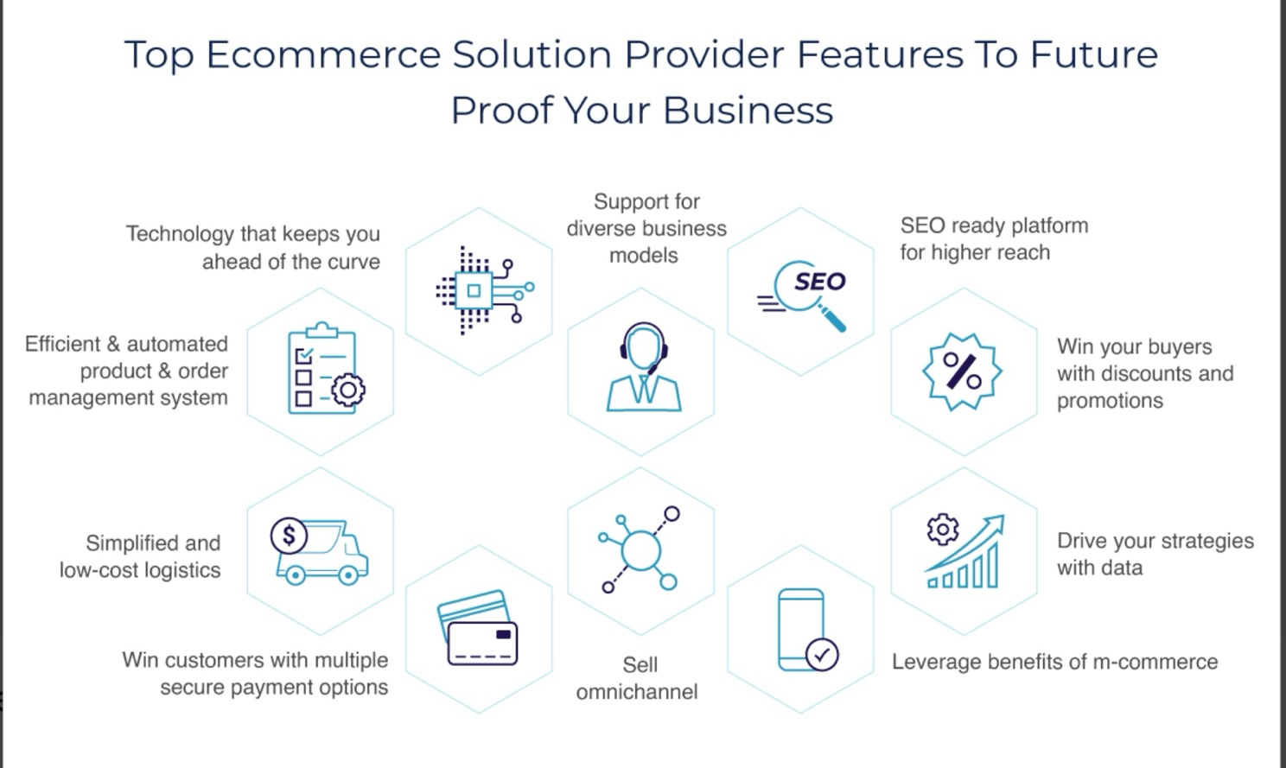

Task 2

Mind-map of Contemporary Software Applications

a. A Contemporary Mind-MAP is a manner of thinking, Ideas, applied to consolidate knowledge and concepts
in the finest way to concretise ideas.
A Mind-MAP is a bridge between your thought and information in a mixture of both information and graphics leading to a successful business in real world, this method has been approved as efficient and suitable to enhance learning resources for students in education industry. Using A Digital Mind-Mapping method, adult students can now be able to establish the link between a gained academic knowledge and information coming out of your mind (your ideas). A Digital Mind-Mapping software is a tool used to put together your knowledge, ideas and your thought while it can also help learners to produce more accurate and nice-looking and visual design. A good Mind-Mapping should. A Digital Mind-Map software can be used as tool to brainstorm your ideas by having a visual concept of your knowledge. Compare to other teaching-learning concept, Digital Mind-mapping software is a fantastic and efficient tool where students can express themselves accurately using visual signs and pictures to display a visible link between student’s ideas and feasibility of the concept in to real world, that can prove student has appropriate knowledge able to evaluate risk and benefit of the business in practice. A good Mind-Mapping will clearly show the link between student’s ideas and the drew concept of Mind-Map therefore this can be use as evidence that student have use his own ideas, though and his academic knowledge to draw a giving Mind-Map. An accurate Mind mapping should identify business difficulties, able to be used in decisions-making and give solutions to business’s challenges.
[4]

Security and software:

A good Modern Mind-Map should have securities measure in place for the safety of both customers and business, therefore use of security software for a secure payment will be beneficial for business efficiency for example, stock management software and drop shipping solutions. Stock Management will significantly reduce the holding costs by making sure you don’t go out of stock or productions which can have direct and positive impact in to the business, therefore a reliable stock management software is a good concept to manage business cost control and manufacture course, Stok management software is useful tool to manage uncertainties in to modern market.

drop shipping system has a great advantage for business as it’s a low startup cost therefore businessmen can start a drop shipping venture with small amount of money because they don’t need to finance a lot of money for store renting or stock analysis. [5]

A regular Internal audit should be in place to identifies weakness of the business which will help with internal issues the business faces to allow the business to deliver a safe and good services to customers, a feedback questionnaire should be provided to business stakeholders as this can enhance business efficiency in the market by increasing professionalism and enhance the quality of a given service to customers due to feedback data received from stakeholders both business and consumers. [6]

b. Create a mind map of contemporary software applications that are used to support day-today business/Organisation operations.

Here is my Mind Map Link below

https://mm.tt/map/3952546410?t=svjo97CMmN

Task 3

Office Applications for Creating, Storing, Presenting, and Analysing Data

Here we need to understand the importance of Data in the first chapter of this study highlights the fundamental issue of data knowledge by showing the need of Data knowledge and worth of Data while making decision. A good Data management will improve the efficiency of decision-making.

Knowledge of handling of data in decision-making. In part we are going to discovers few different data knowledge, schemes as well as collections' showing the function in confronting this subject. It explains the challenges and importance of improved data knowledge; therefore, we need understand the gaps in data literacy training and
policies, also knowing the importance of libraries' task in removing these gaps. Some researchers have concluded that methods, ethical considerations, limits of Data handling in an economy by using Data information in modern Erra would be beneficial as the value of Data has been compared to currency by increasing the value of the economy in term of decision-making and this has become a major source to safeguard accountability
[7]

Therefore, researchers and Data handlers need to train constantly to improve the accuracy of Data literacy.

We have some useful applications that can be used for this process includes:
Power BI, Google Sheets, Microsoft Excel, Microsoft Access, Microsoft world and more, therefore data need to be analysed to allow firms enhance security and comfortable, manageable access to information dada with high standards for better workplace.
The Microsoft 365 suite, including Word, PowerPoint, Excel, and Access, remains the industry-standard software for business operations, facilitating everything from document creation to advanced data management. These applications provide a comprehensive ecosystem that automates tasks, enhances productivity, and secures data through cloud integration.

Microsoft Word (Word Processing)

MS Word is a word processing software tool which is used for designing, editing, and configuring text documents.
We have major feature used with this for example higher formatting tools, text spelling, checks of grammar, Mail Merge for a bunch of documents, prototypes, instantaneous co-authoring, and PDF transfer.
There are a lot of benefits while using MS Word application as this will guarantees professional, coherent document labelling also will facilitate fast document conception by means of pre-designed templates which enhances easy team collaboration.
Like any other software MS Word also has Limits, Complex formatting can break easily in long documents, and it can become slow with enormous graphic-intensive files.

Microsoft PowerPoint

PowerPoint is designed to create visual slideshows to present information efficiently.
The are few major Features which are Slide transitions, animations, rooted multimedia example video and audio, broadcaster view (speaker notes), and Plan Ideas/Creator tab for automatic layout recommendations.
Here are some benefits with Microsoft PowerPoint. Microsoft Office PowerPoint Improves audience commitment throughout visual aids, facilitates intuitive use of design features allowing flawless incorporation of Excel charts and data.
Here are limitations: when there is Significant potential for information overload, this can be distorted to present text-heavy, uninteresting slides also file sizes can become extremely huge.

Microsoft Excel (Spreadsheet Application)

Excel is a spreadsheet tool is used for coordinating, scrutinising, and picturing data using methods and functions provided.
Here are main features for Microsoft Excel: PivotTables, VLOOKUP/XLOOKUP, data visualization (charts/dashboards), Power Query for data transformation, and Macros/VBA for automation.
Here are some benefits for Microsoft Excel: Microsoft is greatly adaptable for financial developing, budgeting, and data analysis, supports rapid, ad hoc calculations and testing of scenarios incorporates with Power BI.
Here are Limitations for Microsoft Excel: Not appropriate for enormous datasets (lack of performance); has small capacity of Data integrity checks for relational database, motionless to human error in complex task.

Microsoft Access (Database Management System)

Access is a relational database management system is a software tool aimed to manage larger datasets by linking tables, enquiries, forms, and statements.
Here are major Features: Relational data constructions, SQL support, GUI-based query producer, individual can customised input forms, it also has automation in tools report. Here are some benefits of Microsoft Access: Microsoft Access can manage huge quantities of data efficiently compare to Excel; Microsoft Access maintains data stability and veracity and allows numerous users to have access with record-level locking.
Here are some limitations: Mainly limited to Windows operating systems; it has less security capacity and ascendable compared to business systems like SQL Server which has a sharper learning curvature. [8] [9]
[6]
By maintaining the uppermost standards for the security of data can allow easy access to huge bench of data records which are very important helping to provide strong evidence for decisions making, this can protect valuable public data therefore using secure procedure of data storage is crucial.
Using automation software for data management will allow users match needed data and avoiding mistake, spending less time, having better quality of work, this can allow workers to share their work ideas within the team in more secure and accurate way. Work needs to be analysed for faster appraisal, and this can have influences in term of understanding decisions-making.

Communication and Collaboration applications
(Approx. 1000 words)

In this chapiter I am going to find a solution using collaboration software for business, tools like Microsoft Team and Microsoft loop which allows multiple users to edit documents concurrently.

Microsoft Teams and Microsoft Loop work together to allow real-time, concurrent editing of documents software tools used by organisations across the world, reports, and duty lists, letting numerous users to co-create and see updates promptly, also co-operate within a shared workspace. Loop component is a portable live structure that allowed information stays among teams. Real-Time Co-Authoring in Teams and Loop
Real-time Component Editing, tables, lists, checklists, paragraphs are created by Loop components to allowed numerous members in team chat or channels to modify inline and see what have been done instantaneously.
Perpetual Synchronising, any change made using a Loop Component can be seen instantly in team anywhere in channels page and anywhere the component is rooted.
Loop Workspaces in Teams, consequently, a team channel account can be added to loop workspace to collect a project-related documents and link the component instantly for live collaboration.
Key Features
Fluid Agenda, Version conflicts have been avoided by using Fluid Framework technology so multi users can modifies content instantaneously.
Circumstantial Collaboration, without switching application, users can use their mind-set or manage task directly with a team chat or meeting.
Moveable Components, work done in a team chat can be copied and pasted into an Outlook email or a loop page without losing its integrity.
Incorporation of AI, simultaneous individual can use Microsoft Copilot across Loop to review content, develop ideas and revise tasks.
Insert Loop Components Loop component can be inserted in a Teams chat or channel by clicking the loop Icon which will allowed individual to add new table, task list and many more.
Loop component can be managed Simultaneously, and chat members can be able to edit content at same time.
By using loop individual can allocate tasks or advise co-workers within the Loop component by means of @mentions, which acts as a dynamic to-do list. [11] [12]
Loop component can be moved to Full Canvas; individual can open the full Loop app interface for a larger for more structured workspace. Loop component has ability to save chat and other content automatically into user’ organisation OneDrive.
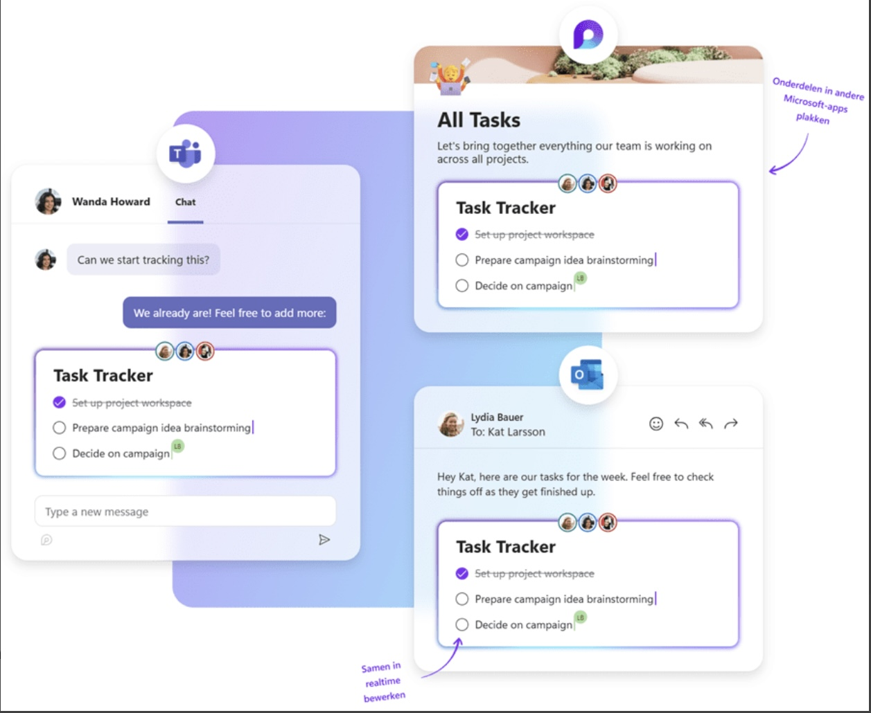 [13]
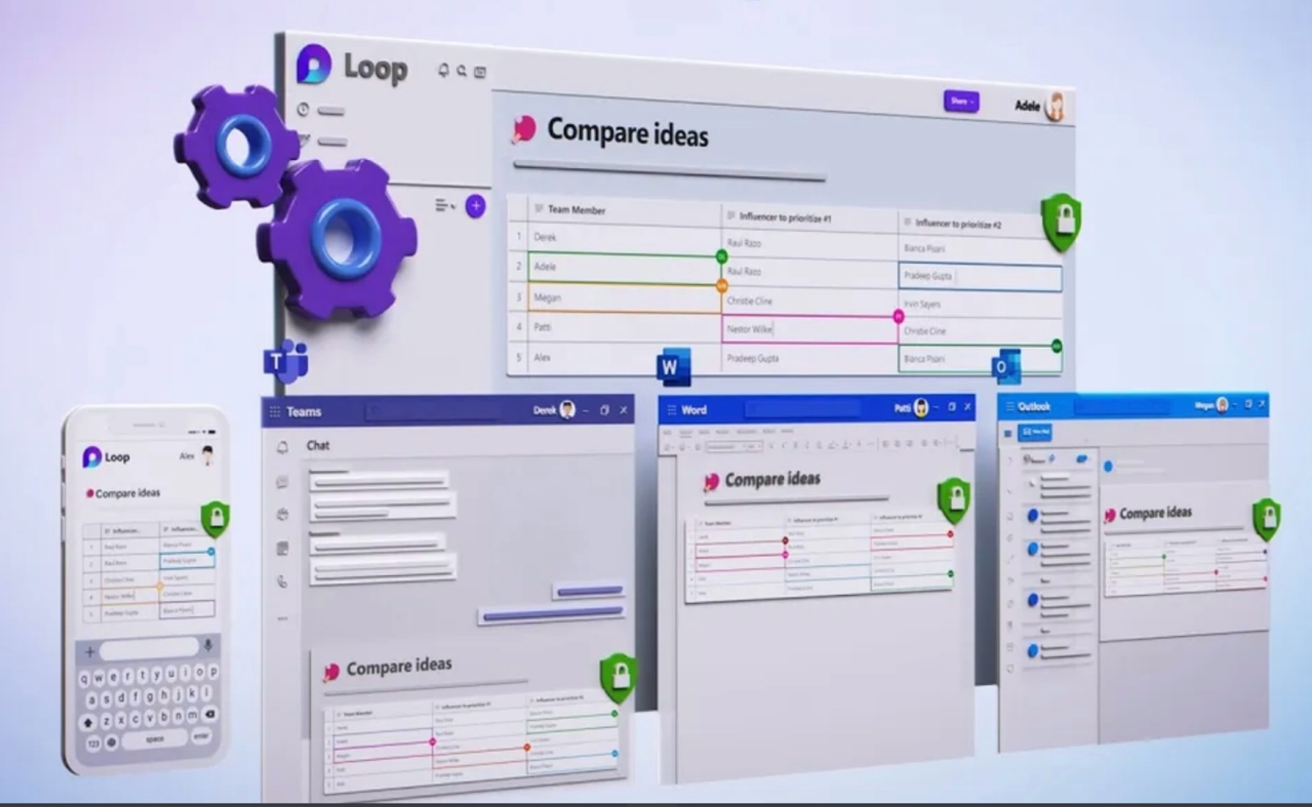 [14]
Analyse one contemporary Communication (Email, MS Teams etc.) and one Collaboration (SharePoint, One Drive etc.) applications/tools used frequently in modern business world and document a summary of their key features, benefits and limitations using written text with some images and relevant citations. (approx. 2/3 sources)

In this topic I am going to explain and analyse E-mail (MS outlouk365), as collaboration application. Email can be used on different support for example it can be considered as desktop-based, mobile apps, or website-based services like (MS outlouk365), It delivers features like inbox management, contact management, book meetings, spam filtering, message categorisation and more.
In another hand E-mail is considered as main method of digital communication, with applications habitually serving as collaborative software tools rather than just simple messaging application. [15] [16]
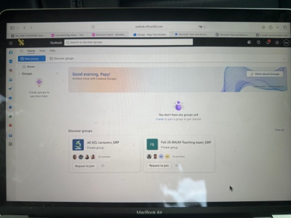
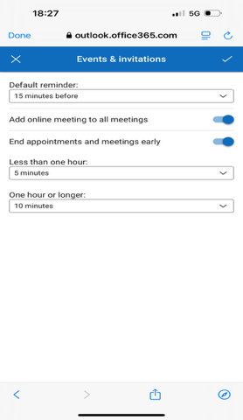
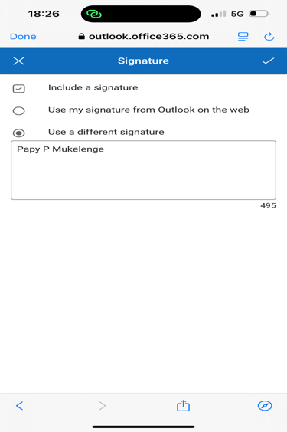

Let talk about communication application, this time I am going to take WhatsApp as a communication application: WhatsApp is mainly extensively used for prompt messaging communication tool. This lets individual to send and receive text messages, make voice & video calls, share multimedia (photos, documents, live location), and create group chats using internet connection. WhatsApp application can be used as personal or business communication application through WhatsApp Business. [17]
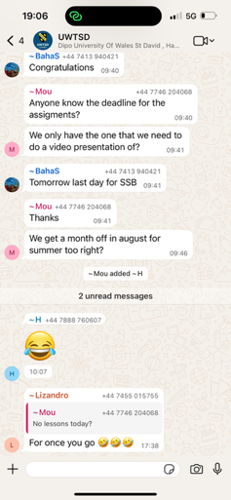


Conclusion

In this assignment I have learned the worth of software solutions in everyday life as individual, and I have also realised the necessity of software solutions in organisation functionality.
As matter of fact this need effective academic knowledge for appropriate software tools handling.
This is my own work acquired from my study and my own research through academic tools across different sources. All My gratitude to my lecturer Amitave Banik.

References

Bibliography

[1] | A. A, Sozinova, K. Nadezhda and Saveleva, “International journal for quality research,” International journal for quality research, 18 Febuary 2022. [Online]. [Accessed 21 Febuary 2026].
[2] | Zumstein and G. Ghodak, “Spring Nature Switzerland,” Spring Nature Switzerland AG, 2025. [Online]. [Accessed 21 Febuary 2026].
[3] | StoreHippo, “StoreHippo,” StoreHippo, 22 Jun 2022. [Online]. Available: https://www.storehippo.com/en/blog/how-a-360-degree-ecommerce-website-builder-can-help-you-future-proof-your-business. [Accessed 21 Febuary 2026].
[4] | Gargouri, Chanaz, Naatus and Mary Kate, E-Journal of Business Educational and Scholarship of Teaching, 2017. [Online]. Available: https://eric.ed.gov/?id=EJ1167335. [Accessed 11 March 2026].
[5] | O. Austine and A. Tiedosto, “THESEUS,” 2025. [Online]. Available: https://www.theseus.fi/handle/10024/908097. [Accessed 11 March 2026].
[6] | S. Al-Okdeh, “IEEE Xplore,” IEEE Xplore, 15 May 2023. [Online]. Available: https://ieeexplore.ieee.org/abstract/document/10111166/authors#authors. [Accessed 11 March 2026].
[7] | Gibson and Mourad, 2018.
[8] | l. F. DAKHIL, M. A. Weffa and A. A. A. REDA, “PRIORITIZING SOFTWARE CAPABILITIES AND FOCAL POINTS OF MS ACCESS AND EXCEL IN PERSPECTIVE OF DATA MANAGEMENT,” vol. 14, pp. 15-30, 2018.
[9] | Packt publishing Ltd, Learn Microsoft Office 2019, Birmingham: Packt publishing Ltd, 2020.
[10] | A. Toomer, “hodigital.blog.gov.uk,” 30 october 2024. [Online]. Available: https://hodigital.blog.gov.uk/2024/10/30/unlocking-the-power-of-data-analysis-at-the-home-office-introducing-the-analytics-workbench/#:~:text=This%20platform%20is%20transformative%20for,and%20management%2C%20analysis%2C%20and%20collaboration.. [Accessed 28 February 2026].
[11] | C. Waghmare, “MR,” 2026.
[12] | M. N. Siddique, A Wahid, MSN Sarker and J Polash, “Documenting team meetings in Microsoft Teams,” Researchgate.net, 2022.
[13] | Valid, “Valid,” Valid, 2026. [Online]. Available: https://www.valid.nl/en/nieuws/microsoft-loop-samenwerken/. [Accessed 27 April 2026].
[14] | T. Andrea, “info.calltower.com,” Calltower, 26 September 2024. [Online]. Available: https://info.calltower.com/blog/revolutionizing-real-time-collaboration-for-teams-users-with-msft-loop. [Accessed 27 April 2026].
[15] | O. Drozd, K. Dmytro, K. Volodymyr and S. Serhiy , “Modeling of collaboration Portals in Microsoft 365,” in Mathematical Modeling and Simulation of System, Springer NaturE Link, 2025, pp. 171-183.
[16] | Ralph Mercurio and B. Merrill, “Beginning Microsoft 365 collaboration Apps,” in Beginning Microsoft 365 collaboration Apps, Springer NaturE Link, 2021.
[17] | N. A. M. Omar, Nur Jijidiana Azmi and A. S. Nurshafawati , “Is whatsapp the future of workplace communication,” Journal of NUSANTARA Studies (JONUS), p. https://journal.unisza.edu.my/jonus/index.php/jonus/article/view/619, 2020.
[18] | D. Dumitru and D. F. Halpern, Effect of Artificial intelligence, Basel: Journal of intelligence, 2023.

https://journal.unisza.edu.my/jonus/index.php/jonus/article/view/619

