Artificial Intelligence and Risk Management in Global Business:
A Strategic Analysis of Tesla Inc. in the United Kingdom and China

University of Wales Trinity Saint David
Assignment Name: Global Business Challenge BMMBS7006
Student Name: Mohmmad Rahil Aabid Hussain Vahora
Student ID: 2508046

Executive Summary
In this report, the strategic implications of artificial intelligence (AI) in Tesla Inc. are assessed in the light of risk management, compliance with regulations, and international business in the United Kingdom and China. Artificial intelligence is at the core of Tesla autonomous driving and efficiency; nonetheless, it also poses serious risks, which should be carefully regulated. The analysis reveals that there are a number of risks. To begin with, safety issues associated with autonomous driving systems will continue to be critical, especially when malfunctions in the system can lead to dire outcomes. Second, the standard of uncertainty brings complexity, with Tesla being subjected to various frameworks in the UK and China.
Third, questions of accountability and trust arise from ethical issues including algorithmic bias and decision making in life-or-death situations. Likewise, organisational exposure is supplemented by cybersecurity risks and data privacy problems. Although there are these risks, AI has huge opportunities. Automation will help Tesla to optimize its operations, minimize long-term expenses and improve its competitiveness in the market of electric vehicles worldwide. Furthermore, the AI-based innovation allows product improvement and differentiation to be done continuously. There is an evident difference between the UK and China as noted in the report.
The UK uses a flexible and safety-based regulatory strategy, which is less likely to be adopted quickly, but facilitates trust. In contrast, China values fast technological progression with strict data control and high state regulation, allowing scaling faster at the cost of higher compliance requirements. To address these challenges, four main recommendations are proposed. A global system of AI governance will be needed first which will strengthen the safety validation systems; localisation of regulatory compliance strategies, and investment in ethical AI transparency to boost its global Approach towards AI governance. All these measures will help Tesla to reconcile the innovation with the responsibility and guarantee sustainable growth and competitive edge in the ever more complicated global landscape.

Contents
Artificial Intelligence and Risk Management in Global Business: 1
Executive Summary 2
2. Introduction 4
3. Global Business Environment (PESTLE Analysis) 5
4. Macro & Micro Economic Impact of AI 9
5. AI & Risk Management in Tesla (Start) 11
5. AI & Risk Management in Tesla (Continued) 11
6. Data Governance, Ethical AI & Customer Trust 13
7. Regulatory Environment (UK vs China) 14
8. Conclusion 16
9. Recommendations + Implementation Plan 16
References 19

2. Introduction
Within this, the transformational growth of artificial intelligence (AI) has altered how businesses globally operate, compete with one another and respond to risk. AI has shifted from a supporting component to a major strategic asset, especially for industries that are tied directly to data and automation. Such a change is most prominent in the automotive industry, where companies are building AI to be part of cars, manufacturing processes and operational standards. In this new era, organizations are inevitably called upon to balance innovation and responsibility when it comes to safety, governance and regulation.
A prime example of this transformation is seen with carmaker Tesla Inc. Rivian has also positioned itself as not just an electric vehicle manufacturer, but a technology company driving towards autonomous cars and AI-powered transit. The Tesla strategy is completely based on machine learning system, processing real-time data and ongoing updates. Although it has facilitated the speed of innovation, this approach has simultaneously raised numerous difficult questions about safety, legal liability and governance of data (Hopkins & Lazonick 2024; Lu 2025).
Arguably, AI is also at the heart of many of Tesla’s self-driving capabilities. Systems like Autopilot and Full Self-Driving (FSD) depend on massive data collection and algorithmic decision making. This technology tends to facilitate driving and reduce human error. However, their use brings up serious questions about the reliability of an ethical decision for the public to trust. For example, the decision-making of autonomous systems needs to be done in a time squeezed manner with uncertain data which sometimes makes it morally compromising. This upswing indicates the looming battle between technological possibility and social acceptability (Zhou, 2023).
This report seeks to provide a roadmap for Tesla leadership on managing AI threats and risks while retaining competitive advantage. Three kinds of analysis all over the crossroads of technological innovation and regulatory pressures on global market dynamics. Specifically, the report considers how Tesla can overcome the difficulties of doing business with competing regulatory environments while still using AI responsibly.
The report covers a comparison of the respective United Kingdom and China. These two areas represent divergent paths of governing AI and growing the market. The UK is more cautious and risks based on regulation, whereas China focuses on fast technological development combined with state control. UK comparison allows for a more nuanced of why global firms need to change different strategies in different institutional contexts.
This report is organized as follows. The first part of the analysis is a PESTLE focused on macro-environmental factors impacting both regions in which Tesla exists within. Then you go into AI effects on the macro and microeconomy. Following closely behind is risk management, data governance and regulatory frameworks. Finally, we shall wrap the report with strategic recommendations and an implementation plan to underpin you on sustainable/ responsible AI adoption.

3. Global Business Environment (PESTLE Analysis)
To assess Tesla’s strategy, it is critical to understand the environment external to the company. The PESTLE framework, which lets you analyse the political, economic, social, technological, legal and environmental factors. In the field of electric and AI vehicles 9,10,11 they are particularly important dimensions as regulations face rapidly changing social and normative pressures (De Sousa & Castañeda-Ayarza et al., 2022; Niño-Suarez et al., 2025).
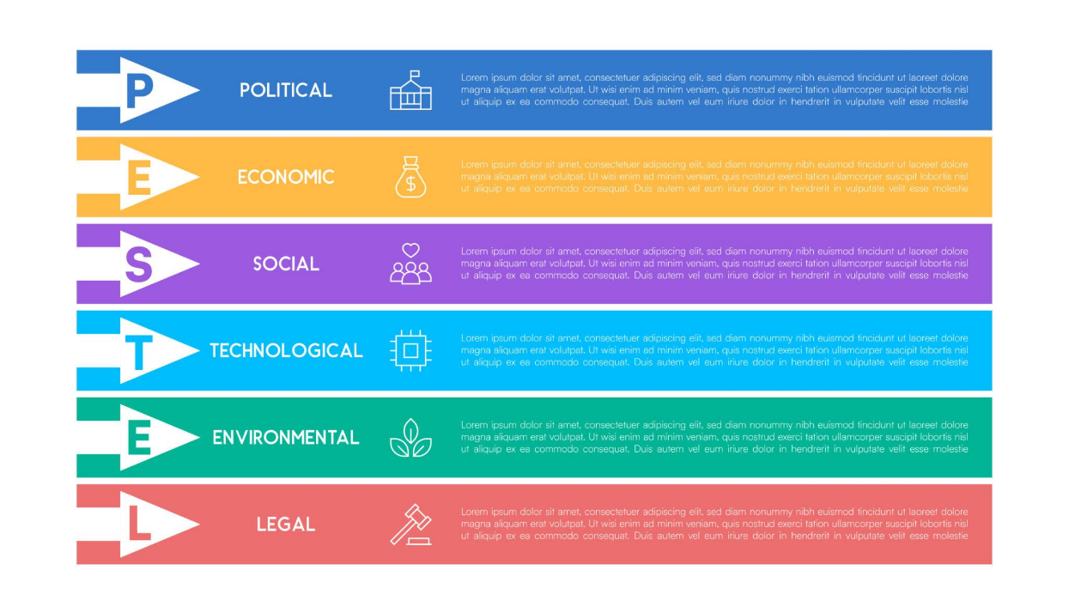
Figure 1: PESTEL analysis overview (International and Ormston, 2025).
Table 1: PESTLE Analysis of Tesla in the UK and China.
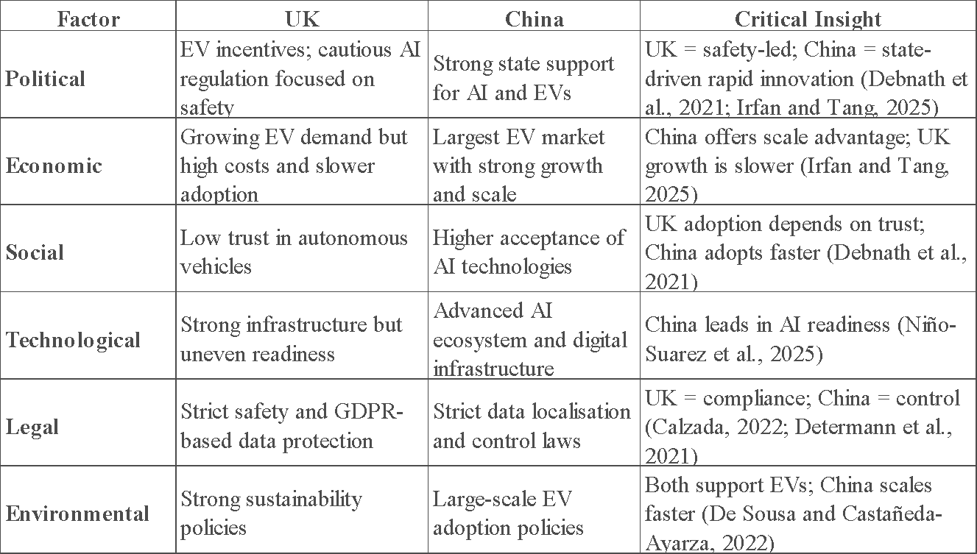
United Kingdom
The UK government was politically very supportive of the move to electrics, with subsidies, continued infrastructure investment and incentives. However, in the case of AI we have a very cautious attitude towards regulation. Policymakers across the globe are particularly attuned to safety and accountability & transparency when it comes to higher-risk applications such as autonomous driving. This promotes regulations that are friendly to innovation but still comes with a huge compliance burden.
From an economic standpoint, the UK has both positive and negatives for Tesla. Environmental awareness and supportive policies are driving the demand for electric vehicles. Conversely, cost pressures continue to be very elevated, especially surrounding infrastructure build and energy costs. These elements could impact both Tesla prices as well as the pathway to market penetration.
Social factors are also important. Self-driving cars: Because it is still unclear how a driverless car will narrow the gap between man and machine to entice a safety and security paranoid public to willingly step into one. Consumer acceptance is, according to some studies, closely related to the perceived risk based on transparency (Debnath et al., 2021). So, Tesla has to try and fix these issues with their own transparency and proof of the system working.
The digital infrastructure here in the UK is strong, but there remains a lot of work to be done on the future of autonomous vehicles. It is possible to use advanced technologies in urban areas, but not necessarily in rural ones. The disparate rates of readiness can hinder the scalability of mobility solutions powered by AI.
The UK has some of the highest legal safety and liability standards. The detailed regulations and the possible consequences of legal issues in case of a failure from the system force autonomous driving systems to comply. This has added crucial importance to effective risk management practices.
Environmentally, sustainability and carbon reduction is very much pushed in the UK. This meshes closely with Tesla's primary value proposition. Environmental expectations, however, are not just limited to production processes and lifecycle emissions which could incur additional operating costs.
China
However, China is a very different story. On the political front, AI and EV development prominently features on China'a national agenda. This builds strong support for creativity and faster expansion. On the other, this support comes with heavy regulation especially around data.
Economically, China is the second largest electric vehicle market globally. D. Tesla is in a sector where demand is high, and governments are giving incentives to accelerate company growth While domestic companies like BYD exert pressing price and innovation pressures (Irfan & Tang, 2025).
We know that Chinese consumers are likely to adopt new technologies quicker than those in the UK, socially. AI-driven systems tend to be widely accepted, albeit with growing data privacy concerns. This sets a dynamic stage with high rates of adoption but shifting expectations.
Once, China was technologically the most progressive in AI development and digital infrastructure. The nation has spent a great deal on smart cities, 5G networks and data infrastructure. This is a foundation for autonomous driving technologies.
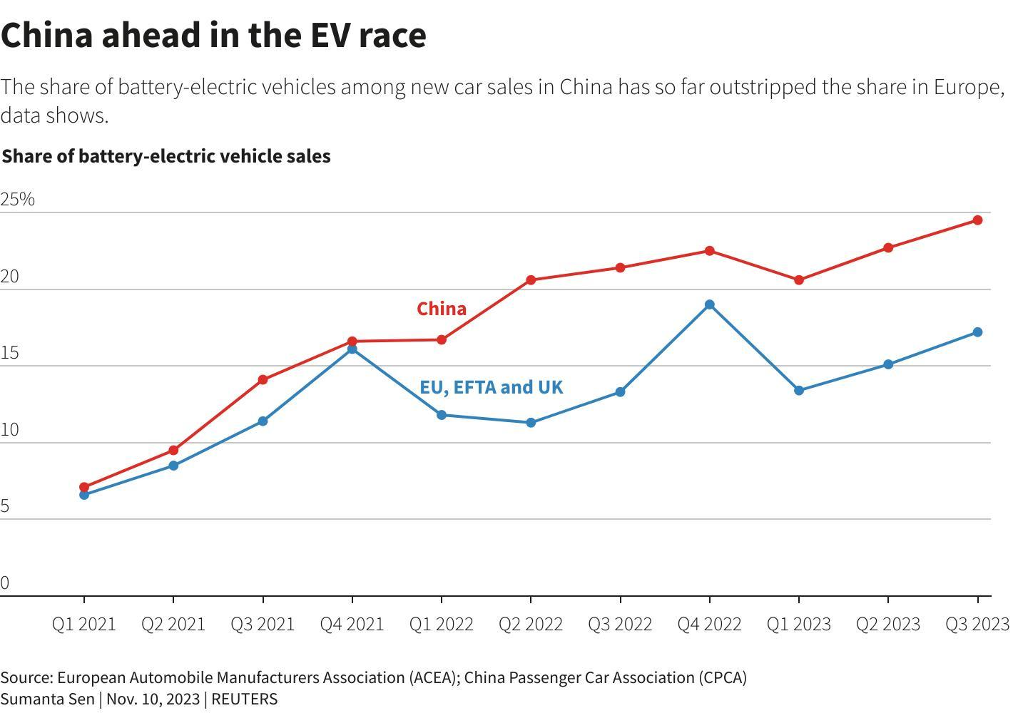
Figure 2: EV market (Visconti, 2023).
At least China has regulatory data localization and privacy laws in place. Laws like the Personal Information Protection Law oblige the storage and management of data in national territory (Calzada, 2022). For multinational companies like Tesla, this makes things even more complicated.
On the environmental front, China is dedicated to emission-cutting and green technologies. It fits with the way Tesla is set up, but environmental regulations do vary per region.
Critical Comparison
Another point of contrast between the UK and China is their regulatory approach. The UK takes a regulatory and ethical approach this may slow down adoption but will create great public trust. China, on the other hand, picks up speed and scale for quick innovations which also means more regulatory control.
This duality presents opportunities and risks for Tesla. The challenge for the company is to ensure compliance this means balancing adherence with flexibility while adjusting its strategies according to institutional contexts. Canz at the exact approach and thus it is important that Barrie (2023) Some Businesses operate span time world which require regional approaches overall strategy coherent.

4. Macro & Micro Economic Impact of AI
Macro-Micro Transformation Whereas AI has started to transform economic structures both at the macro and micro level as seen through such innovations. Globally, it is refashioning labor markets, productivity and competition. It has an impact on cost structures, investment decisions and competitive positioning at the firm level.
Macro-Economic Impact
The most important way macroscopically how AI affects employment. If the job requires repetitive work, automation can step into many centers of grace. If this was applied in an autonomous driving context, it may affect logistics and transport drivers. There is evidence that AI-fueled automation can bring job losses but also more jobs in technology and analytics (Shen and Zhang, 2024; Georgieff and Hyee, 2022).
But the switchover is seldom so smooth. Some workers will lack the skills necessary for new roles resulting in inequality and social upheaval (Cramarenco et al, 2023). It indicates that AI can boost productivity while challenging workforce adaptation.
AI also influences global competition. Companies that implement AI rights can become up to 100 times more efficient than their competition. The result is fierce competition between Tesla and Chinese automakers in the auto space. If succumbing to failure with AI then companies may lose their competitive advantage.
Plus, AI also benefits productivity growth with process computerization and decreases in human error. According to the research AI is expected to enhance decision-making ability and operational efficiency in different industries (Tschang and Almirall 2021). But most of these advantages take considerable initial outlay.
Micro Economic Impact (Tesla)
Table 2: SWOT Analysis of Tesla in the Context of AI and Global Operations.
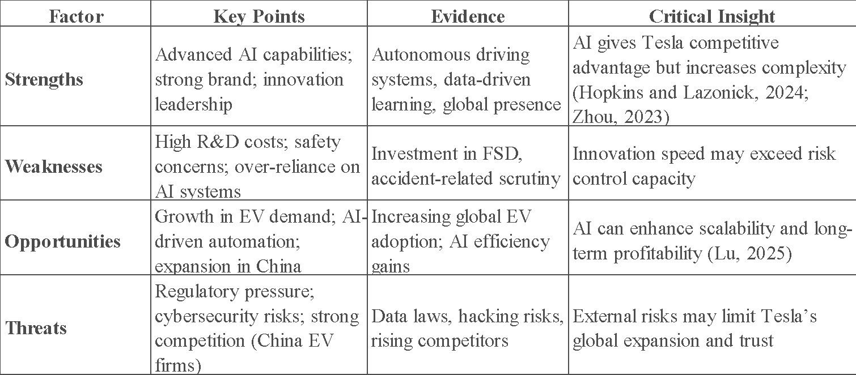
At the level of the firm, artificial intelligence allows Tesla to cut costs by adopting automation. To put it another way, AI powered processes in manufacturing can operate at pace in killing the efficiency and wastage. This in turn will reduce your production costs and increase your profits.
But these benefits require significant investment. Autonomous driving systems are an expensive R&D project. Tesla has to keep putting money into collecting data, improving algorithms and testing the systems. This exposes the financial risk, especially when expected returns do not materialize.
Another item to consider is pricing strategy. Incorporating AI creates value for products that allow Tesla to sell at premium prices. Meanwhile, competition from cheaper manufacturers could restrict pricing headroom. That makes innovation and affordability a competing force.
Critical Evaluation
AI clearly brings some economic advantages and also potential risks. Savings are combined with a high initial capital investment and can be difficult to calculate financially. Further, unequal distribution of benefits possibly creates inequality and resistance in society (Patil, 2024).
Which means, AI can not only be treated as a tool for causing efficiency. Instead, it must be treated as a societal asset for which costs, risk and broad broader-impact society will need to be balanced.

5. AI & Risk Management in Tesla (Start)
On several levels all this integration of AI into Tesla operations entails many intricate risks. These risks are not just technical but also legal, ethical, and reputational. The more autonomous AI systems are, the worse the consequences of failure can be.
Safety Another one of the most important risks identified. Autonomous driving systems must function in inconceivable environments where mistakes refer to disastrous accidents. A tiny decision-making blunder can lead to dire consequences. It emphasizes the significance of comprehensive testing & validation frameworks.
Cybersecurity is another major concern. Considering that connected vehicles heavily rely on data sharing and communication between networks, they are vulnerable to breaches or cyber warfare. Intelligent vehicles are being used but long-term studies indicate that they are increasingly in places where modern technology exposes them to cybersecurity attacks (e.g., hacking and data theft) (Ahmad et al., 2024; Guan et al., 2022). Such risks can put safety and privacy at risk.
Moreover, there is a much larger problem of algorithmic bias. Artificial intelligence systems are trained on biased data These biases pose, risk of negative/unsafe implications if not corrected. This brings forward ethical implications, and questions over the public trust.

5. AI & Risk Management in Tesla (Continued)
Tesla additionally faces operational and legal risks from the complexities of AI systems, on top of safety and cybersecurity concerns. System bugs, sensor limitations, and environmental surprises could impede operational functioning. Predicting these failures is often hard as AI systems themselves are a process of learning and evolution. That will introduce uncertainty and potentially make risk assessment and decisions more difficult.
Legal liability is also a major concern. In normal driving, the human driver is responsible. But liability will be murkier in autonomous systems. That could create challenges in determining if the software, manufacturer or operator is to blame when an accident happens. This ambiguity adds to the risks of litigation and damage to reputation.
These challenges can be addressed by implementing well-defined risk management frameworks for Tesla to adapt. Enterprise Risk Management (ERM), this is a top-down perspective that identifies, assesses, and mitigates risks across the entire organization. Unlike the conventional approaches that treat considerations in isolation of each other, ERM allows the firms to take a hand-on experience and be able to integrate risk considerations with their strategic decision-making process. The issue is especially pertinent for Tesla which carries the closest links between AI risks and innovation/competitive strategy.
ISO 31000 also offers a practical framework for people to tap into risk within their uncertain environment. It highlights the importance of an ongoing, participatory and dynamic process. This system will help Tesla in recognizing risks proactively and responding to them appropriately with the use of ISO principles, which can definitely be a better danger from risk management point of view.
That new framework still keeps cybersecurity front and center. The connected vehicles are often vulnerable to cyber threats, can cause their function and disturb safety. Several studies have focused on the growing vulnerability of intelligent transport systems (Mwanje et al., 2024; Kulkarni et al., 2025) linked to data transmission and/or software verification. This necessitates that Tesla invests in sophisticated security systems like intrusion detection and encryption technologies (Pascale et al., 2021).
Moreover, because AI is by design an adaptive entity that reduces the reliability of system status. The performance gain is ahead to a learning process which continues over time, but this comes at the risk of differentiating models leading into unseen errors. This means that Tesla needs to balance speed of innovation with non-impulsive, thorough testing and validation process.
One of the key observations coming out of this analysis is that Tesla's Accelerated Innovation Strategy may be accelerating beyond Risk Management. In other words, it is a double-edged sword underlying speed competitiveness with increased failure risk. Consequently, the right governance structures to support innovation are necessary in order for any long-term sustainability.

6. Data Governance, Ethical AI & Customer Trust
Central to using AI effectively is the practice of data governance. Long story short, Tesla relies on massive amounts of data from cameras, sensors and even how customers use its cars to help teach its autonomous driving systems. This is the critical data required for training and enhancing algorithm models. But it also opens up the serious issues of privacy, security and compliance.
Good data governance includes implementing transparent policies around data collection, storage and usage. The absence of some level of governance frameworks puts organizations at risk to misuse sensitive information which can bring ethical and legal implications (Gupta, 2022). This is critically important for Tesla because of the size and sensitivity of the data it collects.
Through automation of many processes, AI helps in better data governance and improves decision making. Machine learning tools can, for instance, highlight outliers, assess compliance, and streamline data governance (Gudepu and Eichler 2024). Alternately, it is also risky as the automated systems of AI may not be transparent or accountable.
Privacy issues are quite relevant when it comes to what Tesla has been doing in various locations. While GDPR provides guidelines for the collection and processing of personal information in the EU, UK regulations follow similar principles that champion data security as well as customer consent. However, China has much stricter data localization laws requiring companies to physically store all data in the confines of the national borders. This causes trouble for Tesla, which is forced to alter its data operations in order comply with local regulations.
Ethical considerations are equally important. AI methods ought to be designed to function in a good and accountable approach. Ethical dilemmas in autonomous driving may occur when the system itself must make decisions when harm might come. E.g. to priorities safety in accident scenarios which cannot be avoided how should an AI system decide? All of this raise’s questions about the need for ethical frameworks that direct decision making.
We have also added on the topic of bias in algorithms. If the data used to train AI systems is skewed or lacking, biased results can emerge. Now it endangers public trust, and in turn fairness and safety. To combat bias, you have to work very hard on data selection, monitoring it regularly and assessing it transparently.
Customer Trust: Data governance and ethical AI are intertwined. The assumption is that if consumers believe technology to be safe and have an effective track record, they will adopt it faster. However, trust is a delicate commodity and may be destroyed by one incident or bad press. Studies show that trust is built through transparency and communication (Mattews, Matthis and Emma 2024).
In Tesla's case, you have to keep a lead to stay ahead of the trust. Making how AI systems work, how to show the safety performance and responding according to concerns. Furthermore, companies have to make sure that what they do is acceptable at a societal level and live up to regulatory benchmarks.
From this field of debate, a key contention is that trust might trump online capacity. Regardless of how advanced AI systems are, use will be limited if users do not trust it. As a result, trust needs to be set as a strategic goal by Tesla combining it at technical development and organization level.

7. Regulatory Environment (UK vs China)
This regulatory landscape will have a significant impact on how efficiently Tesla develops and implements AI. This allows regions to take the regulatory approaches that best mirror their economic interests and political systems.
United Kingdom
The UK, with its balanced approach to AI regulation that seeks value and safety. Instead of staking out prescriptive rules, the government refrains to principles and themes, such as transparency, accountability and fairness. At the same time this gives companies the chance to validate innovations at least as long as they are safe.
Still, flexibility is counterbalanced with well-established legal frameworks in data protection and product safety. Laws are strict, in particular with regard to the deployment of high risk technology such as autonomous vehicles. Such builds a conducive regulatory ecosystem as well, one which is challenging and supportive at the same time
China
China, by contrast, is far more exclusive and regulated. The government's been both encouraging the growth of AI but heavily regulating it in other areas (especially data). Since the promulgation of laws such as the Personal Information Protection Law and the Data Security Law, companies are required to manage data with caution (Determann et al., 2021; Chen and Sun, 2021) in accordance with state requirements.
Although the regulations are designed to safeguard national security and personal privacy, they may also raise compliance hurdles for multinational companies. Not only does this require businesses to adjust their operations in accordance with local needs, but these needs can be radically different from what is being practiced elsewhere (Yang, 2022; Verri, 2023).
Comparative Analysis
In fact, the mouthful upgrade between UK and China is that they have got totally different regulatory priorities. The UK prioritises safety and ethics, while in China the emphasis is on control and pace. This forms the dichotomy of flexible versus prescriptive and slow adoption versus rapid scaling.
UK | China
Flexible regulation | Strict regulation
Safety-first approach | Innovation and control
Slower adoption | Rapid scaling
Tesla is not one for all, equal answers do not apply. This difference means that the company has to create region specific solutions while upholding uniformity on the global scale in accordance with local regulations. This entails robust governance structures and a sound knowledge of the regulatory landscape (Guo et al., 2024; Creemers, 2022).

8. Conclusion
In this report we reviewed how AI has impacted on global operations within Tesla and focused specifically on risk, data governance as well regulatory challenges. The analysis points out that AI is both a powerful catalyst for innovation and efficiency and a source of tricky risks that need to be diligently addressed.
The PESTLE analysis shows that Tesla operates in extremely diversified backgrounds and the political, economic and regulatory factors of each differ. If one compares the UK with China, then they essentially represent two very different approaches to innovation and governance that will each require a different type of strategy.
AI and economic analysis: How AI has the potential for productivity/competitiveness gains, but we have inequality and jobs to deal with. According to organization perspective, high investment cost and financial risks are challenges for Tesla but savings few costs and breakthrough innovation help.
One key area is risk management, particularly safety, cybersecurity and legal liability. Frameworks like ERM and ISO 31000 show the way to achieve a more systematic and proactive response.
Ethics and the associated implementation of data governance tensions is also at its centre. Transparency and accountability are essential prerequisites to building trust, and where consumer adoption then follows.

9. Recommendations + Implementation Plan
In conclusion, despite the seriousness of the problem highlighted in this report for Tesla, your people should gain practice in being strategic and systematic with AI governance and risk management before taking on more empirical work (e.g. using students or whether hiring contractors to be short-term practices is worth it). These following recommendations can help you ace long term sustainability and competitive strategy.
Design a Global Governance Framework For AI
Action One: Tesla requires a committed AI governance framework that combines ethical, risk and legal factors. It will need to specify explicit duties, protocols and thresholds for the creation and utilization of AI. That way, Tesla will be able to keep its global strictness and yet adapt to regional laws.
Strengthening Safety Validation Systems
Requirements Test an autonomous system-related technology The unprecedented risks inherent to self-driving are going to mean Tesla needs new systems for safety validation to be properly resourced. This involves lots of testing, simulation and real-time monitoring. You need processes for continuous improvement so as to identify the problems at an early stage and resolve them.
Localize Compliance Strategies
Tesla will have to create local compliance plans for UK/China This means bringing data management in line with where you are and matching operational practices with legal parameters. Utilize your local experts for complex regulatory landscapes.
Prioritize Ethical AI and Transparency
AI ethics need to be addressed at every stage in the life cycle of an AI system. Tesla proved that there is no better transparency than simply saying out loud how the systems work. This will assist to build confidence and address public issues.
Enhance Customer Trust and Engagement
Tesla can earn customers trust only if it communicates and engages better. This includes accessibility of information regarding AI systems, pro-active measures for concerns that arise and simply being gentle into ensuring safety and privacy.
Implementation Plan
Action | Timeline | Cost Level | Risk Level | Expected Outcome
AI safety upgrades | 6–12 months | High | Medium | Reduced accidents and improved reliability
Compliance system development | 3–6 months | Medium | Low | Stronger legal protection and regulatory alignment
Data governance framework | 6 months | Medium | Medium | Improved data security and customer trust
Ethical AI integration | 6–12 months | Medium | Medium | Reduced bias and enhanced transparency
Customer trust initiatives | 3–6 months | Low | Low | Increased adoption and brand reputation

Final Strategic Insight
These recommendations illustrate that governing AI is not just a technical problem but also one of strategy. Tesla has to combine governance, ethics and innovation in a single framework. This way, the firm can lower risks and still keep a strong global leadership position in cars.

References
Abuselidze, G. and Mamaladze, L., 2021, March. The impact of artificial intelligence on employment before and during pandemic: A comparative analysis. In Journal of Physics: Conference Series (Vol. 1840, No. 1, p. 012040). IOP Publishing.
Agarwal, A., Kumar, S., Chilakapati, P. and Abhichandani, S., 2024. Artificial Intelligence in Data Governance Enhancing Security and Compliance in Enterprise Environments. Nanotechnology Perceptions, 20(1), pp.34-45.
Ahmad, J., Zia, M.U., Naqvi, I.H., Chattha, J.N., Butt, F.A., Huang, T. and Xiang, W., 2024. Machine learning and blockchain technologies for cybersecurity in connected vehicles. Wiley interdisciplinary reviews: data mining and knowledge discovery, 14(1), p.e1515.
Barrie, G., 2023. An analysis of Tesla’s market competitiveness using the SWOT-PEST analysis:(TESLA: Transnational Ecosystem Laboratory and Actions). Вестник Томского государственного университета. Экономика, (62), pp.159-170.
Calzada, I., 2022. Citizens’ data privacy in China: The state of the art of the Personal Information Protection Law (PIPL). Smart Cities, 5(3), pp.1129-1150.
Chen, J. and Sun, J., 2021. Understanding the chinese data security law. International Cybersecurity Law Review, 2(2), pp.209-221.
Cramarenco, R.E., Burcă-Voicu, M.I. and Dabija, D.C., 2023. The impact of artificial intelligence (AI) on employees’ skills and well-being in global labor markets: A systematic review. Oeconomia Copernicana, 14(3), pp.731-767.
Creemers, R., 2022. China’s emerging data protection framework. Journal of Cybersecurity, 8(1), p.tyac011.
Cui, S. and Qi, P., 2021. The legal construction of personal information protection and privacy under the Chinese Civil Code. Computer Law & Security Review, 41, p.105560.
De Sousa, G.C. and Castañeda-Ayarza, J.A., 2022. PESTEL analysis and the macro-environmental factors that influence the development of the electric and hybrid vehicles industry in Brazil. Case Studies on Transport Policy, 10(1), pp.686-699.
Debnath, R., Bardhan, R., Reiner, D.M. and Miller, J.R., 2021. Political, economic, social, technological, legal and environmental dimensions of electric vehicle adoption in the United States: A social-media interaction analysis. Renewable and Sustainable Energy Reviews, 152, p.111707.
Determann, L., Ruan, Z.J., Gao, T. and Tam, J., 2021. China’s draft personal information protection law. Journal of Data Protection & Privacy, 4(3), pp.235-259.
Georgieff, A. and Hyee, R., 2022. Artificial intelligence and employment: New cross-country evidence. Frontiers in artificial intelligence, 5, p.832736.
Guan, T., Han, Y., Kang, N., Tang, N., Chen, X. and Wang, S., 2022. An overview of vehicular cybersecurity for intelligent connected vehicles. Sustainability, 14(9), p.5211.
Gudepu, B.K. and Eichler, R., 2024. The role of AI in enhancing data governance strategies. International Journal of Acta Informatica, 3(1), pp.169-186.
Guo, Z., Hao, J. and Kennedy, L., 2024. Protection path of personal data and privacy in China: Moving from monism to dualism in civil law and then in criminal law. Computer Law & Security Review, 52, p.105928.
Gupta, N.N., 2022. How inadequate data governance frameworks lead to unethical outcomes in Artificial Intelligence Systems. International Journal of Science and Research Archive, 7(1), pp.580-590.
Hopkins, M. and Lazonick, W., 2024. Tesla as a Global Competitor: Strategic Control in the EV Transition. Institute for New Economic Thinking Working Paper Series, (225).
Huang, L., 2024. PESTEL and SWOT analysis of electric vehicles development in Thailand.
Irfan, D. and Tang, X., 2025. Evaluating China’s electric vehicle adoption with PESTLE: Stakeholder perspectives on sustainability and adoption barriers. Sustainability, 17(14), p.6258.
Kulkarni, P., Siddharth, T., Pillai, S., Pathak, P., Gangineni, V.N. and Yadav, V., 2025, June. Cybersecurity Threats and Vulnerabilities-A Growing Challenge in Connected Vehicles. In International Conference on Data Analytics & Management (pp. 466-476). Cham: Springer Nature Switzerland.
Lu, Z., 2025, July. An Analysis of Tesla’s Market Position and Future Prospects. In 2025 International Conference on Financial Risk and Investment Management (ICFRIM 2025) (pp. 919-928). Atlantis Press.
Mattews, A. and Emma, O., 2024. The Role of Artificial Intelligence in Automating Data Governance Procedures.
Mwanje, M.D., Kaiwartya, O., Aljaidi, M., Cao, Y., Kumar, S., Jha, D.N., Naser, A. and Lloret, J., 2024. Cyber security analysis of connected vehicles. IET Intelligent Transport Systems, 18(7), pp.1175-1195.
Niño-Suarez, N.A., Flores-Herrera, L.A., Rivera-Blas, R., Calva-Yañez, M.B., Niño-Suárez, P.A., Rivera-Blas, E.Z., Hernández-Galindo, J.E. and Alvarez-Flores, O.A., 2025. A Comprehensive Analysis of Power Electromobility: Challenges from a PESTLE Perspective. Energies, 18(14), p.3632.
Noor, M., Baharom, F. and Mohd, H., 2025. Big Data Governance Framework: Current and Future Trends. Journal of Research and Digital Innovation, 1(1), pp.26-36.
Pascale, F., Adinolfi, E.A., Coppola, S. and Santonicola, E., 2021. Cybersecurity in automotive: An intrusion detection system in connected vehicles. Electronics, 10(15), p.1765.
Patil, D., 2024. Impact of artificial intelligence on employment and workforce development: Risks, opportunities, and socioeconomic implications. Opportunities, And Socioeconomic Implications (November 12, 2024).
Potdar, A., 2024. AI-based big data governance frameworks for secure and compliant data processing. International Journal of Artificial Intelligence, Data Science, and Machine Learning, 5(4), pp.72-80.
R., Subhikshan T., 2023. Impact of Artificial Intelligence on Employment Sector. Issue 2 Indian JL & Legal Rsch., 5, p.1.
Saeed, Z., Masood, M. and Khan, M.U., 2023. A review: Cybersecurity challenges and their solutions in connected and autonomous vehicles (CAVs). JAREE (Journal on Advanced Research in Electrical Engineering), 7(1).
Sharma, A.K. and Sharma, R., 2025. Data governance in the age of artificial intelligence: Challenges, best practices and regulatory compliance. Applied Marketing Analytics, 10(4), pp.390-403.
Shen, Y. and Zhang, X., 2024. The impact of artificial intelligence on employment: the role of virtual agglomeration. Humanities and Social Sciences Communications, 11(1).
Shichun, Y., Zheng, Z., Bin, M., Yifan, Z., Sida, Z., Mingyan, L., Yu, L., Qiangwei, L., Xinan, Z., Mengyue, Z. and Yang, H., 2023. Essential technics of cybersecurity for intelligent connected vehicles: Comprehensive review and perspective. IEEE Internet of Things Journal, 10(24), pp.21787-21810.
Tesla, Inc. (2024) Tesla, Inc. Annual Reports. Available at: Tesla Annual Reports Page
Tsai, P., 2025. How to Build an AI Governance Framework with Data Governance. In Humanism and Artificial Intelligence (pp. 171-186). Cham: Springer Nature Switzerland.
Tschang, F.T. and Almirall, E., 2021. Artificial intelligence as augmenting automation: Implications for employment. Academy of Management Perspectives, 35(4), pp.642-659.
Verri, B., 2023. The Chinese frontiers of data protection: the personal information protection law (PIPL). In Quo Vadis, Sovereignty? New Conceptual and Regulatory Boundaries in the Age of Digital China (pp. 181-197). Cham: Springer Nature Switzerland.
Yang, J., 2022. An Overview of the Chinese “Personal Information Protection Law”. Pin Code, 10(1), pp.8-13.
Zhou, Z., 2023. Tesla marketing analysis. Academic Journal of Business & Management, 5(2), pp.171-7.

