

Assessment 1 – Reading Task Template
PART 1: Upload your photo of your A3 in-class notes here:
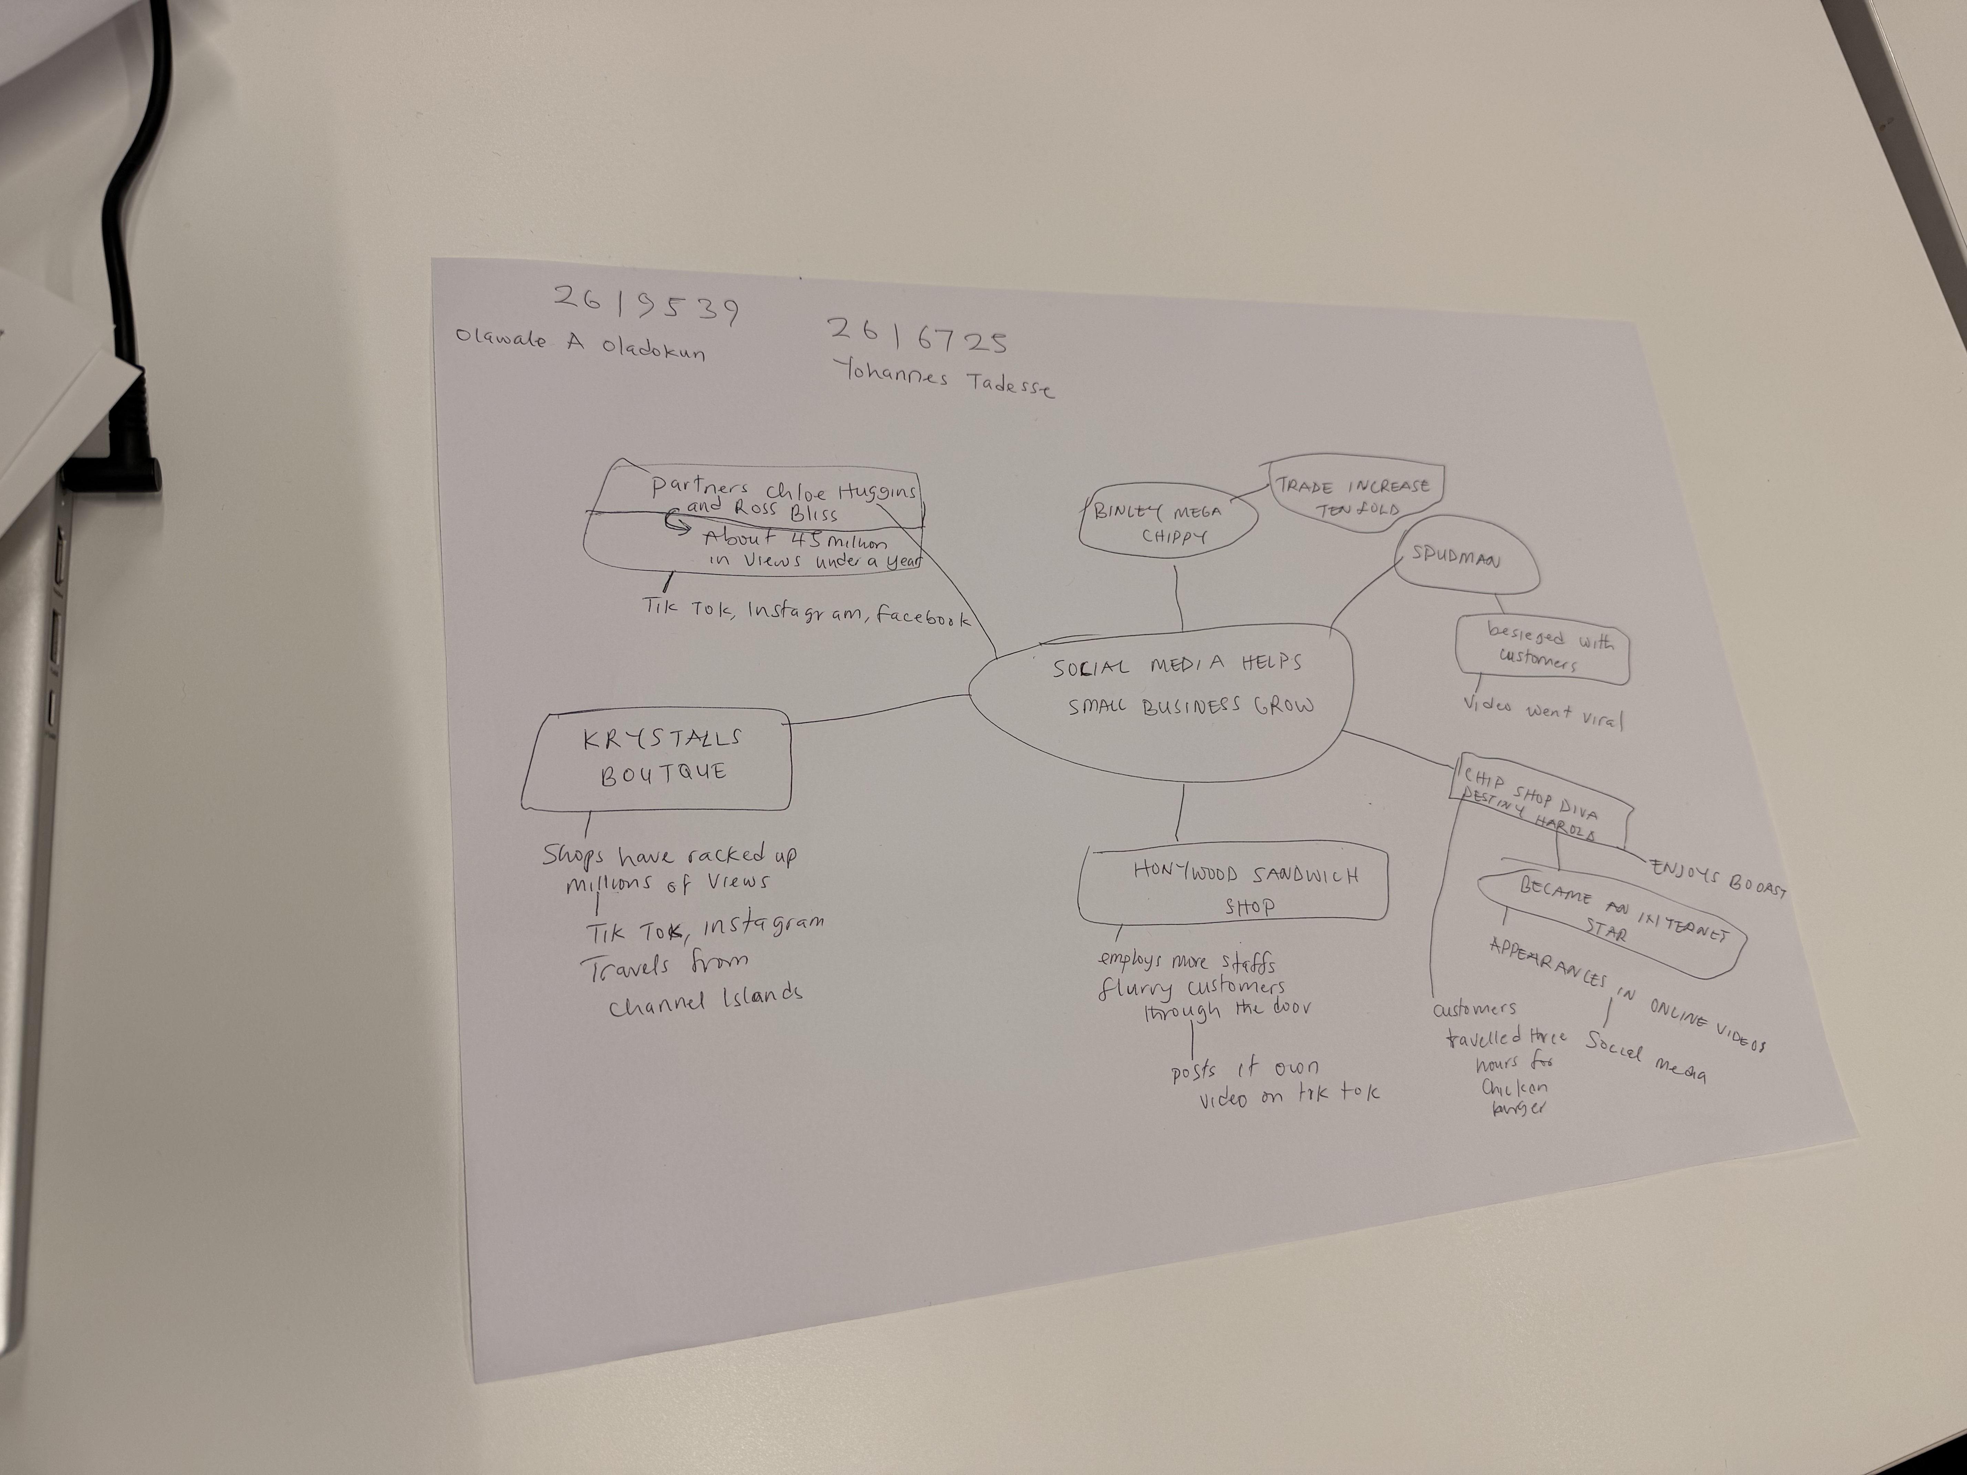

PART 2:
- Answer every question below in 1-3 full sentences.
- Use your own words. Do not use generative AI to answer these questions.
- Include a specific detail from the text when asked.
REMINDER
- The main idea is the overall message of the whole text.
- A key point helps to explain the main idea.
- A specific detail or example from the text shows that the key point is true.

- What is the main idea of the whole text?
The main idea of the article talks about how social media influences businesses positively when it is used as a form of Advert because of its reach.
Social media help businesses grow by making them popular through posts made by the business owners and customers alike. This is possible because social media is easily accessible to more people.

- What is one key point that supports the main idea, and which specific example from the text shows this?
One key point is ‘About 1.5 million businesses operate on Tik Tok, according to figures shared by the social media platform last year’. An example is Krystalls Boutique, a prom dress shop in Leigh on Sea, whose team’s sketches based on funny moments they have observed in the shop have racked up millions of views. She says teenagers travel from the Channel Islands and even Cyprus to pick out a frock after seeing the skits

- What is a different key point that supports the main idea, and which specific example from the text shows this?
Another key point that supports the main idea is according to the government business academy, more than 200 million businesses worldwide are using Instagram to reach customers. An example is Lindy Loo’s Boutique owned by Linda Hunter who had to move the business fully online and ships outfits across the UK and even to Australia.

- Which part of the text do you think is most important, and why?
I think the most important part of the text would be the figures and the facts to back them up because it clearly supports the article to show that indeed social media helps businesses grow when used creatively.

Reflection:
- What did you find difficult in this task (including in-class components), and why was it difficult?
What I found a bit challenging in this task is the making of the mind map itself as the whole idea is new to me but hopefully with more practice I would do better

- What helped you with this difficulty, and how did it help you?
The support from the Lecturer was helpful through her guidance
But more importantly would be the feedback I am anticipating just to get the opinion from her

