

HOTEL PLACEMENT – MANAGING FOOD AND BEVERAGE OPERATIONS

LEVEL 6

Table of Contents
Introduction 3
Discussion 3
Section 1: Reflection on Experience and Personal Development using Gibb’s Model 3
Section 2: Critical evaluation of work-based skills and technical knowledge in the F&B department of Rossington Hall 6
Section 3: Reflection on Organisational Issues at Rossington Hall 6
Conclusion and Action Plan 6
Reference 8

Introduction
The Food and Beverage (F&B) department operations are pivotal to the hospitality industry because they enhance visitors' experiences, which leads to positive reviews and repeat visits (Cousins and Weekes, 2020). It is a major source of business revenue and helps diversify a venue's income while boosting its overall profit (Vallen and Vallen, 2013). I was placed at Rossington Hall during my undergraduate placements. Rossington Hall is a spectacular venue for luxury weddings, dining, events and accommodation from Yorkshire, UK (Rossingtonhall, 2024).
My learning objectives for my placement in Rossington Hall as a trainee supervisor at the F&B department include:
- To enhance teamwork and leadership skills
- To improve time management skills during peak hours
- To adopt transparent communication skills and learn strategies to convey accurate information

Discussion

Section 1: Reflection on Experience and Personal Development using Gibb’s Model
Introduction: I will use Gibb's reflective cycle to describe my role and experience at Rosspington Hall. I was placed as a trainee supervisor at Rossington Hall. During my job there, I have learnt different practical and theoretical management ideas which helped me to solve several professional issues afterwards.
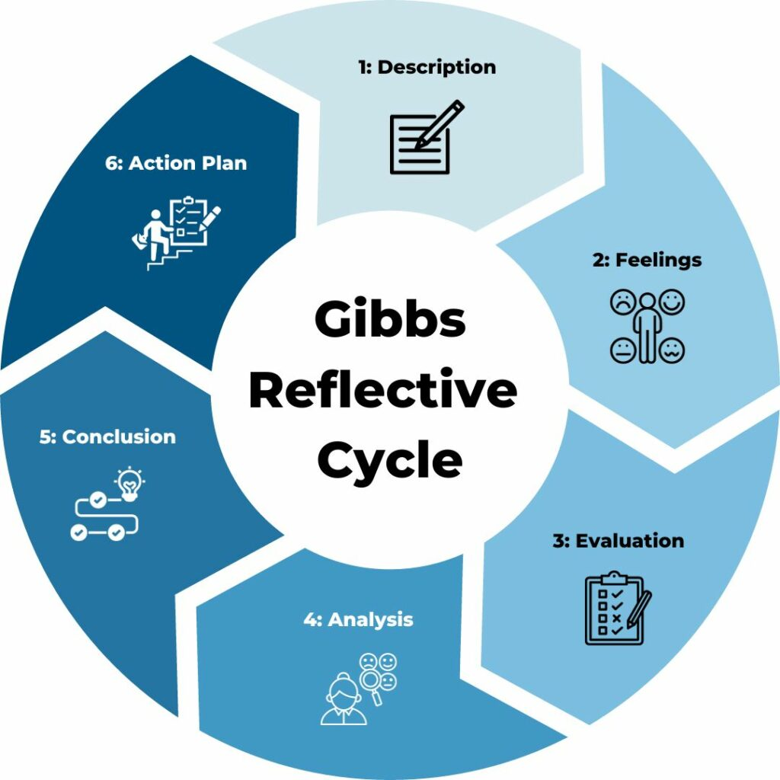
Figure 1: Gibbs reflective cycle
(Source: Adeni et al. 2020)
Description: As a staff of the F&B department, at Rossington Hall, I was in charge of managing a variety of services, like supervising English Breakfast, afternoon tea at a small caffe owned by the hotel called The Lodge and buffet services on wedding events. My responsibilities included ensuring smooth work done, providing excellent services and providing a good dining time for the customers. I handled the afternoon tea setup while assisting, where keeping a refined, tranquil mood and paying special attention to every aspect were crucial. I managed both kitchen organisation and guest relations while supervising the personnel to guarantee the prompt cooking and presenting of conventional English breakfast products for the standard breakfast service. Additionally, I handled the buffet customer service at weddings, ensuring that it was aesthetically pleasing, effectively supplied, and kept up to date concerning sanitation and safety regulations.
Feelings: During this role, I have felt strong frustration and disappointment. Since my initial days at Rossington Hall as a trainee supervisor in the F&B department, I have expected to have practice exposure to the managerial aspects of hotel operations and gain the chance to build my leadership skills. However, I felt disappointed when instead of learning practically, I was repeatedly assigned housekeeping tasks which did not at all align with my career perspectives or goals. I felt underappreciated and undervalued due to a mismatch between my title position and actual responsibilities. This situation has created anxiety and uncertainty regarding service delivery (Johnston and Clark, 2005). In order to reduce my anxiety, I have shifted my focus towards growing from this situation and experience. My colleagues and managers boosted my self-confidence and reinforced the idea that I am not alone.
Evaluation: While evaluating, I can see both negative and positive experiences from my work placement at Rossington Hall. On the positive side, I was able to effectively oversee team collaboration, which resulted in effective customer service at the F&B department of Rossington Hall throughout peak hours. In order to preserve a productive workplace, I was also able to settle disputes inside the group. However, I faced some difficulties as well. For example, I occasionally had trouble communicating clearly while stressed and had trouble managing my time while managing several things at once. It made me more aware of my shortcomings, particularly concerning organisation and more effective work delegation.
Analysis: I have determined that I have to improve 3 of my abilities including time management, effective communication and task delegation. I acquired a lot about time management, leadership and administration from what I learnt. I have seen that effective communication and positive behaviour with the staff can ensure the betterment of both the guests and the workers. However, miscommunications occurred whenever the directions were hurried or imprecise, which affected the quality of the service (Wood, 2020). I also came to the realisation that my reluctance to assign work increased my stress level, making it unsustainable in a hectic environment. In order to boost my overall performance, I had the opportunity to depend on and respect my teammates.
Conclusion: From this experience, I have understood that effective leadership can help to improve the work culture in any organisation. In addition, I believe, effective leaders must also be more approachable and supportive to their teammates.
Action plan: In future, if I face a similar situation, I will ensure to delegate the tasks to my team and support them to every possible extent. I will boost my time management and communication abilities while recognising that it will directly impact the staff morale and the efficiency of my team. I will improve my listening skills and make my instructions clear. I will also maintain a diary to adjust my tasks and keep my progress while seeking advice and feedback from my peers.

Section 2: Critical evaluation of work-based skills and technical knowledge in the F&B department of Rossington Hall
During my role as a trainee supervisor in Rossington Hall, I have gathered several work-based skills which have enhanced my capacities within the hospitality segment of Rossington Hall. Among the most important abilities I acquired was organising my time. In order to make certain every service went well, I needed to meticulously prioritise duties and arrange timetables while overseeing many services, including afternoon tea, brunch operations or English Breakfast in the lodge. I rapidly gained the ability to foresee peak times, assign tasks effectively, and adapt when unforeseen difficulties emerge. This talent has strengthened my capacity to manage demanding situations and remain calm under duress. I have developed technical skills in important F&B tasks like buffet layout, drink planning, and table setup, guaranteeing compliance with Rossington Hall's expectations for service. I tried to set precise standards, set an example of excellence, and continue to demonstrate my approachability because part of my job was to oversee staff members and ensure they provided exceptional customer service.

Section 3: Reflection on Organisational Issues at Rossington Hall
I have seen that the F&B department of Rossington Hall faces numerous inventory issues at their F&B departments such as space management, assembly, scheduling and perishability. It is followed by a lowering of the revenue margins as a consequence of large wastage, staff workflow and extensive rework (Agarwal, 2021). I understood that the lack of transparent communication between housekeeping and the F&B department has led to service delays and created confusion. For example, I missed specific dietary requirements due to miscommunication and disrupted workflow during a large wedding occasion in our hotel. These organisational issues may create guest dissatisfaction and create a ripple effect on the brand itself (Mandić and Walia, 2023). According to Tuckman's 5 stages of group development theory, teams develop the ability and maturity to establish supportive relationships among themselves (Zirar et al. 2023). It also ensures a collaborative approach for shared leadership. This theory can address issues by refining job allocation and team building among F&B staff and boosting team communication for smoother operation in future (Mahmoudpour et al. 2024).

Conclusion and Action Plan
Throughout my reflection journey, I discovered how crucial it is to pay close attention to meal displays and table arrangements as these minor details have a big influence on visitor satisfaction. My knowledge of safety and health laws, especially those on preparing food and ensuring hygiene, has also improved as a result of my hands-on work. I believe these norms are crucial for ensuring compliance and security for clients across every hotel setting. In future, I will develop teamwork and leadership which is a crucial work-related ability for our job.

Reference
Adeani, I.S., Febriani, R.B. and Syafryadin, S., 2020. Using GIBBS’reflective cycle in making reflections of literary analysis. Indonesian EFL Journal, 6(2), pp.139-148.
Agarwal, N., 2021. A STUDY OF IMPORTANCE OF COMMUNICATION SKILLS FOR EMPLOYABILITY IN THE HOSPITALITY INDUSTRY. NeuroQuantology, 19(12), p.585.
Cousins, J. and Weekes, S., 2020. Food and beverage service. Hachette UK.
Johnston, R. and Clark, G., 2005. Service operations management: improving service delivery. Pearson Education.
Mahmoudpour, F., Gholipour, A. and Carmen Galang, M., 2024. Enhancing team building in project-oriented organizations: An arts-based approach. Human Systems Management, p.01672533241290939.
Mandić, A. and Walia, S.K. eds., 2023. The Routledge handbook of nature based tourism development. Routledge.
Rossingtonhall, 2024. Tasting menu, afternoon tea and Sunday lunch at Rossington Hall. Available at: https://rossingtonhall.co.uk/restaurant/ [Accessed on: 12 November 2024].
Vallen, G.K. and Vallen, J.J., 2013. Check-in check-out: Managing hotel operations. Pearson.
Wood, R.C., 2020. Events and hospitality. In The Routledge Handbook of Events (pp. 93-104). Routledge.
Zirar, A., Muhammad, N., Upadhyay, A., Kumar, A. and Garza-Reyes, J.A., 2023. Exploring lean team development from the Tuckman’s model perspective. Production Planning & Control, pp.1-22.

