

Student Name: Molly Ndoya

Student Number: 2423296

Module Code: LCHS4010

Module Title: Psychology in Health and Social Care

Lecturer’s Name: Neale Haddon

Assignment Title: Assignment 2: Written Task

Table of Contents
Introduction 3
1. Setting: Old People Living in a Dementia Care Home 4
2. Detailed Overview of Two Theories 5
3. Application in the Health and Social Care context 8
Critically evaluating how each theory can be applied in the chosen health care 8
Demonstrating how these theories can assist professionals 8
Discussing potential challenges for professionals 9
Conclusion 10
Reference list 11

Introduction
Psychology is very crucial in human behaviour and in assisting people throughout the lifespan. In the case of the elderly, especially due to cognitive impairments like dementia, psychological theories offer a fundamental framework of interpreting emotional, behavioural and cognitive changes. This report will evaluate a residential care home in the UK. This care home is for adults aged 65 and above living with dementia. The people living in such settings usually have memory lapses, orientation, and emotional pain that may affect their interaction with others and their closeness to caregivers.
This report will critically evaluate two theories, such as Bowlby’s Attachment Theory and Piaget’s Cognitive Development Theory, to develop an understanding of how emotional and cognitive development can be used to inform dementia care practices. The lifelong requirement to have secure emotional relationships is emphasised in the work of Bowlby, whereas the theory by Piaget describes the cognitive processes development and deterioration during the ageing process. The report will critically explain how the theories are applicable in the environment of Care Home, and ways of assisting the emotional and cognitive aspects of older adults.

1. Setting: Old People Living in a Dementia Care Home
The dementia care homes in the UK offer residential care to elderly individuals who suffer progressive cognitive decline, memory impairment, and communication and social functioning problems. The Care Home is a facility offering specialised care to elderly adults aged 65 years and above with different levels of dementia. This care home has 24-hour nursing, customised care planning, and organised social activities that improve the quality of life (Care UK, 2023).
Challenges encountered by older adults in dementia care homes include confusion, disorientation, anxiety, and withdrawal of social interactions. These alterations not only impact the cognitive functions, but also emotional reactions and attachment mechanisms to the caregivers (Wang et al., 2023). A significant number of residents lose places of comfort and meet new relationships, lose their families, and adapt to new relationships in the care environment, which may lead to the development of emotional insecurity and distress. Therefore, the employees need a solid knowledge of psychology theories to be empathetic and help stimulate cognitive and emotional health. Hence, the care homes can follow Bowlby’s Attachment Theory and Piaget’s Cognitive Development Theory to analyse psychological perspectives of older adults who are suffering from dementia.

2. Detailed Overview of Two Theories
Bowlby’s Attachment Theory
Definition
According to the Attachment Theory, human beings are endowed with the desire to develop secure emotional relationships with their carers as this relationship offers safety, comfort and stability in life (Robledo et al., 2022). Early attachment influences the person in their adulthood through their ca
capacity to trust, communicate and maintain relationships. Individuals can become anxious, lonely and suffer emotionally when attachment bonds are broken.
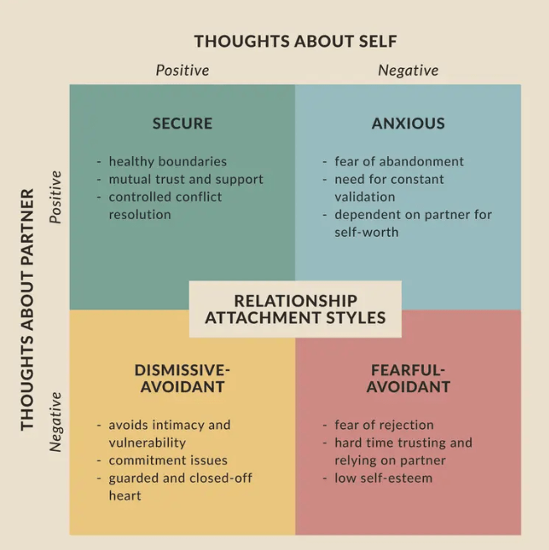
Figure 1: Bowlby’s Attachment Theory
(Source: Robledo et al., 2022)
Relevance
Attachment has been found to play a crucial role in behaviour and emotional regulation in adult development. In older adults, especially those with dementia, the attachment increased with carers due to excessive dependency on them, which leads to a higher reliance on the individual as a source of reassurance and safety. Attachment anxiety can be produced by loss of familiar relationships (Behrens et al., 2025). This situation applies to older adults who are suffering from dementia.

Detailed explanation
In the Care Home, the attachment theory helps staff members to establish regular and compassionate relationships with residents. Moreover, carers should be responsive to the emotions of residents, which is crucial to preserving the mental well-being and confidence in care contexts (Robledo et al., 2022). Consequently, Bowlby's theory is an excellent psychological concept that can be applied in facilitating emotional safety among older adults living with dementia.
Piaget’s Cognitive Development Theory
Definition
The Cognitive Development Theory explains that people obtain, arrange, and apply knowledge at various stages of their lives. Piaget theorised four essential levels, such as sensorimotor, preoperational, concrete operational and formal operational levels (Pakpahan and Saragih, 2022). This theory applies to the current state of the development of cognitive abilities, which can even decrease in some cases during adulthood.
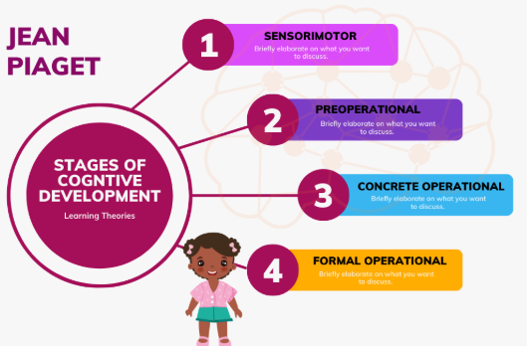
Figure 2: Piaget’s Cognitive Development Theory
(Source: Pakpahan and Saragih, 2022)
Relevance
Among the older individuals and those with dementia, the cognitive regression may reflect the previous stages of development since their memory, thinking, and language are impaired. The effect of this decline is seen in decision-making, problem-solving and emotional control (Chahrak, 2024). Knowledge of these changes can assist health professionals to adjust communication, bring structured routines, and develop interventions that correspond to the cognitive ability of the residents.
Detailed explanation
At the Care Home, person-centred approaches are followed by the Piaget theory that promotes cognitive stimulation and arousal. As an example, memory games, reminiscence therapy, and repetition of familiar tasks are conducted to maintain cognitive ability for older adults who are suffering from dementia. Analysing the cognitive limitations of dementia patients helps caregivers to develop care plans as per the needs (Chahrak, 2024). Therefore, Cognitive Development Theory is appropriate for dementia care as the interventions for the cognitive stages of residents help to foster dignity and mental health well-being.

3. Application in the Health and Social Care context

Critically evaluating how each theory can be applied in the chosen health care
The Attachment Theory facilitates emotional balance by underlining the need to attach to a regime, nurturing relationships between carers (Momeni et al., 2022). Similarly, the Cognitive Development Theory promotes cognitive stimulation and organises tasks according to the mental capacities of older adults, which promotes memory and involvement in emotions. Therefore, the Attachment Theory and the Cognitive Development Theory are both useful for caring for older adults with dementia in Care Home.
On the contrary, there are limitations in applying the theories in practice as well. Bowlby's Attachment model is mainly founded on the child-parent attachment, which might be simplified due to the emotional needs of older adults since dementia changes the patterns of attachment and emotional expression (Pakpahan and Saragih, 2022). Similarly, Piaget's Cognitive Development theory sometimes avoids the role of social and emotional aspects in cognitive loss, emphasising primarily the logic instead of the experience of living with dementia. Nonetheless, a combination of these two frameworks can help the staff of the care home to provide holistic, person-centred care with both emotional security and cognitive support, which will eventually enhance the quality of life and psychological well-being of residents.

Demonstrating how these theories can assist professionals
Psychological theory in the Care Home allows the professionals to deal with the general issues associated with dementia, which include anxiety, confusion, and aggression. Applying the Attachment Theory, staff members develop trust, personalised communication, and give emotional assurances (Momeni et al., 2022). As an example, care workers in the healthcare setting are assigned to help eliminate the fear and agitation among patients when performing personal care routines. Emotional well-being is fostered through the encouragement of family visits and enhancing social interaction. This is only possible with proper staffing and emotional competence. High staff turnover might ruin attachment relationships, leaving residents more distressed.
Based on the Cognitive Development Theory, carers plan activities based on the cognitive development levels of the dementia patients (Sharkiya, 2023). The health care professionals of the Care plan different activities to help people with dementia live healthy lives, such as reminiscence therapy, art or music sessions to foster memory and stay in touch with identity. However, these measures might not be as effective for older adults who are in late dementia stages, as cognitive decline impairs activity. Furthermore, the excessive focus on structured tasks may limit autonomy unless it is balanced with individual preferences. Hence, both of these theories improve empathy, stability, cognitive stimulation, emotional intelligence, and interventions to meet the needs of person-centred care of dementia.

Discussing potential challenges for professionals
The Attachment Theory creates different challenges for professionals in the Care Home. Stable carer-resident relationships are one of the most serious challenges because the low retention and high workload rates may interrupt the attachment relationships and decrease the continuity of emotions (Sagone et al., 2023). Additionally, dementia patients might not be in a position to verbalise the need to be attached, which results in behavioural distress that is challenging to solve. In this regard, emotional intelligence and non-verbal communication should be staff-trained. The use of key-worker systems and adherence to the same routine can lead to stability and trust, as well.
On the other hand, the Piaget theory cannot be implemented due to the progressive nature of dementia, which leads to unpredictable deterioration of cognitive abilities (Schuhmacher et al., 2022). Flexibility and frequent evaluation are necessary to design activities that correspond to the personal cognitive strengths. The professionals of the Care Home might not have time and resources to personalise interventions, which leads to frustration among staff and residents. Multidisciplinary collaboration, person-centred care planning and involvement of family members are some of the strategies that can be used to maintain continuity and relevance of activities.

Conclusion
It can be concluded that Attachment Theory and the Cognitive Development Theory by Piaget are useful in psychology in supporting the needs of older adults with the condition of dementia at the Care Home. The emotional security, as developed by Bowlby, is used to ensure the staff develops trust and lower anxiety, whereas the Piaget framework is used to facilitate cognitive stimulation and meaningful interaction.

Reference list
Behrens, K.Y., Jones-Mason, K. and Forslund, T. (2025) ‘John Bowlby’s theory of attachment and separation: revisiting his original visions after 50+ years, what we know today, and where to go from here?’, Attachment & Human Development, 23(8), pp. 1–5. Available at: https://doi.org/10.1080/14616734.2025.2550829.
Chahrak, N. (2024) ‘Older Adult Education in the Context of Psychological Theories of Ageing’, Journal of Vasyl Stefanyk Precarpathian National University, 11(3), pp. 56–67. Available at: https://doi.org/10.15330/jpnu.11.3.56-67.
Momeni, K., Amani, R., Janjani, P., Majzoobi, M.R., Forstmeier, S. and Nosrati, P. (2022) ‘Attachment styles and happiness in the elderly: the mediating role of reminiscence styles’, BMC Geriatrics, 22(1), pp. 1378–1397. Available at: https://doi.org/10.1186/s12877-022-03053-z.
Pakpahan, F.H. and Saragih, M. (2022) ‘Theory of Cognitive Development by Jean Piaget’, Journal of Applied Linguistics, 2(2), pp. 55–60. Available at: https://doi.org/10.52622/joal.v2i2.79.
Robledo, J.-P., Cross, I., Boada-Bayona, L. and Demogeot, N. (2022) ‘Back to basics: a re-evaluation of the Relevance of Imprinting in the Genesis of Bowlby’s Attachment Theory’, Frontiers in Psychology, 13(1), pp. 103–374. Available at: https://doi.org/10.3389/fpsyg.2022.1033746.
Sagone, E., Commodari, E., Indiana, M.L. and La Rosa, V.L. (2023) ‘Exploring the association between attachment style, psychological well-being, and relationship status in young adults and adults—a cross-sectional study’, European Journal of Investigation in Health, Psychology and Education, 13(3), pp. 525–539. Available at: https://doi.org/10.3390/ejihpe13030040.
Schuhmacher, T.P., Andresen, M. and Fallahpour, M. (2022) ‘Clinical reasoning of occupational therapists in selecting activities together with older adults with dementia to postpone further development of cognitive decline’, Scandinavian Journal of Occupational Therapy, 30(1), pp. 1–11. Available at: https://doi.org/10.1080/11038128.2022.2112282.
Sharkiya, S.H. (2023) ‘Quality communication can improve patient-centred health outcomes among older patients: A rapid review’, BMC Health Services Research, 23(1), pp. 1–14. Available at: https://doi.org/10.1186/s12913-023-09869-8.
Wang, Y., Xu, H., Geng, Z., Geng, G. and Zhang, F. (2023) ‘Dementia and the history of disease in older adults in community’, BMC Public Health, 23(1), pp. 23–60. Available at: https://doi.org/10.1186/s12889-023-16494-x.

