Operating system
Mathis Villa (2501611)

Table of Contents
Task 1 Key functions of general Operating Systems 2
TASK 2 Use of Windows OS CLI commands 6
Task 3 Use of Linux OS CLI commands 14
File and Directory Management 17
Network Testing and Monitoring 19
User Management 21
Task Scheduling 22
Task 4 Use of Windows OS scripts 23
Task 5 Use of Linux OS scripts 26
Conclusion 28

Task 1 Key functions of general Operating Systems
An operating system can be defined as “software that allows other programs like word processors and web browsers to be installed and run on a computer” [1]. The Windows operating system is mainly designed to manage the computer’s hardware and software. The operating system has a user-friendly design where users are able to understand which applications are running and how much memory space is being consumed. The Windows operating system also serves multiple purposes - the user can check different settings such as memory, app performance, users, app history and many more.
One of the most important functions in the Windows operating system is the graphical user interface, also known as the GUI. The GUI includes multiple functions such as the start menu, desktop, taskbar, icons and Windows. These key features allow a simple, user-friendly way of accessing and managing files. It also allows users to find and switch between tasks and files, as seen in Figure 1.[2]
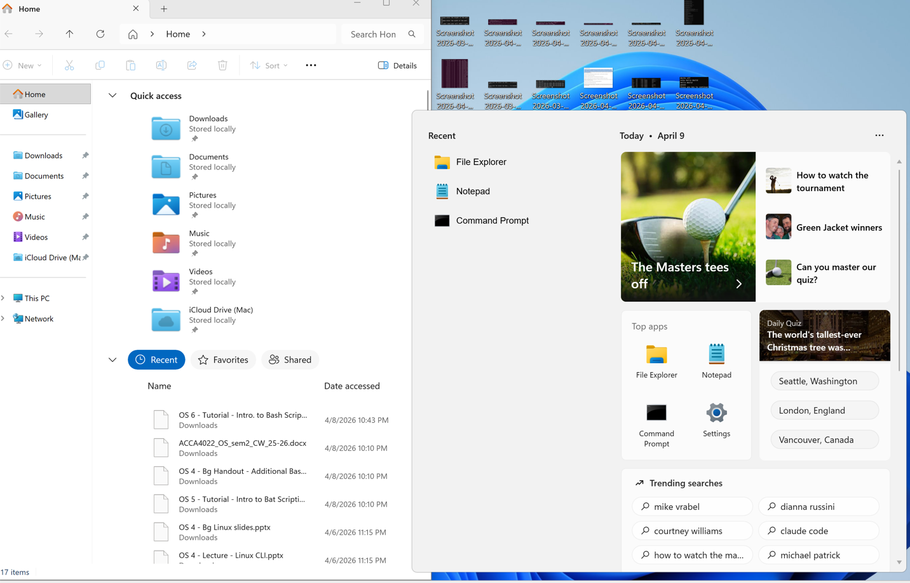
Figure 1 shows windows GUI
For instance, the Start Menu section gives access to pre-installed programs, and the taskbar also shows currently opened applications and other controls such as Wi-Fi and battery.
Another key tool in the Windows operating system is Task Manager. Task Manager allows the user to manage and monitor apps and systems that are running on the computer. Task Manager covers a wide range of factors (see Figure 2) such as:
- Applications currently running
- Background processes
- CPU usage
- Memory usage (RAM)
- Disk activity
- Network activity
- Startup programs

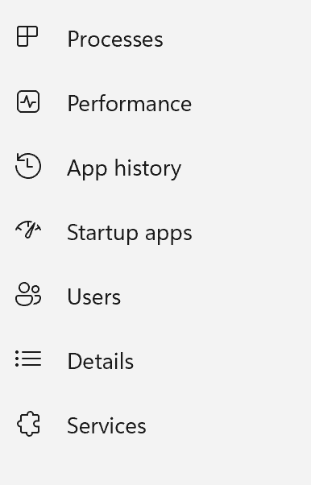
Figure 2 shows the different options available in Task Manager

One of the main functions of Task Manger is managing and controlling system resources. Managing and controlling system resources is very important as it decides how much power and memory each application and system receives, enabling multiple apps to run at the same time without causing excessive lag on the machine. As a result, Task Manager allows the user to identify which application is using the most resources and to see whether it should be shut down or not[3], as seen in Figure 3 where the Task Manager app is using 1.1% of overall power This simple function is very useful for users as it allows them to control their computer’s hardware and software.

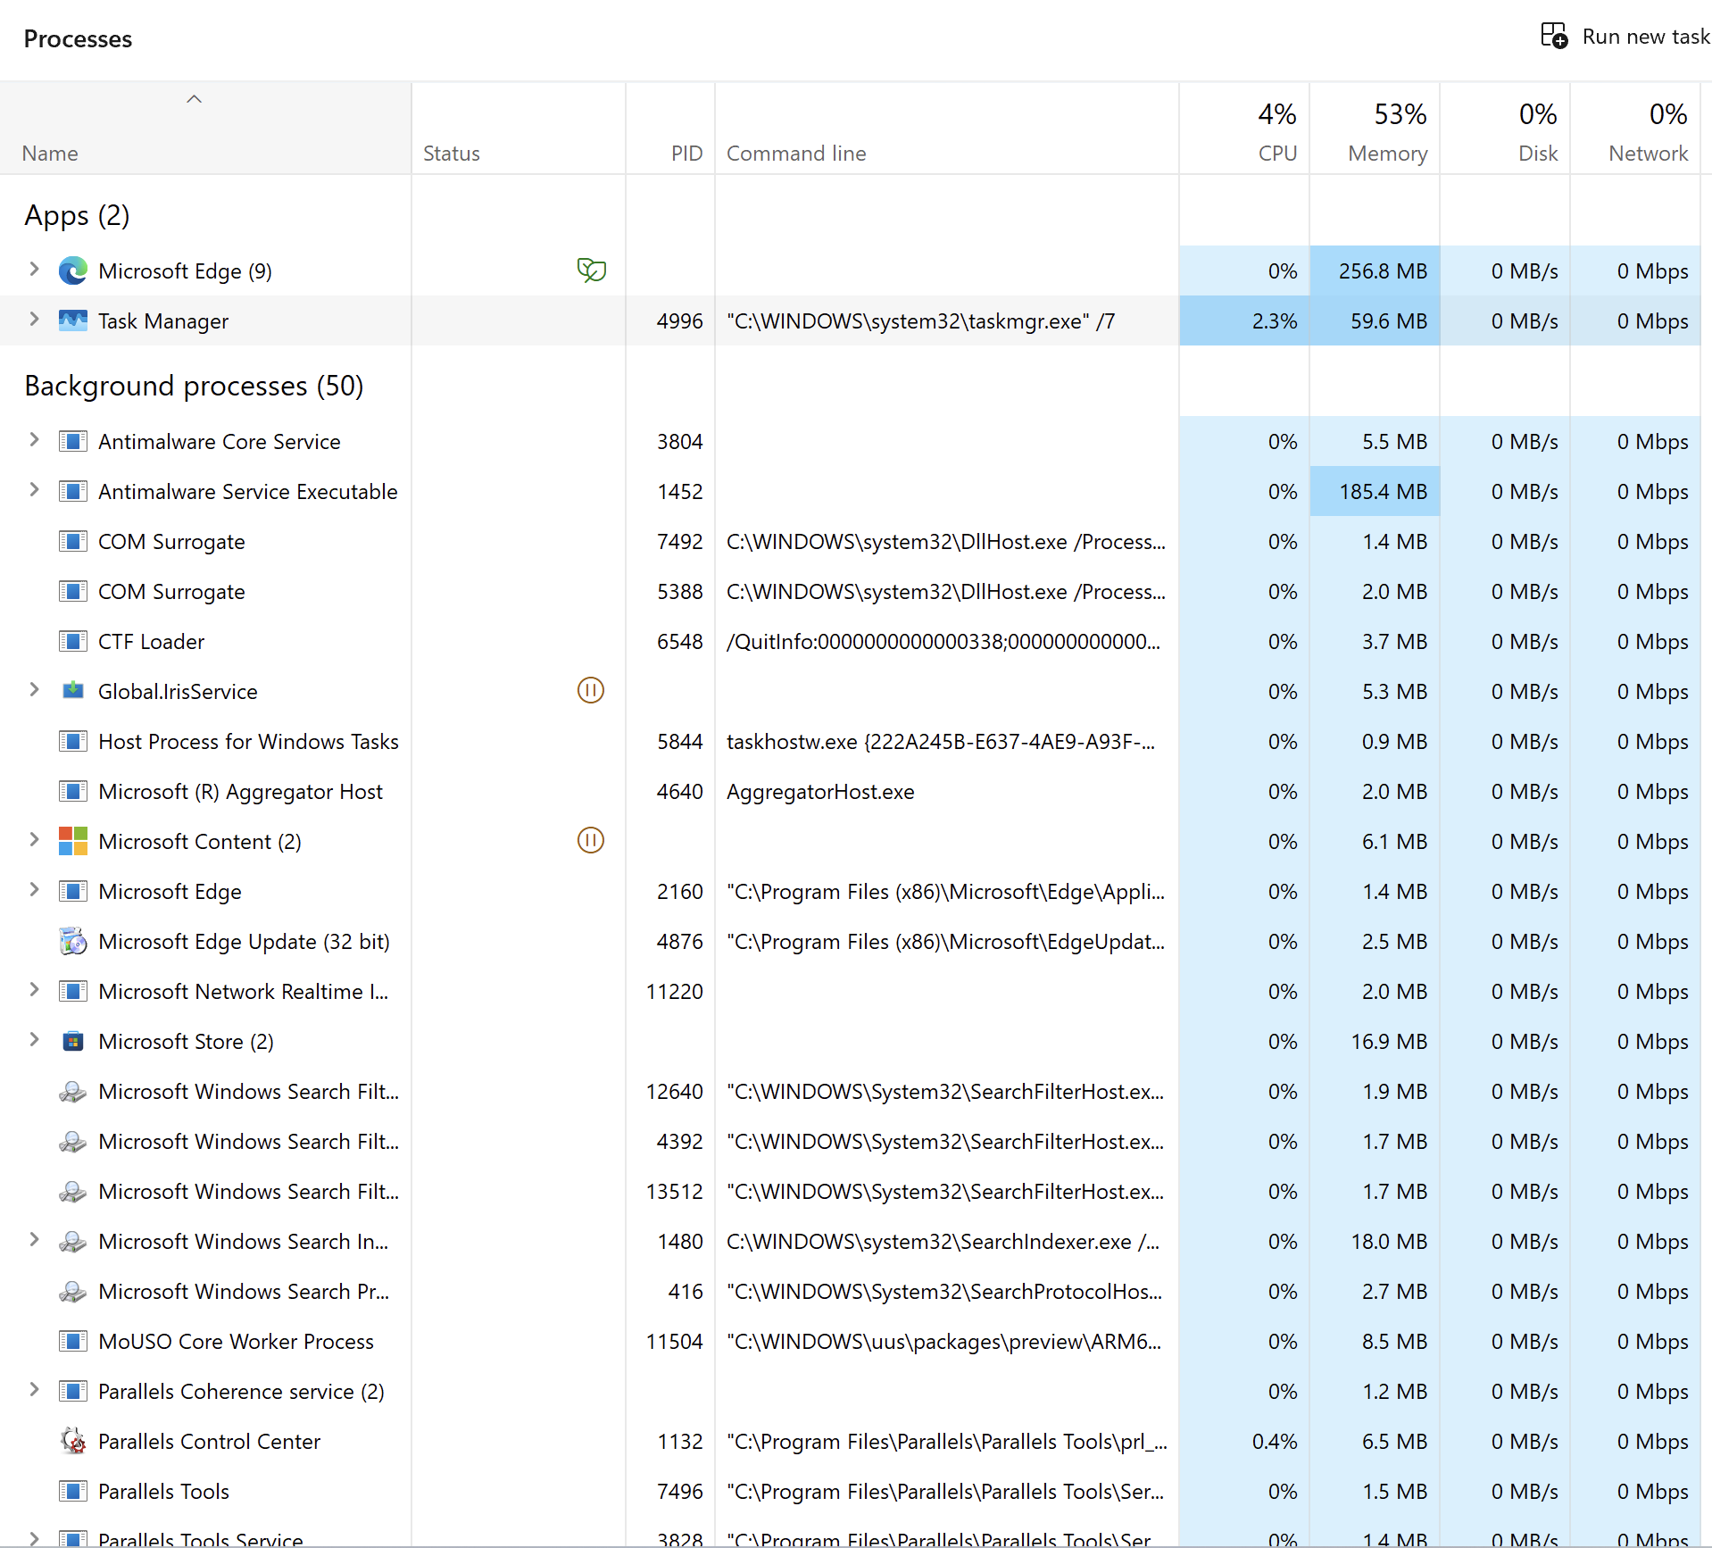
Figure 3 shows the processes section in Task Manager

In addition, there are also a few extra features within Task Manager that are very useful. For instance, the performance section in Task Manager allows the user to view a range of small graphs showing all the different systems such as CPU, Memory, Disk, Ethernet and finally GPU that are all running at the same time. Also, by right-clicking on the apps section, users can add the options of command line and PID, where command line shows the exact command that is used to start the specific program, whereas PID is a specific and unique number assigned to every running process. This therefore allows user greater control over their system. Furthermore, by double-clicking on one of the graphs, the user enters the section and can see the graph enlarged and more information about the system at the bottom, as seen in Figure 4.
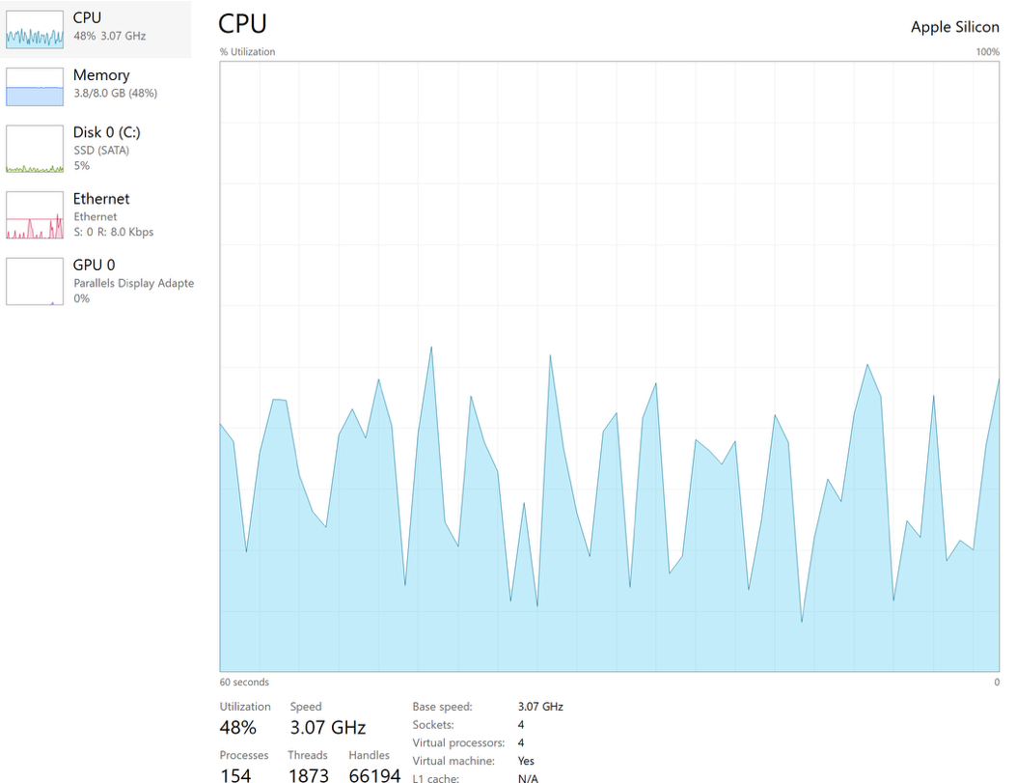
Figure 4 shows the Performance section in Task Manager.

Lastly, Task Manager also includes another section called Startup. This section allows the user to select programs to open automatically when the computer starts up. This is useful as sometimes when too many applications start up at the same time, it can make the system boot and run slowly. With Startup, users can disable apps to open when the systems boot up, as seen in Figure 5, resulting in a less overwhelming desktop when the computer starts up.
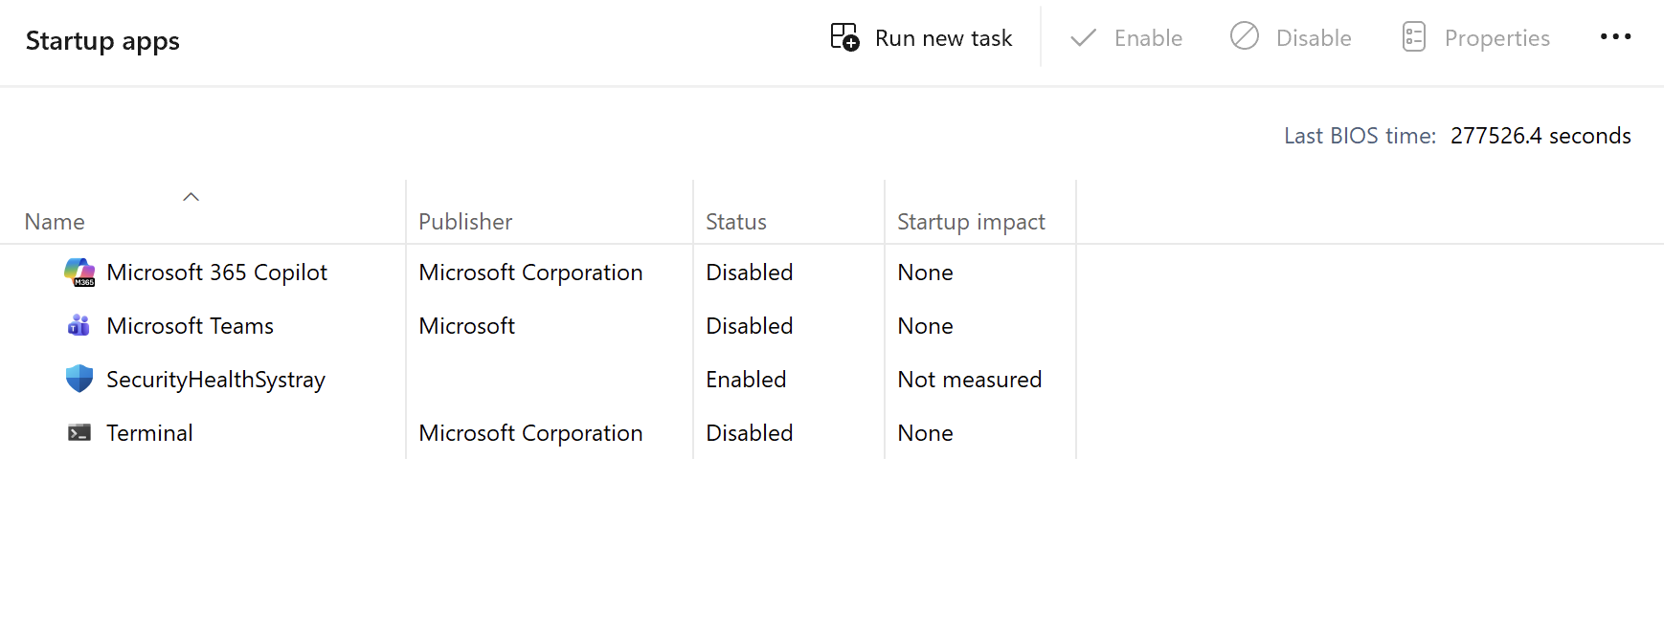
Figure 5 shows the startup apps section in Task Manager.

Overall, it can be said that Task Manager is important as it allows the user to see how the operating system is working in real time.

TASK 2 Use of Windows OS CLI commands

The Windows operating system has two main command line environments in Command Prompt, which are Batch and PowerShell. Both command languages allow the user to manage their operating system more effectively than the Windows Operating System interface. For this task, a mix of Batch and PowerShell commands will be used to demonstrate basic processes to manage files, networking, user administration and task scheduling.

Process management

For the management of processes, multiple Batch commands such as tasklist /v /fi "STATUS eq running" can be used to display running processes, with detailed information about the running system, as seen in Figure 6. To stop these processes, users have to use the command task kill which forces the process to shut down (see Figure 7). [4]

Batch

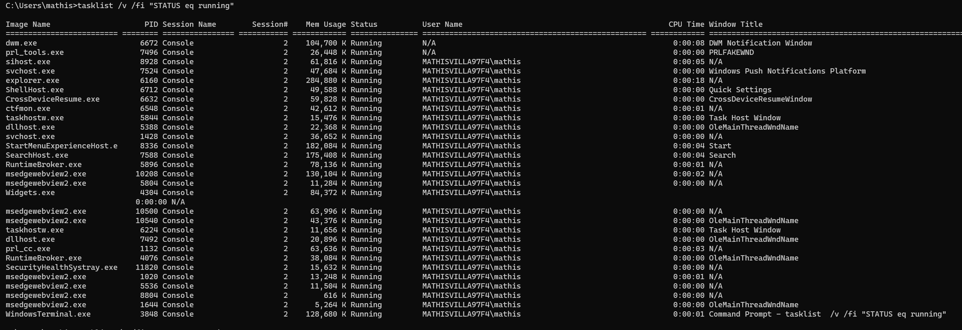
Figure 6 show the Batch command tasklist /v /fi "STATUS eq running
Figure 7 show the Batch command taskill
PowerShell
On the other hand, in PowerShell the command Get-Process…, can be used to manage processes that use more than 60MB of memory, and Stop-Process … can be used to shut down a process [5].

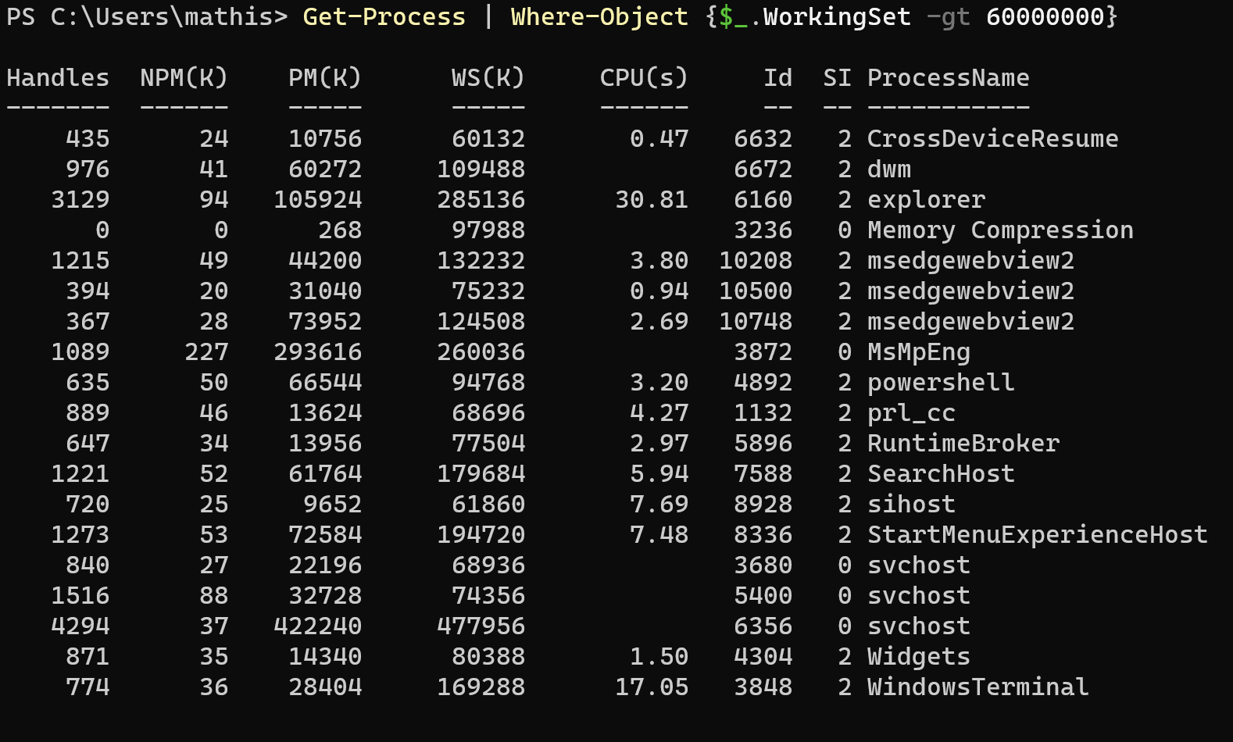
Figure 8 shows the PowerShell command Get-Process

Figure 9 shows the PowerShell command Stop-Process …
Network testing/monitoring

For testing and monitoring networks, Batch commands such as netstat -ano show the user active connections and related process IDs [6].

Batch
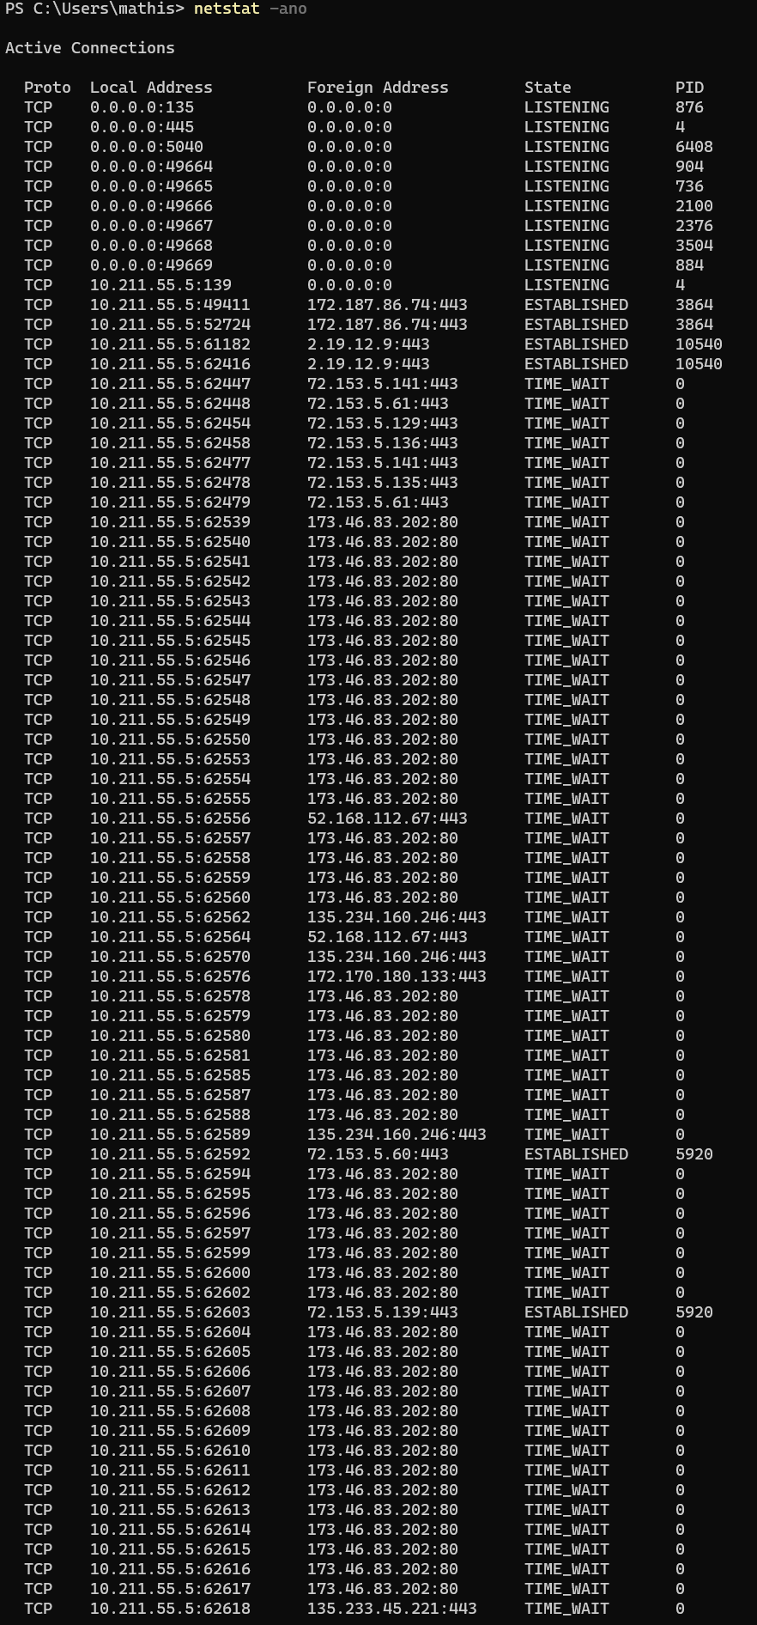
Figure 10 shows the Batch command netstat -ano

PowerShell

For PowerShell, the use of Test-Connection -ComputerName google.com gives the ability to test network reachability. The following commands are helpful in diagnosing network connectivity issues and to view activity on the network. Microsoft also states that by using the command Get-NetTCPConnection, it gives you the ability to see active TCP connections [7].

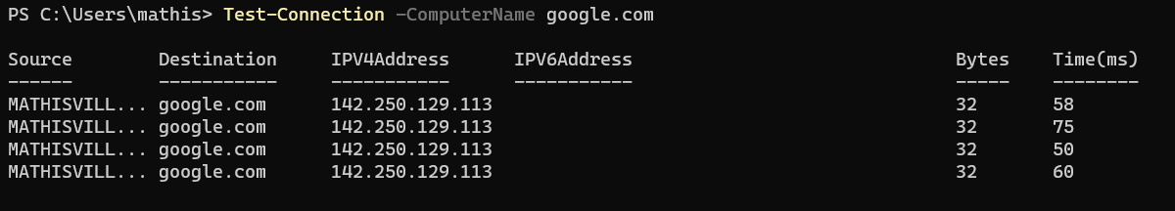
Figure 11 shows the Powershell command Test-Connection - ComputerName google.com

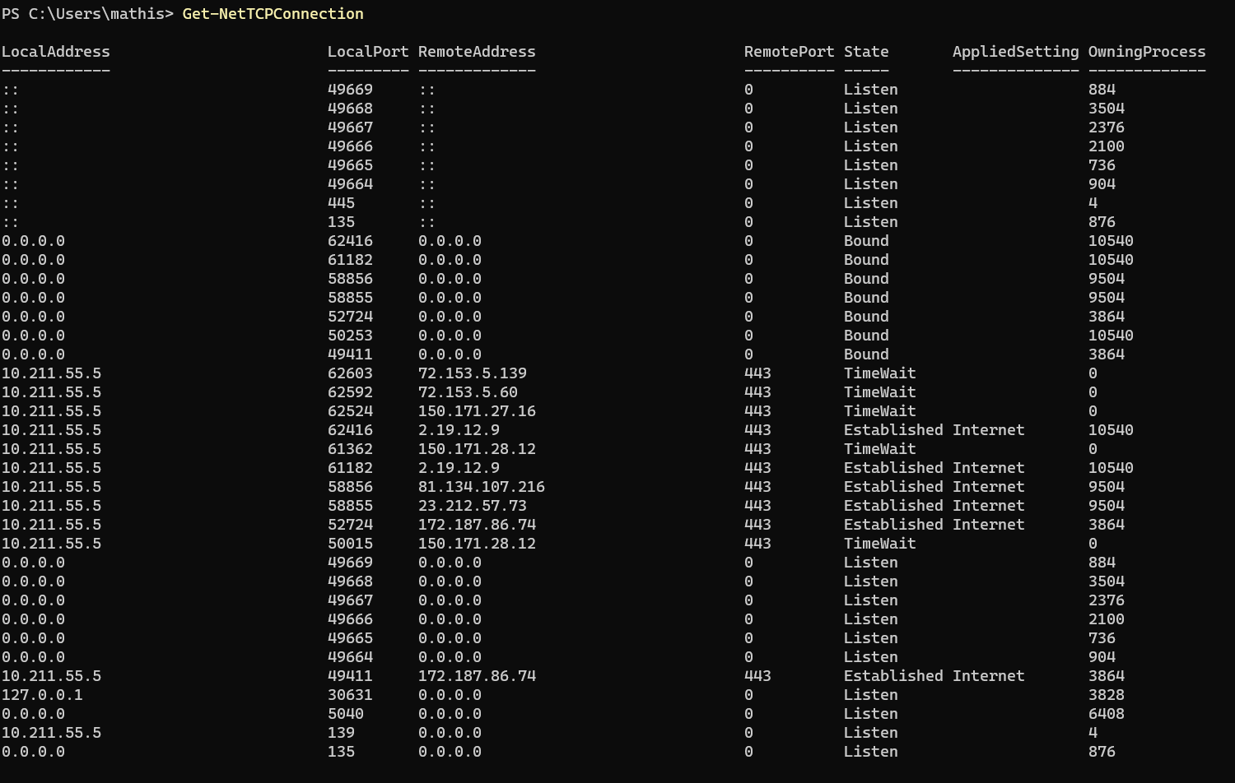
Figure 12 shows the Powershell command Get-NetTCPConnection

User management

Batch

For user management, Batch commands such as net user student Password /add can be used to create a new local user account [8] (but administrative privileges do have to be enabled for it to work. In this case screenshots were not added as permission was not given).

PowerShell

In PowerShell the command Get-LocalUser is used to list existing users on the system.

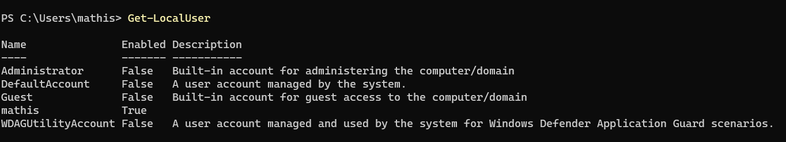
Figure 13 shows the Powershell command Get-LocalUser

Task scheduling

Finally, for task scheduling, users can use Batch commands such as schtasks /create /sc weekly [9] to run a program regularly such as once every Monday at 6 pm and launch the program Disk Cleanup.

Batch

Figure 14 shows the batch command schtasks /create /sc weekly /d MON /tn "CleanupTask" /tr "cleanmgr.exe" /st 18:0

PowerShell

While for PowerShell, users can use Get-ScheduledTask | Format-List TaskName, TaskPath, State to monitor scheduled tasks.

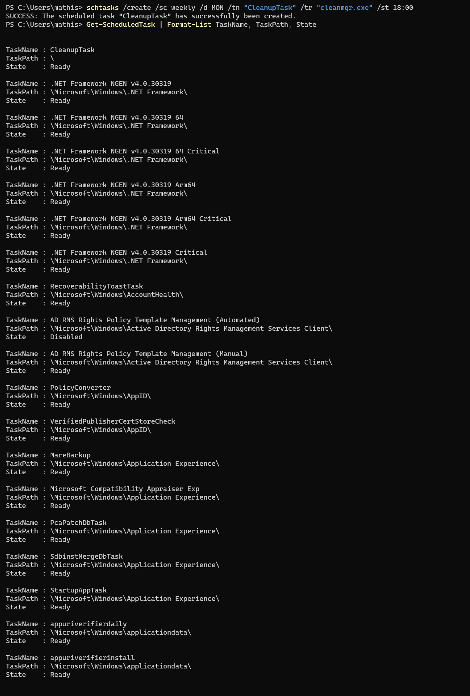
Figure 15 shows the PowerShell command Get-ScheduledTask | Format-List TaskName, TaskPath,
From the demonstration of these basic commands, it shows that Batch is useful for quick system commands, while on the other hand PowerShell gives users more advanced features. These commands are also useful for the future, where the command line is often used to manage users, control processes, and maintain system performance.

Task 3 Use of Linux OS CLI commands
The Linux operating system, which is different from the Windows system, uses a Bash command-line interface (CLI). This allows users to interact and manage their operating system more effectively alongside the graphical interface provided in the settings. These commands can be very useful for administration and troubleshooting purposes as they provide precise and fast control for the user.
Process Management
Linux has several commands for process management such as ps aux, top and htop. The ps command shows the user technical information about processes that are active on the system, as seen in Figure 16. The top command displays a list of processes sorted by CPU usage across different applications (see Figure 17). In addition, as seen in Figure 18, htop provides a well organised and visually pleasing way of monitoring CPU and RAM usage [10].
Ps aux
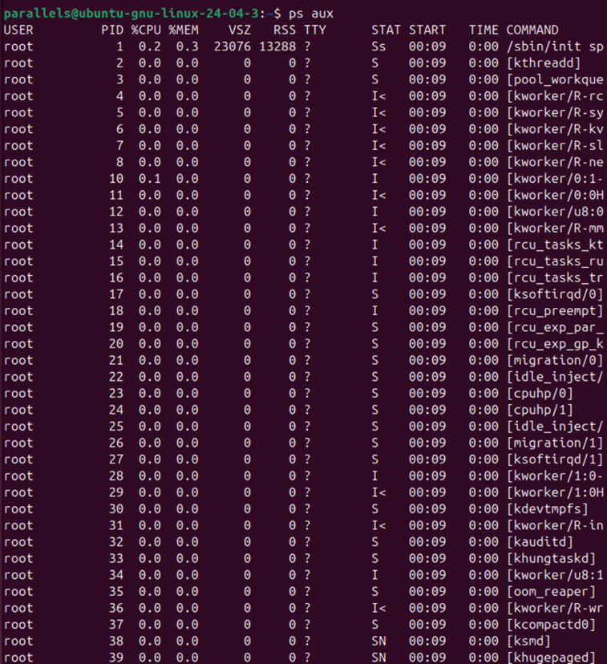
Figure 16 shows the command ps aux
top
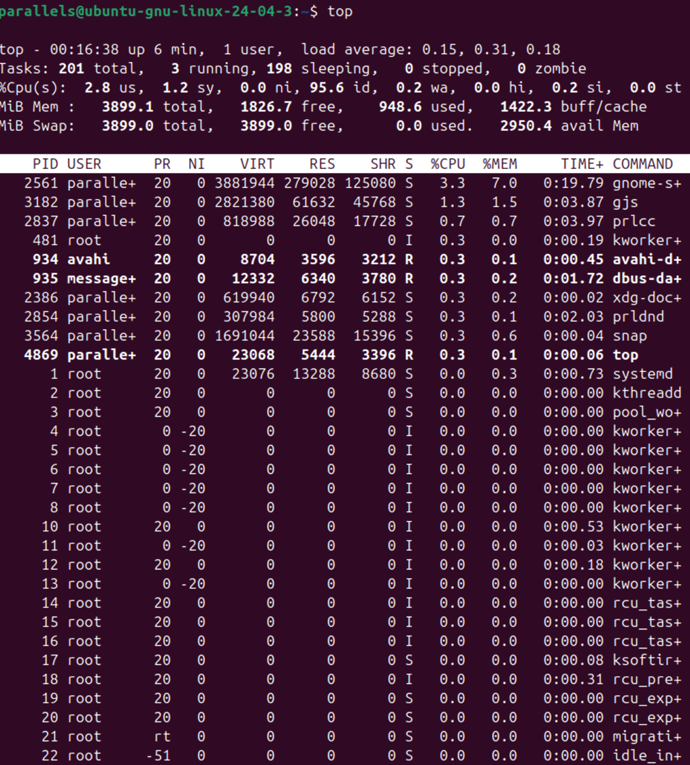
Figure 17 shows the command top

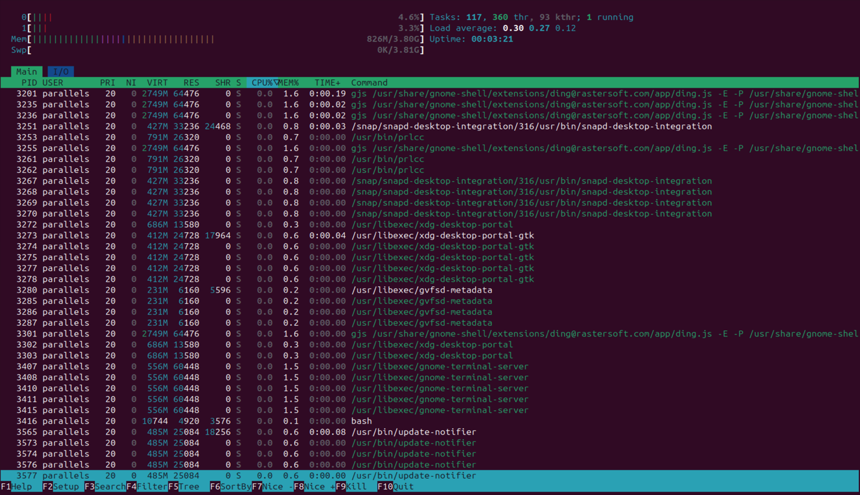
Htop
Figure 18 shows the command Htop

File and Directory Management
In addition, some Linux Bash commands can be useful for file and directory management. For instance, commands such as pwd, ls, ls -l, touch file.txt, echo "Hello World" > file.txt, and cat file.txt can be used to move through directories, create files, and display file contents [11].
Pwd
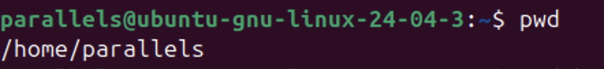
Figure 19 shows the command pwd

Ls
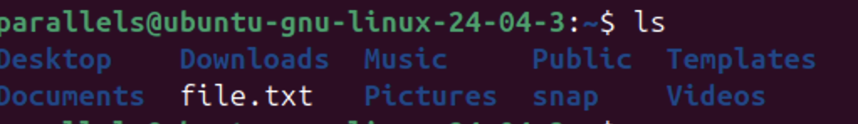
Figure 20 shows the command ls
Ls -l
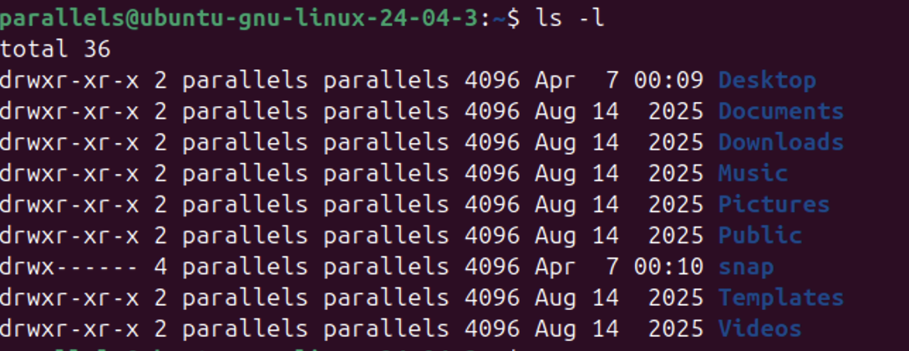
Figure 21 shows the command ls -l

touch file.txt + echo "Hello World" > file.txt + cat file.txt
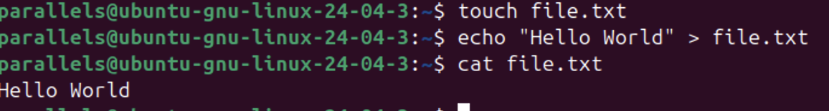
Figure 22 shows the command touch file.txt + echo "Hello World" > file.txt + cat file.txt

Network Testing and Monitoring
Linux also has Bash commands that are very useful for network testing and monitoring. Commands like ip -4 addr are useful as they give an output of the computer’s IPv4 addresses (see Figure 23). The command ss -tulnp shows TCP and UDP can be used to display connections along with their associated numeric addresses, as can be seen in Figure 24. These commands are widely used in networking and monitoring.
ip -4 addr
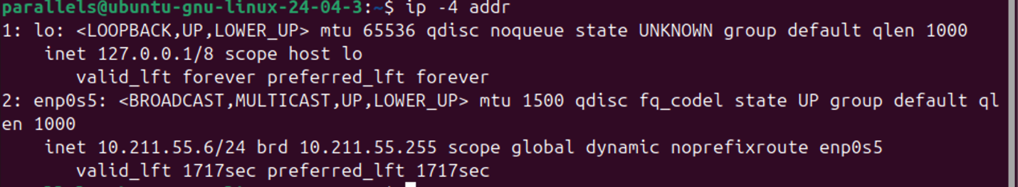
Figure 23 shows the command ip -4 addr
ss -tulnp
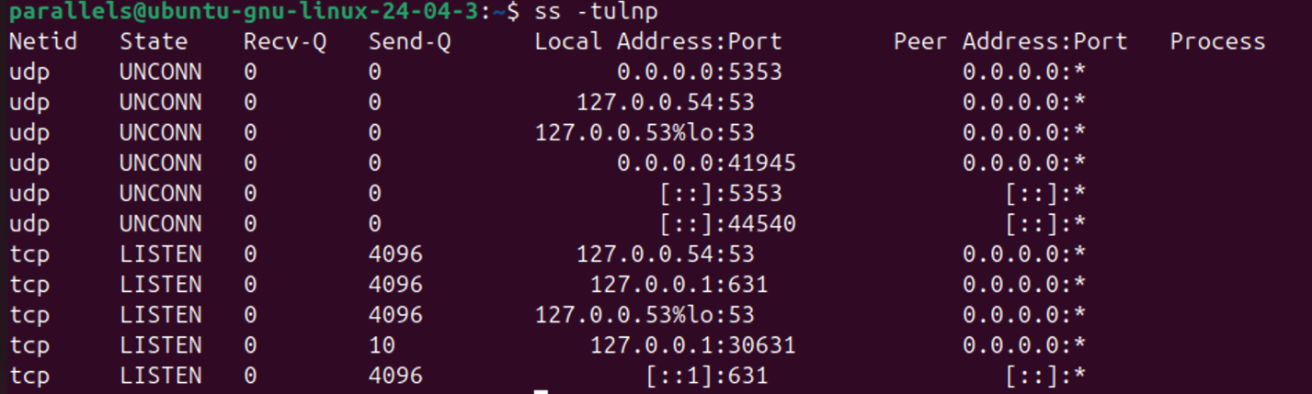
Figure 24 shows the command ss -tulnp

User Management
Linux also allow user management where commands such as sudo add user can be used to create a new user account. In addition, the group’s username command allows an individual to see which user belong to what group. Lastly the sudo userdel username command can be used to delete a user account [12].

sudo adduser username
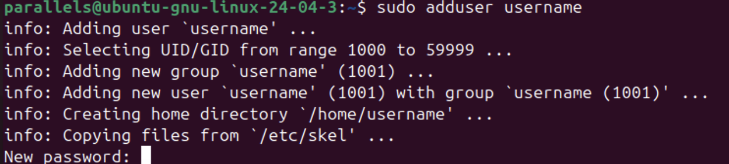
Figure 25 shows the command sudo adduser username
groups username
Figure 26 shows the command groups username
sudo userdel username
Figure 27 shows the command sudo userdel username

Task Scheduling
For task scheduling, Linux uses a system known as Cron (which has to be installed beforehand) which differs from Windows. Commands such as cat /etc/crontab, crontab -l, and crontab -e [13] can be used to view and edit scheduled Cron jobs. These commands also allow users to automate backups, reports, and maintenance tasks at specific times.

cat /etc/crontab
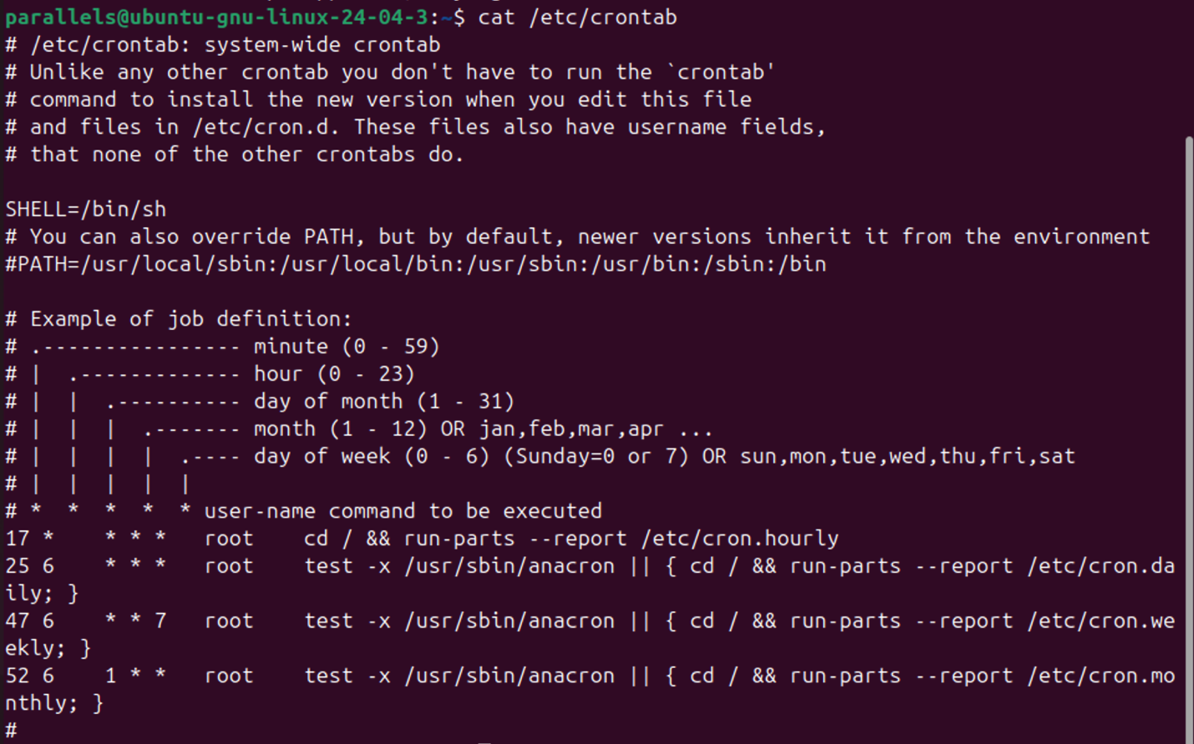
Figure 28 shows the command cat/etc/crontab
crontab -l
Figure 29 shows the command crontab -l

crontab -e
Figure 30 shows the command crontab -e

Task 4 Use of Windows OS scripts
By using Windows operating systems, users also have the ability to script through the use of Batch and PowerShell, where commands and system tasks can be carried out. Users can tell the difference between Batch and PowerShell as Batch files are saved with a .bat ending and are normally used for simple scripting tasks, whereas PowerShell scripts end with .ps1 and have more detailed and advanced scripting features. Batch scripting tends to be more useful for learning key scripting features such as variables, user input, if statements and many more.
For instance, here is a simple Batch script which begins with:
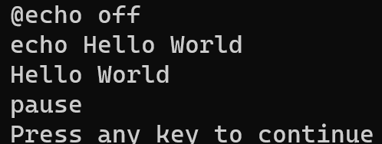
Figure 31 shows a simple echo batch script
Where in the following example @echo off, stops the commands from being displayed. The echo prints the text on the user’s screen and finally pause keeps the window open after the program has run.

In addition, another key feature in Batch scripts is the use of variables, for instance:
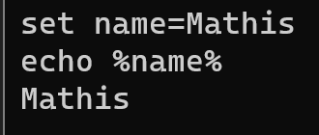
Figure 32 shows variables in Batch
In this example a variable was created because of the use of a set command, where when we echo name, it displays the value stored in the variable.
Furthermore, Batch also supports user input with the use of the /p switch,[14] as seen in this example:
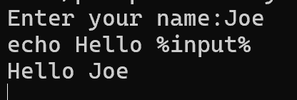
Figure 33 shows user input in Batch
Figure 33 commands the script to wait until a user input is typed in. Batch also supports if statements if validation is necessary for instance:
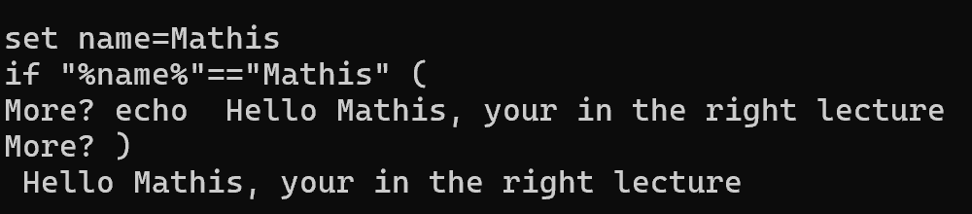
Figure 34 shows if statement in Batch
Lastly, for loops [15] can also be used to repeat a series of code as seen in Figure 35:
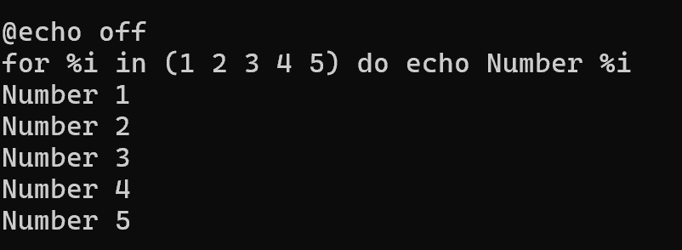
Figure 35 shows loops in Batch

PowerShell can also be used for scripting within Windows. PowerShell uses commands known as cmdlets, which follow a verb-noun format. For instance:
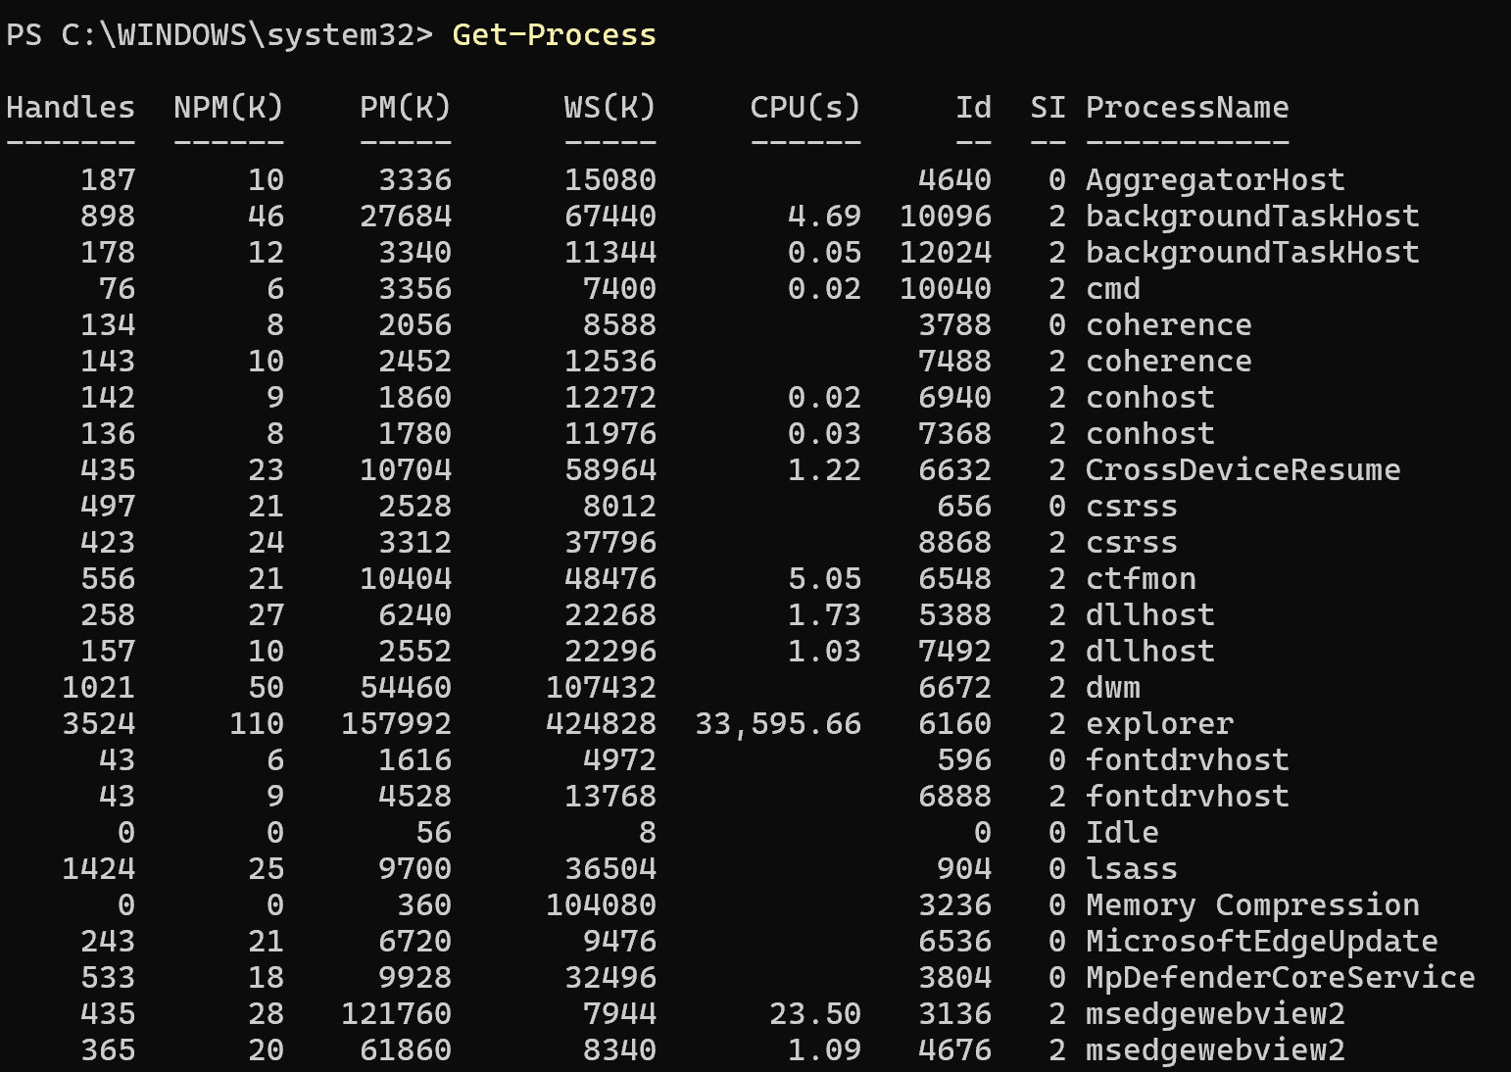
Figure 36 shows the Get-Process command in PowerShell
Figure 36 shows the command Get- process [16] which displays all running processes on the system and therefore can be used for monitoring system activity.
Another useful command in PowerShell is New- item -Path:
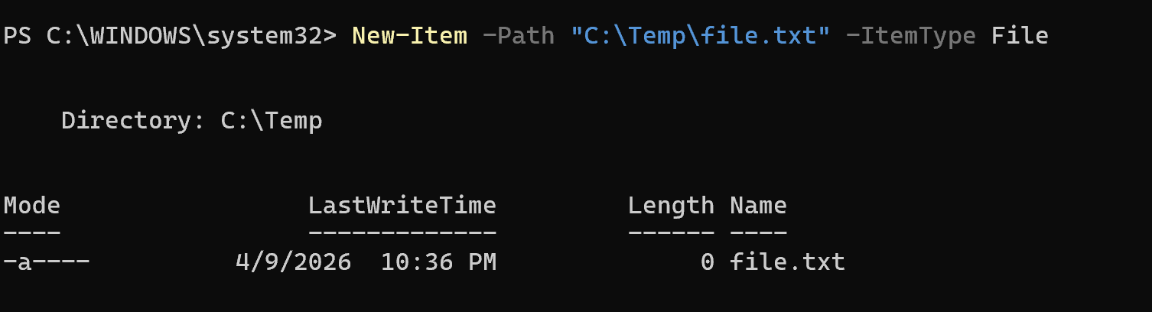
Figure 37 shows the New-Item command in PowerShell
In Figure 37, the command New item creates a new file. Where -Path tells us the location of the file, and -ItemType File tells us that a file has been created.
In conclusion, it can be deduced that both Batch and PowerShell are important Windows scripting languages where Batch is on one hand more effective for simple scripting tasks, whereas PowerShell has more advanced administrative scripting. This is also very useful as it helps build new skills for future jobs such as system administration and cybersecurity, as scripting can be used to automate tasks and manage systems effectively.

Task 5 Use of Linux OS scripts
Similarly to the Windows operating system, Linux also supports scripting with Bash. In Linux, Bash script files all end with .sh and normally run through the Linux terminal. While it may be the same language as the previous task, Bash scripting on Linux differs from Windows as it is not always worded the same. This can be seen in the following examples.
To create a simple Bash command in Linux, the script always begins with #!/bin/bash, which tells Linux that the user is running a script using the Bash shell language. Then, similarly to Windows, the echo command is used to display the desired text on the user’s screen.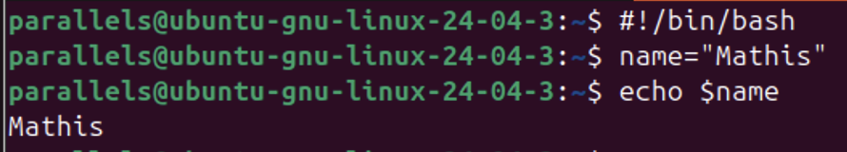
Figure 38 shows variables in Linux
Figure 38 shows the use of a variable where the variable name stores the name Mathis. To display the name variable in Linux, a simple $ has to be added before the variable name to display the name or value.
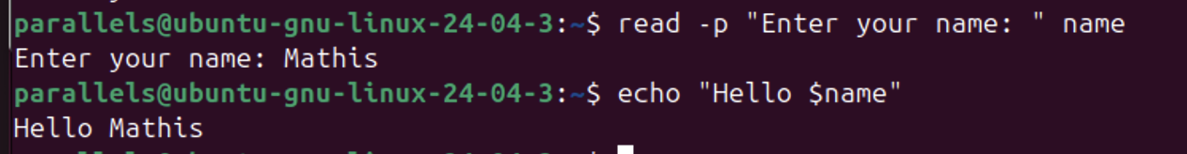
Figure 39 shows the command read -p in Linux
User input can be added with the command read -p which allows users to enter a value, then the program stores the user input and displays it at the end with an echo command (see Figure 39).
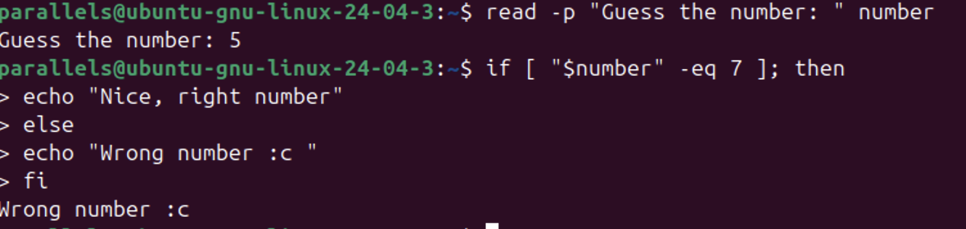
Figure 40 shows if statement in Linux
To add validation in a Bash command on Linux, an if statement [17] can also be added similarly to the Windows operating system. In this example the user has to try to guess the number 7, where the if statement (if [ "$number" -eq 7 ]) tells the program if the user number is equal to 7 it displays ‘congratulations’, as seen in Figure 40, otherwise it displays a different message.
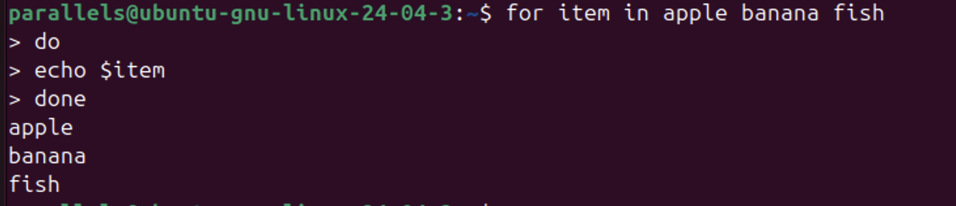
Figure 41 shows a for loop in linux
In this script (Figure 41) a for loop [18] is used to go through each item in a list and then displays each item one at a time. Loops are very useful to repeat commands or parts of a script automatically.

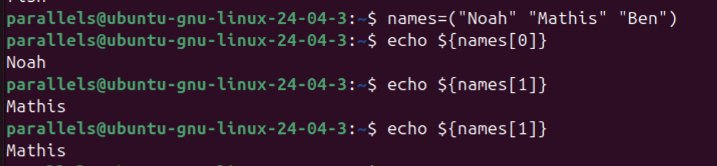
Figure 42 shows an array in Linux
In Figure 42, an array [19] is used where values are stored under different variable names. Each value can be accessed by an index number starting from 0.
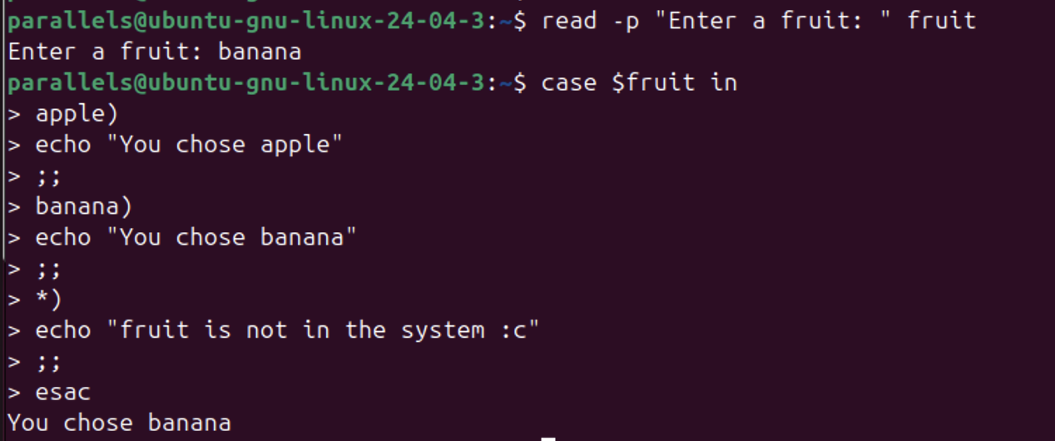
Figure 43 shows a case statement in linux
A case statement [20] can also be used to replace an if statement, as can be seen in Figure 43. It is useful when the program has to handle several answers written differently.
To conclude, this report has shown the values of both Windows and Linux operating systems and the way they give users a variety of tools and features for managing systems effectively. With the help of the graphical interface, and also the command-line interface, it can be said that operating systems play a vital role in controlling essential computer systems such as hardware, software, memory, files, networks and many more. These Linux commands are also very useful for future careers, as the command-line interface is often used to manage hardware, software, and even networks.

Conclusion
The report first showed how the Windows operating system has a user-friendly experience due to its visually pleasing graphical interface, with features such as the Taskbar, Start Menu and Task Manager. These tools are used by nearly all users to interact easily with the operating system. In addition, this report has also explored how both Windows and Linux have a powerful command-line interface where users have direct control over their system. In Windows, Batch and PowerShell can be used to manage various processes such as files and networks, whereas Linux uses the Bash shell that is better for administrative functions. Lastly, this report has also shown how scripting can be used in both Windows and Linux to automate tasks. Both Batch and PowerShell allow users to create scripts with features such as variables, user input, if statements, loops, arrays and many more. These features are very useful as they help reduce repetition, which also helps users complete administrative tasks and therefore improves productivity. It can therefore be concluded that Windows and Linux are both very useful and powerful operating systems that allow users to interact with their system both in simple and advanced ways. While it can be argued that Windows is more accessible through its graphical user interface, and Linux may be harder and more complex with its command-line tools, this report has shown us that both operating systems let their users manage, monitor, and also automate their systems.

Evidence of engagement with 1 online certified course

In addition, I have completed the Cisco operating system basics course:



Sources

[1] contentReference[oaicite:0]{index=0}, “NDG Linux Unhatched,” [Online]. Available: https://www.netacad.com/courses/linux-unhatched?courseLang=en-US. [Accessed: 1-Apr-2026].

[2] Tutorials Point, “Advantages and disadvantages of Windows operating system,” 17-Mar-2026. [Online]. Available: https://www.tutorialspoint.com/article/advantages-and-disadvantages-of-windows-operating-system. [Accessed: 1-Apr-2026].

[3] Microsoft, “Inside Task Manager,” 29-Jan-2019. [Online]. Available: https://learn.microsoft.com/en-us/shows/inside/task-manager. [Accessed: 3-Apr-2026].

[4] Microsoft (2025) Tasklist. Available at: https://learn.microsoft.com/fr-fr/windows-server/administration/windows-commands/tasklist (Accessed: 3 April 2026).

[5] Microsoft (2025) Where-Object (Microsoft.PowerShell.Core). Available at: https://learn.microsoft.com/fr-fr/powershell/module/microsoft.powershell.core/where-object?view=powershell-7.6 (Accessed: 2 April 2026).

[6] Developpez.com, “La ligne de commande Windows et les fichiers batch,” [Online]. Available: https://windows.developpez.com/cours/ligne-commande/?page=page_11. [Accessed: 5-Apr-2026].

[7] Microsoft, “Test-Connection (Microsoft.PowerShell.Management),” [Online]. Available: https://learn.microsoft.com/fr-fr/powershell/module/microsoft.powershell.management/test-connection?view=powershell-7.6. [Accessed: 5-Apr-2026].

[8] Microsoft, “I need to add a user on my laptop but I don’t know how,” Microsoft Q&A, [Online]. Available: https://learn.microsoft.com/en-us/answers/questions/3991784/i-need-to-add-a-user-on-my-laptop-but-i-don-t-know. [Accessed: 10-Apr-2026].

[9] Microsoft, “schtasks create,” 15-Aug-2025. [Online]. Available: https://learn.microsoft.com/fr-fr/windows-server/administration/windows-commands/schtasks-create. [Accessed: 6-Apr-2026].

[10] W3Schools, “Bash ps Command - Snapshot of Current Processes,” [Online]. Available: https://www.w3schools.com/bash/bash_ps.php. [Accessed: 5-Apr-2026].

[11] GeeksforGeeks, “File Management in Linux,” 4-Dec-2025. [Online]. Available: https://www.geeksforgeeks.org/linux-unix/file-management-in-linux/. [Accessed: 4-Apr-2026].

[12] GeeksforGeeks, “adduser command in Linux with examples,” 15-Jul-2025. [Online]. Available: https://www.geeksforgeeks.org/linux-unix/adduser-command-in-linux-with

[13] GeeksforGeeks, “Job Scheduling Commands in Linux,” 22-Dec-2025. [Online]. Available: https://www.geeksforgeeks.org/linux-unix/job-scheduling-commands-in-linux/. [Accessed: 6-Apr-2026].

[14] GeeksforGeeks, “Batch Script – Input / Output,” 28-Nov-2021. [Online]. Available: https://www.geeksforgeeks.org/linux-unix/batch-script-input-output/. [Accessed: 6-Apr-2026].

[15] SS64, “FOR – Looping commands,” [Online]. Available: https://ss64.com/nt/for.html. [Accessed: 4-Apr-2026].

[16] Microsoft, “Get-Process (Microsoft.PowerShell.Management),” [Online]. Available: https://learn.microsoft.com/fr-fr/powershell/module/microsoft.powershell.management/get-process?view=powershell-7.6. [Accessed: 8-Apr-2026].

[17] W3Schools, “Bash If...Else,” [Online]. Available: https://www.w3schools.com/bash/bash_conditions.php. [Accessed: 8-Apr-2026].

[18] V. Gite, “Bash for loop examples,” nixCraft (Cyberciti), [Online]. Available: https://www.cyberciti.biz/faq/bash-for-loop/. [Accessed: 10-Apr-2026].

[19] W3Schools, “Bash Arrays,” [Online]. Available: https://www.w3schools.com/bash/bash_arrays.php. [Accessed: 10-Apr-2026].

[20] PhoenixNAP, “Bash case statement: Syntax and examples,” 9-Dec-2025. [Online]. Available: https://phoenixnap.com/kb/bash-case-statement. [Accessed: 10-Apr-2026].

