

MSc Computer Networks and Cyber Security
ACCA7028: Prof. Carlene Campbell

Wales Institute for Science and Art (WISA)
University Of Wales Trinity Saint David
Swansea

November 28, 2021

CONTENTS

Abstract ……………………………………………………………………………
1-Introduction …………………………………………………………………….
1.2.- Purpose of information security policy………………………………………………
1.3. -information security framework…………………………………………………
1.4. - coordination of framework implementation…………….…………………………
1.4. - how to use security frameworks………………………….
2- Security framework review (task 1) …………………………………………….
2.2. - NIST Cybersecurity Framework………………………………….
2.3. - ISO/IEC 27000 Series………………………………….
2.3.2. - why we use the 27001………………………………….
2.3.3. - advantages of the ISO 27000………………………………….
2.3.4. - Disadvantages of the ISO 27000………………………………….
2.3.5. – Incident discovery and response………………………………….
2.3.6. - assessment and decision on information security events…………………………
2.4. - ITIL Framework…………………………………………………………….
2.4.2. – The Four Dimensions of ITIL 4………………………………….
2.4.3. – ITIL Implementation ………………………………….
2.4.4. - Advantages And Disadvantages of ITIL ………………………………….
3- Security Framework Design Case Scenario For CoffeeBlue (Task 2) ……………………
3.2. - set target and goals………………………………….
3.3. - network implementation and assessment………………………………….
3.4. - create a delegate profile ………………………………….
3.5. – examine your ongoing position………………………………….
3.6. - actions plan taken………………………………….
3.7. - Implementation of the action plan ………………………………….
4- Conclusion ………………………………….
5- Reference ………………………………………………

FIGURES

Figure 1: infosec cycle
Figure 2: Notional Information and Decision Flows within an Organization
Figure 3: NIST cybersecurity framework
Figure 3: The Identify Function is Foundational
Figure 4:ISO 27000 series consulting risk assessment
Figure 5: ISO 27000 family
Figure 6: ITIL framework cycle
Figure 7: ITIL implementation
Figure 8: benefits of ITIL
Figure 9: Intrusion detection and prevention system

ABSTRACT:
Information security is one of the trending topics in the world right now, with the increase in cyber-crimes companies, organisations, and individuals seek to protect their data/information from hackers or unauthorised users whom might use this information to their benefit and damage or cause harm to the victim one way or another. Cyber security or information security provides companies with the concept of CIA (i.e., confidentiality, integrity and availability). This report will help us analyse different security frameworks and models which companies use. we will learn about the breaches in information security, how to build a framework to help us understand this concepts and models and learn the various threats or attacks which can be carried on by attackers on the organisation and how to avoid such attacks with the help of methodological solutions. Following all this researched we have carried out we will develop a security frame work for CoffeeBlue case scenario and come out with its advantages and disadvantages and finding out other recourses on how to maintain it

INTRODUCTION
Information security (infosec) is the techniques, tools, and procedures we use to protect sensitive information of an organisation, company, or users from hackers or attackers [1]. There is a rapid growth in cybercrimes now our days so most companies implement the information security management system (ISMS) which is simply processes and guidelines to aid the organisation in case any data/information breach occurs [1]. Now our days a lot of organisations turn to depend on information technology (IT) to support their everyday transactions and with this dependency, leads to the rise in threats/attack on organisations assets[2]
Companies create an effective information security policy which is simply a set of rules, procedures, and policy built to make sure users and network in the organisation is well protected from attacks or threats that might cause damage to the organisation [3].
As infosec is continuously growing, with new processes, systems, tools, technologies, vulnerabilities, threats etc clear processes and guide should be put in place by the internal staffs who are responsible for managing and maintaining the infosec and information system to aid secure ICRC information and system and reduce any risks as much as possible. Staffs responsible for information management and maintenances must establish these 5 core steps in an information system in a continuous process [4]
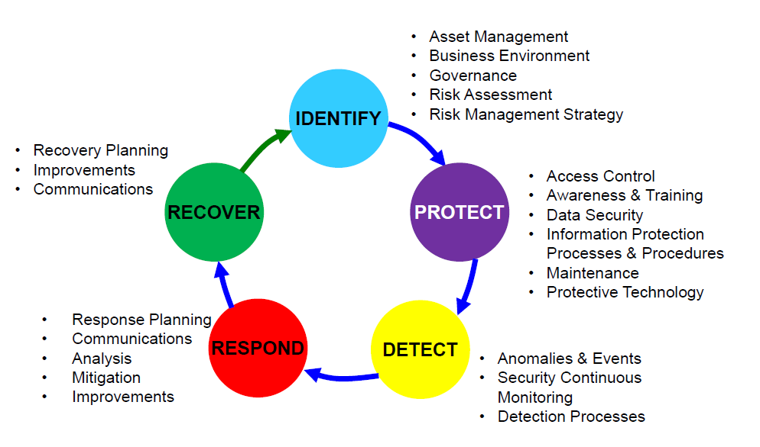

Fig 1: infosec cycle

1.2. Purpose of information security policy

- protect organisation information security
- Detect and prevent information breaches caused my attackers
- Protect organisations reputation
- protect customers and employee’s data [3]
At the end organisations need to know the fundamentals of information security which is CIA i.e.
Confidentiality:
It is important to protect our sensitive information from unauthorised users. Confidentiality is obtained either by encrypting our data making it meaningless to unauthorised users or putting a ban to it.
Integrity:
Here the deletion, misuse, and modification of data is protected against unauthorised users. Should in case the data is changed by an unauthorised user it can be fixed.
Availability:
Here only authorised users can access certain information to Some extent [4]

1.3. information security framework

A security framework is mixed of cybersecurity and state commission policies and processes to help protect important information and infrastructure. These policies are made up of set of instructions for companies to follow in order to control and take good care of information stored in their system to reduce the risk of vulnerabilities [5]
Frameworks helps in managing cybersecurity risk and is made up of three parts which are: the core, the implementation tiers, and the profile [6]

1.4 coordination of framework implementation
Figure 1 describes the flow of information and decision making in an organisation
• Executive
• Business/Process
• Implementation/Operations

The mission priority, overall risk tolerance, available resources is executed by the executive level. Information input is been used by the business/process level into the risk management system and the combine or work together with the implementation/operation level to build a profile and communicate business needs. The implementation/operations level pass on the Profile implementation progress to the business/process level. This profile implementation is then used by business/process level to perform an impact assessment. Business/process level management finally reports the results of that impact assessment to the executive level to inform the organization’s overall risk management process and to the implementation/operations level for awareness of business impact.

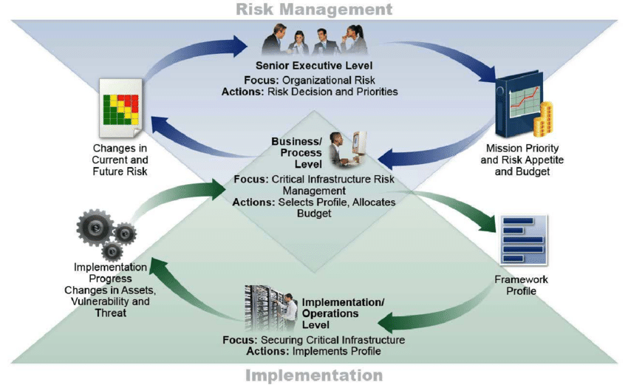
Figure 2: Notional Information and Decision Flows within an Organization [6]

1.4. how to use security frameworks

Organisations/companies uses frameworks to identify, access, and mange cybersecurity risks. Using frameworks helps organisations easily identify activities that are crucial to important service delivery and prioritisation expenditure to increase investment impact. The framework helps in pointing out gaps in an organisations cybersecurity system and practice.
Throughout the life cycle phase, we can apply the framework of plan, design, build, deploy, operate, and decommission. Every system starts with the plan phase it lays the base of everything that follows [6]In the design phase we need to validate that the specification of cybersecurity meets the need and risk disposition of the company as shown in the framework profile. Developing the system in the build phase, the desired cybersecurity outcome should be prioritised in the target profile. When deploying, we use the same target profile which acts as a list for cyber security features that needs to be accessed. The output of the cybersecurity should then serve as a basis for operations which are ongoing in the system. [6]
The framework is used for comparism between organisations recent cybersecurity activities with those put in place in the framework core. With the current profiles been created, organisations can study the extent to which they are attaining the outcome set out in the core subcategories and categories, put in place with the five functions: Identify, Protect, Detect, Respond, and Recover [6]

SECURITY FRAMEWORKS REVIEWS (TASK1)

Here we are going to discuss some security frameworks or models their importance, criticise, analyse and give their importance and why it is necessary to always keep up to date with these systems [7].
Best way to keep users and organisations secure is to always update the security frameworks install new patches because if it’s not updated regularly it puts a hole(vulnerability) in the system for attackers to strike so frequent update is important.

2.2 NIST Cybersecurity Framework

NIST stands for National Institute of Standards and Technology and was introduced in February 2014 [8]. NIST framework is a strong tool organisation use as a guideline to create and top on their cybersecurity programs [9]. A set of recommendations and standard are being set by the framework to enable the organisation prepare in advance in identifying and detecting a cyber-attack, and also puts forth preventive measures and how to respond and recover in case of cyber attack [9]. It also helps organisations identify their weaknesses and find solutions in improving those weaknesses.

The framework is made up of three parts: the core, the implementation and the profile:
• The framework core: it is a set of references, activities and outcomes that gives detail features of cyber security. The core is made up of five functions which are:

Identify: you need to know what assets and processes in the organisation needs protection
Protect: build and apply the proper safeguards to ensure delivery of critical infrastructure services [10]
Detect: build and apply suitable mechanisms to identify when a cyber security incident occurs [9]
Respond: build and apply techniques to quickly react when a cybersecurity event has been detected [9] [10]
Recover: build, apply and implement suitable methods to restore data and services that were damage due to cybersecurity event

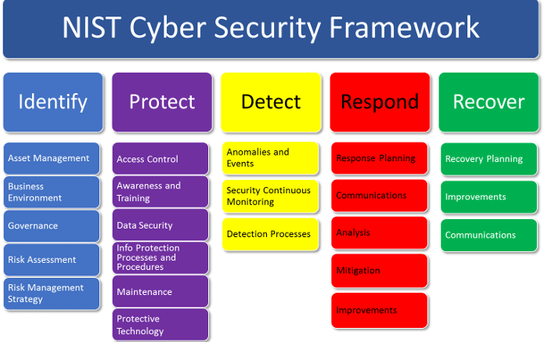

Fig 3: NIST cybersecurity framework

• The framework implementation: we must implement this framework because it will help protect the organisation from unavoidable cyber-attack. Though this implementation process seems inconvenient it will help protect the organisation and its customers. An organisation creates a profile that shows its current cyber security activities and results. From there on it can then develop a target profile to match its current one then steps can be taken to close the gap between its target profile and current one. It is important for the NIST framework to always focus on identifying. Fig 3 shows how identifying relates to all other functions. Implementation is made up of four tiers which are:
Tier 1: partial- indicates an unstable cybersecurity stance
Tier 2: risk informed- risk awareness is been allowed and planning is consistent
Tier 3: repeatable- indicates organisations stable policy and wide CSF standards
Tier 4: adaptive- indicate proactive prediction and threat detections [11]
[9]
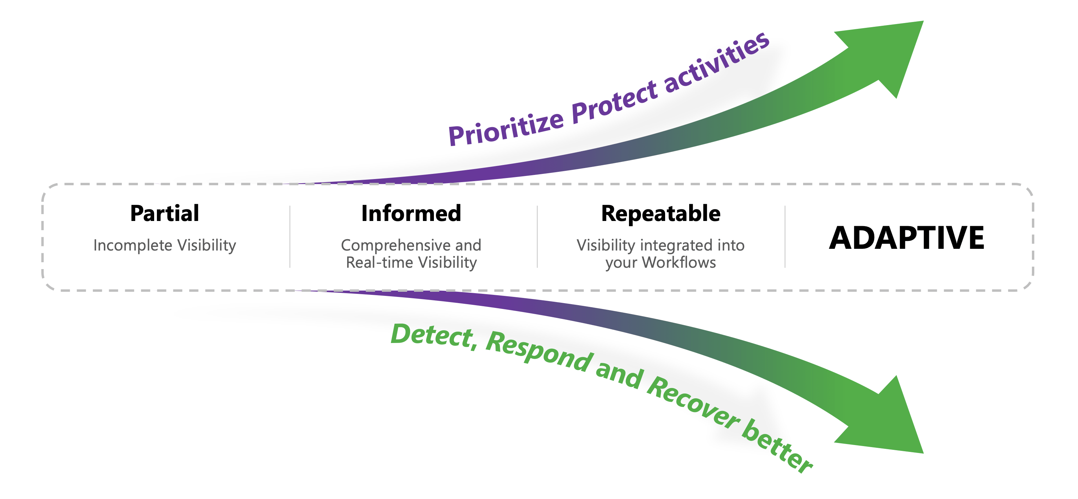
Figure 3: The Identify Function is Foundational

2.3. ISO/IEC 27000 Series:

ISO/IEC stands for the international organisation for standardisation and the international electronic commission (IEC) these are the organisations that creates, manages and set up the standards for the ISO/IEC 27000 series. These organisations exist in various countries to make sure they are widely spread, implemented and recognised around the world [11]
The 27000 series is aims at setting up good operations in relation to the maintenance, implementation and management of the information security system. The aim in establishment of best security practices and strongly focus on continuous evolvement and risk management [11]
ISO 27000 provides the base for the rest of the standards in the series.
ISO 27001describes the requirements necessary to install and manage an SGSI. It enables organisations to demonstrate that they meet regulatory standards that are related to information security and it proves that the organisation devoted to protecting confidential and sensitive data [12]
Companies need to understand the ISO standards to protect customers data, financial information, employees’ details and other important information. The iso standard provides a global framework for information security management and practices. This series aims in information technology, information security management system and security techniques [12]. The ISO 27001 gives a standard framework for companies to use when protecting information. Different technologies, test and practices are used to carry out this protection.it also helps to improve staff knowledge on the ISO 27001 so there is a low risk of breakage of the ISO 27001 in case of internal incident. Normally organisations have different security control to protect them but without the ISMS governing them they will be disjoint. The ISMS can be applied to any business that uses technology regardless of its size. The ISO 27001 needs your data management staffs to have the capability to systematically examine the information security risk of the organisation. This means they need to consider all possible vulnerabilities and threats in the system that could weaken it and also consider the impact it could have on the entire data management system. It also needs you to design and implement a complete information security control that can easily identify risk which are considered dangerous to the system. It also needs your staffs to adapt to a managerial process that the information security control requires for the organisation [12]

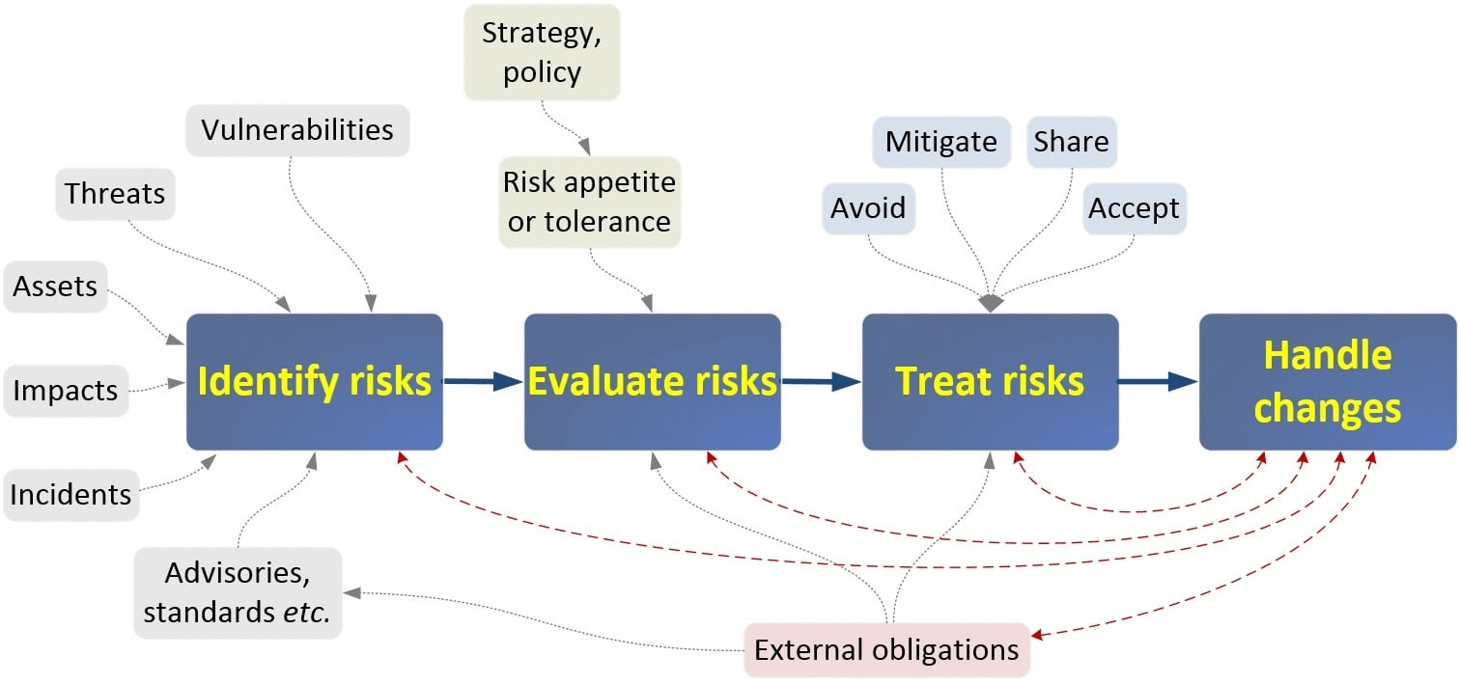
Fig 4:ISO 27000 series consulting risk assessment

2.3.2. why we use the 27001

They are created to help companies manage and control cyber security attacks risk and internal threat to data security. The growth of an organisation makes it more complicated to manage its data/information and it’s opened to a lot of vulnerabilities, with the increase in cyber-attacks, it becomes difficult to protect and manage data.
ISO 27001is the most popular standard among the others and it’s the only standard that can provide an organisation with audited certification [12].

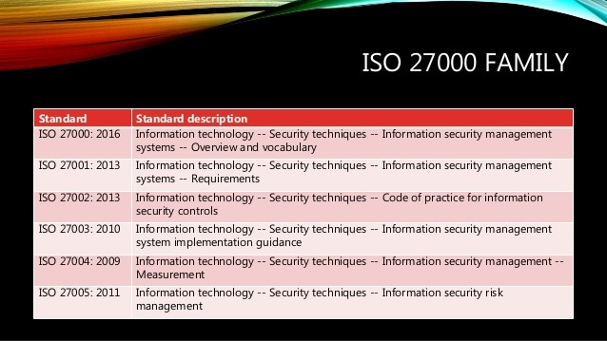
Fig 5: ISO 27000 family

2.3.3. advantages of the ISO 27000

It has various advantages. It allows the protection of business-critical data by the organisation and also aids in the protection of customers and employee data or details. This helps boost employees and customers confidence and trust in the organisation, rapidly increasing your reputation and gaining trust from the audience [12]
In case of any data breach the company will have to pay a huge fine, which will cause not only financial loss but will also damage the reputation of the company. In regards to the ISO 27000 series certificates received for ISO 27000 will show the company’s capabilities to abide by the strongest and most trusted security practices and will help improve on your customers confidence in you.
We should keep in mind that thou the ISO 27000 series is already well defined it is still constantly evolving and will continuously have new updates as new threads keeps coming up and new technologies. And by adopting this standard and always keep up to date you are sure your organisation system and sensitive data is always well protected and trust is built with the employees and customers [12]

2.3.4. Disadvantages of the ISO 27000

Cost- people see it as an expensive standard
Industry takes up and understanding- the certification for this standard has been slow the reason for this is companies do not understand the standard correctly and project cost are highly perceived [13]
One of the main issues is that this is a management standard and not a security standard. It gives a framework for the security management within the company but do not give the best security standards which when implemented an organisation will be well protected [14]

2.3.5. Incident discovery and response
A good control system framework will describe how you can easily and fast can the system respond to security incident, events and weaknesses [15]. This procedures of incident respond, weaknesses and event need to be planned and defined in an earlier stage of the framework in advance should in case any incident transpires. With the use of good management channel any incidents and event can easily be reported as quickly as possible. Employees need to be trained so they have necessary knowledge on how to perform this detections and report to the admin or person in charge of the cyber security framework.

2.3.6. assessment and decision on information security events

Events on the framework needs to be assessed, then a decision can be taken if they should be classified as weaknesses, incident or event. Once this has been done, we will need to determine the best course to solve the problem. The action taken must help prevent further incident and stop the current one. Employees, customers and anyone associated with the organisation is made aware of the incident [15]

2.4. ITIL Framework:

ITIL stands for information technology infrastructure library is a set of best practice processes and procedures for digital service management and delivering IT services. It was created by the British government's Central Computer and Telecommunications Agency (CCTA) during the 1980s, the ITIL was first made up of 30 books which was developed and released over time, which set up best practices in IT gathered from various sources around the world [15] This is a frame work which is been used by several influential organisation to make sure the IT services fully line up to the organisation’s main goals. It is an important tool which helps organisations achieve digital transformation [16]
The ITIL Framework helps companies define their IT services, aligning services with customers’ needs, producing a clear module of continuous success. It is flexible to each company’s specific requirements and use to upgrade their core IT services.
ITIL 4 has an enhanced aim on digital transformation and customers experience. It captures the reality of modern-day IT governance machine learning and cloud-based services. There is a rapid change in digital technology and ITIL gives us the tools to respond and reduce risks [16] . The ITIL Framework aid organizations in the creation of an efficient environment for the delivery of IT services with speed.
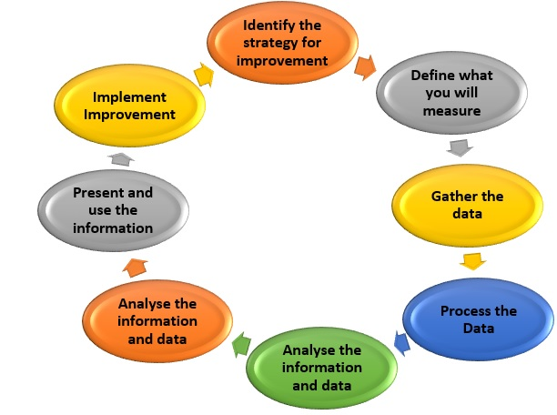
Fig 6: ITIL FRAMEWORK CYCLE

2.4.2. The Four Dimensions of ITIL 4

ITIL 4 has four dimensions which is considered during the delivery of product and services. This makes sure the organisation is accountable, evading inefficient processes. It motivates companies to use the four dimensions together when designing a product or services [16]. These four dimensions are:
Organisation and people
Information and technology
Partners and suppliers
Value streams and processes

2.4.3. ITIL IMPLEMENTATION

Here the time frame available is been divided into chunks, where steps are been addressed according to priorities, the most important ones go first i.e., the have higher priority. It is important to collect Metrix after a quick win so u can observe the progress of the entire project [17] keep checking to see if the implemented plan has met expectation, if all processes and services implemented are producing the output required. If not, the Continual Service Improvement (CSI) can be used to correct and identify any process or service that is not performing well. CSI is an important part of ITIL, as it searches constantly for latest areas that needs improvement and work on them [17]

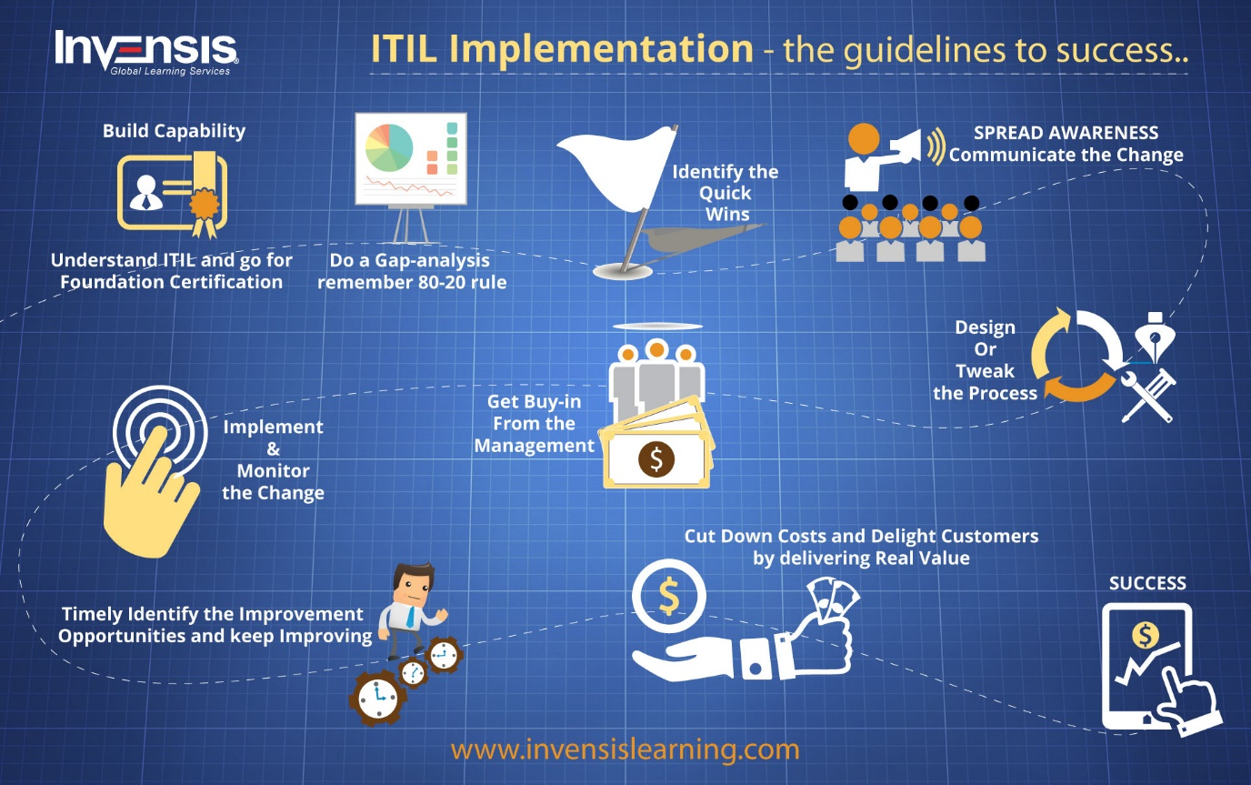
Fig 7: ITIL IMPLENETATION

2.4.4. ADVANTAGES AND DISADVANTAGES OF ITIL

When it comes to IT service management in the world, ITIL is the most acceptable approach. Though it is this successful it also has its disadvantages.
Advantage:
The relationship between ISO/IEC 20000 and ITIL is very important for companies/organisations trying to set up an IT framework suitable for their organisation.
ITIL aids increase customers satisfaction, increases staff maintenance, RIO and morals. It also helps increase staff skills, technique and experience. Helps reduce IT cost and assets [10]
Disadvantage:
The problem faced with the ITIL framework is that the implementation depends on the people who use it i.e., if they don’t have a good understanding of the framework then the output or result will be a failure and they will be a lot of drawbacks whereas if the framework is well understood by the staff, then the result will be successful
So, for ITIL to work well in your organisation, the people involved need to have grip of how the framework functions [10]
ITIL in-depth are covered related to other frameworks which are not relatively covered leading to unevenness [18]

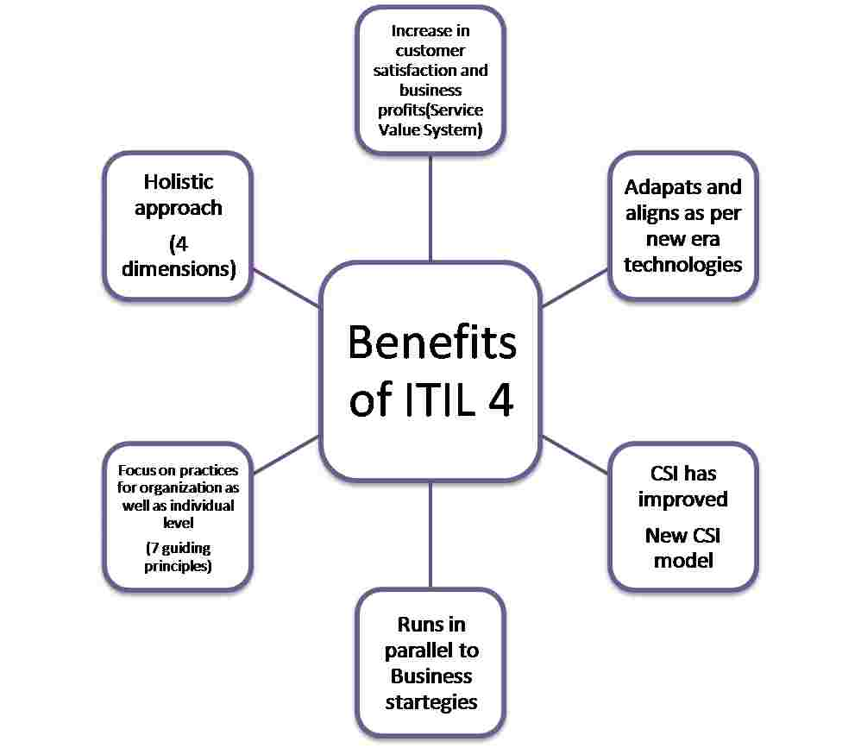
Fig 8: benefits of ITIL

Security Framework Design Case Scenario For CoffeeBlue (Task 2)

This framework is developed to aid coffeeblue with its information/data security maintenance. Since most people access all information now through the internet and with the company’ network/resources being wireless makes it easy for attackers to hack the network and get whatever information he/she wants in case of vulnerabilities. With both staff and customers using their personal devices to have access to the company network/recourses, this framework aims to protect both customers and staff data/information which is its top priority and to protect the business/organisations assets and liability to. Looking at the frameworks mentioned above in (task 1) we are going to build our own frame work to meet good requirements needed by frameworks. To do this we are going to analyse the ones given above use certain important areas to build our own framework.
In this framework we will create a policy on how to protect customers and employee’s information saved in the cloud and in the organisations system, take security measures in case of data breach/theft in the network and how to recover from such attacks and vulnerabilities. We will just look at some few steps on how my framework will look like.

3.2. set target and goals

We already know what the assets of our company CoffeeBlue is all about and what we aim to protect which is employees and customers data/information and also to protect the organisations assets and liabilities. Here we set our goals and target and strive to achieve them. Here we set up all the vulnerability assessment
In this coffeeBlue framework we must always consider the risk management and maintenance which is one of the most important decision to make when putting a business in place.
Next the framework is been customized to meet the specific needs of the organisation. Security policies and guidelines are set up for the customers, employees and everyone associated with the organisation.

3.3. network implementation and assessment

Looking at the ISO 27000 series standard above which focuses on the Infosec like network and app security will help develop standards to help secure this area. As mentioned in the case scenario that most customers and employees will be using their mobiles, tablets, laptops and other devices to access the network recourses. Most of these resources are hosted in the cloud so we have to make sure app security services are fully automated to keep the speed with dynamic clouds.
The organisation should make sure it sets firewalls on its routers, ASA, ACL, block all unused ports in the network, set passwords and authentication on all devices connected to the work. Staffs and client’s personal devices which are use to connect to the organisation network should have access only to resources related only to them, they should not be able to go beyond their privileged. It is also very important to set up pen testing and vulnerability scanning to know what areas of the system is weak and what area is strong in order to manage the system in case of an attack. Techniques, policies and tools (e.g., Nessus) will be set up for intrusion detection and preventive measures in case of an attack it should easily be detected and quick action taken to resolve the problem.

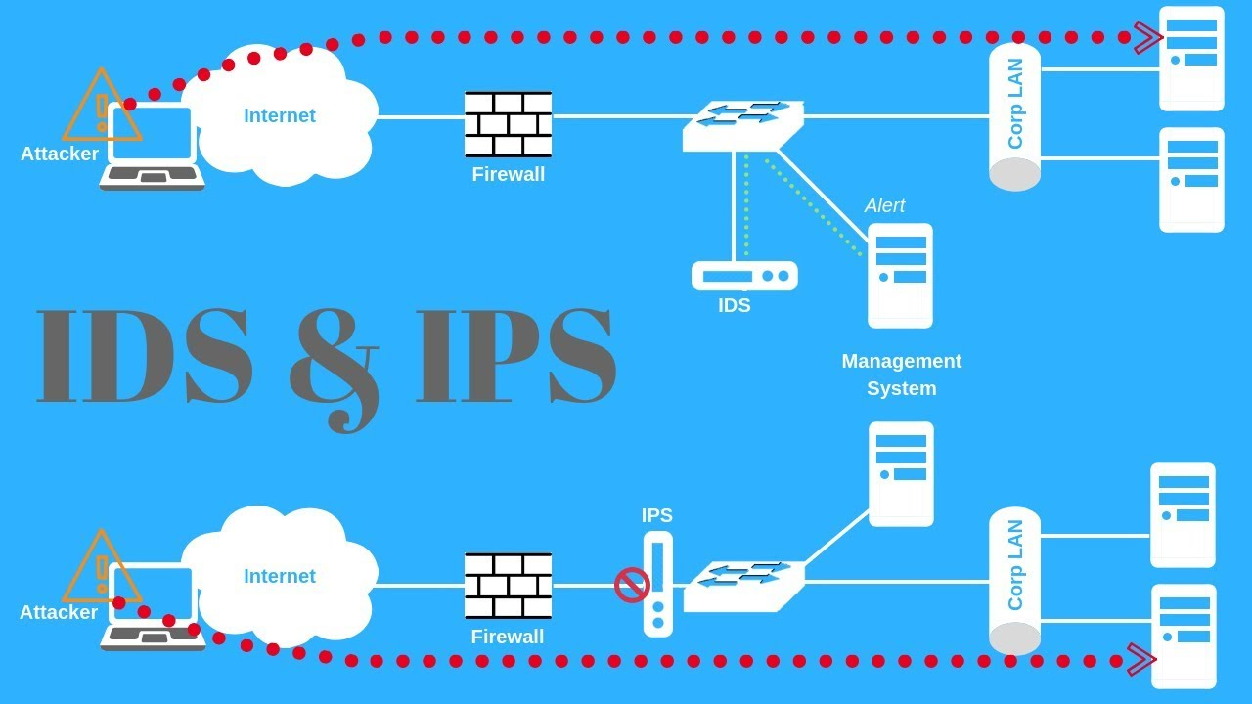
Fig 9: Intrusion detection and prevention system

3.4. create a delegate profile

Now we need to customize the organisation framework to specific business importance. Using the NIST Tier implementation ( as shown on the NIST framework above in Task 1)
Risk Management Process
Integrated Risk Management Program
External Participation
Each Tier runs from 1-4
Tier 1 – Partial
Tier 2 – Risk Informed
Tier 3 – Repeatable
Tier 4 – Adaptive
These steps should match our goals mentioned (3.2.) above. We should aim for the higher levels because they are viewed as a complete implementation of CSF standards. The capability to easily detect and predict threats to the organisation/business.

3.5. examine your ongoing position

Once your goals have been set and your delegate profile created next step is to examine your current position. Perform risk assessment to know the recent status of the organisation. Negotiate with a cyber security expert for them to test the system and give you detail information about your status and position.
Once all the assessments have been performed on all areas of the framework system, all findings should be presented to the stakeholders of the organisation showing them all the security risks that may occur in the system function, individuals and assets of the company. All threats and vulnerabilities should be clearly detailed and explained at each process.

3.6. actions plan taken

Now all the risk, vulnerabilities and potential impact on the organisation framework is been known, we move to the analyses and comparism phase.
At this point in the process, there is a comparism between your actual achievement and your target achievement. We develop a heat map to describe the output in a way which is easily digestible and accessible. If there is a remarkable difference in any area in the organisations business framework it is immediately highlighted and focus is placed on that area. Try to sort out what needs to be done to close the interval between the actual and target score. Come up with a Varity of action solutions to aid you in the process of closing that gap then discuss them with the stakeholders who will help in budgeting.

3.7. Implementation of the action plan

With a clear picture of how your security defence looks, goals set, and gap between the current and target achievement we are how at the process of NIST CSF implementation as shown above in (task 1). All processes here should be documented for future reference and develop training materials for staff. NIST should be implemented here because it will help protect the organisation from unavoidable cyber-attack as mentioned in (task 1). It also helps set up preventive measures on how to respond and recover from cyber-attacks.
CSF should be constantly reviewed to observe its goals and its performance all round constantly revaluating to make sure they are performing as expected.

Conclusion

Cyber security frameworks are very important elements when dealing with cyber-attack threats to your organisation/business. It becomes difficult for the organisation when goals and risk management aspects are not set. Looking at the three framework we talked about above in (task 1) we were able to build our own framework in (task 2) taking strong considerations from the above frameworks in (task 1). It focused on analysing our network, setting goals, taking risk assessment into consideration, protection and recovery processes etc.
Following the steps given in (task 2) on how to build our own security framework for an organisation the best way to succeed in fighting cyber-attacks is been provided here, it protects the organisation from unauthorised users trying to access the system to carry out an attack or steal sensible data/information. Regular updates and checks should be carried out in the entire system as the organisation carries out its day-to-day function make sure all networking device associated with the company is updated to the latest firmware. It is important to know about all the mandatory frameworks standards and policies so as to know which is suitable for your business/organisation and how to implement them alongside vulnerability assessment and tools to use.

REFERENCE

[1] | cisco. [Online]. Available: https://www.cisco.com/c/en/us/products/security/what-is-information-security-infosec.html.
[2] | F. G. K. Doughty, “IT governance: pass or fail?,” Inf Syst Audit Control Assoc, 6 (12), pp. 124-132, 2005.
[3] | A. T. Tunggal, 26 august 2021. [Online]. Available: https://www.upguard.com/blog/information-security-policy.
[4] | ICRC, “INFORMATION SECURITY FRAMEWORK (ISF),” ICRC, 19 Avenue de la Paix, CH-1202 Geneva, 2016.
[5] | s. e. technology, 5 october 2020. [Online]. Available: https://getsmarteye.com/confidentiality-integrity-availability-basics-of-information-security/.
[6] | Techslang. [Online]. Available: https://www.techslang.com/definition/what-is-a-security-framework/.
[7] | N. I. o. S. a. Technology, “Framework for Improving Critical Infrastructure Cybersecurity,” 2018.
[8] | S. M. Kerner, “eWeek,” 24 april 2017. [Online]. Available: https://www.eweek.com/security/how-the-update-framework-improves-security-of-software-updates/.
[9] | a. w. service, “Aligning to the NIST CSF in the AWS Cloud,” 2019.
[10] | balbix. [Online]. Available: https://www.balbix.com/insights/nist-cybersecurity-framework/#:~:text=Overview,and%20improve%20their%20cybersecurity%20posture..
[11] | i. governace, “IT governace,” [Online]. Available: https://www.itgovernance.co.uk/nist-cybersecurity-framework.
[12] | NEC, “NEC,” 21 2020 july. [Online]. Available: https://www.nec.co.nz/market-leadership/publications-media/how-to-implement-a-cyber-security-framework-5-step-plan/.
[13] | G. S. SOLUTIONS. [Online]. Available: https://www.globalsuitesolutions.com/iso-27000-and-the-set-of-information-security-standards/.
[14] | J. miller, “bitlyft,” 5 8 2018. [Online]. Available: https://www.bitlyft.com/resources/what-is-iso-27000.
[15] | n. cooper, 16 june 2012. [Online]. Available: https://nathancooperblogs.wordpress.com/2012/06/16/top-5-weaknesses-of-iso27001/.
[16] | bcs, “bcs,” 6 may 2009. [Online]. Available: https://www.bcs.org/articles-opinion-and-research/why-iso-27001-is-not-enough/.
[17] | “isms.online,” [Online]. Available: https://www.isms.online/iso-27001/annex-a-16-information-security-incident-management/.
[18] | Sarah K. White and Lynn Greiner, “CIO,” 18 january 2019. [Online]. Available: https://www.cio.com/article/2439501/infrastructure-it-infrastructure-library-itil-definition-and-solutions.html.
[19] | M. Nyhuis, “diligent insigths,” 21 october 2020. [Online]. Available: https://insights.diligent.com/compliance/what-is-the-itil-framework/.
[20] | N. Zitek, “20000 academy,” [Online]. Available: https://advisera.com/20000academy/knowledgebase/how-to-implement-itil/.
[21] | f. russo, “the benefit and disadvantages of ITIL”.

