Student Name: Velislava Hristova  Student ID: 2233502  Module Title: Foreign Languages & Cultural Awareness  Module Code: BMIH5003  Lecturer: Heidi Prosser  Date: 05/02/2024 | 
ASSIGNMENT 1: PORTFOLIO
(4 Components)

Component 1: Professional Reflection (500 words +/- 10%)

Weighting: 25%
During dinner service at the prestigious Crewe Hall Hotel & Spa, I, a Food and Beverage (F&B) employee, encountered a cultural misunderstanding with a hotel guest. The guest, hailing from Japan, was dissatisfied with the level of communication regarding the menu. As I attempted to explain the dishes and answer the guest's questions, it became apparent that the language barrier was hindering effective communication. Cultural misunderstandings within the hospitality industry often originate from differences in communication styles, expectations, and social norms (Hofstede, 1980). In this specific scenario, the guest's limited proficiency in English and the F&B employee's lack of awareness of Japanese communication nuances contributed to the communication breakdown. The Japanese culture tends to favor indirect communication and relies heavily on non-verbal cues (Trompenaars & Hampden-Turner, 1997), whereas the Western communication style often emphasizes directness.
Reflection on Cultural Misunderstandings: This experience underscores the significance of cultural sensitivity and effective communication in the hospitality sector. To prevent similar misunderstandings in the future, there is a need for the development of cross-cultural communication skills and an increased awareness of cultural nuances. The following areas necessitate attention:
- Language Proficiency:
  - Enhancing language proficiency is crucial, especially in languages commonly spoken by hotel guests. Language courses, workshops, or language exchange programs could be pursued to facilitate clear and accurate communication (Gudykunst & Kim, 2003).
- Cultural Awareness Training:
  - Participation in cultural awareness training can deepen understanding of diverse cultural norms, communication styles, and expectations. This knowledge will empower employees to adapt their communication approaches based on the diverse backgrounds of hotel guests (Hofstede, 1980).
- Non-Verbal Communication Skills:
  - Developing non-verbal communication skills is paramount for bridging language gaps. Paying attention to body language, gestures, and facial expressions enables a better understanding of guests and facilitates effective communication (Trompenaars & Hampden-Turner, 1997).
- Adaptability and Empathy:
  - Cultivating adaptability and empathy is crucial for anticipating and addressing cultural differences. This involves adopting the perspective of guests, considering their cultural backgrounds, and adjusting communication styles accordingly (Gudykunst & Kim, 2003).
In conclusion, by focusing on these areas, employees can contribute to creating an inclusive and welcoming environment for guests from diverse cultural backgrounds, ensuring positive and memorable experiences at Crewe Hall Hotel & Spa.

References:

- Hofstede, G. (1980). Culture's Consequences: International Differences in Work-Related Values. Sage Publications.
- Trompenaars, F., & Hampden-Turner, C. (1997). Riding the Waves of Culture: Understanding Cultural Diversity in Business. McGraw-Hill Education.
- Gudykunst, W. B., & Kim, Y. Y. (2003). Communicating with Strangers: An Approach to Intercultural Communication. McGraw-Hill Education.

Component 2: Training Plan (500 words +/- 10%)

Weighting: 25%

Identified cultural misunderstanding (in a few words):
During dinner service at Crewe Hall Hotel & Spa, a cultural misunderstanding occurred between a Food and Beverage (F&B) employee and a Japanese hotel guest due to language barriers and differences in communication styles. To address and prevent similar situations in the future, a comprehensive training plan is proposed to enhance the cultural competence of all hotel staff.

Training plan (Why/What//Who/Where/When):

Training Objectives:

- Understanding Cultural Diversity:
  - Provide employees with an overview of various cultures and customs, emphasizing the importance of cultural sensitivity in the hospitality industry (Hall, 1976).
  - Conduct interactive sessions to explore cultural nuances, enabling staff to appreciate and respect differences.
- Communication Skills Enhancement:
  - Offer language training sessions, focusing on common phrases and greetings in different languages to facilitate basic communication with international guests (Chen & Starosta, 1996).
  - Conduct workshops on non-verbal communication, emphasizing the impact of body language and gestures in cross-cultural interactions (Hall, 1976).
- Cultural Awareness in Service Delivery:
  - Incorporate case studies and real-life scenarios to highlight potential cultural misunderstandings during service delivery (Kim, 2001).
  - Role-playing exercises to simulate diverse guest interactions, enabling staff to practice culturally competent responses.
- Customized Guest Services:
  - Implement a system for gathering information about guest preferences related to cultural considerations, such as dietary restrictions or room preferences.
  - Train staff to proactively address these preferences, ensuring a personalized and culturally sensitive guest experience.
- Cross-Cultural Team Building:
  - Facilitate team-building activities that promote understanding and collaboration among employees from different cultural backgrounds.
  - Encourage open communication channels to discuss and address any cultural concerns within the team.
Implementation Strategies:
To effectively implement the training plan, the following strategies will be employed:
- Interactive Workshops:
  - Engage employees in interactive workshops led by cultural experts and language instructors.
  - Encourage participation and discussion to foster a deeper understanding of diverse perspectives.
- E-learning Modules:
  - Develop e-learning modules accessible to all employees, covering cultural awareness and communication skills.
  - Incorporate quizzes and assessments to ensure comprehension and retention of key concepts.
- Regular Training Updates:
  - Schedule regular refresher courses to reinforce cultural competence principles.
  - Integrate feedback mechanisms to gather insights from employees and continuously improve the training program.
In conclusion, enhancing cultural competence among Crewe Hall Hotel & Spa staff is crucial for delivering exceptional service to a diverse clientele. This training plan addresses the identified gaps in cultural understanding and communication skills, ensuring that employees are well-equipped to handle similar situations in the future. By investing in cultural competence training, the hotel aims to create a welcoming and inclusive environment for guests from all backgrounds, further solidifying its reputation as a premier hospitality destination.

References:

- Hall, E. T. (1976). Beyond Culture. Anchor Books.
- Chen, Y., & Starosta, W. J. (1996). Intercultural communication competence: A synthesis. Communication Yearbook, 19, 353-384.
- Kim, Y. Y. (2001). Becoming Intercultural: An Integrative Theory of Communication and Cross-Cultural Adaptation. Sage Publications.

Component 3: Student Self-Reflection (500 words +/- 10%)

Weighting: 25%
Embarking on my academic journey as an International Hotel Management student, my exploration into the significance of cultural awareness within the hospitality industry has been transformative. Employing Schon's reflective model, I aim to critically examine the evolution of my comprehension over time, considering the impact of diverse learning experiences.
Before immersing myself in the cultural awareness class, my grasp of the subject was limited. I possessed a rudimentary understanding of the importance of cultural sensitivity in the hospitality industry, recognizing its pertinence in serving diverse customer bases. However, my comprehension lacked depth, and I was not fully aware of the profound impact that cultural awareness could exert on guest satisfaction, business success, and international collaboration within the industry.
The initial phases of the cultural awareness class exposed me to foundational concepts, theories, and case studies, broadening my perspective. Engaging in class discussions became instrumental in challenging my preconceptions and inspiring me to explore the nuanced aspects of cultural diversity within the hospitality context (Hofstede, 1984). For example, a class discussion on cultural nuances in service expectations enlightened me on the fact that cultural awareness extends beyond mere acknowledgment of differences; it involves adapting service approaches to meet the diverse needs of guests.
Practical exercises, such as analysing real-world scenarios and conducting independent research, furthered my understanding. A particularly enlightening moment occurred during a group project that required investigating a cultural miscommunication incident in a hotel setting. This exercise illuminated the profound impact that cultural misunderstandings can have on customer satisfaction and the reputation of a hospitality establishment. Subsequently, I delved into academic literature to comprehend the underlying theories and frameworks guiding effective cross-cultural communication strategies (Ting-Toomey & Chung, 2005).
Over time, my comprehension of cultural awareness evolved from a surface-level acknowledgment to a profound recognition of its strategic significance within the hospitality industry. Realizing that cultural competence is not merely a moral imperative, but a strategic business advantage became evident. The ability to navigate cultural differences can enhance guest experiences, improve employee satisfaction, and contribute to the global competitiveness of hospitality businesses.
Continuous engagement with course materials, academic literature, and practical exercises facilitated a heightened awareness of cultural nuances, communication styles, and customer expectations. This newfound knowledge equipped me with the skills necessary to adapt and tailor hospitality services to meet the diverse needs of an international clientele.
The experience of delving into cultural awareness has been pivotal in shaping my perspective as an aspiring professional in the hospitality industry. This knowledge is not only crucial for effective customer service but is also integral to fostering positive intercultural relations and maintaining a competitive edge in the global marketplace.
In conclusion, Schon's reflective model has empowered me to critically analyse my journey in understanding the importance of cultural awareness within the hospitality industry. From a nascent awareness to a profound recognition of its strategic significance, my evolution as an International Hotel Management student highlights the transformative power of education. Navigating cultural diversity is not just an ethical responsibility; it is a key driver for success in the dynamic and globalized hospitality landscape. This reflective process deepens my commitment to continuous learning and cultural competence as I embark on my professional journey in the hospitality industry.

References:

- Hofstede, G. (1984). Culture's Consequences: International Differences in Work-Related Values. Sage Publications.
- Ting-Toomey, S., & Chung, L. C. (2005). Understanding Intercultural Communication. Oxford University Press.
- Schon, D. A. (1983). The Reflective Practitioner: How Professionals Think in Action. Basic Books.

Component 4: Training Presentation (6 Slides)

Weighting: 25%
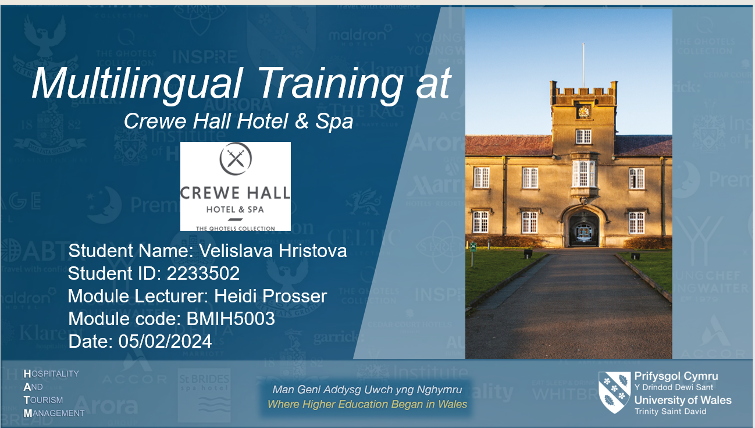
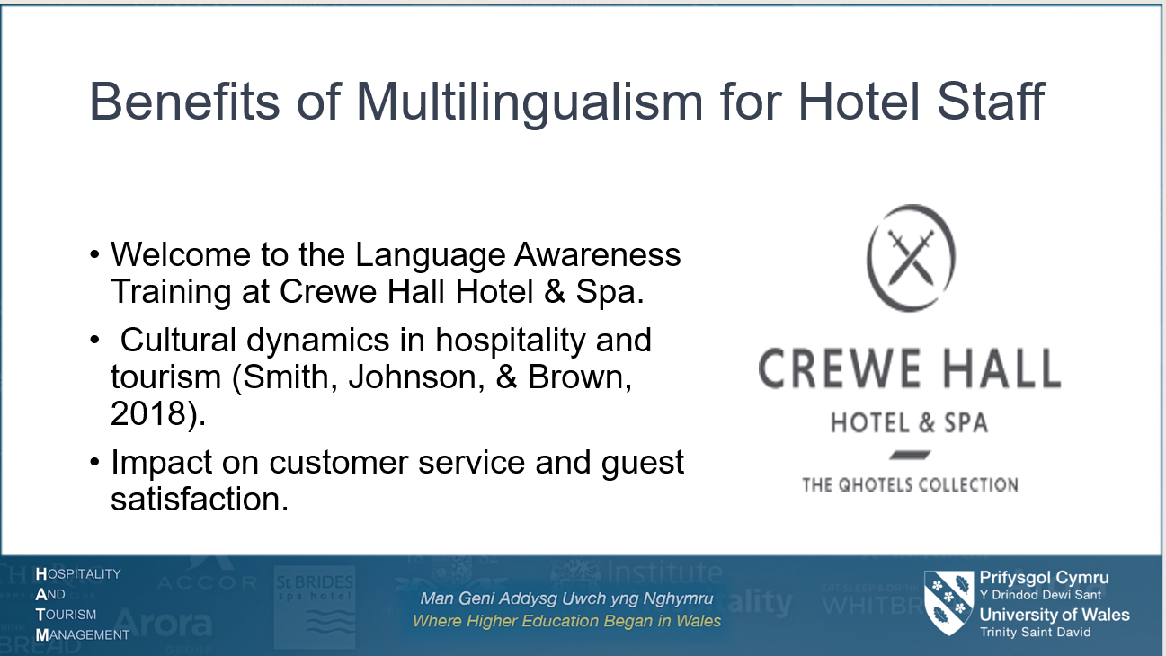



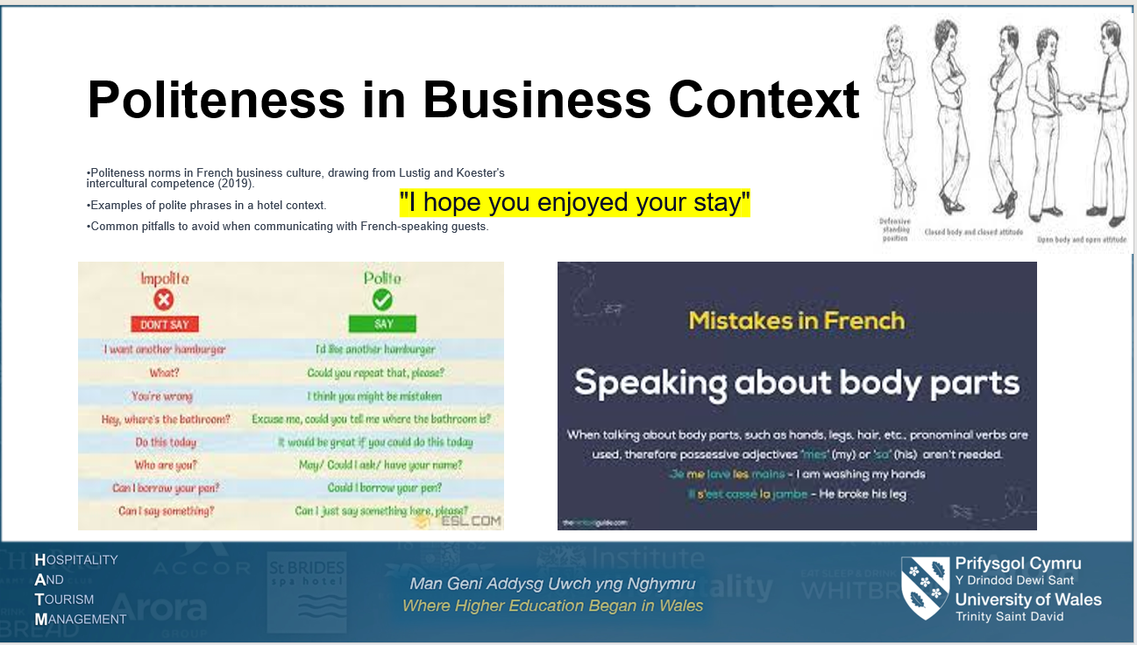

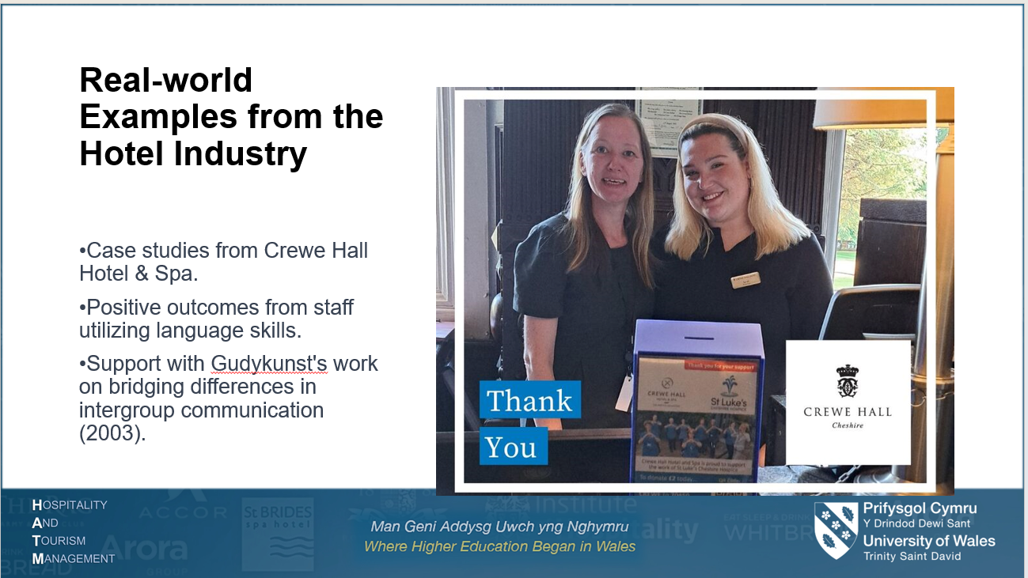

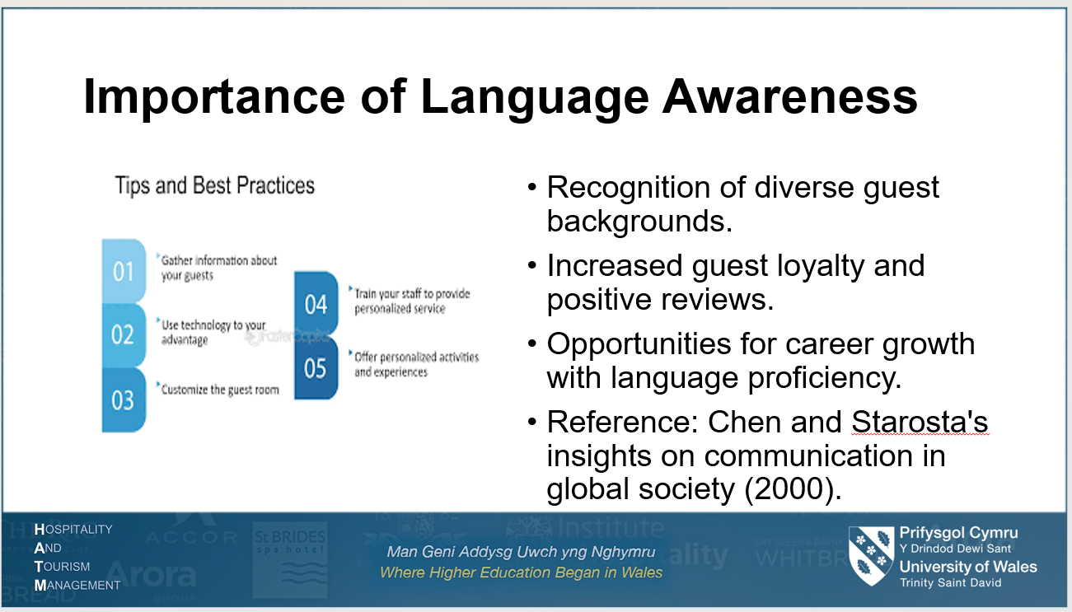
References (no screenshots):

- Smith, J., Johnson, M., & Brown, A. (2018). Cultural Dynamics in Hospitality and Tourism. Routledge.
- Lustig, M. W., & Koester, J. (2019). Intercultural Competence: Interpersonal Communication Across Cultures. Routledge.
- Gudykunst, W. B. (2003). Bridging Differences: Effective Intergroup Communication. Sage Publications.
- Hofstede, G. (2001). Culture's Consequences: Comparing Values, Behaviors, Institutions, and Organizations Across Nations. Sage Publications.
- Chen, G. M., & Starosta, W. J. (2000). Communication and Global Society. Routledge.

