

Master of Business administration

Module Name: Strategic management

Module Code: LCMB7003
Lecturer’s Name: Hoang Dang Nguyen

Student Name: Pratap Chauhan
Student ID: 2436029

Work Count:5000

Table of Contents
Section 1 4
1. Organisational Overview 4
1.1 Company Background 4
1.2 Mission, Vision and Business Model 4
1.3 Industry and Market 5
2. Analysis of External and Internal Environment 5
2.1 PESTEL Analysis 5
2.2 Porter's Five Forces 9
2.3 Internal Environment (Resources) 10
2.4 VRIO Framework 11
2.5 Critical Analysis (VRIO & Performance) 12
3. CSR & Sustainability 12
4. Balanced Scorecard 13
4.1 Financial Perspective 13
4.2 Customer Perspective 14
4.3 Internal Process Perspective 15
4.4 Learning and Growth Perspective 16
5. Strategy & Strategy Implementation 17
5.1 Business-Level Strategy 17
5.2 Corporate-Level Strategy 17
5.3 Evaluation of Strategy 18
5.4 Strategy Implementation 18
6. Strategic Evaluation & Recommendations 19
6.1 SWOT Analysis 19
6.2 Strategy analysis (Ansoff) 20
6.3 Recommendations (Strategic & Justified) 22
Section 2 24
Reflective Account (Gibbs Reflective Cycle) 24
8.1 Description 24
8.2 Feelings 24
8.3 Evaluation 25
8.4 Analysis 25
8.5 Conclusion 26
8.6 Action Plan 26
References 28
Appendices 32

Section 1

1. Organisational Overview

1.1 Company Background
Tesco was established in 1919, and has grown from humble origins as a market stall retailer into the UK's biggest grocery retailer. The company has grown dramatically over the last 100 years through its own growth and acquisitions, as well as overseas expansion, with operations in Europe and Asia. Now, Tesco employs thousands of stores and reaches millions of customers every week, both in physical stores and online. Its size and efficiency have allowed it to retain its market share within the UK grocery market, with a market share of 28.5% in 2025, the largest in over 10 years (Tesco plc,2026).
Tesco's financial performance remains robust, with group sales at around £63.6 billion and operating profit at around £3.1 billion in recent financial reports (Reuters,2025). This growth is indicative of its responsiveness to consumer trends, especially in times of economic volatility and inflation. Tesco's international reach, along with its market share in the UK, puts it in a strong position in the global retail market.

1.2 Mission, Vision and Business Model
The commercial enterprise version of Tesco specializes in presenting value to customers through lower fees, fines and operational efficiencies. It employs a cost leadership approach, achieves economies of scale and provides chain efficiencies so that costs are low even to stay viable This strategy is complemented by an omnichannel retail approach with supermarkets (Tesco Extra), department stores, convenience stores (Tesco Express) and rapidly growing digital businesses.
The other key element of Tesco's business model is its value proposition for the customer, which includes low prices, quality and convenience. Tesco's data analytics, including its customer loyalty program (Clubcard), allow it to offer personalised offers and improve customer loyalty. As part of its strategic priorities, Tesco seeks to offer "value, quality and service" and enhance operational efficiency and sustainability (Tesco plc,2025).

1.3 Industry and Market
Tesco is a part of the fiercely competitive UK grocery retail sector, marked by price wars, thin margins and evolving consumer trends. Despite these challenges, Tesco continues to dominate the market, with a substantially higher market share than its competitors, including Aldi, Lidl and Sainsbury's. Its dominance of the market and steady growth in sales reflect its success in competing with other players in a highly competitive market (Grocery Trade News,2025).
However, the sector remains aggressive, with the emergence of low price stores, inflation and a shift to on line buying. In this way, Tesco generally wants to regulate its pricing strategies, increase its operating profit and expand its online presence to maintain its market role.

2. Analysis of External and Internal Environment

2.1 PESTEL Analysis
Political Factors
The Brexit has had a profound impact on the UK grocery retail industry, with the introduction of customs controls, regulatory differences and more paperwork for imports and exports. This has led to a higher complexity and cost of operations for retailers, especially those with imported products. The Office for National Statistics reports post-Brexit trade difficulties have led to supply chain disruptions and delays, requiring businesses to recalibrate sourcing and supply chain management (ONS,2023).
For Tesco plc, political risk has required a supply chain localisation and resiliency strategy. This has led to enhanced local sourcing, supplier relationships and distribution network development to reduce impacts (Tesco,2024). This highlights Tesco's ability to align its strategy with political uncertainty through minimisation of reliance on globalised supply chains.
Importantly, these responses enhance operational resilience and but could raise costs relative to international sourcing. But Tesco's size enables it to bear or offset these costs through economies of scale, and its cost-leadership strategy. Therefore, political influences have shaped Tesco's business practices and strategies in areas such as supply chain and risk management.
Economic Factors
Economic factors, such as inflation and cost of living, have had a significant impact on the UK grocery sector. Food inflation has spiked to over 15% in 2022-2023, but eased in 2024 (ONS,2024). The latest figures show that grocery inflation has slowed to a point of 4.0% but shoppers are still very sensitive to price (Reuters,2026).
This has resulted in a change in consumer behaviour, with greater preference for own brand and promotions. Consumers are trading up and down, promoting price competition within the industry. In this context, Tesco has strategically enhanced its cost-leadership strategy, notably through schemes like Aldi Price Match and Clubcard pricing (Tesco, 2025; Reuters, 2025).
In addition, Tesco has introduced cost-efficiency initiatives and process improvements to improve profitability, despite cost cuts. This is a strategic decision to prioritise market share over short-term profits. As noted by Reuters (2015), Tesco has been competitive on price to secure customers in a period of high inflation.
More importantly, while these strategies are conducive to customer retention, they continue to put pressure on margins, revealing the difficulties of operating in a low margin business. So, economic factors are a key influencer of Tesco's strategies related to efficiency, scale and price.
Social Factors
The grocery market has seen a shift in consumer behaviour, owing to lifestyle changes, health-consciousness and digitalisation. Consumers are now seeking more convenience, healthier options and online channels, with the COVID-19 pandemic further accelerating these trends, which are now ingrained (Statista, 2024).
On the tab, Tesco has embraced omnichannel retail, combined virtual sales and fast delivery capabilities. It has also accelerated its offering of healthier single brand products to meet consumer shifts (Tesco, 2025).
Moreover, the growth in membership of loyalty cards like Clubcard highlights the value of personalisation. Tesco uses data to personalise marketing and improve the shopping experience, thus increasing customer loyalty.
Even more important are the socially demanding situations and opportunities. Online interactions increase consumer loyalty while raising expectations of comfort and satisfaction. Tesco’s innovative telecommunications strategies ensure it can meet those expectations.
Technological Factors
Technology plays a crucial role in today's retail industry. Tesco's focus on data analytics, automation and digital technologies has allowed it to improve efficiency and customer interaction (Tesco, 2015).
The Clubcard loyalty program is a major technological advantage, enabling Tesco to gather vast amounts of data on its customers. This helps with dynamic pricing, promotional strategies and demand management. Further, the use of self-service checkout, automated warehouses, and AI-powered logistics optimisation has led to cost savings and efficiency gains.
Strategically, technology helps with fee management and differentiation. It can reduce prices and differentiate by presenting a personalized and convenient carrier to Tesco.
But technology is costly to develop and maintain, and other retailers are rapidly adopting new technology. So, Tesco needs to keep innovating to maintain its technological edge and prevent becoming technologically similar.
Environmental Factors
Environmental sustainability is a key factor for the retail industry, due to regulatory, stakeholder and consumer pressure. Tesco is on a journey to net-zero emissions in its operations by 2035 and has made considerable headway in Scope 1 and 2 emissions reduction (Tesco, 2025).
It has also launched programmes to minimise food waste, enhance packaging sustainability and ensure sustainable sourcing. For instance, initiatives to reduce food waste have helped to redistribute millions of meals to the community, improving environmental and social outcomes.
These programs have immediate funding value, but they deliver long-term benefits that include consistency, reduced costs through multiple exposure and improved branding Sustainability at a strategic level translates into details of Tesco’s value proposition, which helps to understand and retain.
Importantly, sustainability also extends into the distribution chain, where Tesco suppliers must adhere to sustainable practices and emission reduction targets and they demonstrate a quit-stop approach to sustainability.
Legal Factors
The UK grocery industry is highly regulated in terms of food safety, labour regulations, competition laws and data protection. Adherence to regulations enforced by authorities like the Food Standards Agency helps build and retain consumer confidence, while avoiding fines and sanctions (FSA, 2023).
Tesco's size allows it to implement compliance measures, such as quality control, staff training and data security. This helps mitigate legal liabilities and improves business stability.
But in areas such as increasing regulatory requirements and data security and environmental guidelines, prices are soaring. The ability to absorb this cost is greater for large companies such as Tesco than for small companies, which can nicely make their competitive advantage.
PESTEL Conclusion
In conclusion, the macro-environment has a strong impact on Tesco's strategy. Economic factors push it towards efficiency and cost reduction, while technology and social factors enable digital and social engagement. Legal and environmental factors influence its sustainability and regulatory compliance measures.Tesco's strategy is well aligned with these factors, highlighting its strategic agility, a key requirement for maintaining competitive advantage in a dynamic and fiercely competitive market.
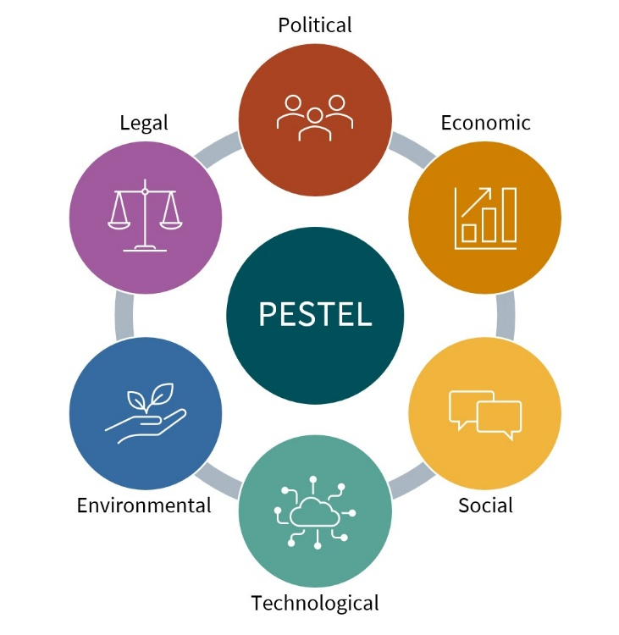
Figure 1. PESTEL Analysis
Source: AKIS Connect,2024

2.2 Porter's Five Forces
Competitive Rivalry (High)
Within the UK grocery market, there is widespread competition between supermarkets (Tesco plc, Sainsbury's and Asda) and discount stores (Aldi and Lidl).
This sharp contrast is about Tesco’s approach to aligning prices and improving efficiency. Kantar (2015) notes that conflict is fieldwork.
Threat of New Entrants (Low)
Entry barriers are high due to high capital requirements, economies of scale, and existing distribution chains. Tesco’s size and the presence of the symbol are a barrier to new competition.
Buyer Power (High)
Customers are payment sensitive, especially characterized by low switching costs during inflation. Tesco counteracts this with loyalty cards (e.g., Clubcard), which increase switching fees and increase retention (Tesco, 2025).
Supplier Power (Moderate)
Large suppliers may have some power but Tesco's size allows it to negotiate with suppliers. Long-term relationships also enhance supplier relations.
Threat of Substitutes (High)
Local retail stores, home meal delivery and restaurants are substitutes. Tesco has minimised this by offering convenience stores and delivery services to improve convenience and the appeal of Tesco products.
Five Forces Conclusion
The UK grocery industry is unappealing because of high rivalry and bargaining power of buyers. Tesco's success is reliant on the scale, efficiency and analytics capabilities of the business.
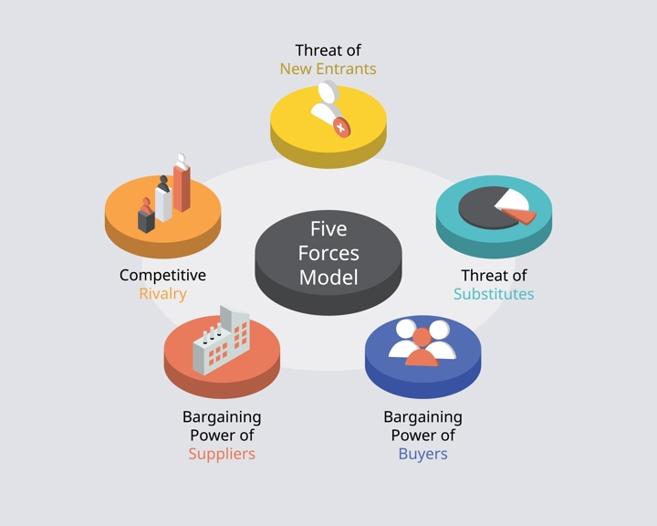
Figure 2. Porter’s Five Force
Source: IBISWorld,2023

2.3 Internal Environment (Resources)
Tesco's internal environment is defined by its tangible and intangible resources that are used to achieve its strategic goals.
Tangible Resources
- Extensive store network
- Advanced logistics infrastructure
- Very good financial results (Tesco, 2015)
Intangible Resources
- Strong brand reputation
- Customer data (Clubcard)
- Supplier relationships
Core Competencies
- Supply chain efficiency
- Data analytics and personalisation
- Omnichannel integration
Tesco uses these resources to create value and be efficient.

2.4 VRIO Framework
Resource/Capability | Valuable | Rare | Inimitable | Organised | Competitive Implication
Brand reputation | ✔ | ✔ | ✔ | ✔ | Sustained advantage
Supply chain & logistics | ✔ | ✔ | ✔ | ✔ | Sustained advantage
Clubcard data analytics | ✔ | ✔ | ✔ | ✔ | Sustained advantage
Store network | ✔ | ✖ | ✖ | ✔ | Temporary advantage

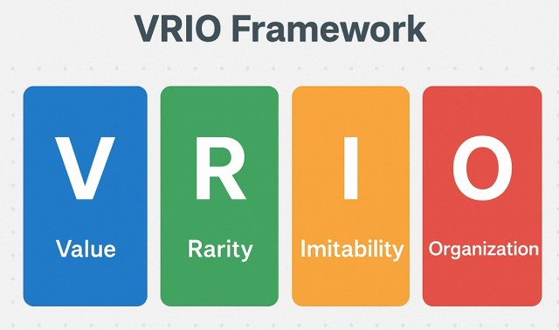
Figure 3. VRIO Framework
Source: The Intact One,2018

2.5 Critical Analysis (VRIO & Performance)
Tesco's success is a result of its integrated resources and capabilities. Its supply chain management enables it to keep costs low, driving cost leadership, and its use of big data analytics helps it to engage and retain customers.
These are difficult to emulate because Tesco operates at scale and is contained, preferably for sustainable and aggressive advantage. But no longer are all possessions, such as save places, so rare, and therefore offer good temporary blessings.
In order to sustain its competitive advantage, Tesco needs to invest in technology, sustainability and innovation. This will help maintain its resources' value, rarity and inimitable nature, and therefore, long-term advantage.

3. CSR & Sustainability
Tesco has integrated corporate social responsibility (CSR) and sustainability into its strategic approach with a focus on sustainability, environment and communities. One of the main focuses of Tesco's sustainability approach is the reduction in carbon emissions and reaching carbon neutrality in its operations by 2035, as well as a net-zero value chain by 2050 (Tesco plc,2024). It has already done much to reach its goals, including a 65% reduction in operational (Scope 1 and 2) emissions, surpassing its original targets (Supply Chain Digital,2025). Moreover, Tesco recorded a 7.1% year-on-year emissions drop in 2025, showcasing its ongoing efforts to improve the environment (Tracenable,2025).
Tesco also has a range of other environmental initiatives, such as sustainable sourcing, renewable energy investments and waste reduction measures. For instance, it has enhanced packaging sustainability, with high rates of recyclability and distribution of a large share of unsold food to minimise waste (Tesco plc,2025). As well as environmental sustainability, Tesco encourages ethical business practices through sustainable supply chain management, requiring its suppliers to report emissions data and meet sustainability goals, thus creating a "shared" CSR approach across its supply chain (Net Zero Compare,2025).
Strategically, CSR activities have several benefits, including improved symbolic image, buyer loyalty and stakeholder engagement CSR activities additionally result in cost savings over the years, which include rebates on electricity and waste. However, such projects require high upfront fees and complexity, especially to cope with scope three emissions along the global supply chain.
In summary, Tesco's CSR initiatives enhance its competitive advantage through the integration of environmental and social issues with business practices. Through embedding sustainability into its business practices, Tesco not only complies with regulatory and societal demands but also enhances its resilience and competitiveness in the fast-evolving sustainability-focused retail landscape.

4. Balanced Scorecard
The Balanced Scorecard (Kaplan and Norton, 1992) is an integrated performance management framework that considers financial and non-financial aspects of performance. For Tesco, the scorecard provides insight into how strategic goals are converted into the financial, customer, internal business process and learning and growth perspectives.

4.1 Financial Perspective
Tesco's financials are highly resilient in a volatile environment and in the face of inflation and competition. In 2025, group sales stood at around £63.6 billion, showing growth as a result of higher volumes and market share growth (Investing.com,2025). Year-on-year growth in adjusted operating profit was also driven by cost reduction measures and growth in demand (Yahoo Finance,2025.
Objectives:
- Sustain revenue growth
- Enhance profitability by efficiency
KPIs:
- Revenue growth rate
- Operating profit margin
- Free cash flow
Targets:
- Consistent sales growth every year (~3-5%)
- Continue to operate at a consistent profitability level (4-5%)
Strategic Initiatives:
- “Save to Invest" cost reduction campaign - save £500 million
- Investment strategies to enable price
Most importantly, Tesco strikes the balance between cost and margin, to maintain profitability in a low-margin environment.

4.2 Customer Perspective
Tesco prioritises customer satisfaction and loyalty. It has delivered a record level of customer satisfaction (Net Promoter Score) in several years, due to greater value, quality and service (Yahoo Finance,2025). The Clubcard loyalty scheme is integral, sending millions of personalised offers to customers each year, increasing customer engagement and loyalty (Redfish Group,2025).
Objectives:
- Increase customer satisfaction and engagement
- Strengthen value perception
KPIs:
- Net Promoter Score (NPS)
- Customer retention rates
- Clubcard engagement
Targets:
- Increasing customer satisfaction
- Increase in the number of members of the loyalty program
Strategic Initiatives:
- Clubcard price and promotions
- Launch of high value and low price product ranges
This focus on customers enhances Tesco's competitive position via customer loyalty and differentiation.

4.3 Internal Process Perspective
The effectiveness of Tesco’s cost management process is fundamental. Tesco is constantly focusing on improving supply chain, automation and store efficiency. Examples of operational efficiency and payment manipulation include price discounts (more than 2,300 items are now cheaper than a year ago) (Tesco percent, 2025).
Objectives:
- Improve operational efficiency
- Decrease supply chain costs
KPIs:
- Cost-to-sales ratio
- Inventory turnover
- Supply chain efficiency
Targets:
- Continuous cost reduction
- Improved operational productivity
Strategic Initiatives:
- Dc automation
- Online supply chain management
- Store efficiency improvements
Process efficiency allows Tesco to offer low prices, while remaining profitable: a cost leadership strategy.

4.4 Learning and Growth Perspective
Tesco's future growth is built on its efforts in innovation and digitisation. Tesco has made significant investments in technology, such as data mining, digital media and e-commerce. Its online business has grown significantly, aided by convenience and same-day delivery services (Director’s Talk Interviews,2025). Moreover, Tesco is also increasing its product development, introducing new products every year to keep pace with market demand (Director’s Talk Interviews,2025).
Objectives:
- Enhance digital capabilities
- Innovate and build skills
KPIs:
- Digital sales growth
- Number of new product launches
- Employee productivity
Targets:
- Grow online sales
- Expansion of innovation
Strategic Initiatives:
- Online grocery shopping and delivery
- Data-driven business decisions
- Training and technology for staff
These measures help Tesco stay agile and relevant in the ever-changing retail landscape.
Balanced Scorecard Conclusion (Critical Insight)
In summary, Tesco's Balanced Scorecard is well-aligned with its four perspectives. Efficient operations underpin financial performance, and customer retention and technological advancement enable future growth. Crucially, this connectivity allows Tesco to maintain its competitive edge in a highly competitive, low margin, market.

5. Strategy & Strategy Implementation

5.1 Business-Level Strategy
Tesco's business-level strategy largely revolves around a cost leadership strategy, allowing it to thrive in the highly competitive UK grocery market. Tesco has implemented aggressive pricing tactics, such as price-matching its discounter counterparts, like Aldi, on hundreds of core products, while still offering quality products and services (Reuters,2025). This strategy has improved Tesco's market positioning, enabling it to boost market share to 28.4% in 2025, compared to its key competitors (Reuters,2025).
In addition, Tesco develops its competitive advantage through the provision of a loyalty program, Club Card, which gives and gives personalized discounts, thus increasing the frequency and breadth of shopper behavior (Reuters,2025). This fee competition and loyalty allows Tesco to pursue its value leadership approach, although it differentiates itself through fact-driven customer engagement.

5.2 Corporate-Level Strategy
Corporate-level strategy for Tesco involves a strategy of selective growth and diversification in the form of digital transformation and internationalisation. The company has a presence in various markets, such as the UK, Ireland and Central Europe, enabling it to spread its revenues and minimise market risk (Tesco plc,2025).
Crucially, Tesco has focused on digital growth, with a focus on online grocery delivery, retail media and analytics. It has enhanced its multi-channel capabilities by linking physical and online services, and personalised digital marketing (Reuters,2025). This is in line with the shift in consumer preferences, with growing appetite for online services.

5.3 Evaluation of Strategy
There are some positives to Tesco's current strategy: First, its cost leadership strategy allows it to compete against other supermarkets and discounters. Second, its size and efficiency enable it to realise cost savings, such as the proposed £500 million efficiency savings program, to reinvest in prices and value for customers (Reuters,2025). Third, its tech and data give it a competitive edge with tailored services.
But there are also disadvantages. Tesco’s gross margins tend to be driven by a cash management approach, especially in times of inflation and rising costs. For example, rising wages, taxes, and politics were a financial burden for the company (Reuters,2025). In addition, the competitive pressure of low-cost retailers also puts pressure on Tesco’s pricing practices, forcing them to invest in price, in order to retain customers.

5.4 Strategy Implementation
The implementation of its strategy is critical to Tesco's success, especially as it relates to change management and digital transformation. It has made substantial changes to its operations, such as automation in warehouse operations, optimisation of supply chains and adoption of digital technologies for efficiency (Tesco plc,2024).
As for change management, Tesco has been flexible in adapting to market factors such as inflation and changing consumer trends. For example, it has changed its pricing, developed online platforms, and enhanced customer experience to meet the challenges (Reuters,2025).
Tesco has also embraced digital transformation, with more data analytics, personalised marketing and e-commerce. These not only drive operational efficiency, but also customer satisfaction and loyalty.
Critical Insight (Conclusion)
In conclusion, Tesco's strategic decisions are in line with the competitive landscape in the UK grocery sector. Its focus on cost efficiency, technological innovation and efficiency has allowed it to stay ahead of the competition despite the many challenges. But to maintain this position it will need to continue to invest in technology, cost management and differentiation to meet the challenges of increasing competition and economic volatility.
6. Strategic Evaluation & Recommendations

6.1 SWOT Analysis
Strengths | Weaknesses
Market leader with ~28–29% UK share | Low profit margins due to price competition
Strong brand and customer loyalty (Clubcard) | High dependence on UK market
Efficient supply chain and economies of scale | Exposure to rising operational costs
Advanced data analytics and digital capabilities | Price wars reduce profitability

Opportunities | Threats
Growth in online grocery and digital retail | Intense competition from Aldi and Lidl
Expansion of private-label and premium products | Inflation and declining consumer confidence
Sustainability and ESG-driven differentiation | Rising labour, energy, and regulatory costs
AI-driven customer personalisation | Changing consumer behaviour

Evidence: Tesco remains the market leader in the UK, with 28-28.7% market share compared to others (Reuters,2026; Reuters,2026). But the market is extremely competitive with discounters gaining market share and putting pressure on prices (Grocery Trade News,2025).
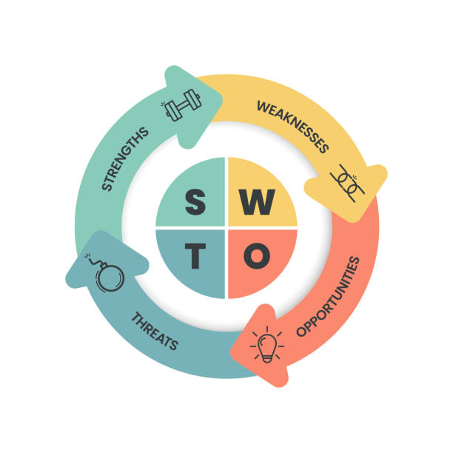
Figure 4. SWOT Analysis
Source: (ProjectWidgets, 2024)

6.2 Strategy analysis (Ansoff)
According to the Ansoff Matrix, Tesco strategy is a mixture of market penetration, product development and diversification.
Market Penetration (Primary)
Tesco is enhancing market share in their current markets via price wars and sales (e.g., Aldi price match). This has led to an increase in market share to almost 28.5% in 2016 (Investing.com,2016).
Product Development
Tesco has also developed its own label ranges (e.g. low price and premium "Finest") to cater for various consumers. This approach is in line with cost leadership and differentiation.
Diversification
Tesco has developed online services, such as online retailing, media and a marketplace. These ventures lower dependency on physical stores, and are in line with consumer trends.
Critical Evaluation
Tesco's business model is very successful but has some drawbacks.
Strengths:
- Well matched to the industry (price sensitive)
- Economies of scale for cost and price advantages
- Big data approach boosts customer retention
Weaknesses:
- Cost leadership strategy has low margins
- Rising costs (labour, energy, taxes) impact on profitability
- Increasing competition
Most importantly, although Tesco has a strategy that guarantees market dominance, it must continually invest in pricing and efficiency to maintain this, constraining profitability.
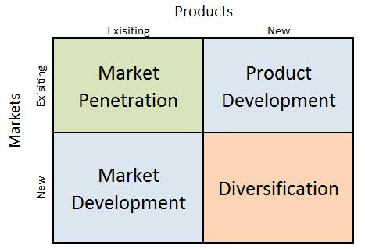
Figure 5. Ansoff Matrix
Source: (Dudovskiy, 2019)

6.3 Recommendations (Strategic & Justified)
1. Enhance Digital Ecosystem & AI
Tesco should continue to build its digital ecosystem and personalisation capabilities using AI to complement existing efforts, such as personalised marketing.
Justification:
- In line with Ansoff matrix for diversification
- Increases customer satisfaction and loyalty
- Backed by positive trends towards digital consumption
Impact:
- Increased lifetime value
- Differentiation beyond cost/price
2. Build a Range of Finest and Sustainable Products
Tesco should develop a broader range of premium ("Finest") and sustainable products to move away from a cost leader strategy.
Justification:
- Adopts differentiation strategy (Porter)
- Captures higher-margin segments
- Responds to sustainability trends
Evidence:
- Sales of upmarket product have helped growth on economic downturns
Impact:
- Improved profit margins
- Stronger brand positioning
3. Increase Efficiency with Automation
Tesco should continue to automate and improve its supply chain to increase its cost efficiency.
Justification:
- Supports cost leadership strategy
- Addresses margin pressures
Impact:
- Long-term cost reduction
- Sustained price competitiveness
Strategic Conclusion (Critical Insight)
In summary, Tesco's existing strategy is in line with the retail industry, allowing it to retain its market position in a competitive retail sector. But in order to remain competitive it needs to move away from a cost leadership strategy to a combination of efficiency, innovation and differentiation. The proposed strategies will allow Tesco to improve its profitability, while also staying ahead of the competition in the dynamic retail environment.

Section 2
Reflective Account (Gibbs Reflective Cycle)
Reflection is a vital aspect of postgraduate education, helping students reflect on their learning, recognise their successes and challenges, and improve their performance. The Gibbs Reflective Cycle is a six-phase process which involves description, feelings, evaluation, analysis, conclusion and an action plan, and contributes to effective learning and development (Simply Psychology,2025; Creately,2026). This reflective assessment assesses the process of research, analysis and report writing of the strategic management report on Tesco.

8.1 Description
This assignment involved choosing an organisation and evaluating its practices of strategic management using tools like the PESTEL, Porter's Five Forces, VRIO and Balanced Scorecard. I chose Tesco as it has a strong market presence and accessible financial and strategic information.
This required extensive research into the use of credible sources, including agency reviews, business reports, and theoretical models. I examined Tesco’s macro and micro environment, as well as its capabilities and attitudes, and then focused on its sustainability approach and performance. I also made strategic recommendations that many used in a theoretical way, such as Ansoff and SWOT.
In doing this, I kept in mind to critically analyse evidence, critically evaluate the analysis, and consider the academic standards of a Level 7 degree.

8.2 Feelings
At first, I was comfortable with my choice of Tesco as I had an awareness of the company and access to relevant information. But as I worked on the assignment, I felt overwhelmed by having to link various strategic frameworks. The intricacy of connecting theory and data generated confusion, especially when trying to adopt a critical as opposed to a descriptive stance.
On the other hand, I was inspired by the chance to translate theory into practice in an organisation. As the course went on I became more confident, especially when I was able to analyse financial data and relate it to strategy. The Gibbs model also enabled me to think more about my learning.

8.3 Evaluation
The experience was rewarding and hard work. A strength of my work was the inclusion of reliable and current sources, such as Tesco's annual and sustainability reports, which added to the validity of this work. What's more, the use of several models allowed for a holistic view of Tesco's strategy.
But there were flaws. It struggled at times to balance complexity with ease, especially when incorporating complex frameworks such as VRIO and Porter's Five Forces. I additionally tend to start and explain, really instead of trying and this should be treated and subtly.
In conclusion, the exercise was a learning experience in terms of my analytical skills, especially with regard to critical analysis and synthesis.

8.4 Analysis
In the analysis phrases, Gibbs Reflective Wheel allowed me to significantly iterate my research and gain insights. Literature shows that the use of mirroring improves the knowledge acquisition of enjoyment and analysis by using engagement with enjoyment of expertise and performing meaningful mirroring (Praveena,2025; Al-Mutawa et al.,2024).
A key lesson from this exercise was the need to integrate theory and practice. For example, while the use of PESTEL analysis was used to inform Tesco’s method, not only necessary to explain how the external factors influenced the process, but also the choices made by the organization. Similarly, the VRIO assessment showed how Tesco’s assets are a valuable and sustainable source of competitive advantage, as well as emphasizing the need for internal assessment.
Data-supported arguments were also a crucial learning outcome of the course. As part of the Level 7 degree, we are expected to provide evidence-based analysis and using reliable sources to back up our claims improved my analysis. Finally, I have improved my understanding of the role of a number of strategic models and how they interact to form a more comprehensive analysis.

8.5 Conclusion
Finally, this assignment has improved my knowledge of strategic management and the use of theoretical models. The Gibbs Reflective Cycle has helped me to reflect on my learning journey and areas I can improve on.
I have gained a greater ability to research and analyse, especially in the application of concepts like PESTEL, Porter's Five Forces and VRIO to various organisations. But I also need to work on further developing my skills in critically analysing information and synthesising various ideas.
In conclusion, this experience has helped me academically and in strategically thinking in the workplace.

8.6 Action Plan
Reflecting on this, I have a number of things I will do to enhance my future academic and work-related performance:
1. Enhance Critical Thinking
I will concentrate on going beyond descriptive writing, by asking why and how when processing information. This will include more in-depth reading of academic articles, and critical assessment of the literature.
2. Enhance Research Skills
I will continue to use reliable and up-to-date sources, with an emphasis on academic journals and company reports. I will also work on my skills of integrating information from different sources.
3. Strengthen Time Management
Effective time management is crucial to delivering quality work. I will use planning strategies, such as breaking an assignment into manageable parts, to plan my work.
4. Practise Applied Skills
I will build on opportunities to apply learning to practical situations, such as case studies and internships, to enhance my knowledge of strategic management.
5. Continuous Reflection
I will continue to use reflective cycles like Gibbs to assess my learning experiences, as this helps to improve and enhance learning and development.
Final Reflective Insight
In summary, my utilisation of the Gibbs Reflective Cycle has allowed me to turn this assignment into a learning opportunity. I have learned to break down my strategies, and this will help me improve my future performance and skills in academia and work.
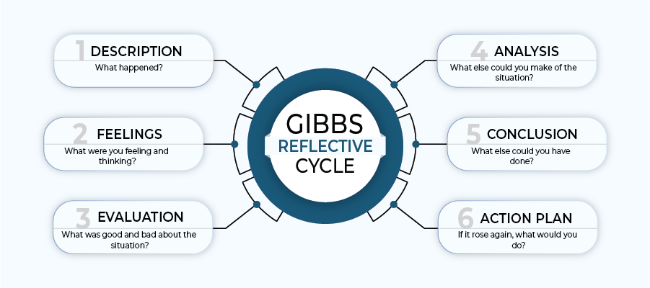
Figure 6. Gibbs Reflective Cycle
Source: (Athal, 2025)

References
Tesco plc (2025) Annual Report and Financial Statements 2025. Available at: https://www.tescoplc.com/media/ky0bfwpo/tesco_ar25_interactive.pdf
Tesco plc (2026) Preliminary Results 2025/26. Available at: https://www.tescoplc.com/media/ch1fbgss/tesco-plc-preliminary-results-statement-fy26.pdf
Technavio (2026) UK Grocery Retail Market Analysis, Size, and Forecast 2026–2030. Available at: https://www.technavio.com/report/grocery-retail-market-in-uk-industry-analysis
Reuters (2025) Britain’s Tesco raises annual profit outlook after strong summer sales. Available at: https://www.reuters.com/world/uk/britains-tesco-raises-annual-profit-outlook-2025-10-02/
Grocery Trade News (2025) UK grocery market share 2025: Tesco leads again. Available at: https://www.grocerytradenews.com/uk-grocery-market-share-2025/
Tesco plc (2024) Climate change factsheet 2024. Available at: https://www.tescoplc.com/climate-change-factsheet-2024
Supply Chain Digital (2025) Yellow labels: How Tesco rescued 60 million meals. Available at: https://supplychaindigital.com/sustainability/yellow-labels-how-tesco-rescued-60-million-meals
Tracenable (2025) Tesco – Greenhouse gas (GHG) emissions data. Available at: https://tracenable.com/company/tesco/ghg-emissions
Tesco plc (2025) Sustainability Report 2025. Available at: https://www.sustainabilityreports.com/tesco/2025/sustainability-report
Net Zero Compare (2025) Tesco environment supplier requirements (Tesco standards). Available at: https://netzerocompare.com/policies/tesco-standards
Investing.com (2025) Tesco warns of profit dip despite strong year amid tax and inflation pressures. Available at: https://in.investing.com/news/earnings/tesco-warns-of-profit-dip-despite-strong-year-amid-tax-inflation-pressures-4768326
Yahoo Finance (2025) Tesco PLC (TSCD.F) FY 2025 earnings report. Available at: https://finance.yahoo.com/news/tesco-plc-tscdf-fy-2025-070046669.html
Redfish Group (2025) Tesco Clubcard success supported by retailer buying strength. Available at: https://www.redfishgroup.co.uk/insights/tesco-clubcard-success-supported-by-retailer-buying-strength/
Tesco plc (2025) Preliminary Results 2024/25 press release. Available at:
https://www.tescoplc.com/media/mxfjrk4x/tesco-plc-preliminary-results-2425-press-release.pdf
Director’s Talk Interviews (2025) Tesco Plc posts strong H1 2025/26 sales growth and raises interim dividend. Available at: https://www.directorstalkinterviews.com/tesco-plc-posts-strong-h1-202526-sales-growth-and-raises-interim-dividend/4121218818
Reuters (2025) Britain’s Tesco warns profit to fall as competition intensifies. Available at: https://www.reuters.com/business/retail-consumer/britains-tesco-warns-profit-fall-competition-intensifies-2025-04-10/
Tesco plc (2024) Annual Report and Financial Statements 2024. Available at:
https://www.tescoplc.com/media/zgvhd0dn/tescos_ar24.pdf
Reuters (2025) Britain’s Tesco raises annual profit outlook after strong summer. Available at: https://www.reuters.com/world/uk/britains-tesco-raises-annual-profit-outlook-2025-10-02/
Reuters (2026) UK’s Tesco says uncertainty on Iran war weighs on profit outlook. Available at: https://www.reuters.com/world/uk/uks-tesco-says-uncertainty-iran-war-weighs-profit-outlook-2026-04-16/
Reuters (2026) UK grocery inflation eases to nine-month low of 4.0%, says Worldpanel. Available at: https://www.reuters.com/world/uk/uk-grocery-inflation-eases-ninemonth-low-40-says-worldpanel-2026-02-03/
Investing.com (2026) Tesco FY 2025/26 slides: market share hits decade high on customer focus. Available at: https://www.investing.com/news/company-news/tesco-fy-202526-slides-market-share-hits-decade-high-on-customer-focus-93CH-4617412
Simply Psychology (2025) Gibbs Reflective Cycle. Available at: https://www.simplypsychology.org/gibbs-reflective-cycle.html
Creately (2026) Gibbs Reflective Cycle – 6 Stage Model Comprehensive Guide. Available at: https://creately.com/guides/gibbs-reflective-cycle/
Statista (2024) Online grocery shopping trends in the UK. Available at:
https://www.statista.com/topics/3122/online-grocery-shopping-in-the-united-kingdom/
Kantar (2025) Grocery price rises slow as retailers roll out festive deals. Available at:
https://www.kantar.com/uki/inspiration/fmcg/2025-wp-grocery-price-rises-slow-as-retailers-roll-out-festive-deals
Food Standards Agency (2023) Starting your food business safely. Available at:
https://www.food.gov.uk/business-guidance/starting-your-food-business-safely
Office for National Statistics (2024) Consumer price inflation, UK: food price trends. Available at:
https://www.ons.gov.uk/economy/inflationandpriceindices
Office for National Statistics (2024) UK trade in goods: year in review 2023. Available at:
https://www.ons.gov.uk/economy/nationalaccounts/balanceofpayments/articles/uktradeingoodsyearinreview/2023
Praveena, K.S. (2025) Using Gibbs' Reflective Model Approach for Enhancing Project-Based Learning. Journal of Engineering Education Transformations. Available at: https://journaleet.in/index.php/jeet/article/view/2071
Al-Mutawa, N.A.A., Mahmoud, M.H., Baisa, K.G.G., Daher-Nashif, S. and Al Wahedi, Z., 2024. Reflective writing among healthcare practitioners in primary care: a qualitative study from Qatar. Cogent Education, 11(1), p.2373555. https://doi.org/10.1080/2331186X.2024.2373555
AKIS Connect (2024) PESTEL Analysis. Available at:
https://akisconnect.eu/iss-tools-and-methods/tool-details?id=34&name=Pestel+Analysis
IBISWorld (2023) Using Porter’s Five Forces to develop business strategies. Available at:
https://www.ibisworld.com/blog/using-porter-s-five-forces-to-develop-business-strategies/99/1127/
The Intact One (2018) VRIO Framework: Components, Advantages, Challenges. Available at:
https://theintactone.com/2018/12/27/vrio-framework-components-advantages-challenges/
ProjectWidgets (2024) SWOT Analysis: Mastering the step-by-step guide & templates. Available at: https://projectwidgets.com/swot-analysis-project-management/ (Accessed: 28 April 2026).
Dudovskiy, J. (2019) Microsoft Ansoff Matrix. Available at: https://research-methodology.net/microsoft-ansoff-matrix/ (Accessed: 28 April 2026).
Athal, K. (2025) Gibbs Reflective Cycle Explained: A Framework for Structured Self-Reflection. Available at: https://drkrishnaathal.com/blog/gibbs-reflective-cycle-explained-a-framework-for-structured-self-reflection/ (Accessed: 28 April 2026).

Appendices
Appendix A: PESTEL Analysis (Tesco plc)
Factor | Key Issues | Impact on Tesco Strategy
Political | Post-Brexit trade barriers, customs checks | Increased costs → shift to domestic sourcing and supply chain resilience
Economic | Inflation, cost-of-living crisis | Price sensitivity → Aldi Price Match, Clubcard pricing
Social | Demand for convenience, health, online shopping | Expansion of online services and healthier product ranges
Technological | AI, automation, data analytics | Efficiency gains and personalised marketing (Clubcard)
Environmental | Net-zero targets, food waste reduction | Sustainability investments and brand enhancement
Legal | Food safety laws, employment regulation | Compliance systems and operational control
Appendix B: Porter’s Five Forces Analysis
Force | Level | Explanation
Competitive Rivalry | High | Intense competition from Aldi, Lidl, Sainsbury’s
Threat of New Entrants | Low | High capital requirements and economies of scale
Buyer Power | High | Price-sensitive customers with low switching costs
Supplier Power | Moderate | Tesco’s scale reduces supplier bargaining power
Threat of Substitutes | High | Alternatives include local stores and food delivery
Appendix C: Market Share (UK Grocery Sector)
- Tesco: ~28%
- Sainsbury’s: ~15%
- Asda: ~12%
- Aldi: ~11%
- Lidl: ~8%
(Source: Kantar, 2025; Grocery Trade News, 2025)

Appendix D: Financial Performance Summary (Tesco plc)
- Group revenue: ~£63.6 billion
- Operating profit: ~£3.1 billion
- Market leadership maintained
- Continued investment in digital and sustainability
(Source: Tesco Annual Report, 2025)

