

PORTFOLIO OF EVIDENCE
  - REFLECTIVE JOURNAL
ANDREA MILEVA | 1812394 | BMSK4005: PERSONAL CAREER DEVELOPMENT
LECTURE: JOANNA WALS

Table of Contents
INTRODUCTION: 2
WHERE I AM NOW 2
My story: 2
Learning styles: 7
WHERE I WANT TO BE: 10
HOW TO BE THERE: 11
WHAT MAY STOP ME: 14
CONCLUSION 14
REFERENCES: 16
APPENDIX: 17

INTRODUCTION:
My name is Andrea Lyusiyanova Mileva, born in Sofia (the capital of Bulgaria). I am 29 years old, currently I am a student and studying Health and Social care program leve4(Certificate for Working place) in University of Wels, Trinity St. David, London.
In this reflective journal I will explore the theories and analysis which I was learn during my course and how they are related to my future success, my PDP and PCD.

WHERE I AM NOW

My story:
I am born at 23th of April 1990 in Sofia, Bulgaria. My birth had been complicated for mum and she recovered for long time. In the same time, I was born there was a fire in the maternity unit and my grandmother took us home, although the doctors where against it. But grandma promised that my mother would lie down and not do nothing, then we were released.
In 1997 I start my primary school, where I was bulled. The bullying of me continued till my 5th year in school. Everything finishes when my mum moves me to another school. In this year my father left us (me, my brother and my mother). I had my up and downs with the protect of my mum. She gives everything for me and my happiness.
From 1998 I start to play volleyball and really enjoying it. In 2000 I become a pioneer at woman’s volleyball club in Bulgaria were later in 2002 take place in national team. I played professional until 2012 when I broke my meniscus and had to stop dreaming about sport.
In 2008 were my 18th Birthday. I organist a big party in my home and everyone from my area was in my apartment for my celebration. In this year I met my true love. We get in love mediately, was magical moment. 11 years later we are still together, but no so happy as before. Maybe we need time some break to think where our love gone and to see if we can bring it back. If the love is gone, one of us should go as well. We live together but is hard to live around us when we start to fight for the everything. Our son is the motivation which I must keep trying save this relationship, do not want my son to live without father like me. I will give my best to change everything in a good way. When I finish with this task and have free time will book some holiday only for me and my partner. Hopefully when we are alone, we can talk and find out what is going with our skid. At the same time, we can change.
In 2009 I finish my high education with qualification for Chemist-Technologist 3rd Degree and I was proud of myself that I did it. It was not easy, but with my knowledge and memory was able to achieve my goals. Despite all the bullying in school, I did it and succeeded. After the successful graduation we had our prom which unfortunately continued short for me. My partner had problem with his stomach, and we went to the hospital in middle of the prom.

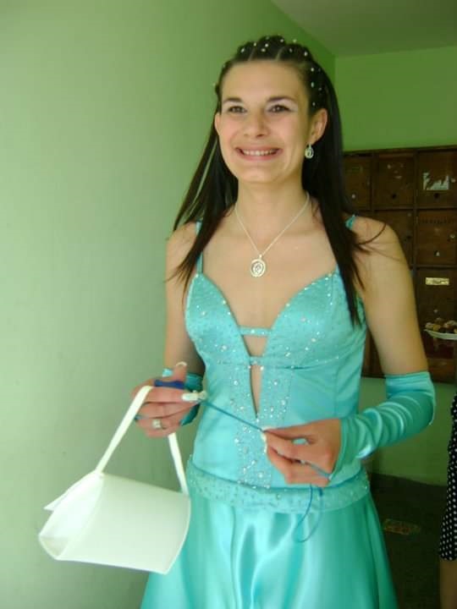 The happy day of my prom

The morning after the prom I noticed that something strange happening to my face- I was able to close only one of my eyes and my mouth was twisted. That afternoon I was revealed that I had facial nerve neuritis and was admitted to hospital when I had to stay 2 weeks or until my face get better. All my hospital stay was nightmare, but with patience and perseverance I was able to cope with this. As the time for discharge came, the doctor explained that all the stress I had been experiencing since primary school was the cause of facial nerve neuritis. I spend 2 months in the hospital until my face become like before. Then I told to myself that whatever was going to happen I would not be stressed anymore.
In 2012 I moved to live in London, which was a big challenge for me. My first job was a house cleaner. I thought it was the same as cleaning your house, but in the hard way I realize it was completely different. Everyone had different claims. They paid me below the minimum and whatever I took from one address I gave it for public transport to the next address. I had to travel all day in all London to spent 2 hours in every address and get less money with which I could not even pay my rent or food. After 3 months spend as house cleaner, I decide it will be better to try in hotel. As a Room Attendant I had to work 8 hours, and had some push-pull factors which helped me to choose Claridge’s Luxury hotel for my first Hotel job:
The push factors where more and earned enough for everything.
PUSH FACTORS: PULL FACTORS:
New place
More money New rules
English practice High cleaning standard
New people Running to finish on time
Friendships One break for 30 minutes

In 2014 I start to work in Claridge’s by agency and was hard from the day 1 of my new working place. The agency gives it like 3 working days in a week, to can every agency staff to get earn some money. From the beginning for me was enough, I had enough for my travel, rent and food. But in 2 months’ time the situation changed completely – we were able to work only one day in a week. I had to survive with £50 per week, but nobody caressed how I will pay for my rent or how will top up my Oyster, what and when I will eat.
Then in 2015 come my time to look for another hotel and to start there with contract. I make my CV and start to send in every single side where looked for Room Attendant. I do not wait long when received a phone call from “Four Seasons” Hotel. When I went for interview the deputy manager of housekeeping showed me every single room in the hotel and meet me with the staff. To be honest I do not like this place by first impression, but the thought of a permanent job did not give it me a choice. I had 2 more interviews with hotel manager and the general manager and then was invited to start my career in “Four Seasons”. In the meantime, the deputy of, housekeeping in Claridge’s wanted to see me. She explains me how the deputy of housekeeping calling her and explaining that they are happy to invite me in their team. Miss Anne was not agreeing to let me go in another place and offered me contract. I was surprise and happy in the same time. Claridge’s is a wonderful place not only to work in, but to get time for yourself.
I worked in Claridge’s for 2 years and if I have another chance to join this place again, will be wonderful. I left Claridge’s in 2016 when was invited to join in “Shangri-La Resort”. There I spent less than a year, was much more paid than Claridge’s, but the behavior was horrible. The managers treated their staff as slaves and paying them to be quiet. I had to work overtime which nobody paying it. My working time where from 8am until 4:30pm, but usually I finished at 20pm and where payed till 4:40pm, the rest hours was unpaid. The mean reason for my left where longer working hour and behavior from the managers.

In 2016 I changed few working places until I get pregnant. In 2015 I was diagnosed with CIN3, a pre-cancerous cervical formation, and had to be removed and large part of the cervix was removed as well. Because of the con biopsy which was done it I had risk pregnancy and had to stop every kind of work. In 18th weeks of my pregnancy I was admitted in Northwick Park hospital for cervical stich. After this day my nightmare start. I had to stay in this hospital more than one week, because of the contractions which I had. The doctors where give me progesterone in the hope that the cervix will stop contracting. After two weeks in this hospital I was able to go home, but not for long …
In 2017 one morning I woke up with bloody spot on my underpants and ran to the hospital. It turned out that my waters were cracked. I spend another in the hospital and because my pregnancy was in 25th week was transferred to “Guy and St Thomas”. I was transferred into maternity immediately and the labor start at 00:00h, at 4 o’clock on 04/27/2017 the cervical stich was removed and at exactly 4:15 my son was born in 25th week and 3 days. He wept immediately and was thoroughly cleansed and intubated for the first 4 hours of his life. After those 4hours I was able to hold him for first time, and to feel truly mother. This where the magical moment in my life. He spends 10 weeks in incubator with a lot of air dispensers. Had a lot of ups and down, nobody was able to say if he will survive or not. I where happy as a child when Alex where ate 1ml every 3 hours and the dose where increased in next days. His birth weight where 990g and go down to 735g during the first 3 days. Within 2 weeks he reached 1kg and my happiness was indescribable. After the first month of his life, Alex was transferred to our local hospital “Northwick Park” where spend 6 weeks in total. 2 weeks before his discharge the doctors diagnosed my boy with chest infection, another hard time for me. One of the nurses in Neonatal Intensive Care Unit (NICU) was so rude with me and explained me how I transferred batteries to my baby and must check myself for Gonorrhea, Chlamydia and other sexual diseases. That was her big mistake. I got only one sexual partner from the past 11 years, she does not know me, and she has not right to speak about me. I make complain to PALS and this lady had to find another job. After a day the doctors found that these bacteria where based in the NICU and everyone come to apologies about the behavior of that nurse. Those 10 weeks where the hardest for me as a mother and my prays not stop even when I slept. The time passed and boy gated better and better each day. My son is already 2 years old and the hard period left in the past. I am a proud mother of premature boy who gives me the power and do not give to give up. After all stressful stay in hospital my son is already 2 years old, healthy and happy.

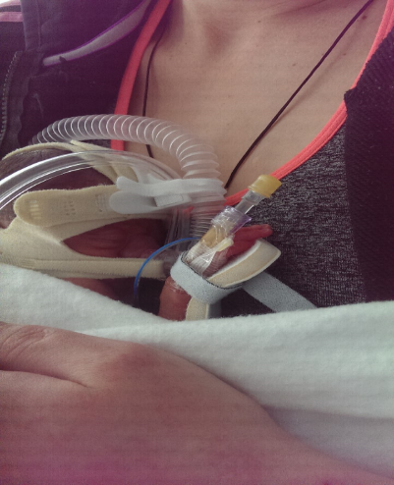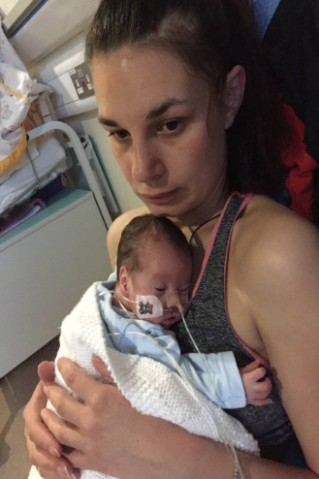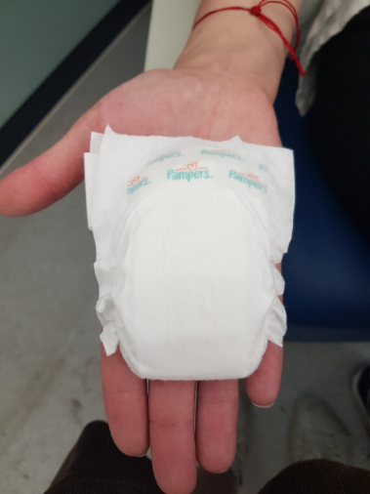
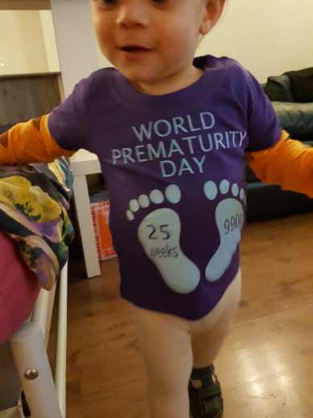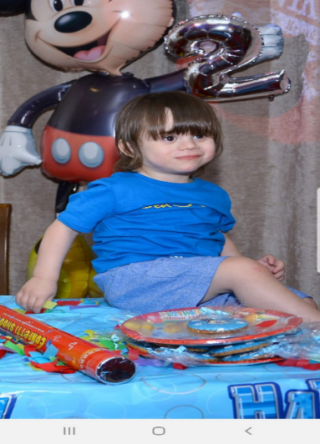
This is the reason to start this course and to achieve my dream job is to be Health Visitor for new mums with babies.
This is my life Line and took me 29 years to be here where I am now.
The best way understand myself is to look at SELF SWOT analysis and check my strengths and weaknesses, opportunities and Threats (Cottrell,2003):

STRENGHTS:  Communication skills  Positive attitude  Patience  Time management  Motivation  Team Worker  IT skills  Working under pressure | WEAKNESSES:  English speaking and writhing  Presentation skills  Lack of Organization  Laziness  Academic writing
OPPORTUNITIES:  To finish this level and the next level for this program |  | THREATS:  English  Presentations  Plan  Academic writhing

In the figure on the top I showed my strengths, my weaknesses, the opportunity which I have and threats.
My threats are the level of my English. I know that my English can be barrier for my future career, however I am sure with the more perseverance and desire from myself will be able to improve my English in all aspects.
When I look to the Gib’s learning circle, can conclude if the same kind of situation come one day, I know what I would do.

Learning styles:
KOLB’s: Kolb (1985) describes 4 learning styles:
(Rumson, 2017)
1.Accommodative: Experimentation
2.Divergent: Reflector
3.Assimilative: Theorist
4.Convergent: Idealist

VAK:
(mindtools.com)
There are four learning styles how persons gather knowledge:
1.Visual: Learn by seeing
2.Auditory: Learn by listening
3.Reading: Learn through reading
4.Kinesthetic: Learn by doing
Common name to this learning style is VARK learning style, but the self-assessment questionnaire which we did it in class is known by VAK learning style. As a shortening the VAK represents:
Visual learners: prefer to learn of what is seeing
Auditory learners: prefer to learn by listening
Kinesthetic learners: prefer learning by doing; touching, experimentation, and operative examination to name a few
According to the VAK test which I make in class I am Auditory and Kinesthetic learner.
It shows that I master well by listening. I continually master well by listening and move it in my memory somewhat than watching.
I cannot explain what mean Kinesthetic, but from mine opinion I think should be person who is preferring to do activities in class and out class. I can descript myself as kinesthetic, because I always try to improve my skills by some practice and find that I learn a lot from them.
Honey and Mumford:
(Www2.le.ac.uk)
Honey and Mumford improved a similar learning style. They are described as:
- Activists: master excellent by operative connection in physical task and from comparatively small task.
- Reflectors: master excellent by reconsidering and reflecting upon what has happened in concrete situation (stay back, pay attention and watch)
- Theorist: master excellent when new knowledge can be discovered within background of ideas and theories.
- Pragmatists: Master excellent when they see connect mid new knowledge and true-being difficulties and points and put them into custom.

Flaming (2001) and Honey and Mumford models displays essentially the same. Every of them has a dissimilar method of explaining the 4 kinds of learning style.

I have done the both tests which are the VAK and Honey and Mumford which shown the results:

VAK: | HONEY AND MUMFORD:
Visual-8 | Activist-11
Auditory-11 | Reflector-16
Kinesthetic-11 | Theorist-8
 | Pragmatist-9

(See Appendix)
Both tests demonstrated that I am auditors, kinesthetic and reflector. That means I master superior by paying attention, undergoing being and reasoning adequately. I continually master superior by paying attention and proceeding it in my recall somewhat than perusal or observing something. My over undergo displayed me that I am reflector seeing that, I double check superior in front of getting resolutions. In the recall I was not getting abundant time in checking the details before doing something, however with the time I master how to improve my time for thinking. With the undergoing people learned from their mistakes how to be more effective.

JOHARY WINDOW:
(Self-Awareness,2013)

Harry Ingham came up using a model in 1955 by the name of Johari Window. This model helps to find how you know yourself and how others know you. There are 4 rooms in this window:

1.Open self/ Arena: contains the conduct know by others and self.
2.Hidden self/Façade: it contains the conduct known self only.
3.Blind self/ Blind spot: it contains the conduct unknown by self and known by others.
4. Unknown self: it contains the conduct unknown by self or others.

When I done the Johari Window test, according to the answers which I give, find that I am hidden self and more unknown self. Show that people and I do not know about my conduct. This is helpful for me, because give me a chance to create friendly atmosphere when working in a group.

WHERE I WANT TO BE:

When I finish this course, my plans are to register for the next level and to get as much as I can the knowledge that need me for my dream job as a Midwife (Health visitor for new mums and babies).
It is a time to do my Personal Development Plan which will include my long- and short-term goals, what, wow, and when want to achieve.

My long-term goal is to become a midwife
My short-term goal is to finish this level of the course and to start with the next one.
What I want to achieve? | How I will achieve? | What I will need for achievement? | How I will evaluate success? | When I want to achieve?
To finish the level 4 of the course | Reading and learning, high attendance, getting knowledge | Pass the assignments and keep learning | Successfully complete the tasks | February 2020
To become a Midwife | Visiting the MC  Discussing what training to be start | Find the training and courses | Successfully complete the courses and training required for Midwife | June 2021

*MC-Midwife Community
GOALS: The goals which I want to achieve are simple enough and if I believe in myself, I will be able to achieve them in the most perfect way. For this purpose, I need to be more concentrate of my study and to learn more about my dream profession. The other thing which I need to do is the SMART analysis:
S- Specific
M-measurable
A-Achievable
R-Realistic
T-Time
Unfortunately, I am not pretty sure how to do the SMART analysis, that is why I will be left for later.

HOW TO BE THERE:
I start to think for job as a Midwife when my son come home for the first time since his birth. Those 3 months were the hardest in my life, I believe that not only me, but also the parents of every premature baby feel the same as me.
When was our first home visit by the Midwife, I wanted to ask her so many things around the baby and wanted to be sure I am doing everything in the right way? During her visit she had to measure my son if he eats enough and if we have everything for him. The Midwife make at all the period about 5 visits, to be sure me and my baby are both fine. In one of her visits she asked me if I am interested as a Midwife job. In this moment I could not thinking seriously about what she had asked me. The time past and I start to realize to a Midwife is good opportunity for me, because I love children and is big pleasure for me to be around them (I like to talk and play with them).
Before starting this course, I looked what, I will need to become a Midwife and there are couple of skills which required for this kind of career:
Active Listening: The Health visitor must be good communicator and to know how to interact with her patients

Problem solving: Should be able to resolve problem by her own
Advisor: Must be able to help patients in every aspect
Respectful- To not be a racist, about skin-color, religion or nationality
Audit skills: It is a time to explore my skills and the gaps for improvement
SKILLS: | SUMMARY: | CONFIDENCE  (1-5) | EXAMPLES:
PATIENCE | From a child I have big patience | 5/5 | Never rushing for anything
TIME MANAGEMENT | I am a mother, student, worker and housewife | 4/5 | From 7 months I do my best to balance between home responsibility, university and social life.  For now, I am doing well
TEAM WORKING | I am a good team player | 4/5 | For another module we had to do presentation in group. My group had clear task and clear roles to everyone which is was helpful. I was the leader in our group and helping to the others
LENGUAGE SKILL | I am monolinguistic  Speaking: Bulgarian, Macedonian, Sorbian and English | Bulgarian 5/5  Macedonian 5/5  Sorbian 4/5  English 3/5 | I am from Bulgaria and my mother language is Bulgarian. Macedonian and Sorbian are like Bulgarian and easy for learning. My English must to be improve
LISTENING SKILLS | I am very good listener | 5/5 | I can listen and thinking in the same time. Always can take some knowledge for every speaker.
DRIVING SKILLS | I get driving licenses 1 year a go | 3/5 | I bought my car in April and driving to visit a friend
WORKING UDER PRESURE | I feel much more successful when work under time limit | 5/5 | In my first job as a room attendant always had to finish cleaning in concrete time. This was giving me motivation to working hard and finish on time.

WHAT MAY STOP ME:
About the things which is happened in UK and the noise around Brexit, do not know if I will be able to take a part of Midwife and Health Visiting trainings. This the main reason which is stop me for now to not start any kind of training.
I planning to go for 2 weeks in Bulgaria from the middle of September until the end of the month, because does not know if later will be possible to travel free around the EU and out of EU.
Until I wait for my flight at 15th of September I will start reading the book of “Life in UK,2019” and hopefully will take the exam will success. The B1 test I believe will be easy for me and not need to worry a lot. When I take both exams hope that still will be able to apply for British passport.
Lack of time management is will be protentional reason to stop me to achieve my plans in future. Need working hard in my planning and organization skills.

CONCLUSION:
Finally, to conclude my Personal Development Plan, I will make a SMART action plan for my future goals:
I want to become a Midwife long period of time and to get another knowledge in health and Social care sector. To understand more about the responsibilities and duty for health and social department, I know the midwifes working together with the social department and this knowledge will help me in my future career.
Based on dissimilar tests finished, I would like to improve myself, my skills and my knowledge. Johari Window will help me a lot in future, since there is personal type which I must develop and not seen yet. I need to learn more how to understand all the reflective and learning styles.

In conclusion I ca said that there are so many factors which need to think about, before taking any actions. Know that if I do not do anything to get my dream, nobody else will do, need to improve my English and soon I feel confident must act and starting to follow my plan.
Hopefully I did something good, even I am not the best writer. But I prefer to my work by myself and to learn from the mistakes.

REFERENCES:

Cottrell, S. (2010) “Skill, s for success”, New York: Palgrave Macmillan, pp: 73-105

BIBLIOGRAFI:
Mindtools.com. (n.d.). VAK Learning Styles: Understanding How Team Members Learn. [online] Available at: https://www.mindtools.com/pages/article/vak-learning-styles.htm
[Accessed 22 Aug. 2019].
Rumson, R. (2017). David Kolb’s learning styles. [online] Available at: https://www.eln.io/blog/david-kolb-learning-styles [Accessed 12 Aug.2019]

Www2.le.ac.uk. (n.d.). Honey and Mumford — University of Leicester. [online] Available at: https://www2.le.ac.uk/departments/doctoralcollege/training/eresources/teaching/theories/honey-mumford
[Accessed 2 Sep. 2019].
Self-Awareness. (2013). Self-Awareness. [online] Available at: https://www.selfawareness.org.uk/news/understanding-the-johari-window-model
[Accessed 1 Sep. 2019].

APPENDIX:



