ECIE5002

Numbers count

Portfolio: By Rae Blick

(Bling picture, 2025)

Contents Page
Element 1: Essay- Why is good numeracy important? ........................................p3
Element 1: Reference List.........................................................................p7

Element 2: Blog – What can schools do encourage numeracy?..........................p10
Element 2: Reference List.......................................................................p12

Element 3: Resource – Information Sheet for professionals about a numeracy resource of your choice which aims to support numeracy development in pupils with ALN ..............................................................................................................p15
Element 3: Reference List.......................................................................p17

Element 4: Video of the resource in action ........................................................p19

Element 5: Evaluation of the resource ..............................................................p20
Element 5: Reference List......................................................................p23

Element 1- Essay
‘Why is good numeracy important?’
Numeracy is one of the most fundamental skills that a person can possess, as it enables the effective evaluation of any data, regardless of its nature or whomever provides it as the source. (Gal et al., 2020). In recent years numeracy has gained recognition as a basic competency equivalent to literacy. This acknowledgement spans various sectors. Policymakers are committing resources to numeracy initiatives, journalists are increasingly incorporating numerical data into public discourse, and there is an expanding conversation regarding the adaptation of education to align with the evolving requirements of the labour market (Bagacina et al.2024). Numeracy connects deeply with everyday life and public debate, justifying a comprehensive view rather than a fragmented one. This essay explores the importance of numeracy but goes beyond mere mathematics, highlighting its significance in personal decision-making, the media’s influence on public anxiety regarding risk, and broader political structures, such as government accountability and democratic efficacy. Without numeracy every person is condemned to remain vulnerable to the societal roles, especially as the public domain is getting overloaded with more data (Zuboff, 2022).
Education today emphasises numerical competency, however, ‘around 40% of working adults in England possess numeracy skills expected of a primary school leaver’ (National Numeracy, 2023). In a knowledge-based society the distribution and information and data are vital for improving societal skills and tackling challenges. The interpretation of the numerical and graphical information, constitute key numeracy skills, and are now as important as literacy. These skills are foundational for information processing, problem analysis, decision- making, and the evaluation of outcomes and processes. This definition includes various learning capabilities but may be too ambitious. Lack of basic numeracy skills hinders the development of others, obstructing informed decision- making, the understanding of societal issues, and affects critical thinking. In contrast, informed decision making stimulates cognitive growth and encourages a positive attitude towards improving numeracy. A study by Peters (2020) highlights that individuals with higher numeracy skills are better at interpreting politically charged numerical information, leading to more informed decision making.
In the political arena numeracy equips individuals with tools to critically assess data presented in policy discussions and media reports. However, there are increasing reports that the media, and politicians are accused of distorting facts, creating ‘partly massaged realities’ linked to low numeracy levels. Political discourse is often filled with statistics, economical figures and data-driven arguments. This endangers democracy, as accurate data interpretation is often ignored, affecting education, healthcare, law enforcement and national defence strategies. Poor statistical analysis limits public understanding of critical issues like unemployment and economic data. Informed societal decisions depend on reliable information, such as student performance and vaccination rates. A numeracy deficit undermines the democratic process. Legislation should start with cost- benefit analyses, prioritizing national goals based on accurate assessments. Many political outcomes reflect the need for effective data, emphasising the importance of enhancing quantitative literacy to empower citizens in demanding informed leadership (Wilkins, 2010; Yu and Opfer, 2024). Governments and political parties use numerical data to support policies, justify spending and persuade voters. Without adequate numeracy skills, individuals may struggle to critically assess these figures, leaving them vulnerable to manipulation. According to Gigerenzer (2014), politicians and media outlets frequently use misleading statistics to sway public opinion, making numeracy a key tool in identifying bias and misinformation.
A clear example of numeracy’s importance in politics, is in the interpretation of economic data. Governments report figures such as GDP growth, unemployment rates, and inflation to indicate economic health. However, these numbers can be presented in misleading ways. For instance, a government might highlight a drop in unemployment without mentioning that many new jobs are part-time or low-paid (OECD, 2013). Furthermore, numeracy is vital in understanding electoral systems and voting trends. Many democracies use complex voting systems, such as proportional representation, which require an understanding of percentages and statistical distributions. An argument could be made that those with substandard levels of numeracy, can lead to misconceptions about how voters translate into political power, affecting public trust in democratic institutions (Reyna et al, 2009). Those lacking the ability to critically assess data presented in policy discussions and media reports. This situation undermines democracy as an accurate description.
Similarly, those with strong numeracy skills can critically assess such data and avoid being misled by selective reporting.
Beyond politics, data which was collected by Nation Numeracy stated that ‘29% of adults actively avoid situations involving numbers and data’ and that ‘24% of adults had low levels of confidence in managing their money. Young people, those from ethnic minorities and the unemployed were affected most’ (National Numeracy, 2023). Numeracy is essential for evaluating social issues such as income inequality, health care and climate change. Many social problems are deeply tied to statistical data and a lack of numeracy can lead to a misinterpretation of trends and polices (Atkinson, 2015).
For example, the Gini coefficient, which measures income distribution within a society (Atkinson, 2015; OECD, 2013). Those with limited numeracy skills may struggle to interpret this coefficient, leading to misconceptions about wealth distribution and economic mobility (Lusardi and Mitchell, 2014). A study by Piketty (2014) highlights how misleading interpretations of wealth distribution data can impact public support such as progressive tax and social welfare programs.
Healthcare polices also rely heavily on numerical data, from medical risk assessments to hospitals resource allocation (Peters et al, 2020). Such examples seen in cancer screening programs, which often present statistical information regarding false positives, survival rates and treatment efficacy (Gigerenzer et al, 2007; Wieman, 2017, p267). Research shows that individuals with lower numeracy skills tend to misinterpret screening statistics, leading to either overconfidence in medical tests or unwarranted fear of certain conditions (Peters et al, 2020; Reyan et al, 2009). Gigerenzer et al, (2007) argue that patients often misunderstand relative risk reduction in treatment, which can influence medical decisions- making and patient anxiety.
To illustrate its relevance during COVID-19 in 2020, governments and the World Health Organisation (WHO), regularly published infection rates, mortality rates and vaccination percentages. The public needed numeracy skills to interpret trends, assess risks and the understanding of public health measures. In the U.K, numeracy is crucial for understanding government policies on wages, taxation and public spending. Key examples include minimum wage and living wage updates, taxation and budget announcements and public sectors pay reviews (Gov.UK, 2025).
Climate change discussions are also deeply rooted in numerical data, such as carbon emission levels, temperature trends and sustainability targets (Doughty, 2016; Lewandowsky et al. 2013). Misinformation about climate science often involves statistical distortion, such as emphasising short term cooling trends to dispute long term global warming (Peters et al. 2020) (Reyna et al. 2009). Research by Lewandowsky et al. (2013) found that individuals with higher numeracy skills were more likely to correctly interpret climate data and support evidence- based environmental policies.
In addition, numeracy enhances critical thinking by allowing individuals to access arguments, identify biases and make informed decisions (Gigerenzer, 2014; Kahneman, 2011). Studies indicate that numerical literacy is crucial for distinguishing between correlation and causation. A fundamental aspect of evaluating numerical literacy is crucial for distinguishing between aspects of political and social claims (Reyna et al. 2009; Lusardi and Mitchell, 2014). To illustrate, crime statistics are often manipulated for political purpose, governments may highlight a reduction in violent crime while ignoring increases in other offenses, leading to misleading conclusions (Lusardi and Mitchell, 2014). Similarly, financial decision- making depends on numerical literacy, as individuals with poor numeracy are more likely to misinterpret and fall prey to predatory lending (OECD,2013). Research highlights that improving numeracy skills enhances an individual's ability to critically evaluate statistical claims, strengthening resilience against misinformation and poor financial choices (Peters et al. 2006; Gigerenzer et al. 2007).
Numeracy encompasses the understanding of symbols, operations, measurements, spatial reasoning, and data analysis. Its significance has surged due to its influence on economic growth and civic participation. A limited view may overlook diverse perspectives. This analysis examines numeracy's role in social and political debates, where prevailing narratives depend on quantifiable data, shaping news and igniting conflict. Data can obscure complexities, especially when manipulated. Conflicting economic data fosters polarized narratives, particularly in local elections, which can disenfranchise voters and cultivate distrust. Evaluating numerical data and ‘precision journalism’ is essential to uncover counter-narratives, emphasizing the need for continuous discussion about numeracy's importance and ongoing reassessment (Stephan et al., 2021).

Element 1- Essay References

Atkinson, A. B. (2018). ‘Inequality: what can be done?’ Harvard University Press.

Bagacina, et al. (2024). ‘Digital Transformation in Numeracy Education’: A Study on Teaching, Learning, and Leadership Perspectives. Excellencia: International Multi-disciplinary Journal of Education (2994-9521), 2(1), pp.133-143. Available at: multijournals.org (Accessed: 14 January 2025).

Bulman, M (2018) England faces ‘crisis’ in adult financial literacy as one in three cannot work out change from shopping trip. The Independent. Available at: https://www.independent.co.uk/news/uk/home-news/england-financial-literacy-shopping-trip-change-numeracy-mental-arithmetic-a8255951.html (Accessed: 29 January 2025).

Doughty, H. A. (2016). Merchants of Death: How a Handful of Scientists Obscured the Truth on Issues from Tobacco Smoke to Global Warming [Review of Merchants of Death: How a Handful of Scientists Obscured the Truth on Issues from Tobacco Smoke to Global Warming]. The Innovation Journal, 21(3), 1-. The Innovation Journal.

Gal, I et al. (2020) ‘Numeracy, adult education, and vulnerable adults’: a critical view of a neglected field. Available at: ncbi.nlm.nih.gov (Accessed: 14 January 2025).

Gigerenzer et al (2007) Helping Doctors and Patients Make Sense of Health Statistics. Psychological Science in the Public Interest, 8(2), 53–96. Available at: https://doi.org/10.1111/j.1539-6053.2008.00033.x (Accessed: 16 January 2025).

Kahneman, D. (2012) Thinking, fast and slow. London. Penguin.

Lusardi, A. and Mitchell, O. S. (2014) ‘The economic importance of financial literacy’: theory and evidence: Theory and evidence. Journal of Economic Literature, 52(1), 5–44. Available at: https://doi.org/10.1257/jel.52.1.5 (Accessed: 15 January 2025).

OECD (2013) OECD Skills Outlook 2013: First Results from the Survey of Adult Skills, OECD Publishing. Available at: http://dx.doi.org/10.1787/9789264204256-en (Accessed: 17 January 2025).

Peters, E. et al. (2006) ‘Numeracy and decision making’, Psychological science, 17(5), pp 407–413. Available at: https://doi.org/10.1111/j.1467-9280.2006.01720.x (Accessed: 20 January 2025).
Piketty. T (2014) ‘Capital in the Twenty-First Century’. Translated by Arthur Goldhammer. Cambridge, Massachusetts: Belknap Press of Harvard University Press, Journal of Social Policy, 45(1), pp. 172–173. DOI:10.1017/S0047279415000616.
Reyna, V.F. et al. (2009). How numeracy influences risk comprehension and medical decision making. Psychological Bulletin, 135(6), pp.943–973. DOI: https://doi.org/10.1037/a0017327.
Stephan, M et al (2021) ‘People use math as a weapon’: critical mathematics consciousness in the time of COVID-19. Available at: ncbi.nlm.nih.gov (Accessed: 14 January 2025).
Wilkins, L. (2016) The role and positioning of numeracy in Australian universities - does it matter? Available at: https://core.ac.uk/download/132799026.pdf (Accessed: 20 January 2025).
Gov. U.K (2024) Income tax rates and allowance for current and past years, GOV.UK. Available at: https://www.gov.uk/government/collections/data-forecasts (Accessed: 26 January 2025).
Nation Numeracy (2023) Our Impact. Available at: https://www.nationalnumeracy.org.uk/sites/default/files/documents/National-Numeracy_Our-Impact_2023.pdf?_gl=1*tbatrc*_up*MQ..*_ga*MjU4NjU0NDAwLjE3N. (Accessed: 25 February 2025)
Wieman, C (2017). ‘Improving how Universities Teach Science’: Lessons from the Science Education Initiative, pp. 267. Harvard University Press, Cambridge.
Yu, S. and Opfer, J. E. (2024). ‘Cognitive support for political partisans’ understanding of policy data. PloS One, 19(10), e0312088. Available at: https://doi.org/10.1371/journal.pone.0312088 (Accessed: 15 January 2025).

Zuboff, S. (2022). ‘Surveillance capitalism or democracy?’ The death match of institutional orders and the politics of knowledge in our information civilization. Organization Theory. Available at: sagepub.com (Accessed: 20 January 2025).

Element 2- Blog 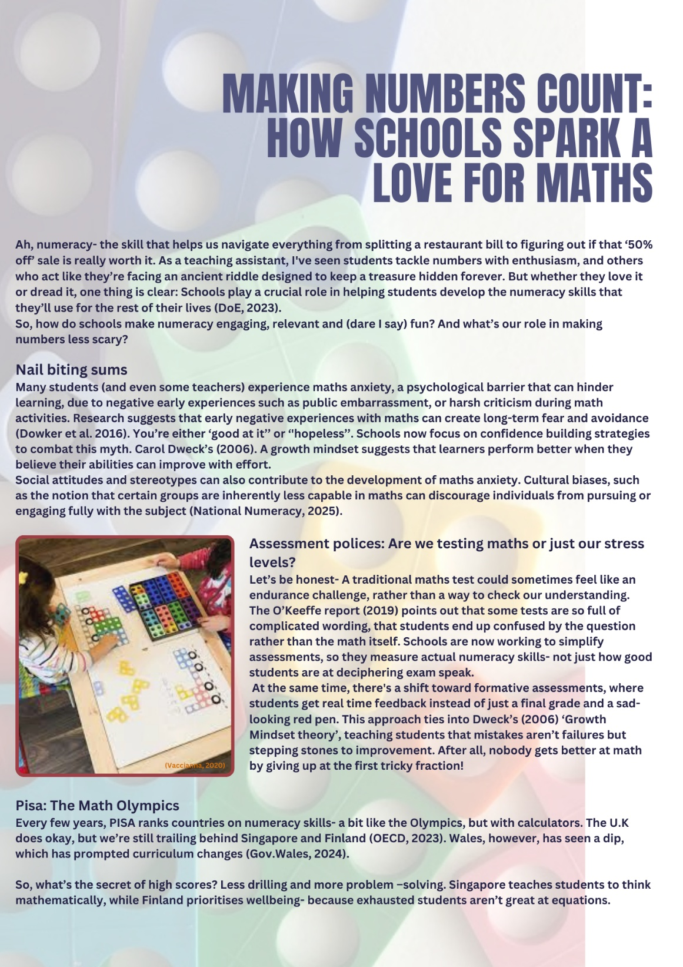
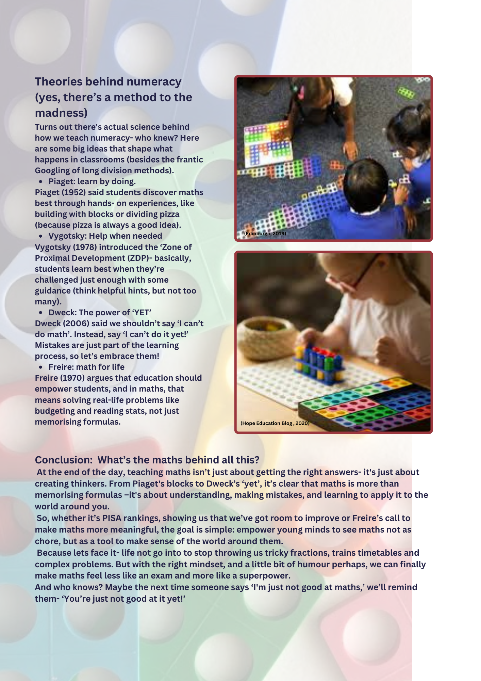
Element 2- Blog References

Askew, M. (2018). Multiplicative reasoning: teaching primary pupils in ways that focus on functional relations. The Curriculum Journal, 29(3), pp.406–423. DOI: https://doi.org/10.1080/09585176.2018.1433545.
Canva (2018). Design Templates - Canva. Canva.com. Available at: https://www.canva.com/templates/. (Accessed: 20 January 2025).
Dowker, A. et al. (2016). Mathematics Anxiety: What Have We Learned in 60 Years? Frontiers in Psychology, 7(508). DOI: https://doi.org/10.3389/fpsyg.2016.00508.
‌Dweck, C.S. (2006). Mindset: The new psychology of success. New York: Random House.
Edinburgh, D.P. (2019). Numicon on the go in P1/2. Dalry Primary Edinburgh. Available at: https://dalryprimaryschool.com/2019/12/06/numicon-on-the-go-in-p1-2/ (Accessed: 19 February 2025).
Estyn. (2024). Raising standards in literacy and numeracy - Estyn. Available at: https://estyn.gov.wales/improvement-resources/raising-standards-in-literacy-and-numeracy/ (Accessed: 27 January 2025).
Freire, P (1970) Pedagogy of the Oppressed. Available at: https://envs.ucsc.edu/internships/internship-readings/freire-pedagogy-of-the-oppressed.pdf (Accessed: 29 January 2025).
Gov.UK. (2020) Mathematics education in schools is improving despite recruitment challenges. Available at: https://www.gov.uk/government/news/mathematics-education-in-schools-is-improving-despite-recruitment-challenges (Accessed: 28 January 2025).
Gov. Wales (2022) Curriculum for Wales - Available at: https://hwb.gov.wales/curriculum-for-wales (Accessed: 28 January 2025).
Gov.Wales (2024) Mathematics and numeracy plan: update 2024 | GOV.WALES. Available at: https://www.gov.wales/mathematics-and-numeracy-plan-update-2024 (Accessed: 1 February 2025).
Hope Education blog. (2020). An extensive guide to Numicon. Available at: https://blog.hope-education.co.uk/guide-to-numicon/ (Accessed: 19 February 2025).
National Numeracy (2025) What is maths anxiety? National Numeracy - Getting on with numbers. Available at: https://www.nationalnumeracy.org.uk/what-issue/about-maths-anxiety (Accessed: 25 January 2025).
OECD (2024) PISA: Programme for International Student Assessment. OECD. Available at: https://www.oecd.org/en/about/programmes/pisa.html (Accessed: 30 January 2025).
O’Keeffe, L. et al (2019) ‘Re-highlighting the Potential of Critical Numeracy.’ Mathematics Education Research Journal: Mathematics Education Research Journal, 2019.
Owl, O. (2020). How Numicon can help develop maths skills at home - Oxford Owl for Home. Oxford Owl for Home. Available at: https://home.oxfordowl.co.uk/how-numicon-can-help-develop-maths-skills-at-home/ (Accessed 19 February 2025).
Piaget, J. and Cook, M. (1998). The origins of intelligence in children. Madison, Conn.: International Universities Press.
National Numeracy (2020). Why is Numeracy Important? - The Effects of Poor Numeracy. Available at: https://www.nationalnumeracy.org.uk/what-numeracy/why-numeracy-important?_gl=1 (Accessed: 30 January 2025).
Vaccianna, A. (2020). Effective early years Numicon activities. Hope Blog. Available at: https://blog.hope-education.co.uk/effective-early-years-numicon-activities/ (Accessed: 19 February 2025).
Vygotsky, L. S. (1978). Mind in society: The development of higher psychological processes. Cambridge, MA: Harvard University Press.

Element 3 – Resource Information Sheet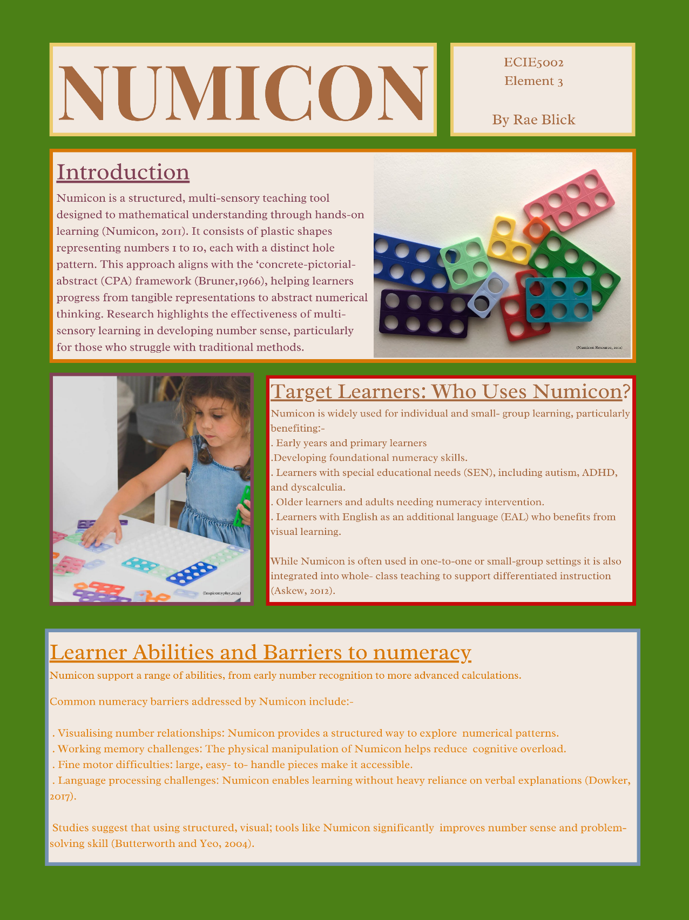
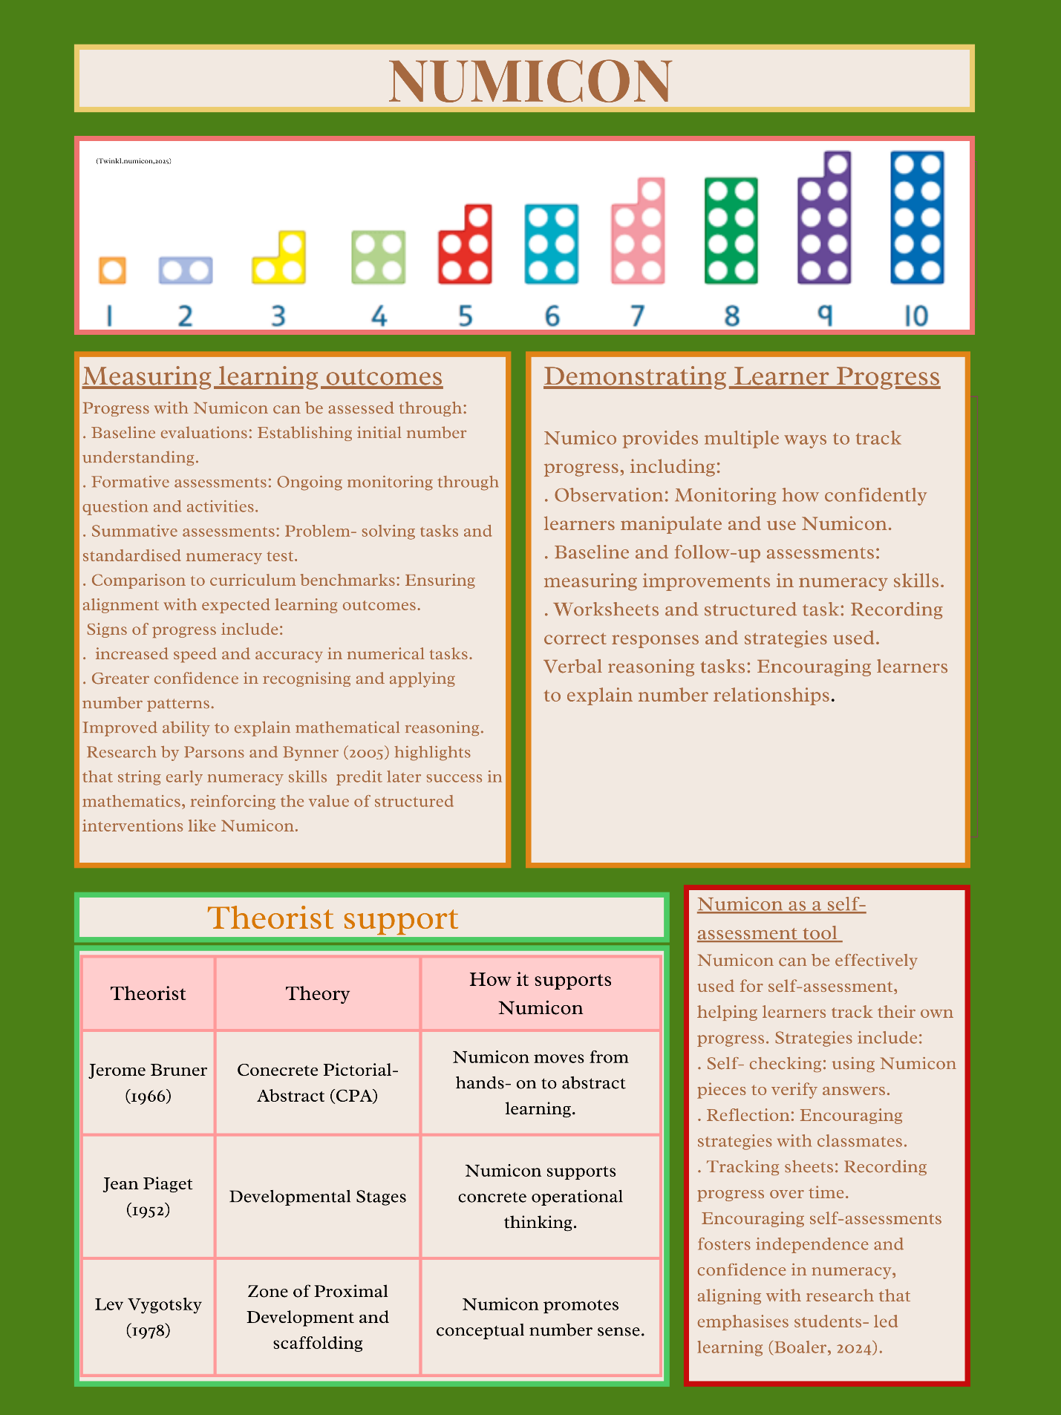
Element 3- Reference List

Askew, M. (2012) Transforming primary mathematics. DOI:10.4324/9780203806746.
Boaler, J. (2024). Transforming Mathematics Education Through Mindset-Based Teaching. Scientia. DOI: https://doi.org/10.33548/scientia1096.
Bruner, J.S. (1966). Toward a theory of instruction. Cambridge, Massachusetts: Belknap Press of Harvard University.
Butterworth, B and Yeo, D (2004) Dyscalculia Guidance: Helping Pupils with Specific Learning Difficulties in Maths. London: Nfer Nelson Publishers.
Canva (2018). Design Templates - Canva. Canva.com. Available at: https://www.canva.com/templates/. (Accessed: 20 January 2025).
Dowker, A. (2017) Interventions for Primary School Children with Difficulties in Mathematics. ScienceDirect. Available at: https://www.sciencedirect.com/science/article/abs/pii/S0065240717300186 (Accessed: 25 January 2025).
Inspire my play (2025). Available at: https://inspiremyplay.com/blogs/blog/6-easy-ways-play-with-numicon-home (Accessed: 19 February 2025).
Numicon (2011). Numicon kit 3- Activity Handbook. Oxford University Press.
Numicon resources (2010) - Mathematics and Science in SD#38 (Richmond). Available at: https://blogs.sd38.bc.ca/sd38mathandscience/2021/07/28/numicon-resources/ (Accessed 11 February 2025).

Parson, S and Bynner, J. (2005) Does Numeracy Matter More? National Research and Development. Available at: https://www.researchgate.net/profile/Sam-Parsons- Sd38.bc.ca.
Twinkl.com.ph. (2025). Available at: https://www.twinkl.com.ph/teaching-wiki/numicon (Accessed: 17 February 2025).
5/publication/245969683_Does_Numeracy_Matter_More/links/569381ee08aec14fa55e8ead/Does-Numeracy-Matter-More.pdf (Accessed: 28 January 2025).
Vygotsky, L. S. (1978). Mind in society: The development of higher psychological processes. Cambridge, MA: Harvard University Press.

Element 4- Video

https://drive.google.com/file/d/1-MSb-dxWrO_5IkQH7Cj_mAGI-hM9iwJ2/view?usp=sharing
Numicon intervention with 2 children, 1 child from year 1, 2nd child from year 2.

Element 5 – Evaluation

Introduction
Numicon is a widely used as a visual and tactile resource, designed to support mathematical understanding, particularly in early numeracy education. This essay evaluates a lesson in which two children – one in Year 1 and one in Year 2- used Numicon to identify missing numbers in a numerical sentence. The session was largely successful, with both effectively employing Numicon to verify their answer. However, while the year 1 child relied on the Numicon, the year 2 child may have been able to solve the problem mentally and appeared to find Numicon less helpful in explaining their reasoning. This evaluation draws on the National Numeracy Framework, The Curriculum for Wales includes theories of learning, and evidence of progress to access Numicon’s effectiveness. It also considers the advantages and limitations of Numicon; alongside other key factors educators should bear in mind when using this resource.
An additional consideration is how Numicon fits within a broader spectrum of Numeracy teaching tools. Educators often use it in conjunction with number lines, counters and mental strategies, which collectively support mathematical progression. Understanding when and how to transition between these tools is crucial for ensuring children do not develop over resilience to any single method.
Theory
Numicon aligns with several key theories of learning, particularly those advocating for multisensory approaches. Piaget’s constructivist theory (1952) suggests that children learn best when they can actively manipulate and explore materials. Vygotsky’s social constructivism (1978) highlights the role of scaffolding and peer interaction, which Numicon supports by providing a concrete visual representation that facilitates discussion and problem-solving. Bruner’s enactive iconic symbolic representation theory (1966) further underpins Numicons design, as it enables children to transition from hands on manipulation, to pictorial understanding and eventually to abstract mathematical reasoning.
Drawing on Paulo Freire’s theory (1970) of critical pedagogy, Numicon can be seen as a tool that empowers learners by encouraging active participation in their own mathematical discovery. Freire emphasised the importance of dialogue and problem-posing education, which aligns with how Numicon allows children to construct knowledge through hands on exploration and discussion.
The National Numeracy Framework (DfE, 2013) emphasises the importance of conceptual understanding, fluency, reasoning, and problem solving. Similarly, the Curriculum for Wales (Gov. Wales, 2022) promotes a holistic approach to numeracy, encouraging problem-solving, reasoning and the practical application of mathematical skills. Numeracy effectively supports these aims by offering a structured way for children to visualise number relationships and patterns. It reinforces fluency through the repetition of number bonds and provides a foundation for reasoning as children articulate their thought processes.
Observation and Analysis
During the session, both children engaged with Numicon to solve the missing number problem. The year 1 child demonstrated clear progress, relying on Numicon to determine and verify their answer. The year 2 child, however, was able to mentally compute the missing number and seemed to find Numicon less useful in explaining their reasoning. This observation aligns with Bruner’s theory (1966), suggesting that the year 2 child may have already transitioned to symbolic stage of understanding, making physical manipulatives less essential for their learning process.
Notably, when the children were checking their answer using the Numicon, finding it was correct. This indicates that Numicon can serve as an effective verification tool, even for children who do not reply on it for the initial problem-solving. However, it also raises questions about whether Numicon benefits all learner’s equally, depending on their stage of numerical development.
Advantages and Limitations
The effectiveness of Numicon as a teaching tool is well-documented. It supports conceptual understanding by providing a visual and tactile method for grasping number relationships. The hands-on nature of Numicon aligns with constructivist principles, making learning more interactive. It allows children at different levels to work at their own pace, making it a flexible resource. By manipulating Numicon shapes, children must articulate their thought processes, reinforcing mathematical reasoning. Additionally, as observed in the lesson, even children who solve problems mentally can use Numicon to confirm their answers.
Despite its benefits, a study by Forder (2016) found variability in the effectiveness of the intervention, however, found that Numicon is not universally effective for all learners. Some children who have developed abstract reasoning skills, may find Numicon to mental arithmetic, leading to over-reliance on manipulatives. Learning styles vary, and not all children benefit from visual and tactile methods; some may prefer verbal or symbolic approaches. Furthermore, effective implementation requires careful planning to ensure all children use Numicon productively and do not become overly dependent on its use.
Factors
To maximise Numicon’s effectiveness, several factors should be considered. Teachers should assess whether children are at the enactive, iconic, or symbolic stage of learning, as outlined by Bruner (1966), to determine the most appropriate use of Numicon. It should be combined with other strategies, such as number lines and mental strategies, to provide a comprehensive numeracy experience. Encouraging mathematical discourse is essential, as teachers should facilitate discussions where children articulate their reasoning, whether using Numicon or other methods. A gradual transition from hands on tools, to mental strategies is crucial to prevent over–reliance on manipulatives. Differentiation and personalisation should also be considered to ensure Numicon enhances rather than hinders progress, meeting the diverse needs of leaners. Another consideration is whether Numicon use aligns with assessment techniques to ensure children demonstrate their understanding without manipulatives when appropriate.
Conclusion
The observed lesson demonstrated that Numicon is an effective tool for supporting numeracy development, particularly for younger learners who benefit from concrete representations. The resources successfully aided the year 1 child in identifying and verifying missing numbers. However, the year 2 child's ability to solve the problem without Numicon suggests that its usefulness varies depending on a child's stage or mathematical development. While Numicon offers significant benefits, such as reinforcing conceptual understanding, encouraging reasoning skills, and promoting engagement, it is not a universal solution for all learners. Teachers must consider cognitive development, learning styles and the need for a balanced instructional approach when integrating Numicon into numeracy lessons. By doing so, educators can ensure Numicon is used effect effectively to support all learners on their mathematical journey.

Element 5- Evaluation References

Bruner, J. S. (1966). Toward a theory of instruction. Harvard University Press.
Bruner, J (1970) The Process of Education. Cambridge, MA: Harvard University Press.
Department for Education (2023). Department for Education. GOV.UK. Available at: https://www.gov.uk/government/organisations/department-for-education. (Accessed: 20 February 2025).
Forder, K (2016) A study to evaluate the impact of a Numicon-based intervention on the numeracy attainment and attitude towards numeracy of children in lower Key Stage 2 identified as experiencing difficulties in mathematics (Doctoral dissertation, University of Nottingham). Available at: https://scholar.google.com/scholar?hl=en&as_sdt=0%2C5&q=kate+forder+2016&btnG= (Accessed: 25 February 2025).
Freire, P. (1970). Pedagogy of the oppressed. New York: Bloomsbury Academic. Available at: https://envs.ucsc.edu/internships/internship-readings/freire-pedagogy-of-the-oppressed.pdf. (Accessed: 20 February 2025).
Piaget, J. and Cook, M. (1998). The origins of intelligence in children. Madison, Conn.: International Universities Press.
Vygotsky, L. (1978). Mind in Society: The Development of Higher Psychological Processes. Cambridge: Harvard University Press.
Welsh Government (2022). Literacy and Numeracy Framework - hwb.gov.wales. Available at: https://hwb.gov.wales/curriculum-for-wales/cross-curricular-skills-frameworks/literacy-and-numeracy-framework (Accessed: 20 February 2025).

