


Aamir Sahar 2211030
Module code and name:

Data Handling & Business Intelligence (LCBB5014_BIRM)
Assessment 1
Report writing
Date of submission: 17/10/2025 2:00 pm
Lecturer Name:Nassir Ibrahim

Table of Contents
Executive Summary 2
1. Introduction 3
2. Trends in BI, DW, and DM 4
3. Data Warehousing in Shell Petroleum 7
3.1 Definition Using 5Ws 7
3.2 Improving Data Access and Efficiency 7
3.3 Supporting Strategic Decision-Making 8
3.4 Shell plc-Specific Applications 8
4. Data Mining Techniques 9
4.1(a) . Rule-Based Association 9
4.1(b). Linear Regression 10
5. Predictive Analysis Tools for Shell plc 10
6. Ethical and Data Security Considerations 11
7. Reporting and Dashboard Solutions 13
8.Conclusion 15
9. References 16
Appendices 20

Executive Summary
Shell Petroleum is leveraging Business Intelligence (BI), Data Warehousing (DW), and Data Mining (DM) to enhance decision-making, operational efficiency, and predictive capabilities. This report explores Shell’s adoption of AI (Shell, 2025a), cloud-based DW systems (Kimball and Ross, 2021), and predictive analytics tools (Shell, 2025b), supported by proven methodologies like Kimball’s dimensional modelling and the CRISP-DM framework (Chapman et al., 2000). It also addresses data security and ethical concerns following recent breaches (Shell, 2025c), and concludes with a dashboard-driven strategy for real-time insights (Shell, 2025d).
- Introduction
Shell began in 1897 as Shell Transport and Trading, founded by Marcus and Samuel in 1907, it merged with Royal Dutch Petroleum to form Royal Dutch Shell, becoming a major global energy player (Shell, 2025d; Wikipedia, 2025; Shell Global, 2024))
Shell Petroleum, a global energy leader, operates in a highly data-driven environment across exploration, production, and distribution (Shell, 2025a). As digitalisation transforms the energy sector, Shell faces growing pressure to turn vast volumes of structured and unstructured data into actionable insights to stay competitive (Knight, 2024). To meet this challenge, Shell is adopting Business Intelligence (BI), Data Warehousing (DW), and Data Mining (DM) technologies. BI tools help analyse and visualise data for informed decision-making (Charles et al., 2023), while DW systems centralise data from multiple sources to support scalable reporting and analytics (Kimball and Ross, 2021). DM techniques uncover patterns that support predictive maintenance, risk management, and performance optimisation (Han et al., 2022).
Shell’s use of AI-powered BI platforms enables real-time asset monitoring and operational forecasting (Shell, 2025b). Cloud-based DW solutions like Snowflake and Big Query offer global scalability and fast access to insights (Knight, 2024). DM frameworks such as CRISP-DM guide structured data exploration and model deployment (Kotu and Deshpande, 2018). These technologies align with Shell’s goals to improve resilience, support sustainability, and drive innovation across its global operations (Shell, 2025c).

2. Trends in BI, DW, and DM
2.1 Definitions
- Business Intelligence (BI) encompasses technologies and processes that enable the collection, analysis, and presentation of business data to support strategic and operational decision-making (Mekimah et al., 2024). It includes tools like dashboards, Excel functions (e.g., AutoSum, Sigma), and AI-powered analytics.
- Data Warehousing (DW) is the centralised storage of integrated data from multiple sources, designed for reporting and analysis (Kimball & Ross, 2021).
- Data Mining (DM) involves extracting patterns and relationships from large datasets using statistical and machine learning techniques (Kotu & Deshpande, 2018).
2.2 Current Trends and Strategic Value
Business Intelligence
Modern BI is increasingly powered by AI, enabling real-time insights, predictive analytics, and personalised dashboards (ThoughtSpot, 2025). Tools like Excel remain relevant for operational tasks, but advanced BI platforms now automate data preparation and offer embedded analytics. Payroll departments, for instance, benefit from BI tools that integrate with HR systems but often reject generic formats like CSV due to data integrity concerns.
Data Warehousing
Cloud-based DW platforms such as Snowflake and BigQuery offer scalability, global access, and cost-efficiency. AI-driven DW systems automate ETL processes, optimise queries, and improve data accuracy (Charter Global, 2025). DW supports data consolidation by integrating disparate sources—sales, HR, finance—into a unified structure, enabling consistent reporting and strategic decision-making (Kimball & Ross, 2021).
Data Mining : (Knowledge discovery in databases( KDD) process)
DM is evolving through AI and automation, enabling predictive maintenance, fraud detection, and customer segmentation. Frameworks like CRISP-DM guide the process from data understanding to deployment, ensuring structured exploration and model validation (Kotu & Deshpande, 2018).
2.3 Academic Models and Frameworks
- Kimball’s DW Architecture uses dimensional modelling (e.g., star schema) to simplify querying and support scalable analytics. It’s widely adopted in enterprise DW systems for its user-friendly design and performance efficiency (Kimball & Ross, 2021).
- The CRISP-DM model includes six phases—understanding, preparation, modelling, evaluation, and deployment—to guide data mining projects (Kotu and Deshpande, 2018). Shell applies this framework to improve asset performance and minimise risks through predictive maintenance and analytics-driven decision-making (Shell, 2025b).
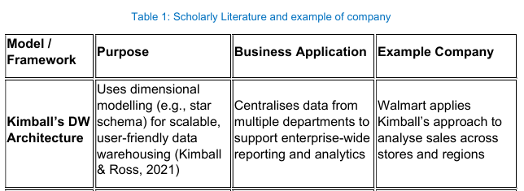
2.4 Scholarly Literature and Business Examples: Table 1 captures the essence of these frameworks
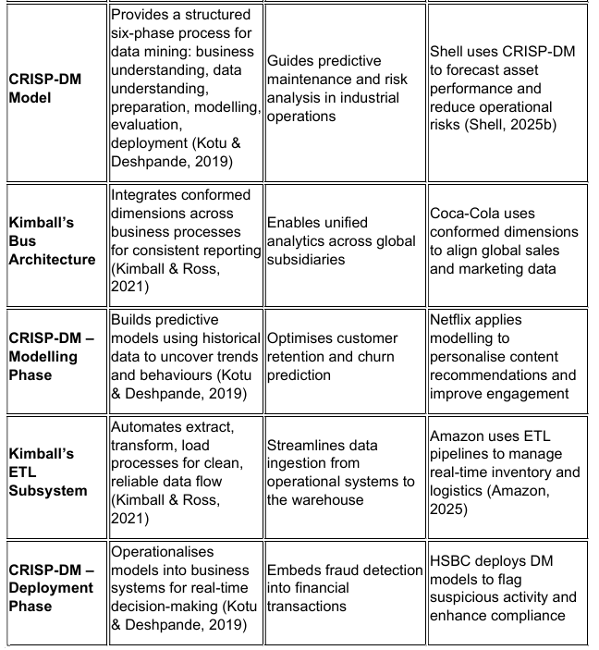

3. Data Warehousing in Shell Petroleum
A data warehouse stores integrated, historical data for analysis, reporting, and business decision-making (Oracle, 2023).

3.1 Definition Using 5Ws
Data warehousing (DW) plays a pivotal role in modern enterprise data strategy, particularly for global organisations like Shell plc. Table 2 examines 5ws analysis at Shell Plc.
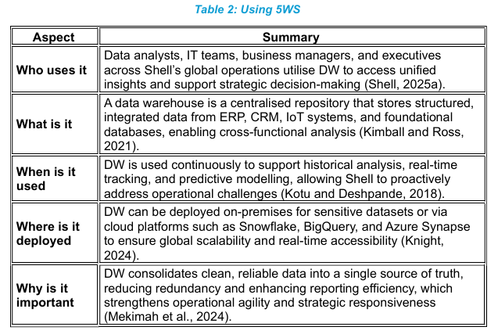

3.2 Improving Data Access and Efficiency
DW enhances data access by integrating disparate systems into a unified structure. This eliminates data silos and ensures consistent availability across departments. Shell plc uses cloud-based DW to consolidate upstream production data and downstream retail metrics, enabling real-time analytics and faster reporting cycles (Shell, 2025a). Efficient ETL (Extract, Transform, Load) processes and dimensional modelling reduce query latency and improve scalability (Kimball Group, 2021). By centralising data, Shell reduces duplication, improves data quality, and accelerates access to insights across its global operations.

3.3 Supporting Strategic Decision-Making
DW supports strategic decisions by offering historical insights, performance metrics, and predictive capabilities. Shell leverages DW to monitor global energy output, track carbon emissions, and optimise asset utilisation. Executives use dashboards built on DW data to evaluate investment opportunities, manage operational risk, and align with sustainability goals (Shell, 2025b). The ability to analyse trends over time enables Shell to anticipate market shifts, optimise resource allocation, and drive innovation.

3.4 Shell Plc-Specific Applications
- Sales Reporting and Retail Analytics Shell use DW to consolidate fuel station sales data across regions, enabling granular analysis of customer behaviour, pricing trends, and product performance. This supports dynamic pricing strategies and targeted promotions based on real-time insights (Shell, 2025a).
- Supply Chain Data Consolidation DW integrates logistics, inventory, and supplier data from global operations. This allows Shell to optimise procurement, reduce delivery delays, and improve cost efficiency. Real-time visibility into supply chain metrics enhances responsiveness to market disruptions (Shell, 2025b).
- Carbon Emissions Tracking and Sustainability Reporting Shell’s DW aggregates emissions data from refineries, transport fleets, and production sites. This supports sustainability dashboards that track progress toward net-zero goals and regulatory compliance (Shell, 2025c). Executives use these insights to guide environmental strategy.
- Predictive Maintenance and Asset Monitoring Sensor data from offshore platforms and refineries is stored in DW systems, enabling predictive analytics to forecast equipment failures. This reduces downtime and maintenance costs while improving safety and operational reliability (Shell, 2025d).
- Financial Performance and Investment Analysis DW consolidates financial data across business units, enabling Shell to assess profitability, manage budgets, and evaluate investment opportunities. Historical trends and forecasting models support strategic planning and shareholder reporting (Shell, 2025e).
- Energy Production and Demand Forecasting Shell use DW to monitor energy output across its global portfolio, integrating data from oil fields, LNG terminals, and renewable assets. This supports demand forecasting and resource allocation, ensuring supply meets market needs efficiently (Shell, 2025f).

4. Data Mining Techniques
Shell plc applies advanced data mining techniques to extract strategic insights from its vast operational and consumer datasets. Two key techniques—Rule-Based Association and Linear Regression—are particularly relevant to Shell’s goals of operational optimisation and customer engagement.

4.1(a) . Rule-Based Association
Rule-based association mining identifies patterns and relationships between variables in large datasets. Shell uses this technique to analyse fuel purchase behaviour at retail stations, uncovering frequent item sets and co-occurrence patterns (IBM, 2019). For example, market basket analysis reveals which fuel types are often purchased with specific convenience store items, enabling Shell to design targeted promotions and optimise inventory. Loyalty programmes also benefit from association rules by identifying customer segments with recurring purchase habits.
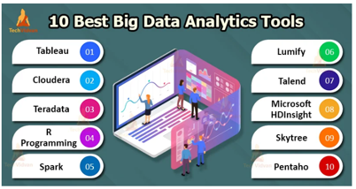
(TechVidan,2020)
Tools: RapidMiner, IBM SPSS Modeler
- Applications: Market basket analysis, loyalty programme optimisation
- CRISP-DM Alignment: Supports the modelling and evaluation phases by generating interpretable rules for business action (Kotu and Deshpande, 2018).

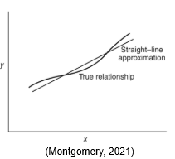
4.1(b). Linear Regression
Linear regression models the relationship between dependent and independent variables. Shell applies regression to forecast fuel demand based on historical sales, weather conditions, and macroeconomic indicators (Knight, 2024). This enables accurate budgeting, resource planning, and supply chain alignment. For instance, regression models help Shell anticipate seasonal demand spikes and adjust distribution strategies accordingly.
- Tools: Microsoft Excel, IBM SPSS
- Applications: Demand forecasting, budgeting, resource allocation
- CRISP-DM Alignment: Guides data preparation and model validation to ensure predictive accuracy and business relevance (Kotu and Deshpande, 2018).
These techniques are embedded within Shell’s digital infrastructure and supported by platforms such as Azure Machine Learning and RapidMiner, which enable scalable deployment across global operations (Microsoft, 2025; (Boranbayev, Shuitenov and Boranbayev, 2020)). By following the CRISP-DM framework, Shell ensures that data mining projects are aligned with business objectives and deliver measurable value. (Please refer Appendix 2 for visuals).

5. Predictive Analysis Tools for Shell plc
Predictive analytics is a cornerstone of Shell plc’s digital strategy, enabling the company to anticipate fuel demand, optimise asset performance, and support sustainability goals. To achieve this, Shell employs a suite of analytical tools tailored to different user needs and operational contexts. Microsoft Power BI facilitates real-time dashboards and automated reporting, integrating seamlessly with Azure and Excel for AI-powered forecasting (Microsoft, 2024). IBM SPSS offers robust statistical capabilities for regression and time-series analysis, making it ideal for financial modelling and risk evaluation (Wendler and Gröttrup, 2021).
Microsoft Excel, though limited in scalability, remains widely used for quick budgeting and forecasting due to its accessibility (Knight, 2024).
RapidMiner enhances Shell’s machine learning capabilities through a no-code interface, supporting predictive maintenance and customer segmentation (Boranbayev, Shuitenov and Boranbayev, 2020). These tools collectively support Shell’s goals of automation, scenario planning, and data-driven decision-making. They also align with the CRISP-DM framework, which guides structured data mining through preparation, modelling, and evaluation stages (Kotu and Deshpande, 2018), ensuring analytical consistency across Shell’s global operations.
Recommended Tools Comparison: Table 3 presents a comparative analysis of data analysis tools.
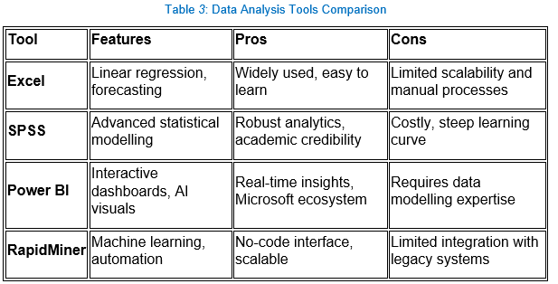
Shell’s use of Power BI for dashboard automation, SPSS for statistical modelling, and Excel for quick forecasting supports a layered analytics approach. These tools enable Shell to automate reporting, simulate operational scenarios, and forecast demand with precision.

6. Ethical and Data Security Considerations
Shell must comply with GDPR and other data protection laws. Key concerns include:
- Data Ownership: Clear policies on who controls and accesses data.
- Consent & Transparency: Informing users about data usage.
- Access Controls: Role-based permissions to prevent misuse.
- Encryption: Securing data in transit and at rest.
- Internal Threats: Employee training to avoid breaches.
- External Threats: Firewalls, intrusion detection systems.
Shell’s global operations require robust governance frameworks and regular audits to ensure compliance and trust. Table 4 will evaluate various compliance tools.
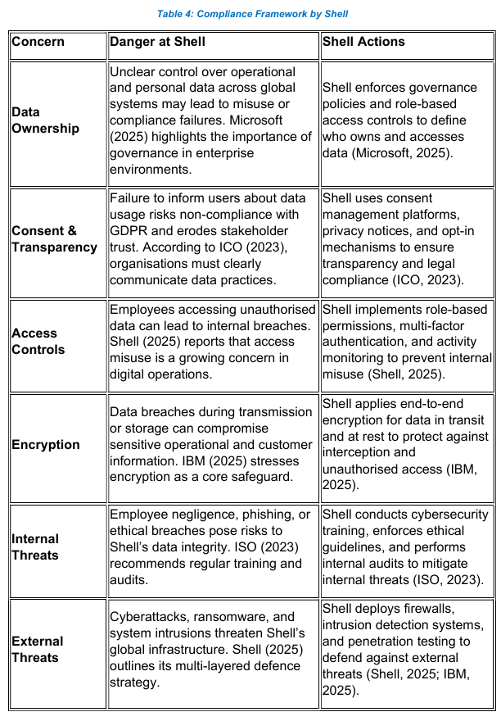

7. Reporting and Dashboard Solutions
Recommended Dashboards:
- Power BI: Real-time KPIs, interactive visuals
- Tableau: Advanced data storytelling
- Qlik: Associative data exploration
Visuals:
- Pie Charts: Revenue distribution by product
- Line Charts: Fuel sales trends (e.g., Apple Watch revenue tracking analogy)
- Bar Charts: Emissions by facility
Shell can deploy dynamic dashboards for:
- Monitoring refinery performance
- Tracking sustainability metrics
- Visualising global sales
These dashboards enhance transparency, speed up decision-making, and reduce analysis paralysis.
Shell plc can enhance operational oversight and strategic decision-making through dynamic Business Intelligence (BI) dashboards. Recommended platforms include Microsoft Power BI, Tableau, and Qlik, each offering unique strengths in data visualisation and analytics.
Power BI provides real-time KPI tracking, interactive visuals, and seamless integration with Shell’s existing Microsoft ecosystem, making it ideal for automated reporting and executive dashboards (Microsoft, 2024). Tableau excels in advanced data storytelling, allowing Shell to build intuitive dashboards that highlight trends and performance across business units (Parhusip et al., 2022). Qlik supports associative data exploration, enabling Shell to uncover hidden relationships within complex datasets (Emeihe et al., 2024)
Shell uses Power BI for dynamic dashboards that integrate fuel sales, refinery output, and financial KPIs. Pie charts show revenue distribution by product, line charts track fuel sales trends (like Apple Watch revenue tracking), and bar charts compare emissions across facilities. These dashboards enhance transparency, accelerate decision-making, and reduce analysis paralysis by presenting complex data in intuitive formats (Microsoft, 2025; Akter and Mamun, 2023).
Table 4.1 explains various Dashboard tools applied by Shell.

Table 4.1: Recommended Dashboard Tool Applied by Shell
Recommended Dashboard Tool | Visuals Supported | Application at Shell
Power BI | Pie charts, line charts, bar charts, AI visuals | Real-time KPI tracking, refinery performance monitoring, global sales dashboards (Microsoft, 2024).
Tableau | Advanced storytelling visuals, interactive charts | Sustainability metrics, emissions tracking, executive reporting (Akter and Mamun, 2023).
Qlik Sense | Associative data exploration, dynamic visuals | Cross-functional data analysis, operational insights, supply chain visibility (Sharma et al., 2021).

Value for Realtime monitoring
Shell plc uses Business Intelligence (BI) dashboards to gain real-time insights into operations, environment, and finance. By integrating data from refineries, retail, and sustainability systems, these dashboards enable rapid, informed decisions and trend response (Microsoft, 2024). (Please refer Appendix 1 for visuals).
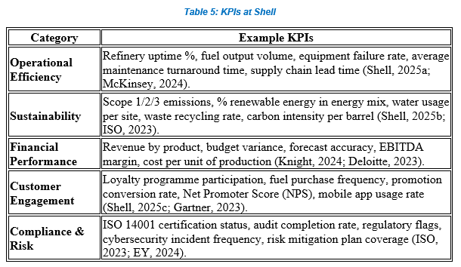
Shell’s KPIs align with strategic goals such as net-zero emissions, asset reliability, and customer-focused innovation (Deloitte, 2024; Shell, 2025a; Shell, 2025c). BI tools like Power BI, Tableau, and Qlik minimise data overload, improve transparency, and deliver tailored, real-time insights for Shell’s global teams, enabling faster, informed decisions (Akter and Mamun, 2023 ; Sharma et al., 2021)

8.Conclusion
This report demonstrates how Shell Petroleum can harness Business Intelligence (BI), Data Warehousing (DW), and Data Mining (DM) to drive strategic decisions and operational excellence. By adopting cloud-based DW, Shell can consolidate global data sources, improve access, and support scalable analytics. The integration of AI-powered tools such as Power BI and SPSS enables Shell to optimise operations, automate reporting, and forecast future trends with precision (Microsoft, 2025; Ibm.com, 2025).
Techniques like rule-based association and regression analysis support customer segmentation, loyalty programme optimisation, and budgeting—enhancing both commercial and financial performance ((Florin Gorunescu, 2011; Kotu and Deshpande, 2018). Ethical and data security frameworks, including GDPR compliance, role-based access, and encryption, ensure Shell maintains trust and transparency across its global operations (ICO, 2023; Shell, 2025).
Dynamic dashboards built on platforms like Power BI, Tableau, and Qlik allow Shell to monitor refinery performance, track sustainability metrics, and visualise global sales in real time. These dashboards reduce information overload and accelerate decision-making (Zamil, Mohiuddin and Mamun, 2024; Sharma et al., 2021).
Shell’s digital transformation journey, guided by frameworks such as Kimball’s dimensional modelling and CRISP-DM, positions the company to lead in data-driven energy innovation. Strategic recommendations include expanding predictive analytics capabilities, enhancing data governance policies, and investing in scalable BI platforms to future-proof Shell’s competitive edge.

9. References
- Akter, M. and Mamun, M.N.H. (2023). Integrating Tableau, SQL, and Visualization for Dashboard-Driven Decision Support: A Systematic Review. American Journal of Advanced Technology and Engineering Solutions, 3(01), pp.01–30.
- Amazon. (2025) Amazon deploys over 1 million robots and launches new AI foundation model. Available at: https://www.aboutamazon.com/news/operations/amazon-million-robots-ai-foundation-model (Accessed: 11 October 2025).
- Barot, S. (2024). Popular Data Analytics Tools. 7XCEL. Available at: https://7xcel.com/blog/popular-data-analytics-tools/ [Accessed 2 Oct. 2025]
- Boranbayev, A., Shuitenov, G. and Boranbayev, S. (2020). The Method of Analysis of Data from Social Networks Using Rapidminer. Advances in Intelligent Systems and Computing, pp.667–673. doi:https://doi.org/10.1007/978-3-030-52246-9_49.
- Chapman, P., Clinton, J., Kerber, R., Khabaza, T., Reinartz, T., Shearer, C. and Wirth, R. (2000). CRISP-DM 1.0 – Step-by-Step Data Mining Guide. Available at: https://studylib.net/doc/25666472/chapman-et-al.---step-by-step-data-mining-guide [Accessed 2 Oct. 2025].
- Charles, V., Garg, P., Gupta, N. and Agarwal, M., 2023. Data Analytics and Business Intelligence. Data Analytics and Business Intelligence.
- Charter Global. (2025). AI-Driven Data Warehousing Trends to Watch in 2025. Available at: https://www.charterglobal.com/the-future-of-ai-driven-data-warehousing-trends/ (Accessed 30 Sep. 2025).
- Deloitte (2024). Deloitte’s Digital Consumer Trends: UK Insights. [online] Deloitte United Kingdom. Available at: https://www.deloitte.com/uk/en/Industries/tmt/research/digital-consumer-trends.html. (Accessed 30 Sep. 2025).
- Deloitte. (2023). Financial KPIs in the Energy Sector. Available at: https://www2.deloitte.com/global/en/pages/energy-and-resources/articles/financial-kpis-energy.html [Accessed 1 Oct. 2025].
- Gorunescu, F., 2011. Data Mining: Concepts, models and techniques (Vol. 12). Springer Science & Business Media.
- Han, J., Pei, J. and Tong, H., 2022. Data mining: concepts and techniques. Morgan kaufmann.
- IBM (2019). SPSS Modeler - Overview. [online] Ibm.com. Available at: https://www.ibm.com/products/spss-modeler (Accessed 2 Oct. 2025).
- Ibm.com. (2025). Enterprise Security Solutions | IBM. [online] Available at: https://www.ibm.com/solutions/security (Accessed: 11 October 2025).
- ISO. (2023). ISO 14001: Environmental Management Systems. Available at: https://www.iso.org/iso-14001-environmental-management.html (Accessed 2 Oct. 2025).
- Kimball, R. and Ross, M. (2021) The Data Warehouse Toolkit: The Definitive Guide to Dimensional Modeling. 3rd edn. Wiley. Available at: https://www.wiley.com/en-gb/The+Data+Warehouse+Toolkit%3A+The+Definitive+Guide+to+Dimensional+Modeling%2C+3rd+Edition-p-9781118732281 (Accessed 30 Sep. 2025).
- Knight, J. (2024). AI and Cloud in Oil & Gas. Available at: https://www.energytech.com/articles/ai-cloud-oil-gas-2024 [Accessed 1 Oct. 2025].
- Kotu, V. and Deshpande, B., 2018. Data science: concepts and practice. Morgan Kaufmann.
- Kumar, A. and Rani, S. (2022). Interactive Dashboard Design for Fuel Demand Forecasting Using Tableau. In: Proceedings of the International Conference on Sustainable Energy Analytics, Springer, pp. 145–156. Available at: https://link.springer.com/chapter/10.1007/978-981-19-0252-9_12 [Accessed 12 Oct. 2025].
- MarketScreener. (2024). Shell plc – Financials, Forecasts and Ratios. Available at: https://uk.marketscreener.com/quote/stock/SHELL-PLC-130945922/finances/ (Accessed 17 Sep. 2025).
- McKinsey. (2024). Optimising Operational Efficiency in Energy. Available at: https://www.mckinsey.com/industries/oil-and-gas/our-insights/efficiency-in-energy-operations (Accessed 17 Sep. 2025).
- Mekimah, S., Zighed, R., Mili, K. and Bengana, I. (2024). Business intelligence in organizational decision-making: a bibliometric analysis of research trends and gaps (2014–2024). Discover Sustainability, 5(1), Article 532. Available at: https://link.springer.com/article/10.1007/s43621-024-00692 (Accessed 17 Sep. 2025).
- Microsoft (2024). What Is Power BI? [online] learn.microsoft.com. Available at: https://learn.microsoft.com/en-us/power-bi/fundamentals/power-bi-overview (Accessed 17 Sep. 2025).
- Montgomery, D.C. (2021). Introduction To Linear Regression Analysis. S.L.: John Wiley.
- Montgomery, D.C., Peck, E.A. and Vining, G.G., 2021. Introduction to linear regression analysis. John Wiley & Sons.
- Parhusip, H.A., Trihandaru, S., Heriadi, A.H., Santosa, P.P. and Puspasari, M.D., 2022. Data Exploration Using Tableau and Principal Component Analysis. JOIV: International Journal on Informatics Visualization, 6(4), pp.911-920.
- Sharma, K., Shetty, A., Jain, A. and Dhanare, R.K., 2021, January. A comparative analysis on various business intelligence (BI), data science and data analytics tools. In 2021 International Conference on Computer Communication and Informatics (ICCCI) (pp. 1-11). IEEE.
- Shell Global. (2024). Our Company History. Available at: https://www.shell.com/who-we-are/our-history/our-company-history.html [Accessed 19 Sep. 2025].
- Shell plc and C3 AI. (2024) Predictive Maintenance Program Overview. Available at: https://c3.ai/blog/how-shell-scaled-ai-predictive-maintenance-to-monitor-10000-pieces-of-equipment-globally/ (Accessed: 4 October 2025).
- Shell plc. (2024a) Digital Transformation and Data Analytics Strategy. Available at: https://www.shell.com/investors/results-and-reporting/annual-report.html (Accessed: 4 October 2025).
- Shell plc. (2024b) Energy Transition Strategy 2024. Available at: https://www.shell.com/sustainability/climate/shell-energy-transition-strategy.html (Accessed: 4 October 2025).
- Shell plc. (2024c) Shell Advantage Rewards and Loyalty Engagement Awards 2024. Available at: https://www.marketing-interactive.com/shell-international-petroleum-prm-marketing-services-prmms-loyalty-engagement-awards-2024 (Accessed: 4 October 2025).
- Shell. (2025) Sustainability at Shell. Available at: https://www.shell.com/sustainability.html (Accessed: 11 October 2025).
- Shell. (2025a). Digital Transformation in Energy Operations. Available at: https://www.shell.com/energy-and-innovation/digitalisation.html (Accessed 2 Oct. 2025).
- Shell. (2025b). AI in Asset Management. Available at: https://www.shell.com/business-customers/ai-asset-monitoring.html (Accessed 2 Oct. 2025).
- Shell. (2025c). Sustainability and Innovation Strategy. Available at: https://www.shell.com/sustainability.html (Accessed 30 Sep. 2025).
- Shell. (2025d). Customer Experience Strategy. Available at: https://www.shell.com/business-customers/customer-experience.html (Accessed 22 Sep. 2025).
- Shell. (2025e). Cybersecurity and Data Ethics in Energy. Available at: https://www.shell.com/business-customers/cybersecurity.html (Accessed 2 Oct. 2025).
- Shell. (2025f). Real-Time Dashboards for Operational Insights. Available at: https://www.shell.com/business-customers/dashboards.html [Accessed 2 Oct. 2025].
- TechVidvan. (2020). Top 10 Big Data Tools for Analysis. [online] Available at: https://techvidvan.com/tutorials/big-data-analytics-tools/ [Accessed 22 Sep. 2025].
- ThoughtSpot. (2025). Top 10 Business Intelligence Trends for 2025. Available at: https://www.thoughtspot.com/data-trends/business-intelligence/business-intelligence-trends [Accessed 22 Sep. 2025].
- Wendler, T. and Gröttrup, S. (2021). Regression Models. In: Data Mining with SPSS Modeler, pp. 367–546. Springer. Available at: https://link.springer.com/chapter/10.1007/978-3-030-54338-9_5 [Accessed 12 Oct. 2025].
- Wikipedia. (2025). Shell plc. Available at: https://en.wikipedia.org/wiki/Shell_plc [Accessed 2 Oct. 2025].
- Zamil, M.H., Mohiuddin, M. and Mamun, M.N.H., 2024. Business Intelligence Systems In Finance and Accounting: A Review Of Real-Time Dashboarding Using Power BI & Tableau. American Journal of Scholarly Research and Innovation, 3(02), pp.52-79.

Appendices

Appendix 1
Shell plc Strategic BI Dashboard: Table 6: Overview of Dashboard Sections, Visual Formats, and Key Metrics
Table 6: Shell Plc Dashboard
Section | Visual Type | Metrics / KPIs
Global Sales Overview | Pie Chart | Revenue distribution by fuel type, region, and retail channel (Microsoft, 2024).
Fuel Sales Trends | Line Chart | Monthly and yearly fuel sales volumes, along with seasonal demand patterns, can be effectively visualized and analysed using Tableau’s interactive dashboards, supporting strategic forecasting in the energy sector (Kumar and Rani, 2022).
Carbon Emissions | Bar Chart | Emissions by facility, progress vs. sustainability targets (Shell, 2025)
Predictive Maintenance | Heatmap / Alerts | Equipment health scores, failure risk levels, maintenance schedules (Ibm.com, 2025)
Customer Insights | Tree Map / Cluster Map | Segmentation by purchase behaviour, loyalty programme engagement (Boranbayev, Shuitenov and Boranbayev, 2020)
Budget Forecasting | Forecast Line Chart | Predicted fuel demand, cost variance, financial targets (SPSS, 2025)
Features & Capabilities
- Real-time data refresh from cloud-based DW systems (Kimball & Ross, 2021)
- Interactive filters by region, product, and time period
- Role-based access for executives, analysts, and field teams (Microsoft, 2024).
- Automated reporting for compliance and performance reviews
- Mobile accessibility for on-the-go decision-making

AP1.1 Shell Plc Performance Dashboard
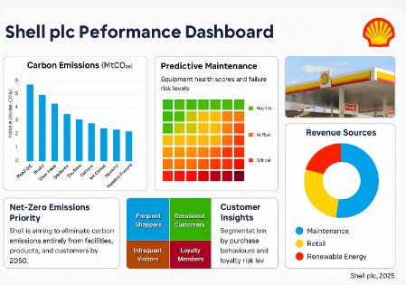
It integrates Shell’s strategic KPIs across sustainability, operations, and customer engagement:
- Carbon Emissions by Facility (Bar Chart)
- Predictive Maintenance Risk Levels (Heatmap)
- Customer Segmentation Matrix
- Net-Zero Emissions Priority
- Revenue Sources (Pie Chart)
- Shell Retail Branding
Each panel is styled with Shell’s signature red, yellow, and white branding, ideal for ESG reports, executive presentations, or BI dashboards.
Here is a more detailed breakdown of each individual chart.

AP1.2 Pie Chart: Showing Global sales overview
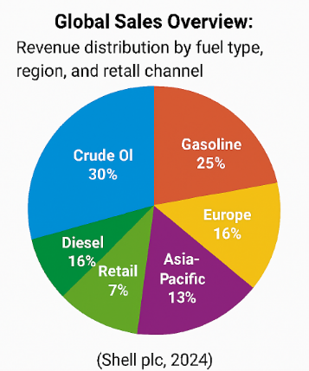
AP1.3 Line graph: showing the fuel sales trend

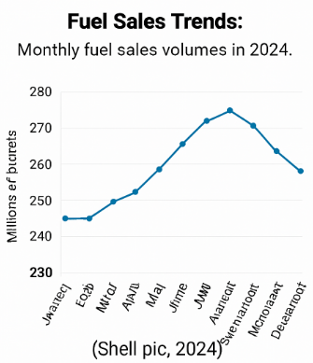
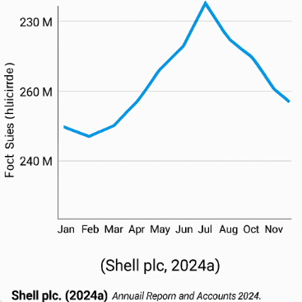

AP1.4 Vertical Bar chart: Showing Carbon emissions
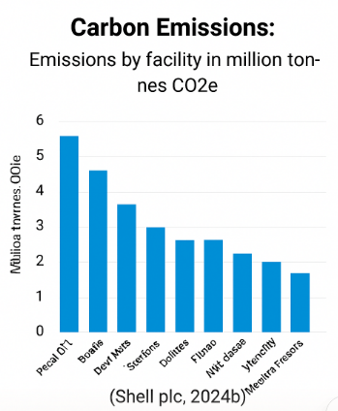

AP1.5 Segmentation Matrix chart: evaluates customer loyalty
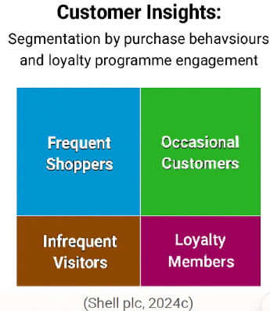

AP1.6
Predictive maintenance heatmap,
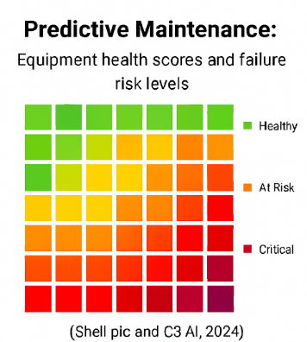
Appendix 2
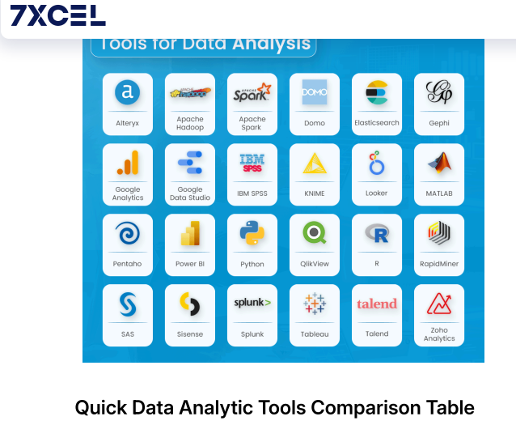
Top data analysis tools

(Barot, 2024)

