Manufacturing Design & Technology M5X02070

Computer Aided Manufacturing and Design for Additive Manufacturing Technologies

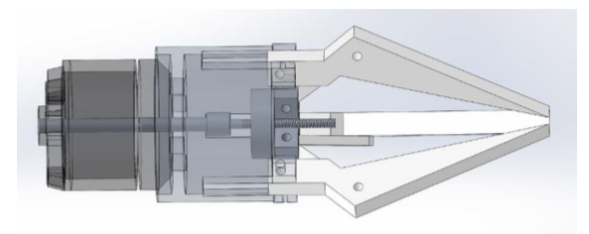
3-Jaw Gripper Design and Development
By Rhodri Williams (1910918)

Table of Contents
- Introduction
- Appraisal of original design
- Manufacturing Process Proposal
- Design and Development Work Undertaken
- Appraisal of new design
- Manufacture process proposal
- Conclusion
- Bibliography

- Introduction
I have been provided with a concept design for a 3-Jaw Gripper and by using industry standard techniques will develop the design with ease off assembly and ease of manufacture in mind. Appraisal methods such as the Lucas method for design assembly and FMEA will be used to highlight what can be done to develop the design.
This report consists of the steps taken to improve design efficiency and manufacturability. Ways to manufacture each component will be explored and appropriate methods chosen. A breakdown of the design modifications along with further appraisal methods are used to compare the old and new designs should hopefully show the improvements made.
- Appraisal of the Original Design
After looking closely at the original design, it is obvious that even though it seemed functional, there design flaws present. Appraising the design using industry standard methods will confirm any flaws and highlight where development is needed. Design for assembly, or DFA’s are a tool used in the design stage of a products life cycle and assist design teams in designing a product that will transition to productions at minimum cost, focusing on handling, number of parts and ease of assembly. I have decided to use the Lucas method to appraise the design.
Lucas Method
Developed by Lucas Corp. in the 1980’s, the Lucas Method uses a point scale to provide design teams a measure the difficulty of assembly. Functional analysis, feeding analysis and fitting analysis are used as part of the assembly sequence flowchart (ASF) to identify problems in the design.
The assembly sequence flowchart:
- Specification
- Design
- Functional Analysis
- Feeding Analysis
- Fitting Analysis
- Assessment
- Return to step 2 if problems are identified
The first steps of design specification and design have been completed prior leading to step 3, functional analysis next:

Functional Analysis
Functional Analysis identifies essential (A parts) and non-essential (B parts). From this information the design efficiency can be calculated, and non-essential parts can be targeted to be designed out.
The design efficiency is the number of essential parts divided by the total number of parts expressed as a percentage.
A | X 100 =
A+B
Efficiency Rating %

Below is the chart used to determine whether a part is essential or not.
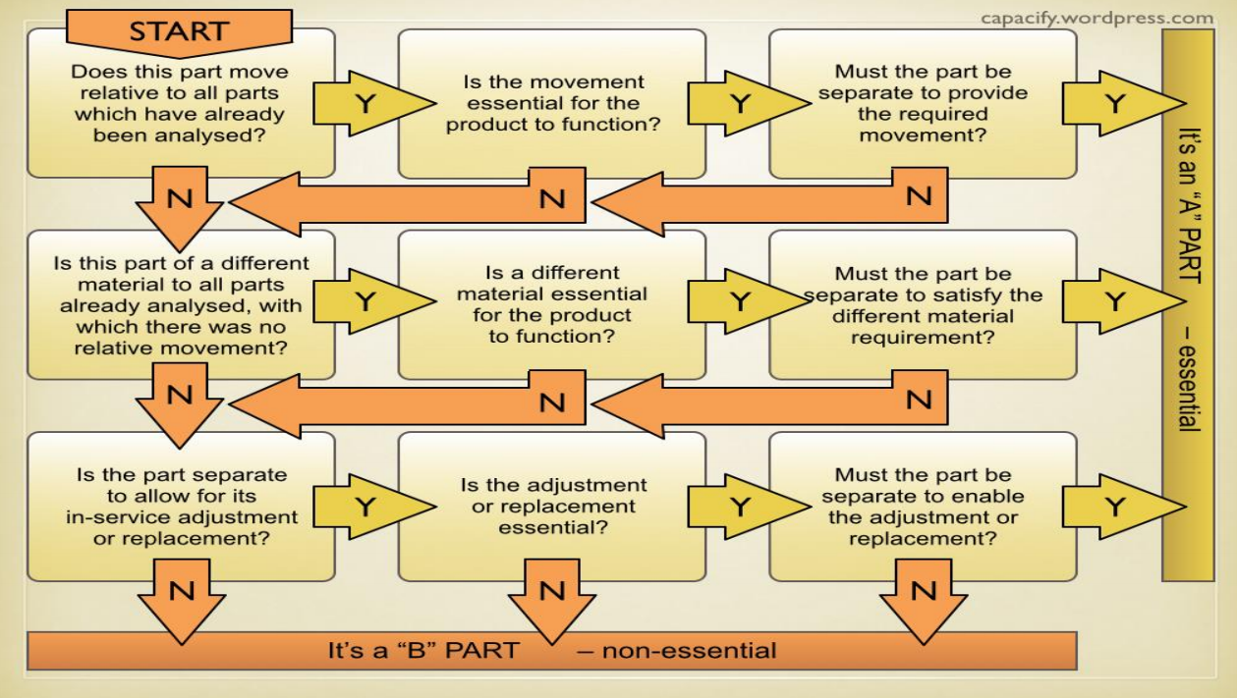

Part | Essential A | Non-Essential - B
Motor | ü
Drive Plate | ü
Worm |  | ü
Jaws (X3) | ü
Cylinder |  | ü
Drive Shaft | ü
Joins (X3) | ü
Fasteners (X13) |  | ü

Using the chart, I have determined that the motor, drive plate, drive shaft, jaws and joins are all essential and therefore cannot be designed out. The worm and cylinder came under non-essential parts although they do have important functions so cannot be removed, however they could be redesigned or modified to increase efficiency. Finally, the joins and bolts/rivets have all been classed as non-essential parts and are targets to be designed out.
The efficiency rating for the original design is calculated as 9 / (9+15) = 0.375 X 100 = 38%.

Feeding Analysis
Feeding analysis or manual handling index analysis uses a point system to assess the difficulty of handling of each component. A score is applied to a component in each of the four categories and added together to give a handling index score. According to (Chan and Salustri, 2013), an ideal score of 1.5 is the target for each component, and anything over should be considered for redesign.
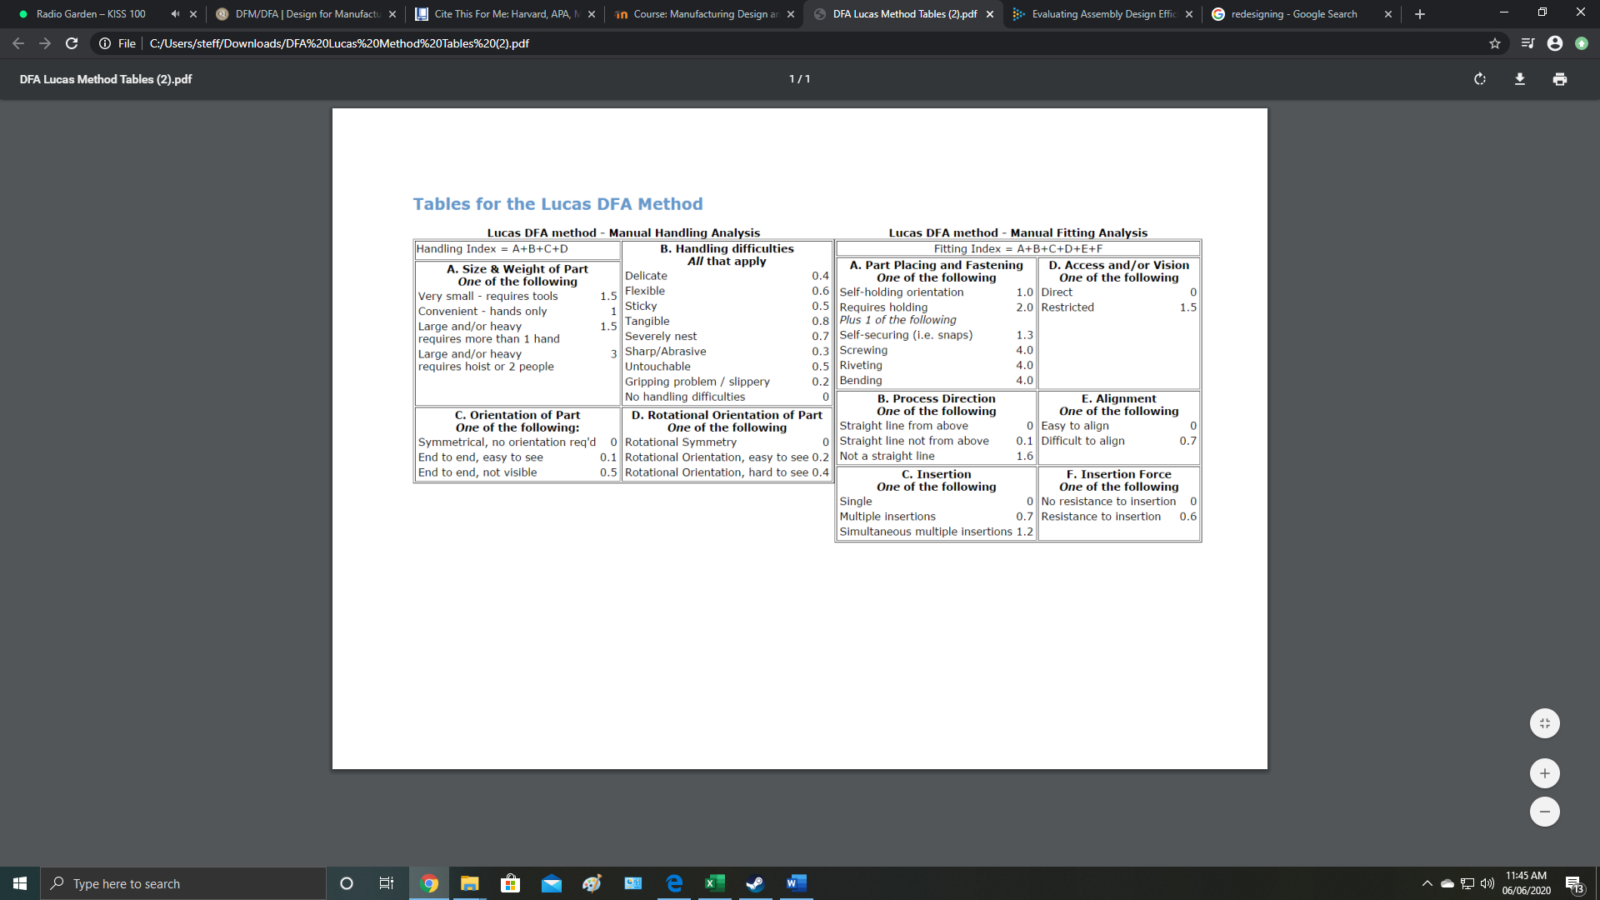

Handling Index
Part | A | B | C | D | Total
Motor | 1 | 0 | 0.1 | 0 | 1.1
Drive Plate | 1 | 0 | 0.1 | 0 | 1.1
Worm | 1 | 0 | 0.1 | 0 | 1.1
Jaws | 1 | 0.3 | 0.1 | 0.2 | 1.6
Cylinder | 1 | 0 | 0.1 | 0 | 1.1
Drive Shaft | 1 | 0 | 0 | 0 | 1
Joins | 1 | 0 | 0 | 0 | 1
Bolts/Rivets | 1.5 | 0 | 0.1 | 0 | 1.6

The analysis shows that handling is not a huge problem for the design, however, does highlight redesign opportunities for the jaws, and as bolts and rivets are always B parts, they can be targeted to be designed out.
Fitting Analysis
The fitting index uses 6 categories to assess the difficulty of fitting each component. Like the above manual handling index, a score is given to each component, highlighting areas to improve design with higher scoring components.

Fitting Index
Part | A | B | C | D | E | F | Total
Motor | 1 | 0 | 0 | 0 | 0 | 0 | 1
Drive Plate | 6 | 0 | 0 | 0 | 0 | 0 | 6
Worm | 1 | 0 | 0 | 0 | 0 | 0 | 1
Jaws | 6 | 0 | 0.7 | 0 | 0.7 | 0 | 7.4
Cylinder | 6 | 0 | 0 | 0 | 0 | 0 | 6
Drive Shaft | 1 | 0 | 0 | 1.5 | 0 | 0 | 2.5
Joins | 6 | 0.1 | 0.7 | 0 | 0.7 | 0 | 7.5
Bolts/Rivets | 6 | 0.1 | 0.7 | 1.5 | 0 | 0 | 8.3
The bolts/rivets are B parts so are already targeted for removal, whilst the jaws, drive plate, cylinder and the joins have higher scores than the other components identifying redesign opportunities.
Further tools, such as a DMFEA can also be used to evaluate, identify and score potential failures and their effects whilst identifying what actions to take to reduce or eliminate any potential failures occurring.

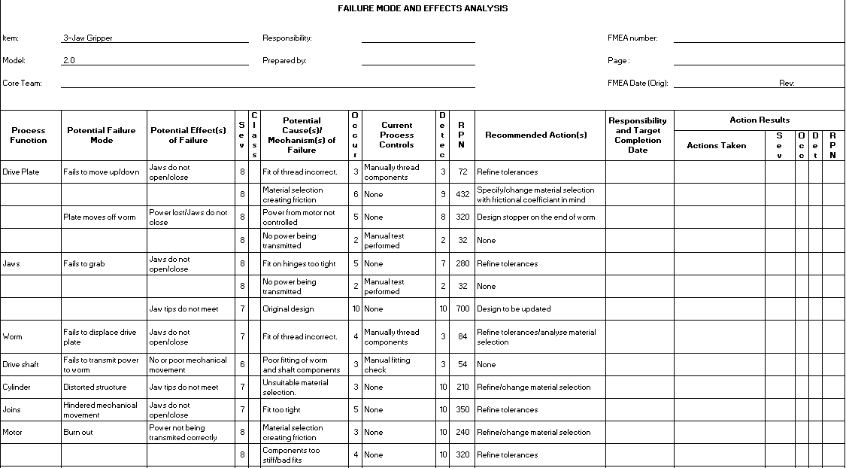

Above is a DMFEA for the original design. The risk priority numbers (RPN) identify areas of the gripper design where failure is most likely to occur, giving clear indications as to what are the targets to modify or remove. The RPN is calculated by first identifying a potential failure mode of a component, followed by rating the severity of failure, likelihood of failure occurring and likelihood of detecting the failure out of 10(1=Low/infrequent/very detectable, 10=High/frequent/not detectable). Once all scores have been identified they can be multiplied together to give the risk priority number. (Montgomery, 2019)

- Manufacturing Process Proposal

Each part will have to be individually made before assembly, with several different ways in which each component could be manufactured. The design and material selection are the biggest factors when choosing how to manufacture a component.
Rivets, pins and fasteners can be bought in standard stock sizes, making them cheaper and more accessible for replacement or repair work.
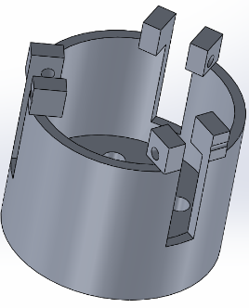
Cylinder
Ways to manufacture:
- Investment Casting
- Additive manufacturing
- Machining
- Plastic injection moulding

The cylinder, which houses the worm and drive plate, whilst securing the jaws for movement could be cast in the required alloy using the investment casting process and finished by being machined to the relevant tolerances. The top three features that are designed to hold the jaws in place are necessary for the grippers function, but their orientation and design on the original part design would make manufacture more difficult, and therefore more expensive making them a target to modify. Investment casting would require an initial upfront cost of tool creation but be far more efficient at manufacturing a large volumes of precision components.
Additive manufacturing could be used to 3D print the cylinder in the desired alloy. The initial overhead of tool creation seen with investment casting would not be needed as parts can be printed from scratch making this method cheaper initially, although a rougher surface finish would be present compared to casting, leaving more time to be spent machining. Additive manufacturing would only be viable if the production volume is relatively low.
Plastic injection moulding can also be used manufacture the cylinder. This method has less process steps than investment casting, with the same initial overhead of tool creation, therefore if the material selection does not necessarily require the component to be metal, a polymer could be a viable, cheaper option. (Bishop, 2017)

Jaws and Joins
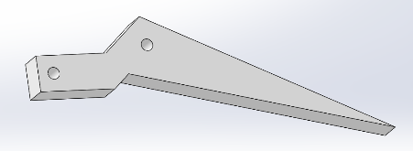
Ways to manufacture:
- Investment Casting
- Additive manufacturing
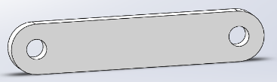
- Cut from sheet
- Machining
- Plastic injection moulding
The Jaws and joins are simple in design and therefore should be simple to manufacture. Once the material has been chosen the profile of the part can be machined from a sheet of the desired material. Investment casting and additive manufacturing can also be utilized to manufacture both parts but will be far less time and cost effective than purchasing sheet material. Machining to relevant tolerances and finish will be required.
Plastic injection moulding could be utilised to manufacture these parts, and with such simple designs tool creation will be relatively cheap compared to the cylinder, and with less machining needed makes this a viable option if material selection is not paramount.

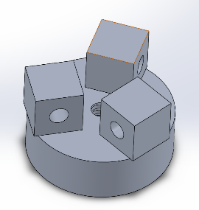
Drive Plate
Ways to manufacture:
- Investment casting
- Additive manufacturing
- Machining
- Plastic injection moulding

The original design for the drive plate would make it relatively difficult to machine, with awkward angles and shapes. This part could be manufactured using investment casting and then machined to within tolerances. Additive manufacturing could also be used to make this component before it gets machined, although depending on the quantity being manufactured, this method will become more impractical as the quantity rises. Poor surface finish and limited fatigue life are two of the largest challenges present with additive manufacturing and would therefore require more machining to get into specification. (RemChem, 2020)
Again, plastic injection moulding is an option depending on importance of material selection. The machining of the bore to the tolerance is absolutely necessary and be cheaper to carry out when using a polymer, again making this a cheaper option.

Worm and Drive Shaft
Ways to manufacture:
- Bar stock
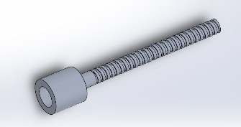
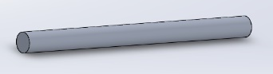
- Additive manufacturing
- Investment casting
- Plastic injection moulding
- Machining

The worm and drive shaft can be bought in from bar stock in their required material, with the worm being machined to a tolerance specific to the profile of the hole situated through the drive plate. The shaft will also have to be machined if the purchased rod does not have the required finish or tolerances. Both components could also be manufactured using investment casting and additive manufacturing rather than purchasing metal rods, although this would be more expensive and take longer to produce.

- Design and Development Work Undertaken
The DFA of the original design has highlighted non-essential components as targets to be designed out, and the DMFEA shows areas that are most likely to fail, and therefore targets to be modified. With the cost of processing, materials and assembly making up 70% of manufacturing costs it is important to keep this in mind when designing a product. This simple, but effective set of rules can help reduce manufacturing costs:
- Reduce the number of parts
- Use standardised components
- Design multifunctional parts
- Design for ease of manufacture
- Avoid separate fasteners
- Minimise assembly directions
- Minimise handling
- Maximise compliance

Drive Shaft/Worm
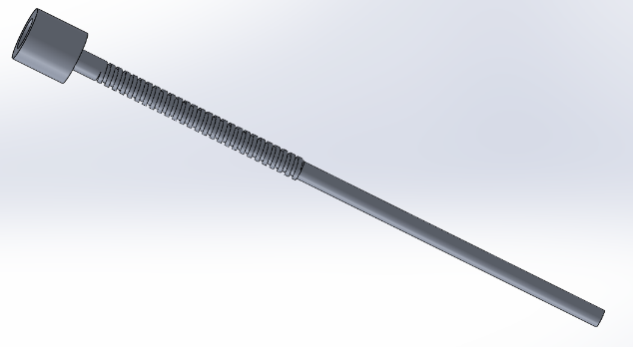
The drive shaft is the first component to be looked at after being highlighted as a target to be designed out. As it has an important function of transmitting power from the motor to the worm it cannot be completely removed, although a slight modification by basically combining the shaft with the worm into one part will remove the need for a specific shaft. The potential for the drive plate separating from the worm highlighted a relatively high Risk Priority Number (RPN) and therefore a need to modify the part to stop this happening. A stopper has been designed at the top of the worm which will nullify this risk.
This component will be manufactured out of steel. Steel has a shear modulus of 78GPA, where other possible materials that can be used such as aluminium and polycarbonate have a 27GPa and 2.3GPA, respectively. (Engineeringtoolbox, 2005)
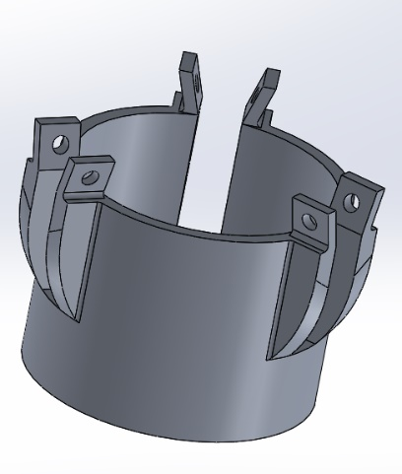
Cylinder
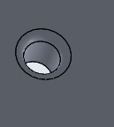
The cylinder was deemed non-essential, although it has an important function. Three rivets are used to connect the jaws, and four bolts are required to hold the cylinder in place with the motor. As previously stated, rivets and bolts are targets to be designed out which leaves some room for design modification. The updated design removes the need for rivets to join the cylinder and the joins by employing a snap and fit design letting the updated jaw click into place, making it a one-step assembly part. An easy slide fit is required for these joints to allow unhindered movement and minimum friction whilst preforming at moderate running speeds.
A taper has been added to the centre hole to allow ease of alignment for the drive shaft/worm.
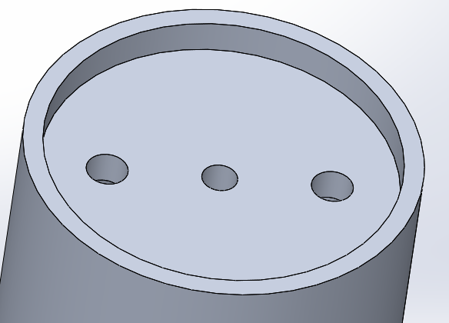
Using two bolts to secure the cylinder to the motor are now required, rather than the original four, and are now the only two bolts/rivets required for this part.
This component can be manufactured out of steel, aluminium or polycarbonate.

Jaws
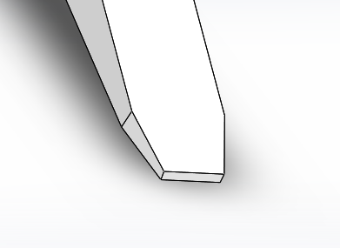
The initial modification to the jaws was to narrow the tips. This was done due to the high RPN given to the component regarding the tips not meeting. A narrower tip lets the gripper pick up smaller items as they have less room to slip out.
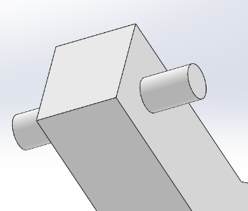
The sharp edge has been removed to increase handling efficiency.
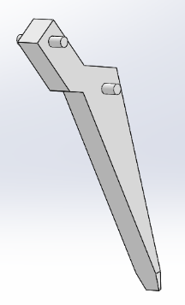
A pin has permanently replaced the hole used for the rivet allowing a snap and fit connection with the cylinder, requiring an easy slide fit removing the need for rivets. The hole used to fasten the jaw to the joins has also been replaced with a pin with snap and fit fitting, allowing the joins to slide into place once fastened to the drive plate.
The jaws can be manufactured out of aluminium, steel, or polycarbonate.
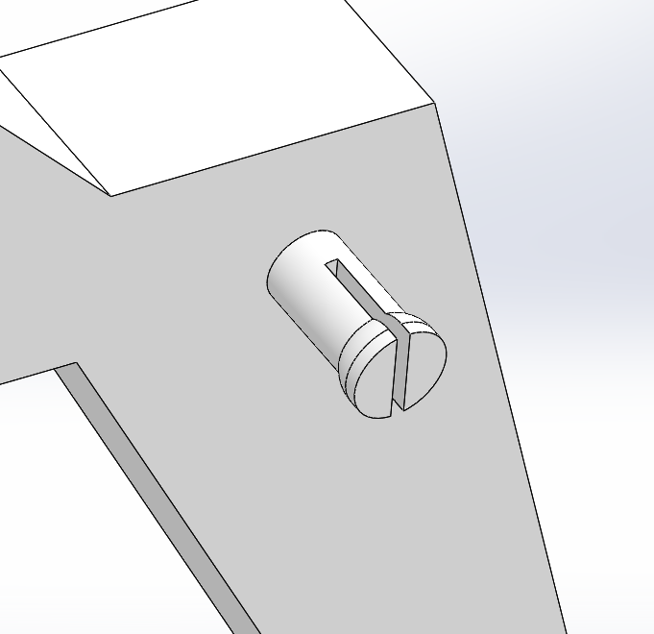

Drive Plate
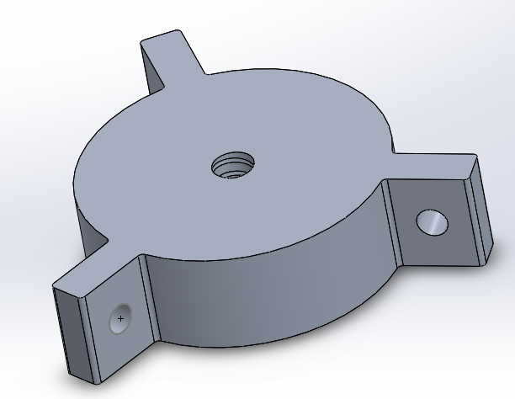
The drive plate has been modified with the diameter has been narrowed and the connection brackets moved from on top to the sides, this is where the joins will be fastened.
Again, an easy running fit is required for these joints.
The bore is to be machined to a running fit relative to the worm comfortably allowing for moderate running speeds without excess friction.
With the worm being manufactured out of steel for durability, the coefficient of friction is an important factor highlighted by a high RPN from the DMFEA, therefore this component can be made from either aluminium or steel. The frictional coefficient whilst sliding (kinetic) for aluminium and steel is μ0.47 whilst for steel on steel is μ0.42.
(EngineeringToolBox, 2004)

Joins
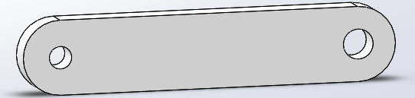
The joins have remained virtually the same, the only change being the size of the bore is now slightly smaller to coincide with the size of the pins located on the new jaws. One rivet is required to fasten the join to the drive plate, which will hold them in place allowing the pin located on the jaw to slide in easily.
The clearance required between the joins, jaws and drive plate is again an easy slide fit.
The joins can be made from aluminium, steel, or polycarbonate.

- Analysis of new design
The Lucas methods is again used to appraise the design to compare with the original design.
New Design Efficiency
Part | Essential - A | Non-Essential - B
Motor | ü
Drive Plate | ü
Worm/Drive Shaft | ü
Jaws (X3) | ü
Cylinder |  | ü
Joins (X3) | ü
Bolts/Rivets (X5) |  | ü
Updated design efficiency = 9 / (9+6) = 0.6 x 100 = 60%.
With a general efficiency goal of >60% as a rule of thumb, the improvement of 22% has met this goal, although there still is room for improvement. (Stienstra, 2020)
Handling Index
Part | A | B | C | D | Total
Motor | 1 | 0 | 0.1 | 0 | 1.1
Drive Plate | 1 | 0 | 0 | 0 | 1
Jaws | 1 | 0 | 0.1 | 0.2 | 1.3
Cylinder | 1 | 0 | 0.1 | 0 | 1.1
Drive Shaft/Worm | 1 | 0 | 0 | 0 | 1
Joins | 1 | 0 | 0 | 0 | 1
Bolts/Rivets | 1 | 0 | 0.1 | 0 | 1.1

Originally the Jaws had the highest handling index of 1.6, and after the redesign this has reduced to 1.3. This small improvement was done by simply removing the sharp edges from the design. The drive plate and worm/drive shaft have also improved by 0.1.

Fitting Index
Part | A | B | C | D | E | F | Total
Motor | 1 | 0 | 0 | 0 | 0 | 0 | 1
Drive Plate | 6 | 0 | 0 | 0 | 0 | 0 | 6
Jaws | 1.3 | 0 | 0.7 | 0 | 0 | 0 | 2
Cylinder | 6 | 0 | 0 | 0 | 0 | 0 | 6
Drive Shaft/Worm | 1 | 0 | 0 | 0 | 0 | 0 | 1
Joins | 6 | 0.1 | 0.7 | 0 | 0 | 0 | 6.8
Bolts/Rivets | 6 | 0.1 | 0.7 | 0 | 0 | 0 | 6.8
The fitting index also show improvement of the design. The jaws have had the biggest reduction from 7.4 to 2. This is due to the snap and fit connections replacing the need for rivets to connect to the cylinder.
The drive shaft/worm have improved by 1.5 due to insertion being less restricted with the component being longer.
The joins are now easier to align, with one side now sliding onto the drive plate, lowering its score by 0.7.
The rivets no longer needing to be fastened to the drive plate have lowered their score by 1.5 as access is no longer restricted.
Updated DMFEA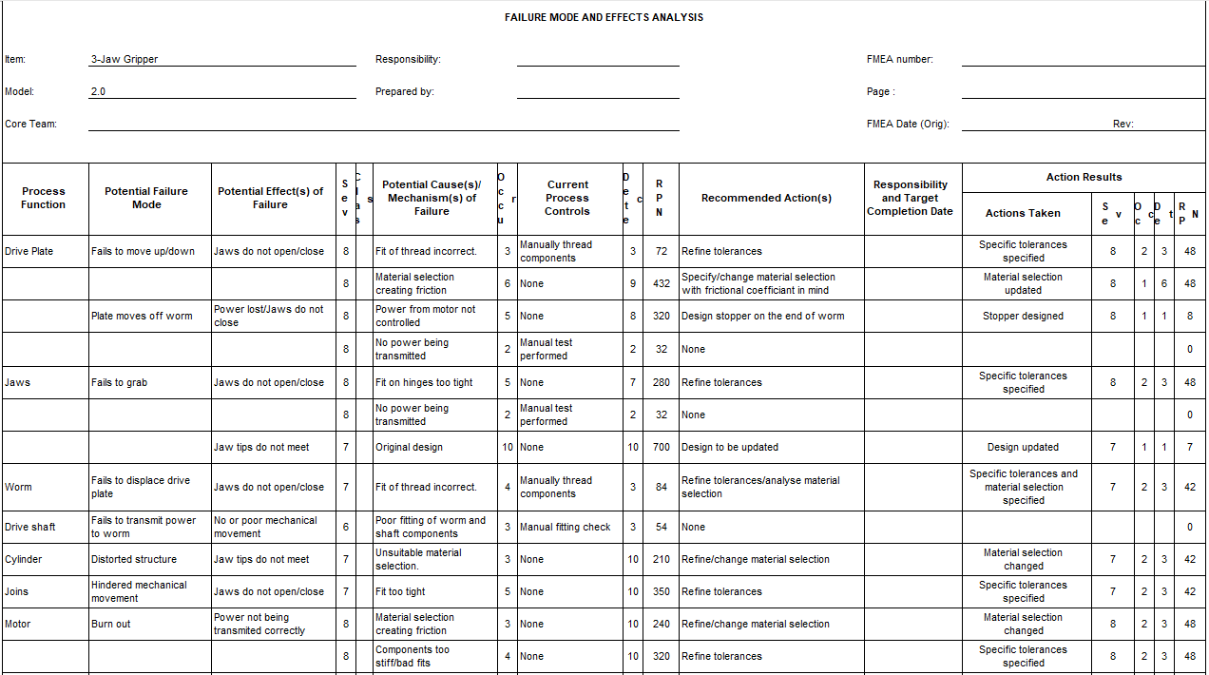

The updated DMFEA indicates the actions taken to lower the RPN of the failures identified. As shown there has been a dramatic drop in all the risks that were originally highlighted, showing improvement in design in all areas.

- Manufacture Process Proposal

Assembly Flowchart

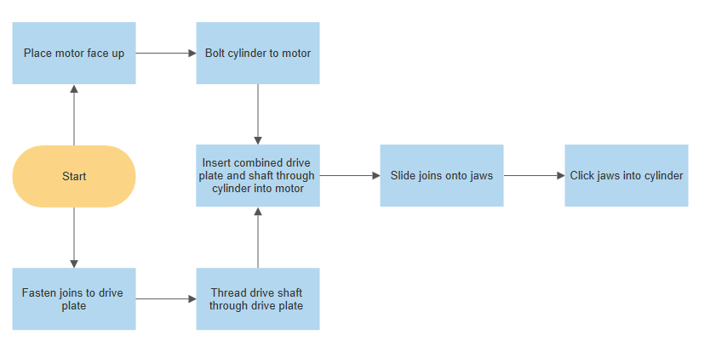

Poka-Yoke Measures Taken
A way of error proofing a design is to use Poka-Yoke. Applied by Shigeo Shingo in the 1960’s, Poka-Yoke is a mechanism that will help prevent human errors. Its aim is to prevent, correct or draw attention to errors as they occur. (Robinson, 1997)
Cylinder – Only one orientation available.
Drive Plate – Symmetrical design makes correct orientation unavoidable
Joins – Symmetrical design
Drive Shaft – Can only be inserted in one direction. Tapered hole through cylinder aids with alignment
Jaws – Potential to be inserted facing the wrong way. Easily spotted and rectified.

Manufacture
Joins – To be cut and machined from aluminium alloy sheet. Aluminium has been chosen for the joins due to its lightweight nature, cost effectiveness and ease of machining. It has a Young’s modulus of 69GPa, ultimate tensile strength of 110MPa and a yield strength of 95MPa showing it is strong enough to comfortably perform its actions without failing.
The sheet material will be cut using a milling operation, first with a roughing cut then with a finishing cut to finish. The holes are to be made using a drilling operation. (Engineeringtoolbox, 2003)

Cylinder – To be cast and machined in aluminium alloy by way of investment casting. Aluminium has been chosen over steel and polycarbonate. Steel, whilst very strong and versatile is relatively heavy compared to aluminium, and with polycarbonates relatively low shear modulus of 2.3GPa, distortion could become a problem if excess force is applied to the snap and fit joints.
The inside bore is to be machined by turning on a lathe, and the outside is to be machined by a combination of turning and milling, with the holes drilled. (Engineeringtoolbox, 2005)

Jaws - To be 3D printed from Polycarbonate. Polycarbonate is high strength making it fracture and impact resistant with good mechanical retention up to 140°C. With no torsion being applied to these parts they do not had the risk of shearing and as Polycarbonate is high in strength it is resistant so fracture and impact ensuring reliability and performance.
Once the 3D printing of the component is complete, the pins can be machined to their required tolerances, with a cutting operation being used define the snap and fit connections. (Specialchem, 2018)

Drive Shaft/Worm – Purchased mild steel bar stock to be machined. Mild steel has been selected as its strong, durable, and cheap. Its ease of machining and shear modulus of 78GPa its strong enough to easily perform its operation and with a low coefficient of friction of μ0.47 when sliding on aluminium it is ideal for the surface contact with the drive plate. (Engineeringtoolbox, 2005)
The rods are to be fed into a reciprocating die, where it is rolled at exceptionally high pressure between to flat dies, one of which remains stationary. (ACCU, 2020)

Drive Plate – Due to its odd shape, this component will be manufactured using additive manufacturing out of aluminium alloy. Lightweight, inexpensive and its relative ease of machining are the driving factors for this choice.
Once printed, the holes are to be drilled and the thread to be machined using a 3-axis CNC machine.
The motor is to be purchased, along with standardised bolts and rivets.

- Conclusion
Appraising the initial system using the Lucas Method of design for assembly highlighted essential and non-essential parts of the design which quickly showed me many opportunities to redesign or completely design out certain features. A design efficiency of 38% was calculated showing how much improvement was needed to match the industry standard efficiency goal of >60%. Several potential failure modes were highlighted by using the FMEA steering me to areas needed for improvement.
Updating the design lowered the number of components from 24 to 16. This was accomplished by designing out the need for 8 fasteners by using snap and fit connections and completely removing one component by combining the worm and drive shaft. This increased the design efficiency to 60% which was the lower end of the goal.
The potential failure modes were greatly reduced with modifications such as specifying tolerances and selecting materials with their properties such as strength, shear modulus and coefficient of friction in mind.
Poka-yoke was employed during the design reducing the handling and fitting matrix’ and with an assembly flowchart showed an improvement in ease of assembly.
The material selection for each component and manufacture proposal gave a balance of cost, ease of manufacture, recyclability, and production time.
Having the appraisal methods used showing a significant improvement with the updated design over the original I am relatively happy overall, however there is room for improvement. Non-essential parts can still be identified and therefore targeted to be designed out, which in turn will lead to increasing the efficiency to over 60%.

- Bibliography
^ Robinson, Harry (1997). "Using Poka-Yoke Techniques for Early Defect Detection". Archived from the original on December 27, 2014. Retrieved May 4, 2009.
Chan, V. and Salustri, F., 2013. DFA The Lucas Method | Database Index | Gear | Free 30-Day Trial | Scribd. [online] Scribd. Available at: <https://www.scribd.com/document/285893812/DFA-the-Lucas-Method> [Accessed 10 June 2020].
Montgomery, C., 2019. What Is DFMEA?. [online] Ansys.com. Available at: <https://www.ansys.com/blog/what-is-dfmea> [Accessed 18 June 2020].
Bishop, M., 2017. The Cost And Performance Benefits Of Switching From Metal To Plastic Parts | Manufacturingtomorrow. [online] Manufacturingtomorrow.com. Available at: <https://www.manufacturingtomorrow.com/article/2018/11/the-cost-and-performance-benefits-of-switching-from-metal-to-plastic-parts/12494> [Accessed 18 June 2020].
Remchem.com. 2020. Surface Finishing For Metal Additive Manufacturing Applications. [online] Available at: <https://www.remchem.com/industries/additive-manufacturing/> [Accessed 19 June 2020].
Engineering ToolBox, (2005). Modulus of Rigidity. [online] Available at: https://www.engineeringtoolbox.com/modulus-rigidity-d_946.html [Accessed 13 June 2020].
Engineering ToolBox, (2004). Friction and Friction Coefficients. [online] Available at: https://www.engineeringtoolbox.com/friction-coefficients-d_778.html [13 June 2020].
Stienstra, D., 2020. Introduction To Design For (Cost Effective) Assembly And Manufacturing. [online] Me.gatech.edu. Available at: <http://me.gatech.edu/files/capstone/L071ME4182DFA> [Accessed 14 June 2020].
Engineering ToolBox, (2003). Young's Modulus - Tensile and Yield Strength for common Materials. [online] Available at: https://www.engineeringtoolbox.com/young-modulus-d_417.html [Accessed Day Mo. Year].
Specialchem, 2018. Polycarbonate (PC) Plastic: Properties, Uses, & Structure - Guide. [online] Omnexus.specialchem.com. Available at: <https://omnexus.specialchem.com/selection-guide/polycarbonate-pc-plastic> [Accessed 17 June 2020].
ACCU, 2020. How Is A Machine Screw Made? | Accu®. [online] Accu.co.uk. Available at: <https://www.accu.co.uk/en/p/105-how-is-a-machine-screw-made> [Accessed 20 June 2020].

