Manufacturing Casting Processes
University of Wales Trinity Saint David
School of Engineering
Mechanical Engineering
James Gregory
P148409
26/02/2018
Materials and Introduction to Manufacturing
R Alexander

Table of Contents
1 Introduction 1
1.1 Objectives 1
2 Background Research 2
3 Results 7
4 Analysis 13
5 Conclusion 15
6 References 16

Figure 1: Fineblanking Process (Google) 2
Figure 2: High Pressure Die Casting Process (CES EduPack 2015) 4
Figure 3: Sand Casting Process (CES EduPack 2015) 5
Figure 4: Close Die Forging Process (CES EduPack 2015) 6
Figure 5: Graph One 7
Figure 6: Graph Two 8
Figure 7: Graph Three 9
Figure 8: Graph Four 10
Figure 9: Graph Five 11
Figure 10: Graph Six 12

Introduction
For this assignment, I have been asked to investigate into three different casting methods as well as a material of my choosing that will be suitable for a company making large batch of cogs as part of the rear cassette gearing system of a bike.

Objectives
Research into how bike cogs are currently made and their material properties.
Research the advantages and disadvantages of the process that is used to make bike cogs.
Research into different casting methods such as sand casting, gravity die casting, investment casting, forging, blanking or polymer injection moulding.
Research the advantages and disadvantages of the three manufacturing processes that I have chosen.
Using the CES package analyse the processes and materials.
Select a suitable process and material with CES results included.

Background Research
A sprocket or cog is a toothed wheel that has the responsibility of providing drive to a bicycle. In a more depth explanation, the mechanism provides transmission of rotary motion between two shafts, so therefore the strength and wear resistance of the material must be of upmost importance when considering the physical properties of this product. The current material required to produce sprockets is medium carbon steel (S50C), however, low carbon steel (SS400) could also be used in future sprockets as it can reduce material cost as well as production time. The process which is used to produce a sprocket is fine-blanking and hobbing (Thipprakmas, 2011).
Advantages:
Fine-blanking has the ability of producing flatness on many parts whereas other processes such as milling machines, drill presses or lathes cannot do this. The process has very good dimension accuracy which can give it the capability of producing cleanly trimmed edges. Many metals can be used to make parts from this process such as aluminium, steel, lead, zinc etc., and heavy metals 16 mm (0.016 m) thick can also be used. Parts can be made relatively quick cutting down production time, and other processes, such as, coining and embossing can also be used in the process (Hedrick, 2006).
Disadvantages:
Fine-blanking requires premium tools with coatings or carbide as the process can cause severe tool wear and because of this it would not be very cost effective as the tools would need replacing regularly (Hedrick, 2006). The process is generally slower than traditional punching operations, such as, piercing, notching and trimming (Engineers Edge , n.d.).
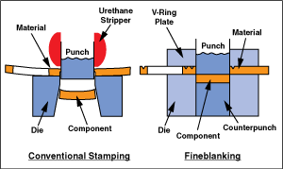

Figure 1: Fine-blanking Process (Google)
In the engineering industry when it comes to producing metal or alloy parts there is no better process than casting. Companies use this method because they can produce very accurate parts at a rapid pace and it is a very cost-effective process. Many parts can be difficult or almost impossible to machine and manufacture and therefore casting comes in handy. However, the process does have its limitations as it cannot produce many types of machined parts due to materials, size, shape, and other physical properties. In industry today, various types of casting processes are used to suit the consumer’s needs. Examples of these casting methods are; die casting, sand casting, investment casting, shell casting, ceramic-mould casting etc (Walsh & Denis, 2005).
The three manufacturing processes that I have chosen to investigate are high pressure die casting, sand casting, and closed die forging.
High Pressure Die Casting (HPDC)
Advantages:
When producing a large quantity of parts in one time the process can become cost-effective. For non-ferrous metals such as aluminium, lead, magnesium, zinc and brass, this process fits well with these materials as they each have a low melting point. The consistency of this process is very high and it can produce an excellent standard of parts consistently (ChinaSavvy, n.d.). The process can produce parts to a high dimensional tolerance, it can produce complex shapes and the dies are very rarely changed which means high production volume (Walsh & Denis, 2005). Once the part has been made it reduces the need to use secondary machining (First-rate Mold Solution Co., Ltd. Team, 2009).
Disadvantages:
For the process to work the weight of the casting must be between 30 g and 10 kg and the size must be smaller than 600 mm (0.6m). To make this process an economical option a larger production volume is needed (First-rate Mold Solution Co., Ltd. Team, 2009). Die castings cannot be welded or heat treated and should not be machined at all after it has been produced, and the tooling cost for this process is expensive (Campbell, 2011). The process is limited to using materials which have melting points no higher than 1,085 °C. When producing complex shapes air entrapment and porosity can occur (Walsh & Denis, 2005).
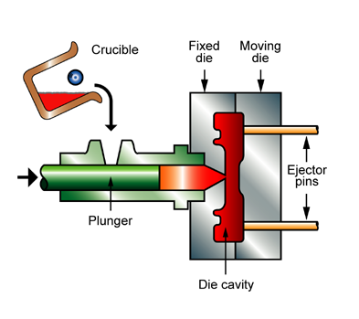

Figure 2: High Pressure Die Casting Process (CES EduPack 2015)

Sand Casting
Advantages:
Compared to other processes sand casting is the most basic and widely used method in the casting industry. The process can be very flexible when it comes to various designs of different complexity. It provides a good surface finish with fine sand and it is used often in the automobile industry to produce crankcases and cylinder heads (Beddoes & Bibby, 1999). As this process requires minimum tooling the cost to produce is cheap. It has a high production rate and can produce casts at a rapid speed. The process can adapt to various designs with different size, weight, shape and material (Olsen, 2017). Compared to other processes sand casting is the least expensive one to use to produce a part (Walsh & Denis, 2005).
Disadvantages:
A secondary machining operation is usually needed after a part has been casted (Walsh & Denis, 2005). It produces a poor dimensional accuracy and frequently provides a rougher surface finish than other processes (Olsen, 2017). Due to the compact of the sand around the mould it can cause materials, such as, wood and plastics to wear away causing it to bend or twist out of shape and because of this it limits reusability; Solid patterns, due to their complexity of how their made are only produce at low amounts (Groover, 2010).

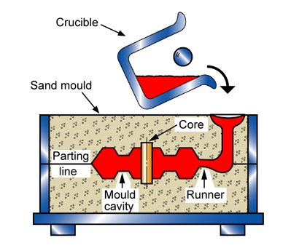

Figure 3: Sand Casting Process (CES EduPack 2015)

Closed Die Forging:
Advantages:
Closed die forging is an appropriate process to produce complex shapes (Beddoes & Bibby, 1999). Parts that have been forged possess better physical properties such as; high ductility and high resistance to impact or fatigue. The process requires minimal labour and materials and due to the process being relatively quick it saves a lot of time compared to cutting and shaping. The process has a high work rate and very good reliability when making parts meaning that mistakes are rarely found. Reasonable accuracy can be implemented on parts as well as easy welding when parts have been forged (Mechanical Engineering , 2017).
Disadvantages:
When forging metals at high temperatures rapid oxidation occurs which results in scaling which wears the dies. High tolerances are hard to achieve. This process can only work with a selection of materials such as aluminium, carbon steel, titanium, alloy steel etc. The initial cost of forging can be high due to the maintenance of the process and the replacement of forging dies. If the materials are worked under a certain temperature they can become damaged or their properties can be change (Mechanical Engineering , 2017). Closed die forging does need close attention to the die design and work piece in case excessive pressure causes the part to fracture when filling the forge cavity. Often the operation cannot forge round or square ingots into complex shapes and because of this extra machining is needed (Beddoes & Bibby, 1999).

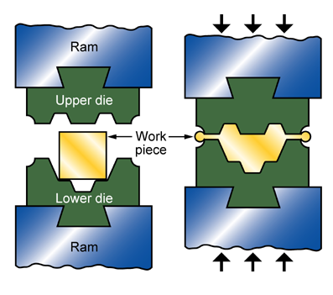

Figure 4: Close Die Forging Process (CES EduPack 2015)

Results
Using the CES EduPack 2015 software I created six graphs, three of them which represent different casting processes and particular areas of them processes and the other three on materials and their properties.
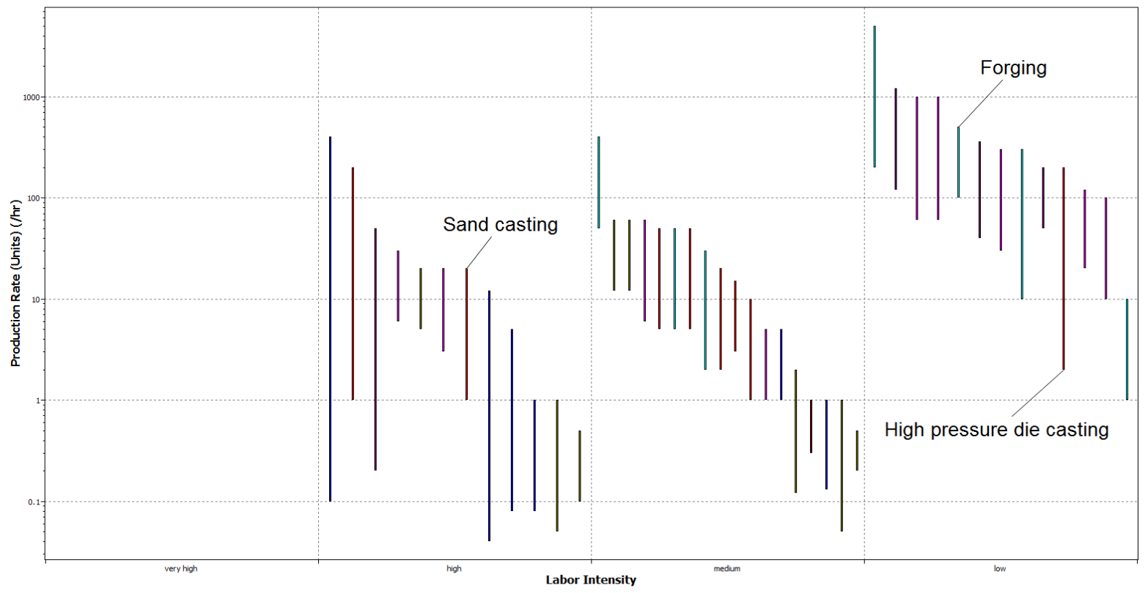
Below is a graph which shows a comparison between production rates against labour intensity. Production rate is how many units a process can produce per hour and labour intensity refers to the amount of people required to produce products or services. The graph reveals that high pressure die casting has the lowest labour intensity, however, the process has one of the highest production rates of 2 up to 200 units per hour. Closed die forging also has a low labour intensity but the process has the highest production rate of 100 up to 500 units per hour. Sand casting has the highest labour intensity, but has the lowest production rate of 1 up to 20 units per hour.
Figure 5: Graph One

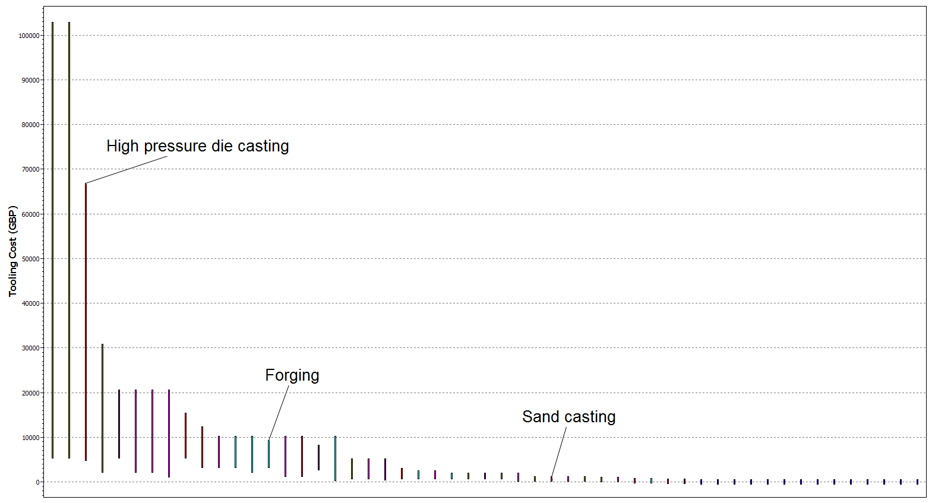
The second graph below represents the tooling cost for each process. Tooling cost is the amount it costs to purchase the tools that are required for a specific manufacturing process. From the graph, it illustrates that sand casting has the lowest tooling cost of £100 up to £1,030, then closed die forging with a more expensive cost of £3,090 up to £9,260 and finally high pressure die casting with the highest tooling cost of £4,630 up to £66,900.
Figure 6: Graph Two

The final graph below represents the tolerance for each casting process; a tolerance is a range of how far a measurement can stay true from its intended value. For example, if a gear needs to be 0.85 mm diameter, then the tolerance can be plus or minus .005 mm. This would make it an acceptable range for the gear diameter to be between the range of 0.845 mm and 0.855 mm. Looking at the graph, it demonstrates that high pressure die casting has the tightest tolerance of 0.15 mm to 0.5 mm, then closed die forging with a slightly larger tolerance of 0.2 mm to 1 mm and finally sand casting with the largest tolerance of 0.8 mm to 3 mm.

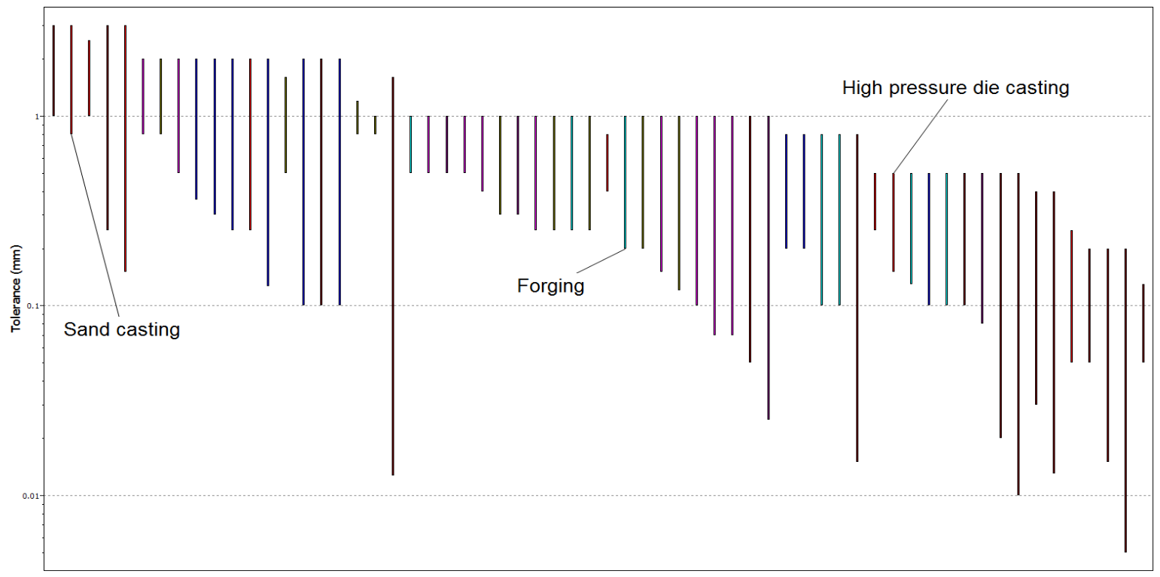
Figure 7: Graph Three

The materials selected for this experiment were aluminium, titanium and stainless steel. The reason why these metals were chosen was because they are the most common materials to be used in making sprockets and because they are non-ferrous metals; they have an advantage of being used in a variety of casting processes.
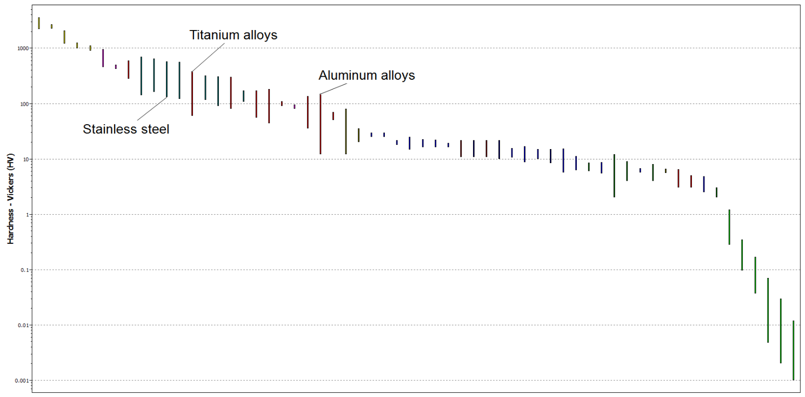
The graph below represents the hardness of each material; the hardness of a sprocket is a very important physical property as it affects the wear resistance of the sprocket, the harder the material the longer it will last. The graph shows that aluminium alloys have the lowest hardness of 12 HV up to 151 HV, then titanium alloys with a hardness of 60 HV up to 380 HV, and finally, stainless steel with the highest hardness of 130 HV up to 570 HV.
Figure 8: Graph Four

Below is another graph which shows the fracture toughness of each material. This physical property is also important when producing a sprocket as it needs to be able to resist fracture when a force is applied to it. For example, when a bike hits the floor from a jump. From the graph, it illustrates that aluminium alloys have the lowest fracture of 22 MPa up to 35 MPa, titanium alloys have a higher fracture toughness of 14 MPa up to 120 MPa and finally, stainless steel has this highest fracture toughness of around 62 MPa up to 150 MPa.

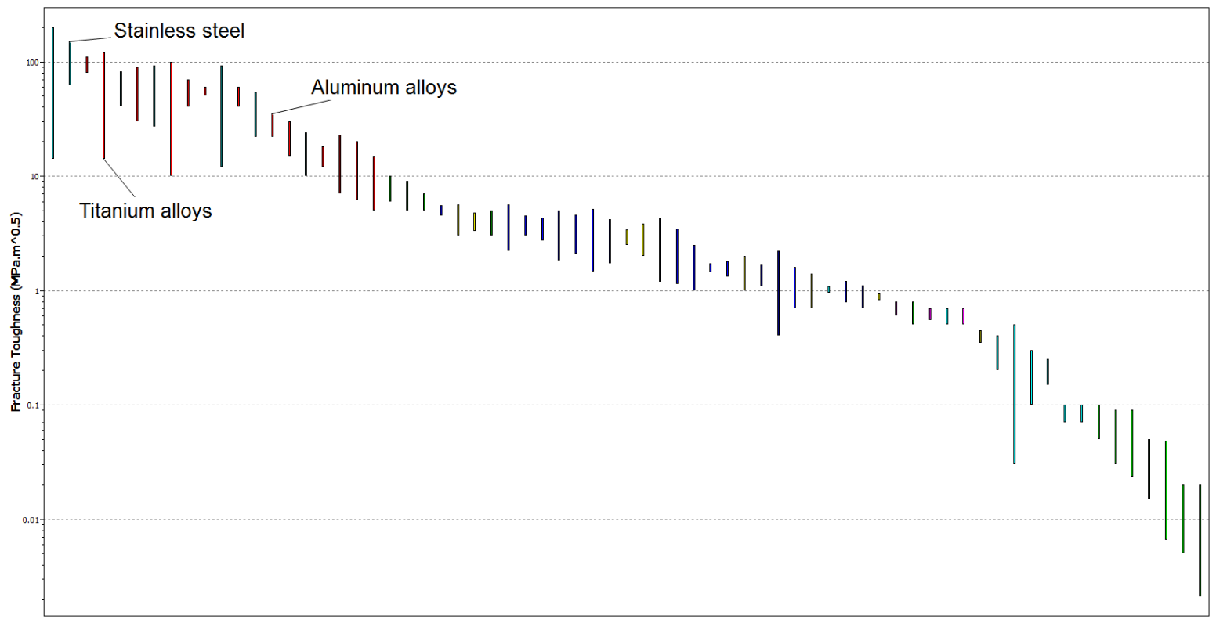
Figure 9: Graph Five
The final graph below represents the price of each material per kilogram (kg). This is important to take into consideration because some materials can cost more than producing the product itself so it is vital to choose a material within budget and that is suitable for the product. From the graph, it shows that aluminium alloys have the lowest price per kg of £1.32 up to £1.46, stainless steel has price per kg of £3.69 up to £4.07 and titanium has the highest price per kg of £13.90 up to £15.40.

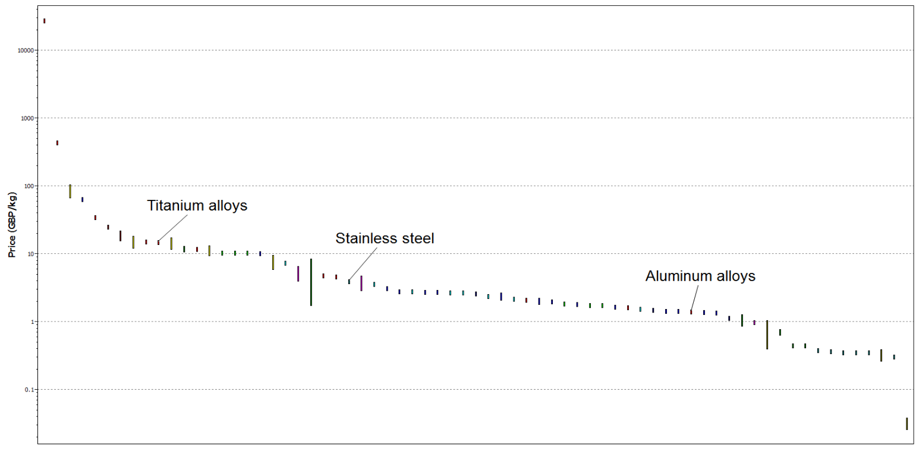
Figure 10: Graph Six

Analysis

By analysing the CES graphs above we can find out which casting process and material will be best to use for producing a sprocket. This will be done by finding out the pros and cons.
Casting processes;
Closed die forging has a low labour intensity meaning that it requires very little need for staff to work or maintain the process, this would make it cost-effective as less would be spent on salaries. Also, the sprockets will be produced to a high accuracy and very little errors will be made. The process has highest production rate per hour out of the three processes, which would make it suitable for producing sprockets in large batches. The downside to this process is that the tools used in this process are quite expensive to purchase and this could affect the cost if damaged tools need to be replaced regularly. Also, the process does not have the tightest tolerances and so secondary machining may be required to finish the product prolonging completion time.
High pressure die casting also has a low labour intensity, and a high production rate per hour, which would also be a good option to choose for producing large batches of sprockets at very good accuracy and saving money in the process. The process can work to very tight tolerances; reduces the need for secondary machining, which decreases time spent on production time. The limitation to this process is that it has the highest tooling cost which could affect the costing.
Sand casting has the lowest tooling cost which means that it would be cheap to purchase new tools. It does, however, have more limitations; the process has the highest labour intensity meaning it requires more staff to work and maintain the process. Due to this, it could lead to the sprockets being made inaccurately because of human error, which means prolonging the process to reproduce more sprockets to a better accuracy. The process has the lowest production rate per hour, indicating that it is only suitable for producing products in small batches. The process works at a large tolerance and so secondary machining will be required to complete the product.

Materials;
Aluminium alloy is the cheapest material to purchase per kg, which can be an advantage compared to other materials. It can save a lot of money in the long run for a company needing to make a product from a cheap but very strong and lightweight material. However, the material does not have the highest hardness or fracture toughness properties and because of this; it could affect how fast the sprockets wear out when they are used.
Stainless steel is more expensive per kg, which is a limitation to it being used more often as it can affect cost if you have a tight budget. However, the advantage of this material is that it has one of the highest hardness and fracture toughness properties out of any material. This means that the sprockets are going to have a longer life span and wear resistance due to the increased hardness and toughness of the material.
Titanium is the most expensive material, which could be a downside if you are on a budget and in need for a very strong material. Just like stainless steel, titanium also has a high hardness and fracture toughness properties and therefore, it might be a good option to choose if you want the sprocket to have much longer life span and very little wear resistance.

Conclusion

From the results and analysis gathered I have decided to choose high pressure die casting (HPDC) to produce a bicycle sprocket. The reason this process was picked is because it has a very high production rate of up to 200 units per hour, which would be a sufficient production rate to produce a large batch of sprockets. The process also has a low labour force which means that it would be a cost-effective method as there would be no need to pay employees. The consistency of this process is very high and it can produce an excellent standard of parts consistently even when it needs to produce complex shapes. It can work at very tight tolerances of 0.15 mm to 0.5 mm, which means that it eliminates the need for secondary operations like machining. The downside of this process is that it does have a very high tooling cost if there is a need for new tools or replacing them.
The material which I have decided to pick is aluminium alloy. The reason why I picked this material is because it fits in well with the HPDC process compared to stainless steel or titanium. It costs the lowest per kilogram of only £1.32 up to £1.46 which means that it is a very cost-effective material to use. Even though the material does not have the highest hardness and fracture toughness compared to the other two materials, the values of both properties are generally very high.

References
Beddoes, J. & Bibby, M. J., 1999. Principles of Metal Manufacturing Processes. s.l.:Butterworth-Heinemann.
Campbell, J., 2011. Complete Casting Handbook. 1st ed. s.l.:Elsevier Ltd.
ChinaSavvy, n.d. Pros and Cons of different types of Casting Processes. [Online]
Available at: https://www.chinasavvy.com/pros-and-cons-of-casting-processes
[Accessed 01 02 2018].
Engineers Edge , n.d. Fine Blanking Manufacturing Review. [Online]
Available at: https://www.engineersedge.com/manufacturing/fineblanking.htm
[Accessed 16 02 2018].
First-rate Mold Solution Co., Ltd. Team, 2009. Advantages and disadvantages of die casting. [Online]
Available at: http://www.firstratemold.com/about-us/c19-news/advantages-and-disadvantages-of-die-casting/
[Accessed 01 02 2018].
Groover, M. P., 2010. Principles of Modern Manufacturing. 4th ed. s.l.:John Wiley & Sons.
Hedrick, A., 2006. Die Science: The process of fineblanking. [Online]
Available at: https://www.thefabricator.com/article/stamping/the-process-of-fineblanking
[Accessed 04 02 2018].
Mechanical Engineering , 2017. Advantages and Disadvantages of Forging. [Online]
Available at: https://pursuitengineering.blogspot.co.uk/2017/01/advantages-and-disadvantages-of-forging.html
[Accessed 08 02 2018].
Olsen, D., 2017. Sand Casting Process: Advantages and Limitations. [Online]
Available at: http://marketing.metaltek.com/smart-blog/sand_casting_process_advantages_and_limitations
[Accessed 02 02 2018].
Thipprakmas, S., 2011. Improving wear resistance of sprocket parts using a fine-blanking process. Wear , 271(9-10), p. 6.
Walsh, R. A. & Denis, C., 2005. McGraw-Hill Machining and Metalworking Handbook. 3rd ed. s.l.:McGraw-Hill Companies.

