University of Wales Trinity Saint David
London Campus



Assignment 1
Programme: BA Business Management
Module: Strategic Management and Sustainability
Module Code: LCBB6004
Lecture: Mr. Riaz Bhatti
Student: Zamsa Dan ( 2028094 )

Table of Contents
Introduction 3
Identify with evidence the key business and corporate strategies of the company 3
Identify with evidence the resources and capabilities of the HSBC 4
Analysis the company implementation about selected business and corporate strategies 6
Evaluate evidence how the selected company has tried to become more competitive in sustainability and the environment 7
Evaluate the choices available for the HSBC Company’s strategic direction in the future 8
Suggestions for Using Sustainability Practices to Gain Competitive Advantages 9
Conclusion 10
References 12
Appendix 15

Introduction
A significant global bank, HSBC, has matched its corporate and commercial strategy with the strategic alignment of its assets in order and capabilities. The bank's technological systems, wide product offering, talented personnel, global network, and competence in managing risks have all been crucial in its successful strategy implementation. HSBC's goal of global growth and outstanding client service in multiple countries is supported by its vast network of stores as well as ATMs, as well as its global presence (HSBC, 2022). HSBC have wide range of products, the bank can meet a wide range of customer requirements, which strengthens its client-centric strategy and encourages loyalty among its clients. In the end least, HSBC's capacity to draw in, nurture, and keep talent puts the company in an opinion to reinvent and adjust with shifts in the market, which helps it carry out its plans successfully.

Identify with evidence the key business and corporate strategies of the company
As a major international bank, HSBC has implemented important business and corporate approaches to manage its rivals and take into account the forces by using Porter’s Five Forces framework.
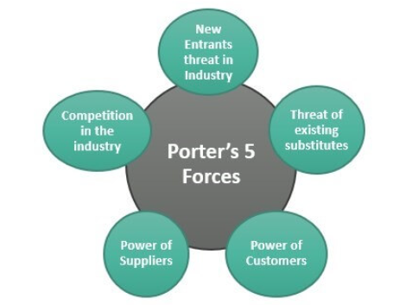
Figure 1: Porters five forces
(Sources: Martinez-Contreras et al., 2022)
Rivalry between Current Competitors: HSBC competes in a highly volatile banking market with several well-established firms. HSBC has concentrated on cost-effectiveness and service differentiation in order to remain successful. In order to boost the client experience, cut expenses, and simplify processes, the bank, for instance, invested in technological innovations (Oi et al., 2023).
Danger of New Competitors: Regulations, economies of magnitude, and high capital needs all work against new players entering the financial services sector. Due to HSBC's wide branch as well as ATM network as well as global reach, it is difficult for startups to get traction.
Purchasing Influence of Suppliers: Within the finance sector, vendors may include software vendors, authorities, and even highly qualified individuals. Building solid connections with partners is a key component of HSBC's plans, especially when it comes to technologies and regulation (Vial et al., 2022). By accomplishing this, the lending institution can guarantee compliance with laws and regulations, acquire utilization of modern technology, and weaken the negotiating position of its suppliers.
Customer Bargaining Power: The banking sector has developed, placing an increasing focus on the needs of its customers. HSBC's approach entails making investments in customer service, providing personalized banking events, and customizing its offerings to match the demands of its clients. HSBC cultivates relationship loyalty and lessens customer negotiating power by offering exceptional service and alternatives.
Threat of Substitutes: Even if peer-to-peer lending networks and financial technology companies might provide alternatives to conventional banking offerings, HSBC has countered this danger with its digital shift. The bank has successfully competed with these alternatives by creating websites, banking mobile apps, and additional digital solutions (Qadeer et al., 2022).
In addition, to reduce the different regulatory as well as reputational risks connected to the sector, HSBC has implemented an overall approach centered on risk administration and regulation. This strategy is in line with the competitive conditions of the banking sector, which include the need to handle legal challenges, legal risks, and the possibility of damage to the bank's name. In addition, HSBC has integrated environmental and ESG concepts into its overall business plan to tackle economic and socioeconomic issues. This strategy not only puts the institution in a place to handle brand and legal hazards related to sustainable ethical banking practices, but it also fits with evolving client expectations.

Identify with evidence the resources and capabilities of the HSBC
One of the biggest and most internationally varied banks in the world, HSBC has a plethora of assets and skills that have bolstered its standing in the field of finance.
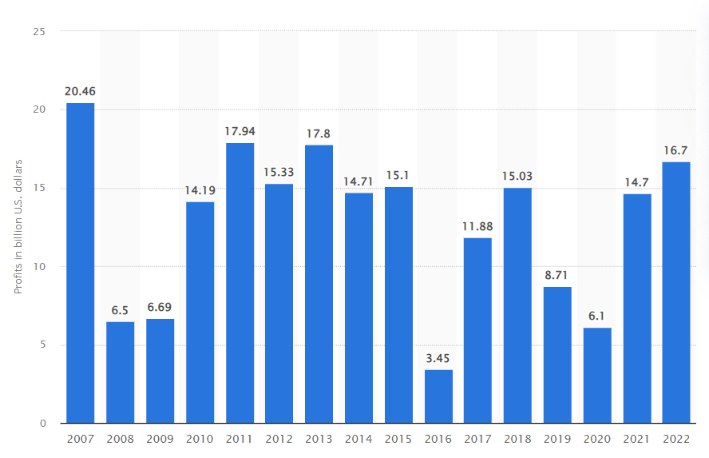
Figure 2: Profit on HSBC
(Source: statista, 2022)
Worldwide Network and Existence: One of HSBC's most notable advantages is its vast international reach. The bank is ideally situated to service business and retail clients globally, with activities across over 60 nations and territories (Balian, 2022).
Reputation and Brand Equity: HSBC is known for its reliability and equilibrium, and it has a powerful brand. The bank's continuing strong brand is demonstrated by its long history, which dates from 1865, and its steady ranking as the biggest banking institution in the world. This reputation draws clients and investors, making it an invaluable intellectual asset.
Infrastructure Technological: Because of significant investments made in its technology facilities, HSBC can provide a variety of electronic banking services. The bank has worked to improve both its mobile and desktop banking services, giving users quick and easy methods to handle their money.
Skill in Risk Management: With all the legal and economic dangers that come with being in the banking business, the bank's strong risk control capacities are essential (Tang, 2023). Compared to some of its competitors, HSBC has a history of navigating through the worldwide financial crisis mostly unscathed, demonstrating its capacity to effectively mitigate risk.
Wide Range of Products: Retail and business finance, wealth administration, management of assets, and reinsurance solutions are all part of HSBC's product offering. Because of its varied portfolio, the bank can serve financial services.
Ability and Proficiency: The personnel at HSBC is an invaluable asset, consisting of proficient experts across multiple fields. The bank serves as one of the largest firms in the financial services industry globally, demonstrating its capacity to draw and hold talent.
Capital Financial: HSBC's annual sales were in the tens of billions of dollars, illustrating the bank's enormous financial strength. With this sum of money, the bank has the stability it needs to invest in expansion prospects and survive economic downturns and booms (Odom and Hyams-Ssekasi, 2022).
Governance and Compliance with Regulations: HSBC has put in place strong compliance and management systems. This is demonstrated by the numerous regulatory licenses and permits it possesses from various countries, which demonstrate its dedication to upholding regulatory standards.

Analysis the company implementation about selected business and corporate strategies
In order to meet strategic goals and stay viable in the international banking sector, HSBC has shown that its assets and expertise are significantly aligned with its present operation and corporate initiatives.
Worldwide Development and Network Usage:
HSBC's worldwide growth is one of its main business strategies. The bank's global reach and wide-ranging network complement this approach flawlessly. It can efficiently service clients in a wide range of geographic areas thanks to its extensive network of subdivisions, ATMs, and online channels. HSBC offers both retail and business financial products and services, leveraging its worldwide reach to tap into numerous markets (Arlett et al., 2022). The bank's capacity to adjust to and satisfy the particular needs of clients in various locations is indicative of this congruence.
Technological Structure and Digital Transformation:
HSBC's technological structure provides strong support for the bank's dedication to its digital evolution. The bank has made significant investments in digital infrastructure, which enable it to offer a wide range of financial services. In order to meet the evolving needs of consumers who are calling for more digital options, this synergy is essential. Additionally, it boosts the efficiency of operations and keeps HSBC viable in the rapidly changing digital banking market.
Risk Control and Adherence to Regulations:
HSBC's approach to mitigating legal, monetary, and public image hazards is precisely aligned with its compliance with laws and regulations and risk-handling capabilities. The bank's history of successfully handling challenging regulatory contexts demonstrates this synergy (Moreno et al., 2022). The capacity of HSBC to recognize, evaluate, and control risks is essential to its long-term viability.
A Broad Range of Products and a Customer-First Focus:
HSBC's broad range of skills enables it to implement an approach that emphasizes customers and offers a comprehensive product line. The bank can provide a range of financial goods and services to meet the needs of diverse customer categories, including individuals and worldwide enterprises. This match is a reflection of HSBC's dedication to meeting the wide range of desires of its clients, which in turn promotes client loyalty.
Talent and Expertise: HSBC's approach to retaining talented and varied staff is in line with its capacity to draw in, develop, and hold on to top talent. The bank can more effectively utilize the understanding and experience of its staff thanks to this synergy, which aids in the formulation and execution of its plans (Odom and Hyams-Ssekasi, 2022).

Evaluate evidence how the selected company has tried to become more competitive in sustainability and the environment
Notable efforts have been made by HSBC to improve its competitive position while taking sustainable and the natural world into account.
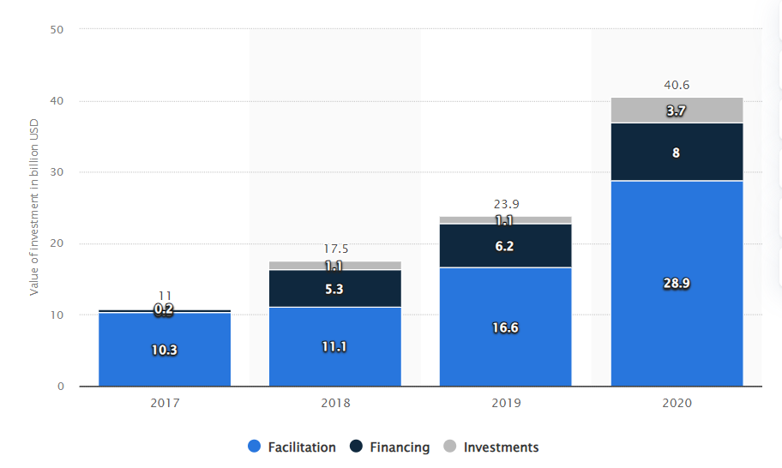
Figure 3: Sustainable finance investment
(Source: statista, 2022)
Initiatives for Sustainability: In order to integrate sustainably into its company's operations, HSBC has made considerable progress. The bank has promised to offer $100 billion in sustainable investment and lending by 2025 and is dedicated to making its activities carbon-neutral by 2030. These programs demonstrate HSBC's proactive stance in resolving environmental problems.
Ecological Funding: HSBC has demonstrated a proactive approach to green finance by endorsing initiatives that yield positive environmental outcomes. The bank's Green Finance division assists customers in obtaining funding for environment action-related initiatives (Karjaya et al., 2019). It has aided in the development of projects utilizing renewable energy, for instance, making the future more environmentally friendly and sustainable.
Integration of Governance, Social Responsibility, and the Environment (ESG): ESG considerations have been incorporated by HSBC into its lending, investing, and risk management procedures. Both hazards as well as possibilities can be identified with the aid of the lender's ESG Risk Dashboards, which offer information on the environmental, social, and governance (ESG) achievements of its clients. This integration is proof of HSBC's dedication to operating with ethical and environmentally conscious business practices in mind.
Lowering the Emission of Carbon: HSBC has established goals to lower its carbon footprint, one of which is to run all of its international operations entirely on green energy. In multiple regions, the bank was currently achieving this goal as of the year 2022. Cutting greenhouse gases can improve the competitiveness of an organization by lowering costs and supporting sustainability goals (Kapmeier et al., 2021).
Eco-Friendly Banking and Investing Solutions: HSBC provides its customers with a selection of financial instruments and financial products. These consist of ESG investments, green bonds, and financing for sustainable commerce and supply chains. By offering such items, HSBC takes a piece of the expanding green banking industry while assisting its clients in matching their financial resources or activities with their environmental goals.
Loyal Involvement: HSBC actively discusses sustainability-related concerns with a variety of customers, such as shareholders, consumers, and government departments. Responsibility and openness are demonstrated by the bank's yearly environmental report and publication of ESG-related indicators (Leclercq-Machado et al., 2022).

Evaluate the choices available for the HSBC Company’s strategic direction in the future
As a major international bank, HSBC will need to make several strategic decisions in the future, particularly about the environment.
HSBC's strategic decisions:
Expanding Sustainable Finance: HSBC has the option of strengthening its dedication to sustainable financing. This entails increasing its financing and dedication to green initiatives like sustainable agriculture, environmentally friendly buildings, and energy produced from renewable sources (Kapmeier et al., 2021). HSBC can obtain an edge over its competitors by focusing on underrepresented areas and industries with significant ecological potential to set itself apart.
Sustainability-Related Items: The bank can launch cutting-edge finance services and solutions that are connected to environmental outcomes. One way to do this would be to provide loans that lowered interest rates contingent upon the clients meeting sustainability goals. In this way, HSBC may encourage customers to embrace sustainable practices and establish a distinctive selling proposition in the financial industry.
Involvement and Reporting of Stakeholders: HSBC has the potential to improve its documentation on environmental and stakeholder involvement. HSBC can get important insights and foster confidence by actively incorporating participants in the financial institution's ecological activities, such as shareholders, clients, and non-governmental organizations (Chen and Lai, 2019). The bank can differentiate itself from rivals by showcasing its dedication to responsible banking and fiscal responsibility through more openness in reporting on sustainability initiatives.
Climate Risk Evaluation: It may be wise for them to strategically consider climatic risk assessments when making financing and investment choices. HSBC can lessen its exposure to possible losses due to the effects of climate change by assessing environmental hazards connected to different initiatives and businesses. By taking a proactive stance, the bank may improve its standing for ethical lending as well as risk management (Sivaprasad and Mathew, 2021).

Suggestions for Using Sustainability Practices to Gain Competitive Advantages

Digital transformation and innovation: HSBC should keep funding technological innovation, particularly in fields like data analytics, block chain technology, and fintech. Employing technologies can lower operating costs, improve customer satisfaction, and assist efforts toward environmentally friendly financing (Katerina, 2020). The creation of intuitive smartphone applications to monitor sustainability metrics and influence investments has the potential to draw in a fresh cohort of environmentally and socially conscious consumers.
Initiatives in Education: HSBC can lead the way. In addition to assisting customers in making educated decisions, the bank can establish itself as a sustainability innovator by offering materials, live webinars, as well as conferences on the advantages and prospects of environmentally friendly banking.
Sustainable investing Funds and Green Bonds: HSBC can draw in customers and investors who care about the surroundings by growing its selection of ecological bonds and environmentally friendly financial vehicles. Clients who value sustainability will be drawn to these investment options because they may generate profits and give them entry to environmentally favorable projects and assets (Maltais and Nykvist, 2020).
Alliances & relationships: HSBC can gain important insights and relationships by working with educational institutions, NGOs, and charitable organizations. These kinds of partnerships may offer creative projects and expertise exchanges that strengthen the bank's efforts to be sustainable and provide it with a competitive advantage.
Worldwide Headship: By actively taking part in international conferences, initiatives, and forums on sustainability, HSBC can establish itself as a pioneer in the field of sustainable finance (Chang et al., 2019) This not only demonstrates the bank's dedication that also strengthens ties with important parties, such as governments, and regulators.
Goals for conservation and the climate: HSBC bank needs to report on its success regularly and set high goals for sustainability. These goals may include cutting emissions of carbon dioxide, raising the amount of money committed to environmentally friendly funding, and developing government and social projects. HSBC's commercial standing and reputation can be improved by meeting and surpassing these goals.
Employee Motivation and Rewards: An employee body that is in line with the the financial institution's sustainability objectives can be developed by promoting environmental ideals among staff members and incorporating them into incentive payments for performance (Kumari et al., 2021). Committed and active staff members are more inclined to promote and lead initiatives that promote sustainability, which can result in improved service to clients and creative problem-solving.

Conclusion
HSBC has demonstrated strategic adeptness by aligning its extensive capabilities and resources with its corporate vision. This alignment has been pivotal in successfully implementing its strategies, with a strong emphasis on technological innovation, risk management, and customer-centricity. HSBC's global network has played a vital role in its expansion, allowing it to offer diverse products and maintain a robust brand reputation. Moving forward, the bank's focus on sustainability and environmental initiatives, coupled with strategic stakeholder engagement and digital transformation, will be critical in enhancing its competitiveness. HSBC's commitment to sustainability is not just an ethical choice but a strategic one, positioning it to meet future challenges and customer expectations in a rapidly evolving global financial landscape.

References
Arlett, P., Kjær, J., Broich, K. and Cooke, E., 2022. Real‐world evidence in EU medicines regulation: enabling use and establishing value. Clinical Pharmacology and Therapeutics, 111(1), p.21.
Balian, M.I., 2022. Reputation Risk and Reputation Risk Management: Case Study Applied on Facebook and HSBC (Doctoral dissertation, Pharos University in Alexandria).
Chang, Q., Conwell, Y., Wu, D., Guo, Y. and Yip, P.S., 2019. A study on household headship, living arrangement, and recipient of pension among the older adults in association with suicidal risks. Journal of affective disorders, 256, pp.618-626.
Chen, Y. and Lai, J., 2019, May. Information and Personal Networking in Decision-making Process: the Case of HSBC. In 2019 International Conference on Management, Education Technology and Economics (ICMETE 2019) (pp. 523-526). Atlantis Press.
HSBC, 2022, company Avaiable at: https://find-and-update.company information.service.gov.uk/company/00617987 [Accessed on 04.11.2023]
Kapmeier, F., Greenspan, A., Jones, A. and Sterman, J., 2021. Science-based analysis for climate action: how HSBC Bank uses the En-ROADS climate policy simulation. System dynamics review: the journal of the System Dynamics Society, 37(4), pp.333-352.
Kapmeier, F., Greenspan, A., Jones, A. and Sterman, J., 2021. Science-based analysis for climate action: how HSBC Bank uses the En-ROADS climate policy simulation. System dynamics review: the journal of the System Dynamics Society, 37(4), pp.333-352.
Karjaya, L.P., Satris, R. and Suspiati, S., 2019. Greenpeace, Corporations and Deforestation Crimes: A Case study of Hongkong Shanghai Bank Corporation (HSBC) in Indonesia. Jurnal Hubungan Internasional, 8(2), pp.203-214.
Katerina, T., 2020. The challenges of digital transformation in banking industry.
Kumari, K., Barkat Ali, S., Un Nisa Khan, N. and Abbas, J., 2021. Examining the role of motivation and reward in employees’ job performance through mediating effect of job satisfaction: An empirical evidence. International Journal of Organizational Leadership, 10(4), pp.401-420.
Leclercq-Machado, L., Alvarez-Risco, A., Esquerre-Botton, S., Almanza-Cruz, C., de las Mercedes Anderson-Seminario, M., Del-Aguila-Arcentales, S. and Yáñez, J.A., 2022. Effect of Corporate social responsibility on consumer satisfaction and consumer loyalty of private banking companies in Peru. Sustainability, 14(15), p.9078.
Martinez-Contreras, R.M., Hernandez-Mora, N.C., Vargas-Leguizamon, Y.R. and Borja-Barrera, S.M., 2022. Pestel Analysis and the Porter's Five Forces: An Integrated Model of Strategic Sectors. In Handbook of Research on Organizational Sustainability in Turbulent Economies (pp. 292-314). IGI Global.
Maltais, A. and Nykvist, B., 2020. Understanding the role of green bonds in advancing sustainability. Journal of Sustainable Finance & Investment, pp.1-20.
Moreno, M.A., Jenkins, M., Binger, K., Kelly, L., Trangenstein, P.J., Whitehill, J.M. and Jernigan, D.H., 2022. A content analysis of cannabis company adherence to marketing requirements in four states. Journal of studies on alcohol and drugs, 83(1), pp.27-36.
Odom, G. and Hyams-Ssekasi, D., 2022. An Exploration of the Implications of Human Resources Analytics for Workforce Planning. Future of Business Administration, 1(2), pp.30-42.
Qadeer, A., Kirsten, K.L., Ajmal, Z., Jiang, X. and Zhao, X., 2022. Alternative plasticizers as emerging global environmental and health threat: another regrettable substitution?. Environmental science & technology, 56(3), pp.1482-1488.
Qi, H., Yao, X. and Fan, W., 2023. Competitive rivalry in the digital market: an action-configuration perspective. Management decision, 61(1), pp.144-175.
Sivaprasad, S. and Mathew, S., 2021. Corporate governance practices and the pandemic crisis: UK evidence. Corporate Governance: The international journal of business in society, 21(6), pp.983-995.
statista, 2022, hsbcs-profit Available at: https://www.statista.com/statistics/224577/hsbcs-profit/ [Accessed on 04.11.2023]
statista,2022 Sustainable finance commitment, Available at: https://www.statista.com/statistics/1088625/cumulative-sustainable-finance-commitment-of-hsbc-bank-globally/ [Accessed on 04.11.2023]

Tang, Z., 2023, October. Research on Digital Technology Empowering Green Finance: Evidence from Financial Enterprises. In 3rd International Conference on Internet Finance and Digital Economy (ICIFDE 2023) (pp. 168-175). Atlantis Press.
Viale, L., Vacher, S. and Bessouat, J., 2022. Eco-innovation in the upstream supply chain: re-thinking the involvement of purchasing managers. Supply Chain Management: An International Journal, 27(2), pp.250-264.

Appendix
Porter's Five Forces Analysis for HSBC:
Force | Impact on HSBC
Rivalry among Competitors | High competition; HSBC focuses on cost-effectiveness and service differentiation through technology investments.
Threat of New Competitors | High barriers to entry due to regulations, capital requirements, and HSBC's global reach.
Bargaining Power of Suppliers | HSBC builds strong relationships with suppliers, particularly in technology and regulation, to ensure compliance and access to technology.
Bargaining Power of Customers | HSBC invests in customer service and personalization to reduce customer bargaining power.
Threat of Substitutes | HSBC counters substitutes with a digital shift, including websites, mobile apps, and digital solutions.

