Cylinder Head Analysis
Powertrain Design and Efficiency
BSc Motorsport Engineering/ Automotive Engineering
Level 5
Daniel Salathiel
P149609

Contents Page:
- Introduction.
- Literature Review.
  - SF300/SF600 Flowbench.
  - Head Designs.
    - Rover K series.
  - Back Ground Literature Review.
- Methodology.
- Results.
  - Range Values for the Flowbench.
  - Rover K Series Head Measurements and Calculated Valve lifts.
    - Flowbench testing Recorded Data for the Intake Valves.
    - Flowbench Testing Recorded Data for the Exhaust Valves.
  - Ford 1.6 Head.
    - Ford 1.6 Head Measurements and Calculated Valve lifts.
    - Flowbench Testing Recorded Data for the Intake Valves.
    - Flowbench Testing Recorded Data for the Exhaust Valves.
  - Rover K Series CFM against Valve Lift Graph.
    - Rover K Series Intake CFM.
    - Rover K Series Exhaust CFM.
  - Rover K Series CFM/Square Inch against Valve lift.
    - Rover K Series Inlet CFM/Square Inch Graph.
    - Rover K Series Exhaust CFM/Square Inch Graph.
  - Ford 1.6 CFM against Valve lift.
  - Ford 1.6 CFM/Square Inch against Valve lift.
    - Ford 1.6 CFM/Square Inch Inlet Graph.
    - Ford 1.6 CFM/Square Inch Exhaust Graph.
- Analysis.
  - Data Calculations.
  - Inlet Results Analysis.
  - Exhaust Results Analysis.
  - Improvements to Head Design
- Conclusion
- Bibliography.

- Introduction:
This report will consider the flow efficiency of a selected head, and how certain testing can be carried out to determine the flow rate, efficiency, and the peak flow. It will focus on the principles of a flow bench test of a head, looking at both the Inlet and Exhaust, collecting data sets for both, leading to analysis. The data and mechanical principles will be processed in this report and used to determine the parameters and specification of a cylinder head design. This will then be compared to a second cylinder head design, showing the difference in the data and parameters. Improvements will be suggested for both heads, dependant on the data seen. This will give a clear indication of the efficiency of the head deigns. And how the inherent manufactures engineering affects flow. Results from the testing will help give a clear flow analysis.

- Literature review:
2.1 - SF-300/ SF600 Flowbench:
The SF600 Flowbench manual states that the SuperFlow SF-300/ SF-600 Flowbench is designed to measure the air-flow resistance of the cylinder head, intake manifold, velocity stacks and restrictor plates. For the intake testing, air is drawn in through the cylinder head into the Flowbench, through the air measuring orifice, through the blower, and exits through the rear of the SF-300/ SF-600 Flowbench. For the Exhaust testing, the path of the air-flow is reversed by a switch on the front control panel.
The Flowbench measures test pressure using a manometer, this measures the pressure or vacuum at the Flowbench’s test cylinder base. The pressure can be adjusted by turning the flow control knob on the lower front panel of the Flowbench. A separate knob controls the intake or exhaust flow. The flow is controlled using the manometer.
(SF300/600 Flowbench Manual, 2009)
2.2 Head designs:
2.2.1 Rover K Series:
The Rover K Series engine as developed by the Rover Group/ Power train Ltd, between 1988-2005. The engines were run in a straight 4 configuration, with displacements of 1,120cc to 17986cc. The Engine Heads had single or double overhead cam configurations. This information is supported by the Rover History article ‘The History of the K Series Engine’ and the article produced by Hughes, S., Welch, M., and Sanghera on the development of such engines.
The head in this report has a dual overhead cam configuration, with two inlet valves and two exhaust valves. This head will be the modified head for this report.
2.3 Back Ground Literature:
Basic cylinder head porting will improve the performance of any production cylinder head by removing flaws that come through mass production. Basic porting does not attempt to correct any design or engineering deficiencies. Once your porting project turns to that, you’re beyond the scope of basic porting techniques, referred to in the literature read at icengineering.com
A possible and significant point of restriction is where the intake or exhaust port floor curves down to meet the valve seat. Called the “short side radius,” it is also a place where sharp edges and roughness pose a threat to flow. In this cutaway of a production cylinder head, the short side radius has not one but two very sharp edges, as quoted by Icegineering.com.
Icengineering.com, SA Motorsport Division, 1998)

- Methodology:
For testing on the Flow Bench the following equipment is needed; Two DTI gauges to measure the valve lift, a cylinder head adapter, a gasket to seal the head to the adapter, and then to seal the adapter to the flow bench itself and an adapter plate with two bolts to push down on the valves to create lift. This valve lifter plate is bolted to the head to allow for the turning of the bolts to push down on the tappets, in turn compressing the valves. A gasket should also be created for the injector port to stop any air from escaping during testing.
The DTI gauges should be set up, resting on top of the valve compression bolts. This will indicate how much lift is generated when turning the bolts. Once these are set up, a leak test can be carried out. This should be carried out with the valves fully closed (seated against the head). As stated by the flow bench 300/600 manual, ‘the intake flow control should be turned until the test pressure meter reads 25.0 (63.5CM)’. Once turned on the pressure should be sustained with no leakage. If a leakage is present, then this can be recorded and deducted from the actual test results being measured.
For the testing process, the valve lift values need to be calculated using L/D. This means the diameter of the valve should be measured and used to calculate the lift values to be used for the testing process for both intake valves and Exhaust valves. The testing can now be carried out on the intake valves. The Flow Bench should be set to the intake position using the flow direction levers. Setting it for intake at below 150 CFM and the flow range to 1. The first lift value for the intake can now be set using the DTI gauge, turning the bolt until the correct lift is achieved. The test pressure can now be recorded for testing, which in the case of our testing was 25 cfm. Using the intake flow control valve to bring up the test pressure as stated by the manual, making sure the flow meter is monitored. If the flow meter reaches 100% for any of the lifts, the range above the one being used needs to be selected. Adjust the test pressure to ’25 cfm’ and record the flow percentage for this valve lift. This process should be repeated for all the valve lifts, for both the intake valves and the exhaust. For the Exhaust valves, the flow direction should be changed to exhaust below 150 cfm, and the ranges reset.
This process can be repeated for the modified head. Recording the results in the same way for comparison.

- Results:
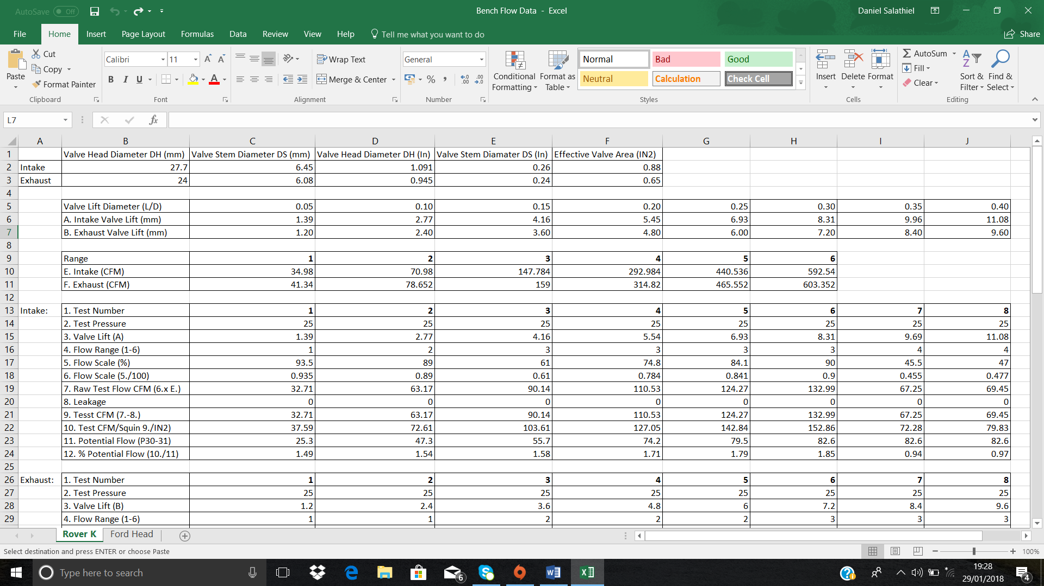
4.1 Range Values for Flowbench:
Table 1: Flowbench Range CFM values for Intake and Exhaust.
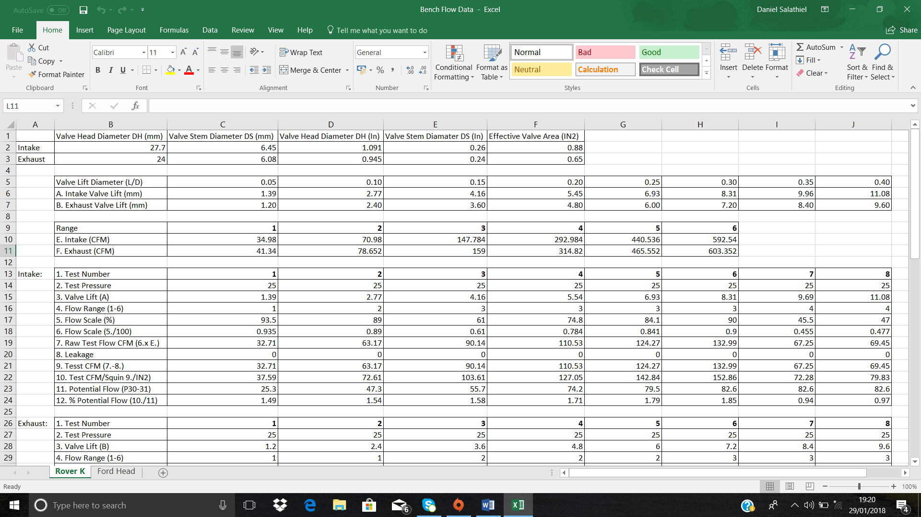
4.2 Rover K series head Measurements and Calculated Valve lifts:
Table 2: Rover K Series Valve measurements.
Table 3: Calculated valve lifts for K Series Head.
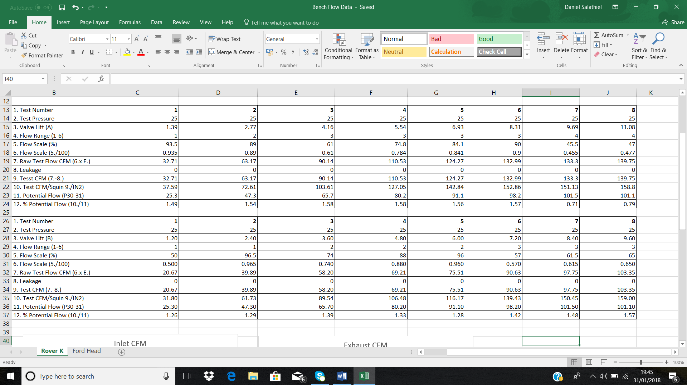
4.2.1 Flowbench Testing recorded data for the Intake Valves:
Table 4: Rover K Series Intake Recorded Data.
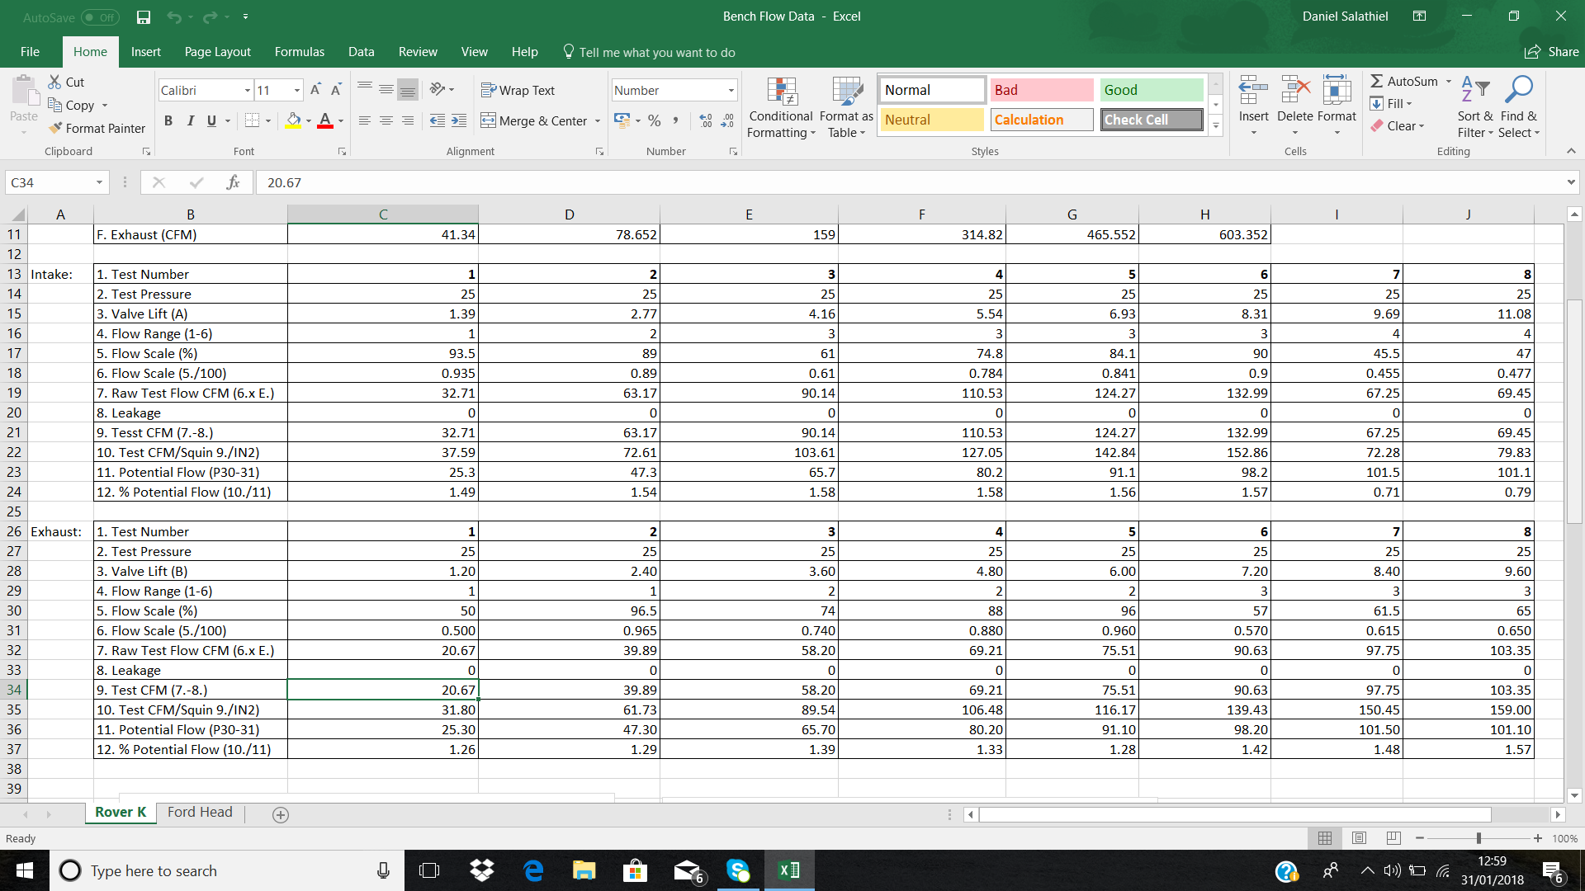
4.2.2 Flowbench Testing recorded data for the Exhaust Valves:

Table 5: Rover K Series Exhaust Recorded Data.

4.3 Ford 1.6 Head:
4.3.1 Ford 1.6 head Measurements and Calculated Valve Lifts:
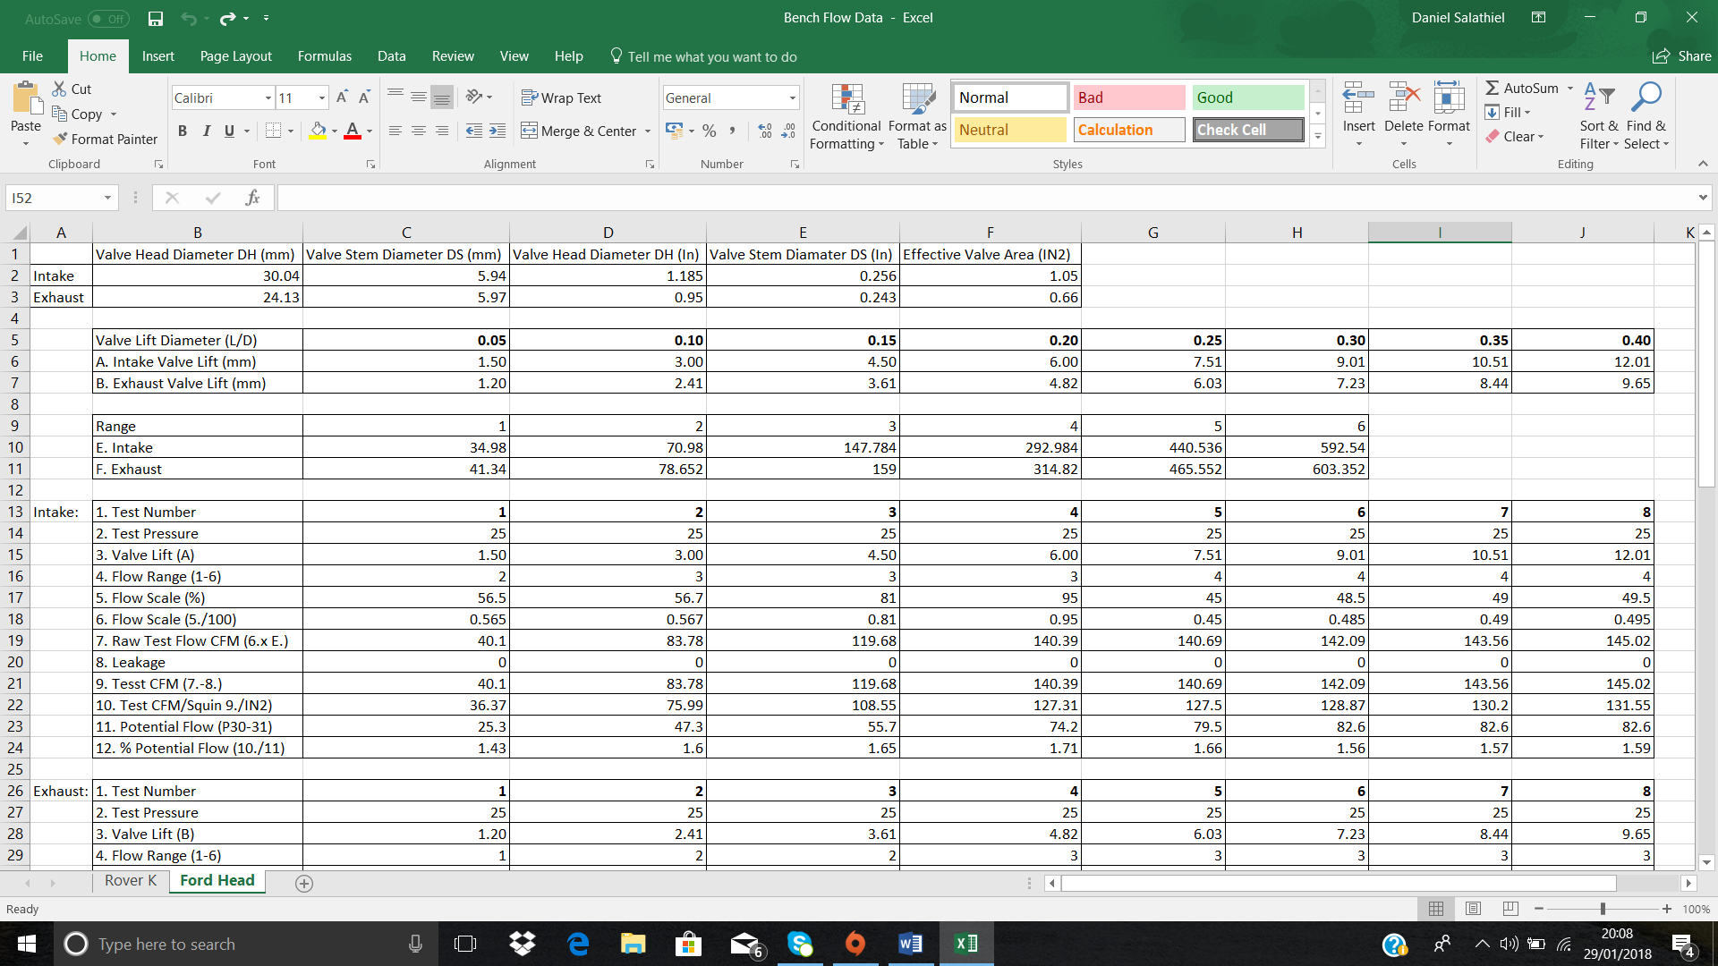
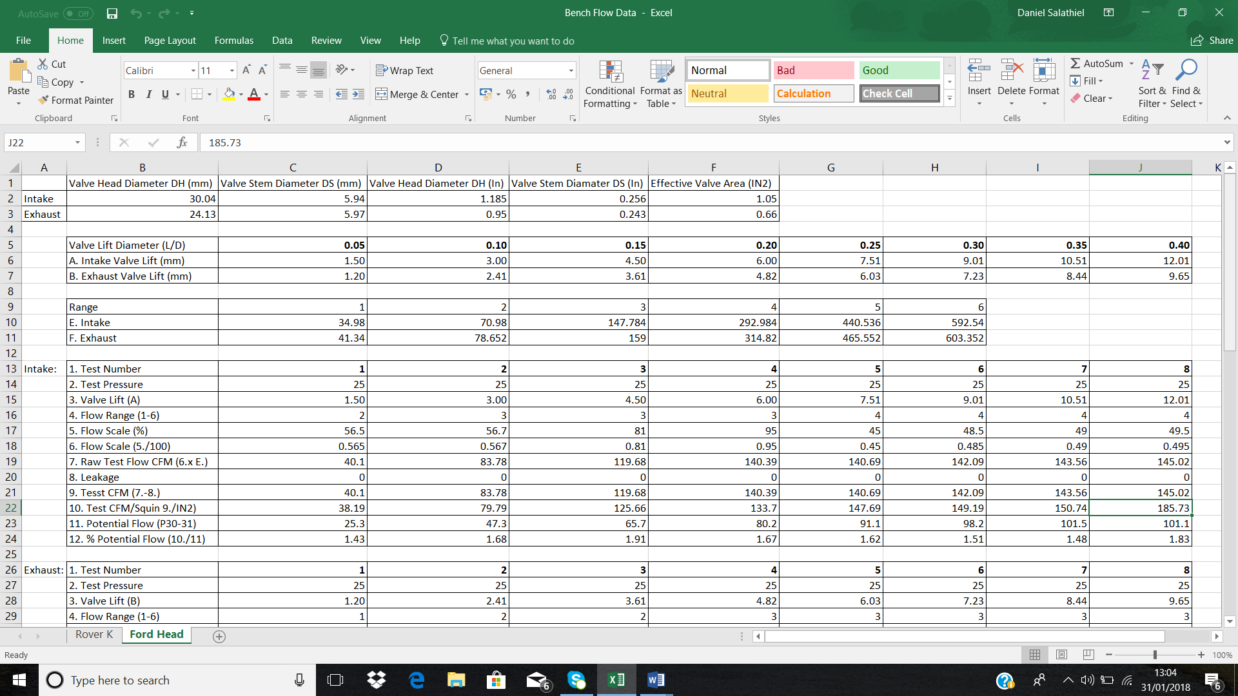
Table 6: Ford 1.6 Valve Head Measurements.
Table 7: Ford 1.6 Calculated Valve lifts
Table 8: Ford 1.6 Flowbench Range Values.
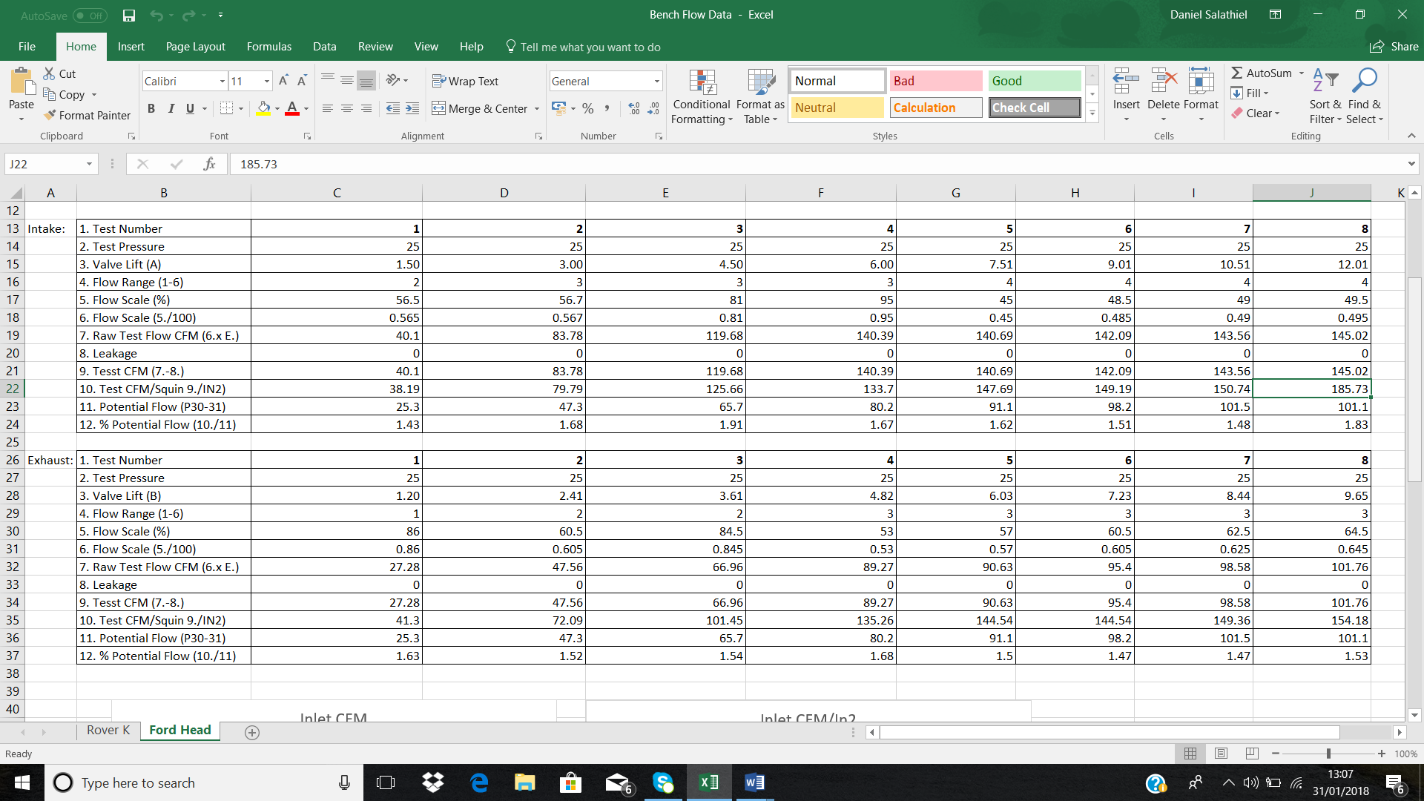
4.3.2 Flowbench Testing Recorded Data For the Intake Valves:
Table 9: Ford 1.6 Intake Recorded Data.
4.3.3 Flowbench Testing Recorded Data For the Exhaust Valves:
Table 10: Ford 1.6 Exhaust Recorded Data.
4.4 Rover K Series CFM against valve lift graph:
4.4.1 Rover K Series Intake CFM:
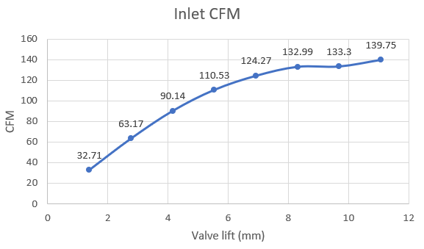
Graph 1: Rover K Series Intake CFM Results.

4.4.2 Rover K Series Exhaust CFM:
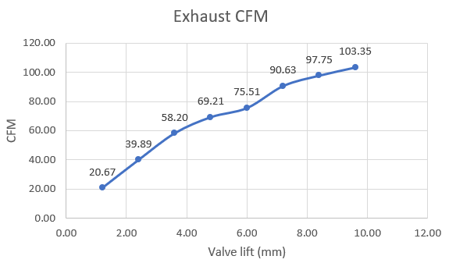
Graph 2: Rover K Series Exhaust CFM Results.

4.5 Rover K Series CFM/Square inch against valve lift:
4.5.1 Rover K Series Inlet CFM/ Square Inch Graph:
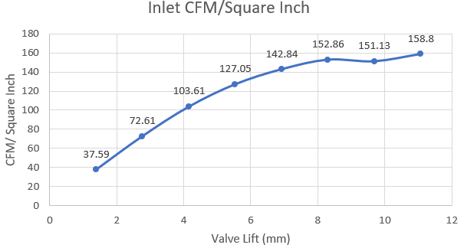
Graph 3: Rover K Series Intake CFM/ Square Inch Results.

4.5.2 Rover K Series Exhaust CFM/ Square Inch Graph:
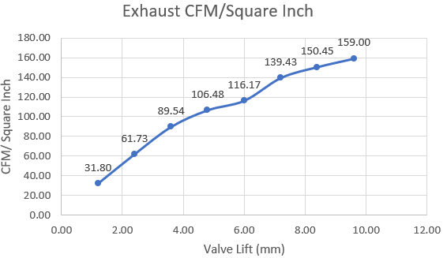
Graph 4: Rover K Series Exhaust CFM/ Square Inch Results.

4.6 Ford 1.6 CFM against valve lift:
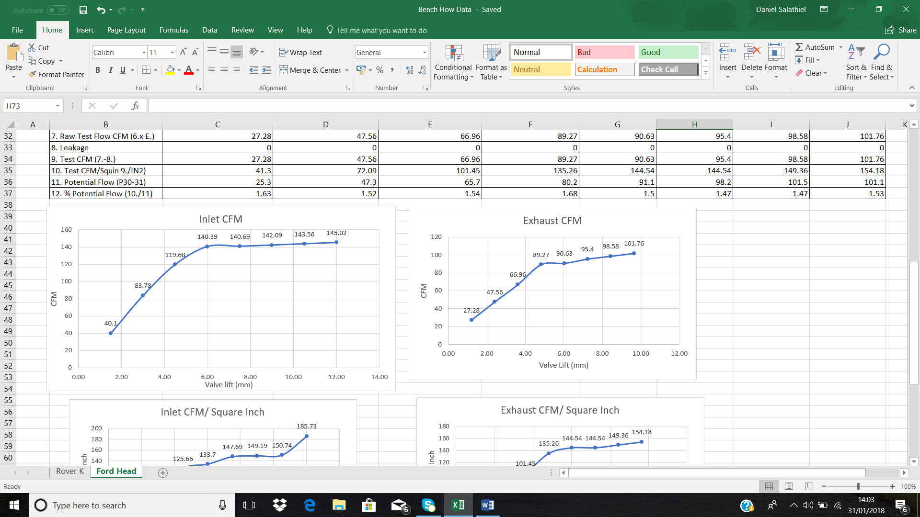
4.6.1 Ford 1.6 Inlet CFM:

Graph 5: Ford 1.6 Inlet CFM results.
4.6.2 Ford 1.6 Exhaust CFM:

Graph 6: Ford 1.6 Exhaust CFM results.

4.7 Ford 1.6 CFM/Square inch against valve lift:
4.7.1 Ford 1.6 CFM/Square inch Inlet Graph:
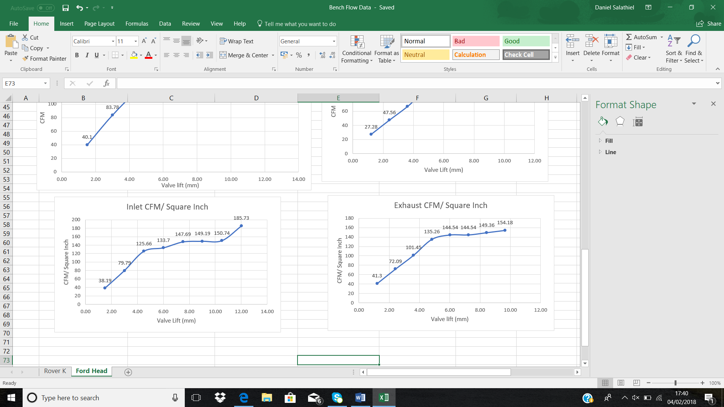
Graph 7: Ford 1.6 Exhaust CFM/Square inch graph.
4.7.2 Ford 1.6 CFM/Square inch Exhaust Graph:

Graph 8: Ford 1.6 CFM/Square inch graph.

5.0 Analysis:
5.1 Data calculations:
To calculate the lifts, measurements of the head specific inlet and exhaust valves were taken. These included Valve head diameters, leading to the calculation of the Effective area through the use of the following equation;
0.785(DH^2-DS^2)… As seen in both tables 2 and 6.
This data was then used to calculate the valve lifts needed for testing using L/D at the given 0.05 increments. These gave the lifts labelled ‘A. Intake Valve lift (mm)’ and ‘B. Exhaust Valve lift (mm)’
The data sets for the graphs shown in the section above were processed using the formulas on the table sheet during testing. The Test CFM results were recorded from the raw CFM results, minus the leakage CFM tested before the main testing was carried out. This process was achieved by taking row ‘7.’ Away from row ‘8.’.
For the Conversion of the Test CFM into CFM/Square inch, the data in row ‘9.’ Was divided by the effective area of the corresponding valves. Either Inlet or Exhaust.
5.2 Inlet Result Analysis:
The Rover K series head results shown in ‘figure 5’, and graphically displayed in ‘graph 1’ Shows a steady climb in the CFM results as the lift increases. This result is calculated by taking away the leakage, which in the case of this test is zero, from the raw test CFM. The highest CFM achieved by the Rover K series engine at the set flow of 25 Inches of H2O is that of 139.75 at 11.08mm of lift.
The CFM/ Square inch results are graphically displayed in ‘graph 3’ of this report. The data shows a positive correlation, showing an increase in flow as the valves increase in lift. The best obtained flow in this case was 158.80 CFM/Square inch. Comparing this to the Super Flow manual, which states that the flow should be that of 101.1 CFM/Square Inch for the selected range and flow test, the potential tuning figure can be calculated. The tuning potential is as followed:
158.80- 101.1= 59.6 CFM/Square inch, this value is the potential flow that can be achieved by the head design. This equals a 0.79% potential as shown in ‘table 4’ of this report.
The data for the Ford 1.6 tested in this testing process can be found in ‘table 9’, and graphically represented in ‘graph 5’. The best CFM value that can be seen is that of 145.02 CFM at a lift of 12.01mm. Seen in row ‘9.’ Of the table. Compared to the Rover K Series Head that achieved 139.75 CFM, but at a lift of 11.08mm, the Rover head had 5.27 CFM less flow over a decrease in lift of 0.93mm. Neither of the graphs for both heads displayed a drop off in peak flow, this is due to the peak valve lift not being achieved. The valve wasn’t opened enough for the flow rate to drop off.
The Inlet CFM/Square Inch for the Ford 1.6 head showed the highest figure for flow rate at 9.65mm of lift of 185.73 CFM/Square Inch shown in ‘table 9’. The Rover head achieved less flow rate, at a value of 26.93 CFM/Square Inch showing less efficiency in flow rate. This can be attributed to the fact the Ford has a greater effective valve area for its exhaust valves. Meaning a greater flow can be achieved.
The graph for CFM/Square inch of the Ford 1.6 head, shown in ‘graph 7’ of this report, shows a positive correlation between increase in valve lift, and the increase in flow. As shown by the trend of the graph. There is no drop off for these results too, this is because the optimum valve lift wasn’t reached during testing. The tuning potential for the Ford 1.6 exhaust valves is 84.63 CFM/Square inch, calculated from the super flow manual figures and the flow data recorded during testing.
5.3 Exhaust Results Analysis:
The Rover K series testing results can be found in ‘table 5’ of this report. The results for the CFM flow rate of the head at 25 inches of H2O was that of 103.35 CFM at a lift of 9.60mm. This isn’t as high as the intake valves due to the effective area being 0.23 In^2 less, meaning less flow rate can be achieved due to the heads design, limiting the amount of charge that can enter while the valve is lifted. Graph 2, shows a steady positive correlation between the increase in valve lift, and the flow rate in CFM.
The CFM/Square inch for the flow head can also be seen in table 5. The highest flow rate obtained at 25 inches of H2O was 159.00 CFM/Square inch. The graph for these values, ‘Graph 4’ shows a positive correlation between the valve lifts and the flow rate being measured. The best obtained flow for the same test pressure in the Super Flow manual was that of 101.10 CFM/Square inch. Meaning the tuning potential is as followed:
159.00- 101.10= 57.9 CFM/Square inch. The value seen here shows the tuning potential, taking into consideration the values with the intake manifold taken in place, this will show a drop-in flow of between 5% to 30% as stated by the Super Flow handbook.
The best flow achieved for the exhaust valves on the Ford 1.6 head was that of 101.76 CFM at a lift of 9.65mm. These results can be seen in ‘table 10’, and ‘graph 8’ of the report. This compared to the highest achieved by the Rover K series head, means that the Ford 1.6 exhaust valves have a lower flow rate of 1.59 CFM. The Ford 1.6 had a greater lift at its highest CFM recorded compared with the K series, meaning its less efficient even though it has a 0.01 in^2 higher effective valve area.
The highest CFM/ Square inch achieved by the Ford 1.6 head was that of 154.18. This compared with the Rover K series head has 4.82 CFM/Square inch less flow rate. The trend on the graph shows a positive correlation between the valve lift and the flow rate through the head. Also, the tuning capacity for the for 1.6 head is that of 53.08 CFM/Square inch, as stated by the Super Flow handbook. This is shown as 1.53 as a percentage.
5.4 Improvements to Head Design:
The Rover K Series Head could be improved by using the tuning potential figure for the Inlet valves. The inlet valves compared to the Ford 1.6 head restrict the flow, this will decrease the over all efficiency of the intake. If the efficiency of the inlet valve design could be improved to increase flow, more charge can pass into the combustion chamber meaning an increase in power and efficiency of the engine overall. This means the charge Is more likely to ignite all the fuel molecules present, increasing efficiency, power outputs and lowering emissions. This could be achieved through the process of polish and porting. The inlet port is enlarged using a grinding or cutting tool. This extra room helps the engine draw in extra air into and out of the cylinders, as stated by autos.com. This coupled with increasing the valve effective area would improve the design of the Rover K Series Head, and the increase in swirl and tumble would mix the charge more affectively. This would increase the surface area of the flame front and propagation. Creating a better ignition of the charge, but also decreasing the turbulence inside the ports, increasing flow rate and velocity. Thus, increasing the amount of fuel and air that can enter. This is backed by the online literature on intake flow analysis. ‘This is due to the air flowing in the port and to the flow quality, resulting from the roof of the port being enlarged, causing more area for the flow to occur’ stated by Awad, B. and Arslan, S., "Cylinder Head Intake Flow Analysis. This literature gives an insight into the flow of the inlet and validates my findings.
For the Ford 1.6 head, the design of the exhaust valves could be improved by increasing efficiency of the porting. The valve effective area was greater than that of the Rover K series, but it had less peak flow. This indicates that the design of the porting is restricting the flow into the combustion chamber. A possible reason for the restriction in flow is the casting of the inner diameter, where it reaches the valve seating. This is referred to also in the literature review by icengineering. This can be improved through increasing the volume of the exhaust port, decreasing back pressure. Decreasing back pressure increases the amount of gas that can flow past the valve on the exhaust stroke. This would also increase the vacuum. The engine can rid itself of spent gases, thus reducing what is called ‘’back pressure’’ as stated in the article on auto.com. The literature review section backs these findings ‘2.3’.

6.0 Conclusion:
The results in this assignment conclude that the Ford 1.6 head has a greater Intake flow over the Rover K series head. This is due to the inlet valves on the Ford 1.6 having a larger valve effective area, leading to greater flow per lift increments. The Ford 1.6 head design also got closer to its peak flow figure, closer than the Rover K series using the calculated lifts in the testing process, at the 25 inches of H20. This means the Ford 1.6 has an increased amount that can be drawn in terms of charge, meaning for the lifts tested, it is more efficient than the Rover K series.
On the Other hand, the Rover K series exhaust valves had better efficiency towards the peak flow, this is due to better designed flow around the valves due to modification and porting, leading to greater CFM/Square inch. This indicates the Rover K series had less restrictive flow compared to the Ford 1.6, leading to an increase in gas flow. This would result in less back pressure, increasing efficiency. I believe that through the techniques I have stated above, in the literature review and improvements in the design, the efficiency can be increased for flow rate on both heads.
For future testing improvements such as increasing the amount of valve lifts used will help give a clearer indication of the peak flow, and display a drop off, where the flow starts to decrease due to it reaching its peak flow allowable by the design of the head. Also, to give a clearer understanding of what’s happening, the increments of 0.05 (L/D) could be reduced to give a more accurate insight into the flow of the head at more valve lifts. This would help identify the peak flow more precisely. In conclusion I felt the testing was accurate, although a drop in the curves weren’t indicated, this was due to the test pressure not being high enough, and not enough lifts. This was due to time constraints. The data besides these showed a clear pattern between valve lift and flow through the head, showing a positive correlation between valve lift increasing, and flow increasing due to greater surface area volume for the charge to pass through. The data collected allowed for improvement suggestions for both heads to be suggested, leading to a clear indication of the pros and cons of both heads.

7.0 Bibliography:
- SF-300/600 Flowbench Operators Manual (SuperFlow Corperation, 2009)
Online copy-
https://www.scribd.com/document/119170567/SF600-Operation-Manual-2009
- Porting and Polishing literature:
Online Resources-
- Autos.com
www.autos.com/aftermarket-parts/what-a-port-and-polish-does
Citation:
- Jawad, B. and Arslan, S., "Cylinder Head Intake Flow Analysis," SAE Int. J. Fuels Lubr. 6(1):132-136, 2013, https://doi-org.ezproxy.uwtsd.ac.uk/10.4271/2013-01-1409.

Citation:
- Hughes, S., Welch, M., and Sanghera, G., "Development of The First Volume Production Thermoplastic Throttle Body," SAE Technical Paper 950228, 1995, https://doi-org.ezproxy.uwtsd.ac.uk/10.4271/950228.

- SA Racing Division Engineering Resource:
ICENGINEERING.COM- Polish and porting heads literature.

www.lcengineering.com/pdf/Head%20Porting%20DIY%20by%20Standard%20Abrasives.pdf

