COMMUNITY CARE AND DEVELOPMENT

By Mutiat Shobajo

Course number: BMHP6022_LON
Professor’s Name: Laila Surani
Institution: University of Wales trinity saint David
Location of Institution: London
Date: March 28, 2023

Introduction
Community
Community development is an essential process that justifies how community members tend to support their identity and take collective actions on various issues that are vital to their lives. Further, the main focus is to empower people to assist in creating stronger and more connections with each other. The concept of community development is recommended to increase the social, environmental, and economic quality of life. Substantially this is because it engages people to promote fairness, wealth, happiness, promoting health among even the marginalized and oppressed within the society. The outcome expected of every community development is based on various characteristics it expresses. These consist of the existing history of the community and its relations among people, the present established social structure, the cultural values, and the ways in which it governs itself in the long run (Mazzarella, 2020). Therefore, this report will evaluate the crime rate and related activities in Waltham Forest borough supported by different theories and policy and legislation acts in the London.
Demographics Of the Community
The selected community is Waltham Forest, located on the North-East side of London and bordered by five other boroughs in London such as Enfield, Haringey, Hackney, Redbridge, and Newnham. The total population within Waltham Forest, according to the 2021 census, estimates that the borough is home to a total 278 400 people. It is evident that the average population in the borough is about 24.5% younger that the average number of people residing in the area (Sarjou, 2021). Besides, the older adult proportionality among the population is nearly 10% and has a life expectancy of 79.8 for males and 83.2 for females. The majority of ethnicity in this borough is appropriate to about 58%, while British and Irish residents and a share of another ethnicity also exist (Office of the national statistics 2023). The other majority ethnic groups in the borough are blacks and Asians in the region. The religious activities in the borough are very diverse, with a range of faith within the communities (Whittaker et al., 2020). However, according to the statistics from the census, Christianity tends to remain the main religion, with about 48% of the residents being identified as Christians and 22% of the residents being Muslims. The other significant demographic of the Waltham Forest borough is the level of education among the people in the community. The borough has sufficient regional educational facilities, with 51 primary schools, about 15 secondary schools, and children's centers (Office of national statistics, 2023). Besides, this reflects about 65% becoming or have achieved the highest level of education in the country. The demographics of employment are also essential to be understood in the borough. The population survey indicates that the employment rates for the working age of between 16 to 64 are relatively high, with about 75% of the population in that category being employed. Further, this region is known to have the 21st-highest rate of employment in London (Kirchmaier et al.,2020).
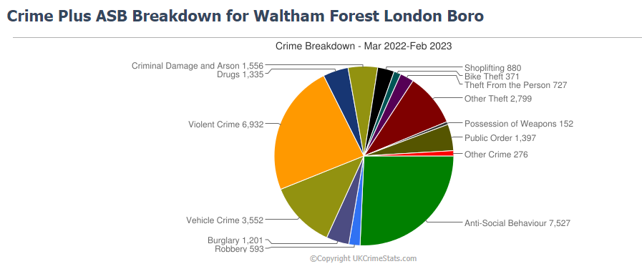
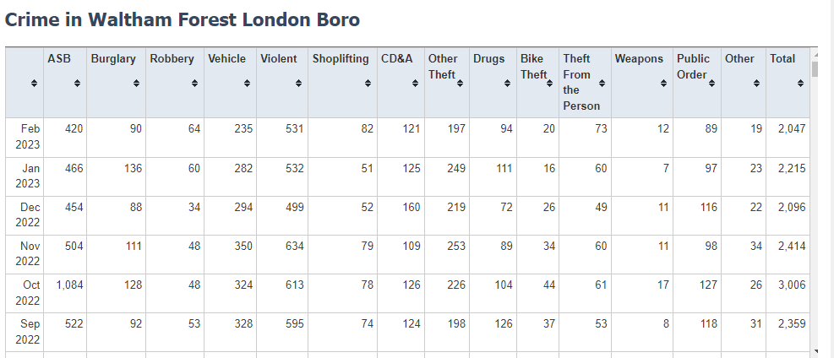
The Problem and Its Causes in The Community
In the contemporary world, every city tends to experience different problems that impact their lifestyle. The problem determined is a crime in Waltham Forest that has been impacting the borough in different measures that include causing personal harm, financial impact, potential disruption to the safety of the society, and damages to the property (Bertotti et al., 2017). The Waltham Forest borough has a lower crime rate than other boroughs' average crime rate. It is estimated that it has about a 14% crime rate and is ranked as one of the top 20 safest boroughs in London, with 81 crimes for every 1000 people (Goodman et al., 2021). Some of the most common crimes experienced in Waltham Forest borough are violence and sexual offenses, homicide, moped crime, assault, and knife and gun crimes, with an estimated 22899 cases in 2022. Further, this symbolizes an increase from the previous year’s record, indicating a 0.9%. The incidences of violent crimes in Waltham Forest borough were about 6723 as of July 2022, with the chance of getting involved in this type of crime being 2.4% in the year (Office of the national statistics 2023). On the other hand, the incidences of theft experienced in the region during the same year was 9700, and the chances of being involved in this type of crime reflect about 3.5% in a year. The murder rate in Waltham Forest is minimal than expected, with only three cases that were reported in the entire year of 2022. Substantially this has indicated a decrease in such crime from the previous years. The crime growth in Waltham Forest has not significantly increased since an estimated 1% change, as evident between 2021 and 2022 (Office of the national statistics 2023). However, theft is the fastest-growing type of crime, which has increased to about 29% over the past year. The type of crime that was reduced over the past year was drug-related offenses, with about 10%. In general, based on these statistics of crime cases in Waltham Forest borough, it is evident that the safety of the borough is higher despite some potential cases of criminal activities that have been emerging.
Maslow’s Theory of Hierarchy of Needs
The evaluation of the crime rate in Waltham Forest can be described effectively by the theory of Maslow. The theory is critical in determining the human decision-making process, which the hierarchy of potential psychological needs embraces. The core proposal for this theory concerning criminal activities is based on human behavioral motivation to their environment in the long run (Hopper, 2020). Further, various factors often increase the individual risks of involving in crime as determined by the framework of the hierarchy of needs. These needs primarily dictate and motivate individual behaviors, even towards criminal activities in different measures. The hierarchy of needs framework entails physiological needs, which are the basic needs for human survival. Therefore, when a person's physiological needs are unmet, they yarn to get satisfaction by every means possible (Hopper, 2020). The level of poverty, for instance, is considered to be one of the drivers of criminal activities since it gives the sense of purpose to participate in the Act and fulfill the needs. The theory of Maslow suggests that there is a relationship between the existing variables where people are engaging in criminal activities to act as a source of income to satisfy their physiological needs, such as shelter and food (Altymurat et al., 2021). The legal means of income may not be accessible to some youths involved in such activities, making it the most attractive and only option to meet these needs in the long run. The other aspect of Maslow's hierarchy of needs theory is establishing safety needs. Maslow states that everyone has the belief and a feeling to be safe within their environment. Individuals who are engaged with those involved in criminal activities may be at risk of joining them as a form of gaining safety needs. The exposure to such activities may feel like their safety may be at risk because they may not be able to belong to a group around them (Wang, 2021). Therefore, such youths may consider criminal gangs the best alternative to feel safe. There are various studies indicating that people living within neighborhoods that have a significant presence of criminal activities are likely to join them. Further, this is established from the behavior learned from the cause of the relationship where they can witness the violence. Based on the hierarchy of needs, such individuals get involved because of the feeling of being unsafe within their environment, thereby looking to meet these safety needs by being members of gangs. The other hierarchy of needs is the love needs that can be evident in the case of crime involvement. The love needs to address the sense of belonging in a friendship relationship that can be romantic or even platonic (Wang, 2021). Criminals in Waltham Forest borough would strive to have the intensity of achieving this goal by being part of a meaningful, cohesive group that shares a similar identity. Therefore, such individuals getting involved in criminal groups can be the most attractive form to fulfill love needs where they may have a sense of belonging. Studies also indicate that most gangs don’t have ties with their friends, families, and relatives, making their criminal groups a perfect fit where they look for love needs. Maslow theory justifies how they look for love needs as part of rejection that arise from the negative influence of the people they hang around within society. Lastly, the other framework from the hierarchy of needs is the esteem needs explained in theory (Saville and Mihinjac, 2022). The main elements involved in this context are self-esteem and the perception of being regarded by other people. Further, there is evidence from these two forms of esteem that they act in a reciprocal measure since they directly relate to how people think about others. Most people fear peer rejection since it can lead to low self-esteem, which has been predicted to increase criminal gang membership. Therefore, youths would look for places where their self-esteem can be met; if not, they would be attracted to groups that show respect for self-esteem (Cobbina et al., 2020). Criminal gangs offer individuals a sense of having power that can be attractive to individuals who feel marginalized in other elements of their lives. In general, understanding Maslow’s theory of the hierarchy of needs is critical in evaluating the needs of criminals participating in the Act. The gap in fulfilling some useful purpose and a sense of power and belonging is some of the major issues that attract them together and participate in such acts.
Legislation And Policy in Community Development
Equality Act of 2010
The United Kingdom is currently experiencing a surge in crime rates in different parts of the country. Criminal activities are caused by several factors, such as poverty, racism, unemployment, and political and religious background in Waltham Forest. However, there are some cases of lack of equality among the people where the minority in the borough are discriminated against and harassed in different forms by law enforcement and authorities. Therefore, establishing the Equality Act 2010 is significant in protecting these minorities within the borough from circumstances of discrimination that they experienced. The Act protects people living within the borough that have been subjected to unlawful treatment from harassment and victimization from criminal gangs. Besides, it has also enabled people to avoid serotypes that can make other ethnic or race a target of scrutiny by law enforcement within the borough (Sánchez-Monedero et al., 2020). It may facilitate the development of employment opportunities if discrimination issues are solved amicably and minimize crime rates in the long run.
The Police and Criminal Evidence Act 1984 (PACE)
The policy is essential in giving the police powers to stop and search an individual or even their vehicles in a public place to determine any stolen prohibited articles and detain any suspect. The execution of this Act is facilitated by law enforcement which put roadblocks to conducting their checks and ensuring the safety of the people in Waltham Forest. The success of executing this Act is facilitated, especially when a search warrant is issued and determined to satisfy the situation because it is reasonable to arrest individuals with serious offenses. As a result, this would be essential to check the balance and maintain control of the borough by limiting increased criminal activity cases due to a lack of random checks from suspected criminals.
Conclusion
Community development in every society provides a sense of belonging by supporting people to understand and embrace their identity. The concept also empowers individuals to create a stronger connection towards each other by building trust and understanding of different perspectives of people by increasing the social, environmental, and economic quality of life. Essentially, this is because it engages people to promote fairness, wealth, happiness, promoting health among even the marginalized and oppressed within the society. The selected community is Waltham Forest borough which is situated in northeast London, England. The borough has a total population 278 400 people, according to the census bureau. The social problem that has been evaluated is the issue of crime in the neighborhood. The crimes experienced in Waltham Forest borough are mainly violent and sexual offenses, with an estimated 81 for every 1000 people.

References
Altymurat, A., Muhai, M. and Saparow, T., 2021. Human Behavior in Organizations Related to Abraham Maslow's Hierarchy of Needs Theory. Interdisciplinary Journal Papier Human Review, 2(1), pp.12-16.
Bertotti, M., Frostick, C., Tong, J., & Netuveli, G. 2017. The Social Prescribing Service in the London Borough of Waltham Forest: final evaluation report.
Cobbina, J.E., Galasso, M., Cunningham, M., Melde, C. and Heinze, J., 2020. A qualitative study of the perception of school safety among youth in a high crime city. Journal of school violence, 19(3), pp.277-291.
Fredman, S., 2023. Discrimination law. Oxford University Press.
Goodman, A., Laverty, A.A. and Aldred, R., 2021. Short-Term Association between the Introduction of 2020 Low Traffic Neighbourhoods and Street Crime in London, UK. Findings.
Hopper, E., 2020. Maslow’s hierarchy of needs explained. ThoughtCo, ThoughtCo, 24, pp.1-3.
Kirchmaier, T., Machin, S.J. and Villa-Llera, C., 2020. Gangs and knife crime in London. Available at SSRN 3521766.
Mazzarella, F., 2020. Making for Change: Waltham Forest.
Office of the national statistics 2023. How the population changed in Waltham Forest: Census 2021. https://www.ons.gov.uk/visualisations/censuspopulationchange/E09000031/
profits. European Journal on Criminal Policy and Research, 26, 1-22.
Sánchez-Monedero, J., Dencik, L. and Edwards, L., 2020, January. What does it mean to'solve'the problem of discrimination in hiring? Social, technical, and legal perspectives from the UK on automated hiring systems. In Proceedings of the 2020 Conference on Fairness, accountability, and Transparency (pp. 458-468).
Sarjou, A., 2021. Violent Crime in London: An Investigation using Geographically Weighted Regression. arXiv preprint arXiv:2101.10388.
Saville, G. and Mihinjac, M., 2022. Third-Generation CPTED—Integrating Crime Prevention and Neighbourhood Liveability. In Urban Crime Prevention: Multi-disciplinary Approaches (pp. 27-54). Cham: Springer International Publishing.
Wang, Y., 2021, June. A Study on Criminal Psychology of Juvenile Violent Murderers. In 2021 2nd International Conference on Mental Health and Humanities Education (ICMHHE 2021) (pp. 299-305). Atlantis Press.
Whittaker, A., Densley, J., Cheston, L., Tyrell, T., Higgins, M., Felix-Baptiste, C. and Havard, T., 2020. Reluctant gangsters revisited: The evolution of gangs from postcodes to profits. European Journal on Criminal Policy and Research, 26, pp.1-22.

