
name of the assignment
Nazrin Karim

[Date]
University of Wales Trinity Saint David

Executive Summary

Table of Contents
Executive Summary 1
Terms of Reference 3
Procedure 4
Introduction 5
Findings 6
Conclusion (average of 10% of word count) 7
Recommendations 8
Bibliography 9
Appendices 10
Acknowledgements 11
UPDATE TABLE FREQUENTLY – CHECK IT HAS BEEN UPDATED PRIOR TO SUBMISSION

Terms of Reference

Procedure

Introduction

Findings

During the first module of my course I have learnt and understood my best learning styles through different learning styles tests. I have chosen to speak about VARK and the Honey and Mumford questionnaire of in more detail.

VARK

VARK is a learning style which was developed by Neil Fleming in 1987. Neil Fleming is a professor from Lincoln University, New Zealand. VARK was developed to help people determine their individual learning style, (VARK, 2018).
VARK stands for: -
Visual - People who learn best using their eyes for example, using diagrams, maps, charts, pictures or videos.
Aural - People who learn better by listening for example, discussions, recordings or lectures.
Read/write - Individuals who learn from reading and writing, for example through assignments, essays books or lists. These learners are often found highlighting in books or even taking their own notes.
Kinesthetic - These learners learn by experience. They learn from a hands-on approach. They learn through trial and error. They prefer the practical approach.
VARK is used to learn information based on the experiences of an individual. VARK model is a questionnaire made up of 16 questions that determines a person’s preference (Cherry, 2017). It helps understand if the individual learns better by visualising, listening, reading and writing or through experience. Many people do not have just one style of learning. They learn through more than one style or even through all four styles. These individuals are known as multi model learners (Flemming, 2018).
Prior to VARK, VAK was widely used. VAK was developed in the 1920s for teaching children with dyslexia. VARK model is based on the VAK model. Fleming split the V into two parts, visual and text as read/write. The R was then adapted into the VAK model to become VARK (Gates, 2016)

I always thought I learn best with experience however after doing the VARK questionnaire I found that I learn best through aural style and secondly through kinesthetic. This has helped me as I know now to concentrate more on lectures and discussions as I understand more when listening to someone. It has helped me plan out the way I study using my strengths more. As I am looking to be a teacher I am hoping this will help me develop ways to teach children and maybe help me understand pupils individual learning styles.
Although my strength maybe aural style my preference is still kinesthetic as I find when I experience something in life or when I am doing something practical I learn faster. I have tried to put both together and plan out my strategies to teach me to hopefully teach others in the future.

Honey and Mumford

In 1986 Peter Honey and Alan Mumford designed a questionnaire so individuals can identify their preferred learning styles. They purposed that individuals needed to use one of four different learning styles to succeed in activities. The questionnaire was based on the Kolb learning cycle, (1984), as explained in more detail below. Honey and Mumford made people aware that there is an association between the learning cycle and learning styles (Rosewell, 2005).
The four styles are: -
Activist – These learners learn by doing things rather than reading, listening or even seeing. In other words, they are more hands on and prefer the practical approach. These learners will avoid repetition or planning things out. They prefer brainstorming and finding new ideas to solve situations. They have a open minded approach to learning (University of Leicester, 2017).
Reflector – These are learners who like to stand back and let others take charge while they observe. They tend to avoid any confrontation. A reflector gathers as much information as possible before making choices or giving any opinions (University of Leicester, 2017).
Theorist – These learners like to think things through step by step in a logical way. They like to understand the theory behind the actions. They are known to be perfectionists who like to have things tidy and in perfect order. They like to use things like models, concepts and facts to engage in their learning process. They also tend to have good analytical skills (University of Leicester, 2017).
Pragmatist – These are learners who enjoy experimenting with new information, technics and theory. they like to put these ideas into action in their lives to see how something will work. They like to get on with things quickly and confidently and can come across as being impatient (University of Leicester, 2017).

When took done the Honey Mumford questionnaire I found that I am a reflector. For me this is quite accurate as I feel that I am not confident enough to take the lead and voice my opinions until I have observed what someone else or had reassurance from someone. There are many benefits of being a reflector, like for example being careful before saying something, being thoughtful and rarely jumping to conclusions, which are all important for me to have in the teaching profession. But this questionnaire has helped me recognise some weaknesses which I need improve to be able to achieve my goal to be a teacher. Like for example, holding back from direct participation, slow at making right decisions and being too careful by not willing to take enough risks. I have found that I need to be more confident to be able to improve my weak points. I have already attempted to do this through a presentation where I built up the courage to speak in front of people loudly and clearly. This really helped me as I feel a lot more confident now but there is still room for improvement.

The Kolb Learning Cycle
As mentioned earlier the Honey and Mumford learning questionnaire was based on Kolbs learning cycle which was published in 1984 by David Kolb in his book, Experiential Learning. According to Kolb, there are four different learning styles which are based on a four-stage learning cycle.

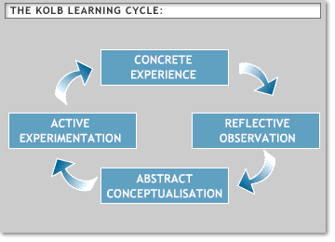
(University of Leicester, 2018).

Concrete Experience – This is when a person decides to try something new or do something that they have not yet done. They are not able to just watch or read about it, they need to do it.
Reflective Observation – The second stage the person needs to think and reflect to what and how they done and ask themselves questions and review what they have experienced.
Abstract Conceptualisation – At this stage they try to conclude what has happened and understand the events and the relationships between them.
Active Experimentation – At this final stage, they think about what they have learnt and how they will act on it. Think about changes that can be made to achieve better results and do it all again.
A good example for me of the KOLB learning cycle is when I done my presentation. As a group we thought of ideas and presented it as a presentation (concrete experience), we then looked back at what we done and spoke to each other about our individual experience and how we felt (reflective observation). As we had another presentation to do, at this stage we discussed what happened and which bits worked well together and what bits didn’t (Abstract Conceptualisation). Even though we had good marks for our first presentation we wanted to achieve more so thought about changes we can make and additions that will help us get us better results. And finally made all the changes and put it to the test by doing the second presentation (Active Experimentation).
I found this theory helped us achieve good results and I will repeat on my next presentation.

SWOT Analysis

From my SWOT analysis, as shown below, I was aware that I lack in confidence which is one of the reasons why I also think I am weak at doing presentation as it requires a lot of confidence to stand and talk in front of people but I hope to improve both these weaknesses by trying to get more involved in group discussions which will help build my confidence and I also aimed to stand up and do presentations even if I think I was making mistakes which is something I have already put to practise and along with the enjoyment I have also had excellent results which has built up my confidence even more and now I am able to do a presentation without hesitation even though I feel there is room for improvement I feel that I will be able to change these into my strengths.
My writing skills are also a big weakness which I aim to improve by just simply writing more and do more reading as I think reading helps understand and learn new ways of writing. I will also try to get help from friends and family where needed.
And lastly to improve my IT skills as well as getting help from my family members who are more familiar with the new software’s, I am hoping to take a course on computer literacy alongside my teaching course once I have finished my graduation on skills in the workplace.

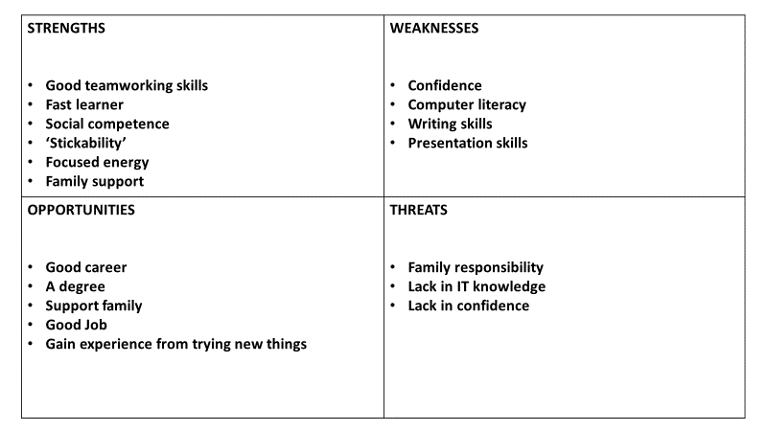

Go MAD Thinking

The Go MAD thinking system was developed by Andy Gilbert in 1997. Andy created this system to help people who wanted to ‘make a difference’, which is what the MAD stands for. His thinking was to help people who wanted to do, improve or change something in life. This could be making a big difference or little difference in someone’s work or home life. He felt that there was a lot of people trying to achieve results but not in the right way (Gilbert, 2016). As people would aim for a result but jump straight into action rather than think first, then act and finally achieve the results they wanted. His theory was that people should think and ask themselves great quality questions to improve probability of success. Today there is a large percentage of people in different countries who are using the Go MAD framework to achieve success. Andy now has over 20 books and over 200 audio and video programmes about leadership, change and coaching.
Furthermore after analysing myself with SWOT, I have invested the framework to focus on my personal goals that I will like to achieve in the future. Below is my personal Go MAD thinking model where I have acknowledged the actions and strategies to help me reach my goal to become a teacher.

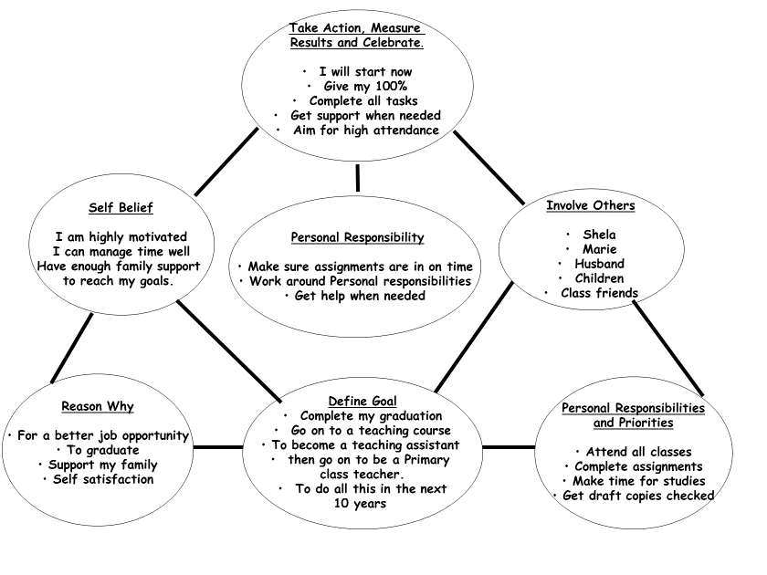

Personal Development Plan

PDP is where an individual plan out what skills they intend to develop, how they will develop it, what barriers they will come across and how it will be overcome ( Morgan, 2017).
When I done my PDP I found that my weakness can be improved with the help of family and friends and of course my lecturers. As mentioned before on my SWOT computer literacy can be improved by simply doing a course on IT and with help from family. My writing skills need more practice and if I can find books that keep me amused I can read them and learn new styles of wring. When I done my PDP I listed confidence and presentation skills as a weakness and thought I would not be confident enough to stand up in front of a group and do a presentation, however since then I have done two presentation and have achieved excellent results and had good feedback from fellow class members as well as the lecturers. This is something I was not aware I had the ability to do which is why I never attempted it and felt it was a weakness of mine. This is something that I would say was unknown to me but known to others as my friends believed I could do all along.

Development  Objective | Specific  Actions | Barriers and how  They will be Removed | Support  Required | How I will know when I have achieved the objective
Computer  Literacy | Get on a IT course.  Get help from family who have good IT knowledge | New systems to what I learnt in school - so will explore more online and research and try new programmes on the computer. | Family  Lecturers  Friends  Books  Online resources | When I feel confident and find that I can use all new soft ware and create things like presentation.
Confidence | Join in on group discussions  Do presentations  Take the lead when I have the opportunity | Being afraid of being wrong - so I will make those mistakes and try to learn from them.  Shyness – so I will do more presentations which should help me come out of my shell more | Family  Friends | When I can give my opinion without being afraid that someone may object.  When I can stand up in front of a group and speak out loudly like a presentation
Presentation Skills | Do more presentations  Speak loudly and clearly and confidently. | Lack of confidence – so I will research and understand what I am presenting and practice beforehand. | Friends  Family  Lecturers | When I feel confident enough to do a presentation and then get good feedback.
Writing Skills | Write more  Do more reading and research more.  Get help from lecturers. | Do not enjoy writing – so I will try and find new things to write which keep me interested | Books  Online resources  lecturers | When I can write a report in the correct way using good grammar and language.

Johari Window

As it can be seen in both my PDP and SWOT I listed presentation skills as my weakness, but I was unaware that tis was not really a weakness but one of my strengths. Sometimes we do not like to make people aware of things we don’t like in ourselves and in the same way sometimes people do not like to tell us things in case we feel bad. From this theory the Johari window was created by Joseph Luft and Harry Ingham. The Johari window consists of four categories according to what we know about ourselves and what others know about us (Morgan, 2017).

They are: -
The Arena - what we know about ourselves and what others know about us.
Façade – what we know about ourselves, but others do not know.
Blind spot – what others believe we can do but we are unaware.
Unknown – what we do not know about ourselves and others do not know either.

As mentioned before I can see from my Johari window that my blind spot was doing my presentation skills and the confidence to get up and speak in front of people, which my friends believed I can do but I was not aware.

Known to self | Unknown to self
Arena  Time management skills  Organised  Passionate | blind spot  Presentation skills  Confidently speak | Known  To  others
Façade  Shy  Nervous  Observant | Unknown  If I will achieve my goal | Unknown to  others

From all my planning technics I have been able to identify my weaknesses and the barriers which I need to overcome. These have been extremely helpful to me as now I clear strategies which I can follow to achieve my goal to be a primary school teacher. And from the learning styles I understand the best ways I can learn which will help me not only to get closer to my goal but hopefully in the future too when I will be teaching myself.

Part Two

John Lewis are looking to hire a result driven store manager who will be responsible for the overall management of one of our new stores opening very soon. The successful candidate will need to enhance customer satisfaction, maximise profits, meet sales targets and manage their staff effectively. The store manager will also be responsible in supervising assistant store managers (Workable, 2018).

Job Description
The successful candidate must develop business strategies to raise our customer pool and optimize profitability. The manger needs to meet all sales targets by training, motivating, mentoring and providing regular feedback to their sales staff. The store manger needs to ensure high levels of customer satisfaction through excellent customer services. All store administration is also to be completed by the store manger ensuring compliance with John Lewis policies and procedures. They must maintain outstanding store conditions always. The store manager needs to conduct regular performance appraisals to assess training needs for individuals and help them build a career path with John Lewis. They must be able to interview and recruit staff. Any issues that arise whether it is from a customer or the staff, it is their mangers responsibility to ensure it is dealt with appropriately. Of course, the store manager needs to be a shining example of well behaviour and high performance. We also expect the candidate, as a store manager to be able to purpose innovative ideas to increase market shares and store sales (Target Jobs, 2018).

Personal specification
This stage of the recruitment process involves looking into all the different skills, experience and qualifications that a candidate possesses, and compares them to the job position criteria that we have produced. It is a very important part of the process as this is what helps us find the perfect candidate who will fit into the management position with all the necessary skills that this job requires.
The candidate must have the following skills as these are very import for the job role: -
Customer service – this should be at the top of the candidates list as this is an essential part of the job. The manger needs to make sure that the customer has the best experience every time they come to shop at John Lewis (Conlan, 2018).
Leadership – As a manager the candidate will be leading a whole team some of who may be inexperienced. It is up to the manager to motivate the staff. You will need to lead training and developments needs and make sure the staff are happy at work (Conlan, 2018).
Organization – John Lewis is a fast-moving organisation therefore it takes a lot to stay on top of things. A good manager is always organised and are well planners (Conlan, 2018).
Communication – The candidate will need to be able to communicate well with staff, customers and our partners. The mangers need to hold meetings, training sessions and may come face to face with situation, both positive and negative (Conlan, 2018).
Administration, financial and general computer literacy – The manager is responsible for store admin work like writing reports for which they will require numeracy, literacy and computer literacy skills. They will also be expected to set budgets and manage them (Bright Knowledge, 2018).

Experience
The experience we require is at least two years’ experience in retail management, some financial background. Experience in designing and managing the implementation of data driven customer strategies and subsequent measurements with continued optimisation. Recruitment experience and some knowledge on consumer research.

Job Advertisement
Now this is an important part of a process to find a suitable candidate for this role (indeed, 2018).
When Advertising for a management post it is significant to put this advertise in the right place such as:
Indeed.co.uk a recruitment site or
Directly on the John Lewis Partnership Online.
A vacancy for such a role must be clear to what we, the team of management for John Lewis require from a potential manager for our retail store.
The key factors that will be specified are:
- Title of the job
- Location job is based
- What level we are requiring
- Closing date
- Type of vacancy (temporary or permanent)
- The hours
- And of course, the salary!!
Then goes onto the duties and responsibilities
- Being efficient
- Motivating team
- Exceptional customer service
- And other responsibilities like merchandising and being a natural leader.
On the advertise we would ensure it is clear what checks the candidate will need to have done in this process, these are:
- Pre-employment screening
- 5 years reference checks
At the end of this advertise we hope to highlight our requirements of someone desirable, experienced skill, qualified and previous experience of managing a team in customer focused environment.
Application Process

As a management team for John Lewis we pride ourselves to select the right candidate for the management role, someone who is well motivated and ambitious in the working industry. The application process is achieved to benefit yourself knowing what to expect, also for us to know what skill sets that you possess that is suited for this role.
All application process starts online, this consists of various questions and video clips to show what the job role consists of. Allowing you to understand if this occupation is right for you before you apply (John Lewis, 2018).
- First protocol that the applicant needs to undergo is going through the making of the application. This may be long and tiring but needs to be done to assess whether the candidate is suitable for the job role. For instance, providing Personal details, stating what experience you have and stating what qualification you possess.
- Secondly, the candidate will have to undergo a management judgement test. This is where the candidate will need to tell us what they would experience in this role, how the applicant will react to different types of challenges that they will face. It also will help us understand what type of possible management skills that the applicant has.
- Thirdly, a skills test is needed to be done by the candidate where certain scenarios will be complied in the questions and the individual will need to answer them. Therefore, we can evaluate what verbal and numeric skills the candidate has.
- Fourthly, once the application process has been done the candidate will receive a telephone interview (this does not mean that the individual has successfully got the job) this is part of the early stages of the selection process. This is where further question will be asked on Leadership and Partnership Behaviours and any experience possess that is linked to the management post. We also might ask the candidate to give us a video interview, this process may contain questions like; what the most difficult period in your life was, what were your last responsibilities of your last position, and lastly what problems have you encountered at work?
- Fifthly, once the fourth stage is successful there will be a face to face interview where the candidate will need to provide legal documents of their rights to work in the UK. Also, further question will be asked based on Leadership and Partnership Behaviours and other questions regarding the post.
- Finally, once the application has been thoroughly looked at by the management team. The offer will be then made to the candidate via email or a letter notifying them whether their application has been successful. A response needs to be made letting us know that the candidate still wants this management role, if no response has been made by the expiry date the application will then be withdrawn.

Possible interview Questions
Below is a list of some possible interview question. This includes both candidate and customer service questions (John Lewis, 2018).

- Do you work well with people?
- What is your greatest strength?
- What is your greatest achievement in retail?
- Why are you applying for this post?
- How many hours a week do you put in your current job?
- What is good customer service?
- Why do customers shop at John Lewis?
- What is important, a good product or a friendly fast service?
- A co-worker is rude to customers, what will you do?
- What is your primary focus as a manger?
- Tell me about the most difficult customer you had to serve?
- Do you do employment performance review?
- How will you handle a situation if most of your team called in sick?
- What do you want to know about John Lewis?

At the end of this process we hope to find a suitable candidate to join our team at John Lewis who is confident, innovative and a responsible person. They must be a good team player as well as have excellent leadership skills. They will need to portray good understanding of problem solving, flexibility and communication skills. They must be able to manage time well and demonstrate good presentation skills.

Conclusion (average of 10% of word count)

Recommendations

Bibliography

Appendices

Acknowledgements

