Business skills for the international hotel industry
Module Code: B4X01917

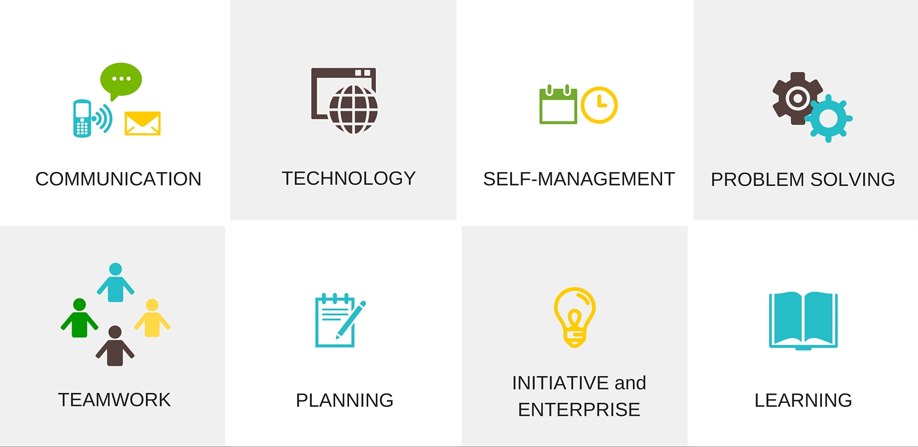

SILVIYA TSEKOVA
1815097

MODULE QUESTION

Using your SWOT and PDP, prepare a report, in which you analyse your current. Academic and employability skills and outline how you intend to use these skills to find employment I the hotel and hospitality industry.

TABLE OF CONTENTS

1.INTRODUCTION………………………………………….1
2.SWOT…………………………………………………….....2-3
3.SKILLS TO DEVELOP……………………………………3
4.MY PERSONAL DEVELOPMENT PLAN…………4
5.CONCLUSION………………………………………………5
6.REFERENCES………………………………………………5-6

INTRODUCTION

Personal development is very important for someone to be liked by future employers .People have a different tactic to convince their employers that they are the ones who will help them .Potential analysis is often done SWOT analysis .SWOT is an important framework that can help companies face the challenges .It helps to find the best in the market .This analysis was created by a group of businessmen: Edmund .P ,Learned ,Kenneth Andrews ,C .Roland Christensen and William D in 1960 .SWOT it was originally used only in business ,but many people use it individually to help them appreciate their Strengths ,Weaknesses ,Opportunities and Threats .
This simple analysis structure provides guidelines that examine internal and external factors. Self-analysis is one of the most complex tasks but plays a very important role in personal progress.
Your personal SWOT analysis will help you learn more about yourself making personal SWOT analysis is a very important step in finding career guidance. With this report I will show how I used my own to show the areas I have to work on and show how I plan to achieve my goals .
I managed to draw my own which includes the following.

STRENGTHS

-Reliable
I think this is very important to me because I have proven in many cases that it can count on me.
-Honesty
When you are honest and pure in dealing with people, they trust you and respect you.
-Responsibility
Responsibility is one of my strengths that I own because through this feature I am taking my clients.
-I get along well with people
I get along with people is very important to me, so I pretend people to threat me better and give them comfort to talk to me.
-I deal with problems
Every day around me there are problems and I have to deal with them in one way or another. I think this is a good country from me and can be translated in to my future work.
-Good communication skills
This quality helps me over the years to build good friendships with people who can be in touch with them at all times.

WEAKNESSES

-I need to make things quickly and remove them from my list usually my work suffers from this.
-The need to cope with things also scares me when I have too many tasks.
-IT skills
It’s very important in this world of technology as my generation doesn’t have enough knowledge.

OPPORTUNITIES

-Obtaining a diploma
Being at university is a step forward in achieving my goals.
-Planning the future
Through the course I will gain knowledge through which I can plan my future employment.
-Using a library
Many of my weaknesses can be improved by using resources in the library.
-Accumulation of knowledge
As long as I train, I will accumulate a lot of new knowledge that will help me in my future plans.

THREATS

-I do not have enough qualifications
Without having qualification any thing that puts me in a very bad position.
-I da not have the necessary experience in academic studies.
This can put me in a very bad position when it comes to completing my course.
-Lack of time
The impossibility of time is great, because I will not know how much time I will need to achieve my goals.

SKILLS TO DEVELOP

There are many skills I need to acquire in order to be able to succeed at my university, my skill that are my weaknesses. I have to develop them to improve me ac a student and to in prove my employment.
As one of these skills is IT skills. For me it is important to be able to handle my tasks. Postponement is also one of the things I have to improve because it can slow me down in achieving my goals. Performance skills also need to be developed as they are also necessary for my development. Without these qualities I know that I will not succeed in training in resolving this my employment will be directed in that direction I in tend to do so gradually and also in the next two years.

MY PERSONAL DEVELOPMENT PLAN

After I made my SWOT analysis, I created a Personal Development Plan is used in business and by students it helps to set goals and set deadlines for achieving these goals. This is beneficial as it will provide direction for success in academic life. Below I outlined the areas I would like to work on and a timetable for doing the job.
My Personal Development Plan includes:

-MY GOALS ARE
Starting a course that will me change my life.
Directing my efforts and knowledge in this direction to build new knowledge and skills in the hotel industry.

-SKILLS AND KNOWLEDGE TO BE LEARNED
I have to learn how to work in business. Behaving working with clients marketing. The way to be good in what you love.
I have to work on every part of the hotel business to know every step of the business.

-NEXT STEPS
Firstly going into the technical matter of business marketing and customer service.
Accumulation of new knowledge use of the library to find and build knowledge related to hospitality.
Then going to practice because work at the hotel gives you more knowledge and skills.

-RESOURCES
Free time to work on my knowledge.
Concentration, academic education more practice and work.

-TIME SHEDULE
Work, lectures, work, practice.

CONCLUSION

Employability skills are skills that make an individual fit for work these skills are important because they are a prerequisite for getting a job.
Taking action and implementing them can help a person achieve their goals as a student or a professional.
The Personal Development Plan is on way I can learn how to improve my skills and ways to work to maximize my weaknesses using the SWOT system I was able to see my strengths and weaknesses, the possibilities and ways in which I can make a personal action plan that will help me during my training period after seeing my weaknesses and making a realistic goals.
I am in a better position to find a suitable job in the near future.

REFERENCES

-Amin, SH, Razmi, J, Zhang, G, (2011). Supplier selection and order allocation based on fuzzy SWOT analysis and fuzzy linear programming. Volume 38 (issue 1), P334-342
Available at: https://www.sciencedirect.com/science/article/pii/S0957417410005750

-Peter Morgan, The Business Student’s Guide to Study and Employability Page 20-22

-Steve Mueller, March 31st,2017 Planet of Success, EST.2010. Retrieved from http://www.planetofsuccess.com/blog/2015/how-to-write-a-personal-development-plan

