Introduction to Web and Database Concepts

Assignment: Database Analysis and Design
Jacob Hopkins
2003836
BSc Computing (Computer Networks and Cybersecurity)
Submission Deadline: Wednesday May 5th

Contents
Context Diagram 3
Level 0 DFD 3
Entity Relationship Diagram 5
Access Relationship Diagram 6
Output from Reports 6
Database Forms 8
Main Menu Form 8
Customer Form 9
Order Form 10
Menu Form 10
Stock Form 11
Stock Invoice Form 11
User Guide 11

Context Diagram
In every business process model, planning starts at the first DFD, the context diagram. This diagram presents the overall business process within a single process. The following context diagram, built using Microsoft Visio, depicts a simple overview of the entire Celtic Caterers System, the diagram is made up of both example data flow and external entities such as the customers and store managers.
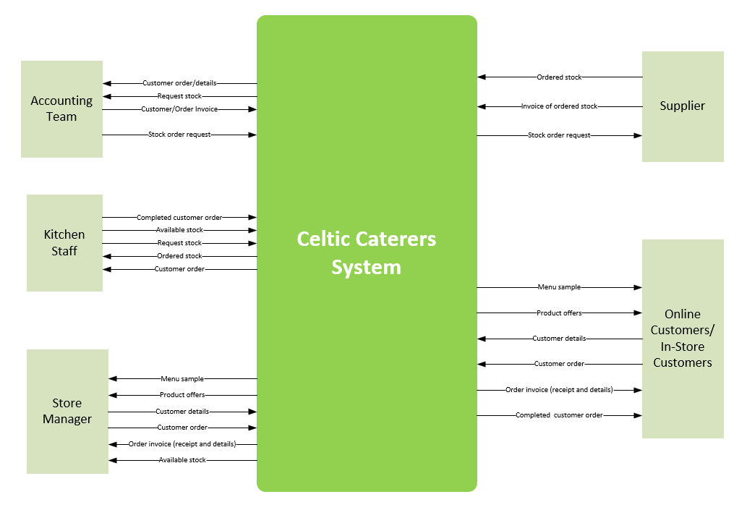

Level 0 DFD
A level above the context diagram is the level 0 DFD. This diagram, built using Microsoft Visio, shows the overall process, but instead in a much greater level of detail, including things such as major processes within the scenario and how they relate using data flow tools. Breaking down the overall process of Celtic Caterers, we can identify six major processes that make up the catering system, each of these connected to their necessary external entities, data stores and processes.
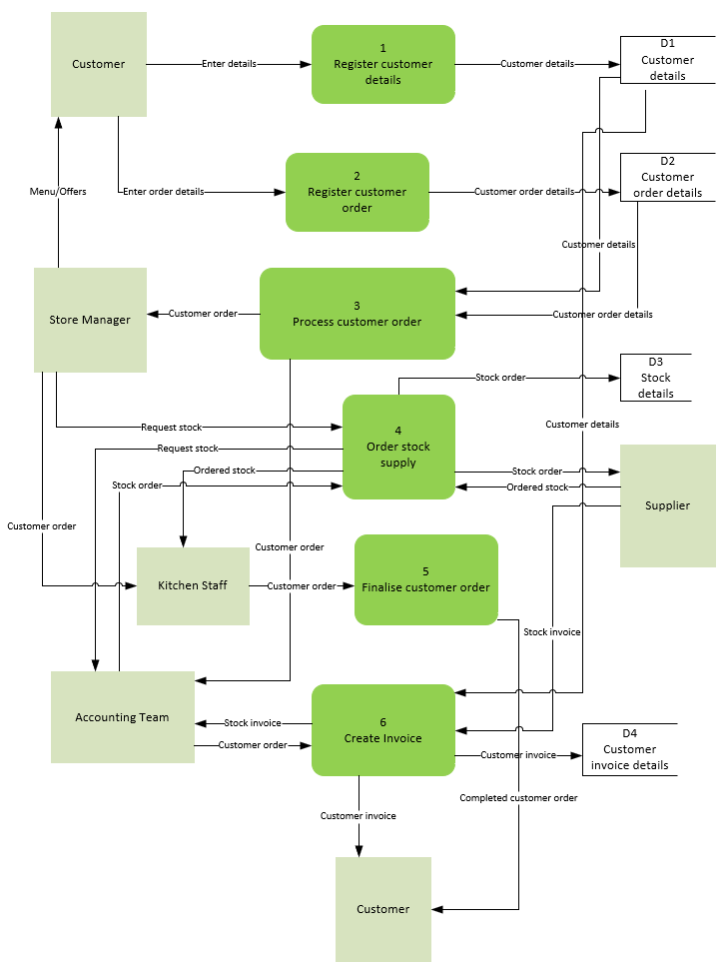
Within this diagram we have a total of four data stores, each of which handling set information relating to their names. The customer details data store for example will handling important information from customers such as their customer ID, name, and contact details. This information is gathered from the customer external entity, with other external entities such as the store manager and accounting team providing further data for the other data stores within the system such as the customer invoice data store. Depicted in much greater detail, we are able to see each transaction of data across relationships between entities and processes that allow our Celtic Caterers system to function as intended.

Entity Relationship Diagram
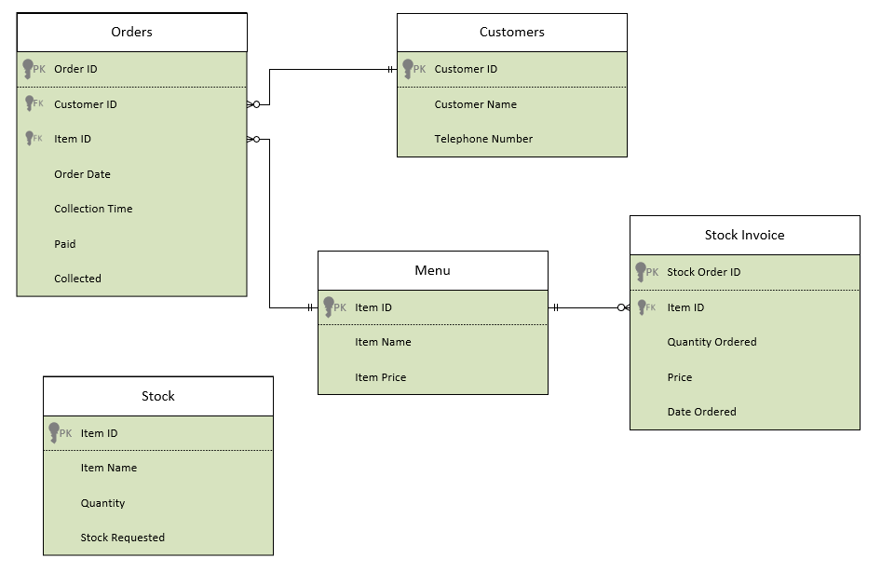
To help display all of the information requirements of a system, we use an entity relationship diagram. As its name implies, the diagram is made up of two elements, entities which store and display information, and relationships that represent the association between entities. There are various types of relationships within databases, consisting of one to one, one to many, and many to many.
Our entities within this database include the businesses orders, customers, menu, stock, and stock invoice; each of which managing their own set of unique data sets. The relationships between these entities are structured as one to many, with records from one table can be related to numerous records from the other table. An example of this would include one customer can have many orders. The degree of a relationship refers to how many different entities are linked within a relationship. In this instance, our entities follow a second-degree relationship, with each entity having both a primary and foreign key from their relationship with each other.
Our customers entity shares a one-to-many relationship with our orders entity, allowing for customers to have more than one active order on record. Similarly, with the relationship between both our menu and stock invoice entities, the one-to-many connection allows for items to be ordered more than once at any time, can be great for when initial orders might not have been large enough for the store.

Access Relationship Diagram
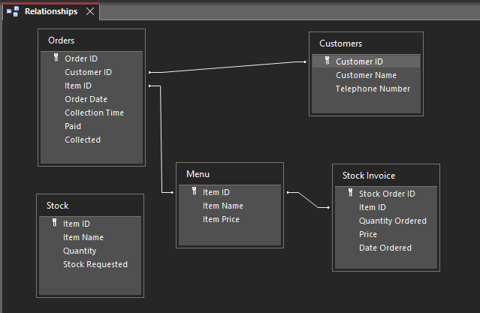
When building relationships within Access, we use an entity relationship diagram much like the one previously showcased. These relationships are what drive the Access database and allow for shared data, using foreign keys to store and retrieve said data within different entities.

Output from Reports
Within the brief, the user requested a way of viewing and printing off invoices from the database system. To do this, a report would have to be created to gather the necessary information for an invoice and collectively display the data to the user. From there, the user is able to print the report to be kept as a physical backup/copy for future use.
Using reports within Access, the user is able to build and print two similar styled reports, the first being an invoice report for a specific stock order selected by the user, and the second a total invoice report including all stock order information across different fields.
Generating a smaller form than what is usually seen, the invoice for a single set order delivers the following output:

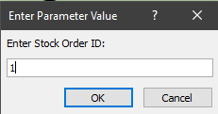
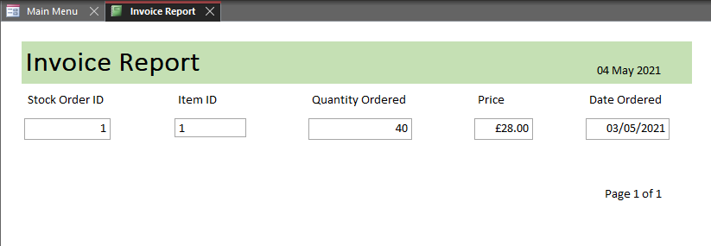
The larger report documenting all invoices, including a total price for the invoices, delivers an identical output, with matching positioning of data and clarity for greater symmetry:
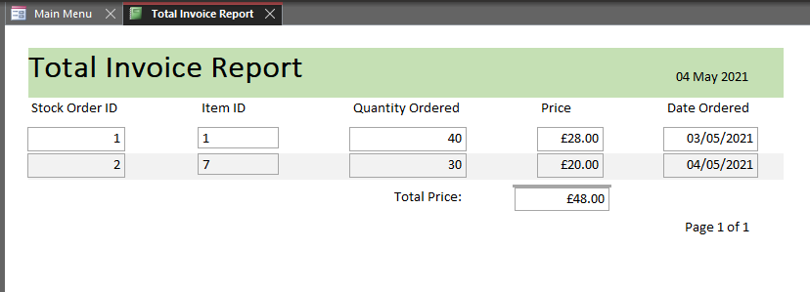
Both of these reports are built in such as way that helps separate the displayed data while maintaining a clear structure of the information. The use of different colours breaking up the reports foreground and content make reading the presented data easier for the systems’ users. Formatting our data in this way helps print all of the necessary information clearly, helping minimise any future issues when outputting data.
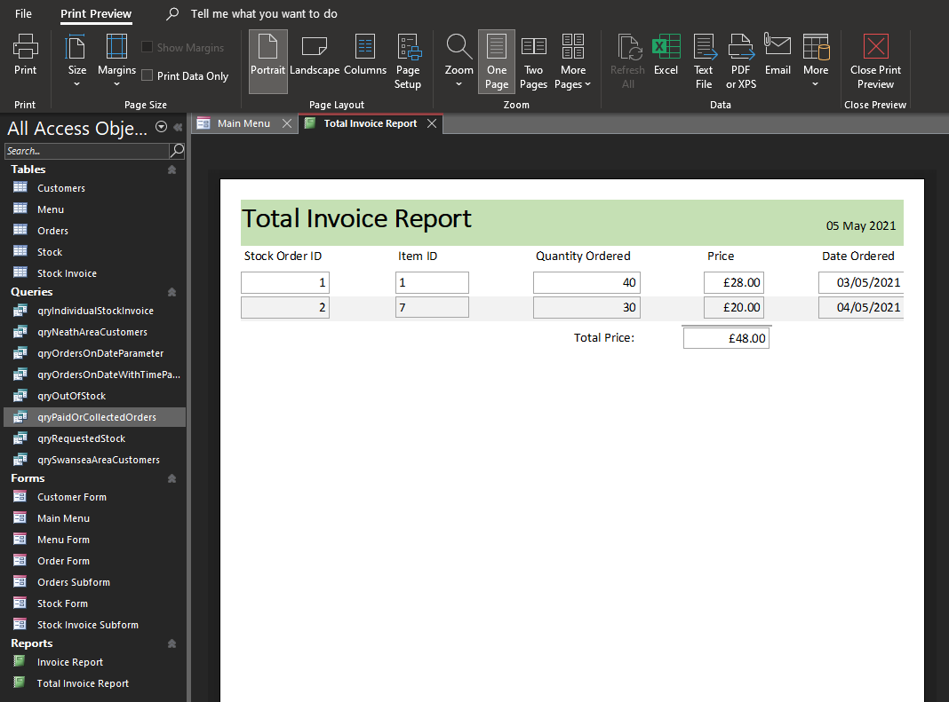

Database Forms
Allowing users to input, modify, or view data from within a table or query; database forms are a user-friendly way of operating a database system. Through the use of attractive visual environments, working with databases can be made more enjoyable and in some cases improve productivity while also reducing errors when using forms.

Main Menu Form
Upon opening our Celtic Caterers database, users are greeted by a main menu form, acting as a hub/portal to other interactive elements such as forms and queries within the system.
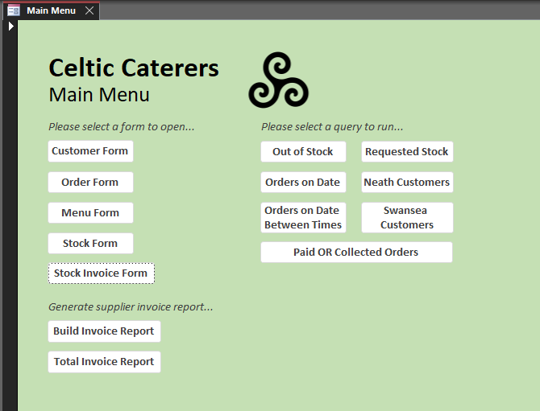
To help with navigation, the main menu holds numerous macro buttons, each uniquely programmed to take the user across the database environment. Whether it is to a different form or to run a query, the macros help make using the database system much more intuitive.
Some example code that makes up the customer form macro can be seen below instructing the system on where to navigate upon being pressed:
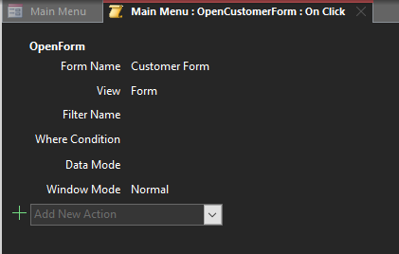

Each form within the database is built around their corresponding table’s fields/data, gathering and displaying the fields within the table in ways that are more appealing and easier to understand for most general users.

Customer Form
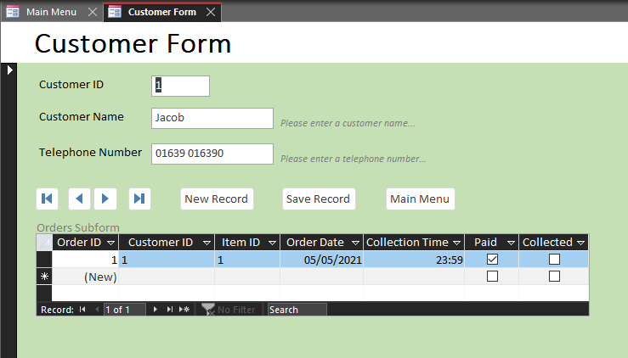
Taking advantage of macro buttons to both navigate between and create/edit fields, the form also displays a sub-form within its layout. This order sub-form uses the relationship between both the customer and order tables, and its foreign keys, to display related data such as the orders placed by the customer being viewed within the form.

Order Form
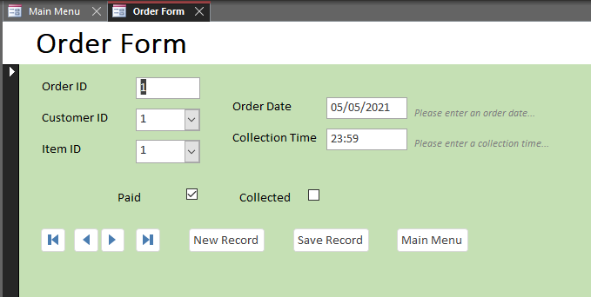
The use of hints and comments throughout the forms, such as those parallel to both order date and collection time fields, help guide the user through the environment. These notes paired with validation rules and text found within each fields properties, help restrict user input to appropriate data, while also helping reduce potential errors caused by user input.

Menu Form
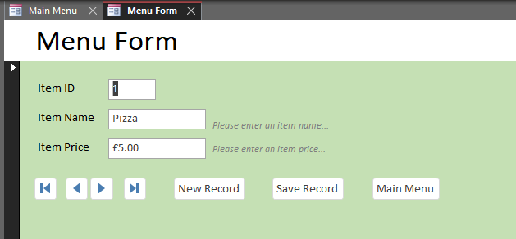

Stock Form
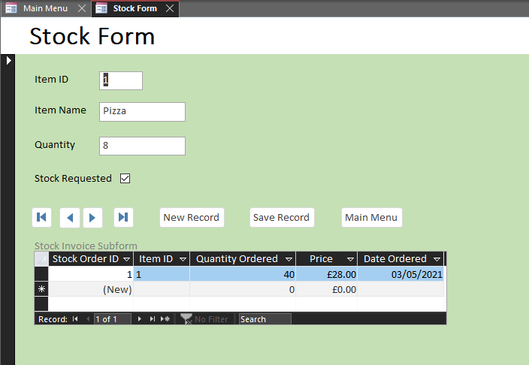
Much like the customer form, the stock form also takes advantage of a sub-form to deliver related data from the related stock invoice table. This sub-form showcases any stock orders placed for the current stock item presented by the stock form.

Stock Invoice Form
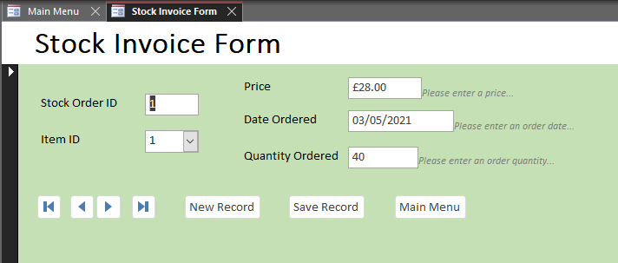
The stock invoice form can create, store, and display records of transactions between the catering business and their supplier, delivering one of the user requirements stated by the scenario.

User Guide
As previously mentioned, the user is greeted by the main menu form when loading up the database. To navigate the database, labelled macro buttons are placed across each form, directing the user to the labelled position within the database (e.g. pressing the customer form button will take the user to the customer form menu). The main menu also holds macro buttons to run pre-determined queries and reports, some of which allow for parameters via user input.
Across each form, users are also presented with two macros, a new record button, and a save record button. These macros allow the user to both alter existing fields from the database’s tables and create/save new fields to the database’s tables. To help ensure the altered/created data is appropriate for the field, validation rules and input masks have been put in place to limit user input while also reducing the user error.

