Human Resource Management (SBMA7101D)
Employee Engagement: The Way Forward for Raspberry Pi Foundation
Assignment Part 1
Aqeel Shakir
April 30, 2018
Table of Contents
Executive Summary 3
Introduction 4
Overview of the Business Problem 4
Meeting Employee Motivational Needs 4
Maslow’s Hierarchy of Needs 5
Herzberg’s Two-Factor Theory 5
Concepts of Employee Engagement/Involvement 6
The Advantages and Disadvantages of the Employee Engagement 9
Application of HRM Models 10
Harvard Model of HRM 10
HRM Lifecycle 11
Recommendations 12
Conclusion 13
References 14
Executive Summary
The report aims to evaluate how employee engagement and employee involvement can play a role in enhancing HR efficiency at Raspberry Pi Foundation. The organization selected is a charity based organization founded in 2009 and focusing on the promotion of the study of basic computer science in schools. It has been drawn that employee motivation has decreased sharply over the time. It can be due to lack of either the intrinsic rewards system or extrinsic rewards system or even both. Various theories have been studied to boost employee engagement and employee motivation at Raspberry Pi Foundation in this report and three recommendations have been made. The theories discussed in this report include Maslow’s Hierarchy of Needs and Herzberg’s Two Factor Theory. Both of these theories have been related to the case of Raspberry Pi Foundation as well. Further, the two key HRM models as considered historically including the Harvard Model of HRM and HRM Lifecycle. The relevance of both models has been found in the case of Raspberry Pi Foundation and the company can also utilize it to better its HRM practices. The recommendations need Raspberry Pi Foundation to focus on implementation of HRM Lifecycle particularly step 6 and 7, apply motivation theories with respect to the concept of employee involvement and alter employee policies with respect to employee influence and reward systems to promote the participation by the employees and the role of their leadership must also be shaped in a way that the democratic leadership is utilized.
Introduction
This part of the report purposes to evaluate how employee engagement and employee involvement can play a role in enhancing HR efficiency at Raspberry Pi Foundation (herein will be referred as Raspberry Pi). The organization selected is a charity based organization founded in 2009 and focusing on the promotion of the study of basic computer science in schools and is also responsible for development of a single board computer namely Raspberry Pi, which is one of the bestselling PCs of all time (Armstrong, 2017).

Overview of the Business Problem
In the view of Henderson (2017), the employees’ motivational needs change over time and these require the companies to adopt quickly in order to keep their employees motivated. The needs of employees are different depending on each level of hierarchy and the social status of the employees. In the view of numerous motivational theories, employees can be motivated using both intrinsic and extrinsic rewards system. In the context of Raspberry Pi, it can be drawn that employees’ motivation has decreased sharply over the time. It can be due to lack of either the intrinsic rewards system or extrinsic rewards system or even both. Therefore, some of the motivational theories are illustrated below to indicate the needs of employees at Raspberry Pi.

Meeting Employee Motivational Needs
As prescribed by Cook (2009), the identification of employee motivational needs and meeting those needs is essential for the effectiveness of HR department at any organization. These needs can be identified by application of motivation theories including Maslow’s needs hierarchy and Hertzberg’s two factor theory.

Maslow’s Hierarchy of Needs
Maslow proposed a famous theory related to motivation of employees at any organization including the non-profit organizations. Maslow proposed five tiers of every human’s needs and believes that these needs are satisfied one by one to keep employees motivated as reflected in the figure below (Edenborough, 2007).
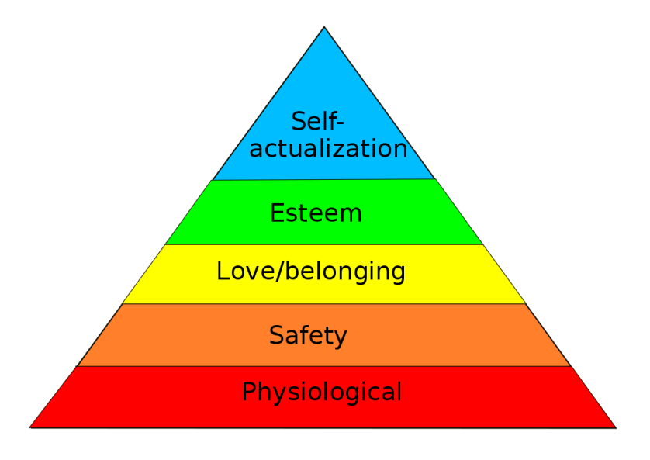
Figure 1 - Maslow's Hierarchy
In the given context of Raspberry Pi, it must be noted that as the company is a non-profit organization, its key focus relates to the satisfaction of love/belonging needs as the business purposes to spread and maintain satisfaction of social needs in the society. Furthermore, it must be noted that Raspberry Pi may not be able to satisfy all levels of needs for every employee but the organization needs to strive for the motivation of majority of its employees and help them reach their self-actualization.

Herzberg’s Two-Factor Theory
In accordance with Armstrong (2017), the Herzberg’s two factor theory also identifies key factors that can help a HR manager motivate his subordinates. Herzberg classified the job related factors into two key categories i.e. factors leading to satisfaction and factors leading to dissatisfaction as illustrated in the figure below:
Figure 2 - Herzberg's Factors
As illustrated from the figure above, the internal factors can account for both the satisfaction and dissatisfaction. Raspberry Pi can apply Herzberg theory to motivate its employees by maximizing the factors for satisfaction and minimizing the impact of factors for dissatisfaction. Some other factors for satisfaction in the case of Raspberry Pi can include the nature of work carried out by the organization as it is a non-profit organization working for the good of people.
These are the two motivational theories that help identify the needs of employees and the factors that can lead to satisfaction/dissatisfaction of the employees. As discussed, these theories carry high importance for non-profit organizations as well suggesting a significant application of these concepts for Raspberry Pi.

Concepts of Employee Engagement/Involvement
In the view of Henderson (2017), the employee engagement can be defined as the involvement of employees in the decision-making at an organization to help employees feel motivated and using their valuable input at the same time. It is further illustrated that employee involvement leads to high commitment on part of organization’s values and success. However, it must be noted that employee engagement at an organization can only be ensured when the leadership style utilized at the organization is democratic as this particular leadership style permits employee engagement to a maximum degree. The concepts and theories related to the enhancement of employee engagement have found 6 steps that can be used to fulfill the purpose at any organization including Raspberry Pi.
- The Strategic Imperative: Firstly, in line with the HR theorists, Raspberry Pi needs to treat employee engagement as a strategic imperative for the country. In order to do so, business strategy and policies must be revised and there needs to be an increased focus on the democratic leadership and employee engagement. As per the current practices at Raspberry Pi, it can be analyzed that employee engagement is lower; however, as per post-training intentions of the managing director, the employee engagement needs to be key focus of the organisation in the coming periods and can become strategic imperative in the meantime (Macey and Schneider, 2008).
- Communication of Vision, Mission and Organizational Goals: Secondly, in a bid to increase employee involvement at her organization after understanding the importance of the concept for Raspberry Pi, the CEO of the company must communicate the updated vision and mission statement of Raspberry Pi with all employees as it improves employee confidence and builds their understanding of what sort of decision-making can involve the employees. Once the employees are taken into confidence, they can help their respective leaders achieve the goals as a team by contributing to the decision making at organization. Furthermore, the organizational goals for Raspberry Pi need to be revised with the consultancy of employees so that the updated goals can be achieved to increase organizational efficiency and motivation of the employees.
- Appropriate Leadership Style: In order to ensure enhanced employee engagement at Raspberry Pi, the leaders of the foundation need to alter their leadership style. They need to be democratic and lead their people by depicting their charisma as it is important for a leader to motivate his/her workers to participate in discussions to enhance employee motivation and engagement so that the overall productivity can be boosted. The appropriate leadership style in this context refers to the democratic and charismatic leadership (Laroche and Rutherford, 2007).
- Listening to the Voice of the Employees: One of the most important aspects to enhance employee engagement relates to the listening of voice of all employees and shortlisting the ideas and welcome all the ideas before going to the process of shortlisting. As an executive at Raspberry Pi, my role is to ensure that every executive listens to the ideas and values those ideas to sustain employee motivation. As Raspberry Pi is a non-profitable organization, the executives can implement ideas which are beneficial for the students focusing on computer science at their schools given that they are main beneficiaries of Raspberry Pi’s non-profit work (Saks, 2006).
- Rewards and Recognition: In the view of Edwards and Rees (2016), another way to keep the employees motivated and engaged is to reward their earlier engagement in the organizational decision making given that it motivates them to perform and engage more to achieve the goals of the organisation. In the case of Raspberry Pi, it has been noted that the foundation rewards its employees as per general standards of the industry; however, in order to avail higher employee engagement, there is a need to go beyond the par and reward and recognize the efforts of human resources persistently.
- Accountability: It has been noted that employees perform better when they are set to meet some tangible goals within a prescribed time. Therefore, in order to get higher employee engagement at Raspberry Pi, it is important to ensure that all employees are accountable for their performance (Edwards and Rees, 2016).
These are the six steps that can be used to enhance the employee engagement at Raspberry Pi. However, it must be noted that the employee engagement has both advantages and disadvantages to an organization as illustrated in the section below.

The Advantages and Disadvantages of the Employee Engagement
As discussed earlier, the employee engagement can lead to higher commitment of employees towards organization and better performance as a whole. First advantage of the enhanced employee engagement is the increase in employee motivation as evident from the discussion in the prior section. The second advantage of the employee engagement relates to the higher retention and lower turnover within the organization. It must be noted that the employee turnover results in significant recruitment and training costs for the organizations and these can be reduced by higher employee engagement (Kompaso and Sridevi, 2010). Furthermore, another advantage of the employee engagement found in the research studies is higher employee productivity as it is concluded that employees’ productivity increases due to employee engagement because they feel responsible for the decisions made by the management (Marchington and Wilkinson, 2016). As prescribed by Taylor (2008), the advantages of employee engagement also include less absenteeism; it is due to the fact that employees feel that their input may be required any day so they avoid being absent from the work.
In contrast to the advantages discussed above, there are numerous disadvantages of employing the employee engagement as well. First disadvantage of the enhanced employee involvement in the decision making is higher privacy breach risk as the decisions taken are known by more individuals highlighting a potential privacy risk. Further, the disadvantages of the participative decision making also include the fragmentation of decision making power as compared to the traditional management. These are the two key disadvantages and the discussion in the section clearly suggests that the benefits of employee engagement clearly overweigh its weaknesses. It can be illustrated from the discussion above that the advantages and disadvantages are relevant to all three types of organizations including the non-profit organisations. Next section applies different HRM models to the Raspberry Pi to analyze how their HR management can be better by enhancing employee engagement.

Application of HRM Models
Two famous HRM models as studied in the module are applied to Raspberry Pi in order to enhance their employee engagement and HR productivity as a whole.

Harvard Model of HRM
One of the most utilized models of HRM, the Harvard Model is illustrated in the figure below:
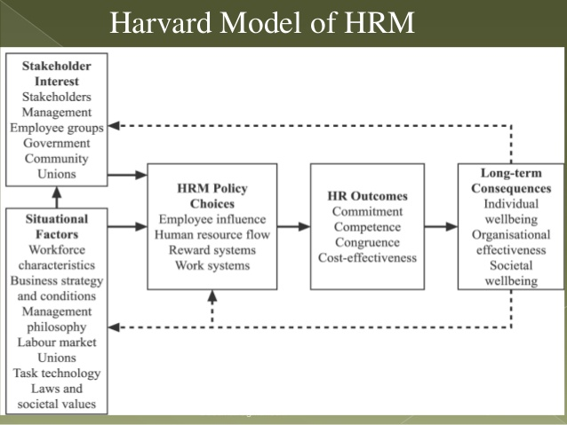
Figure 3 - Harvard Model
The relevance of Harvard Model of HRM to Raspberry Pi and employee engagement can be drawn from the figure above. It can be analyzed that HR managers of the foundation can alter the situational factors and HRM policy choices to ensure higher employee engagement. The HRM policies that can be altered include the employee influence and reward systems as these can be used to trigger the employee engagement at Raspberry Pi. In the view of Taylor (2014), HRM policy choices identified in the Harvard Model play an increasingly important role in shaping the human resource practices at an organization regardless of the type of organization and its business. In the given case, it must be noted that an alteration in HRM policy choices can lead to significant changes in the employee engagement, motivation and overall boost in employee productivity.

HRM Lifecycle
The HRM Lifecycle illustrated in the following figure identifies 9 steps to Human Resource Management at an organization. With respect to HRM Lifecycle, it must be noted that few steps need to be implemented effectively by the Raspberry Pi to ensure enhancement in the employee engagement. Two key steps in this regard are identified to be reward & recognition and development of the workforce as these relate to motivation of the employees and development of their skills to participate in the decision making respectively (Torrington et al., 2009). Furthermore, every step in the HRM Lifecycle is equally important for the effective management of human resources at an organization like Raspberry Pi.
Figure 4 - HRM Lifecycle

Recommendations
- The first recommendation for Raspberry Pi is based on the HRM Lifecycle. Raspberry Pi is recommended to focus on step 6 and 7 respectively to ensure employee retention at the foundation. However, Raspberry Pi is recommended to focus on all other steps identified in the lifecycle because the overall effectiveness of HRM process is the key to success of the foundation especially when number of employees is expected to grow significantly.
- The second recommendation for Raspberry Pi relates to the application of motivation theories and relevance of employee engagement to the motivation of employees. Raspberry Pi is recommended to identify the needs of employees and try maximum to satisfy the needs of employees to achieve higher productivity. Moreover, the satisfaction factors identified by Herzberg also need to be identified and maximized for greater employee motivation. The employees can be better engaged when they are motivated and vice versa as it is a two-way relationship.
- The third recommendation for Raspberry Pi is based on the Harvard Model of HRM as it is identified that Raspberry Pi needs to alter their policy choices and make sure that employee influence and reward systems promote the participation by the employees and the role of their leadership must also be shaped in a way so that it democratic leadership is utilized.

Conclusion
On the basis of the report, it can be concluded that Raspberry Pi can apply motivational theories to boost motivation level of its employees. Further, it is found that employees consider intrinsic factors of motivation as important and it also highlights the importance of employee engagement. Several advantages of employee engagement highlight that Raspberry Pi needs to engage its employees in decision making to ensure motivation level of employees. Further, it can be concluded that Harvard Model of HRM and HRM Lifecycle highlight that the company needs to focus specifically on some steps such as step 6 and 7 of the HRM Lifecycle.

References
Armstrong, M. (2017). Armstrong’s Handbook of Human Resource Management Practice. 14th ed. London: Kogan Page.
Cook, M. (2009). Personnel Selection: Adding Value Through People. 5th ed. Chichester: John Wiley.
Edenborough, R. (2007). Assessment Methods in Recruitment, Selection & Performance: A Manager's Guide to Psychometric Testing, Interviews and Assessment Centres. London: Kogan Page.
Edwards, T. and Rees, C. (2016). International Human Resource Management: Globalisation, National Systems & Multinational Companies. 3rd ed. Harlow: Pearson Education Limited.
Henderson, I. (2017). Human Resource Management for MBA and Business Masters. 3rd ed. London: CIPD.
Kompaso, S. and Sridevi, M. (2010). Employee Engagement: The Key to Improving Performance. International Journal of Business and Management, 5(12), pp.89.
Laroche, L. and Rutherford, D. (2007). Recruiting, Retaining, and Promoting Culturally Different Employees. Oxford: Butterworth-Heinemann.
Macey, W. H. and Schneider, B. (2008). The meaning of employee engagement. Industrial and Organizational Psychology, 1(1), pp.3-30.
Marchington, M. and Wilkinson, A. (2016). Human Resource Management at Work. 6th ed. London: CIPD.
Taylor, S. (2008). People Resourcing. 4th ed. London: CIPD.
Taylor, S. (2014). Resourcing and Talent Management. 6th ed. London: CIPD.
Torrington, D. Hall, L. Taylor, S and Atkinson, C. (2009). Fundamentals of Human Resource Management: Managing People at Work. London: Prentice Hall
Saks, A. M. (2006). Antecedents and consequences of employee engagement. Journal of managerial psychology, 21(7), pp.600-619.

