Consultancy Project- Project Initiation Document
Black Powder Gin Company/AA Events
‘Ginsperience’

Contents Page:
Executive Summary
- Project Justification
  - Project Rationale
  - Background- Business Case and Approach
  - Constraints

- Stakeholders
  - Businesses
  - Staff
  - Customers/Consumers

- Project Management Plan
  - Potential Risks
  - Potential Costs
  - Potential Benefits

- Communication strategy

- Research Methods

- Project Plan/Gant Chart

- Bibliography

Executive Summary
Project Aim:
- To critically analyse and evaluate the current marketing strategies utilised by The Black Powder Gin Company and AA Events.
- Discover alternative effective marketing strategies which The Black Powder Gin Company and AA Events can apply in order to attract their target demographic.
Project Objectives:
- To evaluate the effectiveness of present marketing strategies which attract the target demographic.
- To identify best practice examples of successful marketing strategies used in other establishments which directly relate to the Ginsperience.
- To produce a strategic marketing plan with recommendations for increasing the general attendance of the target demographic.
Benefits to the organisation:
- Increased revenue and profit levels.
- Increased attendance at the Ginsperience.
- Greater awareness of the Ginsperience and The Black Powder Gin Company’s products/services offered in the surrounding areas.
- More consumers which creates atmosphere and positivity in the venue enhancing the experience of the event.

Project Authorisation (Please Sign, Print and Date)

Consultant : _______________________________________________________ Date: / /

Participant: _______________________________________________________ Date: / /

- Project Justification-
The aim of the following project is to critically analyse and evaluate the current marketing strategies used by The Black Powder Gin Company and AA Events to promote their Ginsperience. The objective of this is to ensure that both companies can help the Ginsperience reach its full potential audience amongst their target demographic.
In order to discover the most effective marketing strategies in relation to achieving the objective, it is taken into consideration the effectiveness of present marketing activities utilised by the companies involved as well as effective strategies used by other strategies which have proven successful in other scenarios.
The investigations help to produce a strategic marketing plan with recommendations for improvement which can be utilised by the company in the future in order to achieve the objective.

With the focus being concentrated upon this aim the hope is that the following will be achieved by the companies involved as a result of the marketing strategies presented:

- That the business will see an increase in trade and revenue.
- That the establishment will see an increase in popularity amongst the targeted demographic.
- The company’s products/services will increase in popularity.

‘Social networks are now a substantial part of every marketing strategy, and the benefits of using social media are so great that anyone not implementing this cost-effective resource is missing out on a phenomenal marketing opportunity.’ (Blue Fountain Media)

  - Project Rationale
The following project could be beneficial for the businesses involved for a number of reasons due to the general advantages of influential marketing. The Black Power Gin Company and AA Events are currently utilising online marketing as they have an existing website which presents their products and services to the general public; as well as this they have social media pages, however the social media pages and website are only accessible when the public actively searches for them. Although an effort is being made to market the Ginsperience online, the use of aspects such as social media could be used more effectively in order to attract passing trade.
‘Marketing is an essential activity for any successful organization. Marketing is the process of communicating value to customers and “meeting needs profitability” (Keller & Kotler, 2009, p. 5).

  - Background- Business Case and Approach
The Black Powder distillery is a family run business that has been producing fruit infused gins for a number of years. All of their gins are made from select fruits and botanicals, harvested from their estate located in Weeton, Preston. They also offer a variety of other spirits and services which include private hire for weddings and parties and their Ginsperience.
The Ginsperience is an experience available to the public hosted on the estate of the distillery which features live music, a variety of drinks and cocktails and food in a picturesque setting and is available all year round across select dates and are accessible at the expense of £54 for a ticket.
Black Powder Gin and myself are working in co-ordination to attract a demographic aged between 25-65, with the main target areas being ‘millennials’ and ‘baby boomers’ (people aged between 45-65) from the distillery’s surrounding areas specifically, to the ‘Ginsperience’ Events. With the knowledge that these age groups in particular are more likely to attend such an event research has primarily focused on how to attract these demographics in a cost-effective manner.
‘60% of people in the 50 – 64 year age group, which is most of the boomer population, are now on at least one social media site. Facebook is by far the most popular social media site for baby boomers’ (Colorado University, 2016)
With the knowledge that this age group in particular are more likely to have expendable income for an event such as the Ginsperience due to many now being ‘empty nesters’ and some perhaps retiring, it would make sense to consider the option to advertise alongside Facebook as it is a proven cost effective method of reaching this area of our target demographic. The option to advertise with Facebook lets you decide how much you would like to invest into the advert and even gives you the option to select details about the demographic you would like to target, with the knowledge that from location analysis all of the surrounding areas have a larger population of ‘baby boomers’ this would make Facebook Advertisement an efficient method of reaching them as there would be the option to select the areas and ages to target.
‘While many Millennials haven't hit their peak purchasing power due to student loans and starting a family, they are certainly heading that way, and brands realize the importance of getting in front of them early. But marketers should take care in making sure that they aren't alienating other groups of consumers in the process.’ (Kim Speier, 2016)
The location analysis indicates that millennials are not that large of a demographic in the target areas meaning that there is a limited market, however with the knowledge that they are more likely to invest their time and income into events such as the Ginsperience this makes them an ideal target with the potential of longevity if a good customer-company relationship is maintained.
Although Facebook is again rated the most popular platform amongst millennials, a more effective choice of reaching millenials could be Instagram. Instagram is becoming increasingly popular and gives businesses the chance to present an advertisement post amongst their target demographics newsfeed as if it were a post from anybody else that they might follow.
  - Constraints
When undergoing any project, one must consider what could considered a constraint towards it. In this instance there are numerous constraints that could occur:
- Legal legislations and licenses that need to be adhered to whilst undertaking online advertising, including the business protection from misleading marketing regulations 2008 (UK Government, 2008).
- That the organisation may not have a willingness to accept the recommendations given by the consultant to improve their business once research has been collected and collated.

- Stakeholders
AA Events/Black Powder Gin Company- Black Powder Gin and AA events have together produced a well-received service in the Ginsperience. Due to the existing success of the Ginsperience the businesses involved are interested in expanding it’s popularity amongst the target demographics. The increase in popularity will benefit the businesses involved as it will also raise awareness of their other products/services.
Staff- The staff are a mix of ages from the surrounding areas giving the Ginsperience a local feel. This could also prove beneficial to them as if the Ginsperience does successfully advertise the private hire services available this will result in more potential work opportunities.
Customers/Consumers- The current attendance of the Ginsperience are generally consumers of Black Powder Gin’s products and are of a variety of walks of life from the surrounding areas. Much of the attendance are aged between 30-50 and so with the aim of attracting an audience both older and younger there could be a concern that the experience which is already enjoyed could be altered to accommodate them. However, with this in mind the changes addressed by the business strategy won’t directly affect the existing experience.

- Project Management
3.1) Potential Risks-
The biggest risk in trying to market the Ginsperience to a younger crowd is that if it is too successful and attracts a lot of attention then this could perhaps persuade the existing customers to go elsewhere.
The risk in trying to attract the older crowd (the ‘baby boomers’) is that it will be difficult to successfully market to both them and millennials, however it is possible to market them both completely separately.

3.2) Potential Costs-
With the main marketing strategy being focused around advertising through popular media sites the costs can be kept minimal. Social media sites such as Facebook and Instagram give the customer the option to invest as much as they would like to over a period of time, the more the businesses wish the invest the more their advert will be present amongst their target demographics social media feeds.
Any costs included will more than likely require finance from management, however the costs of advertising on social media are reasonable and the extent of the investment is entirely dependant on how much management are willing to invest.
3.3) Potential Benefits-
The benefits of using social media amongst other effective methods is that it is a proven efficient method with more people spending more and more time on social media platforms every day. If the marketing strategies are successful and the target market is attracted to the Ginsperience then this will raise awareness of the products and alternate services which are also offered by AA Events and Black Powder Gin Company.

- Communication Strategy
Due to the Black Powder Gin company and AA Events being based in Lancashire communication has been reduced to email for the time being. However, regular contact is maintained and they have been kept up to date with the consultancy projects progress.

- Research Methods
-In order to determine which demographics should be targeted and marketed towards most of the research conducted has been secondary.
-Primary research in the form of a questionnaire is scheduled to be carried out.

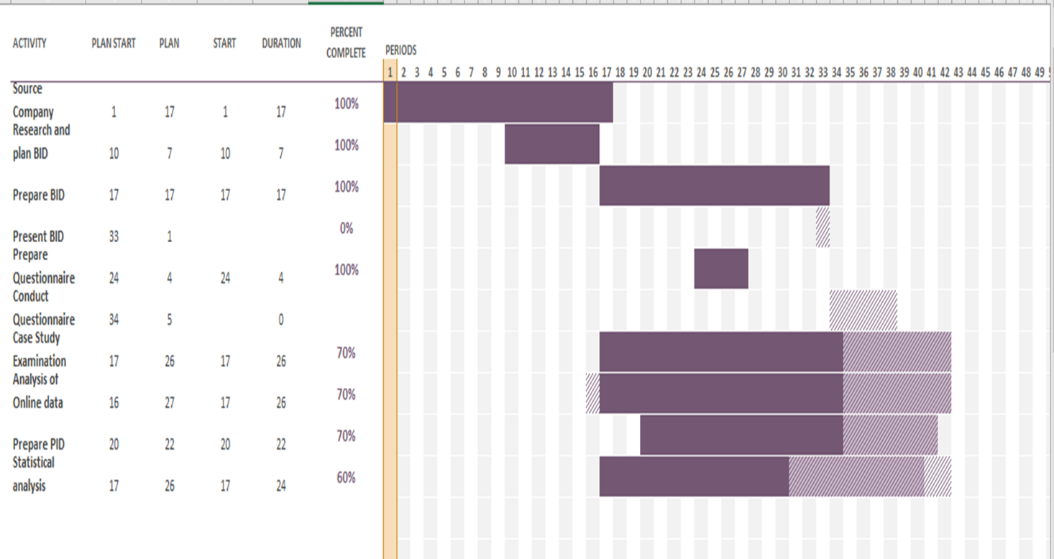
- Project Plan/Gant Chart

- Bibliography
- https://www.smartinsights.com/digital-marketing-strategy/baby-boomer-marketing-statistics/
- https://www.goldmansachs.com/insights/archive/millennials/
- https://www.thedrum.com/opinion/2018/11/30/top-five-tips-attract-younger-audience
- https://www.socialmediatoday.com/marketing/why-are-marketers-so-obsessed-millennials
- https://www.digitalmarketingcommunity.com/indicators/social-networks-millennials-usage-2018/
- https://edkentmedia.com/5-benefits-advertising-social-media/
- https://www.bluefountainmedia.com/blog/advantages-of-social-media-marketing

- https://www.webfx.com/internet-marketing/social-media-marketing-advantages-and-disadvantages.html
- https://business.instagram.com/advertising/
- https://en-gb.facebook.com/business/ads/pricing
- https://en-gb.facebook.com/business/ads/

