

EMERGENT LEADERSHIP SKILLS IN THE WORKPLACE reflective report part 2
BA Leadership and Management BMSW6101

April 5, 2024
SABRINA REID 1920873
LECTURER: Dr Sujeewa Herath

Reflection Report

The given reflection report adheres to the Driscoll framework, as established by Driscoll and Borton, (1994).

What...
During my time at The University of Wales Trinity Saint David (UWTSD), (Uwtsd, 2024) whilst studying the emergent leadership module, the exploration caused me to become more conscious of the importance of the various strategies for effective leadership inside an organization. I have come to appreciate how crucial leaders are in evaluating employee performance, establishing standards for behaviour, and determining whether organizational goals have been achieved (Antonakis et al., 2009; Dinh and Lord, 2012).

Additionally, I acknowledge the significance of moral leadership in forging a solid moral and ethical foundation, that can positively impact employees within a company (Antonakis et al., 2009) and (Dinh and Lord, 2012). We were all required to complete an emotional intelligence checklist, a task relationship questionnaire, and a conceptualizing leadership questionnaire during various academic sessions of this module to determine our capacities for emotional intelligence, concept of leadership, and task relationship. The findings from all of these can be found in the images below.

Emotional Checklist
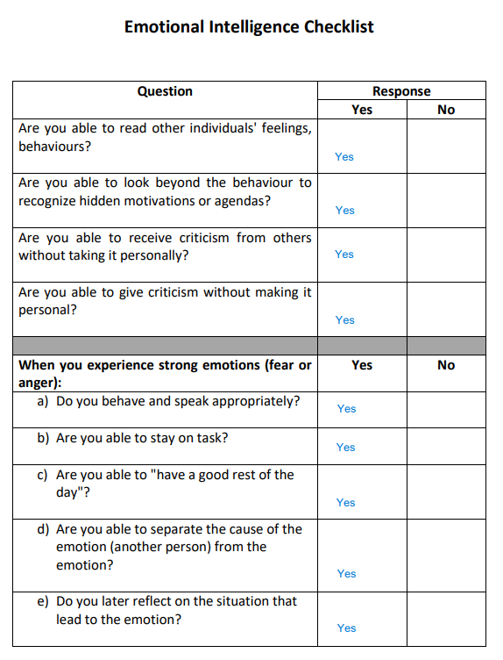

Figure 5: By (Uwtsd, 2024) and Author

Task Relationship Questionnaire
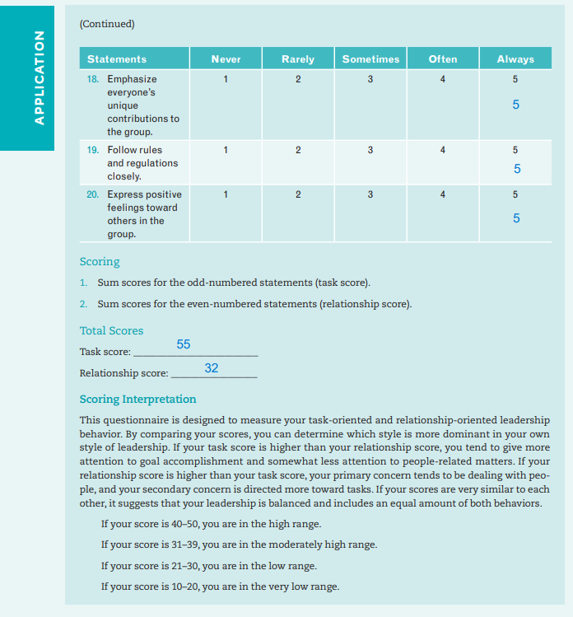

Figure 6: By (Uwtsd, 2024) and Author

Conceptualizing Leadership Questionnaire
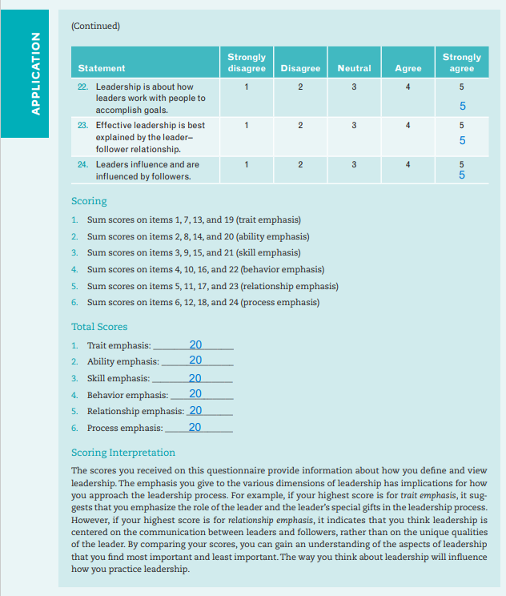

Figure 7: By (Uwtsd, 2024) and Author

Completing these questionnaires enabled me to view my comprehension and perceptions of leadership with the knowledge I am acquiring as a result of studying and developing these aptitudes and abilities. I am conscious of the difficulties that leaders may encounter when leading an organization. In particular, when an authoritarian approach to leadership is misused, the result is discontentment among the workforce since the leader becomes dictatorial, controlling, and oppressive (Cherry and Susman, 2023).

However, I recognize that this strategy could prove more effective when combined with additional techniques, particularly transformational or democratic practices. Furthermore, I am conscious of how democratic decision-making is distributed including how critical it is to acknowledge the skills and expertise of employees which are essential to an effective contribution within a democratic framework (Cherry and Susman, 2023).

Studying this module enabled me to become instantly aware of the dark leadership triad when I watched the Royal Mail Horizon scandal and the catastrophic impact that it had on the lives of the employees involved (Lawson, 2023), (Kollewe, 2023). To understand the devastating effects of dark leadership in any organizational environment, I researched further into this area of leadership. Identifying dark leadership early on and putting an abrupt stop to it is crucial (Boddy, 2011, 2017; Margalit, 2022).

My analysis of the various leadership philosophies and qualities essential to effectively leading a dynamic, constantly developing company has led to an expansion of my present position of growth and development derived from the emergent leadership module. To effectively assist employee morale and efficiency within an organizational environment, I additionally recognize what a vital asset it is to develop high levels of self-awareness, strong emotional intelligence, and effective interpersonal abilities (Hall, 2004), (Danae F. Sfantou et al., 2017).

During my time at UWTSD, (Uwtsd, 2024) I additionally had an opportunity to observe these attributes through observing various lecturers' interactions when assisting their students. Furthermore, career advisors, program managers, the UWTSD (Uwtsd, 2024) assessments team, and other faculty members working within the UWTSD's (Uwtsd, 2024) various departments have all demonstrated varying styles of leadership attributes within their interactions with students, including myself, regarding different aspects of my journey.

I am cognizant of how critical it is that I continue to cultivate these attributes and grow. According to analysis, strengthening these qualities is essential for developing into a powerful leader (Sharifi-Rad et al., 2017), (Danae F. Sfantou et al., 2017). I am aware that for me to achieve positive results, I must constantly enhance and broaden my diverse set of leadership abilities.

So, what…
Studying this module has been enjoyable for me as it has strengthened my understanding of leadership and given me more confidence, especially since I have not worked for a while now.
Furthermore, while studying alongside my fellow classmates during multiple lectures, within classroom discussions regarding the various aspects of leadership abilities and traits, gaining an understanding of people’s perspectives of leadership for instance, whether someone can be a born leader or develop these characteristics, was particularly interesting hearing varying viewpoints that were not always correlating with my opinion of these both being feasible.
However, these diverse classroom discussions, gave me great insight into other individual’s thought processes, including the style of leadership we all viewed ourselves to have, in comparison to what the results of questionnaires we all completed indicated. I found that these discussions actually brought us closer as a group, as we would continue them after the lecture was over, which created an open environment to hear that even though my fellow colleagues who many work, have their own business or are self-employed, also encountered the same insecurities I was experiencing.
This brought me a form of comfort and ease during times when doubting the levels of my capabilities and comprehension of our studies. Collectively we have worked as a team supporting, encouraging, and assisting each other on our academic journey. The personal development that I have gained from studying this module has empowered me and afforded me the skills and knowledge that enable me to impart in my professional, personal, and family life.

Now what…
I believe these skills and abilities I have gained through this module will be beneficial to me in my future endeavours. However, I intend on continuing with my studies to further expand my knowledge base and develop my skill set and abilities as I believe this will assist me in becoming an asset to an organisation, should I apply these attributes.
For instance, I can identify certain traits that I already possess and can apply Lewin's democratic, autocratic, and laissez-faire leadership styles to a variety of circumstances and environments in both my personal and professional life.
I found this encouraging which assisted in building my confidence given I have been out of work for some years, so my appreciation for the various leadership styles active in the workforce is not on the same parity as my fellow associates at UWTSD (Uwtsd, 2024). Furthermore, I recognize by combining Lewin’s different methods of leadership and applying them within various scenarios and settings can prove to be more effective.
I additionally was able to experience this during my time at university by observing various lecturers and their methods of leadership when assisting and supporting students. Furthermore, from their interactions with these students, including myself, concerning all aspects of my academic journey, program managers and other faculty members working within the university's various departments have all demonstrated varying styles of leadership attributes.

References
Antonakis, J., Ashkanasy, N. and Dasborough, M. (2009) 'Does leadership need emotional intelligence?', The Leadership quarterly, 20(2), pp. 247–261. Available at: https://www-sciencedirect-com.ezproxy.uwtsd.ac.uk/science/article/pii/S1048984309000174?via%3Dihub (Accessed: Accessed: 13 January 2024). Boddy, C. (2011) 'The Corporate Psychopaths Theory of the Global Financial Crisis', Journal of Business Ethics, 102(2), pp. 255–259. Available at: https://www.proquest.com/docview/883904642?accountid=130472&parentSessionId=3L1McWrnZWdviMOuiw22cFklMN82T%2Bshav0O3Zhowps%3D&pq-origsite=primo&sourcetype=Scholarly%20Journals (Accessed: 04 March 2024).
Boddy, C. (2017) 'Psychopathic Leadership: A Case Study of a Corporate Psychopath CEO', Journal of Business Ethics, 145(1), pp. 141–156. Available at: https://www.proquest.com/docview/1940078816?accountid=130472&parentSessionId=SoroSuw9rUE7590f%2FGBXglNdi%2FGpBLskr9IPv5u789E%3D&pq-origsite=primo&sourcetype=Scholarly%20Journals (Accessed: 04 March 2024).
Cherry, K. and Susman, D. (2023) What Is Autocratic Leadership? Characteristics, Strengths, and Weaknesses of Autocratic Leadership, Very Well Mind; Personality Psychology. Available at: https://www.verywellmind.com/what-is-autocratic-leadership-2795314#:~:text=Because%20autocratic%20leaders%20make%20decisions,hurt%20the%20group%20from%20performing. (Accessed: 17 February 2024).
Danae F. Sfantou , D.F.S. et al. (2017) ‘Importance of Leadership Style towards Quality-of-Care Measures in Healthcare Settings: A Systematic Review’, Healthcare, 5(4). Available at: https://www.mdpi.com/2227-9032/5/4/73#metrics (Accessed: 17 February 2024).
Dinh, J. and Lord, R. (2012) ‘Implications of dispositional and process views of traits for individual difference research in leadership’, The Leadership Quarterly, 23(4), pp. 651–669. Available at: https://www-sciencedirect-com.ezproxy.uwtsd.ac.uk/science/article/pii/S1048984312000203?via%3Dihub (Accessed: 13 January 2024).
Driscoll, J. and Borton, T. (1994) Driscoll (by Borton) Model of Reflection (1994), Borton model of reflection.pdf. Available at: https://www.bradfordvts.co.uk/wp-content/onlineresources/teaching-learning/reflection/borton%20model%20of%20reflection.pdf (Accessed: 01 March 2024).
Hall, D. (2004) ‘Self-Awareness, Identity, and Leader Development’, in D. Day, S. Zaccaro, and S. Halpin (eds.) Leader Development for Transforming Organizations Growing Leaders for Tomorrow. Milton Park, Oxfordshire: Taylor & Francis, pp. 153–173. Available at: https://www.google.co.uk/books/edition/Leader_Development_for_Transforming_Orga/3s54AgAAQBAJ?hl=en&gbpv=1&dq=Hall+D+T+(2004),+%E2%80%9CSelf-Awareness,+Identity,+and+Leader+Development%E2%80%9D,+in+D+V+Day,+S+J+Zacarro+and+S+M+Halpin+(Eds.),+Leader+Development+for+Transforming+Organizations:+Growing+Leaders+for+Tomorrow,+pp.+153-176,+Erlbaum,+Mahwah,+NJ&pg=PA153&printsec=frontcover (Accessed: 13 January 2024).
Kollewe, J. (2023) ‘ Royal Mail staff to stage 24-hour strike on 16 February’, The Guardian Newspaper, 2 February. Available at: https://www.theguardian.com/business/2023/feb/02/royal-mail-staff-striken-16-february-cwu-pay (Accessed: 13 February 2024).
Lawson, A. (2023) ‘Royal Mail workers poised for strikes after Easter as talks falter’, The Guardian . Uk Edition, 28 March. Available at: https://www.theguardian.com/business/2023/mar/28/royal-mail-strikes-after-easter-talks-cwu-union#:~:text=Relations%20between%20Royal%20Mail%20executives,over%20pay%20and%20working%20practices. (Accessed: 12 February 2024).
Uwtsd, T. (2024) About the University of Wales Trinity Saint David. Available at: https://www.uwtsd.ac.uk/ (Accessed: 02 March 2024).

