Marketing plan

Student name: Ana Maria Bosuioc
Student ID: 2126864
Tutor Name: Luciana Suardi

Table of Contents
Introduction 3
Situation Analysis 4
Objectives 5
Strategy 6
Tactics 6
Action 8
Control 8
Conclusion 10
References 11
Appendix 13

Introduction
The Ritz Carlton hotel is a luxury hotel chain that is known for its exceptional customer service, premium amenities, and unique experiences. In this report, we will explore the marketing essentials of the Ritz Carlton hotel, including its target market, marketing mix, segmentation, targeting and positioning, and marketing communications. We will also provide recommendations for the hotel to improve its marketing strategies and continue to attract and retain its target market. Through this report, we aim to gain a deeper understanding of the marketing strategies that have made the Ritz Carlton hotel a success in the luxury hospitality industry.
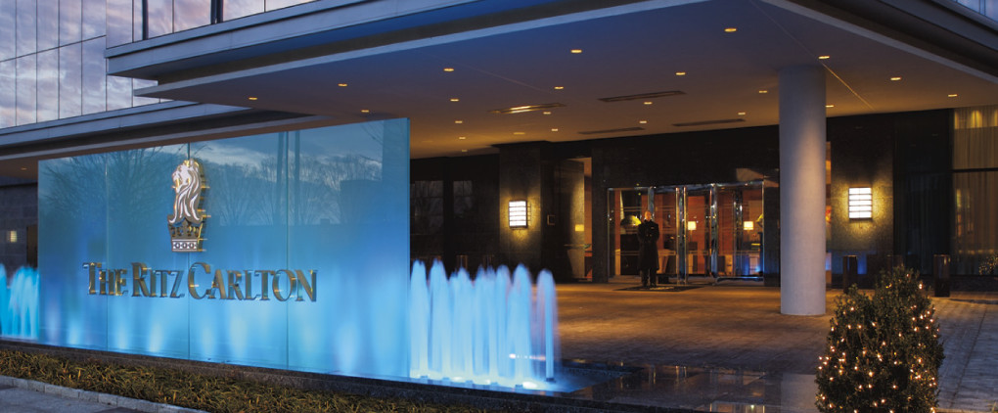
Figure 1: The Ritz Carlton
(Source: rcresidencewestchester.com)

Situation Analysis
The Ritz Carlton hotel is a luxury hotel chain that operates in 30 countries worldwide. It targets affluent travelers seeking a premium experience and emphasizes exceptional customer service and unique experiences. The hotel faces competition from other luxury hotel chains and must continue to innovate and differentiate itself in the market (Yadav, and Rahman, 2017).
5C’s
The 5C's analysis is a useful tool for understanding the external and internal factors that affect a business. Here is an analysis of the 5C's for the Ritz Carlton hotel:
Customers: The Ritz Carlton hotel targets affluent travelers seeking a premium experience. Its customers value exceptional customer service, unique experiences, and luxury amenities. The hotel must continue to understand its customers' needs and preferences to maintain its competitive edge (Wan, 2015).
Competitors: The luxury hospitality industry is highly competitive, with other luxury hotel chains such as Four Seasons, Mandarin Oriental, and St. Regis vying for the same target market. The Ritz Carlton must differentiate itself through exceptional customer service, innovative offerings, and a strong brand reputation (Sainaghi, Phillips and Corti, (2017).
Collaborators: The Ritz Carlton hotel collaborates with other luxury brands, such as Tiffany & Co. and Bulgari, to offer unique experiences to its guests. It also partners with airlines and travel companies to provide seamless travel experiences. The hotel must continue to cultivate these partnerships to provide added value to its guests (Baines, Fill, and Rosengren, 2017).
Climate: The hospitality industry is sensitive to economic conditions and global events, such as natural disasters and pandemics. The Ritz Carlton must be agile and adaptable to changing conditions and have contingency plans in place (Zhang, and Hong, 2017).
Company: The Ritz Carlton hotel has a strong brand reputation and a commitment to exceptional customer service. It invests heavily in employee training and development to ensure its staff provides personalized and memorable experiences to its guests. The hotel must continue to innovate and differentiate itself to maintain its competitive edge and appeal to its target market.
Overall, the Ritz Carlton hotel must continue to understand its customers, differentiate itself from competitors, collaborate with partners, adapt to changing conditions, and invest in its employees to maintain its position as a leader in the luxury hospitality industry (Chen, and Lin, 2019).

Objectives
The Ritz-Carlton is a luxury hotel brand that aims to provide exceptional customer service and create memorable experiences for its guests. To achieve this, the company may set SMART objectives such as:
- Increase guest satisfaction scores by 10% in the next year through personalized service and attention to detail.
- Improve employee retention rates by 15% by implementing a comprehensive training program for new hires and providing ongoing professional development opportunities.
- Increase revenue by 20% in the next fiscal year by expanding marketing efforts and targeting new markets.
- Reduce operating expenses by 5% in the next year by implementing cost-saving measures such as energy-efficient technologies and waste reduction programs.
- Achieve a 95% occupancy rate during peak seasons by increasing online marketing efforts and partnering with travel agencies to promote the brand.

Strategy
The strategy of the Ritz Carlton hotel is to provide a premium luxury experience to its target market of affluent travelers. The hotel achieves this through exceptional customer service, unique experiences, and luxury amenities.
One of the key aspects of the Ritz Carlton's strategy is its focus on employee training and development. The hotel invests heavily in its employees, known as "Ladies and Gentlemen," to ensure they provide personalized and memorable experiences to its guests. This commitment to exceptional customer service is a key differentiator for the Ritz Carlton and has helped the hotel build a strong brand reputation (Schuler, 2015).
Another aspect of the Ritz Carlton's strategy is its emphasis on unique experiences. The hotel offers a variety of programs and services, such as cooking classes, spa treatments, and cultural tours, to provide guests with a one-of-a-kind experience. This focus on unique experiences helps the Ritz Carlton differentiate itself from other luxury hotel chains and appeal to its target market.
Finally, the Ritz Carlton's strategy includes expanding its global footprint while maintaining its commitment to exceptional customer service and unique experiences. The hotel has expanded to 30 countries worldwide and continues to look for opportunities to expand its reach and appeal to new markets (Dillard, et al, 2020).

Tactics
The marketing mix of the Ritz Carlton hotel includes the 4P's: Product, Price, Place, and Promotion. Here is an analysis of each element:
Product: The Ritz Carlton hotel provides a premium luxury experience to its guests, including luxury accommodations, exceptional customer service, and unique experiences. The hotel offers a variety of room types and suites, each with premium amenities such as fine linens, high-end toiletries, and state-of-the-art technology. The hotel also provides a range of services such as spa treatments, cultural experiences, and dining options, to enhance the guest experience (Hsu, 2022).
Price: The Ritz Carlton hotel is a premium luxury brand, and its pricing reflects this. Room rates are high compared to other hotel chains, reflecting the premium experience and unique offerings provided by the hotel. The hotel also offers packages and promotions to attract guests, such as seasonal specials and loyalty programs (Hussain, Konar, and Ali, 2016).
Place: The Ritz Carlton hotel operates in 30 countries worldwide, with a focus on premium destinations such as major cities, resorts, and vacation spots. The hotel often locates in iconic buildings or landmarks, such as historic buildings or skyscrapers, to provide a unique and memorable experience for guests.
Promotion: The Ritz Carlton hotel's promotion strategy focuses on highlighting the hotel's unique offerings, such as exceptional customer service and unique experiences. The hotel uses a variety of marketing channels to reach its target market, including social media, print ads, and sponsorships. The hotel also partners with luxury brands to offer unique experiences to its guests, such as exclusive shopping events or private tours (Bayraktaroglu, and Kutanis, 2018).
Overall, the Ritz Carlton hotel's marketing mix reflects its position as a premium luxury brand. The hotel's focus on exceptional customer service, unique experiences, and luxury amenities has helped it differentiate itself from competitors and appeal to its target market of affluent travelers (Bilgin, 2018).

Action
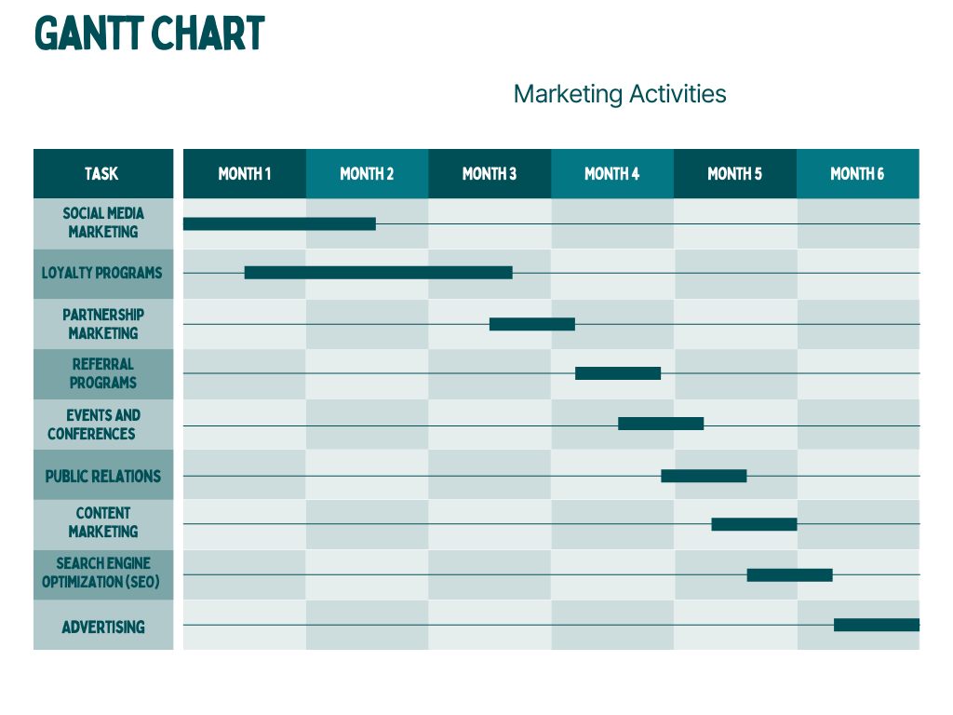

Control
The success of the Ritz Carlton hotel can be measured in several ways. One key metric is customer satisfaction, which is tracked through guest surveys and feedback. The hotel strives for a high level of customer satisfaction, as this leads to repeat business and positive word-of-mouth marketing.
Another measure of success is revenue growth, which reflects the hotel's ability to attract guests and generate income. The Ritz Carlton's premium pricing strategy helps drive revenue growth, as guests are willing to pay a premium for the hotel's luxury experience and unique offerings (Aldehayyat, Al Khattab, and Anchor, 2021).
The Ritz Carlton also tracks brand reputation, both through its own marketing efforts and through monitoring social media and online reviews. Maintaining a positive brand reputation is critical for the hotel's success, as it helps attract new guests and retain existing ones (Seo, and Park, 2018).
Finally, the Ritz Carlton tracks employee satisfaction and retention rates, as this is a key factor in providing exceptional customer service. Happy and engaged employees are more likely to provide exceptional service to guests, leading to higher customer satisfaction and repeat business (Sainaghi, 2020).

Conclusion
In conclusion, the marketing essentials of the Ritz Carlton hotel have been essential to its success as a premium luxury brand in the hospitality industry. The hotel's focus on exceptional customer service, unique experiences, and luxury amenities has helped it differentiate itself from competitors and appeal to its target market of affluent travelers. Through a comprehensive analysis of the hotel's situation analysis, marketing mix, segmentation, targeting, and positioning strategies, and marketing communications, this report has highlighted the key factors contributing to the Ritz Carlton's success.

References
- Aldehayyat, J.S., Al Khattab, A.A. and Anchor, J.R., (2021) ‘The use of strategic planning tools and techniques by hotels in Jordan’, Management Research Review, pp.477-490
- Baines, P., Fill, C. and Rosengren, S., (2017). Marketing. Oxford University Press.
- Bayraktaroglu, S. and Kutanis, R.O., (2018) ‘Transforming hotels into learning organizations: A new strategy for going global’, Tourism Management, 24(2), pp.149-154.
- Bilgin, Y., (2018) ‘The effect of social media marketing activities on brand awareness, brand image and brand loyalty’, Business & management studies: an international journal, 6(1), pp.128-148.
- Chen, S.C. and Lin, C.P., (2019) ‘Understanding the effect of social media marketing activities: The mediation of social identification, perceived value, and satisfaction’, Technological Forecasting and Social Change, 140(2), pp.22-32.
- Dillard, C., Browning, L.D., Sitkin, S.B. and Sutcliffe, K.M., (2020) ‘Impression management and the use of procedures at the Ritz‐Carlton: Moral standards and dramaturgical discipline’, Communication studies, 51(4), pp.404-414.
- Hsu, Y.L., (2022) ‘Facebook as international eMarketing strategy of Taiwan hotels’, International journal of hospitality management, 31(3), pp.972-980.
- Hussain, K., Konar, R. and Ali, F., (2016) ‘Measuring service innovation performance through team culture and knowledge sharing behavior in hotel services: a PLS approach’, Procedia-Social and Behavioral Sciences, 224, pp.35-43.
- Sainaghi, R., (2020) ‘Hotel performance: state of the art’, International Journal of Contemporary Hospitality Management, 22(7), pp.920-952.
- Sainaghi, R., Phillips, P. and Corti, V., (2017) ‘Measuring hotel performance: Using a balanced scorecard perspectives’ approach’, International Journal of Hospitality Management, 34, pp.150-159.
- Schuler, R.S., (2015) ‘The 5-C framework for managing talent’,Organizational Dynamics, 44(1), pp.47-56.
- Seo, E.J. and Park, J.W., (2018) ‘A study on the effects of social media marketing activities on brand equity and customer response in the airline industry’, Journal of Air Transport Management, 66, pp.36-41.
- Wan, T., (2015) Analyzing the relationship between customer satisfaction and customer loyalty case: Ritz-Carlton Guangzhou. Lapland University of Applied Sciences
- Yadav, M. and Rahman, Z., (2017) ‘Measuring consumer perception of social media marketing activities in e-commerce industry: Scale development & validation’, Telematics and Informatics, 34(7), pp.1294-1307.
- Zhang, S. and Hong, H., (2017) ‘February. Research on Hainan's Global Tourism Development Strategy Based on SWOT Analysis’, International Conference on Humanities Science, Management and Education Technology (HSMET 2017), 96, pp. 518-526

Appendix
Slide 1

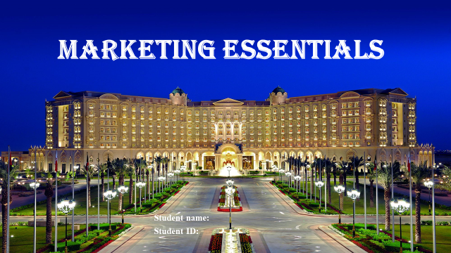

Slide 2

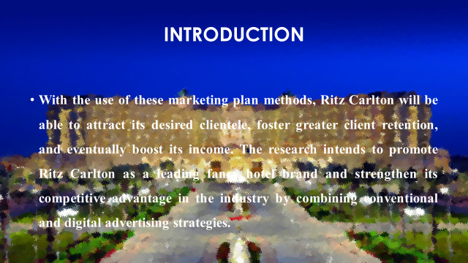

Slide 3

Slide 4

Slide 5

Slide 6

Slide 7

Slide 8

Slide 9

Slide 10

