Marketing Essentials (BMIH4005)

Topic - A comparison of the marketing method of two multinational hotel brands

Student Name: Andreea Gama
Student ID: 2219781
Module Title: Marketing Essentials BMIH4005
Lecturer’s Name: Ruth Taylor Davies
Word Count: 1529

Introduction
Marketing is extremely important because it helps the organiser to sell and promote their products to the marketing industry. The main aim of an organisation is to make profit and marketing is one of the most effective channels in order to reach their goals. This essay also offers detailed information related to Six Senses and Moxy hotel and the steps they have taken to bring sustainability.

Main Body
Six Senses Hotels Resort Spas functions and operates 11 resorts and 12 spas in more than 20 countries all around the world with the brand name Six sense. Six sense offers quality services, luxurious hospitality and treatment to their customers (Yousaf et al., 2021). The organisation aims for sustainability and welcoming nature to become one of the leading hospitality brands (Ketter and Avraham, 2021).
Moxy is one of the most stylish, affordable hotel brands which is mainly designed in order to offer extremely luxurious services. The main goal of Moxy hotels is to provide everything their guests desire (Weinstein, 2022).
SWOT Analysis of Six Senses Hotel & Resort;
One of the major strengths of Six Senses Hotel & Resort is their uniqueness of products and services which helps the organisation to be competitive in the marketing industry. One of the major weaknesses of Six Senses Hotel & Resort is their unclear selling propositions and very low online and social media understandings and presence which act as a major barrier for growth and productivity of their business (Han, 2020). Some of the major opportunities for Six Senses Hotel & Resorts are making the improvement in the online booking and flexibility in prices and expenses. Threats that Six Senses Hotel & Resort may face during their journey is the rise and expansion of Airbnb, which is widely popular in the current marketing industry.
SWOT Analysis of Moxy Hotel;
One of the utmost strengths of Moxy Hotel is its Global Presences. The global operations not only help the organisation to increase their revenues but also maintain their standards in the industry. Moxy is basically marketed as the family focused business from the marketing position to the management which may act as the weakness of the organisation. The opportunity of the company is that Moxy Hotel needs to invest their quality time on the young generation people, who possess high potentiality to completely transform the image of the organisation. The company may face threats such as The Hospitality industry is highly competitive. Everyday new organisations emerge in the marketing industries with their own creative ideas which give severe challenges to the company.
PEST Analysis of Six Senses Hotel & Resort and Moxy Hotel;
The Political factors include the prime challenges of Six Senses Hotel and Moxy hotel is the Political instability of the UK government. The fluctuation of policies will severely hamper the overall business of the organisation in multiple areas. The Economic Factors include the Economic conditions like unemployment, recession, financial instability and Inflations hugely influence the performances of Six Senses Hotel and Moxy Hotel. When the economy is on the rise, people usually prefer the luxurious hotels bringing profit to them. The social factors of the company may relate to travellers and customers from different classes, backgrounds and age groups (Yetimoğlu and Uğurlu, 2020). The Technology Factors relates with the factors of Artificial Intelligence that plays a major role when it comes to increasing the productivity of the organisation. Implementation of Artificial intelligence can help the organisation to gather some important information.
The marketing choices of Six Senses and Moxy hotel can be analysed by the 7Ps of the marketing mix. The marketing decisions for the products of Moxy hotel consists of various unique services relative to flights, reservations of hotels, packages of hotel, vacations and car rental services (Piuchan and Prachansit, 2019). On the other hand, Six Senses marketing decisions relating to products through the holistic approach where their main base is centred upon empathy towards the customers and offering best services.
Price is defined as the value for which the company provides their products or services to the customers. The pricing strategy of Moxy hotel includes premium pricing strategy; it refers to the strategy where the company sets the prices of the products artificially high to influence the favorable perception among the customers. On the other hand, the pricing strategy of Six Senses includes competitive pricing policy; it refers to the strategy where the company sets the prices of the products according to the prices set by their competitors.
Place refers to the place where the company can meet their targeted customers. Moxy is located in London. The hotel features a winery which puts the customers within a 15 minute Windsor castle drive. To inform their customers about the place and features of the hotel, their marketing choices of place relate with the idea of a free city guide of two to three short road trips. On the other hand, Six Senses is headquartered in Whiteley, where the location of the hotel provides their customers with features of an ecstatic ecosystem with dedicated restaurant and communal spaces (Pinto, 2022).
Six Senses hotel’s promotional activities were through social media marketing where they used different social media platforms to advertise their brands (Fahreza, 2019). The marketing decisions of Moxy to promote their products, they started a campaign called the “30 stays 300 days” which outlined that each traveller will be provided with ten incredible stays in their hotels over the course of 300 days. The similarweb software helps them to ascertain their marketing position in the industry (Refer to Appendix). Their hotels are equipped with sound-absorbing multi-layer technology that helps the customers to avoid the noise system and vibrations (Andi, 2021).
Physical evidence implies the experiences or tangible goods that attract the customers towards the company’s brand. Moxy hotel provides an economic and new lifestyle to the young generations (Andi, 2021). On the other hand, Six Senses hotels provide their customers with great and close beauty of nature.
People are the groups who come in direct contact or touch with the company's targeted customers. Both Moxy hotel and Six Senses hotel have hired employees with the best experiences in the tourism industry.
Process refers to the way the company offers their products to the customers. Moxy Hotel provides their clients or customers with well equipped hotel rooms that have walk-in shower, MUK bath amenities. Six Senses hotel provides their customers with a wide range of beauty and treatment, holistic wellness, and rejuvenation.
Moxy hotel improved their engagement with the customers through their newly developed user-generated content which helps them to attract the attention of the millennial and engage their customers with the help of influencers (He et al., 2021). Their application “MLive” helps them to gain the instant feedback of their customers during their stay.
Six Senses hotel applies the traditional marketing strategy which means that they engage or communicate with their customers with the usage of offline media to attract the targeted customers (George, 2021).
STP of Six Senses Hotel;
Being one of the well-known hotel companies, with lots of unique services and offerings provided to their customers, Six Senses follows the Demographic Segmentation in their business and organisation (Eskerod et al., 2019). The targeted customers of Six Senses hotel are from 18-24 years old.
Positioning; the Six Senses hotels & resorts lie in high quality and low price categories. This means that the company offers high quality of services and products at lower price to the consumers in the markets (Refer to Appendix).
STP of Moxy Hotel;
Moxy hotel & Resort can be discussed in relation to four segments like Luxurious hotels, upper middle-scale hotels, upper upscale hotels and upscale hotels. Moxy addresses the importance of the geographic segmentations and mainly focuses on such regions where engagement is very high (Amoako et al., 2021). Their targeted audiences are people from 30-50 years.
Positioning; the Moxy Hotel falls under High quality and High price categories which means that the organisation provides high quality products and services at a high price (Refer to Appendix).
Six Senses Company applies Internet marketing strategy in order to promote their products and services in the National and International market. The Company promotes their products and services through social media.
Moxy Hotel follows the Relationship marketing strategy in order to promote current relationships with their customers and build customer loyalty.
For Six Senses Hotel, sustainability means being environment friendly (Eskerod et al., 2019). Six Senses is now focusing on saving marine life such as green turtles, whale sharks, etc. (Mishra and Gupta, 2019). Moxy Hotel 2025 sustainability and social impact Goals and plans their path in order to make a positive and sustainable influence. Their goal is to support meaningful progress towards the United Nations Sustainable Development goals (Hojnik et al., 2019).

Conclusion
This essay has covered the information related to the Marketing essentials by showcasing two leading organisations Six Senses Resort and Moxy Hotels and their role towards sustainability in their organisations and environment. The essay also offers information related to current marketing strategies used by the two mentioned organisations and what changes they have brought for the betterment of the world, animals and human beings.

References
Amoako, G.K., Doe, J.K. and Dzogbenuku, R.K., 2021. Perceived firm ethicality and brand loyalty: the mediating role of corporate social responsibility and perceived green marketing. Society and Business Review.
Andi, B.B., 2021. THE IMPACT OF BRAND IMAGE ON CUSTOMER LOYALTY IN MOXY BANDUNG HOTEL (Doctoral dissertation, Poltekpar NHI Bandung).
Eskerod, P., Hollensen, S., Morales-Contreras, M.F. and Arteaga-Ortiz, J., 2019. Drivers for pursuing sustainability through IoT technology within high-end hotels—an exploratory study. Sustainability, 11(19), p.5372.
Fahreza, G., 2019. STUDI TENTANG INOVASI PRODUK PELAYANAN HOTEL UNTUK GENERASI ZDI YELLO HOTEL BANDUNG (Doctoral dissertation, UNIVERSITAS NEGERI JAKARTA).
George, R., 2021. Market Segmentation, Targeting, and Positioning. In Marketing Tourism and Hospitality: Concepts and Cases (pp. 221-246). Cham: Springer International Publishing.
Gil-Soto, E., Armas-Cruz, Y., Morini-Marrero, S. and Ramos-Henríquez, J.M., 2019. Hotel guests’ perceptions of environmental friendly practices in social media. International Journal of Hospitality Management, 78, pp.59-67.
Glenister, G., 2021. Influencer Marketing Strategy: How to create successful influencer marketing. Kogan Page Publishers.
Han, H., 2020. Theory of green purchase behavior (TGPB): A new theory for sustainable consumption of green hotel and green restaurant products. Business Strategy and the Environment, 29(6), pp.2815-2828.
He, J., Morrison, A.M. and Zhang, H., 2021. Being sustainable: The three‐way interactive effects of CSR, green human resource management, and responsible leadership on employee green behavior and task performance. Corporate Social Responsibility and Environmental Management, 28(3), pp.1043-1054.
Hojnik, J., Ruzzier, M. and Konečnik Ruzzier, M., 2019. Transition towards sustainability: Adoption of eco-products among consumers. Sustainability, 11(16), p.4308.
Hu, B., Zhang, T. and Yan, S., 2020. How corporate social responsibility influences business model innovation: The mediating role of organizational legitimacy. Sustainability, 12(7), p.2667.
Ketter, E. and Avraham, E., 2021. # StayHome today so we can# TravelTomorrow: tourism destinations’ digital marketing strategies during the Covid-19 pandemic. Journal of Travel & Tourism Marketing, 38(8), pp.819-832.
Matura, P. and Takaza, A., 2020. Profiling The Needs and Wants of Millennials in The Tourism Industry: Implications for Zimbabwe. Hospitality & Tourism Review, 1(2), pp.36-49.
Mishra, A. and Gupta, A., 2019. Green hotel servicescape: Attributes and unique experiences. Current Issues in Tourism, 22(20), pp.2566-2578.
Pinto, I.C.F., 2022. Marketing de Conteúdo: o caso Six Senses Douro Valley (Doctoral dissertation).
Piuchan, M. and Prachansit, S., 2019. Hotel pioneers' leadership styles: A case study on the founders of Oberoi Group and Soneva and Six Senses Resort and Spa. Tourism: An International Interdisciplinary Journal, 67(4), pp.375-388.
Salem, I.E., Elbaz, A.M., Al-alawi, A., Alkathiri, N.A. and Elkhwesky, Z., 2022. Is eco-label hotel engagement the pathway to sustainability practices via entrepreneurial resilience and orientation in Oman? Findings from PLS-SEM and fsQCA. International Journal of Contemporary Hospitality Management.
Singh, K. and Misra, M., 2022. The evolving path of CSR: toward business and society relationship. Journal of Economic and Administrative Sciences, 38(2), pp.304-332.
Weinstein, A.T., 2022. Customer obsession–the springboard for a value creation strategy. Journal of Business Strategy, (ahead-of-print).
Yetimoğlu, S. and Uğurlu, K., 2020. Influencer marketing for tourism and hospitality. In The Emerald handbook of ICT in tourism and hospitality (pp. 131-148). Emerald Publishing Limited.
Yousaf, Z., Radulescu, M., Sinisi, C.I., Serbanescu, L. and Paunescu, L.M., 2021. Harmonization of green motives and green business strategies towards sustainable development of hospitality and tourism industry: green environmental policies. Sustainability, 13(12), p.6592.

Appendix
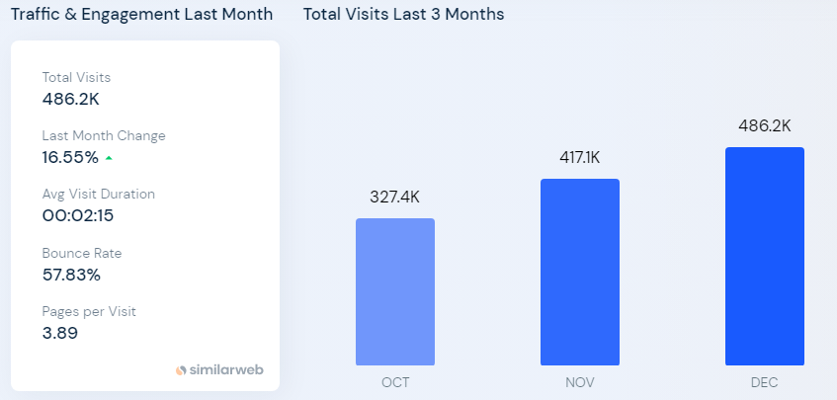
Figure No.1: Traffic and Engagement of Six Senses Hotel
(Source: Singh and Misra, 2022)

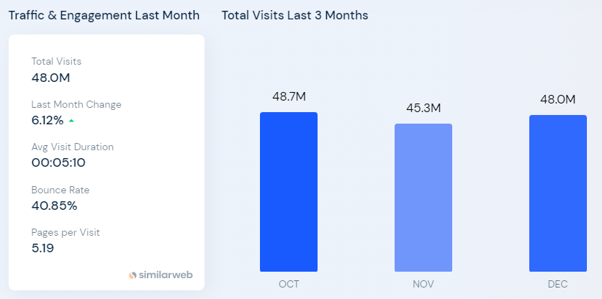
Figure No.2: Traffic and Engagement of Moxy Hotel
(Source: Amoako et al., 2021)
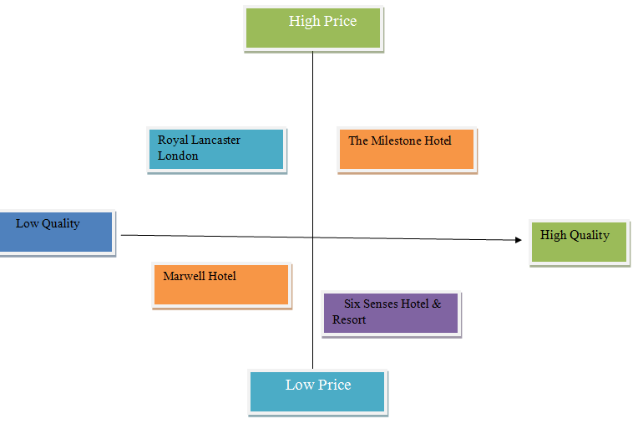
Figure No.3: Positioning of Six Senses Hotel
(Source: Created by the learner)

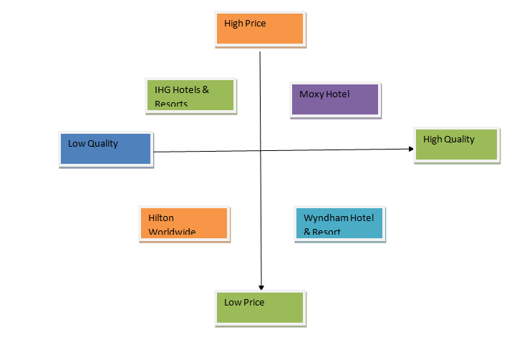
Figure No.4: Positioning of Moxy Hotel
(Source: Created by the learner)

