IONUT TUDUREANU

STUDENT NUMBER: 1917144
Programme: BA BUSSINESS MANAGEMENT
Module title: MANAGING PEOPLE
Module code: LCBB5004
Assignment title: Assessment 1
Lecturer’s name: ZAINAB ATTA

HUMAN RESOURCES- ORGANIZATIONAL OBJECTIVE AMAZON


 | 
  HUMAN
  RESOURCES
  - Human Resources is a crucial component of every company's overall operating strategy (Daley, 2012). A company's achievements and outcomes may be
  directly influenced by it, and it has the potential to make a substantial difference in the immediate and long-term success of the organization's strategy and objectives.
  - Furthermore, Storey (1995) describes HRM as a separate approach to employment management that aims to gain competitive advantage via the strategic deployment of highly dedicated and talented employees by utilising a diverse range of cultural, structural, and people strategies.
  - Fig.1: Human Resources importance
  - Source: UW.com,(2021)

THE IMPORTANCE OF HUMAN RESOURCES
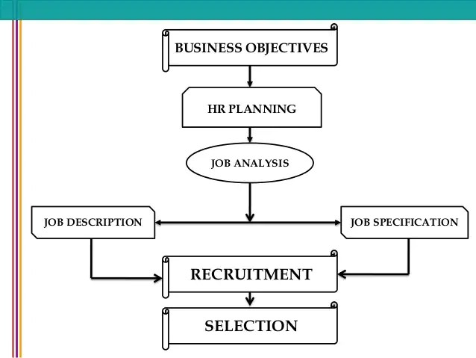
- People are the only ones who can realise organisational goals.
Organizational jobs must be filled by people who are capable of doing so. In order to meet these demands, human resource management must be well thought out.HR planning is done, and then the organization's employment needs are met through the hiring process.
- As a result of the difficulty in finding appropriate candidates to fill job vacancies in both manufacturing and service firms, managers have taken on a new role in recruitment. In a research by the Society for Human Resource Management (SHRM), most companies have entered a phase in which positions ranging from the unskilled to the professional and technical are difficult to fill; and this situation is unlikely to abate in the near future, according to the report.
- It is now impossible for managers to depend only on unsolicited applicants to fill positions. Managers must be flexible in their approach to hiring in order to find the best candidates in today's competitive job market.
- Planning for human resource requirements, candidate sources, and recruiting strategies will necessitate a slew of new, creative approaches.
- Fig.2: Planning, Recruitment and Selection
- Source: AIMS Education, (2013)

HUMAN RESOURCE MANAGEMENT
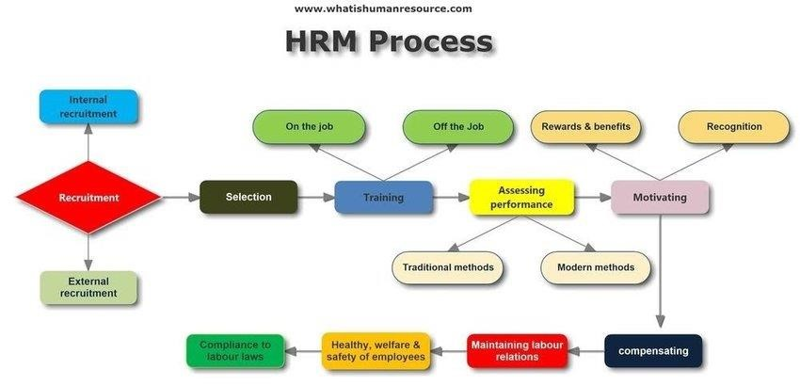

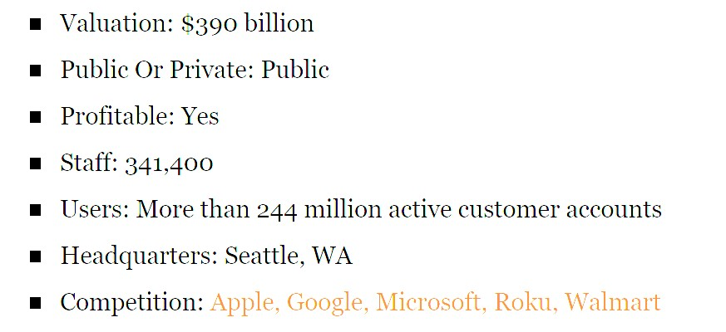
○Amazon is the most popular online retailer in the United States and a cloud computing powerhouse.
AMAZON
○In 1994, Jeff Bezos founded it.
○Amazon now sells everything from apparel to lawn furniture to janitorial supplies, making it a one-stop shop for clients. Amazon also offers customer support, inventory, and delivery.
○The site also sells digital media such as music, movies, and software. Cloud computing services provider Amazon Web Services (AWS) is a multibilliondollar supplier of cloud-based services to a wide range of clients, including government agencies and institutions.
○The Alexa AI assistant grabbed headlines at the CES 2017 gadget show by being integrated into everything from LG refrigerators to Ford autos.
- Amazon is also a major participant in consumer electronics, not just through its Fire tablets and TV boxes, but also through its Alexa AI assistant service.
○Amazon is becoming a prominent player in the entertainment business after taking home two Golden Globes in 2017. Even said, Bezos' core business approach has stayed the same throughout the years, focusing on long-term client loyalty instead of short-term profitability and ongoing expansion into new markets.
- When it comes to the delivery of goods, Amazon's focus on efficiency is evident in the two-hour Prime Now service and the fleet of autonomous aerial vehicles that will handle shipments under five pounds.

AMAZON HUMAN RESOURCES

- Human resource managers at Amazon are skilled generalists who use both tactical and strategic approaches to increase employee satisfaction and growth. For these crucial positions, HR executives must maintain regular touch with fulfilment employees and collaborate closely with operations.
- For Amazon's fulfilment centres to continue to be the most inventive and agile on Earth, their HR leaders must be approachable and authentic. Human Resources (HR) is not a distinct company department, but rather an integral part of the business team.
- Employee relations, performance management, succession planning, talent management, and employee engagement are all areas of expertise for the company's HR generalists. This gives them a strong foundation from which they can serve as business partners to line managers in every stage of the employee lifecycle (amazon,2021).

AMAZON HR STRATEGIC PURPOSE
- When it comes to the success of any commercial organisation or firm, human resource management plays a crucial role (Snell, Morris, and Bohlander, 2015).
- Amazon is aware of the importance of having the right people in place to fulfil a variety of roles and tasks that are critical to the company's success.
- Amazon's strategic goals are closely matched with the strategic goals of the human resources management division of the company. Employees and workers are viewed as one of the most important components in the success of any firm by the company.
- Companies, like Amazon, have made a commitment to upgrading and expanding the workforce's abilities via the implementation of effective programmes for employee development and training. Employees would be more satisfied with their jobs as a result.
- At Amazon, the core duties of human resources include selection and recruiting, training and development and pay administration, as well as the maintenance of a healthy working relationship between workers and maintaining legal and ethical compliance (McDonald and Hite, 2015).
- Employees and workers alike benefit from these functions, which promote a productive work environment and enable them perform to their fullest ability at work. The company's human resources departments have helped to keep employees' morale and attitude high.
- The goal of Amazon's human resource management is to foster positive working relationships based on mutual respect and consideration for one another. Workers' needs and requirements are met by the company's HR managers, who provide a coordinated environment for all employees.


  AMAZON STRATEGIC MANAGEMENT
  - A company's strategy determines how its employees behave and what HR practises they should follow, both of which are influenced by marketing and positioning. To meet customer expectations, Amazon employees are often asked to work longer hours and under tough conditions. Jeff Bezos, Amazon CEO, was asked in an interview for a response to the public criticism of Amazon's severe regulations for employees that completely oppose work-life balance.
  - Jeff stated that Amazon's approach is entirely to blame for this. Jeff believes that a high level of work is essential, as is the ability of employees to cope with stress and achieve "Harmony" between work and life.
  - It is possible to discern Amazon's aggressive techniques from the behaviour of its employees. It's a smart step for Amazon to match its workforce with its long-term goal. Even said, there is a growing debate over whether or not Amazon should take larger risks in order to attain its long-term strategic goal.

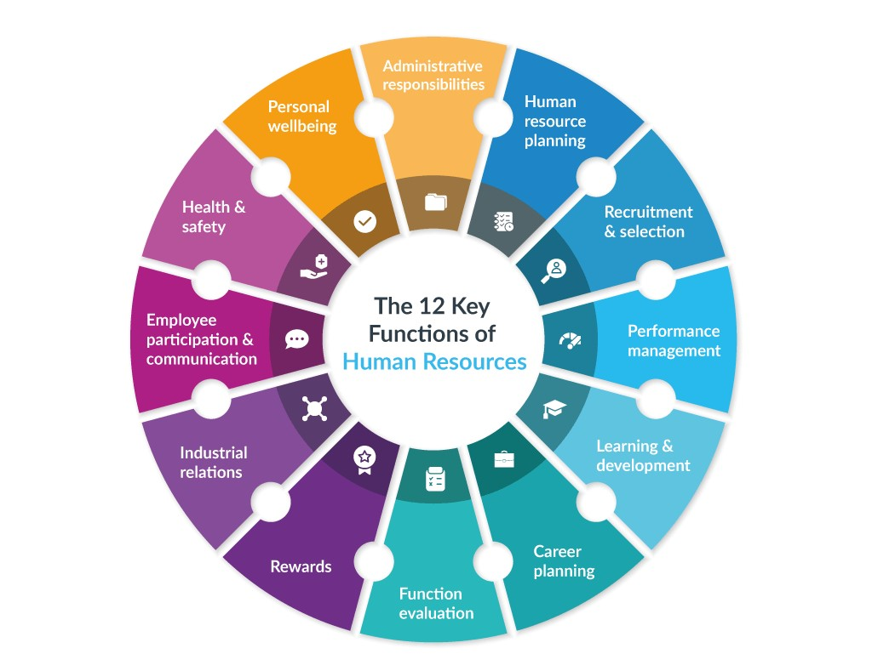
HUMAN RESOURCES FUNCTIONS
As can be seen there are many functions that HR department is covering.
The main focus will remain on the resourcing activities.
- Planning
- Recruitment
- Selection
Fig.4: The Human Resources functions
Source: AIHR.com, (2021)

PLANING
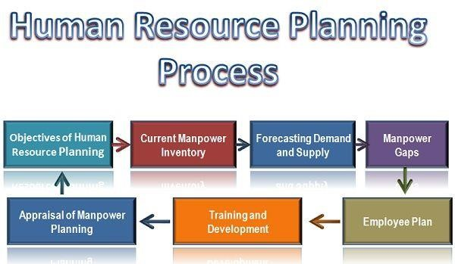
- The planning role is all about anticipating what the company will require in the future. How many and what sort of employees does the company require? Knowing this will influence all aspects of human resources management, including recruiting, selection, performance management, and training & development.
- In human resource management, a collection of methods used to manage employees and maximise their potential is referred to as "workforce planning" (Othman, Bhuiyan and Gouw, 2012).
- Personnel planning is primarily concerned with ensuring a company's long-term success and maximising its revenue and profit from its operations. Long-term and short-term objectives are met through a combination of operational and strategic workforce planning at Amazon (Adogla and Collins, 2014).
- According to Armstrong and Taylor (2014), strategic workforce planning helps companies effectively forecast and plan for their workforce in order to guarantee that they recruit the appropriate people at the right time to achieve their objectives and goals.
- It is Amazon's strategic personnel planning that helps the company adjust to future workforce changes. In addition, the corporation makes use of operational workforce planning to identify and address problems that arise at various levels of the organization's operations (RetailDive, 2017).
Fig.5: Human Resources Planning Process
Source: J. Award, (2019)

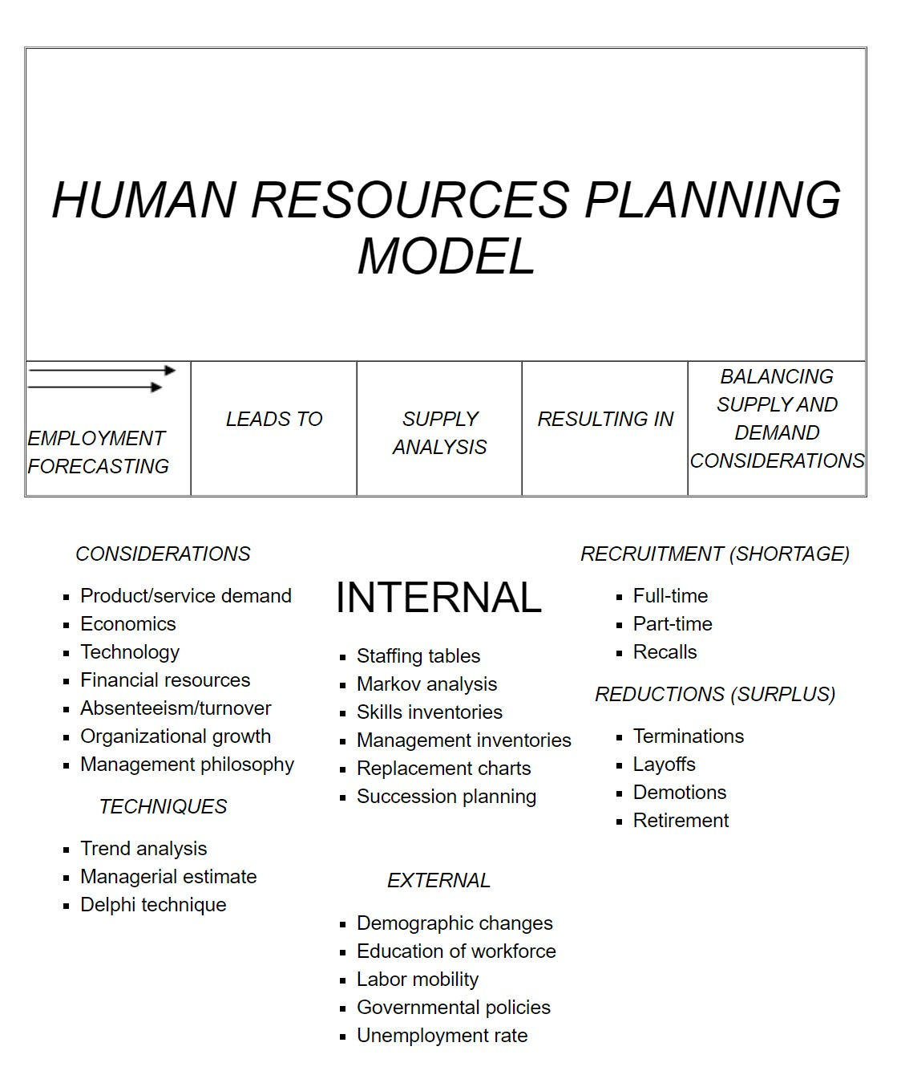
  THE IMPORTANCE OF PLANNING
  - Prioritizing HRP offers the foundation for building an effective HR programme and coordinating HRM activities within it, both of which have traditionally been critical management processes.
  - If for example Amazon, organisation is contemplating mergers, relocations, downsizing, or shutting facilities, HRP is crucial.In the absence of HRP, a business may face a number of intangible expenses.
  - A lack of HRP can lead to openings remaining unfilled, for example. The consequent loss in productivity can be expensive, especially if substitutes need time to be trained.
  - Other scenarios include the termination of personnel in one department and the subsequent hiring of applicants for similar positions in the other. It's possible that this may lead to overhiring and the necessity to lay off freshly hired personnel.
  - It is also difficult for employees to prepare for their career or personal development if they lack the HRP they need. Therefore, some of the most capable and ambitious employees may decide to look for another job, one with more advancement potential.

RECRUITMENT
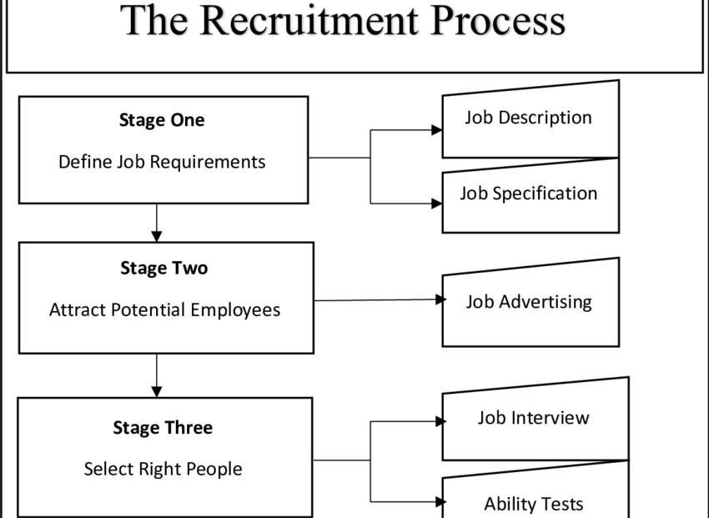
- Human resource management is concerned with finding and hiring the most suitable candidate for a vacancy as quickly as possible while also keeping costs to a minimum. Recruitment is the process of identifying and enticing qualified candidates to submit their resumes for open jobs inside a company.
- To begin, the organisation has to be identified in relation to the post, and the procedure culminates with the person being officially introduced to their new workplace.
- When a candidate is selected for a position, it signifies that they possess all of the necessary abilities, talents, and qualities for that position.
- Recruitment that is cost-effective on the other hand, signifies that the procedure has been completed without a significant financial burden on the company.
- The HR department has an increased probability of identifying the best possible candidate for the post if they follow the method.
- The company's resources will be wasted if the wrong or incompetent employee is hired. Because of this, the firm is going to face long-term problems and will have squandered resources training an employee who wasn't up to snuff, especially when it comes to fulfilling its goals (M. Luenendonk, 2021).
Fig.6: The Recruitment process
Source: researchgate.com, (2021)

 | 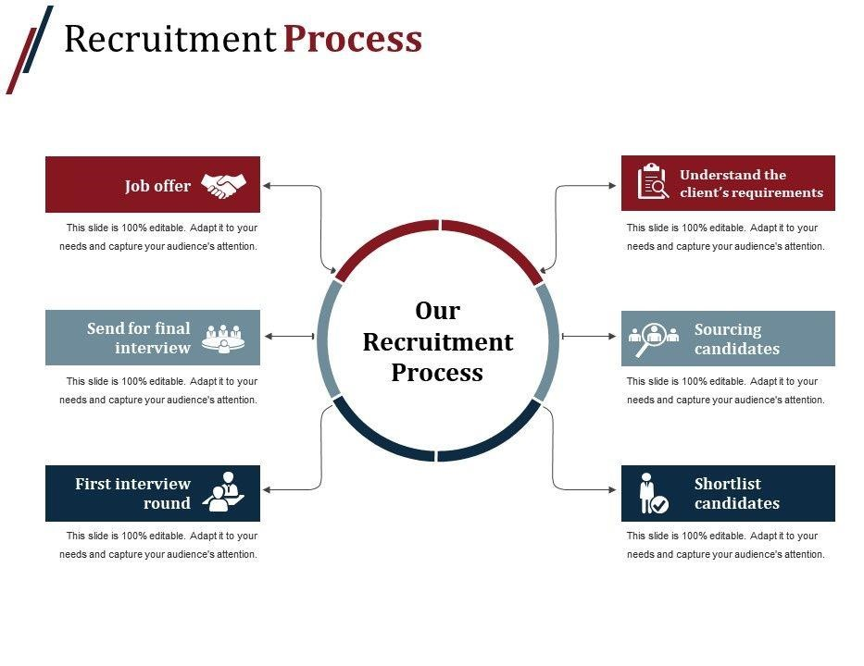
  HUMAN RESOURCE
  RECRUITMENT AT
  AMAZON
  - As a result of Amazon's stringent hiring and selection procedures, only the best and brightest may be kept. Many people are familiar with Amazon's unusual utilisation of human resources. Jeff understands that attracting and retaining talented employees is critical to the company's long-term success. Amazon is looking for people who can bring new ideas to the table, and it doesn't care about their previous work experience.
  - Rather of using traditional methods of interviewing and testing, the business depends on the network's convenience and efficacy to recruit new employees in order to save money.
  Fig.7: Amazon recruitment process
  Source: amazon.com, (2021)

RECRUITMENT SOURCES
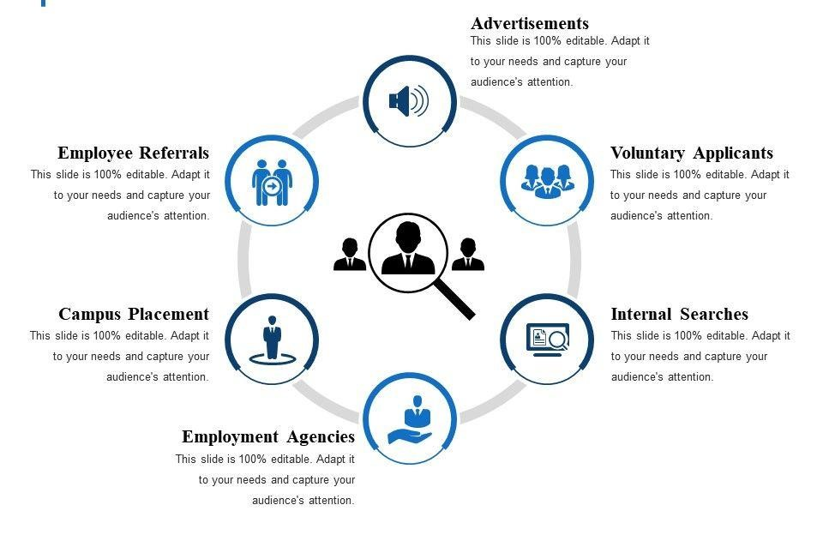

HUMAN RESOURCE RECRUITMENT- AMAZON
- When it comes to finding new talent, Jeff takes a fresh approach. This method has been dubbed "the experiment of Socrates" by a journalist, and it requires applicants to pass not just his interview but also interviews conducted by Amazon employees.(Goldmanis, 2009).
- When Amazon hires an employee, the qualifications for this individual are more stringent, which means that the requirements rise constantly, and this is how Jeff prevents all the candidates from losing interest.
- There are three things to bear in mind while applying to Amazon, according to Gayle (2016), a former Amazon employee who has worked there previously. To begin with, it is important to focus on the process. There may be numerous phone interviews, an online interview, and a face-to-face interview before a candidate is officially approved.
- Gayle advises interviewees to be fully prepared due of the rigorous training of the interviewers. Applicants will be tested in a variety of ways by Amazon's interviewers, who have a specific job description and criteria in mind. In Gayle's second piece of advice, she encourages individuals to display leadership.
- Fourteen leadership concepts must be kept in mind by candidates. Individuals care about their past because they believe that what they have done in the past is a good predictor of what they will do in the future.

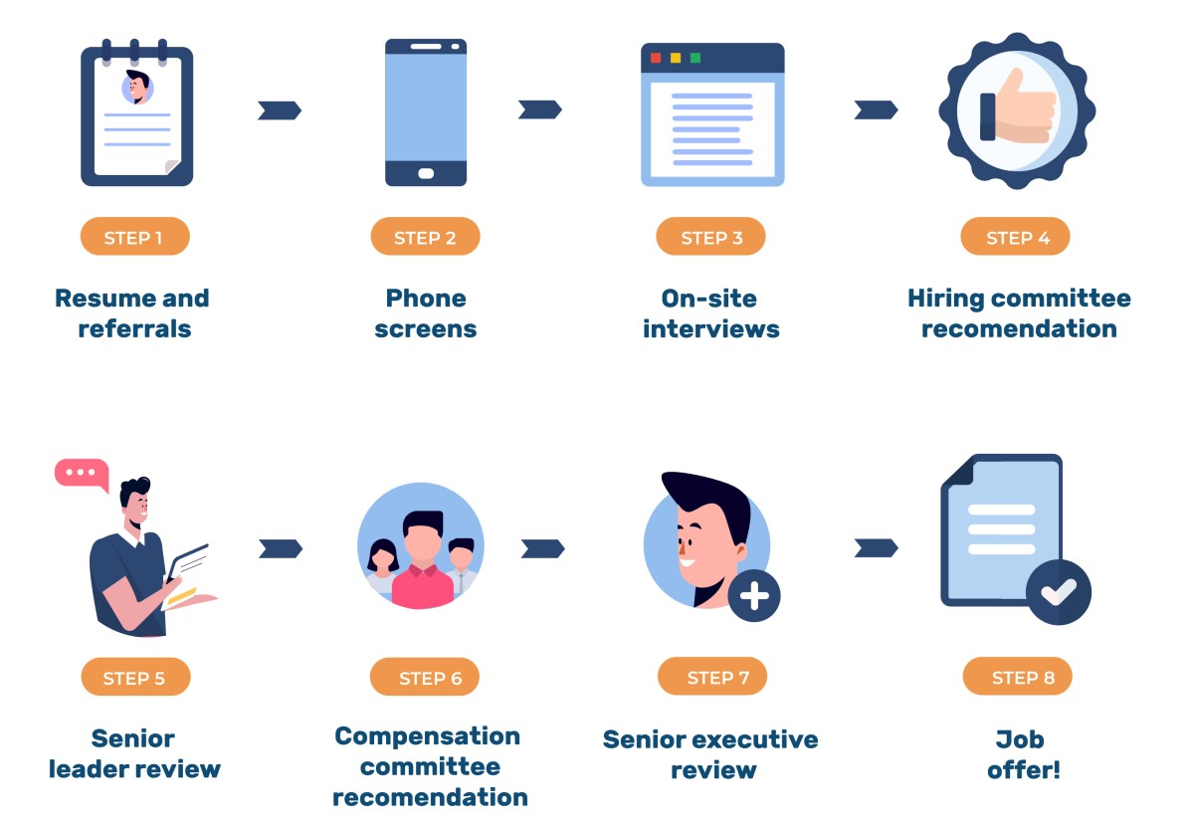
  AMAZON RECRUITTING APROACH
  - The Amazon has a highly methodical approach to the recruiting procedure.
  - Before any interviews are conducted, the job description and personal attributes are established.
  - When interviewers follow these tight standards, they are more likely to focus on the requirements of the candidate rather than their own perceptions.
  - It is possible to overcome biases such as early information prejudice and preconceptions by interviewing a variety of people at different times. Overall, this method helps to ensure that decisions are based on solid facts.
  - As a result, this organisation does not need applicants to have worked in a specific field in the past, which allows for a wide range of backgrounds.
  Fig.8: Amazon recruiting approach
  Source: Pmexecices.com

HUMAN RESOURCE SELECTION PROCESS
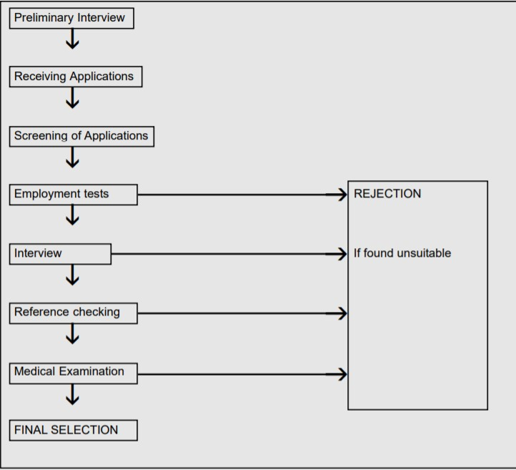
- The selection process, a key part of Human Resource Management and is essential to developing a complete workplace.
- The employer must determine what capabilities they are seeking for in an employee and then design their interviewing and selection process to find those individuals with those skills. In addition, the organisation is assessing the present team's strengths and weaknesses.

HUMAN RESOURCE SELECTION IMPORTANCE
- An effective selection process is essential to avoid wasting corporate resources on the incorrect person.

- After posting job advertising and conducting interviews, employers are also responsible for training new hires. Due care must be taken to ensure the best possible candidate is chosen.
- Fair selection promotes cost-efficiency, takes into consideration time, corrects for bias, and conducts comprehensive background checks. While exceptional people should be allowed to grow, the whole process should be intended to exclude those who are not capable of succeeding.

KEY STEPS OF HUMAN RESOURCE SELECTION PROCESS
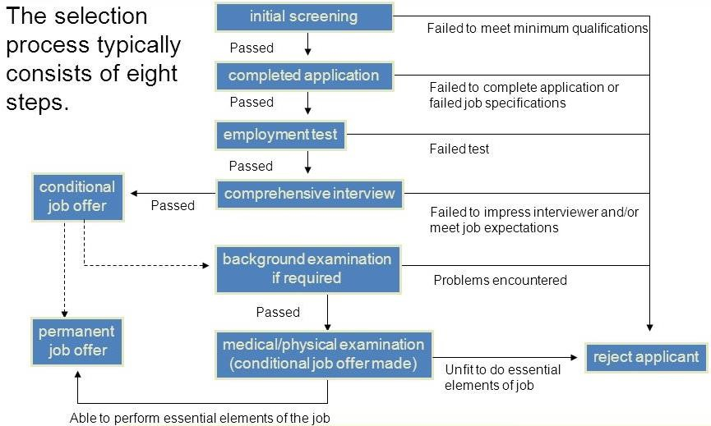
Fig.9: Hey steps of HRS process
Source: K.Baker, (2016)

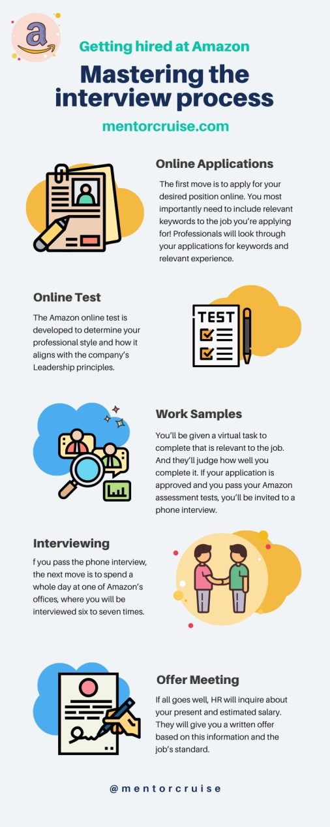
  HUMAN RESOURCE
  SELECTION PROCESS-
  AMAZON
  - Online application
  - Online test
  - Work samples
  - Interviewing
  - Offer meeting

AMAZON PERFORMANCE AND REWARD MANAGEMENT
- Amazon's pay and performance policies are prescriptive. Every Amazon employee is subject to stringent performance standards.Every employee at Amazon is held to a high level, from their daily tasks to their job descriptions, as well as their overall work plans and work habits. Furthermore, the management of performance and compensation is intertwined (The Stranger, 2018).
- Additionally, Amazon leaders from all levels of the company will meet every year to discuss the performance of their employees (Houde,2017). From the annual meetings, they can gain insight on how to improve their performance.
- The flat organisational structure of the corporation includes product managers, senior managers, directors, and the core leadership teams.
- Flexible shifts, according to Amazon's official website, provide workers more possibilities. For those that do well enough, they might become a permanent part of the team. The company provides "career options" finance for pre-paying up to 95% of tuition and related fees for nationally certified programmes, up to £8,000 over four years, for adults' education within the structure of the organisation (amazon.jobs, 2018).
- Clearly, Amazon's performance management is difficult yet efficient, as every time period, from one day to a year, is analysed. Employees are more likely to perform well when their salary and bonuses are directly tied to their results. Insurance and efforts are also included. All of these programmes have the potential to motivate employees.

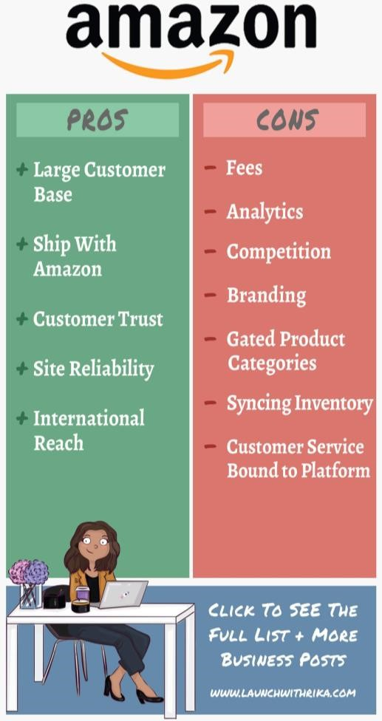
  AMAZON HR DEPARTMENT PROS AND CONS
  - Amazon has a low retention strategy, according to James (2018).
  - Amazon management is rumoured to put pressure on their staff to succeed even if they are dealing with personal or family issues.
  - To be ready for their occupations, some individuals have to get up at 5 a.m., while others put in up to 50 hours a week of labour.
  - As can be seen, Amazon's employment opportunities are promising, but the company's management approach is at risk.
  - Employees are motivated by strict working circumstances, yet a restrictive contract will force them to leave.
  - From this perspective, Amazon looks to put profits ahead of employee satisfaction.
  - Despite the inclusion of employee welfare protection and other employee development programmes in the incentive programme, they may not be as important as regular workplace care.

CONCLUSION
- The following summarises Amazon's human resource management approach, including hiring and selection, as well as performance and reward management can demonstrate the company's seriousness about achieving its own strategic objective and its excellent human resource management strategy for employees, despite certain challenges.
- This is a problem with humanising the management of employees.
- Employee turnover does not decrease due of high work pressure and long hours since employees are not taken care of.
- There are several reasons why this problem should be resolved. Other technologies can be used to boost productivity.
- It's time for Amazon to invest more in artificial intelligence so that computers can perform more labour instead of humans. Change the business culture as a second step, as well.
- The company is now being slammed for its overworked staff and lack of concern for their well-being. Employee care is important to Amazon since the company's ethos values customers over employees.

REFERENCES
- amazon.com,(2018). “Fulfilment Associate”,”Recruitment”, Available at: https://www.amazon.jobs/en-gb/landing_pages/warehouse-operative, Accessed: 01.12,2021.
- E.Daniels, (2017), “HUMAN RESOURCES PLANNING AND RECRUITMENT”, (chapter 3),Available at: https://silo.tips/download/chapter-3-human-resources-planning-and-recruitment , Accessed: 14.12.2021.
- Boyle, A. (2018), “Chief slowdown officer” Available at: https://www.geekwire.com/2018/full-transcript-chief-slowdown-officer-jeff-bezos-shares-amazon-management-wisdom/ , Accessed: 02.12.2021.
- Cadwalladr, C. (2018), “ My week as an Amazon insider the Guardian”, Available at: https://www.theguardian.com/technology/2013/dec/01/week-amazon-insider-feature-treatment-employees-work , Accessed:02.12.2021.
- E.V.Vulpen, (2021), “The 12 Key Functions of Human Resources”, Available at: https://www.aihr.com/blog/human-resources-functions/ , Accessed:05.12.2021.
- Forbes.com. (2018), “Amazon Is Successful Because Of These Two Things”, Available at: https://www.forbes.com/sites/brittainladd/2018/08/27/these-two-things-are-what-make-amazon-amazon/ , Accessed:02.12.2021.
- L.Peterson, (2019), “Why Is the Human Resource Selection Process Important?”, Available at: https://smallbusiness.chron.com/human-resource-selection-process-important-14399.html , Accessed: 05.12.2021.
- Gaylord, S. W., & Haile, A. J. (2011), “Constitutional Threats in the E-Commerce Jungle: First Amendment and Dormant Commerce Clause Limits on Amazon Laws and Use Tax Reporting Statutes”, North Carolina Law Review.
- J.Awad, (2019), “HRM Process”, Available at: https://www.researchgate.net/figure/Human-Resources-Management-Process_fig3_340931714 , Accessed: 06.12.2021.
- AIMS Education(2019), “Human Resource Management”, Available at: https://www.slideshare.net/umerkhalidhabib/recruitment-and-selection-24053999 , Accessed: 06.12.2021.
- M. Luenendonk, (2021), “What is Recruitment? Definition, Recruitment Process, Best Practices”, Available at: https://www.cleverism.com/what-is-recruitment/, Accessed: 10.12.2021.

