Soldaten:
A Study in to the Reasons why the Ordinary German Soldier fought on the Eastern Front 1943-1945
Robin Taylor
Dissertation submitted in partial fulfilment of a B. A. (Hons.) in History
University of Wales Trinity Saint David
May 2018

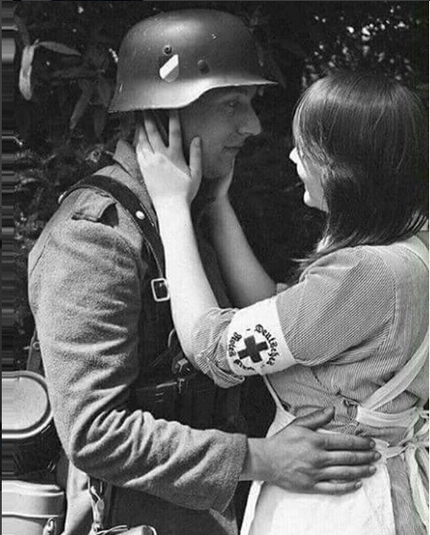

Contents:

Abstract iii
Acknowledgments iv
List of Illustrations v
Introduction 1
Aims and Methodologies 4
Ethics 6
Chapter 1 – Nazism and the Fight for Ideology 8
1.1 A ‘Holy’ War 9
1.2 Young Men 10
1.3 ‘Blissfully Unaware’ 10
1.4 Criticism of the Regime 11
Chapter 2 – Pride of the Family 13
2.1 ‘I met my Beatrice’ 14
2.2 Kamaraden 15
2.3 ‘It really was a scandal’ 15
Chapter 3 – Enjoying the Fight 17
3.1 ‘We charged like maniacs’ 18
3.2 Technology at War 18
3.3 Freedom 19
3.4 ‘Laughing to split his sides’ 20
Chapter 4 – Survival 21
4.1 ‘Simple fear’ 22
4.2 Brutality 23
4.3 No Escape 24
Conclusion 25
Bibliography 28
B.1 Extended Reading 28
Abstract

The dissertation thesis focuses upon examining, analysing and deciphering the overarching reasons as to why the German soldier of the Wehrmacht continued to fight following the aftermath of the defeat at Stalingrad in 1943. Defying past historiography, the paper seeks to ‘humanise’ aspects of the German individual and highlight how their fight was more akin to the experience felt by the Allies than previously thought. Ideology, family, thrill and survival are the main reasons that this paper attributes to why the German soldier carried on fighting.
Not only does the thesis cover these umbrella reasons, but it goes in to detail in each; uncovering other areas of the German frame of mind within the frames of reference offered. Within the fight for ideology there is also criticism, within the presence of family there is love and sex, for instance.
The paper does not seek to delegitimise the fact that the Wehrmacht was not complicit in war crimes, and instead seeks to look deeper in to the mind of the ordinary German soldier while using the impact of their war crimes as a frame of reference. In this way, the text assures that the Wehrmacht was responsible for crimes on the Eastern Front and uses this as a focus to examine the minds of the men of the German army.

Title Page: Image 1 – A German soldier embraces his partner, a member of the Deutsches Rotes Kreuze (German Red Cross)

Acknowledgments

Firstly, for instigating my deep passion for the war between Germany and Russia, I would like to thank Elissa Proctor, my college History teacher. Her straightforward methods of teaching made that segment of the Second World War deeply interesting and personal to me. It was her tutelage that inspired me to thoroughly research and learn about the Russian and German sides of the conflict, with the natural progression being to write something about it: the product of which is displayed here.
I would also like to thank Dr Lester Mason and Dr Harriet Webster for providing me counsel throughout the writing process. Their expertise within historical study opened my eyes to alternative methods of approaching my chosen dissertation topic, chiefly in looking at it from a Subaltern point of view. This has not only influenced my dissertation, but also my outlook on history in general.
A man who I have to thank for always pushing me to retain my studies of history is my father, Robert. Ever since I first showed an interest in History it was my father who would talk to me about different historical eras and be receptible to my fact barrages. Without his encouragement, love, intelligence and understanding I would never have made it this far. He has since passed away, but I’d like to think he would be happy that I managed to finish my third-year dissertation, especially focusing on something that we used to talk about often. I can not thank him enough.
Finally, I would like to sincerely thank my best friend, Lynn. Not only does she share a keen interest in the history surrounding the Germans of World War Two, but she has provided solace, calm and focus throughout the time it has taken me to author this dissertation. If it wasn’t for her, the process of research, collation and committing this information to paper would have been infinitely more arduous and stressful. This dissertation would have been much harder to write without her friendship helping me along the way. My most heartfelt thanks go out to her.

List of Illustrations

Image 1 - https://www.instagram.com/p/BejDqDgFQkL/?saved-by=theonetheycallrembo (accessed: 10/02/2018)
Image 2 - http://www.bytwerk.com/gpa/posters3.htm (accessed: 20/04/2018)
Image 3 - http://www.oldpicz.com/picz/2017/03/ww2-soldiers-saying-goodbye-to-their-children-7.jpg (accessed: 20/04/2018)
Image 4 - http://4.bp.blogspot.com/_oIAhQMTG-dU/S9RCC_lalbI/AAAAAAAAEPc/YrseEzrrLFY/s1600/german_brutality_ww2_second_world_war_history_pictures_incredibel_amazing_rare_photos_russia_009.jpg (accessed: 20/04/2018)
Image 5 - https://www.theatlantic.com/photo/2011/10/world-war-ii-the-fall-of-nazi-germany/100166/ (accessed: 20/04/2018)
Image 6 - http://tonyvaccaro.studio/defeated-soldier/ (accessed: 20/04/2018)

Introduction

“War has its own rules”
A quote from an unknown German Wehrmacht veteran

“Our arms were exhausted, our knees buckled … machine-gun bullets sprayed around us … ripped open the ground at our feet. The first of us was felled, hit by a bullet in the heel … a second was hit in the head, a step away from me … [another] took a bullet to the chest. He gurgled for a while and stopped moving”. No, this is not the description of a futile attack and subsequent retreat of an Allied force in the Second World War. This is the account of Soldat Willy Peter Reese, a German soldier running for his life from the advancing Russian foe. His unit had been providing artillery support to defensive positions in Palov, a village in Russia, when the Red Army had overrun their positions and forced them to retreat. When he obtains a moment to calm himself, he compares himself to a camera, a ‘mechanically adaptable being’, with ‘will and fear, mind and soul’ purged from his self. His ability to continue resisting the Russian advance dissolves to pure instinct and a joy in avenging his comrades.
This is only one of many accounts of that terrible campaign, itself part of a horrific conflict, one in which claimed over twenty-three million lives. Only 13% of the original invasion force in to Russia would emerge unscathed. Ordinary people; farmers, factory workers and bank clerks (in Reese’s case) all were called to fight on both sides, eschewing their own thoughts on the matter for the inevitable clarion call of war to muster them to rank. For the Germans, historiography surrounding the Second World War (especially from a Western perspective) has eschewed the individual in favour of painting the German war machine as being an impenetrable jackboot of Nazism: the willing servants of their totalitarian master. But this is not the case. Common memory seeks to see the soldier as a cog amidst a giant machine, but while the Allies may be painted as damascened and gilded in their own right, the German is washed as a blackened, charred instrument filled with hate for those who were not German. This annulment of personality among the foe of World War Two is a crime against not only their memory, but their legacy in history. Perhaps it was easier to see the German as an unthinking creation forged only to kill to spur men to fight, and thus their experience has seeped in to our very own education system and collective memory of the conflict. It is easier to look upon a foe as a ‘thing’, and not a human, after all.
Before looking at individual reasons as to why the German soldier fought, it is important to note that while some acted beyond their parameters and persecuted civilians over the course of their soldiering careers, for the ordinary Wehrmacht their orders did not encourage them to indulge in such savagery. I do not aim to cancel the memory of those civilians and soldiers who were crushed beneath the heel of the German war machine, such a practise would be a disservice to history itself, as every account surrounding an event is valid in their own right. The memoirs of Marshall Zhukov are just as valid as a diary from a peasant farmer in the Caucasus, for example. And it is with this ethos I move forward with studying the German experience of the Eastern Front campaign.
Looking beyond the ideological screen, I have outlined four key reasons as to why the ordinary German soldier fought on the Eastern Front. As much as I have attempted to look beyond it, it is worth studying the ideological roots of the soldiers, especially those of a younger generation, as these men were proselytized through the extensive indoctrination techniques employed by the Nazi Party. So, the reasons are as follows: Nazism, family and pride, enjoying the fight and survival. While the first three reasons have been very prevalent in my studies, it is the Wehrmacht’s experience of survival that epitomises the reason why the ordinary German soldier continued to fight. This is the overarching experience Willy Peter Reese had, and what many thousands of soldiers felt when the Red Army closed in on their homeland. The Wehrmacht even had a name for what they would become if captured by the Russians, a ‘Stalinpferd’ or ‘Stalin’s horse’. Because this is such an all-encompassing and universal topic, it will be acknowledged in a later chapter.
In short, this study aims to ‘humanise’ the German Wehrmacht, to shed light on those that have been overshadowed by history. A history text book can tell us that a ‘panzerfaust’ was an excellent, cheap and easy-to-use means of destroying enemy tanks, but what that omits is that they were considered cumbersome and suicidal, as they had to be deployed in extreme close proximity to enemy tanks; the likes of which were often supported by infantry. The ordinary soldiers, like Guy Sajer and Willy Peter Reese, are certainly victims of Walter Benjamin’s mantra “History is written by the Victors”, as their story has been cast aside in favour of Allied experiences of the war. Because the German soldier has, historically, been seen as a tool of Adolf Hitler for his nefarious schemes, they have been attributed the same mention in history as a handsaw or drill in human hands. My aim is to highlight the stories of these ordinary German soldiers, explore their thoughts and feelings, and examine the history of the retreat from Russia from a Subaltern viewpoint.

Aims and Methodologies

I first set out to create such a dissertation thesis because I am an avid historian of the Second World War. Throughout my life I have bared witness to an Allied perspective of the entire conflict, only in the past few years even emerging away from a British perspective and looking at an American and Russian one. These proved interesting, but still, something was missing. I had recently started reading more in to the Spanish Civil War, and with the analysis of the Nationalist side came a realisation as to the pieces of the puzzle I had been missing from studying World War Two: I had never thought about the German perspective. I applied my interest in looking at history from the ground-up to this perspective, and that is when I envisioned the idea for my dissertation. I would aim to accurately represent the German perspective of the war from the viewpoint of the ordinary soldier; the man who, from my research, had been overlooked in history. This stems from a perhaps misguided opinion that no matter the ‘problematic’ areas associated with a certain aspect of history, it is still pertinent to learn and understand them. It is only through open discourse that new ideas can be formulated. This applies keenly to the German soldier of World War Two who, being human, felt trauma, pain, sacrifice and death. On Remembrance Sunday common memory does not take the experience of World War Two and use it to believe in a world with differences between us, instead it is used to remember the noble sacrifice emblazoned by the Allies to exterminate Fascism. No mention is given of the German soldier that felt his cause was just as legitimate as the Allies. If the roles were reversed, the Allies’ cause would be seen as the misguided one. And so, it is with this emotion that I carried out my first aim, and that was to better highlight the plight of the ordinary German soldier.
My second aim was to better understand and represent individual soldiers’ testimonies amidst my work in an effort to grasp the true picture of the German perspective. Upon deciding my question, I immediately set to work finding testimonies from veterans or serving soldiers of the period. Two soldiers’ stories stuck out amongst the rest, that of: Willy Peter Reese and Guy Sajer. I wanted to bring particular interest to the Eastern Front, as some of the most brutal and gruelling warzones existed on this front, and both of these men served in this campaign. They came from wholly separate units, locations and even backgrounds, providing a good range for analysis as that way I could look at experiences from two men who led completely different lives, but were united in their presence in the army. Reese proved to be the most enlightening; his self-aware style made examining his reasons for fighting all the more apparent. His was the only testimony that outlived him, as it wouldn’t be published till just over 40 years after his death, being published in 1984. His life and style reminded me of war poets that are revered in the United Kingdom, such as Siegfried Sassoon and Wilfred Owen. His likeness to them, in my mind, made him all the more apparent to study as his story is not as widely told as Sassoon’s or Owen’s. Sajer on the other hand was matter-of-fact. His retelling of events is methodical, as if he were speaking at a trial. He proved effective, though he rarely delves in to his own mind, and thus does little to aid in finding his reasons for fighting. To cross-reference these, I used testimonies from captured German POWs, the likes of which proved very enlightening to my study. While each individual has their own needs and wants, there are apparent connections between those who served in the Wehrmacht, and this helped my study immensely. I also managed to locate a spontaneous interview conducted with German veterans in 2010. Spurred on by a heckling journalist, they reluctantly discuss the reasons why they fought, and their motivation that kept them alive through the duration of the Eastern Front campaign. This viewpoint has aided me, chiefly in that they are Germans living in modern times who are not afraid of speaking about their traumas, something that was suppressed post-war. Therefore, my second aim to bring to light these individual testimonies has proven to be a success, as I have incorporated them in to my study efficiently.
My third and final aim was to collate information in a way that would provide future academia the means to examine the German Wehrmacht from a Subaltern Studies point of view. From doing historical research, both academically and for leisure, I have come to realise that I find the most enjoyment by looking at history from the ground looking up. I am a firm believer that it is the ordinary folk of a nation that can tell you the truest events of any given moment of history. This is certainly true of the German war experience. But as well as simply demonstrating it to argue an existence of the fact, it would be wise to take in to account the future readership of this piece. A future thesis conducted with reference to the German Wehrmacht of World War Two could use this text as a reference point, even to go so far as to simply use the same testimonies I have to better grasp an understanding of the German war machine. In that case, I have segmented my thesis by theme and reason for fighting to better find a particular area to which the reader would be interested. I have also maintained a close link to the testimonial evidence I have collated in order to keep alive the Subaltern outlook on my work. Therefore, I feel I have achieved my third aim in that I have provided information and an argument to benefit future readers and analysers of the German Wehrmacht on the Eastern Front.

Ethics of this Study

Choosing to study the Third Reich does not come without its troubles and affiliated political tribulations, and I have taken these in to consideration when conducting my research. A regime that was responsible for the death of six million Jewish persons, amongst some 10,000 homosexuals and 100,000 disabled people is a subject in history that must be studied akin to using a scalpel, not a hammer. While these statistics are abhorrent, the regime that perpetrated them is still worthy of discussion. I am firmly of the belief that no matter how ‘problematic’ the history surrounding an event, it is pertinent to study and understand it; the consequences of letting such a magnanimous event slip out of common memory would be a disservice to those who suffered under the heel of it. By censoring the retelling of it, it would crush the souls of those who died in antithesis to it. And so, to this end, I pressed on; paying heed to the ethical questions raised by having such a study take place, but also wary of the fact that history should remain partisan and open for all to share and learn from. This study aims to both uncover the experience of the ordinary German soldier, while also maintaining a close adherence to ethical questions raised by convening such a study, so as to conduct a reasonable research vector while also paying heed to the memories of those who died as a result of the regime. In a way, I wish to highlight the memories of both the soldiers and the civilians, one through direct study and one through circumstance and context.
Another aspect to the ethical question that is raised by studying within the Third Reich is that of examining the Wehrmacht and the soldiers within, due to the volatile nature of the German war machine. It is undoubtable that the German Heer wrought terrible destruction on the Russian homeland, slaughtering their hosts and burning their land. Tens of millions of Russian civilians died as a result of German sieges and occupation, and it is for these crimes that the Wehrmacht, along with the SS and the concentration camp superstructure, are marred considerably in the eyes of the modern historian. By no means does my study represent action that would minimise the crimes the Wehrmacht committed, as this would do disservice to those that their crimes victimised. Instead, I wish to look at the soldiers’ perspectives on these crimes, and whether they used them as a means of fighting, to give them meaning in the face of such a relentless foe. My studies have shown the soldiers found joy in brutality and inflicted it out of finding joy amidst so much death around them. I do not intend to perpetuate the view that the German soldiers have been subjected to ‘victim-blaming’, as it goes against my entire understanding of the German Wehrmacht as the perpetrators of many terrible crimes against the Russian populace. This view has been revived in light of Neo-Nazism; the likes of which try and create blameless victims of the German troops. In my study I have found no evidence to suggest German troops were complacent in brutalities concurred by the Wehrmacht, and by no means do I want to perpetuate this myth. This only serves to discredit the experiences of those who suffered as a result of German occupation in Russia, and it creates an eschewed image of the history surrounding the Eastern Front campaign. It is better to understand history from an egalitarian point of view than to favour a particular side, and this is what I tried to attain by completing this study. My aim was to better represent the German Wehrmacht, while maintaining a close connection to the serious ethical questions surrounding the Heer, and in this regard I believe I have succeeded.
The final ethical question raised by conducting this study is concerning the memory of the Jewish persons who the primary victims of the Nazi regime were. As mentioned previously, millions of the Jewish population of Europe were systematically annihilated over the course of German occupation, some 1.5 million of them being from Poland. This has always been a monument to the evil of the Third Reich and has been a point of contention for historians wanting to study them, the issue of Jewish memory being an important reminder to stay partisan on the course of retelling Germany’s history. This is something I kept in mind throughout my study, as I did not want to desecrate the memory of the Jewish people who suffered. To that end, I tried to ensure my study remained partisan, and not to glorify any aspect of the Wehrmacht’s campaign. I believe retelling the history should come first, however, and so any atrocities that the testimonies I have collated have mentioned I have not omitted. Only through fully understanding the conflict and every person involved does a historian understand an event completely. To this end, I have kept the Jewish experience as part of my study and ensured that I do not glorify the atrocities committed by the Wehrmacht, instead using them as facts to which better provide an insight in to the psyche of the ordinary German soldier. I can concur that my study has achieved this aim and answered this serious ethical question maturely and satisfactorily.

Chapter 1: Nazism and the Fight for Ideology
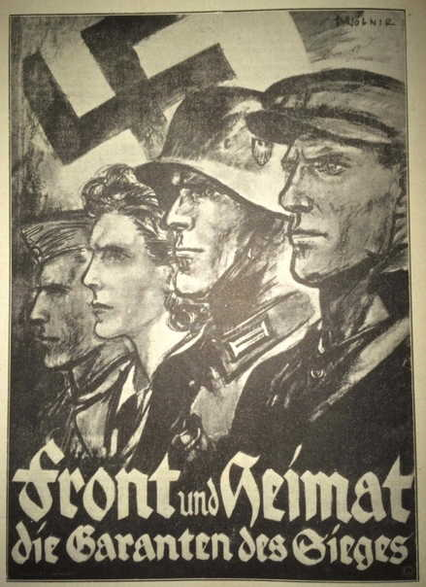
“Hatred is enough of a spark … German hatred is not a reason, but a sheer fact”
Image 2 – A propaganda poster issued in 1941 depicting the assurance of total victory through both frontline and home front aid.

When studying any aspect of the German experience of World War Two, it is impossible to overlook the now-infamous ideology that ruled over Germany: Nazism. Upon becoming a full-fledged soldier in the Wehrmacht, an oath was taken; declaring that the new soldier would fight and die for the glory of the Third Reich and of their Fuhrer, Adolf Hitler. Not only did this cement Hitler’s position as being totally in control of Germany, it tied the army directly to the ideology of the State, something that has remained the overall image of the German army of World War Two. To this end, the Wehrmacht was put at the mercy of the Nazi ideology. Bringing this generalisation down towards a subaltern- and micro-level, individuals in the German Wehrmacht were not against the maltreatment of Jewish persons in occupied territories, as one puts it “I am the ping-pong champion of West Germany … I gave up the game after [a] Jew-boy had beaten me … that is not real sport!”. A popular quotation passed around the soldiers of the Wehrmacht when morale was low was that “National Socialism means fighting”, hoping to instil a revelry for the political ideology to which the Wehrmacht wore on the breast of their tunic.
But how far did the men of the German Armed Forces truly fight for the ideology to which their government ascribed? It is true, Nazism seeped in to every vein of the German army, going so far as to install political officers amongst the infantry to uphold Nazi ideals and reaffirm why they were fighting. Some soldiers did fit in to the stereotype of the ‘willing executioner’, the soldier so engrossed in ideology that they refuse to see the humanity in those they are being told to destroy. One of those is Willy Peter Reese. Judging by the title of his memoirs (“My Confession”) and the overall tone of his recollection of what he did on the Eastern Front, it is clear that the orders he was given, and his unconscious predilections are born of a distaste towards the Russian people. He describes how he steals supplies from the farmers they pass, and despite ‘tears, hand-wringing and curses’ they carried on, as they were sure of their victory against the Bolshevik foe.
A ’Holy’ War
The idea of an ideological conflict is corroborated by an interview done in the Panzer Museum at Munster, where a few German veterans were present. “[We didn’t fight] against the Russians, but against Bolshevism. They were people like you and I” describes one veteran (who unfortunately is not named). In order to justify their experience in Russia, the veteran sees it as a war against Stalinism. Not only does he delegitimise the war against the Allies, he hints towards the idea that the German soldier saw the Eastern Front campaign as not only being an ideologically-driven conflict, but also the only important conflict to which Germany devoted troops to. The empirical information surrounding the Eastern Front campaign seems to shed truth to this, as not only did the Germans want to create a larger state to which they could grow in to a World Power (outlined in Hitler’s Mein Kampf), but they also wanted to eliminate the Communist enemy in the East; the number of troops on the Eastern Front numbered three times as many as was on the Western Front in 1944. Looking at the fact that the very reason as to why the Germans invaded the Soviet Union was due to a long-held notion within the National Socialist Party to create more room for German people to grow, it is apparent that the Wehrmacht, and therefore the regular soldiers involved in the Heer, were subject to the political machinations of Hitler and his Party. Not only did their orders reflect the dogma to which their government institutions subscribed to, but this idea of an ideological conflict at the centre of all their actions kept the ordinary German soldier fighting during the Eastern Front campaign.
Young Men
While the stereotype of the German Wehrmacht remains that the entire army, young to old, was staunchly National Socialist, evidence shows that the ideological roots were deeper in younger men of the army. A study conducted after the war involving 621 soldiers highlighted that a significant minority, some 30 of those polled, described themselves as ideological warriors, where the rest of them viewed the racial Nazi policies negatively. To bring this to focus, however, all of those who described themselves as fighting for Nazism possessed the rank of Junior Officer, mostly Lieutenants, the youngest of the officer class. Neitzel seems to explain this through their age, as these men would have grown up and matured throughout the rise and subsequent rule of the National Socialist Party, meaning that they were groomed in the time where they were the most impressionable. It is with these men (and boys, in the case of the final fight for Berlin) that the cause of Nazism swayed the most favour. Since these men were brought through the German indoctrination system from a very young age in the Hitler Youth, their devotion to the National Socialist cause was complete. They took the ideology up like a standard from the battlefield; when one would fall, another would pick it up.
‘Blissfully Unaware’
However, there is evidence to highlight the fact that the German war machine was not wholly dedicated to the ever-forward march of the Nazi jackboot, regardless of age. Anti-Semitic attitudes pervade all aspects of the German armed forces, most notably in the Wehrmacht. ‘Work-shy’, ‘Jewefied-Britain’ and World Jewry’ are all phrases commonly found in transcripts of Prisoners of War. However, they chose to not focus on the mass-executions of the Jewish populations of occupied countries, instead ignoring the brutality to which the Nazi ideology persecuted them. For many, it became a matter of focusing on the self. For others, they adopted a policy of mutatis mutandis, that is to argue that because it was far away, it was none of their concern. This revelation only comes out from post-war conversations; transcripts of diaries does not reveal an ignorance or acknowledgment of the atrocities being committed by the German war machine in the East. Both Willy Peter Reese and Guy Sajer, the two main case studies that have been chosen for this analysis, never mention the racial policies of Nazi Germany. This could highlight perhaps another reason for why the German soldier did not actively partake in conversation about the brutalities: they were too busy fighting to care. As mentioned before, many men sought for the self, and as part of that their own survival meant more to them. The soldier merely fought without question.
Criticism of the Regime
To add to the opposing argument that the German Wehrmacht was not fighting an ideological war, it is apparent some members of the Army were critical of the Nazi Party’s leadership and the reason to which they were fighting. A conversation between two soldiers by the names of Holscher and Bastian, recorded after they were taken prisoner, catches them discussing their opinions on the Nazis. Inherent in their conversation is their distancing from the ideology (a product of their capture or post-war disgust, is undeterminable), as well as their distrust in the governmental system, and whether there was ever consideration for the German people. They go on to say Hitler had lied about wanting to go to war, and that the Nazis had sent them to war when Germany was not prepared for it. They even go so far as to call the government ‘swine’. This sort of anger towards the regime can be mirrored in the diaries I have collated: Guy Sajer says that “if the Fuhrer had seen us, he would have either sent us all home, or had us shot”. Willy Peter Reese calls his dedication to the cause a ‘mask’, a means to fight anonymously and remove himself from the death and destruction around him. This clear displeasure for the regime is mirrored across not only the Eastern Front but through even the most ideologically-founded units of the German Army (Guy Sajer served in the GroB-Deustchland Panzer Grenadier regiment). While perhaps they had been sent to war with the fires of Nazism in their hearts, it is clear that ordinary soldiers quickly found displeasure in their government and sought to criticise it, personally.

Chapter 2: The Pride of the Family
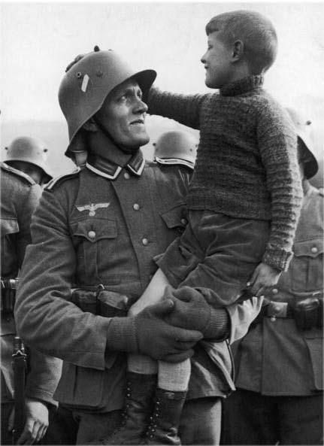
“Home! Home! But it was just an interval. The war went on”
Image 3 – A German soldier says goodbye to his son, shortly before departing for either the invasion of Poland or France.
When I first decided to study the lives of ordinary Germans on the Eastern Front, and the reasons they gave as to why they were fighting, I was expecting to unearth a connection towards the families of those at war amidst the testimonies. My most prominent case study, Willy Peter Reese, yearns for home at every possible opportunity, even going so far to wound himself to be sent home. It is the dream of seeing his family again that drives him onward, to push him in to the horror of the Eastern Front, and when he cannot take it anymore it is to their arms that he runs. To a historian of any conflict the want for the normality of family is no surprise. Upon study of the American Civil War, yearning for family and a normal life again is somewhat common. Sullivan Ballou, a Union volunteer who perished at the First Battle of Bull Run, writes fondly to his wife Sarah, asking her not to mourn him when he dies, and instead to remember him as if he were gone, so as not to extinguish the love they have for each other. While fatalist, it is an incredibly heart-wrenching letter to read. But using this as a framework for looking at the importance of family to the Wehrmacht, the de-humanising historiography surrounding the German Eastern Front stretches to this element of the soldiers’ lives. If other combatants in other conflicts can be attributed the emotional separation from their loved ones, why are the German soldiers overlooked in this regard?
Of course, the other side to the somewhat innocent and light-hearted connections between the soldiers and home is to visit lovers, wives, or fancies picked up during the advances. When the soldiers were degraded to the point of sliding in to their bestial nature, it is almost predictable that they should fight to see them, or at an even more primal level, to take out their frustration sexually. This is an antithesis to the romantic image of a young man returning to his loving family, but this was often the case amongst the German Wehrmacht. Rape, sexual conquest and prostitutes were all prevalent in the German soldiers’ lives, even in Willy Peter Reese’s. As part of uncovering the elements that could increase tenability between the Allied experience and the German experience, it is also prudent to examine the distasteful experiences to better get an understanding of the ‘why’ of the German soldier.
‘I met my Beatrice’
To men like Willy Peter Reese, family provided the solace and security to which the army could not. On his leave, he constructed a “beautiful and painful film on the canvas of the soul” through his childhood memories, interconnecting the horrors of war and the innocence of his youth. Love, life and a disregard for his persona as a soldier were all vestiges of freedom that he got from home. It was this escape that provided one of the reasons why he carried on fighting. While many German soldiers neglect to mention their immediate family, it is their memory and homes that carries them to war. The German citizenry was suffering greatly by the war’s end, especially in Berlin. At the largest bunker in the city, the Anhalter bunker, 12,000 people were forced in to a space only 3,600 metres squared. One woman exclaimed that she had spent six days stood on the same step. This experience was relayed back to the troops on the Eastern front, fuelling their need to continue fighting, as the Red Army was the cause of their families’ misery. Guy Sajer also feels a distinct homesickness for home, his mind desperately trying to imagine the soldiers around him as being his mother, or his brother. Home seemed to portray a life away from the fighting, a dream with which to believe in once the war was done.
Kamaraden
However, along with enjoying the family life back home in Germany, Reese still feels a homesickness for what he calls ‘the intermission between wanderings’, Russia. He sees it as a journey away from home to visit his family and is cheerful when he returns to his postings. The ‘family’ he had constructed away from home was made up of his fellow soldiers, his ‘Kamaraden’. This feeling of comradeship turning to familial connection is shared with Guy Sajer, the losses in his unit he describes as ‘a great loss’ and likens one to an uncle that he had perhaps lost contact with. It is not surprising that such a trying campaign in Russia would create strong connections between soldiers, their shared experiences providing the solid bedrock of continued brotherhood and friendship. This sense of comradery was measured also by the disdain for senior officers and their generals, the ones who were used to leading from the back, much as in World War One. The ordinary troops saw the immediate soldiers around them as being their world and relied on them for their continued survival, whereas the generals were the ones who put them in the situation they were in. In contrast to experiences amongst Italian and Japanese troops, the other members of the Axis Powers, the German war machine did not collapse under extreme pressure, the ‘every man for himself’ mentality being erased by the strong links made between the ordinary troops of the Wehrmacht. In this way, the German Wehrmacht was no different to Allied units in the Second World War, men bonded together out of friendship and desperation, men forged together as comrades and brothers, regardless of the uniform they wore.
‘It was really a scandal’
Not only did the regular German soldier find meaning in the comfort of home, either in Germany or on the frontline, but they found it in the arms of strange women. Officially, the German Wehrmacht harshly punished those found to be engaging in sexual acts while on duty, but this did not stop the men from partaking regardless. Some 70% of garrisoned troops in Warsaw were afflicted with venereal diseases, highlighting the proclivity of women and the fact that multiple soldiers were sharing the same female partner. This possession of disease even became a trope for some soldiers, using it to brag about their conquests within their newly-formed family. It can be argued, too, that sexual conquest was a group activity, something that was shared and experienced by a squad that better strengthened their comradery. Willy Peter Reese speaks of ‘greasing a Russian woman prisoner’s breasts with boot polish’ while being surrounded by his entire squad. This, combined with talking about sex and the things they would do to a woman (one man remarks about a pistol being used on a woman sexually) seems to increase the bonding felt between Reese and his unit. This provides Reese a want to fight, to see the men he has bonded with again and to experience these joys of the flesh once more.
Coupled with the pleasures of the physical realm, there was a dangerous scandal surrounding the Jewish women of occupied territories. In light of them being executed, some men chose to take advantage of them before their ultimate death, some ‘falling unconscious’ from the sheer force to which the soldiers raped them. This ‘racial crime’ (as the German authorities coded it) was strictly forbidden, punishable by assignment to a penal battalion, and yet this sense of danger spurred a few soldiers on. Some women were being raped by 14-15 men within an hour, according to an eyewitness, Wallus. The constant fear and anguish from the front line was being taken out on these women, and since they were to be executed there was no immediate consequence of responsibility. Some men found comfort in the knowledge that they could carry on fighting to be sent on leave and ‘relax’ with the women they had no feelings or attachment to.

Chapter 3: Enjoying the Fight
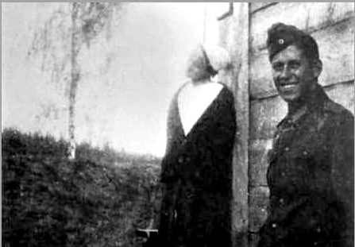
“Then I shot him from behind through the head. He was dead before he knew”
Image 4 – A German ‘soldat’ smiles for the camera next to a Russian nurse that has just been hung. This sort of killing became commonplace for the soldiers of the Eastern Front.

Naturally, upon being thrust in to a situation where violence is accepted and killing is mandatory, some German soldiers revelled in the new-found freedoms that they were given. After all, new technologies, constant success and advanced tactics had forged the German army as a thoroughly modern one, and its troops knew of this fact explicitly. But what this chapter is focused on is the grim reality and dark humour that circulated around the German lines, a process to which many became desensitized to the killings going on around them (see Chapter 1). They looked past the killings themselves, being blind to the carnage from witnessing so much of it and criticised the inefficiency of it instead. This process of ‘brutalisation’, a term coined by SS doctors to describe the undermining of ‘manly discipline’ within the ranks, is felt throughout the German armed forces of the Second World War, most notably in the Wehrmacht.
‘We charged like maniacs’
Bringing this ‘brutalisation’ towards a single case study, Willy Peter Reese’s account of the Eastern Front campaign certainly exhibits his pleasure, and the pleasure of those around him, in fighting and killing. The cold had made Reese and his comrades bitter, while after a successful attack the Soviet troops had burned the only shelters useable for shelter. This ignites a spark, it seems, as the remaining defenders in the town, while surrendering, are ‘gunned down mercilessly’. Reese’s unit, while still cold, find a fragile solace in the death of the opposing force. Not long after, a Cossack unit burns down a house filled with German soldiers, and as retribution a sergeant gives one hundred Russian prisoners hand grenades, pulls the pins on them, and shoots the survivors. This is dealt with unflinchingly, as the brutal toll payed by both sides becomes a self-fulfilling prophecy. It is evident, then, that German troops were desensitised to the fighting, the ongoing killing of Soviets who had brought death to their comrades providing a brief, if not grim, respite from the melancholy. Continuing to fight and kill the Russian foe, then, provided the only real happiness to a soldier on the front line, and to this he resigned himself, as Reese outlines. Their joy in killing gives them a tangible reason to carry on fighting.
Technology at War
Coupled with the happiness found in eliminating the Red Army soldiers, the hastily-developed technologies brought to bear on the Eastern Front in the closing years of the Second World War brought satisfaction to the ordinary German soldier, as it seemed their suffering may not have to last much longer. Weapons such as the SturmGewehr44, the V1 and V2 rockets and tanks such as the Maus were developed in a race to develop a ‘Wunderwaffe’ (or ‘Miracle Weapon’) to reverse the retreat of Germany from the Eastern Front and beyond. While very few Wehrmacht troops managed to see these weapons in combat, their psychological impact was felt over a large area. If a weapon was described to be the most destructive, or most devastating, the soldiers felt greater joy in their usage. This confidence, brought on by the knowledge that greater weapons were being developed to combat the Red Army, spurred many to fight. Equipment that proved to be efficient and reliable made the soldiers’ task easier, and therefore more enjoyable. This link between technology and warmongering can be attributed more towards the elite members of the Wehrmacht, but to an ordinary soldier even a few extra rounds or a new rifle would have been considered new technologies with which to defend against the Soviets. Therefore, the growth in new technologies, while not being adopted en masse, had a significant psychological effect on the soldiers of the Wehrmacht, and encouraged them to fight on. The new technologies made by the Germans gave the ordinary troops another reason to fight.
Freedom
Another way in which the ordinary soldiers of the Wehrmacht enriched their love of fighting was basking in the new freedoms that were given through the necessity of fighting on the Eastern Front. A report published within the spheres of the German High Command highlights how the soldiers had started taking liberties with their position as occupying forces; driving people away from their homes to kill them, confiscating belongings and threatening their superiors. The impression they left was that of ‘mercenaries’ that did not have to answer to anyone. The fighting provided a freedom that was not felt back at home, hence why soldiers like Willy Peter Reese feel more like themselves on the front. This could be attributed to the lack of teenage angst growing up in Nazi Germany, as the obedience to State, parent and elder would have provided very little room to be oneself and be able to exert their frustration in the typical manner to which teenagers do: rebel. Instead, this rebellious streak was furnished by the presence of uniform and gun, and all their pent-up aggression could finally be released. This is where the German high command saw the troops, being mercilessly brutal towards the enemy and sometimes, anyone who happened to be in the way.
To home in this point towards one of my case studies, this sense of freedom was experienced by Willy Peter Reese in being part of the occupying armies of Russia. When his unit starved they ‘requisitioned’ (as he terms it) food and milk, along with scraps of clothing they had torn from bedsheets and linen to keep themselves warm. This he excuses with war, and the very notion that by his participation in the Wehrmacht’s initial victory he deserves these items. His compulsion to take without remorse is urged on by the freedom that he has felt away from home and Germany, as if Russia was a huge playground for the army to take toys and play with them at will. Reese here enjoys a liberation he couldn’t experience anywhere else, and this provides a reason why he continues to fight. His sub-conscious need to continue killing, taking and conquering empowers his mind and body in preparation for the next big ‘high’, and keeps him going when he is losing or retreating.
‘Laughing to split his sides’
Not only did the ordinary German soldier revel in killing, but, in some cases, they found joy in dying too. Guy Sajer reports on an event he witnessed, immediately following a Russian air raid. Only one in his unit was hit by the cannon fire, and his lieutenant picked the man up, convulsing with laughter. He is laughing because he thought he would survive the war, and his disproving forced him to laugh. One calls him a philosopher; the lieutenant tells him the war is no picnic. Amidst his raucous giggling, he finally collapses, and dies. Sajer reflects on this, and he concludes that his laughing is not the symptom of madness, and instead is akin to being the victim of a practical joke. Sajer witnessed a man enjoying his death as being somewhat ironic and laughable, punctuated by his remark ‘Now I know why … Its idiotic’, and this final sense of clarity brings joy to a war where the lines between right and wrong were blurred to the point of transparency. The soldier Sajer witnesses saw his place, finally, in the grand scheme of the conflict, and realised that this was the part soldiers had to play. Their lives and their struggles would end. But this does not bring sadness, and instead brings happiness to the soldier in question. This puts Sajer at ease with death and is perhaps one reason as to why he fought on; he was no longer afraid of dying. He had seen his part in the conflict and was at peace with it.

Chapter 4: Survival
“And you know I never believed that I would ever return home. From the start I didn’t believe it”
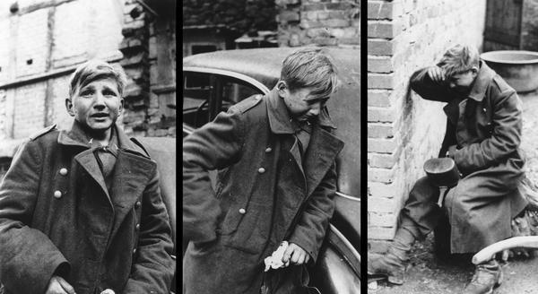
Image 5 – 16 year-old Hans George Hanke, a Luftwaffe anti-air gunner, cries after being captured by American forces. His crew had been killed, and as the last survivor, sought refuge in the Allies.
What could be considered the most basic reason for the continuing fight on the Eastern Front, the instinct for survival, pervaded the German troops’ experience of the war on the Eastern Front. One German sergeant fighting on the outskirts of Berlin noted that while the cause was lost, he and his fellow soldiers would fight to the last man. Now that the Russians had carved in to the very heartland of the German Reich its defenders would fight on even harder. No memory of home, of love, of joy or even the ideology they displayed on their chest brought them solace any longer, only the knowledge that every day they woke up they would have to fight harder to protect themselves from the grotesque treatment the Russians would enact. One soldier recalls how he witnessed a scene in which around fifty German troops had been tortured and killed in a village; some nailed to tables by their tongues, others suspended by meat hooks, and the rest were stoned to death in the well. Tales like these only made the German need to survive stronger. The war became a single great act of revenge for the retreating Germans; sensing that they had already conceded too much for victory, they fought to enact vengeance for their fallen comrades.
‘Simple fear’
By war’s end, around 300,000 soldiers were dying, on average, every month. 50% of these casualties came from the Volkssturm, a military formation consisting of ill-equipped and ill-trained civilian soldiers with which the Nazi leadership felt would bring ‘National Socialist comradery’ to the front. This unrivalled spectacle of death and destruction on the German side, combined with the knowledge that civilians were being ravaged under the yoke of the Red Army and that reinforcements were never to materialise, this only served to make the Germans fight more desperately. One describes themselves as fighting ‘like a rat’. Men fought not for their comrades or the coming of victory, but for a chance to live another day. Even when rations were cut short in the fighting for Berlin, soldiers simply grabbed schnapps, a handful of others and tried to mount an effective defence on makeshift barricades. Their fighting was not spurred on by rhetoric (although the Nazi leadership tried, with Wehrmacht copies of the Soviet Commissar), instead it was trumped by the imminent threat of torture at the hands of the enemy.
Willy Peter Reese feels this sense of fear too, as his anti-tank unit was constantly harassed by the enemy. Amidst relocating his gun in the German retreat, Reese has time to reflect on his reasons for fighting and his spiritual crutches. He confesses that he is not a Christian, so the only way he can hope to live a different life away from the war is to continue fighting. His survival is the only way that he believes life can find meaning again. He feels as if his true potential won’t begin again until he is back home, or to paraphrase his own words ‘on the West bank of the Dnieper’, and this is the hope he clings on to as he continues to fight. He admits that his heart has admitted defeat, but since he still fears death his mind is trying to keep alive the dream of peace just so as he can remain on the frontline. In this regard, Reese regards himself as ‘free’: free to think, to live and to fight. Extrapolating this information, it could be ascertained that Reese fights out of a fear of not getting to live his dream, as if it is a lure constantly evading him. Instead of getting to see his dream, however, Reese would disappear shortly after writing this thought, his body or circumstance of death never being found or ascertained. Reese’s fear, combined with his need to survive, drove him on to continue fighting the Russian foe, and live in the knowledge that his dream would hopefully come true.
Another case study that exhibits these feelings of bestial fear is that of Guy Sajer. As he is retreating, his unit set up camp amidst a destroyed German village and begin to organise sentries to ward off the advancing Russians. This is for naught however, as the sentries run back, forcing the soldiers in to a defensive position. Sajer describes each man turned in to a ‘hunted beast’, acting on primal fear of being attacked. He even fears his rifle is not substantial enough to repel a Russian offensive anymore. This fear of death seems to drive him on, as if it is a hound constantly pursuing behind him. He cannot slow down, because as soon as he does the Russians are at his heels and their jaws are closer to bringing him death. Survival is the only thought that runs through his consciousness, and it is this that urges him to continue fighting.
Brutality
‘You reap what you sow’ – this proverb applies surprisingly well to the fight between the Red Army and the German Wehrmacht. The frame of reference for the German soldier was dramatically changed when Operation Barbarossa was enacted, most notably in the style of warfare exhibited by the Red Army in response to German aggression. Prisoners were shot, soldiers were starved, and brutal tortures were enacted. In response, the Red Army reciprocated this excessive brutality, ending the war with a figure of 91% dead German Prisoners of War. Only 10,000 would survive the Russian camps post-war. As a means to not become a victim of the wrath of the Red Army, the German Wehrmacht fought harder, the troops wanting to avoid being treated the same way in which their comrades had been. A more fatalistic approach was taken by Guy Sajer, as he believes that the actions taken by his own German Wehrmacht only allowed the ‘path of fear and blood’ created by the Russians to come to fruition. The gulags provided a particular means of contrition amongst the troops, as they believed they would become ‘Stalin’s horses’ and be worked to death for the amusement of the Communist regime. The very fact that they heard tales of women being raped and murdered behind the lines also raised the need for survival, although the stories were deliberately exaggerated to try and raise a want to fight the Russians. Despite inflation, the official figure stood at around 1.5 million women who were raped by the advancing Red Army. News of such brutality only made the German soldier on the Eastern Front fight harder and encouraged them not to surrender to a potentially ruthless foe, who would hold no qualm over showing no mercy.
No escape
A point made most prominently by Willy Peter Reese, but reinforced by other accounts, is the notion that the German soldier had no choice but to fight. Nearly being blown apart by a bridge exploding, Reese continues the fight, attempting to hold the Red Army back. His body is bandaged, one man next to him has no boots, and their incessant defence defies all logic to him, but there was ‘no other choice’ but to fight. This can be corroborated by the high levels of executions made by the Nazi political commissars and SS troops in the final months of the war, the likes of which presented the men fighting the advancing Red Army very little choice. This did not stop some desperate enough to want to find refuge away from the lines, but the punishment for their capture was extreme. Some were desperate enough to end their own lives, Reese remarks, while some simply disappeared during the night to never be seen again. With no escape, and a choice between dying at the hands of the Russians or their own soldiers, many continued the resistance, hoping for a quick death so as not to face torture on either side. The soldiers in this situation were caught between a rock and a hard place. They had no choice but to fight, and this is what kept the Wehrmacht fighting for so long on the Eastern Front.

Conclusion
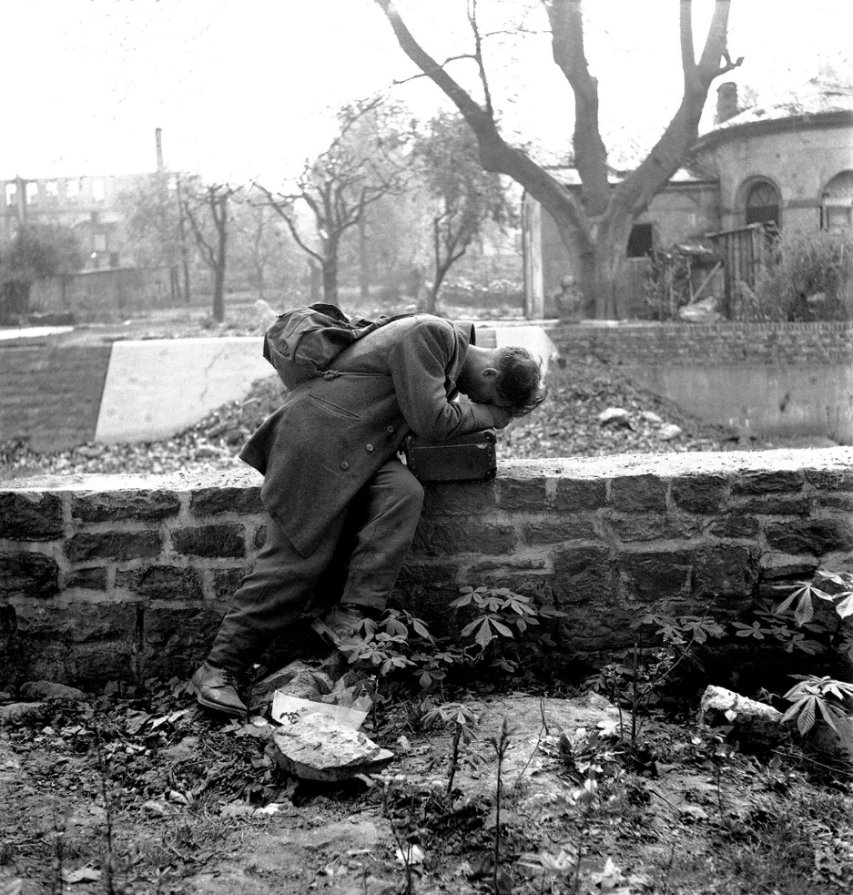
“Don’t be worried for me, I’ll soon be home safe and sound”
Image 6 – A German soldier returns home from an American POW camp, only to find his family, house and neighbourhood gone.
The Second World War is an incredibly interesting and diverse conflict to study. Millions of men and women from all across the world could say they took part in the war – one that would take millions of lives in kind in the ensuing slaughter. While they viewed themselves as the harbingers of a new phase of humanity, the soldiers of the Wehrmacht have now been memorialised as the antagonists of the war; the vanquished foe that the Allies rightly claimed to be a victory for democracy and freedom. However, this way of remembering the German Wehrmacht does not give justice to those who fought within the Heer and does not allow for a deeper analysis on the thoughts and feelings of the ordinary soldier. This was the motivation for me to conduct this study.
It is easy to forget that those we consider our enemies in history felt very similarly to us. A Nationalist and Republican soldier of the Spanish Civil War were made antithesis, but they both felt fear, anguish, pride and joy. In much the same way, the Allied soldier and the Axis soldier have been polarised through history, making them appear like a proverbial Saint George and the Dragon respectively. But what I found was lacking in this interpretation was the experience of the common soldier on the German side, as there are more than enough accounts of Allied troops due to the lack of stigma surrounding their experience. I could not have hoped to uncover every single thought and feeling, such a study would take years to accumulate and interviews would have to be arranged, carried out, and translated. But alas, I have made do with the most glaring ones, and these I feel reflect a universal truth amongst those soldiers. The soldiers I have read about felt pride, sadness, sacrifice, pain and cruelty in equal measures to the Allied soldiers they fought against.
By no means does this study reflect an act of selective remembrance. It is impossible to study the history surrounding the Third Reich without finding the untold brutality founded in racial supremacy, one of the worst crimes humanity has committed. It is upon these deeply atrocious actions that modern egalitarianism is founded, and without the vanquishing of such evils the world would be in a worse state. The intention with this study, instead, was to uncover the experiences of regular German soldiers, testimonies of which have been overruled by the prevailing narrative of the slaughter committed by the Third Reich. If an Allied soldiers’ combat experience can be remembered without the stigma of the government in charge, why does the German experience get forgotten merely because their government proved to be so abhorrent? It has been through this rhetorical musing that I studied this topic, and what has led me to the conclusion I have laid out here.
In equal measure, the German soldier continued to fight for ideology, family, love, sex, joy, thrill and victory. But it is with the very act of survival, the process to which every soldier continues to fight, that the German soldier exhibited the most fervour. As the Red Army swept through their homeland, destroying homes and families, the ordinary German soldier felt a need to fight harder than any time previously witnessed in the grand campaigns of the Second World War. It is by their need to survive that characterised the Wehrmacht in the final months and years of the war.
This study has highlighted what binds us together as people, and what is universal amongst the soldiers of that terrible conflict. The inherent flaw and binding contract to which every soldier subscribed is that they, and we, are all human. Their human courage, depth of character and brutality was universal among all soldiers, the likes of which was not diminished by ideology or circumstance. The very idea of going to war spawns dark and brutal musings to form in a soldiers’ mind, and their experience being shot at, seeing their friends be torn apart and being wounded themselves is something that can change a person forever, regardless of the government or army fought for. Just because a soldier served the Wehrmacht does not mean they suffered any less than a soldier serving the British Army or the United States Army. The German soldier was capable of incredible feats of bravery just as much as an Allied soldier was, the same being said for cowardice or brutality on both sides. In a way, being the victors of the Second World War, the Allies have had the record cleared in terms of brutalities committed, even mentioning them warrants ‘treason’ in the face of history. Yet when these same human characteristics are applied to German troops, it immediately becomes amicable and truthful to their reputation. In light of this study, I feel this to be a deep-seated unkindness to the memory of those German soldiers. They were victims of their own humanity, both in their good qualities and evil, just as much as the soldiers who fought for the Allies were.

Bibliography:
Secondary sources:
- Beevor. A, Berlin: The Downfall 1945 (St Ives: Penguin Books, 2002)
- Beevor. A, Stalingrad (St Ives: Penguin Books, 1999)
- Hitler. A, Mein Kampf, seventy-fourth edn (Mumbai: Jaico Publishing House, 2016)
- Kershaw. I, The End (New York: Penguin Books, 2011)
- Neitzel. S and Welzer. H, Soldaten: On Fighting, Killing and Dying (London: Simon and Schuster, 2012)
- Peter Reese. W, A Stranger to Myself: The Inhumanity of War 1941-1944 (New York: Farrar, Straus and Giroux, 2003)
- Sajer. G, The Forgotten Soldier: War on the Russian Front (London: Weidenfeld and Nicolson, 1997)
- Simons. G, Victory in Europe (Alexandria: Time–Life Books, 1982)
- The Civil War – A Film by Ken Burns, Dir Kenneth Burns, (Kenneth Lauren Burns Productions, 1990) [DVD]
- Facing Stalingrad, Gerhard Hinderlang [online] Available: http://facingstalingrad.com/interviews/gerhard-hindenlang/
- Interview conducted with German veterans during a museum tour, World War Two justified by former soldiers, YouTube. Available: https://www.youtube.com/watch?v=LQdDnbXXn20
- United States Holocaust Memorial Museum, Persecution of Homosexuals in the Third Reich [online] Available: https://www.ushmm.org/wlc/en/article.php?ModuleId=10005261
Extended reading:
- Alexander. C and Kunze. M (ed.), Eastern Inferno: The Journals of a German Panzerjager on the Eastern Front 1941-1943 (Newbury: Casemate, 2010)
- Beevor. A, The Second World War (London: Weidenfeld & Nicolson, 2014)
- Browning. C. R, Ordinary Men: Reserve Police Battalion 101 and the Final Solution in Poland (New York: Harper Perennial, 2017)
- Citino. R. M, The Wehrmacht’s Last Stand (Kansas: University Press of Kansas, 2017)
- Gorlitz. W (ed.), The Memoirs of Field-Marshal Wilhelm Keitel: Chief of the German High Command, 1938-1945 (New York: Cooper Square Press, 2000)
- Howard. M, War in European History, updated edn (Oxford: Oxford University Press, 2009)
- Huber. C, The Dying Days of the Third Reich: German Accounts from World War Two (Stroud: The History Press, 2016)
- Kirchubel. R, Atlas of the Eastern Front: 1941-1945 (Oxford: Osprey Publishing, 2016)
- Koschorrek. G, Blood Red Snow: The Memoirs of a German Soldier on the Eastern Front (Barnsley: Frontline Books, 2011)
- Maeger. H, Lost Honour, Betrayed Loyalty: The Memoir of a Waffen SS Soldier (Barnsley: Frontline Books, 2015)
- Moorhouse. R, Berlin at War: Life and Death in Hitler’s Capital, 1939-1945 (New York: Vintage Press, 2011)
- Overy. R, Russia’s War (London: Penguin Books, 1999)
- Reitlinger. G, The SS: Alibi of a Nation 1922-1945 (London: Arms and Armour Press, 1981)
- Scheiderbauer. A, Adventures in my Youth: A German Soldier on the Eastern Front 1941-1945 (Birmingham: Helion and Company, 2013)
- Stargardt. N, The German War: A Nation Under Arms 1939-1945 (New York: Vintage Publishing, 2016)
- Tucker-Jones. A, Slaughter on the Eastern Front: Hitler and Stalin’s War 1941-1945 (Stroud: The History Press, 2017)
- The World at War, Jeremy Isaacs (Thames Television, 1974) [DVD]
- Siegried Knappe, Interview conducted with a German Wehrmacht veteran, detailing his time in the last months of the Second World War, HistoryNet. Available: http://www.historynet.com/interview-with-world-war-ii-german-officer-siegfried-knappe.html
- A German soldier is interviewed detailing his experiences of fighting within the Wehrmacht, German Soldier speaks about World War Two, YouTube. Available: https://www.youtube.com/watch?v=AQCujrud-_g
- A German veteran recalls memory of fighting with the Wehrmacht, German Veteran recalls World War Two memories, YouTube. Available: https://www.youtube.com/watch?v=4maBAsQWz4U

Interview conducted with German veterans during a museum tour, World War Two justified by former soldiers, YouTube. Available: https://www.youtube.com/watch?v=LQdDnbXXn20 (accessed: 10/02/2018)
W. Peter Reese, A Stranger to Myself: The Inhumanity of War 1941-1944 (New York: Farrar, Straus and Giroux, 2003), p. 116.
Peter Reese, A Stranger to Myself: The Inhumanity of War 1941-1944, p. 117.
A. Beevor, Berlin: The Downfall 1945 (St Ives: Penguin Books, 2002), p. 11.
G. Simons, Victory in Europe (Alexandria: Time–Life Books, 1982), p. 42.
G. Sajer, The Forgotten Soldier: War on the Russian Front (London: Weidenfeld and Nicolson, 1997), p. 490.
Peter Reese, A Stranger to Myself: The Inhumanity of War 1941-1944, p. xx.
United States Holocaust Memorial Museum, Persecution of Homosexuals in the Third Reich [online] Available: https://www.ushmm.org/wlc/en/article.php?ModuleId=10005261 (accessed: 14/03/2018)
Peter Reese, A Stranger to Myself: The Inhumanity of War 1941-1944, p. ix.
United States Holocaust Memorial Museum, Persecution of Homosexuals in the Third Reich [online] Available: https://www.ushmm.org/wlc/en/article.php?ModuleId=10005261 (accessed: 14/03/2018)
S. Neitzel and H. Welzer, Soldaten: On Fighting, Killing and Dying (London: Simon and Schuster, 2012), p. 228.
Neitzel and Welzer, Soldaten: On Fighting, Killing and Dying, p. 230.
ibid., p. 231.
ibid., p. 233.
Peter Reese, A Stranger to Myself: The Inhumanity of War 1941-1944, p. 35.
Interview conducted with German veterans during a museum tour, World War Two justified by former soldiers, YouTube. Available: https://www.youtube.com/watch?v=LQdDnbXXn20 (accessed: 10/02/2018)
A. Hitler, Mein Kampf, seventy-fourth edn (Mumbai: Jaico Publishing House, 2016), p. 573.
Neitzel and Welzer, Soldaten: On Fighting, Killing and Dying, p. 234.
ibid., p. 234.
Sajer, The Forgotten Soldier: War on the Russian Front, p. 337.
Neitzel and Welzer, Soldaten: On Fighting, Killing and Dying, p. 234.
ibid., p. 236.
ibid., p. 231.
Sajer, The Forgotten Soldier: War on the Russian Front, p. 339.
Peter Reese, A Stranger to Myself: The Inhumanity of War 1941-1944, p. 159.
Peter Reese, A Stranger to Myself: The Inhumanity of War 1941-1944, p. 165.
ibid., p. 101.
The Civil War – A Film by Ken Burns, Dir Kenneth Burns, (Kenneth Lauren Burns Productions, 1990) [DVD]
Peter Reese, A Stranger to Myself: The Inhumanity of War 1941-1944, p. xvii.
Neitzel and Welzer, Soldaten: On Fighting, Killing and Dying, p. 165.
Peter Reese, A Stranger to Myself: The Inhumanity of War 1941-1944, p. 5.
ibid., p. 62.
Beevor, Berlin: The Downfall 1945, p. 280.
Sajer, The Forgotten Soldier: War on the Russian Front, p. 318.
ibid., p. 318.
Peter Reese, A Stranger to Myself: The Inhumanity of War 1941-1944, p. 62.
Sajer, The Forgotten Soldier: War on the Russian Front, p. 73.
Neitzel and Welzer, Soldaten: On Fighting, Killing and Dying, p. 280.
ibid., p. 285.
Neitzel and Welzer, Soldaten: On Fighting, Killing and Dying, p. 167.
Peter Reese, A Stranger to Myself: The Inhumanity of War 1941-1944, p. 149.
Neitzel and Welzer, Soldaten: On Fighting, Killing and Dying, p. 166.
ibid., p. 168.
Neitzel and Welzer, Soldaten: On Fighting, Killing and Dying, p. 88.
ibid., p. 186.
ibid., p. 121.
ibid., p. 44.
Peter Reese, A Stranger to Myself: The Inhumanity of War 1941-1944, p. 43.
ibid., p. 43.
ibid., p. 46.
ibid., p. 81.
Neitzel and Welzer, Soldaten: On Fighting, Killing and Dying, p. 191.
ibid., p. 192.
Neitzel and Welzer, Soldaten: On Fighting, Killing and Dying, p. 53.
Peter Reese, A Stranger to Myself: The Inhumanity of War 1941-1944, p. 62.
Neitzel and Welzer, Soldaten: On Fighting, Killing and Dying, p. 90.
Peter Reese, A Stranger to Myself: The Inhumanity of War 1941-1944, p. 35.
ibid., p. 35.
Sajer, The Forgotten Soldier: War on the Russian Front, p. 138.
ibid., p. 138.
ibid., p. 138.
Facing Stalingrad, Gerhard Hinderlang [online] Available: http://facingstalingrad.com/interviews/gerhard-hindenlang/ (accessed: 11/03/2018)
Beevor, Berlin: The Downfall 1945, p. 11.
Neitzel and Welzer, Soldaten: On Fighting, Killing and Dying, pp. 90-91.
Beevor, Berlin: The Downfall 1945, p. 11.
ibid., p. 11.
ibid., p. 311.
ibid., pp. 11-12.
Peter Reese, A Stranger to Myself: The Inhumanity of War 1941-1944, p. 159.
ibid., p. 160.
ibid., p. 162.
Sajer, The Forgotten Soldier: War on the Russian Front, pp. 486-487.
ibid., p. 489.
Beevor, Berlin: The Downfall 1945, p. 11.
ibid., p. 25.
I. Kershaw, The End (New York: Penguin Books, 2011), p. 181.
Peter Reese, A Stranger to Myself: The Inhumanity of War 1941-1944, p. 142.
Beevor, Berlin: The Downfall 1945, pp. 11-12.
Peter Reese, A Stranger to Myself: The Inhumanity of War 1941-1944, p. 145.
A. Beevor, Stalingrad (St Ives: Penguin Books, 1999), p. 292.

